Establish a new directory, populate it with script files, initiate an empty repository on GitHub, convert the local directory into a Git repository, and link it to GitHub for pushing the code into the repository.Perform merge, rebase, stash commands in following github repo.

Initiate an empty repository on GitHub, convert the local directory into a Git repository, and link it to GitHub for pushing the code into the repository

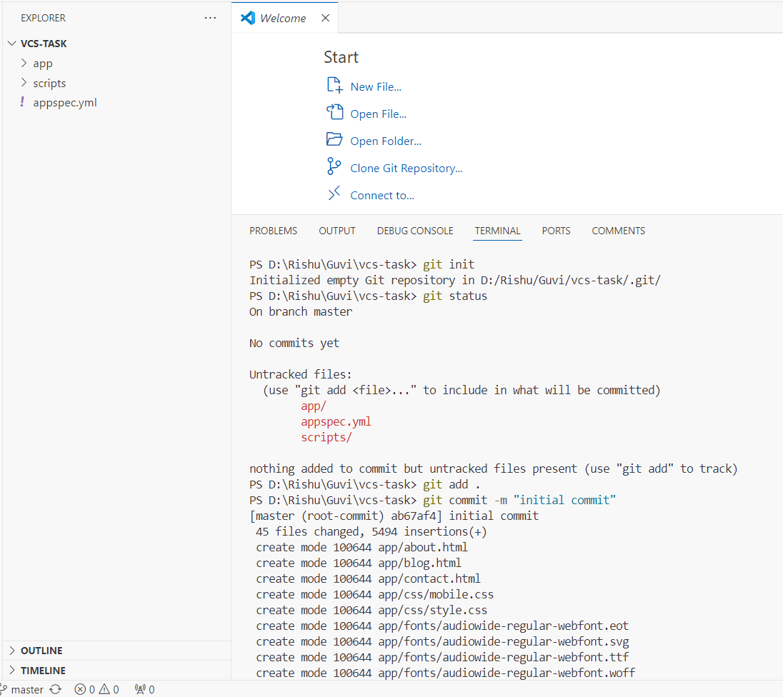

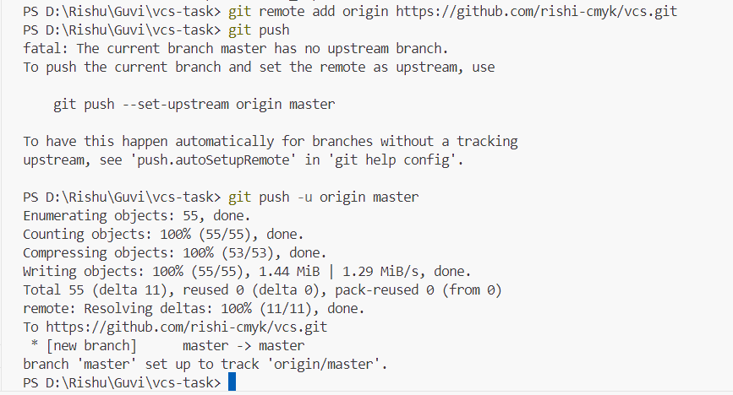

New Brach Creation

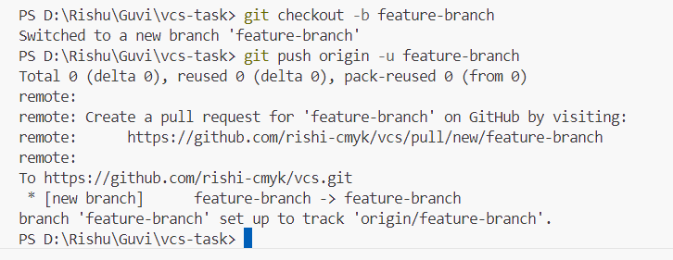

Pull Request

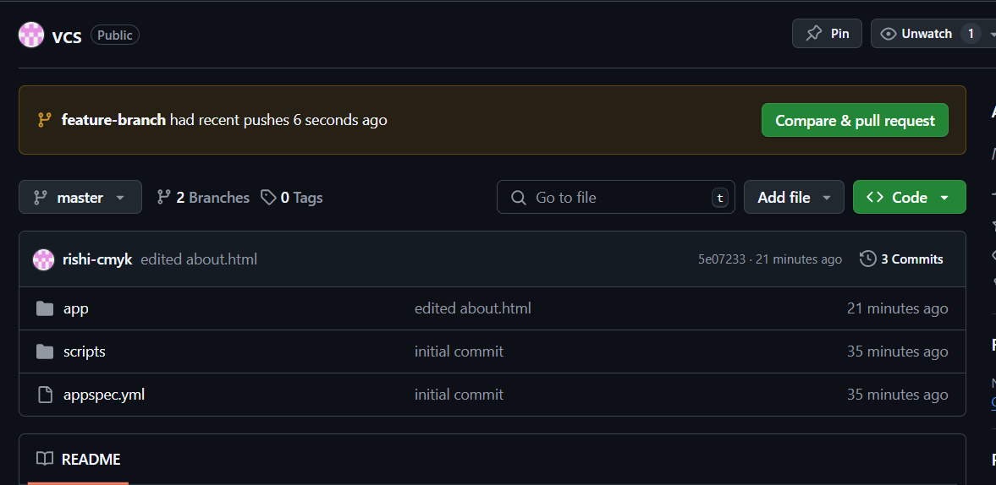

Merge

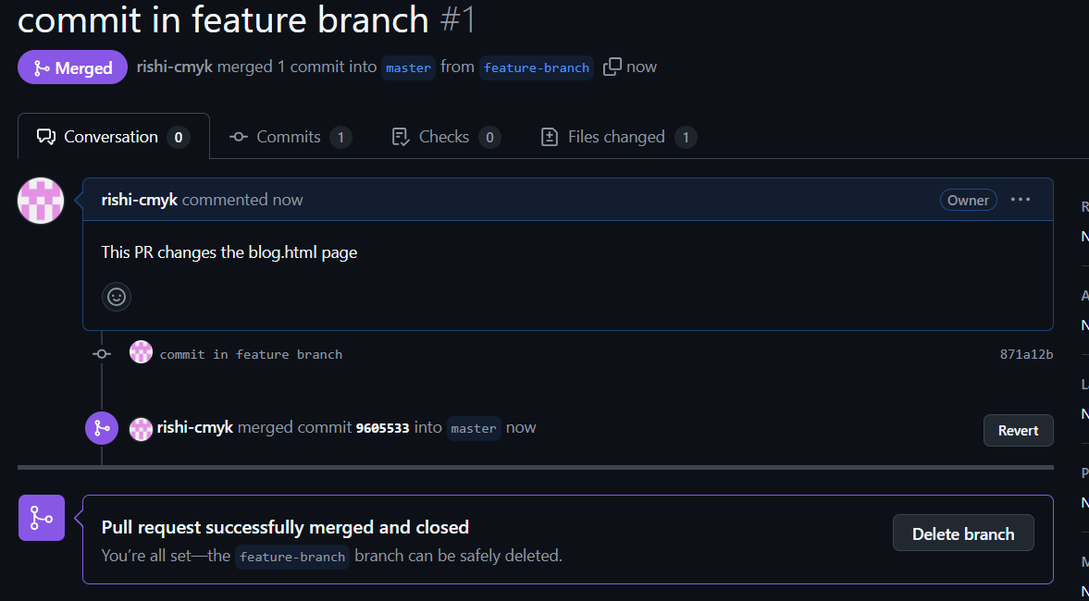

Rebase:

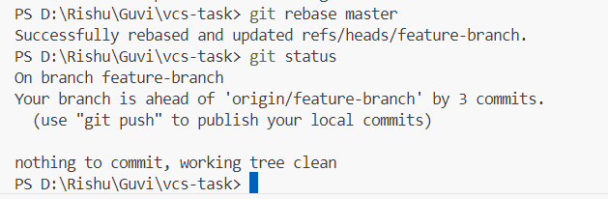

Stash:

