A First Project Final Report on

**ShukraSanchaya**

Submitted in the Partial Fulfillment of the

Requirements for the Degree of **Bachelor’s in Software Engineering** under Pokhara University

Submitted by:

**Hansika Jha, 191709**

**Rishikesh Sharma Poudel, 191737**

**Menuka Lamsal, 191712**

Date:

**11/8/2022**

**Department of Software Engineering**

**NEPAL COLLEGE OF**

**INFORMATION TECHNOLOGY**

Balkumari, Lalitpur, Nepal.

**Acknowledgment**

First of all, we would like to express our sincere gratitude towards the **Department of Software Engineering, Pokhara University** for including the 4th Semester first project as part of the syllabus. Also, we extend our gratitude towards **Mr. Birendra Bista**, Head of Department, Computer Engineering, for assisting us in the project.

Extending thanks to the mentor **Mr. Roshan Chitrakar** for his valuable time and guidance.

Our thanks go to all our fellow friends and college staff who willingly helped us out with their abilities in the completion of this project. Every attempt has been made to include each and every aspect of the project in this report so that the reader can clearly understand the project.

Sincerely,

Hansika Jha, 191709

Rishikesh Sharma Poudel, 191737

Menuka Lamsal, 191712

**Abstract:**

As we know, the world is changing in different things, and in the same way, the thing of conceiving a child is also revolutionized. In ancient times, couples didn’t have any options if they had any kind of problems in childbirth such as infertility, sexually transmitted diseases (STDs), etc. Couples had to stay childless, and this was supposed to be very tough for them from their personal and social point of view. Many women had lost their husbands before conceiving the child and they wanted to have children but were not able to. For many women who don’t want to marry but wanted to have children (single mothers) was not possible. Considering these things, we are now enabling people to have children despite the aforementioned issues.

With the advancement in science and technology, the methods of pregnancy through artificial insemination have been introduced. We encourage people to use these methods to achieve parenthood. What we basically do is, bring the clients (individuals needing sperm), hospitals/clinics (operating sperm banks), and donors (individuals interested to donate sperm) to the same platform. They all will be acting their part based on their requirements.

We only operate on the online platform but do not provide physical banks to store the semen. The hospitals will be fully responsible for the screening tests of donors, asking Medical History Questions (MHQ), and other kinds of stuff. The first and foremost thing we do is create awareness about Artificial pregnancy through semen insemination and what are the methods currently in practice worldwide widely we will be creating awareness primarily through our website by posting blogs, articles, and other mediums. Secondarily we will be physically campaigning the awareness programs. We are planning to take this project to the market after the final project. This being the first project we are just working on the basic things where we will not be operating the system, but the basic functionalities will be properly working. We have worked on user authentication and authorization. The donor registration part is also included after which the interested candidate will be sent to the hospital for screening and further tests.

Keywords: Artificial insemination, assisted reproduction, history, human, intrauterine insemination, semen

**Table Of Contents**

**Acknowledgment**

**Abstract**

**Table Of Contents**

**List Of Figures Tables**

**1. Introduction**

1.1 Problem Statement

1.2 Project Objectives

1.3 Significance of the Study

**2. Literature Study**

**3. Methodology**

3.1 UML Diagram

3.1.1 Use Case Diagram

3.1.2 Activity Diagram

3.1.3 ER Diagram

3.1.4 Class Diagram

3.2 Tools And Technology Used

3.3 Data Storage

3.3.1 MongoDB

3.3.2 NodeJS

3.4 Software Development Process

**4. Project Task And Time Schedule**

**5. Conclusion**

**6. Limitations and Future Works**

**7. Bibliography**

**List of Figures**

**1. System Use-Case Diagram**

**2. Activity Diagram**

**3. ER Diagram**

**4. Class Diagram**

**List of Table**

**Table 1: Project Task And Time Schedule**

**1. Introduction**

ShukraSanchaya is a web application that manifests the integration of three different parties that are donor, client, and clinics/hospitals. The hospitals that are operating sperm banks will get both donors and clients from our web application. For this, we will register the interested donor candidates and these individuals can make appointments with the hospitals or doctors based on their choice and they will be proceeding with further tests/processes. The other side is the clients can look for donors who are registered with us and after the selection of a donor the individuals can make appointments to the hospitals/clinics/doctors to claim their product based on the package and donor they have chosen. This will encourage artificial insemination and sperm donation.

This is a reliable platform that connects three parties and provides a safe environment. This is the certified process that enables the user to easily make appointments with the medical authorities as well as search for a reliable donor.

It is free to use by any required personnel. All the required information for this process is stated on the home page. If the clients have any queries, they can even contact the concerned medical authority, whose contact information is provided in the web application.

**1.1 Problem Statement:**

We see that there is no reliable platform for sperm banking in Nepal. People are facing difficulties in finding the right clinics and suitable donors. Clients must personally visit or call clinics or hospitals to get pieces of information. They might even have to wait for long hours just to get their registration form. There is no certainty that the individual’s information or identity is kept private. There are always chances of their information getting leaked.

Most people in Nepal are not much aware of the artificial method of pregnancy. Although the people who are aware of this, hesitate to try this method for pregnancy. All these problems arise due to a lack of awareness and information among people.

Similarly, for some individuals or couples, it is hard to find a suitable donor since they what certain specifications for their donor. This leads to major time consumption in finding a suitable donor. For the donation process and requirements, the donor must personally visit or call the clinics or hospitals.

**1.2 Project Objectives:**

• The objective of this project is to provide a common platform for donors, clinics,

and clients.

• The main objective of our project is to provide reliability, convenience,

anonymity, and safety for the involved parties.

• To create awareness about pregnancy issues and the methods to overcome them.

• To create awareness about how the artificial method of pregnancy works.

• To promote the hospitals/clinics that are working in this sector.

• To encourage investors to indulge in the business by clarifying the business

prospects in this sector.

• To find suitable donors for the couple without needing to go or call the

clinics/hospitals.

**1.3 Significance of the study:**

This project is supposed to integrate the individuals needing the sperm, the donor, and the hospitals/clinics operating the sperm banks. We ensure reliability, accessibility, and anonymity to the donors and the clients (individuals needing sperm) through our platform.

For every person, family is a matter of utmost significance, we are encouraging and enabling people to make families. Basically, we are changing the lives of people by making and growing a family. People feel hesitation even to talk about these things and we here are openly promoting these things. From a business point of view, this business is rapidly growing every year, making this industry worth billions, it can also be a profitable business here in Nepal as well. And from the donor’s point of view, many people are jobless and are facing financial problems to run day-to-day life. Once registered as an eligible donor they will be paid depending on the quality of the sperm and the number of times they have donated. This project is also supposed to break the stereotypes of our society and revolutionize artificial insemination to achieve childbirth.

**2. Literature Study/Review:**

Web technologies have achieved milestones where a lot of things are common in use. There are different kinds of technologies being used in different domains (frontend, backend, and database).

**Frontend:**

Hypertext Markup Language (HTML) being the backbone of web development has usually been the same but there have been certain advancements in Stylings basically called Cascading Style Sheets (CSS) which are used to style HTML pages. JavaScript has always been the web language and is also known as the brain for web pages. JavaScript has revolutionized user interaction and enabled dynamism in web pages.

Different things like event handling, animations, DOM manipulations, Asynchronous tasks, HTTP requests, etc. are handled using JavaScript.

**Backend:**

The backend encompasses handling the Application Programming Interface (API) requests, connectivity of the database, and manipulating the database based on the requests sent from the web application. Basically, the backend acts as a mediator for the front end and the database.

Not only this backend also runs different kinds of algorithms as per the requirement. Backend also enhances the confidentiality in the functioning of the algorithms and program codes. Our backend will be running on NodeJS, and the API requests will be handled by ExpressJS (the framework of NodeJS). NodeJS is basically a runtime environment that uses Chrome's V8 engine to decode JavaScript provided with other packages, libraries, frameworks, etc. with various kinds of functionalities.

**Database:**

The database is of mainly two types:

1. Relational Database (that uses Structured Query Language (SQL)).

2. Non-Relational Database (that uses Not Only Structured Query Language

(NoSQL))

In this project we are using, a Non-Relational Database that stores the information in the form of Documents within the Collection. The Non-Relational Database that we are using is MongoDB which is very popular and preferred by many web developers. MongoDB mainly provides the command line, local database, and remote database namely MongoDB Atlas. We will be using MongoDB Atlas in this project. The NodeJS framework that will help us to connect to the database namely Mongoose is being used.

Mongoose is easy to use NodeJS framework that works by making Schema (that defines the structure of the collection), and further making the collections using schema. Mongoose also allows inbuilt validation.

**3. Methodology**

Based on the nature and requirements of a project we have chosen an incremental model. Another reason for choosing the incremental model over other models is that we don’t have a definite idea about the end product, and it may change based on our requirements and further analysis. Every task is carried out with some method, the method is either scientific or common; it provides desired output. Every work is planned before it is started. This model combines a linear sequential model with the iterative prototype model. The first increment is a “core product”. The plan addresses the modification of the core product to meet the needs of the customer and the delivery of additional features and functionality. The process is repeated following the delivery of each increment until the complete product is produced.

**3.1 UML Diagram**

**3.1.1 Use Case Diagram**

Figure: System Use case

**3.1.2 Activity Diagram**

Figure: Activity Diagram

**3.1.3 ER Diagram**

Figure: ER Diagram

**3.1.4 Class Diagram**

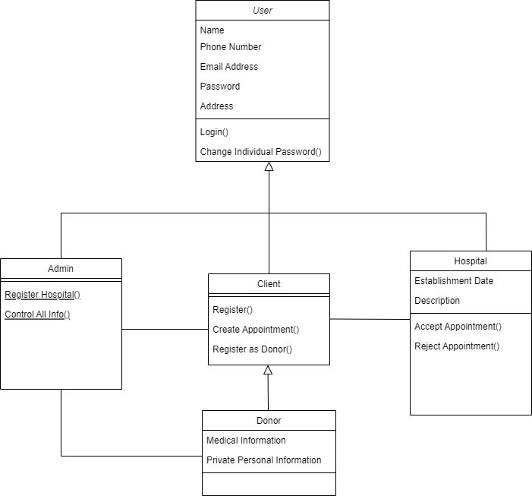

Figure: Class Diagram

**3.3 Data Storage**

**3.3.1 MongoDB**

MongoDB is an open-source document database and NoSQL database. It is used to store data in a key-value pair. Its work is based on the concept of document and collection. MongoDB uses JSON-like documents with optimal and defined schemas which makes MongoDB so scalable as well as flexible. NoSQL database means a database that does not use query languages and schemas is employed for managing the massive collection of unstructured data and when our data is not piled up in tabular format or relation like that in a relational database. MongoDB provides high performance, scalability as well as availability to manage the database. MongoDB is beneficial for highly elastic scalability and is valuable and reliable for big data and is cheaper and follows agile data models.

**3.3.2 NodeJS**

NodeJS is an open-source, cross-platform, back-end JavaScript runtime environment that runs on a V8 engine and executes JavaScript codes outside a web browser. NodeJS allows developers to run JavaScript on the server. NodeJS eliminates the waiting for execution and simply continues with the next request execution. NodeJS runs the single-threaded event, non-blocking execution, and asynchronous programming where sequential execution is not carried out, which is very memory efficient.

**3.4 Software Development Process**

**Incremental model includes the following phases:**

1. Requirement analysis:

In the first phase of the incremental model, the product analysis expertise

identifies the requirements. And the system’s functional requirements are

understood by the requirement analysis team. To develop the software under

the incremental model, this phase performs a crucial role.

2. Design & Development:

In this phase of the Incremental model of SDLC, the design of the system

functionality and the development method are finished with success. When

software develops new practicality; the incremental model uses style and

development phase.

3. Testing:

In the incremental model, the testing phase checks the performance of each

existing function as well as additional functionality. In the testing phase,

various methods are used to test the behavior of each task.

4. Implementation:

Implementation phase enables the coding phase of the development system. It

involves the final coding that is designed in the designing and development phase

and tests the functionality in the testing phase. After the completion of this phase,

the number of the product working is enhanced and upgraded up to the final

system product.

**5. Proposed Task and Time schedule**:

|  |  |
| --- | --- |
| **Task** | **APPROX.DURATION(in days)** |
| Requirement Analysis and Specification | 4 |
| Undertake Analysis of the System | 3 |
| Design System | 5 |
| Produce Requirement Specifications | 4 |
| Testing and debugging | 4 |
| Test System Modules | 2 |
| Overall System Test | 3 |

**6. Conclusion**

In this growing world of technology, the methods of pregnancy through artificial insemination have been introduced. We encourage people to use these methods to achieve parenthood. What we basically do is, bring the clients (individuals needing sperm), hospitals/clinics (operating sperm banks), and donors (individuals interested to donate sperm) to the same platform. They all will be acting their part based on their requirements.

We only operate on the online platform but do not provide physical banks to store the semen. The hospitals will be fully responsible for the screening tests of donors, asking Medical History Questions (MHQ), and other kinds of stuff. The first and foremost thing we do is create awareness about Artificial pregnancy through semen insemination and what are the methods currently in practice worldwide widely we will be creating awareness primarily through our website by posting blogs, articles, and other mediums. Secondarily we will be physically campaigning the awareness programs. We are planning to take this project to the market after the final project.

**7. Limitations and Future Works**

We just act as mediators connecting the donor, client, and hospitals/clinics but not taking authority over how the further process goes on after the client or donor has taken an appointment. We will not also be responsible for sperm storage (Cryopreservation).

We will also not be taking liabilities for the payments though we will be displaying the different packages in the initial phase. The financial part is completely obsolete. We will not also be responsible for the consequences/complications occurring after the client has purchased the product.

In future work, we are planning to include the whole detailed information about donors (their medical history, family background, personal interests, appearance, etc.) We will as well try to connect with social organizations for providing awareness about artificial pregnancy. After the final project, we are planning to launch this project for public use.

**Bibliography/References:**

* Figure of Incremental model: <https://www.javatpoint.com/software-engineering-incremental-model>
* Article about Artificial insemination:

<https://www.sciencedirect.com/science/article/pii/B9780120749034500108>

* NCIT LMS old project