

**Tribhuvan University**

**Faculty of Humanities and Social Sciences A PROJECT REPORT**

**ON**

## DIABETES PREDICTION SYSTEM

### Submitted to Department of Computer Application

**Ratna RajyaLaxmi Campus**

***In partial fulfillment of the requirements for the Bachelors in Computer Application***

Submitted by

Susil Saud (6-2-40-58-2019)

July, 2023

Under the Supervision of

**Mr. Bhupendra Ram Luhar**



**Tribhuvan University**

**Faculty of Humanities and Social Sciences Ratna RajyaLaxmi Campus**

## Supervisor’s Recommendation

I hereby recommend that this project prepared under my supervision by SUSIL SAUD entitled “**DIABETES PREDICTION SYSTEM**” in partial fulfillment of the requirements for the degree of Bachelor of Computer Application is recommended for the final evaluation.

Mr. Bhupendra Ram Luhar

### SUPERVISOR

Lecturer

Department of Computer Application Ratna RajyaLaxmi Campus, Kathmandu



**Tribhuvan University**

**Faculty of Humanities and Social Sciences Ratna RajyaLaxmi Campus**

## LETTER OF APPROVAL

This is to certify that this project prepared by SUSIL SAUD entitled “**DIABETES PREDICTION SYSTEM**” in partial fulfillment of the requirements for the degree of Bachelor in Computer Application has been evaluated. In our opinion it is satisfactory in the scope and quality as a project for the required degree.

|  |  |
| --- | --- |
| Mr. Bhupendra Ram Luhar Lecturer  BCA, Ratna Rajyalaxmi Campus | Mr. Bhupendra Ram Luhar HOD  BCA, Ratna Rajyalaxmi Campus |
| **Internal Examiner** | -  **External Examiner** |

# ACKNOWLEDGEMENT

The satisfaction that accompanies that the successful completion of any task would be incomplete without the mention of people whose constant cooperation made it possible, whose constant guidance and encouragement crown all efforts with success. I am grateful to my project guide and Head of Department, **Mr. Bhupendra Ram Luhar** for the guidance, inspiration and constructive suggestions that helpful us in the preparation of this project.

I would like to thank my other lecturer **Mr. Bhoj Raj Joshi, Mr. Deepak Thakur, Mrs. Kriti Nemkul** and **Mr. Bijay Mishra**, who always helped me without hesitation. Their suggestion and directions have helped a lot in the completion of the project.

Finally, I would like to thank my friends who have always been there to support me and my parents who gave me feedbacks on improving my project work.

# ABSTRACT

Diabetes mellitus is a chronic metabolic disorder that affects millions of people worldwide, posing significant health challenges and economic burdens. Early detection and timely management of diabetes are essential to prevent its complications and improve the quality of life for affected individuals. In this context, we need an innovative Diabetes Prediction System (DPS) aimed at predicting the risk of diabetes development in individuals based on a set of diabetes parameters.

The DPS utilizes advanced machine learning algorithm i.e. Logistic Regression to analyze a diverse range of input data, including medical history. These inputs are obtained from user through user-friendly interfaces. By using the artificial intelligence, the DPS can effectively identify patterns and correlations within the data to generate accurate and personalized predictions.

To ensure the reliability and robustness of the prediction model, the DPS is trained on large and diverse datasets, containing information from diverse populations and various diabetes risk factors. The model undergoes rigorous validation to guarantee its generalizability and effectiveness.

Moreover, the DPS empowers healthcare providers with valuable insights into individualized risk profiles, enabling them to tailor their preventive strategies and allocate resources more efficiently. Additionally, users benefit from increased awareness of their health status, motivating them to adopt healthier behaviors and actively engage in disease prevention.

In conclusion, the Diabetes Prediction System represents a promising advancement in the field of diabetes management and prevention. By harnessing the potential of machine learning and data analytics, this system has the potential to revolutionize diabetes care, reducing the burden of the disease on both individuals and healthcare systems.

**Keywords**: Chronic Disease, Diabetes, Machine Learning, Prediction System

# Table of Contents

ACKNOWLEDGEMENT i

ABSTRACT ii

List of Tables v

List of Figures vi

List of Abbreviations vii

Chapter 1: Introduction 1

* 1. Introduction 1
  2. Problem Statement 1
  3. Objectives 2
  4. Scope and Limitation 2
  5. Report Organization 2

Chapter 2: Background Study and Literature Review 3

* 1. Background Study 3
  2. Literature Review 3

Chapter 3: System Analysis and Design 5

* 1. System Analysis 5
     1. Requirement Analysis 5

1. Functional Requirements 5
2. Non Functional Requirements 5
   * 1. Feasibility Analysis 6
3. Technical Feasibility 6
4. Operational Feasibility 6
5. Economic Feasibility 6
6. Schedule Feasibility 7
   * 1. Data Modeling using ER diagram 8
     2. Process Modeling using DFD 8
   1. System Design 9
      1. Architectural Design 9
      2. Database Schema Design 11
      3. Interface Design 11
      4. Physical DFD 15

3.3 Description of Algorithm 15

Chapter 4: Implementation and Testing 17

* 1. Implementation 17
     1. Tools Used 17
     2. Implementation Details of Modules 18
  2. Testing 18
     1. Test Cases for Unit Testing 18
     2. Test Cases for System Testing 21

Chapter 5: Conclusion and Future Recommendation 23

* 1. Lesson Learnt 23
  2. Conclusion 23
  3. Future Recommendations 23

References 24

**Appendices**

# List of Tables

Table 4.1: Testing Registration Form 18

Table 4.2: Testing Login Form 19

Table 4.3: Testing Admin Dashboard 20

Table 4.4: Testing User Dashboard 21

Table 4.5: Diabetes Prediction System 21

# List of Figures

Figure 3.1: Use Case Diagram of Diabetes Prediction System 5

Figure 3.2: Gantt chart of Diabetes Prediction System 7

Figure 3.3: ER diagram of Diabetes Prediction System 8

Figure 3.4: Context Level of Diabetes Prediction System 8

Figure 3.5: Level 1 DFD of Diabetes Prediction System 9

Figure 3.6: Architectural diagram of Diabetes Prediction System 10

Figure 3.7: Database Schema Diagram of Diabetes Prediction System 11

Figure 3.8: Home page of Diabetes Prediction System 11

Figure 3.9: Admin login page of Diabetes Prediction System 12

Figure 3.10: User registration page of Diabetes Prediction System 13

Figure 3.11: User login page of Diabetes Prediction System 14

Figure 3.12: Physical DFD of Diabetes Prediction System 15

# List of Abbreviations

CSS – Cascading Style Sheet DFD – Data Flow Diagram

DPS – Diabetes Prediction System ER – Entity Relationship

HTML – Hypertext Markup Language JS – JavaScript

ORM – Object Relational Mapper SQL – Structured Query Language

* 1. **Introduction**

# Chapter 1: Introduction

Diabetes is a non-communicable chronic disease caused because of high glucose level in a human body. Diabetes should not be ignored if it is untreated then people having diabetes have high risk of diseases like heart disease, kidney disease, stroke, eye problem, nerve damage and it can also affect other organs of human body. Diabetes can be controlled if it is predicted earlier. Early prediction of diabetes can help to reduce the risk of life- threatening complications and improve the treatment of the disease.

“Diabetes Prediction System” is a web based application that predicts diabetes by taking various attributes related to diabetes. For this purpose, the Pima Indian Diabetes Dataset is utilized to anticipate diabetes using machine learning techniques. By utilizing a number of diabetes disease related characteristics, this system predicts diabetes. This system would help user to predict diabetes at early stage. This system offers a user-friendly interface that allows users to browse on the platform with ease. Users can predict whether they are suffering from diabetes or not as per their particular input related to diabetes attributes from the system.

This system is developed using HTML, CSS, JavaScript, Django, Python and MySQL. This system mainly contains two side. One is admin, who is responsible for managing the system as well as the user. The admin can change his/ her profile from the system. And the other is user, who can register into the system and can predict diabetes according their input attributes related to diabetes. User can change their profile as well from the system. User can be able to download their diabetes report from the system. Overall, this system would be very helpful for anyone who want to know whether they are suffering from diabetes or not.

## Problem Statement

There is not so much available system that predict diabetes. Due to which user has to visit hospital and consult to doctor for knowing whether they are suffering from diabetes or not. This process is tedious as well as time consuming for detection of diabetes. And there is limited system that predicts diabetes which are not so user friendly and accurate. Hence, there is need of diabetes prediction system to overcome the drawback of existing system.

## Objectives

* + - To predict diabetes from given user input attributes related to diabetes.
    - To download diabetes report.
    - To upload profile picture.

## Scope and Limitation

### Scope

The scope of the system is that user can predict diabetes easily sitting at home within a couple of minutes. The system is developed as a web-application, and for now it runs only on system it’s installed. But later the system can be modified to operate it online for commercially.

### Limitation

If anyone shares his/her confidential details with other than that user can access his/her account.

## Report Organization

The report can be organized into 5 chapters which are given below:

**Chapter 1** includes the brief introduction of the system, statement of problem, objectives, scope and limitation.

**Chapter 2** includes the previous work related to the systems and similar works were studied and are summarized.

**Chapter 3** includes different feasibility analysis and designed system architecture, system flow diagram, dataflow diagram.

**Chapter 4** includes various implementation method and tools and also contains description of testing.

**Chapter 5** includes outcomes of the system, conclusion to the system and description about what features can be added in the future.

# Chapter 2: Background Study and Literature Review

## Background Study

Diabetes mellitus, commonly known as diabetes, is a chronic metabolic disorder characterized by elevated blood glucose levels resulting from either insufficient insulin production or the body's inability to effectively use insulin. It affects millions of people worldwide and poses significant health challenges, including an increased risk of cardiovascular diseases, kidney dysfunction, and other complications.

Over the years, the prevalence of diabetes has been steadily rising, making it a major public health concern. Early detection and proactive management of diabetes are crucial to prevent its complications and improve the quality of life for affected individuals. However, many cases of diabetes remain undiagnosed until the disease has reached an advanced stage, leading to delayed interventions and increased healthcare costs.

In recent years, there has been a growing interest in applying artificial intelligence (AI) and machine learning (ML) techniques to healthcare, including diabetes management and prediction. Machine learning algorithms have demonstrated the ability to analyze vast amounts of data and identify patterns and correlations that can assist in predicting diabetes development and assessing individual risk profiles.

The use of predictive modeling and data analytics in diabetes prediction systems has the potential to revolutionize the field of diabetes management. By leveraging user data, including demographic information, medical history, lifestyle habits, and biomarkers, these systems can accurately assess an individual's risk of developing diabetes within a certain timeframe.

## Literature Review

Diabetes Prediction using Machine Learning detect and classify the presence of diabetes in e-healthcare environment using Ensemble Decision Tree Algorithms for high feature selection. Model validation and performance evaluation metrics have been used to check the validity of the proposed system. Two ensemble learning Decision Tree algorithms, such as Ada Boost and Random Forest are also used for feature selection and compared the classifier performance with wrapper based feature selection algorithms also. Machine

learning classifier Decision Tree has been used for the classification of healthy and diabetic subjects [1].

Diabetes Prediction using Machine Learning is a web based application developed in python, pandas, numpy and flask. This system predicts whether the person has diabetes or not based on various features like Number of Pregnancies, Insulin Level, Age, BMI. The data set that has used in this project has taken from the kaggle. Several constraints were placed on the selection of these instances from a larger database. In particular, all patients here are females at least 21 years old of Pima Indian heritage [2].

Diabetes Prediction System is a web based application based on the prediction of type 2 diabetes with given data. This system uses various algorithm to predict and detect diabetes. The analysis includes symptoms in human body for diabetes like frequent urination, sudden vision changes, excessive thirst, extreme hunger and unexplained weight loss [3].

Diabetes prediction using Machine Learning is a web based application developed in python and streamlit framework to deploy model. This system predicts diabetes based on various parameters of diabetes. Support vector classifier algorithm is used to build this model [4].

Diabetes Prediction Web App can be used in the medical field. It is basically a user-friendly web app where a person can know whether he is diabetic or not. In this project python and streamlit is used to develop model. And support vector machine algorithm is used to build this model [5].

Diabetes Prediction Project in Django uses the Django framework using Python. In this project, logistic regression algorithm of Python machine learning is used to predict diabetes diseases in a person by observing the input values filled by the person according to their health [6].

# Chapter 3: System Analysis and Design

## System Analysis

### Requirement Analysis

The requirements determination turns the very high-level explanation stated in the system request into a more precise list of requirements that can be used as inputs to the rest of analysis. And a requirement is simply a statement of what the system must do or what characteristic it must have. The system requirements are often classified as functional and non-functional requirements.

### Functional Requirements

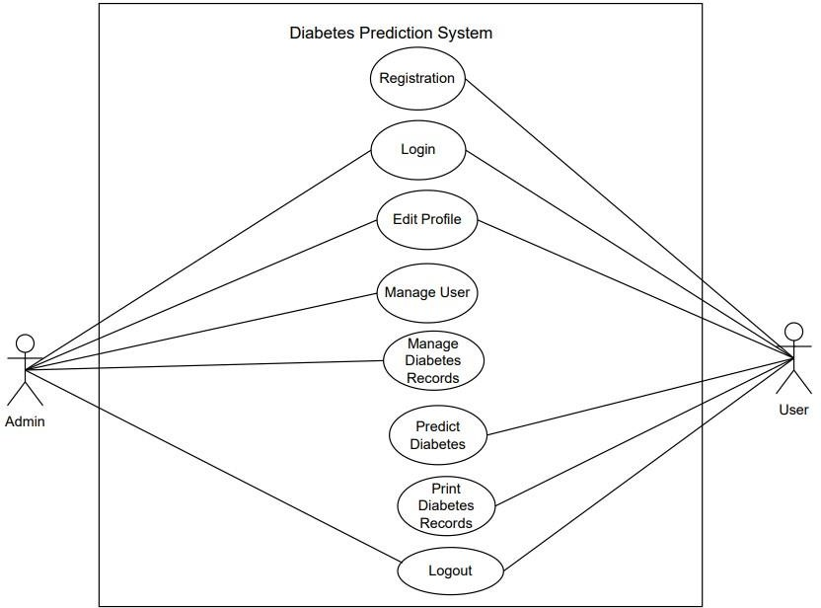

**Figure 3.1: Use Case Diagram of Diabetes Prediction System**

In this use case diagram, the functional requirement of the system is shown i.e. admin, and user. The user can register into the system and then can login into the system. User can edit their profile into the system. The user can predict diabetes whether he/she has or not diabetes from the system. The admin controls and manage the overall system including user.

### Non Functional Requirements

1. **Availability:**

The system should be available 24 hours of the day. The system should be accessible throughout the day from any location which has internet connection.

### Performance:

The system should be easy to use. The system should perform efficiently.

### Reliability:

The system should be reliable to use. The system should be responsive enough so that its user can rely fully on it.

### Security:

The system must secure the data. The system must guarantee the security of data from various threats like virus attack, malware attack and unauthorized access and so on.

### Feasibility Analysis

In this Diabetes Prediction System different feasibility study has been done to determine whether this system is feasible or not.

### Technical Feasibility

Technical feasibility is an evaluation of the hardware and software and how it meets the need of the proposed system. Since this system is developed using HTML, CSS and JavaScript as frontend support whereas Python, Django and MySQL as backend support. The system is smooth in functioning, efficient and convenient to use. This system is easily accessible to all the people. So, this system is technically feasible.

### Operational Feasibility

Operational feasibility is the measure of how well a proposed system solves the problems. This system is simple in nature that no special technical knowledge is required to use the system. Due to which all general people can use it easily. So, this system is operationally feasible.

### Economic Feasibility

This evaluates whether or not a project is cost-effective. Cost- effective in the sense that components used in the development process is economical or not. This system is economical because software component used in this project are easily and freely available in the internet. The development of this system is highly economically feasible.

### Schedule Feasibility

This project will complete in three months and can be shown in following Gantt chart.

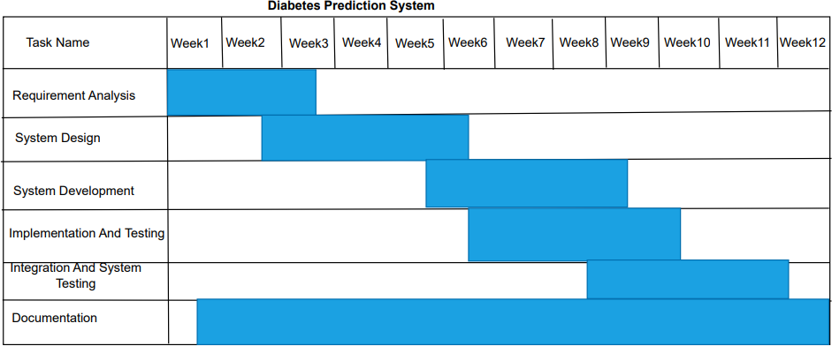

### Figure 3.2: Gantt chart of Diabetes Prediction System

This above figure is the Gantt chart of this system. This chart shows the time duration and completion of the project.

### Data Modeling using ER diagram

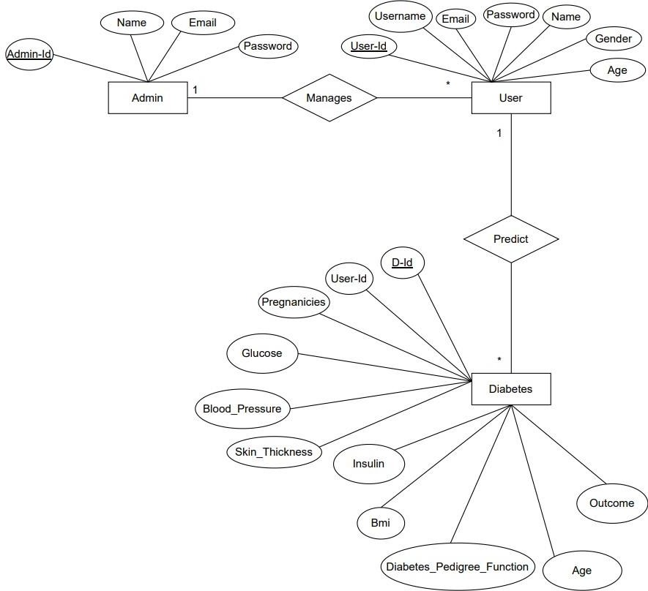

**Figure 3.3: ER diagram of Diabetes Prediction System**

E-R diagram shows the relationship between entities. Here, admin manages user. The user can predict diabetes whether they have or not from the system.

### Process Modeling using DFD

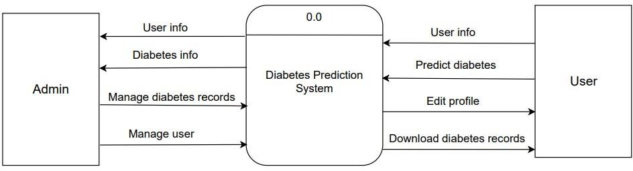

**Figure 3.4: Context Level of Diabetes Prediction System**

User have to login into the system to give their information. After providing their information they can predict diabetes whether they have or not. They can download their diabetes records from the system. The user can edit their profile which include they can upload their profile picture. The admin manages both the user and the diabetes records.

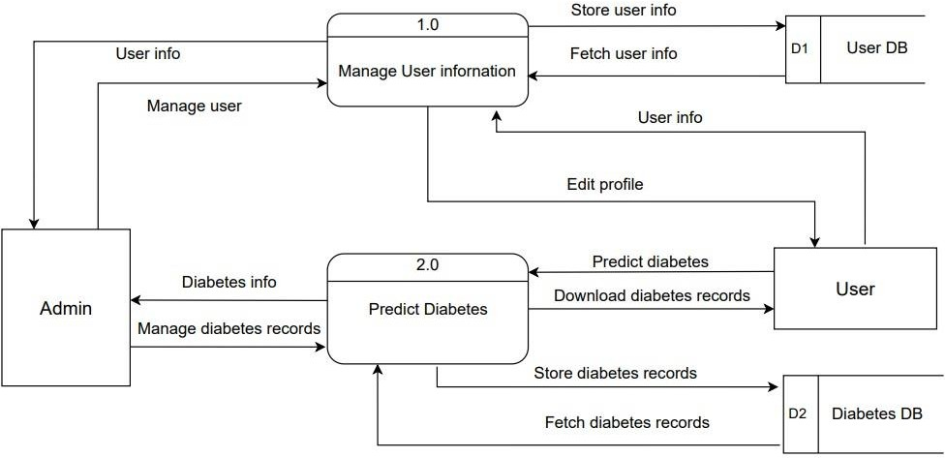

### Figure 3.5: Level 1 DFD of Diabetes Prediction System

Admin manages the user information and diabetes records. The admin can view all the registered users and diabetes records. User give their information to the system. Then he/she predict whether they have diabetes or not. The user can upload their profile picture and can update their profile as well from the system.

## System Design

### Architectural Design

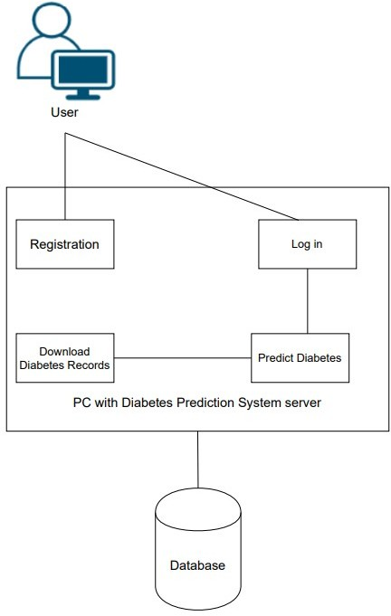

**Figure 3.6: Architectural diagram of Diabetes Prediction System**

Figure 3.6 represents the architectural diagram of the system. The user needs to fill registration form to get register into the system then he/she can login into the system. Then he/she can predict diabetes whether they have or not and they can download their diabetes records from the system. These all data are stored into the database of the system.

### Database Schema Design

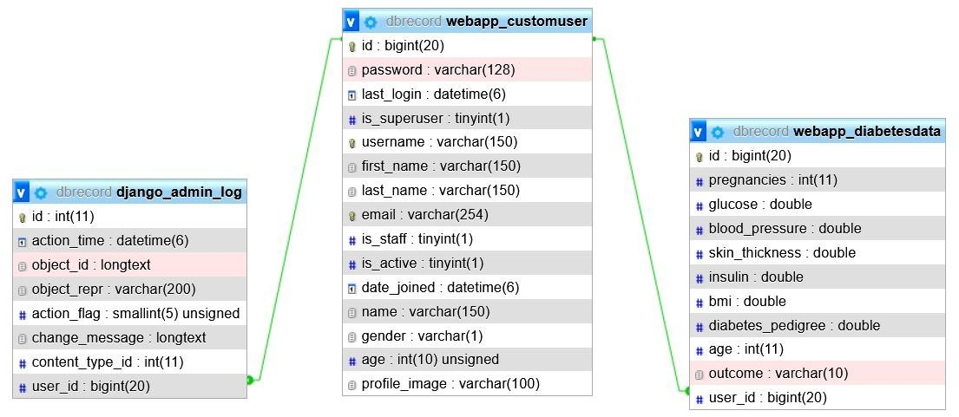

**Figure 3.7: Database Schema Diagram of Diabetes Prediction System**

Figure 3.7 shows the schema diagram of the database. There are three table in this system. First table stores admin information and the next table stores user information and the last table stores diabetes records of the registered user. Admin must enter valid credentials to login into the system. Similarly, the user should fill all the fields to register into the system.

### Interface Design

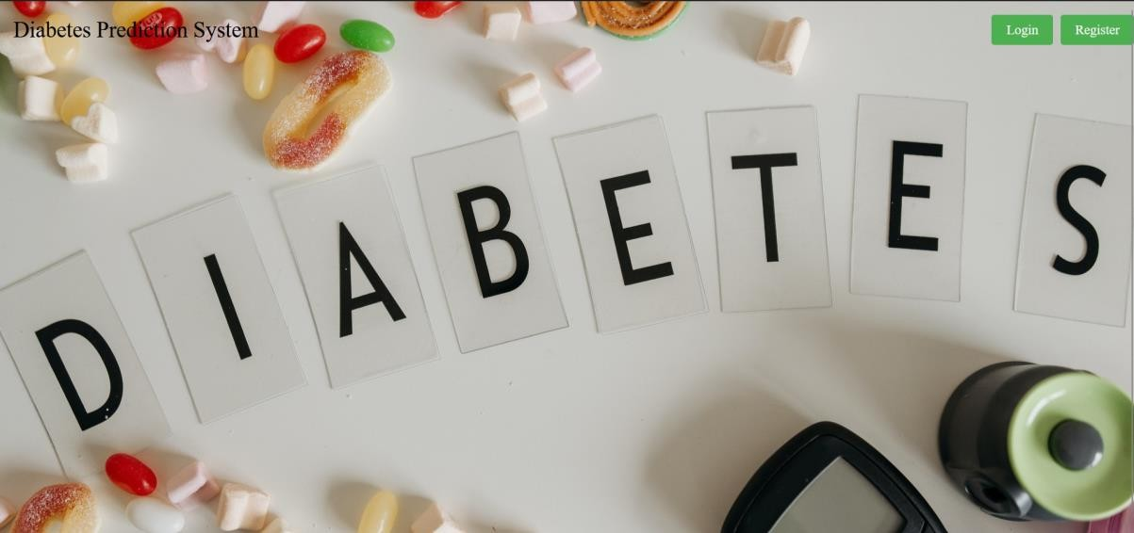

**Figure 3.8: Home page of Diabetes Prediction System**

This is the main page of this system. There are two button which are login and registration. The user can register themselves into the system by clicking register button and then they can login into the system by clicking login button.

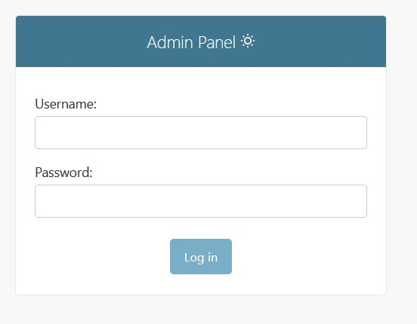

### Figure 3.9: Admin login page of Diabetes Prediction System

This is the admin login page of the system. The admin must enter valid credentials to login into the system otherwise he cannot login into the system.

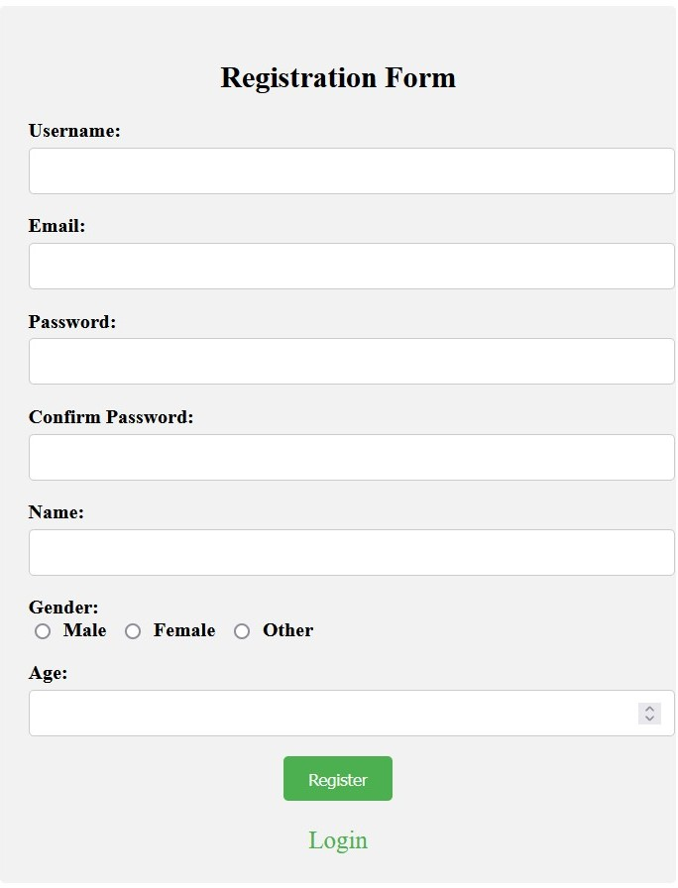

### Figure 3.10: User registration page of Diabetes Prediction System

This is the user registration page of this system. The user must fill all fields to register into the system. If user tried to skip anyone field, then he/she cannot register into the system.

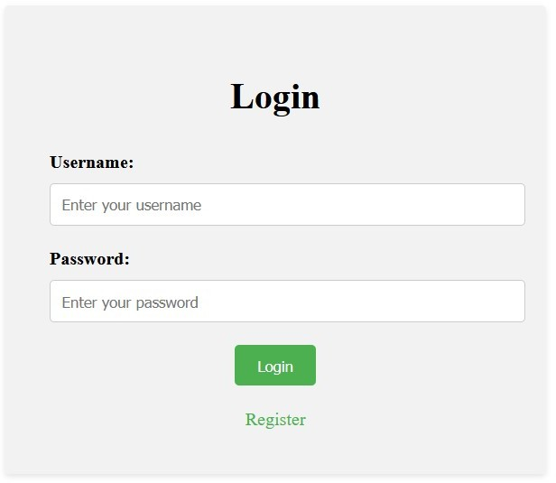

### Figure 3.11: User login page of Diabetes Prediction System

This is the user login page of this system. The user must enter valid credentials to login into the system otherwise he/she cannot login into the system.

### Physical DFD

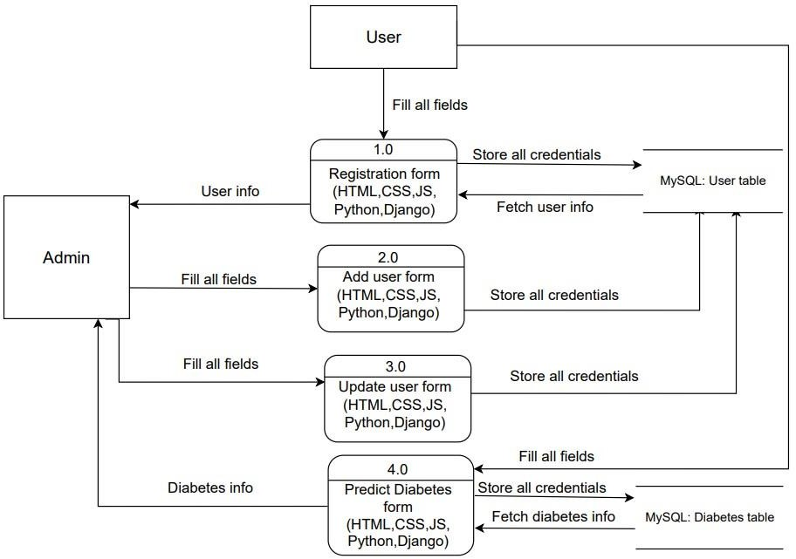

**Figure 3.12: Physical DFD of Diabetes Prediction System**

This above figure is the physical DFD of this system. User should fill all the registration fields to register into the system. The user details are stored into the user table. The user

should fill all the fields of diabetes form to predict diabetes. The user predict diabetes is stored into the diabetes table. The admin can get user information and can view user’s diabetes records from the system.

### Description of Algorithm

* + - **Logistic Regression:**

Logistic regression is a supervised machine learning algorithm mainly used for classification tasks where the goal is to predict the probability that an instance of belonging to a given class or not. It is a kind of statistical algorithm, which analyze the relationship between a set of independent variables and the dependent binary variables. The steps of involved in logistic regression algorithm are:

1. Define the problem: Identify the dependent variable and independent variables and determine if the problem is a binary classification problem.
2. Data preparation: Clean and preprocess the data, and make sure the data is suitable for logistic regression modeling.
3. Exploratory Data Analysis (EDA): Visualize the relationships between the dependent and independent variables, and identify any outliers or anomalies in the data.
4. Feature selection: Choose the independent variables that have a significant relationship with the dependent variable, and remove any redundant or irrelevant features.
5. Model building: Train the logistic regression model on the selected independent variables and estimate the coefficients of the model.
6. Model evaluation: Evaluate the performance of the logistic regression model using appropriate metrics such as accuracy, precision, recall, F1-score, or AUC- ROC.
7. Model improvement: Based on the results of the evaluation, fine-tune the model by adjusting the independent variables, adding new features, or using regularization techniques to reduce overfitting.
8. Model deployment: Deploy the logistic regression model in a real-world scenario and make predictions on new data.

The logistic regression algorithm can be represented mathematically as follows: Linear Combination:

The linear combination of the features, denoted as X, is calculated using the feature coefficients, denoted as β, and the intercept term, denoted as β0:

Z = β0 + β1X1 + β2X2 + ... + βn*Xn

where Z represents the linear combination. Logistic (Sigmoid) Function:

The logistic function, denoted as g(Z), is applied to the linear combination to obtain the predicted probability, denoted as P, of the event occurring:

P = g(Z) = 1 / (1 + e^(-Z))

In the logistic function, e represents Euler's number (approximately 2.71828). The logistic function maps the linear combination Z to a value between 0 and 1, which can be interpreted as the probability of the event occurring.

# Chapter 4: Implementation and Testing

## Implementation

### Tools Used

* + - 1. **Front-End Tools**

1. HTML

Hypertext Markup Language(HTML) is used for documents designed to be displayed in a web browser.

1. CSS

Cascading Style Sheet(CSS) is used for describing the presentation of a document written in a markup language such as HTML.

1. JS

JavaScript(JS) is used in user dashboard for designing.

### Back-End Tools

1. Python

Python is the primary programming language used for the backend development.

1. Django

It is the web framework of Python that helped to build the application's backend logic and handle HTTP requests and responses.

### Data Modeling:

Django's built-in ORM (Object-Relational Mapping) is used for data modeling and defining the database schema.

### Machine Learning Libraries:

Scikit-learn is used as the machine learning library used to implement the Logistic Regression algorithm for diabetes prediction system.

### Database Tools

a. MYSQL

MySQL was used to store and manage the data for diabetes prediction system.

### Server Tools

a. XAMMP

XAMMP is used for hosting platform for web app.

### Diagramming Tools

a. Draw.io

Draw.io is used for drawing use case diagram, flowchart and DFD, ER diagram, physical DFD, architectural design of the system.

c. Edrawmax

Edrawmax is used for drawing Gantt chart of the system.

### Documentation Tools

a. MS word

Microsoft Word is for used for documentation of the system.

### Implementation Details of Modules

1. **Admin Login Module**

This module contains username field for admin name and password of admin respectively. If the admin entered wrong credentials, then he cannot login into the system.

### User Registration Module

This module contains username field for user name, email, password, confirm password, name, gender and age fields of user respectively. These all fields are mandatory. If user tried to skip any one field, then he/she cannot register into the system.

### Diabetes Module

This module contains pregnancies, glucose, blood pressure, skin thickness, insulin, bmi, diabetes pedigree function and age for predicting diabetes. These all fields are mandatory. If user tried to skip any fields then he/she cannot predict diabetes whether they have or not.

## Testing

Once source code has been generated, software must be tested to correct as many errors as possible before delivery to customer. The goal is to design a series of test cases that have a high likelihood of finding errors. Following testing techniques are well known and the same strategy is adopted during this system testing.

### Test Cases for Unit Testing

**Table 4.1: Testing Registration Form**

|  |  |  |  |  |  |  |  |
| --- | --- | --- | --- | --- | --- | --- | --- |
| S N | Test Case ID | Test Case Name | Test Case Description | Step | Expected Result | Actual Result | Test Case  Status Pass/Fail |

|  |  |  |  |  |  |  |  |
| --- | --- | --- | --- | --- | --- | --- | --- |
| 01 | TC 01 | Registration Form Password validation | Input unmatched password | Input unmatched password | Display message “Password and Re-enter password must match.” | Display message “Password and Re-enter password must match.” | Pass |
| 02 | TC 02 | Registration Form email validation | Email validation | Input email | If same email alert display message “Email already exists.” | Message displayed “Email already exists.” | Pass |
| 03 | TC 03 | Registration Form validation | Provide valid username password email and other | Provide valid username password email and other | Display alert message “Registered  Successfully” | Display alert message “Registered  Successfully” | Pass |

**Table 4.2: Testing Login Form**

|  |  |  |  |  |  |  |  |  |
| --- | --- | --- | --- | --- | --- | --- | --- | --- |
| SN | Test Case ID | Test Case Name | Test Case User | Test Case Description | Step | Expected Result | Actual Result | Test Case status Pass/ Fail |
| 1. | TC 04 | Validate Login | Admin | Enter valid username and password | Choose user type  Admin Enter  username and password | Login Successful | Successful Login Directed to Admin dashboard. | Pass |
| 2. | TC 05 | Validate Login | Admin | Enter invalid username and password | Choose user type  Admin Enter invalid  username and  password | An error message “Invalid credentials.” must be displayed. | An error message “Invalid credentials” was displayed. | Pass |
| 3. | TC 06 | Validate Login | User | Enter valid username and password | Choose user type User Enter username and password | Login Successful | Successful Login Directed to  User Dashboard. | Pass |

|  |  |  |  |  |  |  |  |  |
| --- | --- | --- | --- | --- | --- | --- | --- | --- |
| 4. | TC 07 | Validate Login | User | Enter invalid username and password | Choose user type User Enter invalid username and invalid password | An error message “Invalid credentials” must be displayed. | An error message “Invalid credentials” was Displayed. | Pass |
| 5. | TC 08 | PREVI EW |  | To check if the admin and  user will be  able to visit their respective dashboard | Enter valid username and password | Successfully Visit their own dashboard | Successfully Visit their own dashboard | Pass |

**Table 4.3: Testing Admin Dashboard**

|  |  |  |  |  |  |  |  |
| --- | --- | --- | --- | --- | --- | --- | --- |
| SN | Test Case ID | Test Case Name | Test Case Description | Step | Expected Result | Actual Result | Test Case Status  Pass/Fail |
| 1. | TC 09 | Edit User | Edit selected user data | Click on manage user and then click edit to edit selected user | Display form to edit user details and then Updated successfully message should be  displayed | Updated successfully | Pass |
| 2. | TC 10 | Delete User | Delete selected user data | Click on manage user and then click delete to delete selected  user | Delete selected user details | Deleted successfully | Pass |
| 3. | TC 11 | Add User | Add new user data | Click on manage user and then click on ADD  to add new user data | Display form to add details and then Registered successfully or display an error message “email already exists” message should be  displayed | Registered successfully | Pass |

|  |  |  |  |  |  |  |  |
| --- | --- | --- | --- | --- | --- | --- | --- |
| 4. | TC 12 | View diabetes records | To view diabetes records | Click on diabetes records | Direct admin to user predicted diabetes records | Directed to diabetes records | Pass |
| 5. | TC 13 | Manage profile | Edit admin profile | Click on manage profile | Display form to edit details and then Updated successfully or display an error message “Not updated” message should be displayed | Updated successfully | Pass |
| 6. | TC 14 | Logout | To exit from  the dashboard | Click on Logout | Direct to index page | Directed to index page | Pass |

**Table 4.4: Testing User Dashboard**

|  |  |  |  |  |  |  |  |
| --- | --- | --- | --- | --- | --- | --- | --- |
| SN | Test Case ID | Test Case Name | Test Case Description | Step | Expected Result | Actual Result | Test Case Status Pass/Fail |
| 01 | TC 15 | View diabetes records | View diabetes records | Click on my diabetes records | Display predicted diabetes records | Displayed predicted diabetes  records | Pass |
| 02 | TC 16 | Predict diabetes records | Predict diabetes records | Click on predict and then click on submit to Predict diabetes | Display form consisting of diabetes attributes of user and prediction result or display an error message “error” should be displayed | Prediction | Pass |
| 03 | TC 17 | Manage profile | Edit patient profile | Click on profile | Display form to edit details and then  Updated successfully or display an error message “Not updated” message  should be displayed | Updated successfully | Pass |
| 04 | TC 18 | Logout | To exit from the dashboard | Click on Logout | Direct to index page | Directed to index page | Pass |

### Test Cases for System Testing

**Table 4.5: Diabetes Prediction System**

|  |  |  |  |  |  |  |  |
| --- | --- | --- | --- | --- | --- | --- | --- |
| SN | Test Case id | Test Case Name | Test Case  Description | Step | Expected Result | Actual Result | Test Case status Pass/ Fail |
| 01. | TC 19 | Security Testing | Checking Security to access system | Login with your registered username and password | Successful Login  Directed to User dashboard. | Successful Login  Directed to User dashboard. | Pass |
| 02. | TC 20 | Security Testing | Checking Security to access system | Try Login with unauthorized username and password | An error message “Invalid credentials” must be  displayed. | An error message “Invalid credentials” displayed. | Pass |
| 03. | TC 21 | Usability Testing | Eliminate Duplicate email data on registration | User Registration with already available email | Message displayed “Email already exists.” | Message displayed “Email already exists.” | Pass |
| 04. | TC 22 | Load Testing | Testing Load of system | For demo test we have added 7 user | System performs well | System performs well | Pass |
| 05. | TC 23 | Regression Testing | Testing new bugs during the development and  changes | Development and changes on code. | Bugs found and solved | Bugs found and solved | Pass |
| 06. | TC 24 | Recovery testing | Input Recovery testing | Updating user detail | User detail Updated | User detail Updated | Pass |
| 07. | TC 25 | Migration testing | Migrating System to another PC | Migrating System to  another PC | System run successfully | System run successfully | Pass |

# Chapter 5: Conclusion and Future Recommendation

## Lesson Learnt

While working on this project, I have learned a lot of things like how can I can implement machine learning algorithm to make predictive model. During this project, I also learned a lot of things that are being implemented in real-world projects. This project provided me the golden opportunity to implement the programming language I have learnt till now. With the help my supervisor and other teachers, I have learned many more about software engineering, testing, database management, rules to create software, time management and better audience targeting.

## Conclusion

This system “Diabetes Prediction System” is web-based application which helps users to predict diabetes sitting at home. This system provides easy interactive interface. The user can login into the system and can predict diabetes whether they have or not. The user can download their diabetes report easily from the system. This system allows user to upload their profile picture easily.

## Future Recommendations

The system has a very vast scope in future. In order to improve the effectiveness of the application to its greater height and full potential, it’s recommended that the following features should be added for future expansion of this system.

* + - Email authentication.

# References

|  |  |
| --- | --- |
| [1] | jpinfotech, "Diabetes Prediction using Machine Learning," 17 March 2022. [Online]. Available: https://jpinfotech.org/diabetes-prediction-using-machine-learning/. [Accessed 20 April 2023]. |
| [2] | Yugesh Verma, "Diabetes Prediction using Machine Learning," 13 March 2021. [Online]. Available: https://projectworlds.in/diabetes-prediction-using-machine- learning-project-code/. [Accessed 22 April 2023]. |
| [3] | freeproject, "Diabetes Prediction System," 04 May 2020. [Online]. Available: https:/[/www.fr](http://www.freeprojectz.com/paid-project/python-django-machine-learning-)e[eprojectz.com/paid-project/python-django-machine-learning-](http://www.freeprojectz.com/paid-project/python-django-machine-learning-) projects/diabetes-prediction-system-multiple-algorithm. [Accessed 24 April 2023]. |
| [4] | K. Buvaneshwaran, "Diabetes prediction using Machine Learning," 17 september 2017. [Online]. Available: https://copyassignment.com/diabetes-prediction-using- machine-learning/. [Accessed 12 06 2023]. |
| [5] | Devfolio, "Diabetes Prediction Web App," 24 Februray 2022. [Online]. Available: https://devfolio.co/projects/diabetes-prediction-web-app-2e42. [Accessed 14 06  2023]. |
| [6] | prathamsahani0368, "Machine Learning Diabetes Prediction Project in Django," 26  April 2023. [Online]. Available: https:/[/www.g](http://www.geeksforgeeks.org/machine-learning-)e[eksforgeeks.org/machine-learning-](http://www.geeksforgeeks.org/machine-learning-) diabetes-prediction-project-in-django/. [Accessed 17 06 2023]. |

**1. Screenshots**

# Appendices



**Screenshot: Home page of Diabetes Prediction System**



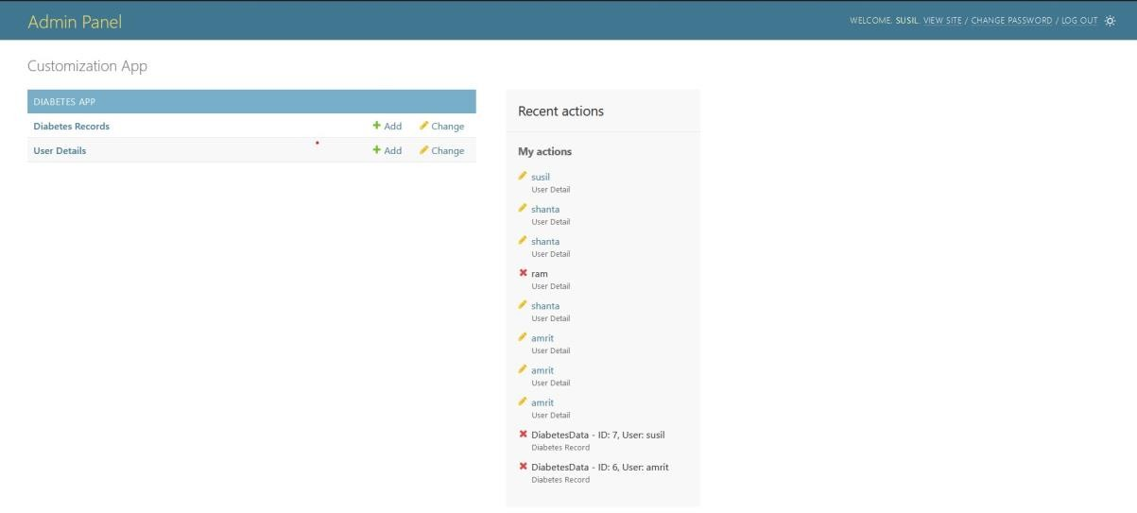

**Screenshot: Admin dashboard of Diabetes Prediction System**





**Screenshot: User login of Diabetes Prediction System**

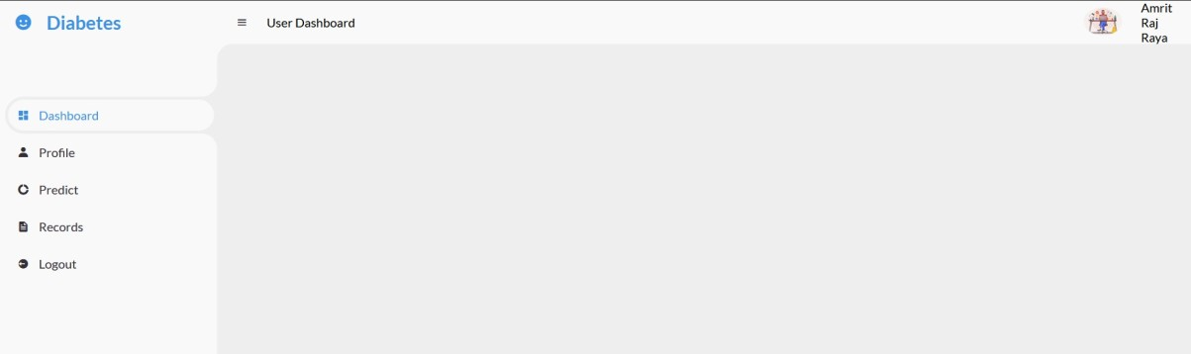

**Screenshot: User dashboard of Diabetes Prediction System**

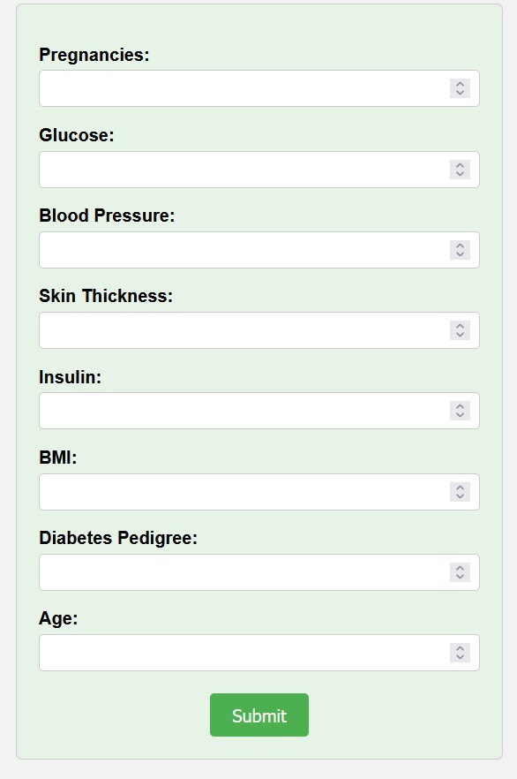

**Screenshot: User predict diabetes form of Diabetes Prediction System**

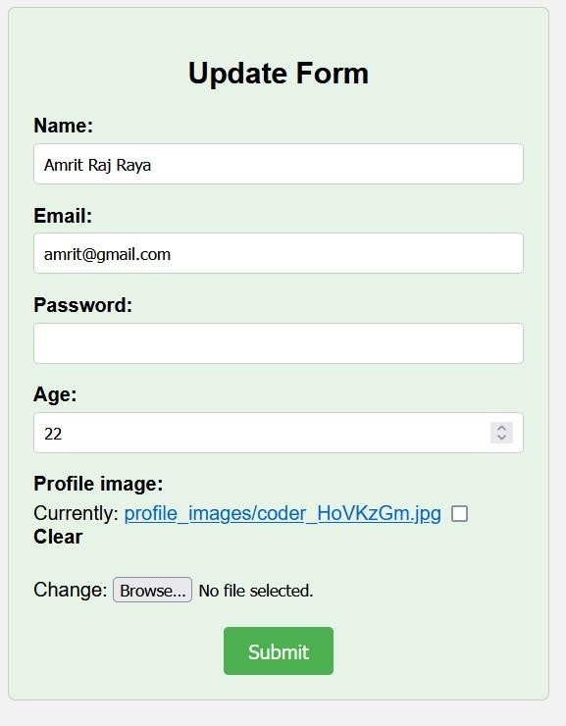

**Screenshot: User edit profile of Diabetes Prediction System**