**PURBANCHAL UNIVERSITY**



**Faculty of Science and Technology**

Biratnagar, Nepal



**KIST College of Information and Technology**

Kamalpokhari, Kathmandu

**6th Semester Project**

**on**

**“Polling Application”**

In the partial fulfillment for the requirement of the 5th Semester Project - VI (**Subject code – BIT378CO**) in the completion of Bachelor of Information Technology (BIT) degree at KIST college of Information Technology, under Purbanchal University.

|  |  |  |
| --- | --- | --- |
| **Submitted By** |  | **Submitted To** |
| Diwash Kumar Poudel | 352541 | Purbanchal University |
| Prabin Thapa Magar | 352552 |  |
| Saroj Adhikari Nepal | 352563 |  |
| Sunil B.K. | 352566 |  |

DATE: 06/08/2021

Acknowledgement

We take this opportunity to express our gratitude and unfathomable regards to the Information Technology (IT) department for this commendable guidance, monitoring and constant encouragement throughout the course of this project. The help and guidance given by shall carry us the long way, in the journey in which we are about to commence.

We also take this opportunity to express a deep sense of gratefulness to our college’s IT department coordinator as well as our project teacher Mr. Arun Aryal for his amiable support, valuable information and guidance which helped us in completing this task throughout its various stages. We are indebted to all members of KIST College, for the valuable support and suggestion provided by them using their specific fields’ knowledge. We are grateful for their cooperation during the period of our project.

We would also like to express our gratefulness towards Purbanchal University for designing such a wonderful course structure. It will help us to get more knowledge in the field of Information Technology & help us to have a bright future in the field of technology.

At the end we would like to express our sincere thanks to all our friends and families who helped us directly or indirectly during this project work.

Thank You.

Student’s Declaration

We hereby declare that the project report entitled “**Polling Application**” is a result of our own work. If we are found guilty of copying any other report or published information and showing as our original work, we understand that we shall be liable and punishable by Purbanchal University.

We further certify that this Project submitted in partial fulfillment of the requirement for the award of Bachelor in Information Technology (BIT) of the Purbanchal University is our original work and has not been submitted for award of any other degree or other similar title or prize.

|  |  |  |  |
| --- | --- | --- | --- |
| **S.N.** | **Name** | **Registration No.** | **Symbol No.** |
| **1** | Diwash Kumar Poudel | 052-3-2-01919-2018 | 352541 |
| **2** | Prabin Thapa Magar | 058-3-2-01907-2018 | 352552 |
| **3** | Saroj Adhikari Nepal | 058-3-2-07628-2018 | 352563 |
| **4** | Sunil B.K. | 058-3-2-01897-2018 | 352566 |

**EXAMINER’S CERTIFICATION**

**The Project Report**

**On**

**“Polling Application”**

**Developed By:**

**Diwash Kumar Poudel**

**Prabin Thapa Magar**

**Saroj Adhikari Nepal**

**Sunil B.K.**

is approved and is acceptable in quality and form.

…………………………………. ………………..…………………

**Internal Examiner External Examiner**

Name: Name:

Designation: Designation:

To Whom It May Concern

This is to certify that **Mr. Diwash Kumar Poudel, Mr. Prabin Thapa Magar, Mr. Saroj Adhikari Nepal** and **Mr. Sunil B.K**. of Bachelor in Information Technology (**BIT**) has studied as per the curriculum of BIT 5th semester and completed the project entitled **“Polling Application”.**

This project is the original work of Mr. Diwash Kumar Poudel, Mr. Prabin Thapa Magar, Mr. Saroj Adhikari Nepal and Mr. Sunil B.K. and was carried out under the supervision as per guidelines provided by Purbanchal University and certified as per the students declaration that project **“Polling Application”** has not been presented anywhere as a part of any other academic work.

**The details of the students are as follows:**

|  |  |  |  |
| --- | --- | --- | --- |
| **S.N.** | **Name** | **Registration No.** | **Symbol No.** |
| **1** | Diwash Kumar Poudel | 058-3-2-01919-2018 | 352541 |
| **2** | Prabin Thapa Magar | 058-3-2-01907-2018 | 352552 |
| **3** | Saroj Adhikari Nepal | 058-3-2-07628-2018 | 352563 |
| **4** | Sunil B.K. | 058-3-2-01897-2018 | 352566 |

**Course Semester:** **-** 6th Semester

**Subject:** **-** Project-VI

**Subject code:** **-** BIT378CO

……………………………………..

**Mr. Arun Aryal**

**Project Instructor, BIT**

**KIST College of Information Technology**

Table of Content

1. Abstract of the project
2. Acknowledgement
3. Introduction
4. Aim of the project
5. Overall Description
6. System Requirement
7. Key Features
8. Module Description
9. Table Structure
10. Entity-Relationship Diagram
11. Implementation
12. Operational Requirements
13. Limitations
14. Future Work
15. Conclusion
16. References

Abstract of the project

In today’s fast-changing business environment, it’s extremely important to be able to respond to client needs in the most effective and timely manner. If your customers wish to see your business online and have instant access to your products or services.

“**Furnish.Nepal**” is an online shopping website which displays the furniture or furnishings related products. It is an ecommerce site where you can find different types of furniture which falls under different types, brands, specifications and categories.

This project allows viewing various products available enables registered users to purchase desired products. In order to develop an e-commerce website, a number of Technologies must be studied and understood. These include multi-tiered architecture, server and client side scripting techniques, implementation technologies such as Laravel framework, programming language (such as PHP) and relational databases (MySQL). This is a project with the objective to develop a basic website where a consumer is provided with a shopping cart application and also to know about the technologies used to develop such an application. This document will discuss each of the underlying technologies to create and implement an ecommerce website.

Acknowledgement

In completing this graduate project we have been fortunate to have help, support and encouragement from many people. We would like to acknowledge them for their cooperation. First and foremost we are deeply thankful to Mr. Arun Aryal for his wonderful guidance during this project who is also working as a Laravel Developer in a reputed IT company.

We are also thankful for his continuous feedback and encouragement throughout this project work. His broad knowledge and hardworking attitude has left us with very deep impressions and they will greatly benefit us throughout my life.

Introduction

E-commerce is fast gaining ground as an accepted and used business paradigm. More and more business houses are implementing web sites providing functionality for performing commercial transactions over the web. It is reasonable to say that the process of shopping on the web is becoming commonplace.

The objective of this project is to develop a general purpose e-commerce based furniture store where product like furniture can be bought from the comfort of home through the Internet. However, for implementation purposes, this paper will deal with an online shopping for furniture products.

An online store is a virtual store on the Internet where customers can browse the catalog and select products of interest. The selected items may be collected in a shopping cart. At checkout time, the items in the shopping cart will be presented as an order. At that time, more information will be needed to complete the transaction.

The motivation for designing this furniture related shopping-cart application came because we love online shopping rather than spending lot of time at physical markets. Further, using the available stores to sell the products, there is also the possibility of designing one’s own customized shopping-cart application from scratch because custom-designed platforms are expensive. Moreover, we value recent learning about the PHP programming language and Laravel framework as well as seeing how powerful and dynamic they are when it comes to web designing and applications. Apart from helping computer science students understand the concepts of web-application designing, it would be very easy to incorporate the idea of using programming techniques from the available visuals to understand how a piece of code appears on a user interface.

Aim of the project

This software is developed to help, we computer science students to learn about application designing using JavaScript and HTML from our basic capabilities. This application allows the student like us to understand the basics about the appearance of a first web page and how a complete working application can be built from scratch. It allows students like us to understand the concept of user-integrated graphics and how JavaScript can be embedded into HTML. Further, it gives insight about how the client-side language interacts with the server-side language, PHP, and finally with the database.

This shopping-cart application is designed, primarily, to learn and understand the concept of application development, and can also be used to teach ecommerce and web-application topics. This shopping-cart application is very versatile and can be enhanced by adding more functions and modified graphics for use with commercial purposes.

Overall Description

**Description:**

* Any member can register and view available products.
* Only registered member can purchase multiple products regardless of quantity.
* Contact us page is available to contact Admin for queries.

There are three roles available: Visitor, User and Admin.

* Visitor can view available products.
* User can view and purchase products.
* An Admin has some extra privilege including all privilege of visitor and user.
* Admin can add products, edit product information and add/remove product.
* Admin can add user, edit user information and can remove user.
* Admin can ship order to user based on order placed.

**Using the code:**

1. Attach the database in your "MySQL Workbench" or “phpmyadmin”.

2. Run the application on Microsoft Visual Studio as web site.

3. Locate the database.

**Web Pages details:**

* Home Page
* Categories Page
* Shop Page
* Add To Cart Page
* Profile Page
* Admin Page
* Login Page
* Register Page
* Products Page
* Product Type Page
* Brand Page
* Transaction details Page

**Interface**

The two interface types found in the online shopping-cart application are as follows:

**1. User Interface**: Users are able to view the home page of the shopping-cart application, browse the different categories, browse and add any number of items from any categories in the shopping cart, look for information about each product, delete the items in the shopping cart, save the cart for later viewing, check out or continue shopping after adding the item to the cart, and check out the items by completing the required information in the order form.

**2. Admin Interface**: The administrator is able to view the users’ information that was entered during checkout in the database, can update the information, price, shipping costs of the items, add or remove items from the main display.

Programming Language and Framework Used

**PHP**

PHP started out as a small open source project that evolved as more and more people found out how useful it was. Rasmus Lerdorf unleashed the first version of PHP way back in 1994.

* PHP is a recursive acronym for "PHP: Hypertext Preprocessor".
* PHP is a server side scripting language that is embedded in HTML. It is used to manage dynamic content, databases, session tracking, even build entire e-commerce sites.
* It is integrated with a number of popular databases, including MySQL, PostgreSQL, Oracle, Sybase, Informix, and Microsoft SQL Server.
* PHP is pleasingly zippy in its execution, especially when compiled as an Apache module on the Unix side. The MySQL server, once started, executes even very complex queries with huge result sets in record-setting time.

**Common uses of PHP**

* PHP performs system functions, i.e. from files on a system it can create, open, read, write, and close them.
* PHP can handle forms, i.e. gather data from files, save data to a file, through email you can send data, return data to the user.
* You add, delete, and modify elements within your database through PHP.
* Access cookies variables and set cookies.
* Using PHP, you can restrict users to access some pages of your website.
* It can encrypt data.

**Laravel Framework**

Laravel is an open-source PHP framework, which is robust and easy to understand. It follows a model-view-controller design pattern. Laravel reuses the existing components of different frameworks which help in creating a web application. The web application thus designed is more structured and pragmatic.

Laravel offers a rich set of functionalities which incorporates the basic features of PHP frameworks like CodeIgniter, Yii and other programming languages like Ruby on Rails. Laravel has a very rich set of features which will boost the speed of web development.

If you are familiar with Core PHP and Advanced PHP, Laravel will make your task easier. It saves a lot time if you are planning to develop a website from scratch. Moreover, a website built in Laravel is secure and prevents several web attacks.

**Composer**

Composer is a tool which includes all the dependencies and libraries. It allows a user to create a project with respect to the mentioned framework (for example, those used in Laravel installation). Third party libraries can be installed easily with help of composer. All the dependencies are noted in **composer.json** file which is placed in the source folder.

**Artisan**

Command line interface used in Laravel is called **Artisan**. It includes a set of commands which assists in building a web application. These commands are incorporated from Symphony framework, resulting in add-on features in Laravel 5.1 (latest version of Laravel).

Integrated Development Environment (IDE) & Server

**Visual Studio Code**

Visual Studio Code is a lightweight but powerful source code editor which runs on your desktop and is available for Windows, macOS and Linux. It comes with built-in support for JavaScript, Typescript and Node.js and has a rich ecosystem of extensions for other languages (such as C++, C#, Java, Python, PHP, Go) and runtimes (such as .NET and Unity).

**MySQL Database**

MySQL is a fast, easy-to-use RDBMS being used for many small and big businesses. MySQL is developed, marketed and supported by MySQL AB, which is a Swedish company. MySQL is becoming so popular because of many good reasons −

* MySQL is released under an open-source license. So you have nothing to pay to use it.
* MySQL is a very powerful program in its own right. It handles a large subset of the functionality of the most expensive and powerful database packages.
* MySQL uses a standard form of the well-known SQL data language.
* MySQL works on many operating systems and with many languages including PHP, PERL, C, C++, JAVA, etc.
* MySQL works very quickly and works well even with large data sets.
* MySQL is very friendly to PHP, the most appreciated language for web development.
* MySQL supports large databases, up to 50 million rows or more in a table. The default file size limit for a table is 4GB, but you can increase this (if your operating system can handle it) to a theoretical limit of 8 million terabytes (TB).
* MySQL is customizable. The open-source GPL license allows programmers to modify the MySQL software to fit their own specific environments.

**MySQL Workbench**

**MySQL Workbench** is a **Visual database designing and modeling** access tool for MySQL server relational database. It facilitates creation of new physical data models and modification of existing MySQL databases with reverse/forward engineering and change management functions. The purpose of MySQL workbench is to provide the interface to work with databases more easily and in a more structured way.

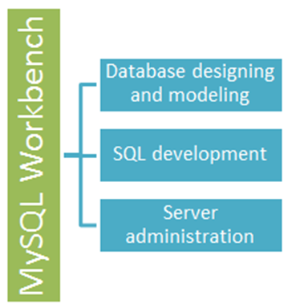

Other Technologies Used

**HTML:** Page layout has been designed in HTML

**CSS:** CSS framework i.e. Bootstrap is used for all the designing part

**JavaScript/JQuery:** All the interactive features has been developed by JQuery and JavaScript

System Requirement

**Hardware Interface**

The online furniture shopping-cart application shall provide minimum hardware requirements. The following hardware configurations are required for a PC using the online shopping-cart application:

* Pentium processor 10
* 32 MB of free hard-drive space
* 128 MB of RAM

**Software Interface**

This section lists the requirements that are needed to run the system efficiently. The operating system needed for the system to run effectively, the interface to run the application, the driver for running Laravel based web applications, the integrated development environment to develop the application, and the third-party tool used for editing purposes are as follows:

1. Operating System: Windows (Windows 8, 8.1, 10) or MAC OS

2. Web Brower: Mozilla Firefox, Google, Chrome, Safari etc.

3. Integrated Development Environment: Visual Studio Code (With extensions for PHP support)

4. Composer and XAMPP Local Server

5. MySQL Workbench or phpmyadmin

**Assumptions and Dependencies**

The assumptions and dependencies are as follows:

1. Users and the administrator are accustomed to the paper-based system and would require training to use the online shopping-cart application.

2. The system is dependent on the availability of an Apache Server to run.

3. We assume that system users adhere to the system’s minimum software and hardware requirements.

4. This system will use third-party software, and it is assumed that system users are familiar with the software.

Online Furniture Shop Key Features

1. **Admin Side** - This is where only authorized personnel of a company can access

* Login System
* Register System
* Product Management
* Categories, Brands & Type Management
* Customers Management
* Transactions Details

1. **Client-Side** - This is where the client can do business with you

* Client Registration
* Client Login
* Product Lists
* Add to Cart feature
* Product details
* Carts List
* Client Information

Module Description

1. **Registration Page**

This page will let you to register yourself as a new user or customer.

1. **Login Page**

This is the initial form displayed for the authentication purpose both for admin and customer. For the backend or admin panel you must be registered before or you should be authorized person. But in the case of the website visit, a customer can easily visit and see the products. If the customer wants to buy to add the product to the cart then only the user or customer has to login or register as a new customer.

1. **Customer Module**

The main aim of this module is to provide all the functionality related to customers. It tracks all the information and details of the customer. We have developed all type of CRUD (Create, Read, Update and Delete) operations of the customers.

1. **Product Module**

The main aim for developing this module is to manage the products data. This module is the main module in the project Furniture E-commerce Website project. All products will be managed by admin.

1. **Product Type Module**

The main objective for developing this module is to manage the product types. A furniture product can of different types like chair, sofa, table etc.

1. **Category Module**

This module is used to add, update and delete the different categories of furniture project. A furniture product can be categorized as living room furniture, kitchen and dining furniture, bedroom furniture etc.

1. **Brand Module**

This module is about managing the brand details of different furniture product. Same product can be produced by different brands or manufacturers.

1. **Cart Module**

This module contains the information about the cart as per the customer.

1. **Cart Items Module**

On the basis of the cart module, the cart items module will contain the information regarding different products which are selected or added by the customer in their purchase cart.

1. **Transaction Module**

The module contains the information about the transactions that have occurred.

1. **Transaction Details Module**

This module encompasses the individual record of the order made by the customer.

Table Structure

**Users Table**

|  |  |  |
| --- | --- | --- |
| **Column Name** | **Null** | **Data Type** |
| id (Primary Key) | Not null | bigint |
| first_name | Not null | string |
| last_name | Not null | string |
| email | Not null | string |
| email_verified_at | Nullable | timestamp |
| password | Not null | string |
| profile_image | Not null | string |
| role_id (foreign Key) | Nullable | bigint |

**Role Table**

|  |  |  |
| --- | --- | --- |
| **Column Name** | **Null** | **Data Type** |
| id (Primary Key) | Not null | bigint |
| name | Not null | string |

**Product Table**

|  |  |  |
| --- | --- | --- |
| **Column Name** | **Null** | **Data Type** |
| id (Primary Key) | Not null | bigint |
| name | Not null | string |
| category_id (foreign Key) | Nullable | bigint |
| type_id (foregin Key) | Nullable | bigint |
| price | Nullable | string |
| description | Nullable | text |
| brand_id | Nullable | bigint |
| sku | Nullable | string |
| stock | Nullable | integer (unsigned) |
| image | Nullable | string |

**Categories Table**

|  |  |  |
| --- | --- | --- |
| **Column Name** | **Null** | **Data Type** |
| id (Primary Key) | Not null | bigint |
| name | Not null | string(150) |
| icon | Not null | string(150) |
| image | Not null | string |

**Types Table**

|  |  |  |
| --- | --- | --- |
| **Column Name** | **Null** | **Data Type** |
| id (Primary Key) | Not null | bigint |
| name | Not null | string(150) |
| icon | Not null | string(150) |

**Brands Table**

|  |  |  |
| --- | --- | --- |
| **Column Name** | **Null** | **Data Type** |
| id (Primary Key) | Not null | bigint |
| name | Not null | string(150) |

**Customer Table**

|  |  |  |
| --- | --- | --- |
| **Column Name** | **Null** | **Data Type** |
| id (Primary Key) | Not null | bigint |
| first_name | Not null | string |
| last_name | Not null | string |
| gender | Not null | enum |
| phonenumber | Not Null | string(15) |
| email | Not null | string |
| password | Not null | string |
| date_of_birth | Not null | date |
| address | Not null | string |
| district_id | Not null | bigint |

**Carts Table**

|  |  |  |
| --- | --- | --- |
| **Column Name** | **Null** | **Data Type** |
| id (Primary Key) | Not null | bigint |
| added_at | Not null | date |
| payment_method | Nullable | string |
| order_status | Nullable | string |
| sub_total | Nullable | string |
| tax | Nullable | string |
| total | Nullable | string |
| is_cash_received | Not null (default(0)) | boolean |

**Cart_Items Table**

|  |  |  |
| --- | --- | --- |
| **Column Name** | **Null** | **Data Type** |
| id (Primary Key) | Not null | bigint |
| cart_id (foreign key) | Nullable | bigint |
| product_id (foreign key) | Nullable | bigint |
| quantity | Nullable | integer |
| unit_price | Nullable | string |
| customer_id | Nullable | bigint |

**Transactions Table**

|  |  |  |
| --- | --- | --- |
| **Column Name** | **Null** | **Data Type** |
| id (Primary Key) | Not null | bigint |
| cart_id (foreign key) | Nullable | bigint |
| delivery_charge | Not null (default(100)) | string |
| grand_total | Nullable | string |

**Transactions Table**

|  |  |  |
| --- | --- | --- |
| **Column Name** | **Null** | **Data Type** |
| id (Primary Key) | Not null | bigint |
| transaction_id (foreign key) | Nullable | bigint |
| product_id (foreign key) | Nullable | bigint |
| unit_price | Nullable | string |
| quantity | Nullable | integer |

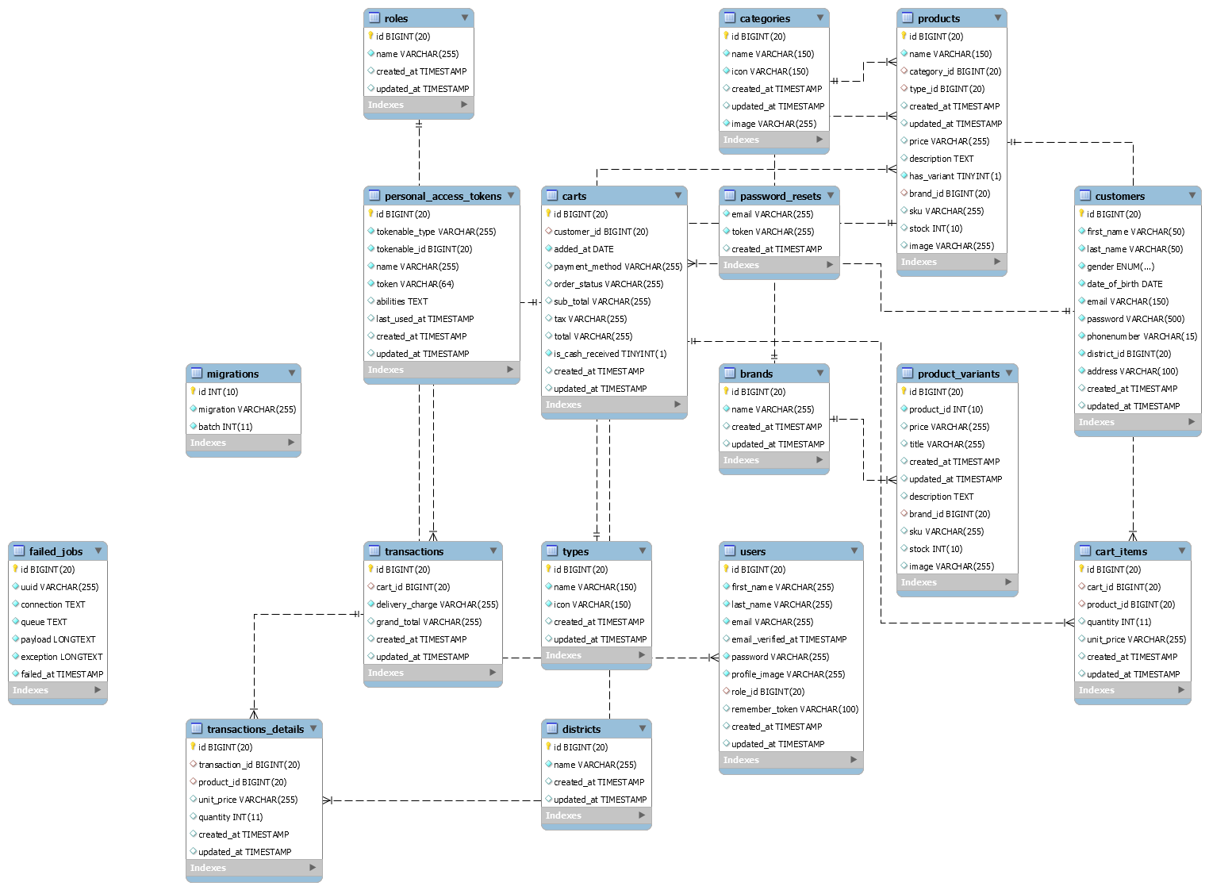Entity-Relationship Diagram



Implementation

This chapter includes the detailed design used to build the online shopping-cart application. The system's design is used to create the functions and operations of the gathered requirements in detail, including screen layouts, business rules, process diagrams, and other documentation. The output of this chapter describes the new system which is defined as a collection of modules and subsystems. This design stage takes the initial input requirements that were identified in the approved requirements specification document. For each requirement, there is a set of one or more design elements that are produced using the different prototypes. These design elements describe the desired software features, in detail, including functional hierarchy diagrams, screen layouts, activity diagrams, and class diagrams. The intention of these diagrams is to describe the software in detail so that the system can develop the application with less additional design input. The system’s mock screen shots are shown later in this chapter.

**Detailed Scope**

This project is supposed to be delivered in three phases, with each phase being an add-on to the project that makes it more usable and acceptable.

1. In the first delivery, the application must be able to add an item to the shopping cart and case.

* Browse categories on the home page
* Select a category and browse through the items
* View more information about an item.
* Add an item to the shopping cart.
* Continue shopping or go to checkout for the item.

2. The application must be able to check out the items in the cart.

* Check out the items.
* Continue shopping.
* Delete the items to update the shopping cart.

3. The application asks for user authentication before checking out.

* Add items to the cart.
* Check out the items
* Log in with a valid username and password.

4. The application must bring up the order form for the check out.

* Complete the information on the order form.
* Place the order.

User Case Diagram

A use case diagram at its simplest is a representation of a user's interaction with the system that shows the relationship between the user and the different use cases in which the user is involved. The purpose of a use case diagram in UML is to demonstrate the different ways that a user might interact with a system.

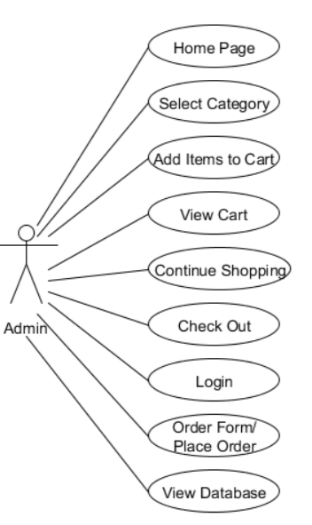

The above figure shows the use case of for an administrator where he or she has access to the application. The administrator can access the home page, select a category, or add/delete items to/from the cart.

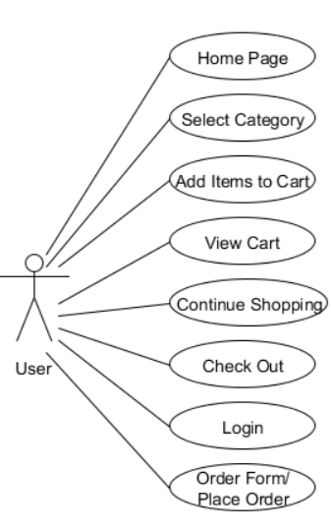

The above figure shows the use case for users where they have access to the online shopping-cart application. They can access the home page, select a category, add/delete items to/from the cart, view the shopping cart, and decide to either continue shopping or check out. They are required to go through the user-authentication form (login) which would only allow them to place an order for the items they selected.

Data Flow Diagram

DFD is the abbreviation for Data Flow Diagram. The flow of data of a system or a process is represented by DFD. It also gives insight into the inputs and outputs of each entity and the process itself. DFD does not have control flow and no loops or decision rules are present. Specific operations depending on the type of data can be explained by a flowchart. Data Flow Diagram can be represented in several ways. The DFD belongs to structured-analysis modeling tools. The DFD of “Grocery Store Management System” is given below:

**Context level DFD – 0 level**

The context level data flow diagram (dfd) is describing the whole system. The (o) levels DFD describe the all user module who operate the system. Below data flow diagram of online shopping site shows the two users can operate the system Admin and Member user.

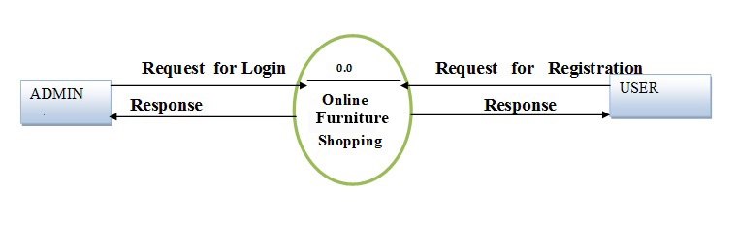

**1st Level Admin Side DFD**

The Admin side DFD describes the functionality of Admin. Admin is an owner of the website. Admin can first add category of item and then add items by category wise and admin can manage order and payment detail.

[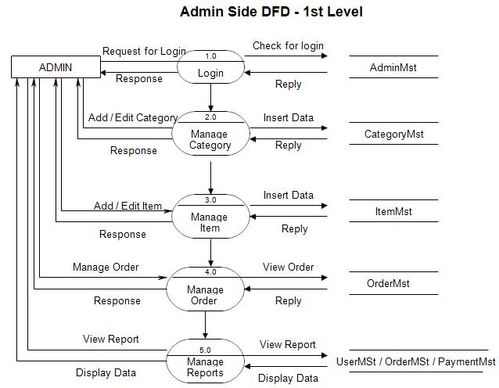](https://meeraacademy.com/wp-content/uploads/2016/09/adminside-first.jpg)

2nd Level – Admin side DFD (3.0)

[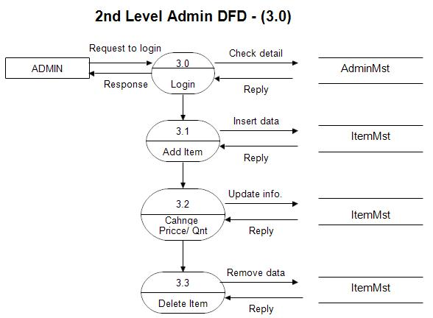](https://meeraacademy.com/wp-content/uploads/2016/09/admin3.0.jpg)

2nd Level – Admin side DFD (4.0)

[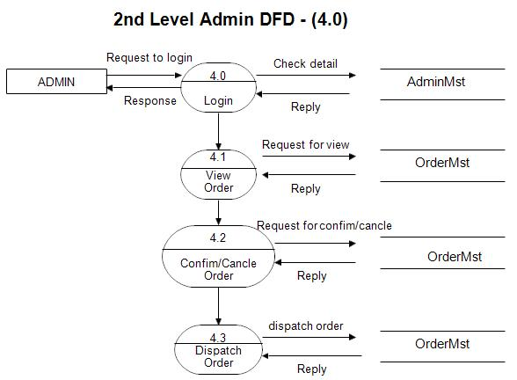](https://meeraacademy.com/wp-content/uploads/2016/09/admin4.0.jpg)

Screenshots

**Frontend View**

* 1. **Homepage**

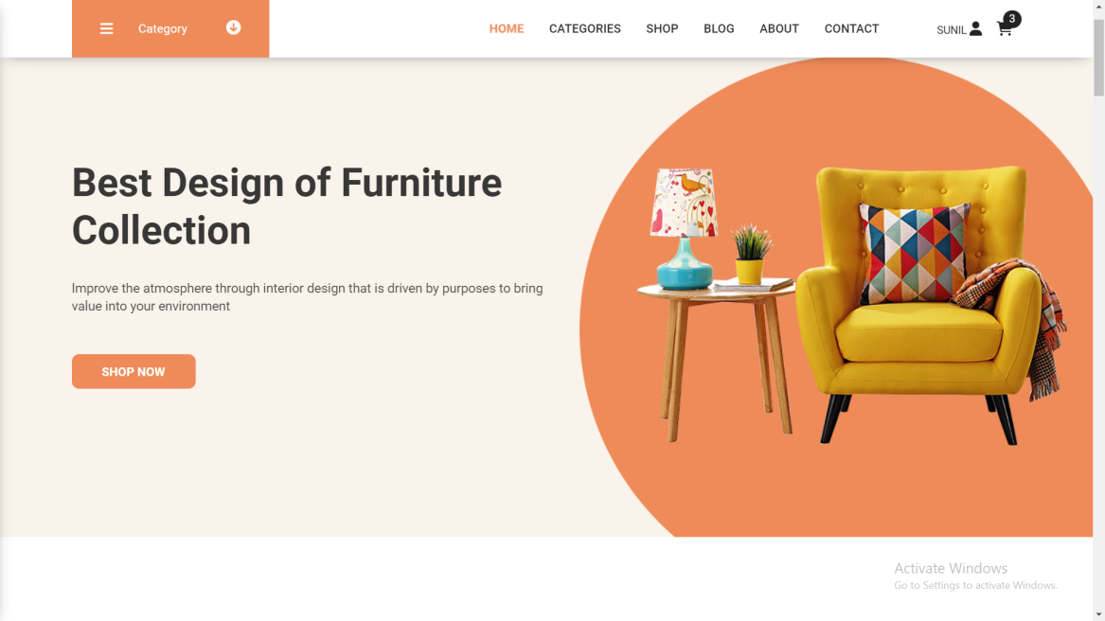

* 1. **Categories Page**

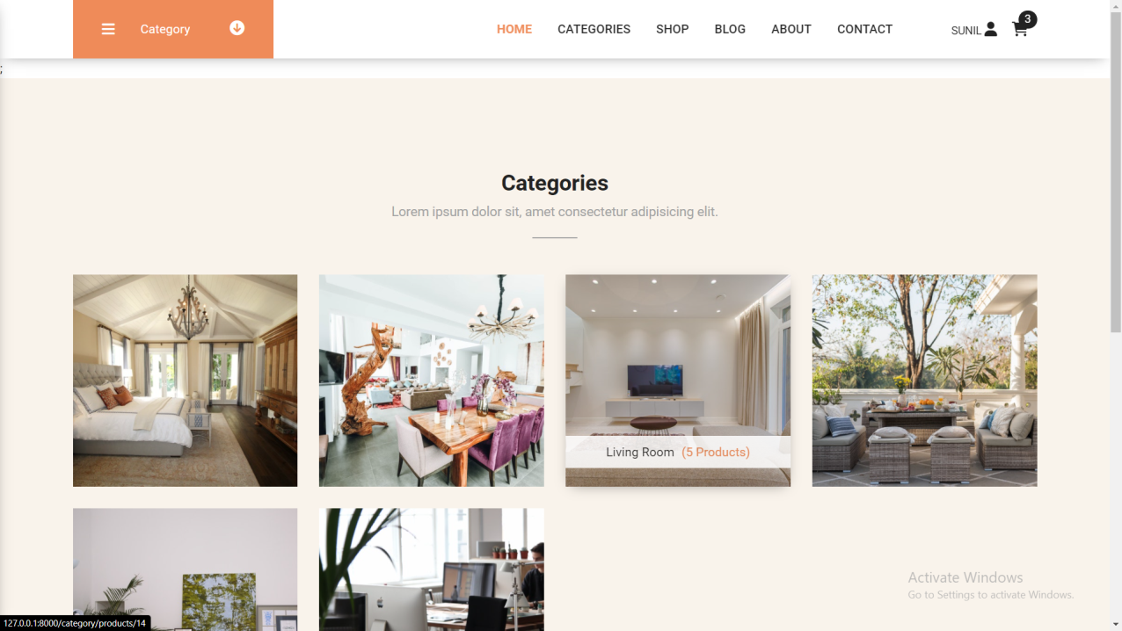

* 1. **Shop Page**

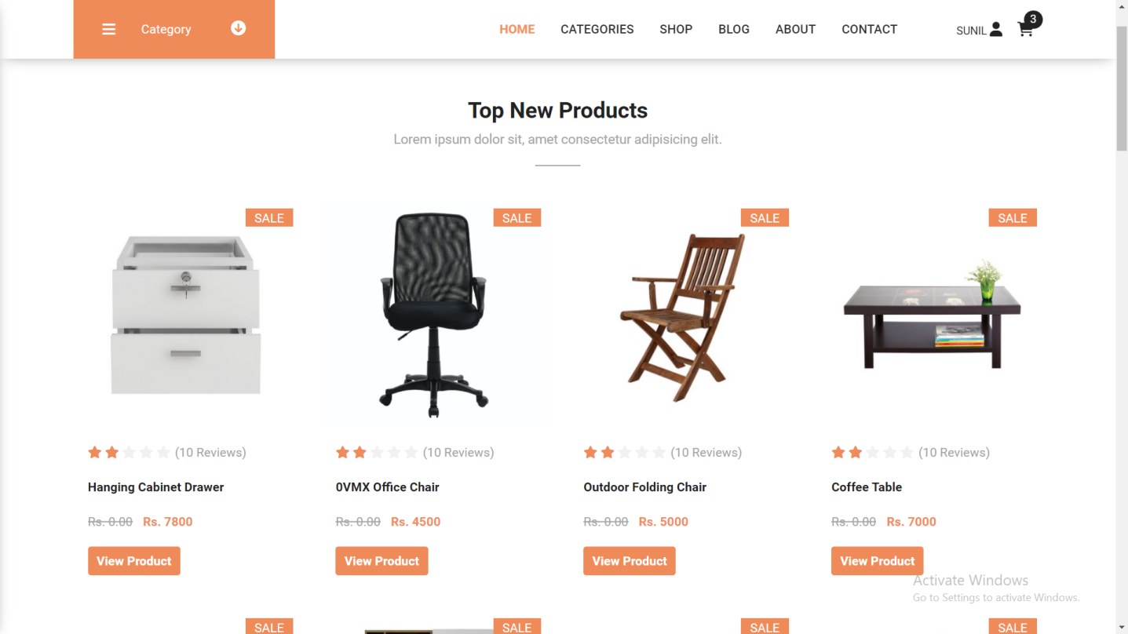

* 1. **Product Details Page**

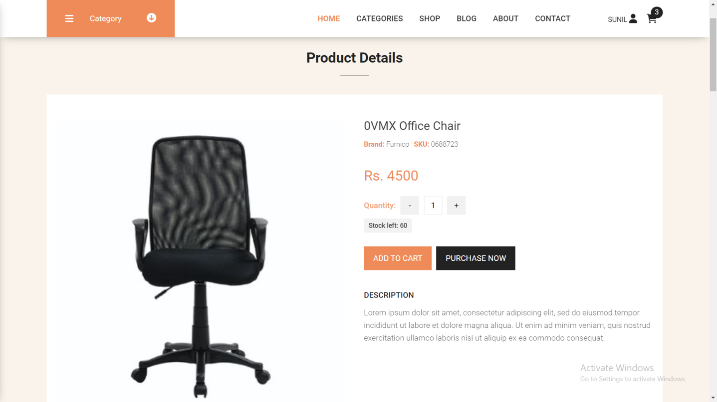

* 1. **Customer Profile Page**

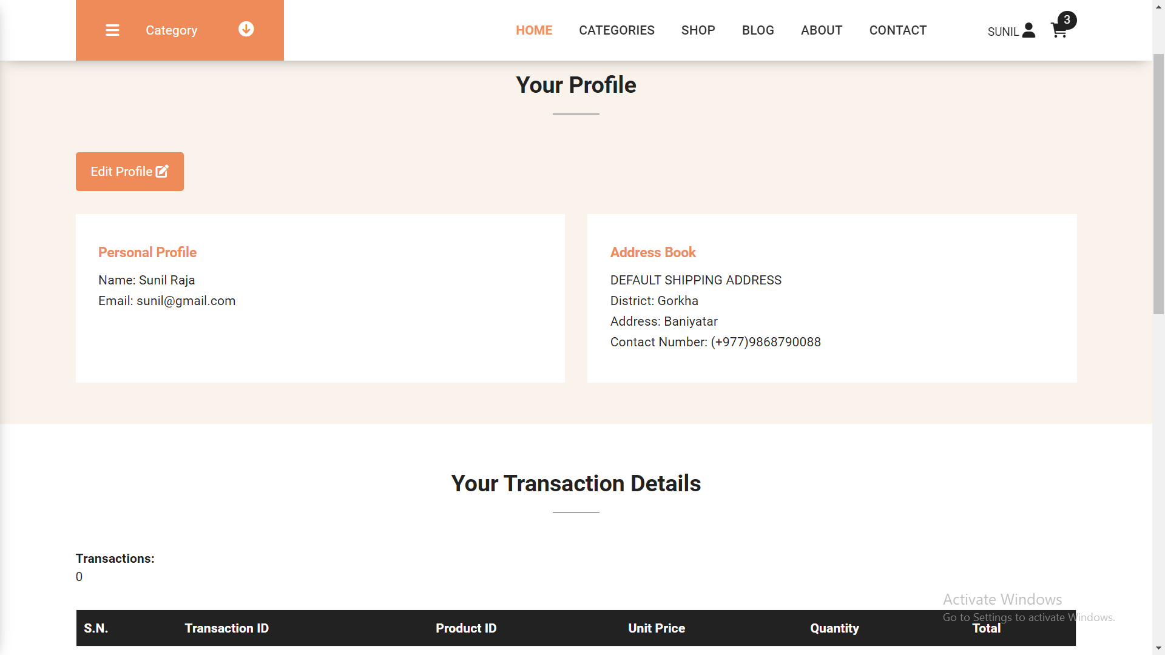

* 1. **Cart Page**

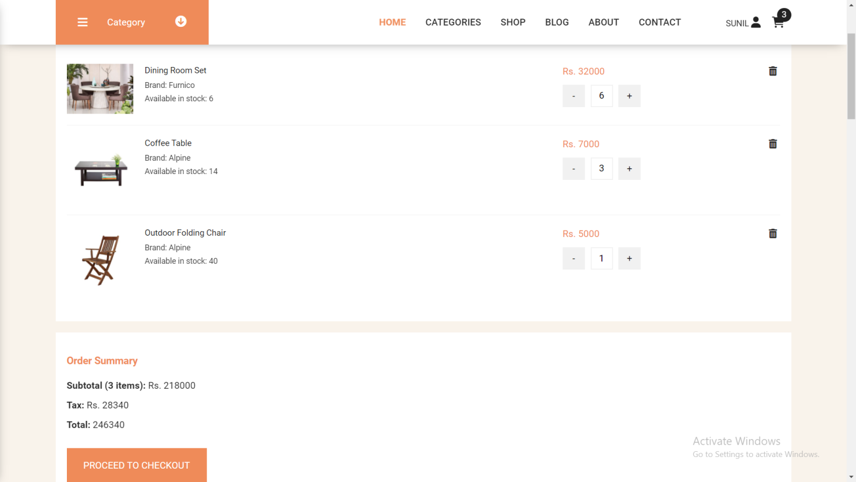

* 1. **Checkout Page**

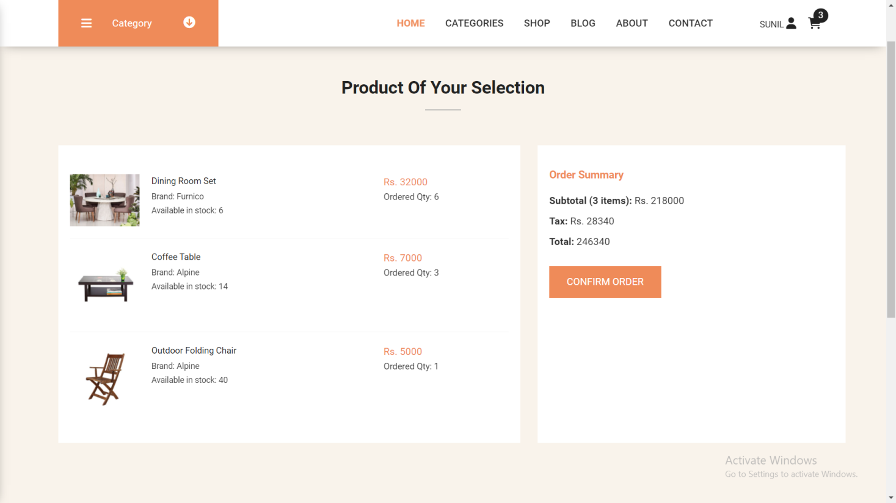

**Backend View**

1. **Dashboard**

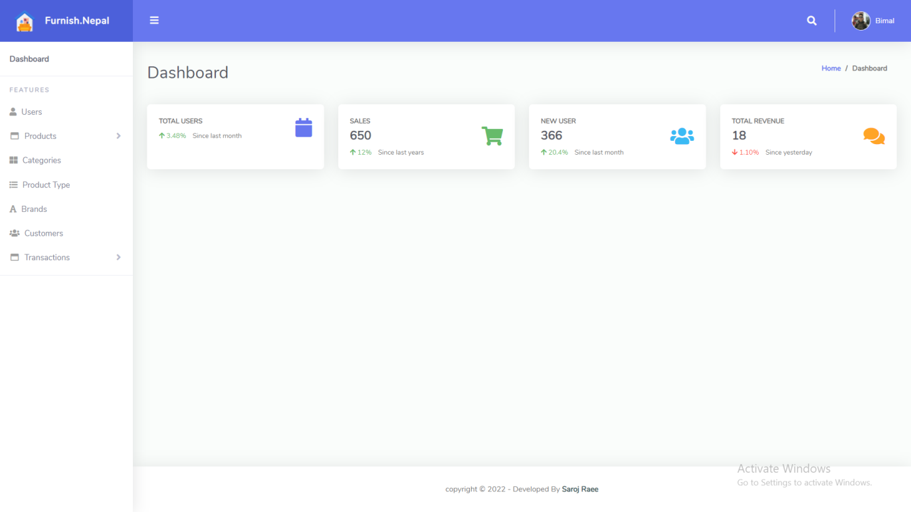

1. **Users**

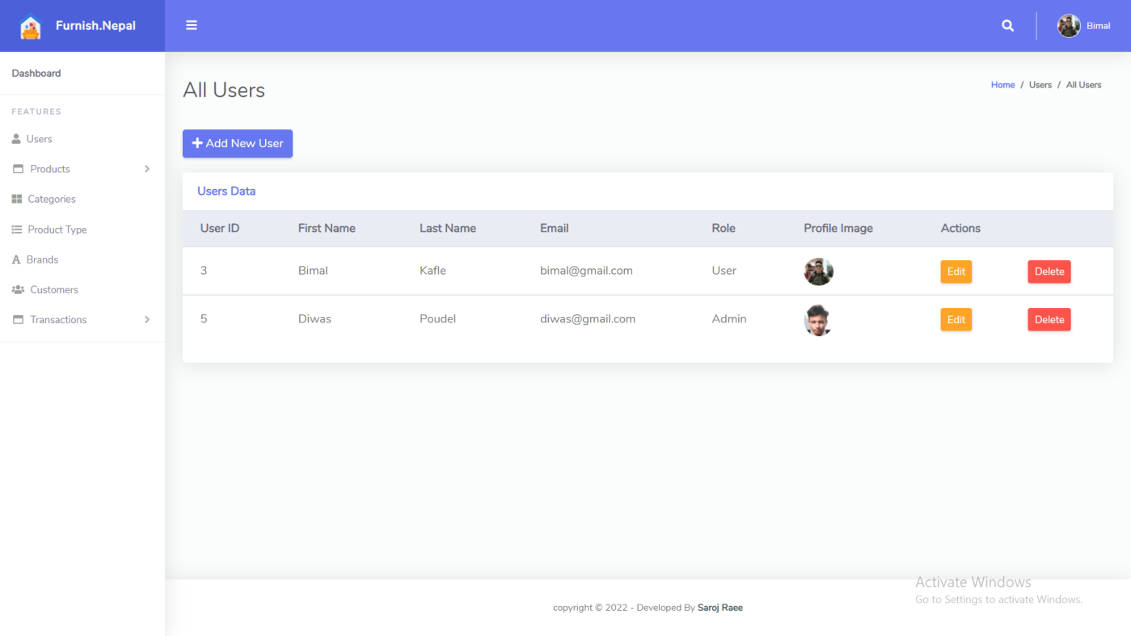

1. **Product**

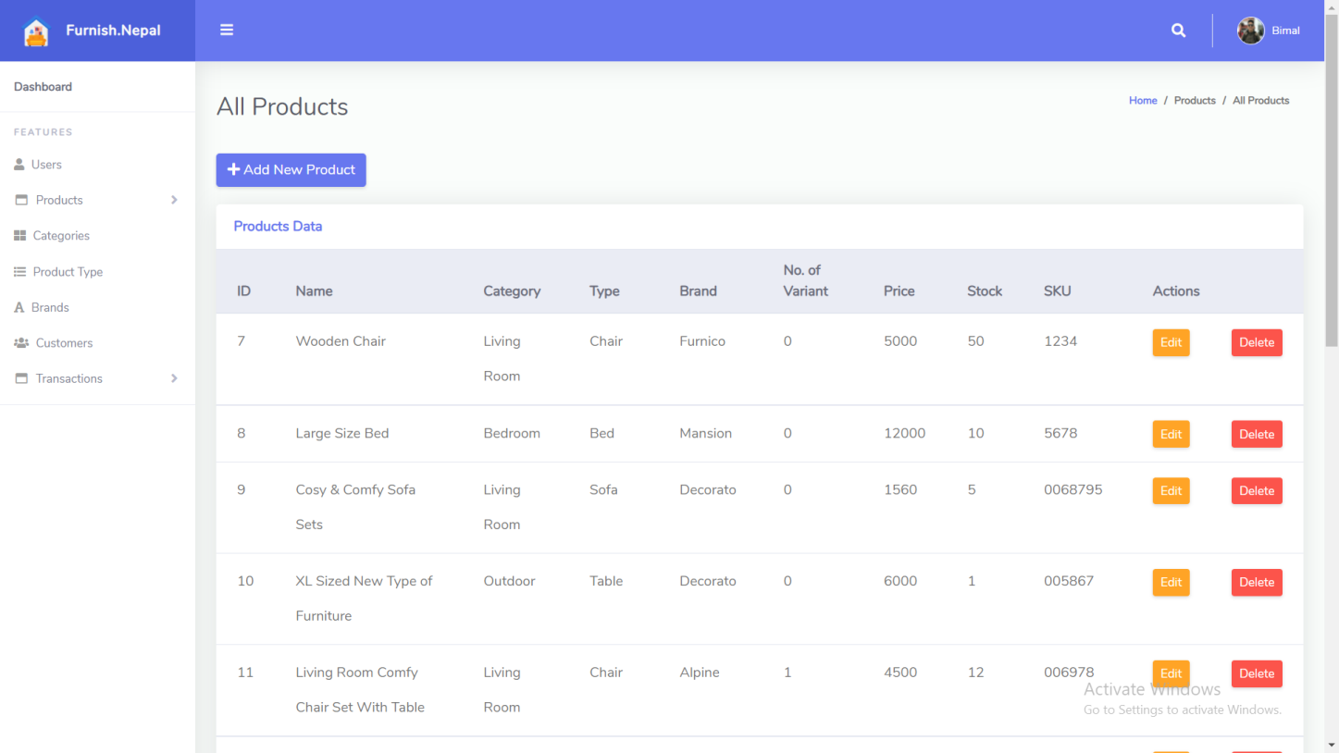

1. **Categories**

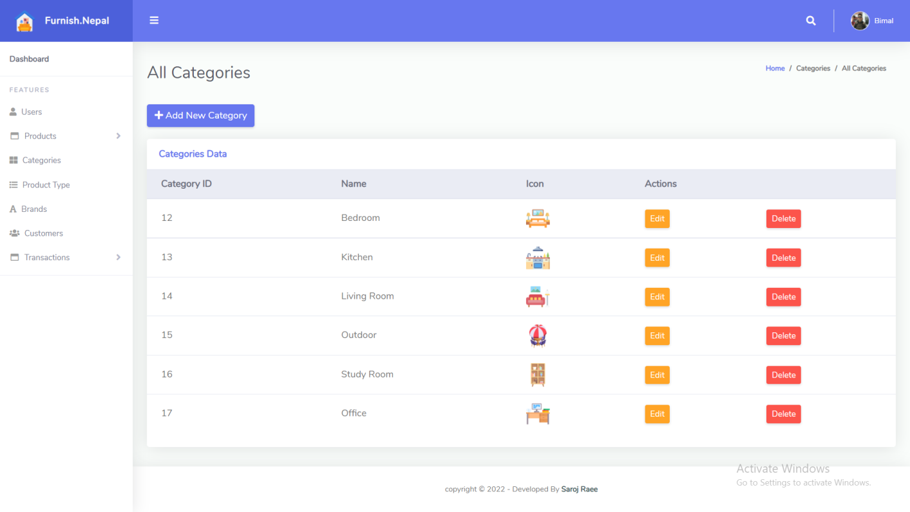

1. **Types**

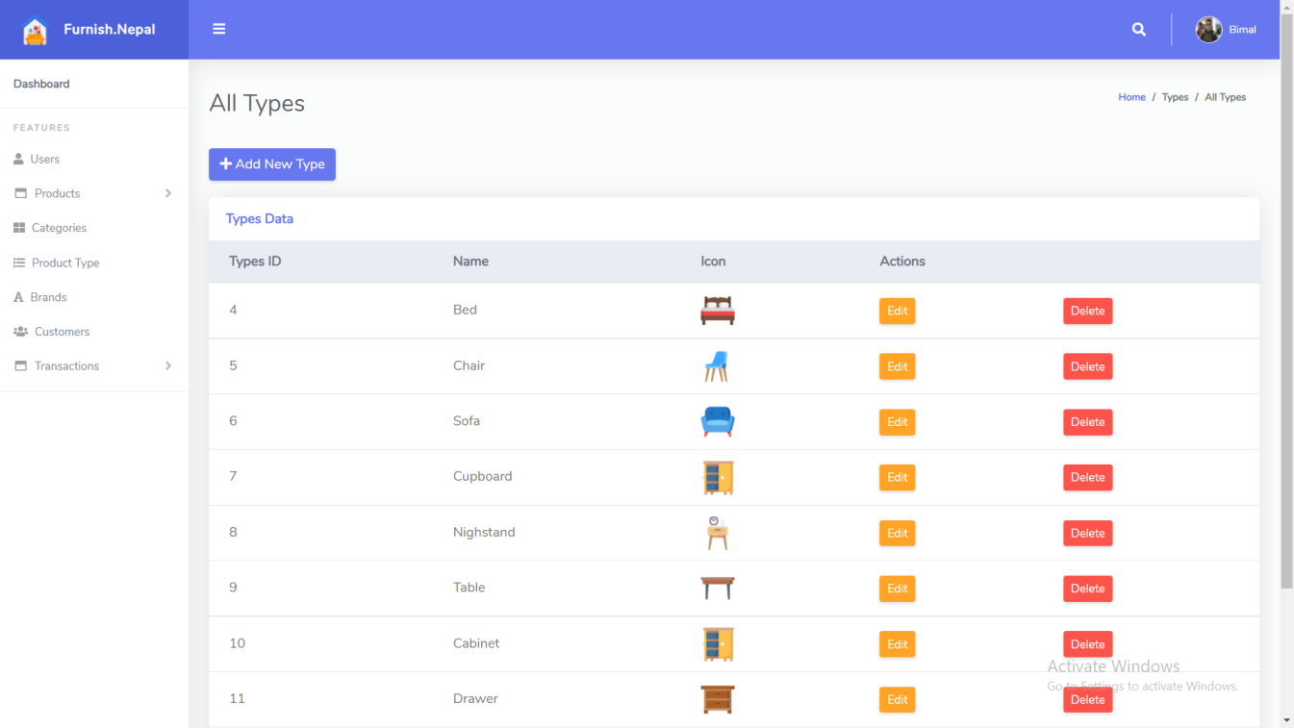

1. **Brand**

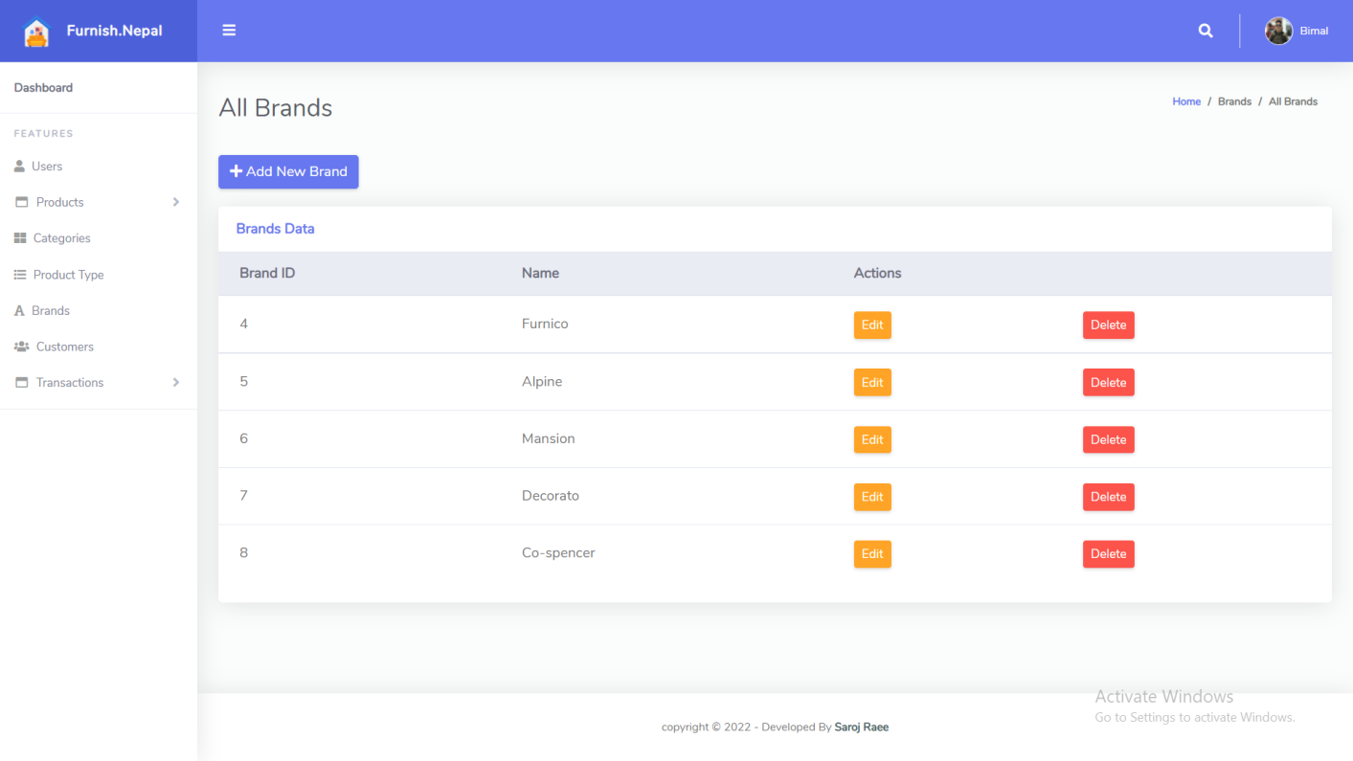

1. **Transactions**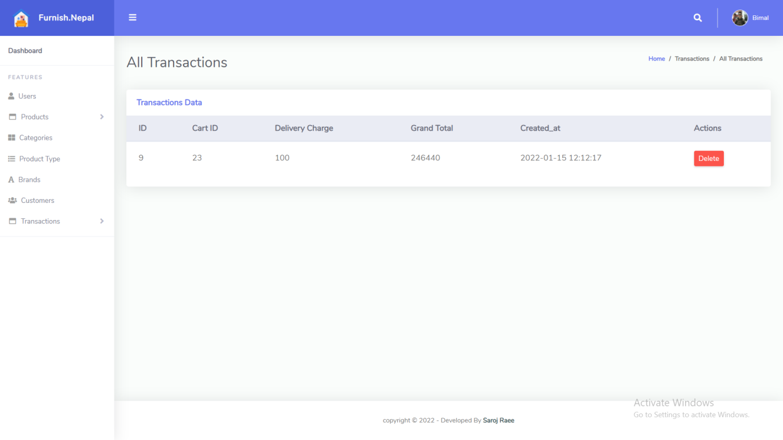
2. **Customers**

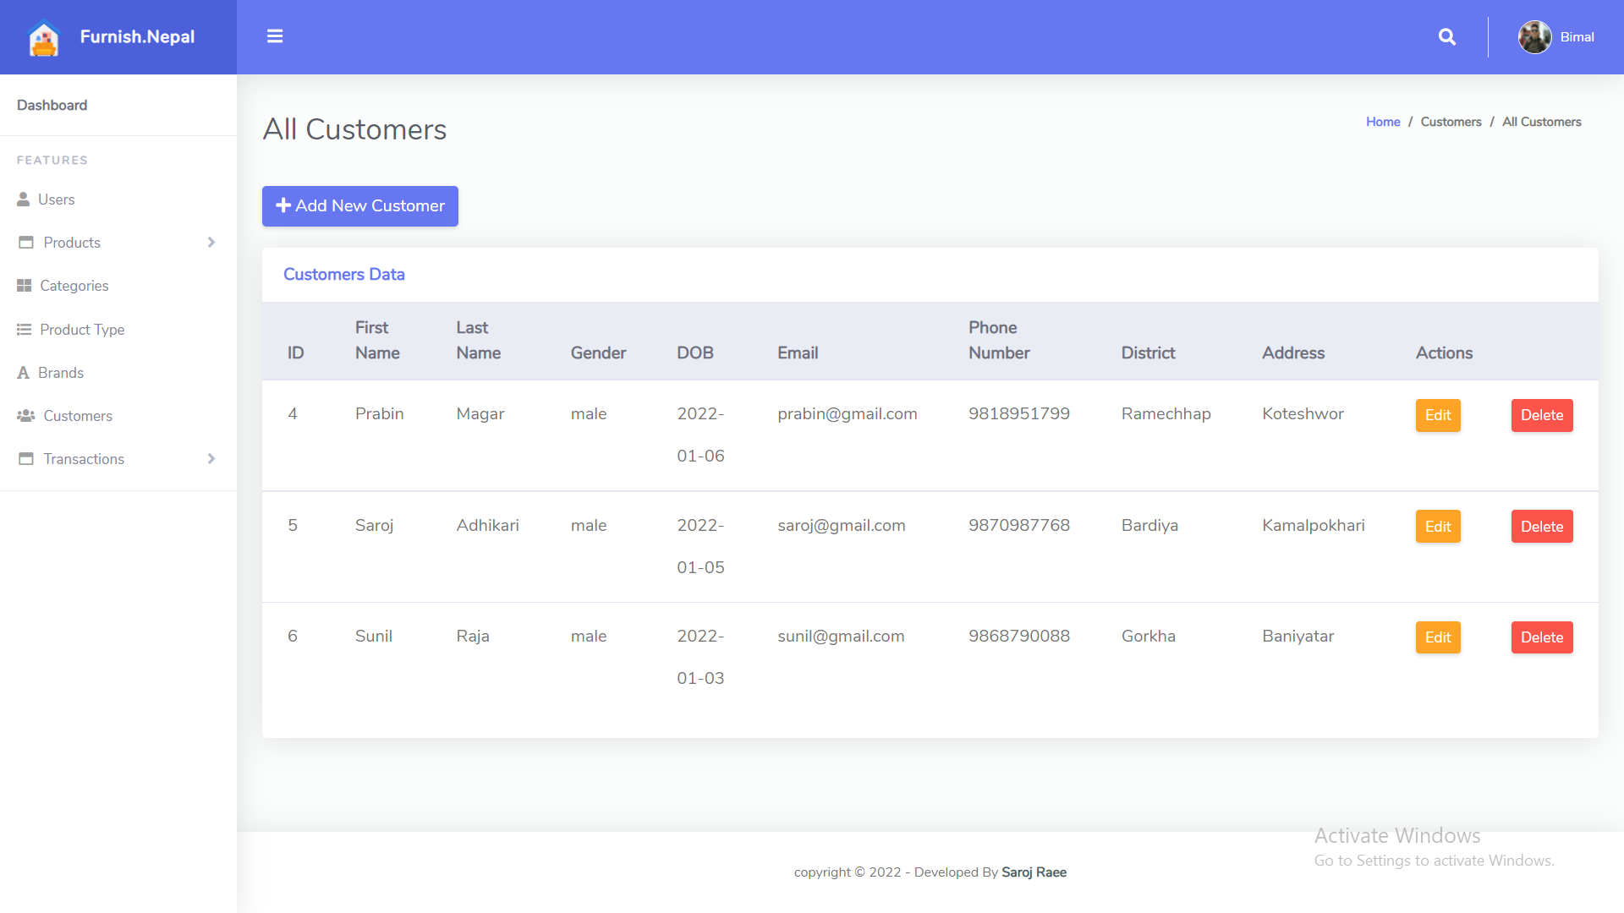

Non-Functional / Operational Requirements

1. **Security**

* Pages of the website must be access in the way they were intended to be accessed. Included files shall not be accessed outside of their parent file.
* Administrator can only perform administrative task on pages they are privileged to access. Customers will not be allowed to access the administrator pages.

1. **Efficiency and Maintainability**

* Page loads should be returned and formatted in a timely fashion depending on the request being made.
* Administrators will have the ability to edit the aspects of the order forms, product descriptions, prices and website directly

Limitations

* This system called “Furniture E-commerce Site” is platform dependent.
* Slow in performance for huge amount of data.
* The product variants are not displayed.
* Payment method needs to be integrated.

Future Work

The following section discusses the work that will be implemented with future releases of the software.

**1. Detailed categories:** Future work could involve adding more categories which are more detailed and have additional items.

**2. Watch/Wish List:** Work can add a watch list or wish list so that users can add an item to a list to watch for item prices to go down or to see when there is a sale on any of those items.

**3. Enhanced User Interface:** Work on enhancing the user interface by adding more user interactive features.

**4. Recommended Items:** Add a bar that would display the most-recommended items which would depend on the number of times an item has been purchased by any users.

**5. Payment Options:** Add different payment options, such as esewa, Khalti, IPS connect, etc., where a user can also save the card information for later checkouts.

**6. Shipping Options:** Add different types of shipping options: regular shipping, expedited shipping, international shipping, etc.

**7. Recent History:** Display the user’s recently browsed items in the recent-history tab.

Conclusion

The Internet has become a major resource in modern business, thus electronic shopping has gained significance not only from the entrepreneur’s but also from the customer’s point of view. For the entrepreneur, electronic shopping generates new business opportunities and for the customer, it makes comparative shopping possible.

As per a survey, most consumers of online stores are impulsive and usually make a decision to stay on a site within the first few seconds. “Website design is like a shop interior. If the shop looks poor or like hundreds of other shops the customer is most likely to skip to the other site. Hence we have designed the project to provide the user with easy navigation, retrieval of data and necessary feedback as much as possible. In this project, the user is provided with an ecommerce web site that can be used to buy books online. To implement this as a web application we used Laravel Framework as the Technology. Laravel Framework has several advantages such as enhanced performance, scalability, built-in security and simplicity.

This project helps in understanding the creation of an interactive web page and the technologies used to implement it. The design of the project which includes Data Model and Process Model illustrates how the database is built with different tables, how the data is accessed and processed from the tables. The building of the project has given me a precise knowledge about how Laravel Framework is used to develop a website, how it connects to the database to access the data and how the data and web pages are modified to provide the user with a shopping cart application.

References

* Laravel Documentation - https://laravel.com/
* Stack overflow - https://stackoverflow.com/
* Tutorials point Tutorial - https://www.tutorialspoint.com/laravel/laravel_overview.htm
* Laravel 8 Tutorial - https://www.javatpoint.com/laravel
* W3Schools - https://www.w3schools.in/laravel-tutorial/