WEEK 6 TASK
Integrative Capstone Project and Evaluation
End-to-End Data Science Pipeline with Python

1. Executive Summary
This capstone demonstrates an end-to-end data science workflow using the public Wine Recognition dataset distributed with scikit-learn. The project combines data acquisition, data quality checks, exploratory data analysis (EDA), preprocessing, supervised classification, unsupervised clustering, evaluation, and interpretation. For supervised learning, Logistic Regression and Random Forest are compared with stratified five-fold cross-validation, and the model with the higher mean cross-validation accuracy is evaluated on a held-out test set. For unsupervised learning, standardized features are clustered with K-Means and reviewed using inertia, silhouette score, PCA visualization, and cluster profiles. The results show how predictive and descriptive methods can complement one another in a single analytical workflow.

2. Problem Statement and Objectives
The Wine Recognition dataset contains chemical measurements for wine samples assigned to one of three cultivars. The project asks: (1) can supervised machine learning predict the cultivar class from the measured features, and (2) can unsupervised clustering reveal groups with distinguishable chemical profiles without using the known cultivar labels during fitting?
- Acquire a public dataset and document its origin and structure.
- Inspect data quality and summarize the feature distributions and relationships.
- Prepare features appropriately for distance-based and scale-sensitive algorithms.
- Compare supervised classification algorithms with cross-validation and held-out testing.
- Apply K-Means clustering and interpret cluster profiles independently of the supervised model.
- Communicate findings, limitations, recommendations, and reproducible code.

3. Data Acquisition and Dataset Description
The data is loaded using `sklearn.datasets.load_wine`, which distributes the Wine Recognition dataset for machine-learning education. The underlying dataset is publicly available through the UCI Machine Learning Repository. It contains 178 observations, 13 numeric features, and three target classes. Features include alcohol, malic acid, ash, alkalinity of ash, magnesium, total phenols, flavanoids, nonflavanoid phenols, proanthocyanins, color intensity, hue, OD280/OD315 of diluted wines, and proline. The target identifies the cultivar class.
Dataset shape: 178 rows × 13 features. Missing feature values: 0. Duplicate feature rows: 0.

4. Data Cleaning and Preprocessing
The feature table is checked for missing values, duplicate feature rows, data types, and descriptive statistics. The loaded feature matrix contains no missing values and no duplicate feature rows, so imputation and duplicate removal are not required in this run. The class label is separated from the predictors. For supervised learning, the dataset is split into 80% training and 20% testing observations using stratification and random_state=42. This keeps class proportions similar between the partitions. A StandardScaler is placed inside the Logistic Regression pipeline so scaling parameters are learned from the training folds only. Random Forest does not require feature scaling, but it is evaluated on the same split for a fair model comparison. For K-Means, a separate StandardScaler transforms the features because Euclidean-distance clustering is sensitive to feature scale.

5. Exploratory Data Analysis
EDA is used to understand the class distribution, feature ranges, and relationships before fitting models. Descriptive statistics summarize central tendency and spread. The class-count chart checks whether classes are strongly imbalanced. Feature histograms compare selected measurements across the three classes. The correlation heatmap helps identify pairs of numeric features that move together; high correlation can indicate redundancy and can affect coefficient interpretation.
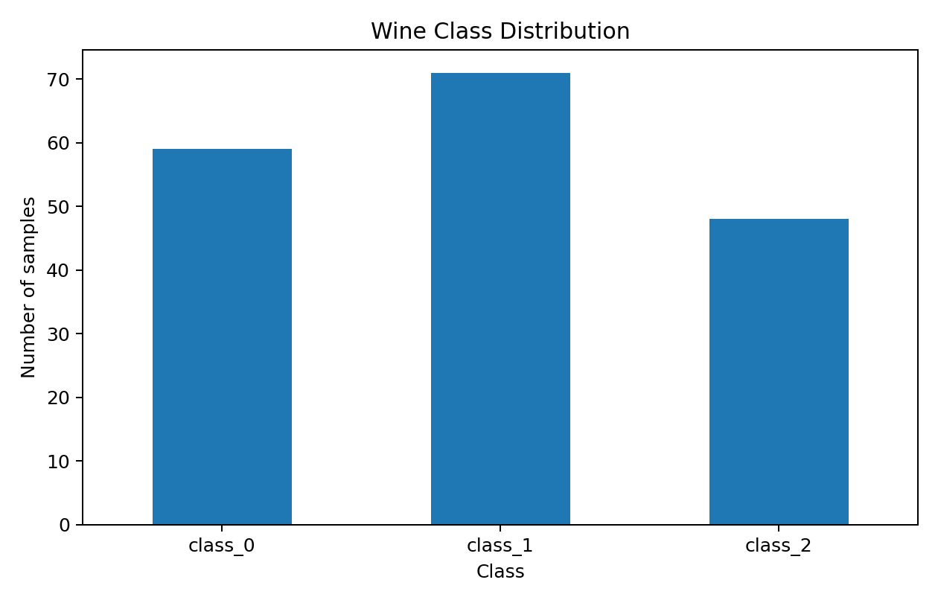
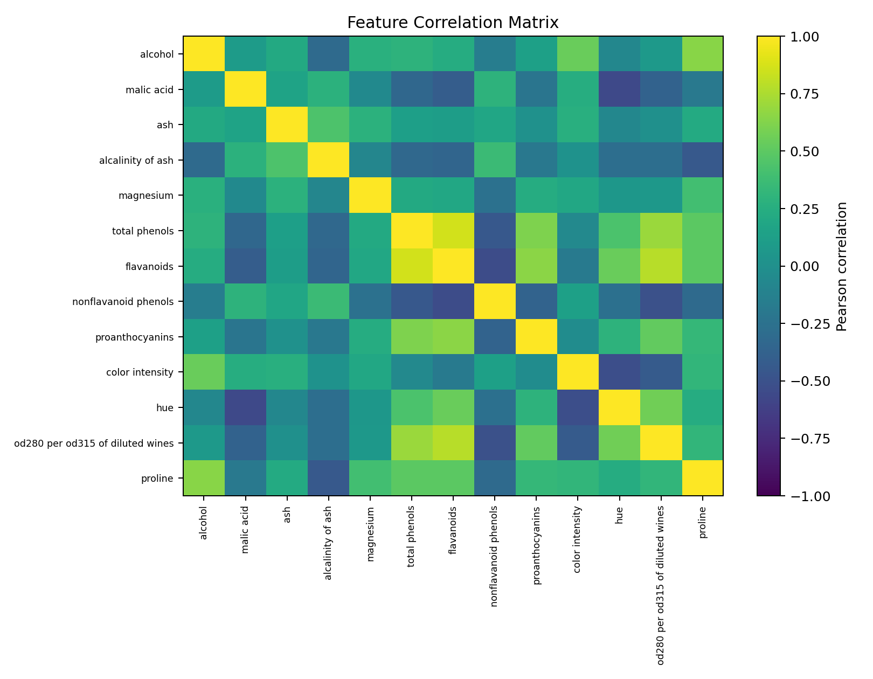
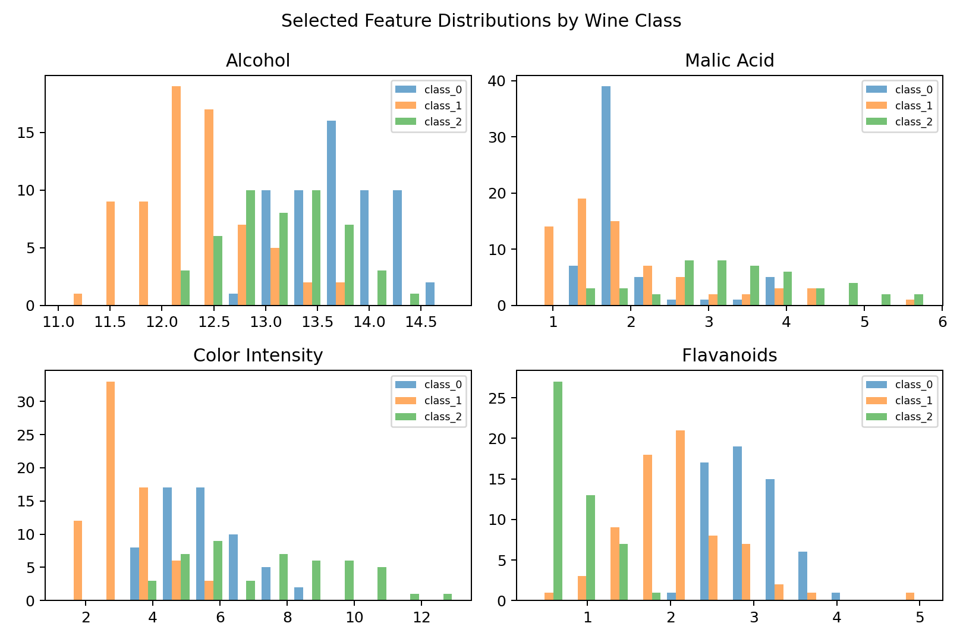

5.1 EDA findings
The dataset has 178 rows and 13 numerical predictors. The feature table contains no missing values or exact duplicate feature rows. The class counts are not identical, making stratification appropriate. The feature-correlation plot shows that some chemical measurements are related, which supports using scaling and encourages caution when interpreting any single feature as uniquely important. EDA provides context but does not by itself establish causal relationships.

6. Supervised Modeling

6.1 Candidate algorithms
Two classifiers are compared. Logistic Regression is a scale-sensitive, relatively interpretable baseline and is wrapped in a pipeline with StandardScaler. Random Forest combines many decision trees and can model nonlinear relationships without requiring standardized input. The models are evaluated using the same training partition and stratified five-fold cross-validation with shuffled folds and a fixed seed.

6.2 Validation and selection
Cross-validation accuracy is computed on the training partition only. The classifier with the higher mean five-fold accuracy is selected. That selected model is then refitted on the full training partition and evaluated once on the held-out test set. This process reduces the risk of choosing a model based on test-set performance.
Selected model: Logistic Regression. Mean cross-validation accuracy: 0.9791 (standard deviation 0.0277).
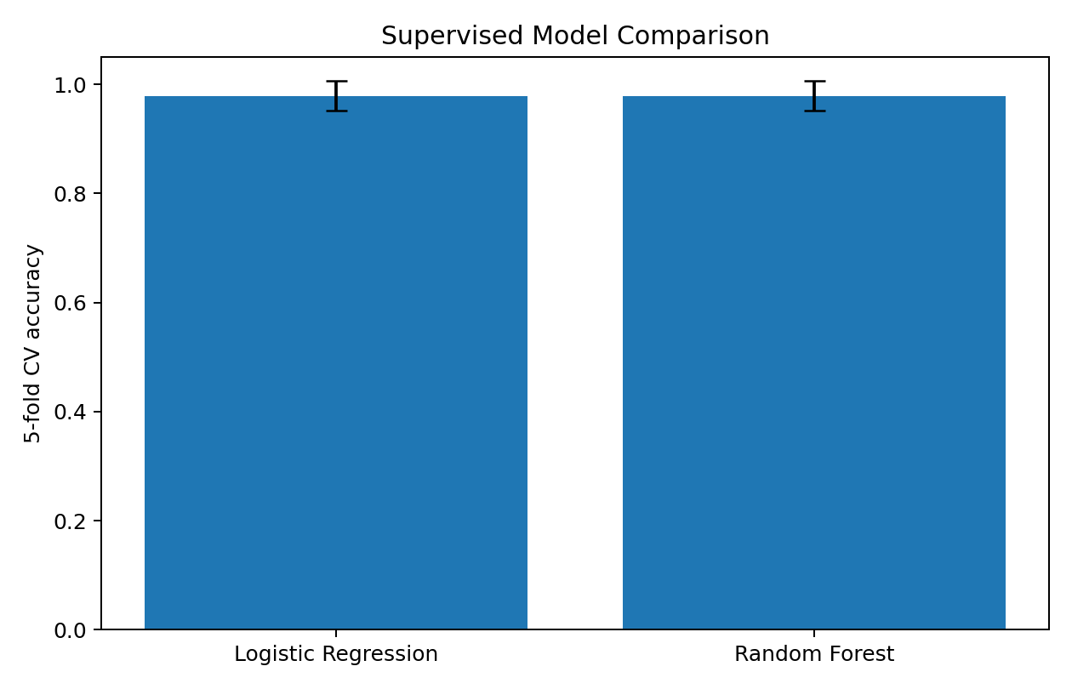

6.3 Metrics
Accuracy is the proportion of correctly classified test observations. Macro precision, recall, and F1-score compute the metric separately for each class and average the three class results equally. The confusion matrix shows which classes are correctly identified and where mistakes occur. Cross-validation mean and standard deviation indicate both typical performance and variability across folds.
Metric | Result
Test accuracy | 0.9722
Macro precision | 0.9778
Macro recall | 0.9667
Macro F1-score | 0.9710
5-fold CV mean accuracy | 0.9791
5-fold CV standard deviation | 0.0277
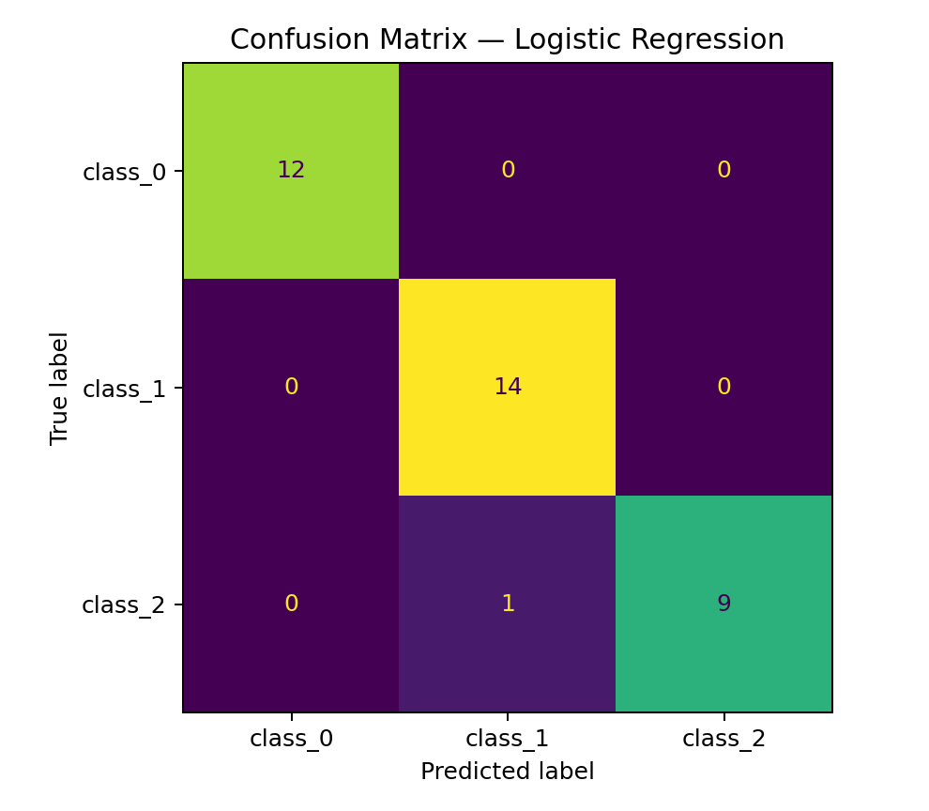

6.4 Supervised result interpretation
The selected model achieved test accuracy of 97.22%, with macro precision 0.978, macro recall 0.967, and macro F1-score 0.971. These values indicate strong classification performance on this held-out split. However, the dataset is small and results from a single split can vary; the cross-validation results provide complementary evidence but do not guarantee performance on new sources or future observations.

7. Unsupervised Learning: K-Means
K-Means groups observations by assigning each sample to the nearest centroid and updating centroids to reduce within-cluster squared distance. The three target classes provide context for interpretation, but their labels are not used to fit K-Means. All 13 features are standardized before clustering so variables with larger numeric ranges do not dominate the Euclidean distance. Candidate values k=2 through k=7 are examined using the elbow curve and silhouette score. For this capstone, k=3 is used as an interpretable exploratory segmentation that can be compared after fitting with the dataset's three known classes.
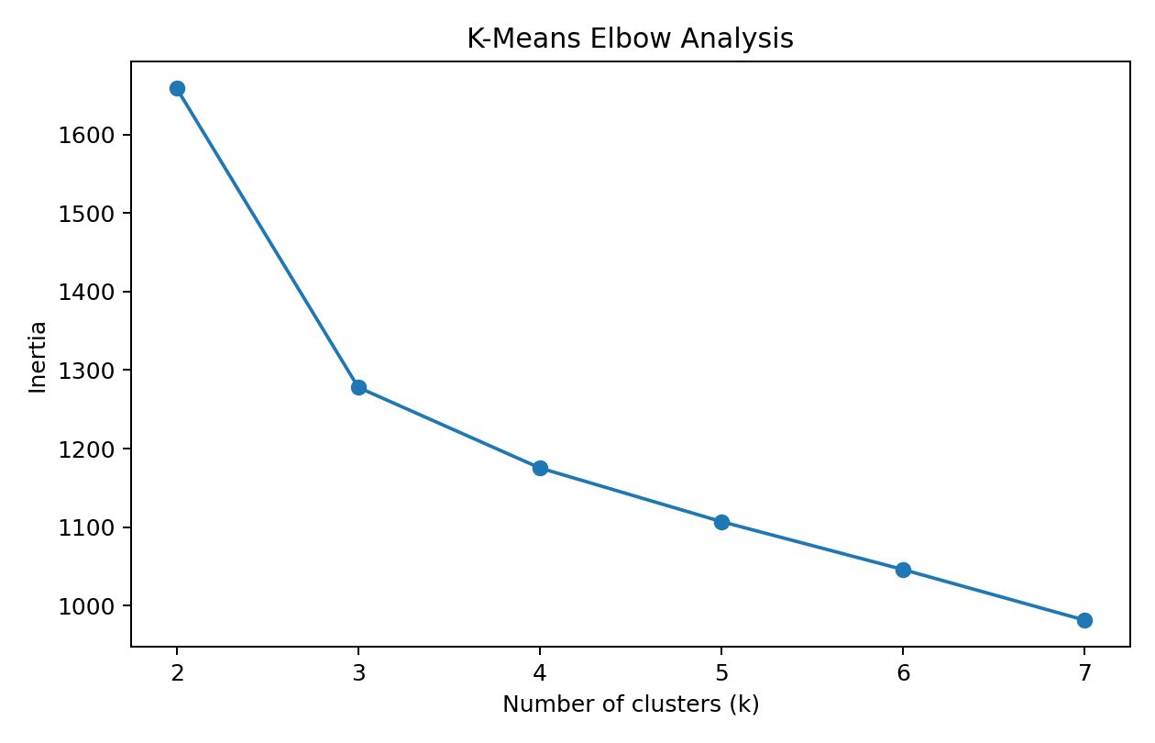
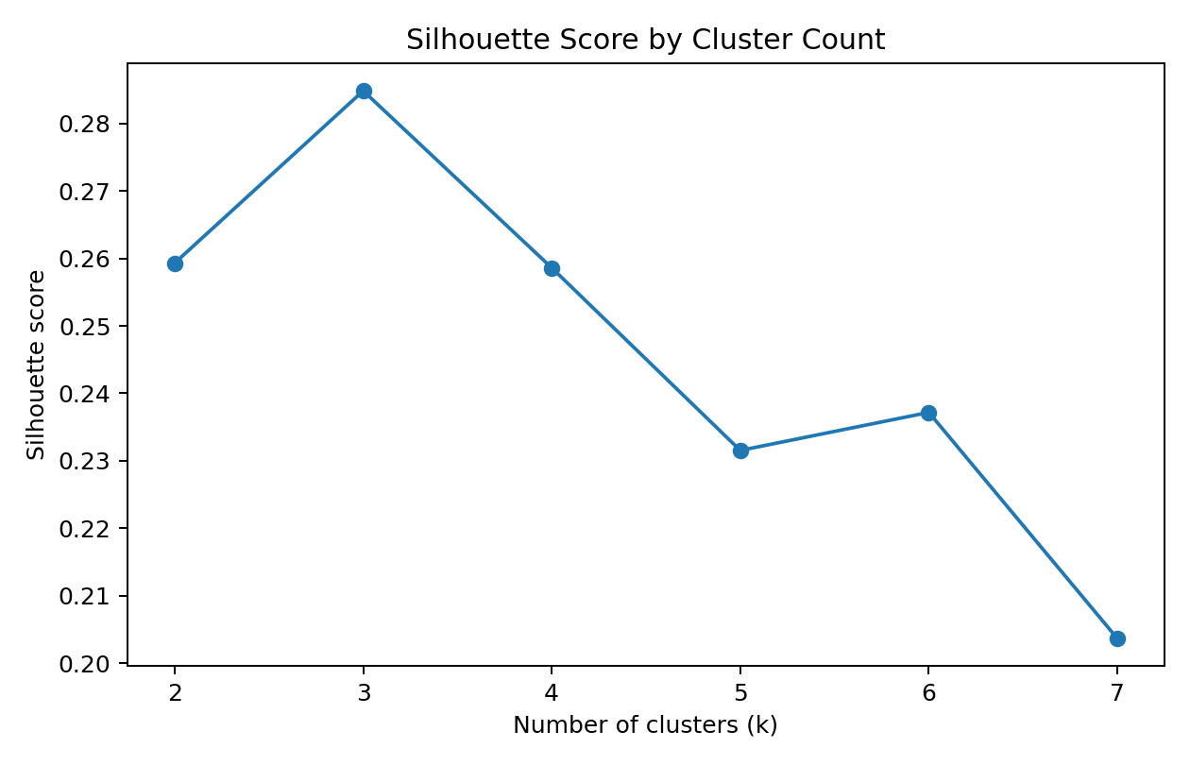
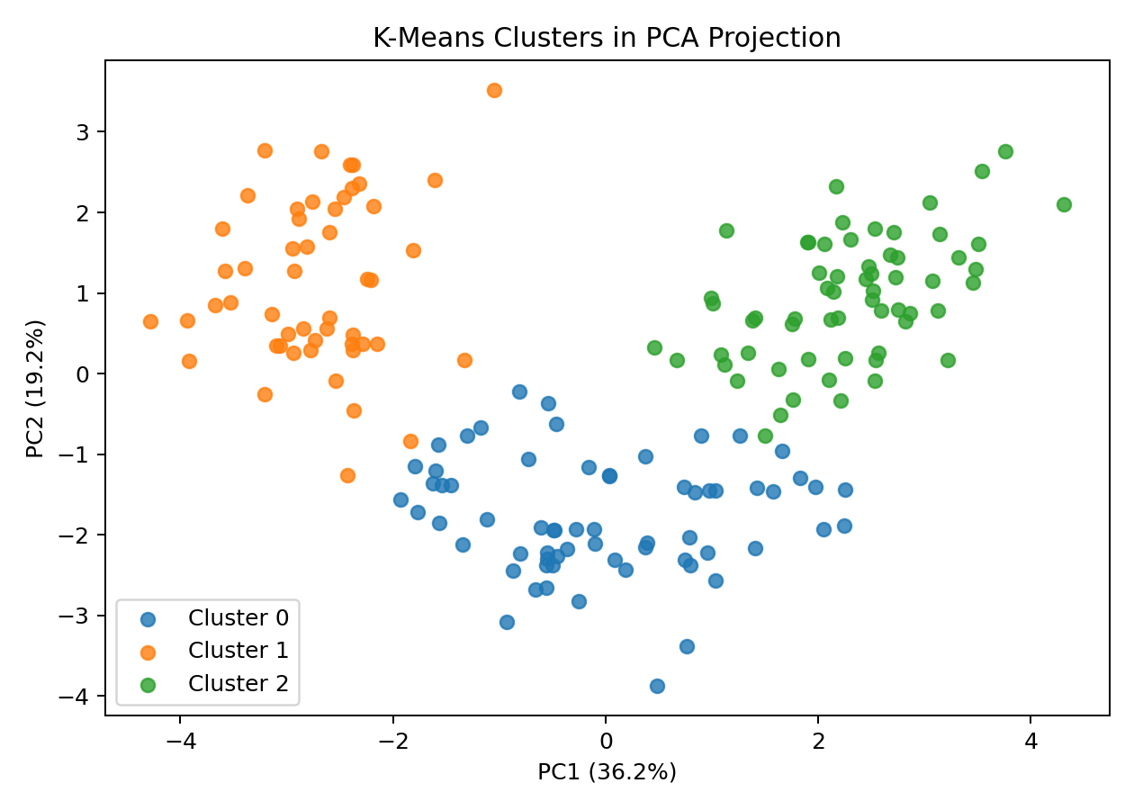
For k=3, the silhouette score is 0.285. Silhouette values range from -1 to 1; higher values generally indicate better separation and cohesion. The PCA chart projects the standardized 13-dimensional observations into two dimensions for display only. Since the plot retains only part of the total information, visible overlap in two dimensions does not necessarily mean the clusters are identical in the full feature space.
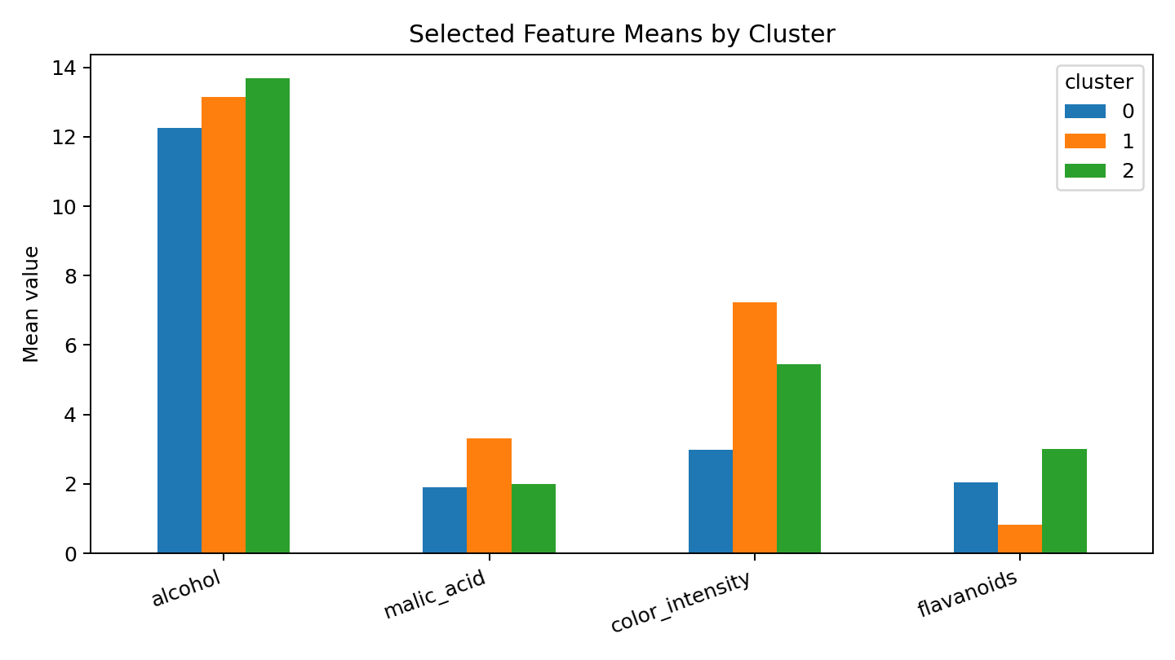

7.1 Cluster profile and post-hoc comparison
The Adjusted Rand Index comparing K-Means assignments with the known class labels after clustering is 0.897. This is a post-hoc comparison only; the labels were not used to train the clustering algorithm. ARI measures agreement between two partitions while accounting for chance, with 1 representing identical partitions and values around 0 representing chance-level agreement. Cluster numbers themselves are arbitrary and should not be interpreted as a ranking.
Cluster | class_0 | class_1 | class_2
0 | 0 | 65 | 0
1 | 0 | 3 | 48
2 | 59 | 3 | 0
Cluster-level feature means can be used to describe groups with comparatively higher or lower alcohol, color intensity, flavanoids, and other chemical measurements. These profiles are descriptive, not causal, and require domain context before they can support decisions.

8. Integrated Insights and Recommendations
- Use supervised classification when the goal is to predict a known cultivar category for a new sample, and monitor performance with cross-validation plus a held-out test set.
- Use clustering as an exploratory tool to discover structure when labels are absent or to check whether measured features form natural groups.
- Standardize features for algorithms based on distances or scale-sensitive optimization; fit transformations only on training data for supervised evaluation.
- Use class-wise metrics and confusion matrices in addition to accuracy, especially when error costs differ by class.
- Investigate highly correlated features and consider feature selection or dimensionality reduction if interpretability or measurement cost is important.
- Validate the pipeline on larger, independent, or newly collected datasets before operational use.

9. Challenges, Successes, and Reflection
A central challenge is ensuring that preprocessing and model selection do not leak information from the test set. The supervised workflow addresses this with a stratified split, cross-validation restricted to training data, and a pipeline for scaling. A second challenge is that supervised classification and unsupervised clustering answer different questions; their scores cannot be compared directly. Accuracy evaluates prediction against known labels, while silhouette evaluates geometric separation of clusters. A success of this project is that both approaches are applied to the same feature space, allowing their different purposes to be demonstrated. The main limitation is the dataset's small size and curated nature, which constrains conclusions about real-world deployment.

10. Limitations and Further Work
- The dataset contains only 178 samples and may not represent wider real-world variation.
- Cross-validation and one hold-out split estimate performance but do not guarantee future generalization.
- K-Means assumes centroid-based groups and can be affected by outliers, scaling, and the chosen k.
- Further work could tune model hyperparameters, compare support vector machines or gradient boosting, inspect per-class errors, and use repeated cross-validation.
- For clustering, further work could compare hierarchical clustering or Gaussian mixture models and assess stability across random seeds.
- Domain experts and additional data would be needed before using model outputs for consequential decisions.

11. Conclusion
This capstone combines the major stages of a data science pipeline: acquiring a public dataset, checking and preparing the data, exploring distributions and relationships, training and evaluating supervised classifiers, and applying unsupervised clustering. The selected supervised model achieved strong performance on the held-out test partition, while K-Means provided a complementary view of structure in the chemical measurements. The project highlights that model selection, validation, visualization, and critical interpretation are all essential; metrics must be understood in the context of the dataset and the intended use.

12. Reproducibility and Code
The full Python workflow is included in `capstone_analysis.py`. Run it from the extracted project directory:
python -m venv .venv
.\.venv\Scripts\Activate.ps1
python -m pip install -r requirements.txt
python capstone_analysis.py

13. References
Scikit-learn, Wine Recognition dataset: https://scikit-learn.org/stable/modules/generated/sklearn.datasets.load_wine.html
UCI Machine Learning Repository, Wine recognition data: https://archive.ics.uci.edu/dataset/109/wine
Scikit-learn, model selection and cross-validation: https://scikit-learn.org/stable/modules/cross_validation.html
Scikit-learn, clustering: https://scikit-learn.org/stable/modules/clustering.html

