WEEK 5 TASK
Deep Learning Application in Data Science
Handwritten Digit Classification with a Convolutional Neural Network (PyTorch)

1. Abstract
This project applies deep learning to handwritten digit classification using a Convolutional Neural Network (CNN) implemented in PyTorch. The public Digits dataset distributed with scikit-learn contains 1,797 grayscale images, each measuring 8 × 8 pixels, representing digits from 0 to 9. Pixel values are normalized and the observations are separated into training, validation, and test partitions. The model learns image patterns using convolution, pooling, and fully connected layers. Training behaviour is monitored through loss and accuracy curves, and final performance is evaluated on a held-out test set. The report discusses architecture decisions, regularization, evaluation results, limitations, and potential improvements.

2. Problem Statement and Objectives
The task is a ten-class image classification problem: given a small grayscale image, predict which digit (0–9) it represents. Objectives are to prepare the data, design a suitable neural network, train it reproducibly, monitor validation performance, evaluate generalization, visualize results, and critically discuss the strengths and limitations of a compact CNN.

3. Dataset Description
The Digits dataset is a public educational dataset available through `sklearn.datasets.load_digits`. It contains 1,797 images with 64 pixel values per image and a label from 0 to 9. Pixel intensities range from 0 to 16 in the original dataset. This project converts them to floating-point values in the range 0 to 1 by dividing by 16. Unlike the larger MNIST dataset, these images are only 8 × 8 pixels, making the experiment small enough to train on a CPU.
Samples: 1797 | Image size: 8 × 8 | Classes: 10 | Training samples: 1257 | Validation samples: 270 | Test samples: 270.

4. Data Preparation
A stratified split is used so the digit classes remain approximately represented in each partition. First, 70% of observations are assigned to training and 30% are held aside. The held-aside portion is split equally into validation and test sets, resulting in approximately 70% training, 15% validation, and 15% test data. A fixed random seed of 42 makes the split reproducible. Each image is reshaped to the tensor format expected by PyTorch convolution layers: batch × channels × height × width. The channel dimension is one because the images are grayscale.

5. Network Architecture and Rationale
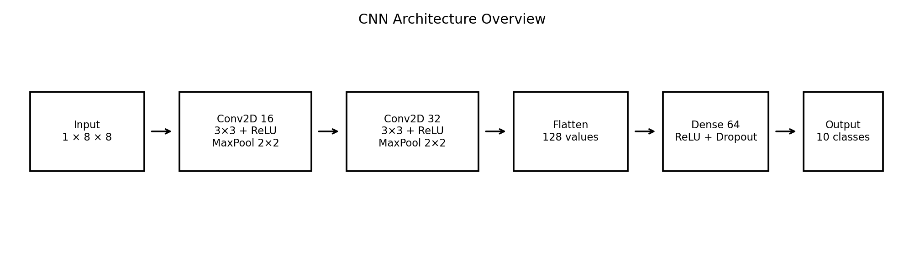
The network contains two convolutional blocks. The first convolution maps one input channel to 16 feature maps; the second maps 16 feature maps to 32. Each convolution uses a 3 × 3 kernel with padding and ReLU activation, followed by 2 × 2 max pooling. The 8 × 8 input becomes 4 × 4 after the first pooling stage and 2 × 2 after the second. The resulting 32 × 2 × 2 tensor is flattened to 128 values and passed to a 64-unit fully connected layer. Dropout with probability 0.25 reduces reliance on individual activations. The final layer has 10 outputs, one per digit. It returns logits; CrossEntropyLoss internally applies the appropriate log-softmax operation.

6. Training Configuration
Setting | Choice
Framework | PyTorch
Optimizer | Adam
Learning rate | 0.001
Loss function | CrossEntropyLoss
Batch size | 64
Maximum epochs | 25
Weight decay | 0.0001
Dropout | 0.25
Validation patience | 6 epochs without improvement
Random seed | 42
Adam was selected for its practical adaptive learning-rate updates. A small weight-decay value provides L2-style regularization. Validation loss is monitored and the best-performing model weights are restored; training can stop early after six epochs without validation-loss improvement. The final test partition is not used to select model weights or hyperparameters.

7. Code Examples

7.1 CNN model definition
class DigitCNN(nn.Module):
def __init__(self):
super().__init__()
self.features = nn.Sequential(
nn.Conv2d(1, 16, kernel_size=3, padding=1), nn.ReLU(),
nn.MaxPool2d(2),
nn.Conv2d(16, 32, kernel_size=3, padding=1), nn.ReLU(),
nn.MaxPool2d(2)
)
self.classifier = nn.Sequential(
nn.Flatten(),
nn.Linear(32 * 2 * 2, 64), nn.ReLU(),
nn.Dropout(0.25),
nn.Linear(64, 10)
)
def forward(self, x):
return self.classifier(self.features(x))

7.2 Training step
optimizer.zero_grad()
logits = model(images)
loss = criterion(logits, labels)
loss.backward()
optimizer.step()
The optimizer gradients are cleared at the start of each batch. The forward pass generates logits, the loss compares logits with the true labels, backpropagation computes gradients, and the optimizer updates the parameters.

8. Evaluation Metrics and Results
Accuracy is the proportion of correctly classified test images. Macro precision, recall, and F1-score calculate each metric separately for every class and then average the ten class scores equally, so each digit contributes equally to the summary. The confusion matrix shows which digits are correctly identified and which pairs are confused.
Metric | Result
Test accuracy | 0.9630
Macro precision | 0.9631
Macro recall | 0.9628
Macro F1-score | 0.9624
Test cross-entropy loss | 0.1127
Best validation loss | 0.1361
The final run completed 25 epochs. Test accuracy of 96.30% indicates that the model correctly classified most images in the held-out test set. These results apply to this small benchmark dataset and should not be generalized automatically to real-world handwriting.
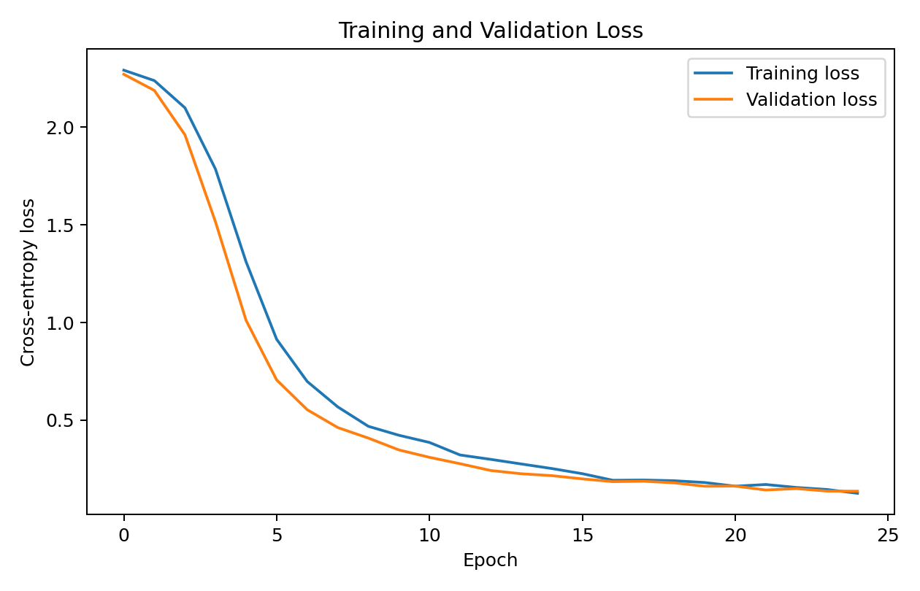
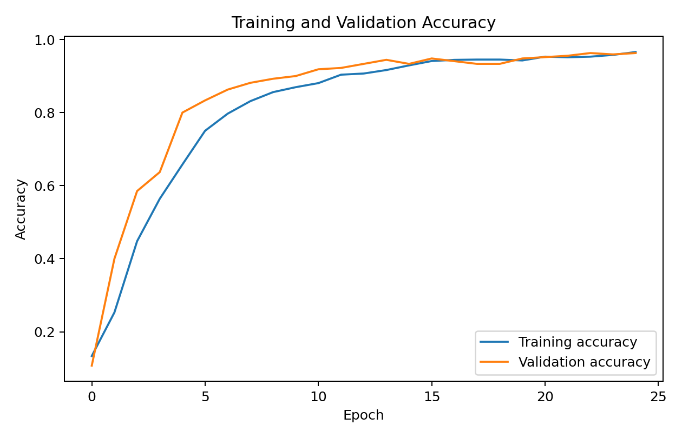
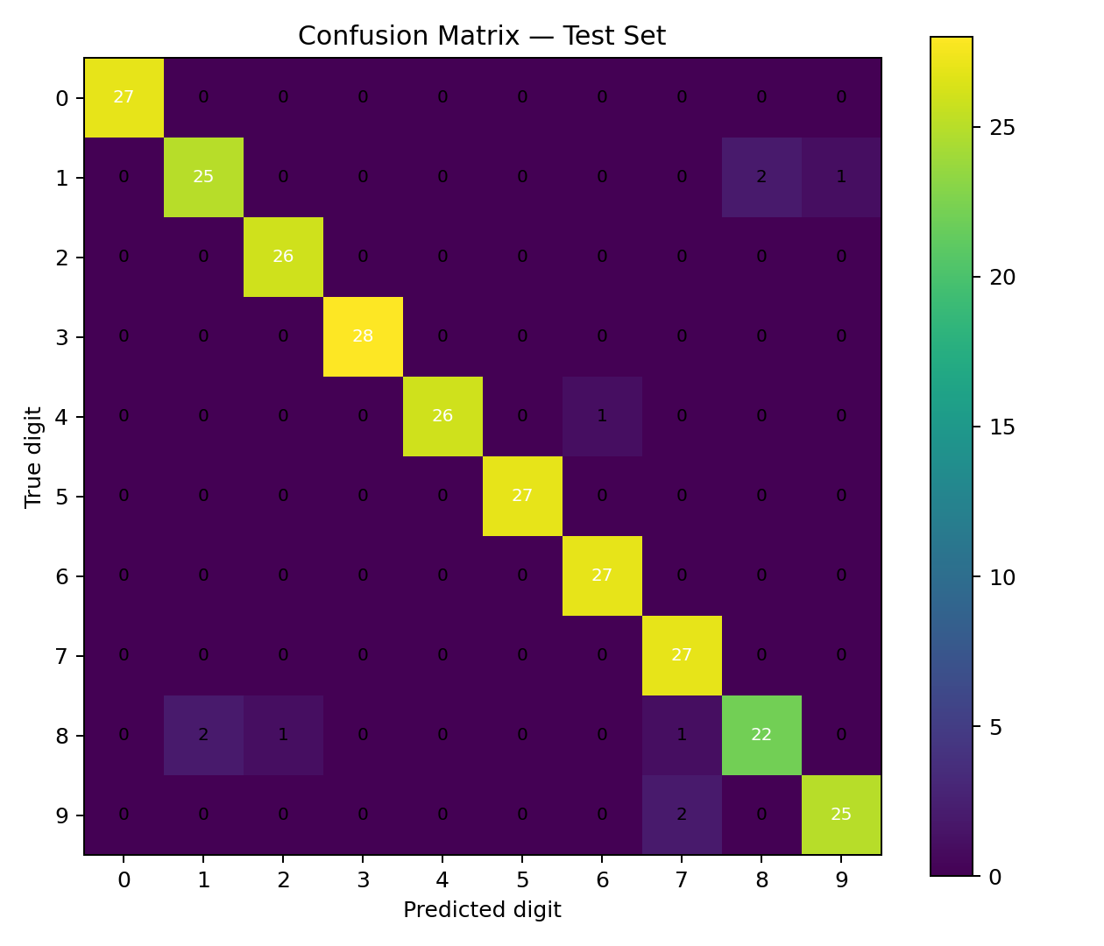
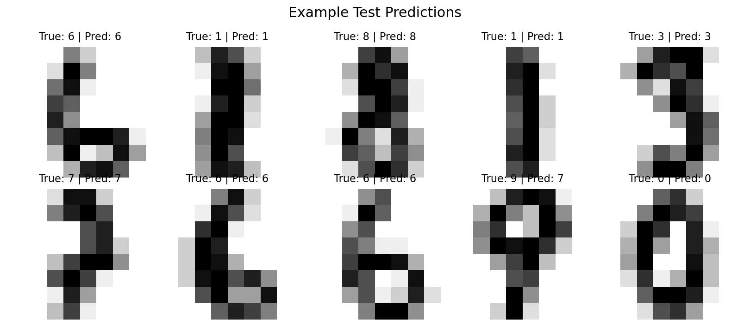

9. Challenges and Mitigation
- Small image resolution: 8 × 8 pixels limits fine visual detail. A compact CNN reduces the risk of a model that is unnecessarily large for the data.
- Overfitting: training metrics can improve while validation metrics stagnate. Dropout, weight decay, validation monitoring, and best-weight restoration are used to reduce this risk.
- Class confusion: some handwritten digits have similar shapes. The confusion matrix helps identify which classes are most often mistaken for each other.
- Compute constraints: the dataset is small and the network is lightweight, so the experiment can run on a CPU without requiring a GPU.
- Reproducibility: fixed random seeds are used for data splitting and PyTorch initialization, though small differences can still occur across environments and library versions.

10. Strengths and Limitations
Strengths: convolution layers learn spatial features; the network is compact; evaluation uses a separate test set; training curves and confusion matrix provide complementary diagnostics; and the script is reproducible.
Limitations: the dataset is small and low resolution; the experiment does not test generalization to camera images or varied real-world handwriting; only one main architecture and configuration are reported; and one random split cannot fully represent all possible test conditions.

11. Possible Improvements
- Compare the CNN against a multilayer perceptron baseline.
- Tune learning rate, batch size, filter counts, dropout, and weight decay using validation data.
- Use cross-validation or repeated stratified splits for a more stable performance estimate.
- Try carefully designed data augmentation, such as small rotations and translations, while ensuring labels remain valid.
- Evaluate per-class precision and recall and inspect the most frequent confusion pairs.
- For more realistic image classification, test on a larger dataset such as MNIST and document the computational cost.

12. Conclusion
This project demonstrates the end-to-end deep learning workflow for ten-class handwritten digit recognition. A CNN was designed to extract spatial features, trained using Adam and cross-entropy loss, and evaluated with a held-out test set. Validation monitoring, dropout, and weight decay were used to manage overfitting. The experiment shows that even a compact neural network can learn useful patterns from image data, while also highlighting that dataset size, resolution, and test-domain similarity constrain the conclusions.

13. Reproducibility
The complete script is provided as `deep_learning.py`. From the project directory, run:
python -m venv .venv
.\.venv\Scripts\Activate.ps1
python -m pip install -r requirements.txt
python deep_learning.py

14. References
Scikit-learn, The Digits Dataset: https://scikit-learn.org/stable/auto_examples/datasets/plot_digits_last_image.html
PyTorch, Neural Networks: https://pytorch.org/tutorials/beginner/blitz/neural_networks_tutorial.html
PyTorch, Training a Classifier: https://pytorch.org/tutorials/beginner/blitz/cifar10_tutorial.html

