WEEK 2 TASK
EXPLORATORY DATA ANALYSIS
AND VISUALIZATION
Final Report

Name: ______________________________
Department / Course: ______________________________
Organization / College: ______________________________
Submission Date: ______________________________

1. Abstract
This report presents an exploratory data analysis (EDA) of the diabetes dataset distributed with scikit-learn. The dataset contains 442 observations, ten baseline variables that have been mean-centred and scaled, and a quantitative target measuring disease progression one year after baseline. Pandas is used for inspection, summaries and aggregation; Matplotlib is used to create labelled visualizations. The analysis examines data quality, distributions, relationships with the target, correlations, potential outliers and differences across BMI quartiles. The work is descriptive: associations do not establish causation and the dataset is not intended for individual medical diagnosis.

2. Objectives
- Load a documented public dataset and understand its structure.
- Inspect data types, missing values, duplicate rows and descriptive statistics.
- Visualize the target and selected feature distributions.
- Examine pairwise correlations and the strongest linear association with the target.
- Screen selected features for unusual values and aggregate target values by BMI quartile.
- Communicate findings, limitations and reproducible code clearly.

3. Dataset Description
Dataset: Diabetes dataset available through the scikit-learn dataset API. It originates from a diabetes study and includes ten baseline variables: age, sex, body mass index (bmi), average blood pressure (bp), and six serum measurements (s1–s6). The target is a quantitative measure of disease progression one year after baseline.
Dataset size in this analysis: 442 rows and 11 columns (including the target). Feature values are standardized, so values should not be interpreted as raw clinical units. The target is a progression measure, not a diagnosis or a probability.
Source / access: https://scikit-learn.org/stable/datasets/toy_dataset.html#diabetes-dataset. The dataset is loaded using sklearn.datasets.load_diabetes(as_frame=True), avoiding a manually edited copy and supporting reproducibility.

4. Tools and Environment
- Python 3.10 or newer (recommended).
- Pandas: data frames, descriptive statistics, correlation and group aggregation.
- Matplotlib: histograms, scatter plot, heatmap-style correlation matrix, boxplots and bar chart.
- scikit-learn: reproducible access to the public diabetes dataset.
pip install -r requirements.txt

5. Methodology and EDA Process

5.1 Load the data
from sklearn.datasets import load_diabetes\nimport pandas as pd\ndata = load_diabetes(as_frame=True)\ndf = data.frame.rename(columns={"target": "disease_progression"})
The data is loaded into a Pandas DataFrame and the target column is renamed to a descriptive label. The original feature values are retained; no unnecessary rescaling is performed because the dataset already provides standardized feature values.

5.2 Inspect rows, shape and data types
print(df.head())\nprint(df.shape)\nprint(df.dtypes)\nprint(df.info())
The dataset has 442 observations and 10 explanatory features plus one target. The initial row inspection helps verify column names and data formatting before analysis.

5.3 Check missing values and duplicates
print(df.isna().sum())\nprint('Duplicate rows:', df.duplicated().sum())
Missing values found: 0. Duplicate rows found: 0. Since the dataset is complete, no imputation or row deletion is required. In a different dataset, missing values should be investigated before choosing imputation or removal.

5.4 Descriptive statistics
print(df.describe().T.round(3))
The count, mean, standard deviation, minimum, quartiles and maximum provide a compact numerical summary. Because features are standardized, many feature means are close to zero. A minimum or maximum far from the interquartile range may warrant review, but it is not automatically an error.

6. Descriptive Summary
The target distribution is examined first to understand its spread and whether values cluster around a central range. Feature summaries are interpreted cautiously because the feature columns are standardized. The following table shows the target's principal summary statistics.
Statistic | Disease progression
count | 442.000
mean | 152.133
std | 77.093
min | 25.000
25% | 87.000
50% | 140.500
75% | 211.500
max | 346.000

7. Visualizations and Interpretations

7.1 Target distribution
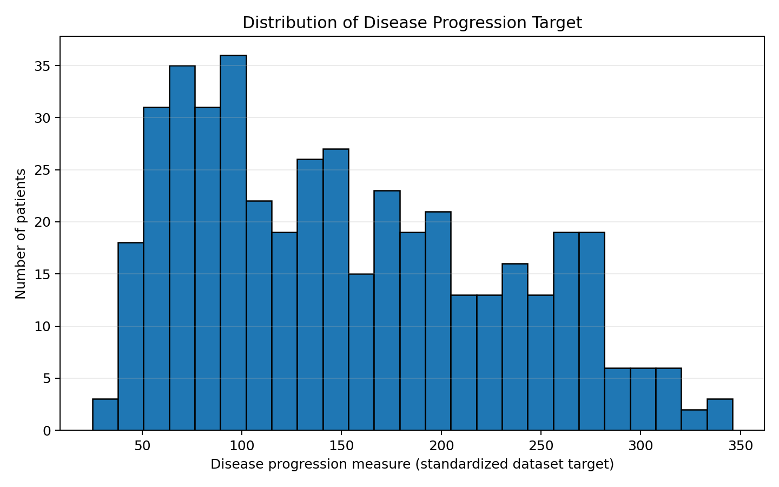
Figure 1. Histogram of the disease progression target.
Interpretation: The histogram shows the frequency distribution and spread of the target. The shape indicates whether observations are concentrated in particular ranges and whether the distribution has a long tail. This is useful for understanding variation before comparing features. The histogram alone does not explain why any observation has a particular outcome.

7.2 Correlation matrix
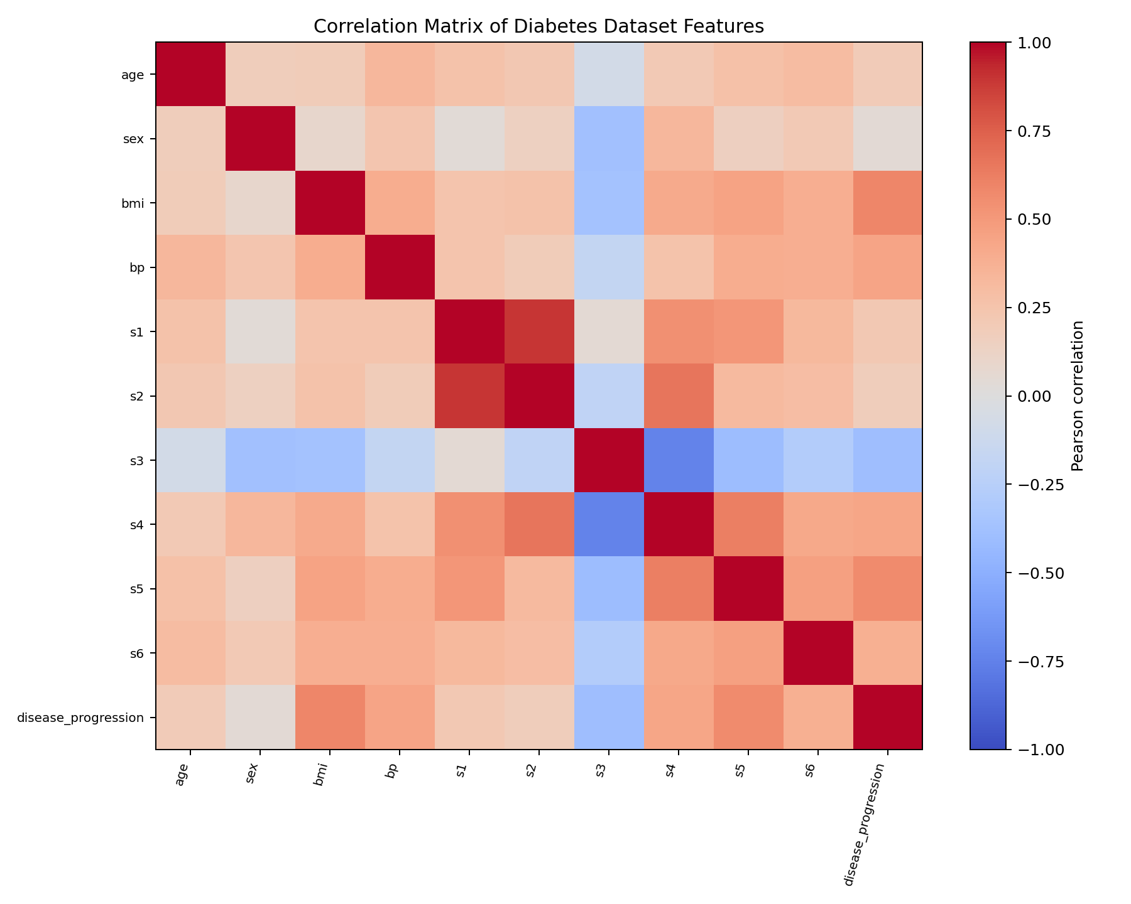
Figure 2. Pearson correlation matrix for the ten features and target.
Interpretation: Correlation coefficients range from -1 to +1. Positive values indicate that two variables tend to increase together; negative values indicate an inverse linear relationship; values near zero indicate a weak linear relationship. Correlations among predictors may indicate overlapping information. Correlation is not proof of causation and may miss nonlinear relationships.

7.3 Strongest feature-target association
The feature with the largest absolute Pearson correlation with the target in this dataset is 'bmi', with correlation 0.586.
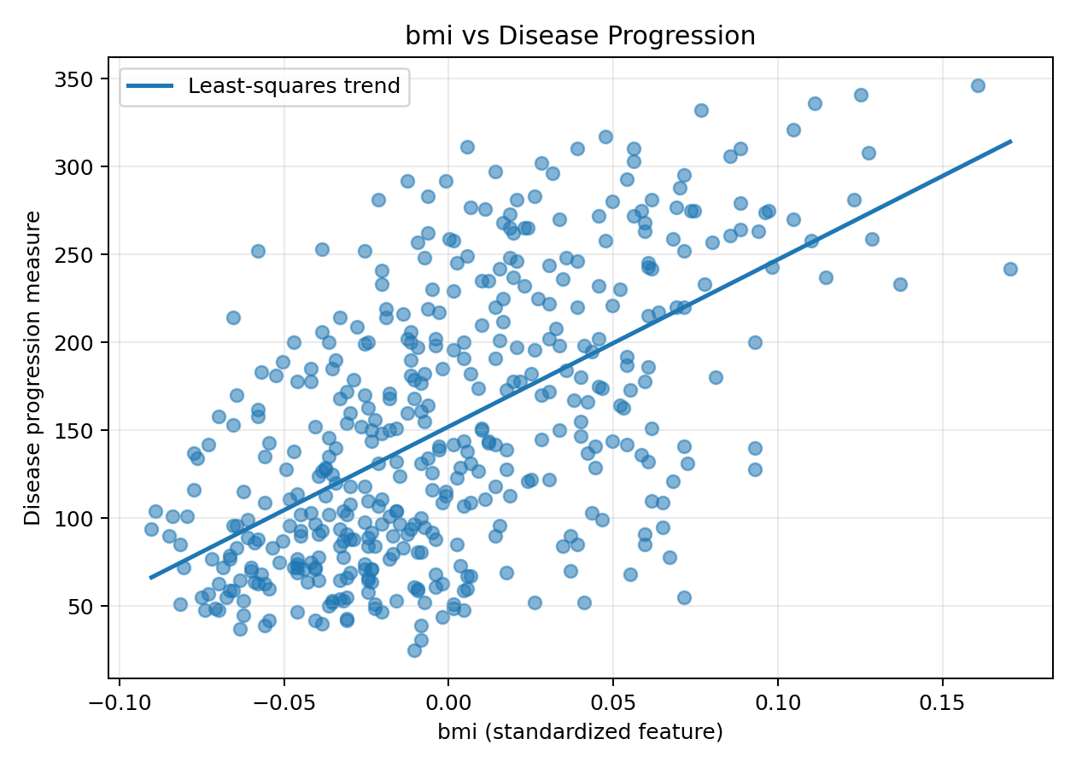
Figure 3. Scatter plot of bmi against the target with a least-squares trend line.
Interpretation: Each point represents one observation. The fitted line summarizes the overall linear direction; the spread around it shows that the feature alone cannot explain all variation in the target. A visible trend indicates association, not causality or a reliable individual prediction.

7.4 Feature distributions
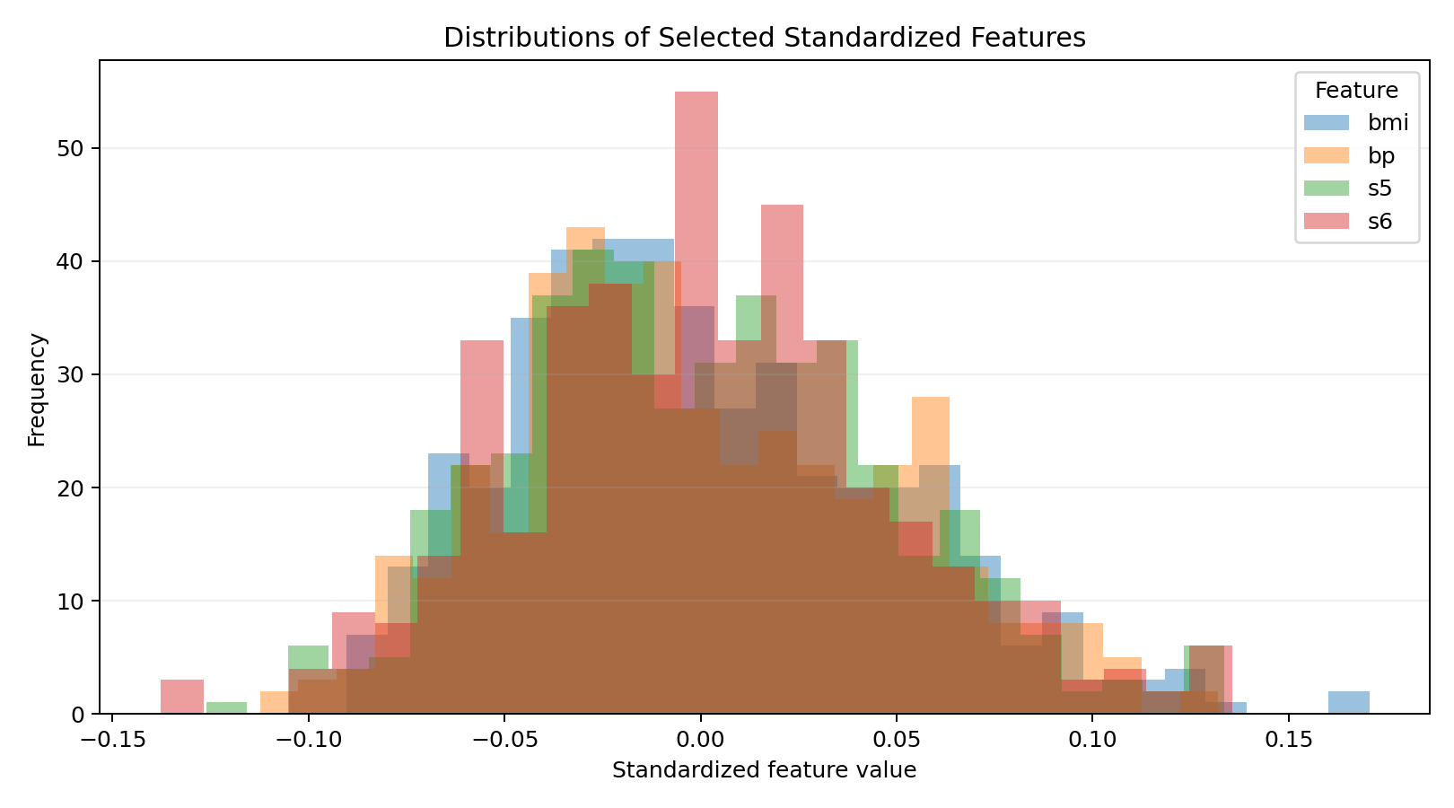
Figure 4. Histograms of selected standardized features: bmi, bp, s5 and s6.
Interpretation: Comparing histograms helps identify concentration around zero, skewness and differences in spread. Since the features are standardized, their values are not raw BMI, blood pressure or serum units. Overlapping histograms are a compact comparison and are not intended to imply that these variables share a clinical scale.

7.5 Potential outliers
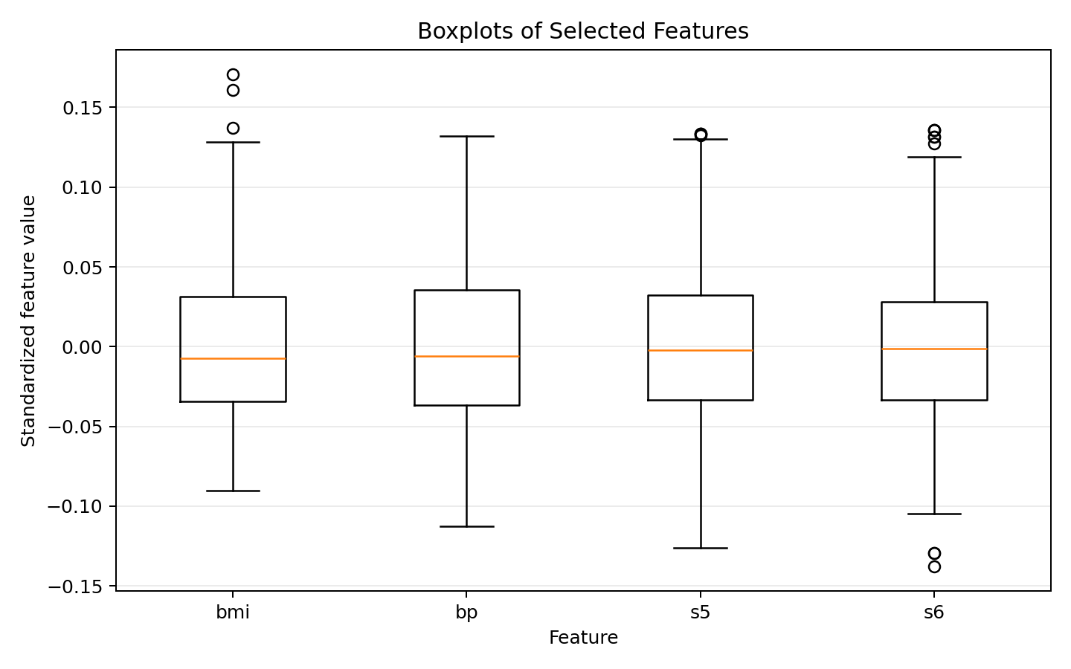
Figure 5. Boxplots for selected features. Points beyond whiskers are potential outliers.
Interpretation: Boxplots show the median, interquartile range and values beyond the whiskers. Such values are candidates for review, not automatic errors. Standardized measurements can legitimately be extreme. Any removal would require subject-matter justification and sensitivity analysis.

7.6 Aggregation by BMI quartile
df["bmi_group"] = pd.qcut(df["bmi"], 4, labels=["Q1 (lowest)", "Q2", "Q3", "Q4 (highest)"])\nsummary = df.groupby("bmi_group", observed=False)["disease_progression"].agg(["count", "mean", "median", "std"])
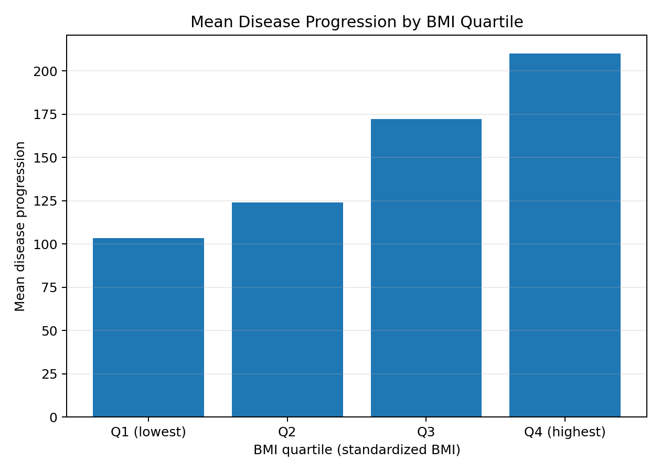
Figure 6. Mean target value for observations in each BMI quartile.
Interpretation: BMI values are split into four approximately equal-sized groups using quartiles, then the mean target is calculated for each group. This aggregation makes it easier to compare broad groups. Differences between group means may reflect BMI association, other correlated variables or confounding factors; they should not be interpreted as BMI causing the outcome.

8. Key Findings
- The dataset contains 442 rows and 10 explanatory variables plus the target.
- The dataset has 0 missing cells and 0 duplicate rows in the initial quality checks.
- The feature most strongly correlated in absolute terms with the target is bmi (Pearson r = 0.586).
- Correlation analysis provides a useful overview of linear relationships and possible redundancy between predictors.
- Histograms and boxplots reveal variation and potentially unusual observations; extreme values require investigation rather than automatic deletion.
- BMI quartile aggregation provides a descriptive group comparison but cannot establish a causal relationship.

9. Data Transformations and Aggregations
- Target column renamed from 'target' to 'disease_progression' for clarity; values are unchanged.
- Numeric descriptive statistics and Pearson correlations are calculated from the original columns.
- Four BMI quartiles are created with pandas.qcut. This is a derived categorical column used only for grouped analysis.
- Mean, median, count and standard deviation of the target are calculated for each BMI quartile.
- No missing-value imputation, outlier removal or feature scaling is applied during this EDA.

10. Limitations and Critical Discussion
- The dataset is relatively small (442 observations) and may not represent all populations.
- Feature values are standardized and therefore do not directly correspond to original clinical measurement units.
- The analysis is observational and descriptive; correlation does not imply causation.
- Outlier flags from boxplots are heuristic and require domain knowledge.
- Results from this dataset must not be used for medical diagnosis or treatment decisions.
- Further work could include confidence intervals, nonlinear analysis, subgroup sensitivity checks and a separately validated predictive model.

11. Reproducibility and How to Run
Place eda_analysis.py and requirements.txt in a working folder. Open a terminal in that folder and run:
python -m venv .venv\n# Windows PowerShell:\n.venv\\Scripts\\Activate.ps1\n# Install dependencies:\npip install -r requirements.txt\n# Run analysis:\npython eda_analysis.py
The script creates an 'eda_outputs' folder containing the exported data, descriptive statistics, correlation matrix, BMI quartile summary and six PNG visualizations. If PowerShell blocks activation, use the Python executable inside the environment directly or follow your institution's approved environment setup.

12. Conclusion
This EDA demonstrates a reproducible workflow for understanding a public dataset: inspect structure, validate data quality, summarize distributions, visualize relationships, identify potential anomalies and aggregate observations into meaningful groups. The strongest feature-target correlation is a useful lead for further analysis, but the scatter plot also emphasizes that a single variable does not explain all outcome variation. Clear annotation, cautious interpretation and transparent limitations are essential parts of a high-quality EDA report.

13. References
1. scikit-learn Developers. “Toy datasets — Diabetes dataset.” https://scikit-learn.org/stable/datasets/toy_dataset.html#diabetes-dataset
2. pandas documentation. https://pandas.pydata.org/docs/
3. Matplotlib documentation. https://matplotlib.org/stable/
4. scikit-learn dataset loading API. https://scikit-learn.org/stable/modules/generated/sklearn.datasets.load_diabetes.html

Appendix A: Complete Analysis Code
The complete runnable script is supplied separately as eda_analysis.py in the package. Selected core code is shown below.
corr = df.corr(numeric_only=True)\nprint(corr["disease_progression"].drop("disease_progression").sort_values(key=abs, ascending=False))\n\nplt.hist(df["disease_progression"], bins=25, edgecolor="black")\nplt.title("Distribution of Disease Progression Target")\nplt.xlabel("Disease progression measure")\nplt.ylabel("Number of observations")\nplt.tight_layout()

