WEEK 4 TASK
Supervised Learning Model Implementation
Binary Classification using Logistic Regression

1. Abstract
This report develops and evaluates a supervised machine learning classifier using the Breast Cancer Wisconsin (Diagnostic) dataset available through scikit-learn. The goal is to predict whether a recorded tumor observation is labelled malignant or benign from numeric measurements. A Logistic Regression model is implemented inside a preprocessing pipeline that standardizes features. The workflow includes dataset inspection, a stratified train-test split, five-fold cross-validation, held-out evaluation, visualizations, and discussion of strengths, limitations, and improvements. This is an educational machine learning exercise and is not intended for clinical diagnosis.

2. Problem Definition and Objectives
The problem is binary classification: map 30 numerical measurements to one of two target categories. The target coding in scikit-learn is 0=malignant and 1=benign. The main objectives are to build a reproducible classifier, avoid preprocessing leakage, estimate generalization performance, and interpret metrics with attention to the importance of detecting malignant observations.

3. Dataset Description
The dataset contains 569 observations and 30 numeric input features derived from digitized images of fine needle aspirates of breast masses. Features describe characteristics such as radius, texture, perimeter, area, smoothness, compactness, concavity, concave points, symmetry, and fractal dimension. For several characteristics, mean, standard error, and worst-value measurements are provided. The dataset is included in scikit-learn and is widely used for educational classification examples.
Dataset dimensions: 569 rows × 30 features. Missing feature values: 0.

4. Data Preparation and Feature Engineering
The numeric feature matrix was inspected for dimensions and missing values. The dataset supplied by scikit-learn has no missing values in the selected feature table, so imputation was not necessary. The target was retained separately from the features to prevent target leakage. A stratified 80/20 train-test split was used with random_state=42 to maintain similar class proportions in both partitions. StandardScaler was included inside a scikit-learn Pipeline. This is important because scaling is fitted on the training data within each cross-validation fold rather than on the complete dataset, helping prevent leakage. No new domain-derived variables were invented; standardization is the primary feature transformation.

5. Model Selection: Logistic Regression
Logistic Regression was selected as a baseline because it is a widely used classification algorithm, trains efficiently, provides class probabilities, and offers coefficients that can be inspected for model interpretation. Standardization is helpful because the features have different numeric ranges and the model is regularized. The pipeline uses StandardScaler followed by LogisticRegression(max_iter=5000, random_state=42). The maximum iteration count is increased to support convergence on the standardized feature set.

6. Validation Strategy
The held-out test set contains 20% of the observations and is not used during model fitting or cross-validation. On the remaining 80%, StratifiedKFold with five splits, shuffling, and random_state=42 estimates training-set stability. Accuracy is recorded for each fold, with the mean and standard deviation summarized. After cross-validation, the pipeline is fitted to the full training partition and evaluated once on the held-out test partition.

7. Evaluation Metrics and Results
Accuracy is the fraction of all predictions that are correct. Precision for the malignant class measures how many observations predicted malignant are actually malignant. Recall for the malignant class measures the fraction of all malignant observations correctly identified; it is especially important in this educational example because false negatives may be consequential. The F1-score is the harmonic mean of precision and recall. ROC-AUC summarizes ranking discrimination between malignant and benign observations using predicted malignant probabilities.
Metric | Result
Test accuracy | 0.9825
Malignant precision | 0.9762
Malignant recall | 0.9762
Malignant F1-score | 0.9762
Malignant ROC-AUC | 0.9954
5-fold CV mean accuracy | 0.9780
5-fold CV accuracy standard deviation | 0.0098
The metrics above were calculated by running the accompanying Python workflow with a fixed random seed. Small differences may occur if library versions or code settings are changed. The confusion matrix should be read with malignant as the first class and benign as the second class.
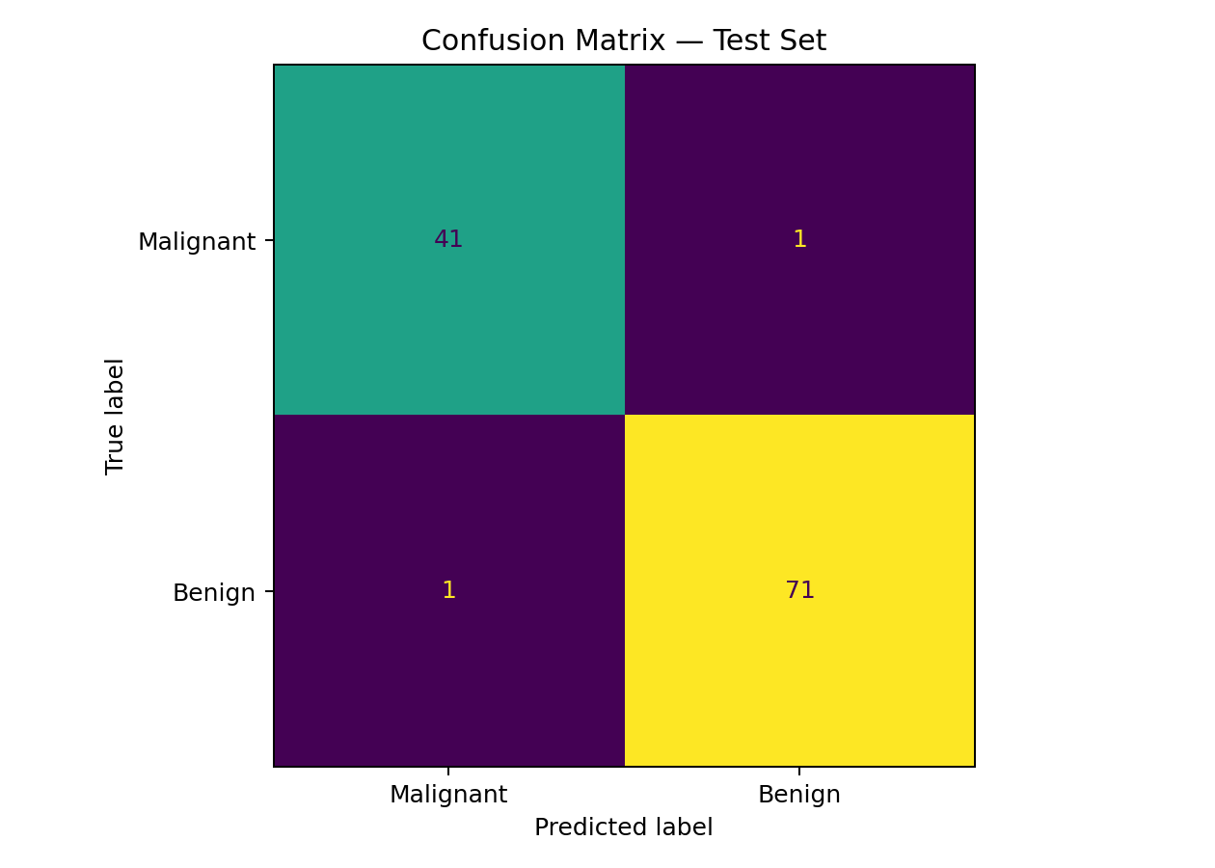
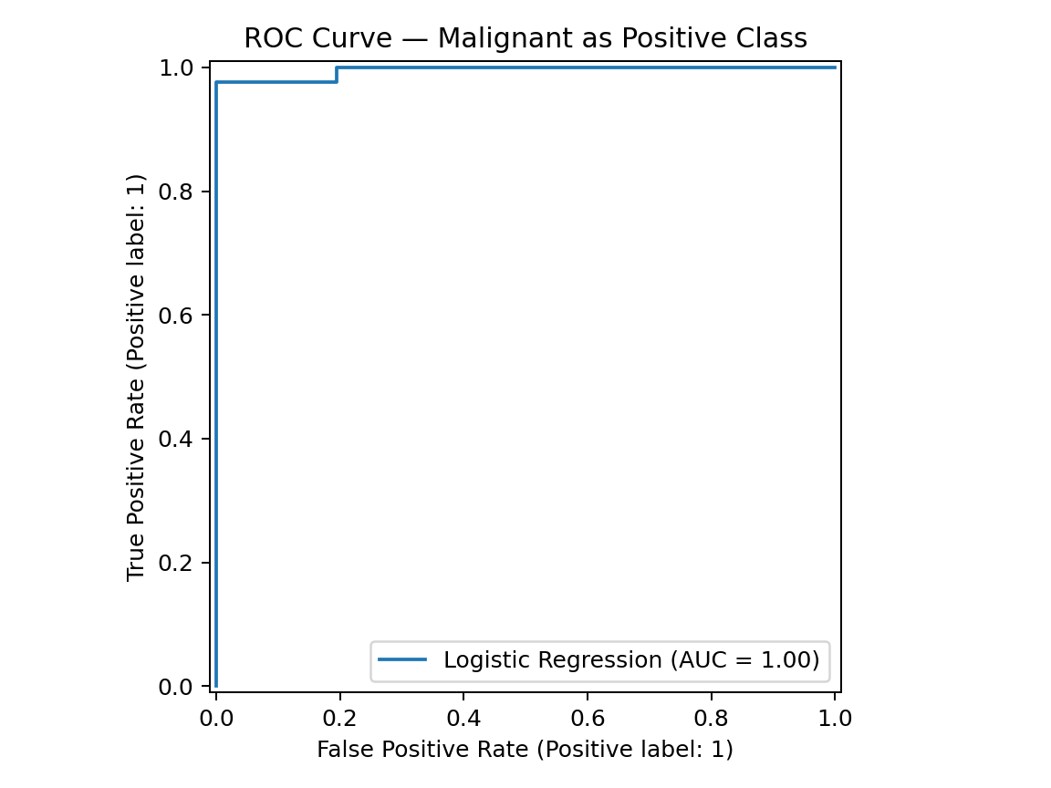
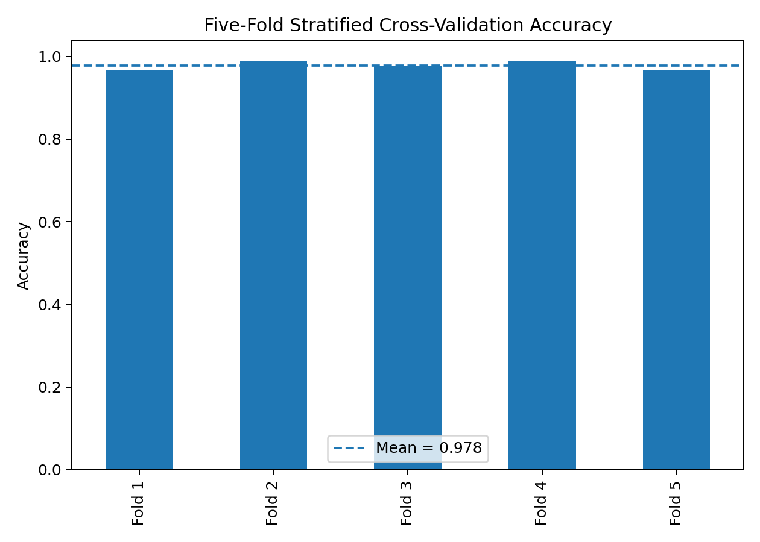

8. Feature Coefficient Analysis
The absolute values of standardized Logistic Regression coefficients are plotted as a simple model-based indicator of which features have larger fitted weights. Coefficient magnitude is not proof of causality, and correlated input features can share or redistribute coefficient weight. The sign of a coefficient also matters for direction, while this chart shows magnitude only.
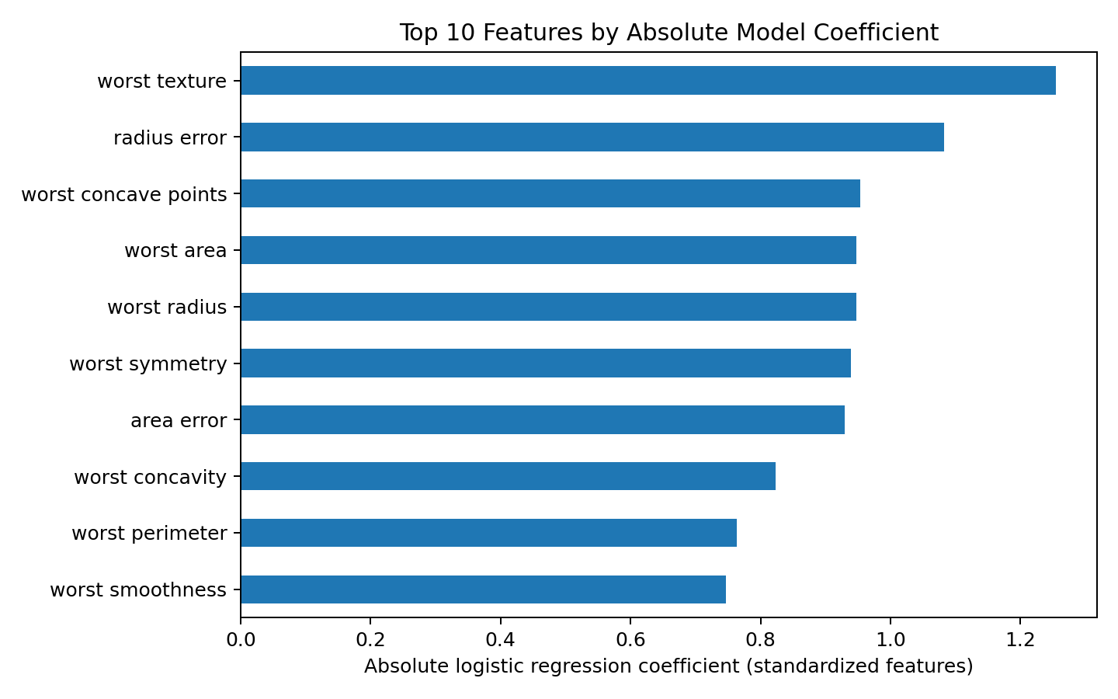

9. Strengths and Limitations
- Strength: a transparent and reproducible baseline with class probabilities and interpretable coefficients.
- Strength: a pipeline keeps scaling within training folds and helps prevent data leakage.
- Strength: stratified splitting and cross-validation provide a more dependable estimate than a single training score.
- Limitation: this dataset is a curated benchmark and may not reflect differences across hospitals, populations, or measurement devices.
- Limitation: Logistic Regression models a linear relationship between predictors and log-odds; complex nonlinear patterns may be missed.
- Limitation: correlated features can make individual coefficients unstable or difficult to interpret.
- Limitation: high evaluation scores do not establish clinical readiness or replace professional medical judgment.

10. Potential Improvements
- Use GridSearchCV to tune regularization strength and penalty choices within cross-validation.
- Compare Logistic Regression with Support Vector Machines, Random Forest, and Gradient Boosting using the same data split.
- Inspect precision-recall curves and threshold trade-offs, especially for malignant-class recall.
- Assess calibration of predicted probabilities and evaluate decision thresholds with domain experts.
- Perform independent external validation and document subgroup performance before considering any real-world deployment.

11. Conclusion
This project demonstrates an end-to-end supervised learning workflow: defining a classification task, preparing data, building a preprocessing pipeline, validating with five-fold cross-validation, evaluating on held-out data, and interpreting results with quantitative metrics and figures. Logistic Regression provides a useful baseline, while the evaluation also illustrates why accuracy alone is insufficient. Model improvements and independent validation are necessary before any high-stakes use.

12. Code and Reproducibility
The full implementation is provided in `supervised_learning.py`. Install dependencies and run:
pip install -r requirements.txt
python supervised_learning.py

13. References
1. Scikit-learn, Breast Cancer Wisconsin dataset: https://scikit-learn.org/stable/modules/generated/sklearn.datasets.load_breast_cancer.html
2. Scikit-learn, Logistic Regression: https://scikit-learn.org/stable/modules/linear_model.html#logistic-regression
3. Scikit-learn, model selection and cross-validation: https://scikit-learn.org/stable/modules/cross_validation.html
4. UCI Machine Learning Repository, Breast Cancer Wisconsin (Diagnostic): https://archive.ics.uci.edu/dataset/17/breast+cancer+wisconsin+diagnostic

