WEEK 3 TASK
Unsupervised Learning and Clustering Analysis
Dataset: Iris dataset | Algorithm: K-Means clustering

1. Abstract
This report applies an unsupervised learning method to the public Iris dataset. K-Means clustering groups observations using four numeric flower measurements without using the species labels during model fitting. The workflow includes data inspection, standardization, selection of k, cluster visualization with Principal Component Analysis (PCA), and interpretation of cluster profiles. The purpose is to demonstrate how clustering can reveal structure in data when predefined labels are not used.

2. Objectives
- Select a publicly available dataset suitable for clustering.
- Inspect and preprocess numeric features before clustering.
- Apply K-Means and explain the choice of the number of clusters.
- Evaluate cluster separation with inertia and silhouette score.
- Visualize the groups and summarize their feature characteristics.
- Discuss practical uses, limitations, and possible improvements.

3. Dataset Description
The Iris dataset is a classic public dataset distributed with scikit-learn. It contains 150 observations and four numeric features: sepal length, sepal width, petal length, and petal width, measured in centimetres. The dataset also includes a known species category (setosa, versicolor, or virginica). For this task, the species category is kept only for optional post-hoc comparison; it is excluded from the input features used to train K-Means.
Rows: 150 | Numeric features: 4 | Missing feature values: 0

4. Methodology

4.1 Data inspection and preprocessing
The feature table was inspected for its dimensions, data types, missing values, and duplicate rows. The four numeric columns were used as model inputs. StandardScaler was applied so each feature has approximately zero mean and unit variance. Scaling is important because K-Means uses distances, and features with larger numeric ranges could otherwise dominate the result.

4.2 Algorithm selection: K-Means
K-Means partitions observations into k clusters by assigning each observation to its nearest centroid and repeatedly updating centroids to minimize the within-cluster sum of squared distances (inertia). It was chosen because it is widely used, computationally efficient on small numeric datasets, and its centroids make cluster profiles straightforward to interpret. Its limitations include sensitivity to scaling and initialization, preference for roughly spherical clusters, and the need to specify k in advance.

4.3 Choosing the number of clusters
Candidate values k = 2 through 8 were tested with fixed random_state=42 and n_init=20 for reproducibility and more stable initialization. The elbow method compares inertia: inertia always decreases as k increases, so the curve is examined for a point where improvements become smaller. The silhouette score ranges from -1 to 1; higher values generally indicate that observations are closer to their own cluster than to neighbouring clusters. For the final analysis, k=3 was selected as an interpretable three-group solution and because the Iris benchmark is commonly examined as three natural groups. The reference species labels were not used to fit the model.
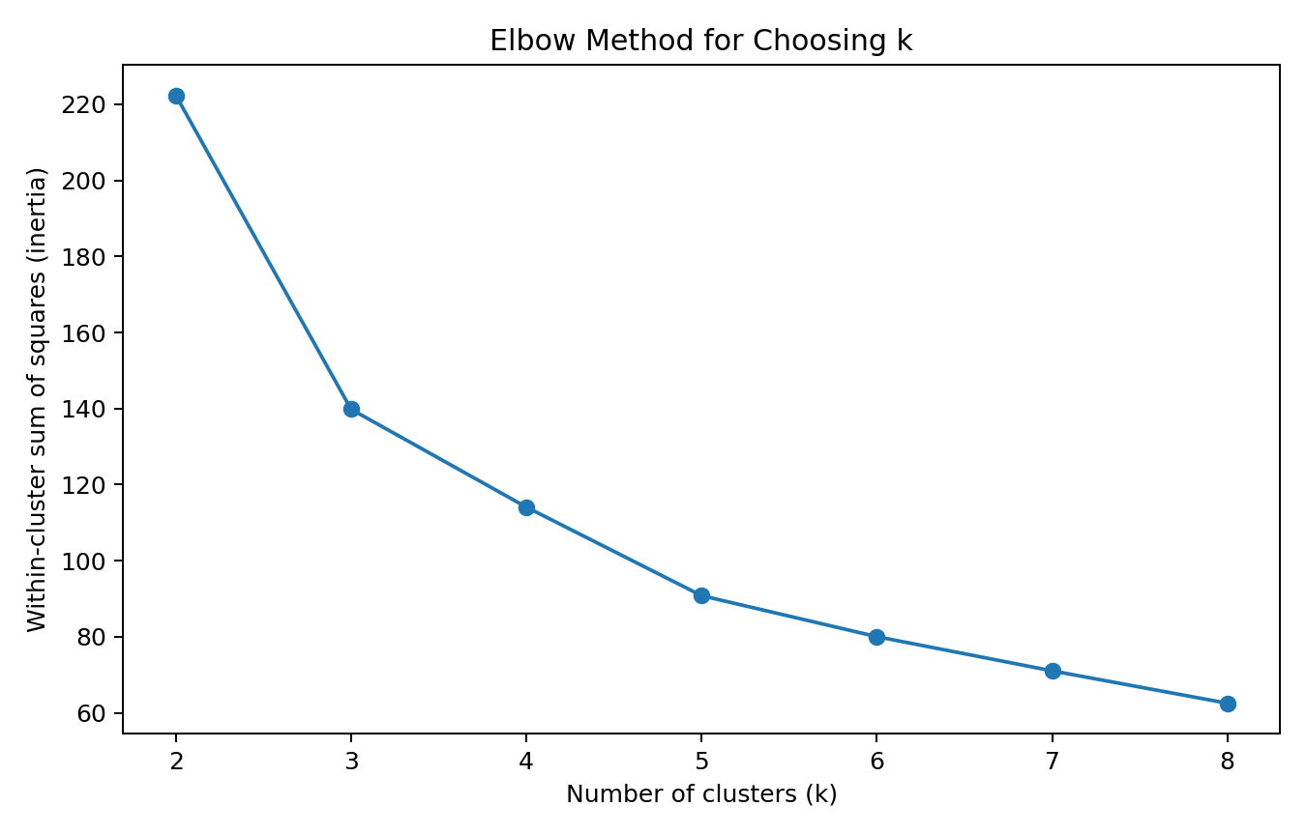
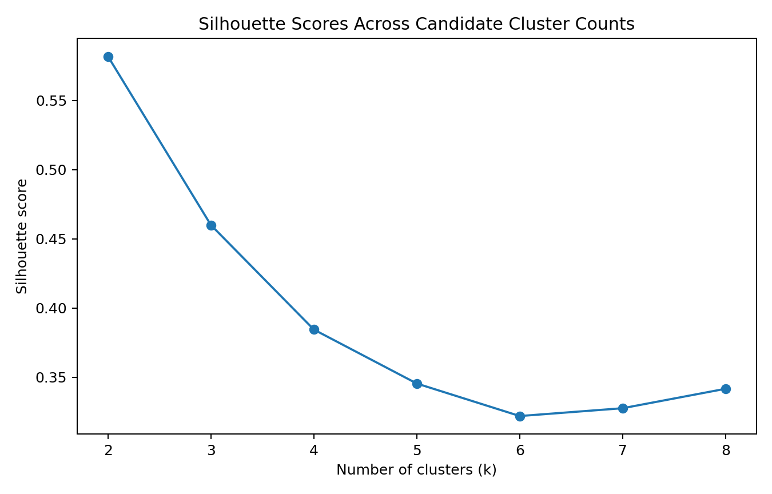

4.4 Final model settings
The final model uses KMeans(n_clusters=3, random_state=42, n_init=20). Standardized feature values are used to fit the model. PCA with two components is used only to project the four-dimensional data into two dimensions for visualization; it is not used to fit K-Means.

5. Results
The final model's silhouette score is 0.460. The first two principal components explain 95.8% of the standardized feature variance, so the PCA plot is a useful but incomplete 2D view.
Cluster sizes:
- Cluster 0: 53 observations
- Cluster 1: 50 observations
- Cluster 2: 47 observations
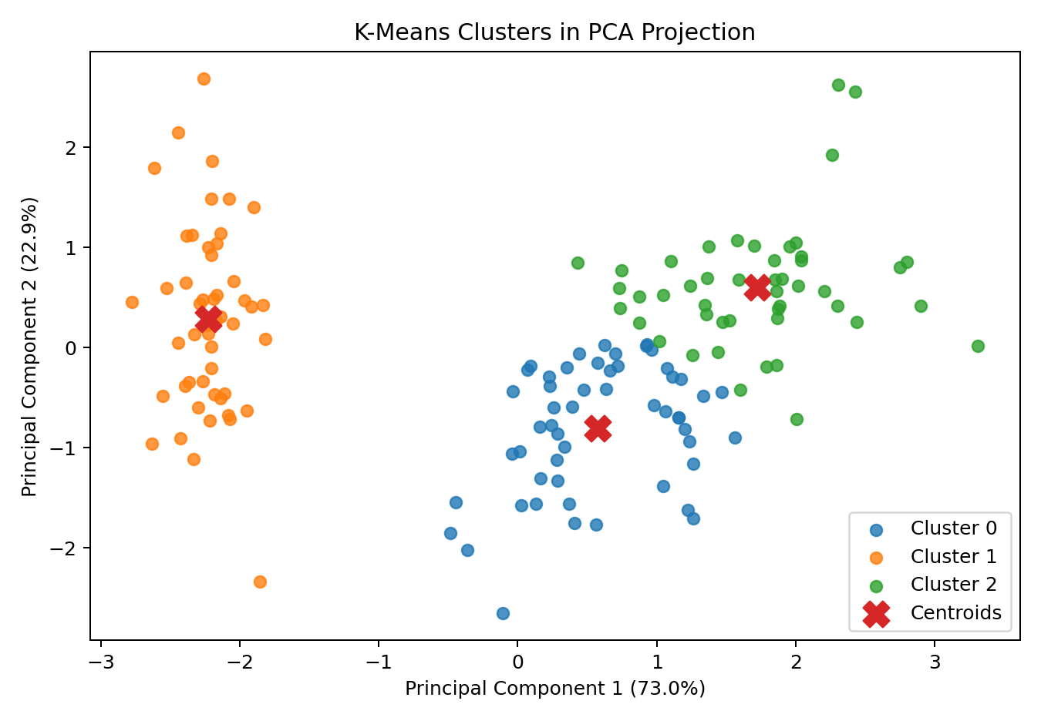

5.1 Mean feature profile by cluster
Cluster | Sepal Length | Sepal Width | Petal Length | Petal Width
0 | 5.80 | 2.67 | 4.37 | 1.41
1 | 5.01 | 3.43 | 1.46 | 0.25
2 | 6.78 | 3.10 | 5.51 | 1.97
These are means in the original measurement units. Use them alongside the standardized profile plot to understand which features distinguish each group.
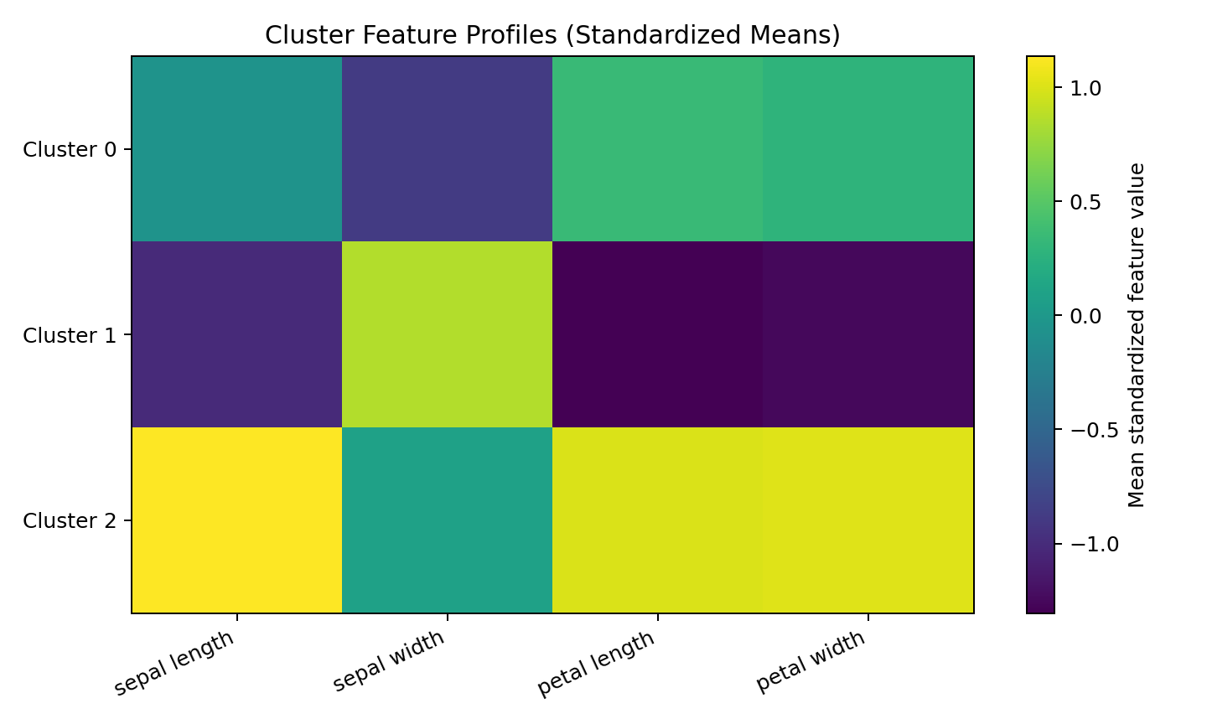
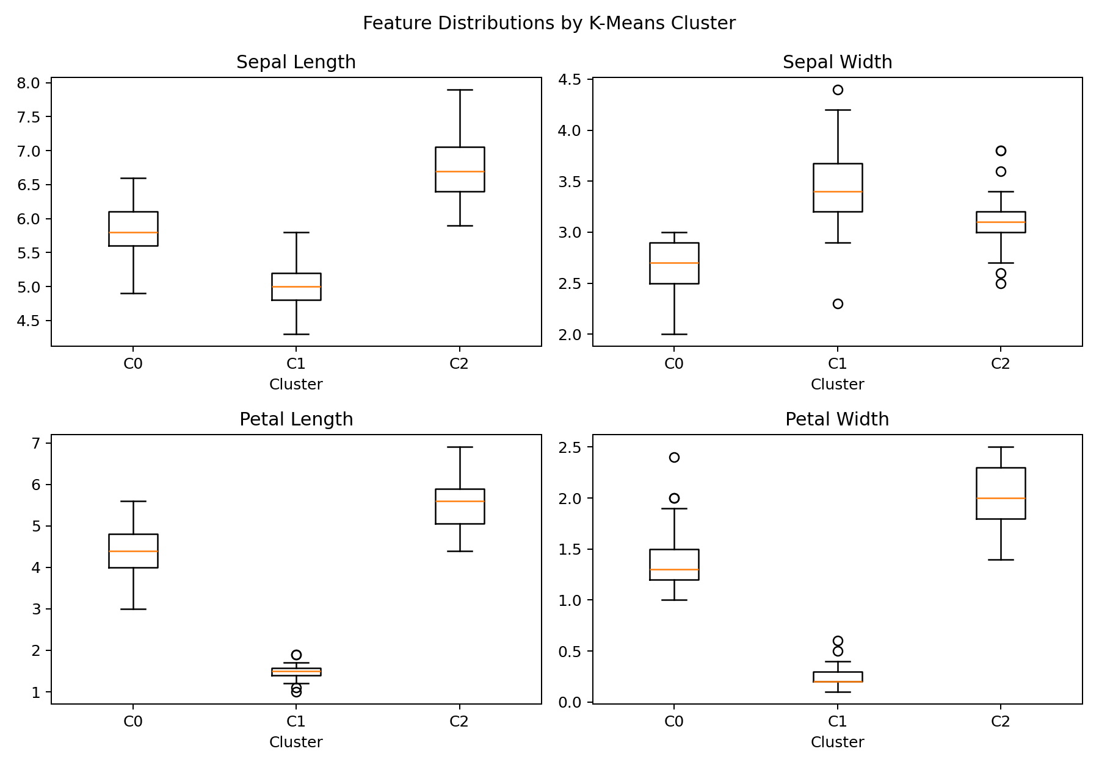

6. Cluster Interpretation
Cluster IDs are arbitrary: Cluster 0 is not inherently better or more important than Cluster 1 or 2. Interpretations below are based on the measured feature profiles, not on the cluster number itself.

Cluster 0 (53 observations)
This group has mean measurements of sepal length = 5.80 cm, sepal width = 2.67 cm, petal length = 4.37 cm, petal width = 1.41 cm. Among the four features, its largest means are sepal length and petal length, while its smallest means are petal width and sepal width. These relative differences help describe the measurement profile of the group.

Cluster 1 (50 observations)
This group has mean measurements of sepal length = 5.01 cm, sepal width = 3.43 cm, petal length = 1.46 cm, petal width = 0.25 cm. Among the four features, its largest means are sepal length and sepal width, while its smallest means are petal width and petal length. These relative differences help describe the measurement profile of the group.

Cluster 2 (47 observations)
This group has mean measurements of sepal length = 6.78 cm, sepal width = 3.10 cm, petal length = 5.51 cm, petal width = 1.97 cm. Among the four features, its largest means are sepal length and petal length, while its smallest means are petal width and sepal width. These relative differences help describe the measurement profile of the group.

6.1 Optional comparison with known species labels
After fitting the model without labels, the Adjusted Rand Index (ARI) against the known species labels is 0.620. ARI is included only as a post-hoc diagnostic, not as a training input. A score of 1 indicates identical partitions up to relabelling; a score near 0 indicates agreement close to chance. Some overlap is expected because the Iris classes are not perfectly separated in the measured feature space and K-Means assumes distance-based, centroid-shaped groups.
Cluster | setosa | versicolor | virginica
0 | 0 | 39 | 14
1 | 50 | 0 | 0
2 | 0 | 11 | 36

7. Potential Business and Research Implications
Although Iris is a botanical benchmark rather than a commercial customer dataset, the workflow generalizes to segmentation problems. For example, organizations can cluster customers by purchase behaviour, products by attributes, or samples by measured properties. The resulting groups can support targeted investigation, resource allocation, and hypothesis generation. Cluster profiles should be validated by domain experts before being used to make operational decisions.

8. Limitations
- The dataset is small and clean, so it does not represent all challenges found in real-world data.
- K-Means requires a chosen k and can be sensitive to initialization and outliers.
- Clusters depend on the selected features, distance measure, and scaling approach.
- PCA reduces four dimensions to two for display, which loses some information.
- The species labels are only used after fitting for interpretation; cluster membership is not guaranteed to match species categories exactly.

9. Conclusion
This project demonstrates a complete unsupervised learning workflow using K-Means on the Iris dataset. Standardization ensures the four measurements contribute on comparable scales, the elbow and silhouette methods provide evidence for selecting k, and PCA plus feature profiles make the resulting groups easier to inspect. The analysis illustrates both the usefulness and limitations of clustering: it can reveal structure without labels, but cluster meaning must be established through careful profiling and domain context.

10. Reproducibility and Code
The accompanying Python file `clustering_analysis.py` contains the complete workflow, including preprocessing, candidate-k evaluation, final K-Means fitting, cluster metrics, PCA plot, profile heatmap, and feature boxplots.
Run the project using:
pip install -r requirements.txt
python clustering_analysis.py

11. References
1. Scikit-learn documentation, Iris dataset: https://scikit-learn.org/stable/auto_examples/datasets/plot_iris_dataset.html
2. Scikit-learn documentation, K-Means clustering: https://scikit-learn.org/stable/modules/clustering.html#k-means
3. Scikit-learn documentation, silhouette coefficient: https://scikit-learn.org/stable/modules/clustering.html#silhouette-coefficient

