ACADEMIC PROJECT REPORT ON

Smart Campus & Academic Suite

Submitted to partial fulfillment of the requirements for the award of the degree of BACHELOR OF TECHNOLOGY
In
COMPUTER SCIENCE AND ENGINEERING (DATA SCIENCE)
By

V. Sai Rishi
Mummadisetty Advyth
P.V.S Sebareesh
K. Bharath Reddy
25911A67B7
25911A67A3
25911A67C4
25911A6784

Under the Esteemed Guidance of
Ms. M. PRASANNA KUMARI
Assistant Professor


Department of Computer Science and Engineering (Data Science)

VIDYA JYOTHI INSTITUTE OF TECHNOLOGY
(Approved by AICTE, New Delhi & Affiliated to JNTUH, Hyderabad)
An Autonomous Institution
AZIZ NAGAR, C B POST, HYDERABAD-500075
2026-2027


DEPARTMENT OF COMPUTER SCIENCE & ENGINEERING (DATA SCIENCE)

CERTIFICATE
This is to certify that the project titled “Smart Campus & Academic Suite” is being submitted by V. Sai Rishi (25911A67B7), Mummadisetty Advyth (25911A67A3), P.V.S Sebareesh (25911A67C4), K. Bharath Reddy (25911A6784). In partial fulfillment for the award of the Degree of Bachelor of Technology in Computer Science & Engineering (Data Science), is a record of Bonafide work carried out by them under my guidance and supervision. These results embodied in this project report have not been submitted to any other University or Institute for the award of any degree.

Head of the Department
Dr.K.S.R.K.SARMA

Internal Guide
Ms. M. Prasanna Kumari
Assistant Professor

DECLARATION

We, V. Sai Rishi, Mummadisetty Advyth, P.V.S Sebareesh and K. Bharath Reddy, bearing Roll Numbers 25911A67B7, 25911A67A3, 25911A67C4 and 25911A6784 hereby declare that the project entitled, “Smart Campus & Academic Suite” submitted for the degree of Bachelor of Technology in Computer Science and Engineering (Data Science) is original and has been done by us and this work is not copied and submitted anywhere for the award of any degree.

Date:
Place: Hyderabad
V. Sai Rishi (25911A67B7)
Mummadisetty Advyth (25911A67A3)
P.V.S Sebareesh (25911A67C4)
K. Bharath Reddy (25911A6784)

ACKNOWLEDGEMENT

We express our sincere gratitude to our internal guide Ms. M. Prasanna Kumari, Assistant Professor, Department of Computer Science and Engineering (Data Science), Vidya Jyothi Institute of Technology, for the valuable guidance, encouragement and constant support given throughout this project.
We are grateful to Dr.K.S.R.K Sarma, Associate Professor and HOD department of CSE (DS), Vidya Jyothi Institute of Technology Hyderabad, for his timely cooperation and valuable suggestions while carrying out this work. It is his kindness that made us learn more from him.
We whole-heartedly convey our gratitude to Dean of Accreditations Dr. A. Padmaja for her constructive encouragement.
We would like to take this opportunity to express our gratitude to our principal Dr.A.Srujana for providing necessary infrastructure to complete this project.
We would like to thank our Parents and all the Faculty Members who have contributed to our progress through the course to come to this stage.

V. Sai Rishi (25911A67B7)
Mummadisetty Advyth (25911A67A3)
P.V.S Sebareesh (25911A67C4)
K. Bharath Reddy (25911A6784)

ABSTRACT

Academic records in many college departments are still kept in attendance registers and separate spreadsheets. The same data is typed several times, grades and attendance percentages are calculated by hand, students learn that they are short of attendance too late to recover, and nothing prevents duplicate enrollments or a teacher being booked into two classes at once.
Smart Campus & Academic Suite is a department-level academic management system built to solve these problems. All data is kept in one normalised (3NF) MySQL 8.0 database of eleven tables. The academic rules are enforced inside the database itself: CHECK, UNIQUE and foreign-key constraints reject invalid data, triggers compute totals and grades and record every change of marks in an audit table, views compute attendance percentages, the below-75% defaulter list and GPA, and a stored procedure declares the defaulters. Two applications share this database. A Django 5.2 web portal gives Admin, Faculty and Student users role-based pages in which each user sees and changes only what their role allows. A Java 17 engine, written with core object-oriented programming and raw JDBC, provides the same reports from the command line, including a multithreaded dashboard and CSV export, and is called safely from the portal through a validated subprocess bridge that exchanges JSON.
The system was developed following the software development life cycle: requirements were specified in an IEEE 830 style SRS, the design was documented with UML, data flow and entity relationship diagrams, and the implementation was verified with 29 JUnit tests, 71 Django tests and 78 documented unit, integration, white-box and black-box test cases, all of which pass. Ordinary pages respond in about 50-70 ms and engine reports in under one second on a laptop. The project shows that placing business rules in a shared database keeps several applications consistent, and it serves as one worked example for the DBMS, Java, Django and Software Engineering laboratories.
Keywords: academic management system, MySQL, triggers, Django, Java, JDBC, role-based access control, software engineering.
TABLE OF CONTENTS
S.No | Chapter Name | Page No
1 | Chapter 1: Introduction | 1
 | 1.1 Introduction to the project | 1
 | 1.2 Background of the project | 1
 | 1.3 Problem statement | 2
 | 1.4 Motivation for the project | 2
 | 1.5 Objectives of the project | 2
 | 1.6 Scope of the project | 3
 | 1.7 Existing system | 3
 | 1.8 Limitations of the existing system | 4
 | 1.9 Proposed system | 4
 | 1.10 Advantages of the proposed system | 4
 | 1.11 Organization of the report | 5
2 | Chapter 2: Literature Review | 6
 | 2.1 Introduction | 6
 | 2.2 Review of existing research papers | 6
 | 2.3 Review of existing applications or systems | 7
 | 2.4 Comparison of related systems | 8
 | 2.5 Research gaps and limitations | 8
 | 2.6 Proposed approach based on the literature review | 8
 | 2.7 Summary | 9
3 | Chapter 3: Software Requirements Specification (SRS) | 10
 | 3.1 Introduction | 10
 | 3.2 Purpose of the software | 11
 | 3.3 Functional requirements | 12
 | 3.4 Non-functional requirements | 12
 | 3.5 Hardware requirements | 13
 | 3.6 Software requirements | 13
 | 3.7 User requirements | 14
 | 3.8 System constraints | 14
 | 3.9 Use case specifications | 14
 | 3.10 Feasibility study | 17
4 | Chapter 4: System Analysis and Design | 19
 | 4.1 Introduction | 19
 | 4.2 System Architecture | 19
 | 4.3 High-level design | 20
 | 4.4 Low-level design | 22
 | 4.5 UML diagrams | 22
 | 4.6 Data Flow Diagrams | 38
 | 4.7 Entity Relationship Diagram (ERD) | 40
 | 4.8 Database design | 41
 | 4.9 Database tables and attributes | 43
 | 4.10 Input design | 46
 | 4.11 Output design | 46
 | 4.12 User interface design | 47
 | 4.13 Module design | 47
 | 4.14 Security and access control design | 48
5 | Chapter 5: System Development and Implementation | 49
 | 5.1 Introduction | 49
 | 5.2 Development environment | 49
 | 5.3 Technologies used | 49
 | 5.4 Programming languages | 50
 | 5.5 Frameworks and libraries | 50
 | 5.6 Database implementation | 50
 | 5.7 Module-wise implementation | 51
 | 5.8 Algorithm or pseudocode | 52
 | 5.9 Important code snippets | 53
 | 5.10 Implementation screenshots | 56
 | 5.11 Integration of modules | 63
 | 5.12 Challenges faced during development | 64
 | 5.13 Summary | 64
6 | Chapter 6: Software Testing | 65
 | 6.1 Introduction | 65
 | 6.2 Testing objectives | 65
 | 6.3 Testing methodology | 65
 | 6.4 Unit testing | 66
 | 6.5 Integration testing | 66
 | 6.6 System testing | 68
 | 6.7 Functional testing | 68
 | 6.8 Performance testing | 69
 | 6.9 Security testing | 70
 | 6.10 User Acceptance Testing (UAT) | 70
 | 6.11 Test cases and test results | 71
 | 6.12 Defect identification and correction | 78
 | 6.13 Test summary | 78
7 | Chapter 7: Deployment and Installation | 79
 | 7.1 Introduction | 79
 | 7.2 Deployment architecture | 79
 | 7.3 Deployment environment | 79
 | 7.4 System installation procedure | 79
 | 7.5 Configuration details | 80
 | 7.6 Database setup | 80
 | 7.7 Application deployment steps | 81
 | 7.8 User access and credentials management | 81
 | 7.9 User manual | 81
 | 7.10 Deployment screenshots | 82
 | 7.11 Deployment challenges | 83
8 | Chapter 8: Maintenance and Future Enhancements | 84
 | 8.1 Introduction | 84
 | 8.2 Types of maintenance | 84
 | 8.3 Bug fixing and updates | 84
 | 8.4 Performance improvement | 85
 | 8.5 Security updates | 85
 | 8.6 User feedback and enhancements | 85
 | 8.7 Limitations of the current system | 85
 | 8.8 Future enhancements | 86
 | 8.9 Maintenance plan | 86
9 | Chapter 9: Results and Discussion | 87
 | 9.1 Introduction | 87
 | 9.2 Results obtained | 87
 | 9.3 Output screenshots | 87
 | 9.4 Performance evaluation | 93
 | 9.5 Comparison with the existing system | 94
 | 9.6 Discussion of results | 94
 | 9.7 Achievement of project objectives | 95
 | 9.8 Summary | 95
10 | Chapter 10: Conclusion | 96
 | 10.1 Conclusion | 96
 | 10.2 Summary of the project | 96
 | 10.3 Contribution of the project | 96
 | 10.4 Learning outcomes | 96
 | 10.5 Scope for future work | 97
11 | References | 98
12 | Appendix A: Software Configuration Management | 100
 | A.1 Configuration identification | 100
 | A.2 Version control | 100
 | A.3 Baselines | 101
 | A.4 Change control | 101
 | A.5 Build and release management | 102
 | A.6 SCM tools | 102
13 | Appendix B: Risk Management | 103
14 | Appendix C: Automated Test Log | 104
LIST OF FIGURES
S.No | Figure Number & Name | Page No
1 | Figure 4.1: System architecture of the Smart Campus & Academic Suite | 20
2 | Figure 4.2: High-level design: three tiers and the modules in each (rotated to fit the page) | 21
3 | Figure 4.3: Use case diagram | 23
4 | Figure 4.4: Class diagram: Java domain model (package com.smartcampus.models) | 24
5 | Figure 4.5: Class diagram: checked exception hierarchy (package com.smartcampus.exceptions) | 25
6 | Figure 4.6: Class diagram: configuration and DAO layer of the Java engine (generic CrudDao, JDBC implementations) (rotated to fit the page) | 26
7 | Figure 4.7: Class diagram: service and CLI layers of the Java engine (rotated to fit the page) | 27
8 | Figure 4.8: Object diagram: one defaulter's CS301 record (values read from smart_campus_db) | 28
9 | Figure 4.9: Sequence diagram: Admin runs a Java report from the portal (rotated to fit the page) | 29
10 | Figure 4.10: Sequence diagram: faculty saves marks; the database grades and audits them (rotated to fit the page) | 30
11 | Figure 4.11: Collaboration (communication) diagram: admin enrolls a student | 31
12 | Figure 4.12: Activity diagram: faculty marks entry and grading | 32
13 | Figure 4.13: Activity diagram: from attendance to a declared defaulter | 33
14 | Figure 4.14: Statechart diagram: life cycle of a marks record | 34
15 | Figure 4.15: Statechart diagram: attendance status of a student | 35
16 | Figure 4.16: Component diagram | 36
17 | Figure 4.17: Deployment diagram (as run for this project) | 37
18 | Figure 4.18: Data flow diagram, level 0 (context diagram) | 38
19 | Figure 4.19: Data flow diagram, level 1 | 39
20 | Figure 4.20: Data flow diagram, level 2: process 4.0 "Record marks and grade" | 40
21 | Figure 4.21: Entity relationship diagram (11 tables of smart_campus_db) | 41
22 | Figure 4.22: Login page | 47
23 | Figure 5.1: Student dashboard of a defaulter (25cse004) with the 75% warning | 57
24 | Figure 5.2: Student dashboard of a student in good standing (25cse001) | 58
25 | Figure 5.3: Faculty dashboard: own courses and weekly timetable (ananya.rao) | 59
26 | Figure 5.4: Faculty course roster for CS301 | 59
27 | Figure 5.5: Faculty attendance sheet for a date | 60
28 | Figure 5.6: Faculty marks sheet; totals and grades come from the database | 61
29 | Figure 5.7: Admin dashboard | 62
30 | Figure 5.8: Admin student list with search and pagination | 62
31 | Figure 5.9: Admin student form | 63
32 | Figure 5.10: Timetable clash refused by the trigger, shown as a readable message | 63
33 | Figure 7.1: Database build with init_db.py | 80
34 | Figure 7.2: Maven build of the engine JAR | 81
35 | Figure 7.3: Engine help output after deployment | 82
36 | Figure 7.4: Portal running after deployment (admin dashboard) | 83
37 | Figure 9.1: Admin defaulter list with the declare button | 87
38 | Figure 9.2: GPA report: weighted GPA next to the official CGPA | 88
39 | Figure 9.3: Enrollments list and enroll form | 89
40 | Figure 9.4: Marks audit history written by the AFTER UPDATE trigger | 90
41 | Figure 9.5: Delete confirmation page | 90
42 | Figure 9.6: Java engine dashboard run from the portal, with thread names and timings | 91
43 | Figure 9.7: Typed error card from the engine page | 91
44 | Figure 9.8: Access denied (403) page for a wrong role | 92
45 | Figure 9.9: Django admin over the domain tables and the four views | 92
46 | Figure 9.10: Engine dashboard in the terminal | 93
47 | Figure 9.11: Engine defaulter report in the terminal | 93
48 | Figure 9.12: Engine student lookup in the terminal | 93
LIST OF TABLES
S.No | Table Number & Name | Page No
1 | Table 1.1: User types and their functions in the proposed system | 4
2 | Table 2.1: Comparison of related systems with the proposed system | 8
3 | Table 3.1: User characteristics | 10
4 | Table 3.2: Functional requirements | 12
5 | Table 3.3: Non-functional requirements | 12
6 | Table 3.4: Hardware requirements | 13
7 | Table 3.5: Software requirements | 13
8 | Table 3.6: Use case specification UC1: Log in | 14
9 | Table 3.7: Use case specification UC2: View own academic record | 15
10 | Table 3.8: Use case specification UC3: Record attendance | 15
11 | Table 3.9: Use case specification UC4: Enter marks | 15
12 | Table 3.10: Use case specification UC5: Manage master data | 16
13 | Table 3.11: Use case specification UC6: Enroll student | 16
14 | Table 3.12: Use case specification UC7: Add timetable entry | 16
15 | Table 3.13: Use case specification UC8: Declare defaulters | 17
16 | Table 3.14: Use case specification UC9: Run engine report | 17
17 | Table 3.15: Cost estimate | 18
18 | Table 3.16: Project schedule (from the Git history) | 18
19 | Table 4.1: Java engine packages | 22
20 | Table 4.2: Django apps | 22
21 | Table 4.3: CASE and support tools | 37
22 | Table 4.4: Main functional dependencies | 42
23 | Table 4.5: Triggers in smart_campus_db | 42
24 | Table 4.6: Views, functions and procedure | 43
25 | Table 4.7: Table departments | 43
26 | Table 4.8: Table faculty | 43
27 | Table 4.9: Table students | 43
28 | Table 4.10: Table courses | 44
29 | Table 4.11: Table enrollments | 44
30 | Table 4.12: Table attendance_records | 44
31 | Table 4.13: Table marks | 44
32 | Table 4.14: Table marks_audit | 44
33 | Table 4.15: Table rooms | 45
34 | Table 4.16: Table time_slots | 45
35 | Table 4.17: Table timetable_entries | 45
36 | Table 4.18: CHECK constraints | 45
37 | Table 4.19: Input forms | 46
38 | Table 4.20: Outputs of the system | 46
39 | Table 4.21: Module design | 47
40 | Table 4.22: Role and access matrix (HTTP status returned) | 48
41 | Table 4.23: Security threats and measures | 48
42 | Table 5.1: Development environment | 49
43 | Table 5.2: Technologies | 49
44 | Table 5.3: Source size by language (counted from the repository) | 50
45 | Table 5.4: Frameworks and libraries | 50
46 | Table 5.5: Project team | 52
47 | Table 5.6: Development challenges and solutions | 64
48 | Table 6.1: Test levels and tools | 65
49 | Table 6.2: Unit test cases | 66
50 | Table 6.3: JUnit results (mvnw clean package, build SUCCESS) | 66
51 | Table 6.4: Django test results (71 tests, result: OK) | 66
52 | Table 6.5: Integration test cases | 67
53 | Table 6.6: System test: live pages | 68
54 | Table 6.7: Requirement traceability | 68
55 | Table 6.8: Page response times (5 requests each) | 69
56 | Table 6.9: Java engine command times (5 runs each, including JVM start-up) | 69
57 | Table 6.10: Security test cases (error guessing) | 70
58 | Table 6.11: User acceptance walk-through | 70
59 | Table 6.12: Statement and branch coverage of fn_grade_points | 71
60 | Table 6.13: Branch coverage of role_required | 71
61 | Table 6.14: Path coverage of enroll_student | 72
62 | Table 6.15: Condition coverage of MarksSheetForm.clean and trg_marks_after_update | 72
63 | Table 6.16: Loop testing | 73
64 | Table 6.17: JaCoCo coverage of the Java engine by the JUnit suite | 73
65 | Table 6.18: coverage.py results for the Django suite | 74
66 | Table 6.19: Equivalence partitioning and boundary value test cases | 74
67 | Table 6.20: Decision table: enrollment | 76
68 | Table 6.21: Decision table: marks entry | 76
69 | Table 6.22: Decision table test cases | 76
70 | Table 6.23: State transition test cases | 77
71 | Table 6.24: Defects found and corrected | 78
72 | Table 6.25: Test summary | 78
73 | Table 7.1: Deployment environment | 79
74 | Table 7.2: Configuration variables | 80
75 | Table 8.1: Maintenance plan | 86
76 | Table 9.1: Results obtained | 87
77 | Table 9.2: Performance evaluation | 93
78 | Table 9.3: Existing system vs proposed system | 94
79 | Table 9.4: Achievement of objectives | 95
80 | Table A.1: Configuration items | 100
81 | Table A.2: Git history of the project | 100
82 | Table A.3: Baselines | 101
83 | Table A.4: Build and release | 102
84 | Table A.5: SCM tools | 102
85 | Table B.1: Risk register | 103
86 | Table C.1: JUnit tests | 104
87 | Table C.2: Django tests | 104
LIST OF ABBREVIATIONS
S.No | Abbreviations | Description
1 | AICTE | All India Council for Technical Education
2 | API | Application Programming Interface
3 | CASE | Computer-Aided Software Engineering
4 | CGPA | Cumulative Grade Point Average
5 | CLI | Command-Line Interface
6 | CRUD | Create, Read, Update, Delete
7 | CSE (DS) | Computer Science and Engineering (Data Science)
8 | CSRF | Cross-Site Request Forgery
9 | CSS | Cascading Style Sheets
10 | CSV | Comma-Separated Values
11 | DAO | Data Access Object
12 | DBMS | Database Management System
13 | DFD | Data Flow Diagram
14 | ERD | Entity Relationship Diagram
15 | ERP | Enterprise Resource Planning
16 | FD | Functional Dependency
17 | FK | Foreign Key
18 | FR | Functional Requirement
19 | GPA | Grade Point Average
20 | HOD | Head of the Department
21 | HSTS | HTTP Strict Transport Security
22 | HTML | HyperText Markup Language
23 | HTTP(S) | HyperText Transfer Protocol (Secure)
24 | IEEE | Institute of Electrical and Electronics Engineers
25 | JAR | Java Archive
26 | JDBC | Java Database Connectivity
27 | JDK | Java Development Kit
28 | JNTUH | Jawaharlal Nehru Technological University Hyderabad
29 | JSON | JavaScript Object Notation
30 | JVM | Java Virtual Machine
31 | LTS | Long-Term Support
32 | MVT | Model-View-Template
33 | NFR | Non-Functional Requirement
34 | OOP | Object-Oriented Programming
35 | ORM | Object-Relational Mapping
36 | PK | Primary Key
37 | RBAC | Role-Based Access Control
38 | SCM | Software Configuration Management
39 | SDLC | Software Development Life Cycle
40 | SQL | Structured Query Language
41 | SRS | Software Requirements Specification
42 | TLS | Transport Layer Security
43 | UAT | User Acceptance Testing
44 | UML | Unified Modeling Language
45 | URL | Uniform Resource Locator
46 | UTC | Coordinated Universal Time
47 | VJIT | Vidya Jyothi Institute of Technology
48 | XSS | Cross-Site Scripting

CHAPTER 1: INTRODUCTION

1.1 Introduction to the project
Smart Campus & Academic Suite is a college academic management system for one department. It keeps students, faculty, courses, enrollments, class timetables, attendance and marks in a single MySQL database, smart_campus_db, and gives each kind of user the part of that data they need. Students see their own attendance, marks, grades and CGPA. Faculty record attendance and marks for the courses they teach. The administrator manages master data, enrolls students, builds the timetable, publishes the defaulter list and reads academic reports.
The system has three parts that share the same database. A MySQL 8.0 schema holds the data and the rules that must always hold (constraints, triggers, views and a stored procedure). A Java 17 engine reads and writes the database through raw JDBC and runs reports from the command line. A Django 5.2 web portal offers role-based pages for Admin, Faculty and Student, and can call the Java engine. The project was built as one codebase that serves four third-semester labs: DBMS, Java, Django and Software Engineering. This report is the Software Engineering deliverable and follows the SDLC from planning to maintenance.

1.2 Background of the project
In most colleges, attendance is marked in registers or spreadsheets kept by each teacher, internal and external marks are typed into separate sheets, and the examination section computes grades and CGPA later. A student usually learns that their attendance has fallen below the 75% requirement only when the defaulter list is put up near the end of the semester. Timetables are prepared by hand, so a teacher can be booked into two classes at once without anyone noticing until the clash happens.
Relational databases were designed to remove exactly this kind of duplicated, inconsistent data by keeping each fact once and deriving everything else from it [1]. Role-based access control gives each user only the operations their role needs [2], [3]. The project applies both ideas to the daily academic work of a department.

1.3 Problem statement
Academic records in the department are spread across registers, spreadsheets and separate examination files. The same student details are typed in several places, grades and attendance percentages are calculated by hand, and nothing stops two inconsistent copies from existing. Students cannot see their own standing in time to act on it, faculty cannot record attendance and marks in one place, and the administrator has no reliable, current view of defaulters, GPA or timetable clashes. The problem is to build one consistent, secure system in which each user records or views academic data according to their role, and in which the academic rules (grading, the 75% attendance rule, timetable clashes, unique enrollments) are enforced automatically.

1.4 Motivation for the project
• Students should know their attendance and marks while there is still time to improve them.
• Teachers should spend less time on registers and grade calculations, and more on teaching.
• Rules such as "75% attendance" and the grading scale should be applied identically for everyone.
• One shared database lets the DBMS, Java, Django and Software Engineering labs be demonstrated on one realistic system instead of four unrelated toy programs.

1.5 Objectives of the project
• O1. Design a normalised (3NF) relational database for departments, faculty, students, courses, enrollments, attendance, marks, rooms and timetables, with all integrity rules declared in MySQL.
• O2. Compute grades, attendance percentages, defaulters and GPA in the database (triggers, functions and views) so that every application gets the same answer.
• O3. Build a role-based web portal in which Admin, Faculty and Student each see and change only what their role allows.
• O4. Build an object-oriented Java engine that reads and writes the same database through JDBC and produces reports from the command line, including a concurrent dashboard and CSV export.
• O5. Connect the portal to the engine safely, so an administrator can run engine reports from the browser.
• O6. Verify the system with automated tests and documented test cases, and record the design with UML, ER and data flow diagrams.

1.6 Scope of the project
In scope: one department's academic year (demo data: 3rd semester CSE, academic year 2026-27, 10 students, 5 faculty members, 6 courses, 60 enrollments, 720 attendance records and 60 marks rows). The system covers master data, enrollments, timetables, attendance, marks, grading, defaulters, GPA reports, a marks audit trail, a command-line engine and a web portal with three roles.
Out of scope: fee payment, admissions, library and hostel modules, e-mail or SMS notifications, a mobile app, and hosting on a public server. The demo logins share one password and are meant only for local evaluation.

1.7 Existing system
The existing (manual) process followed in the department works as follows:
1. The office keeps student and faculty details in spreadsheets; each new semester's list is typed again.
2. Each teacher marks attendance in a paper register or a personal spreadsheet for every class.
3. Near the cut-off date, teachers total the attendance by hand and send it to the office, which prepares the defaulter list (students below 75%).
4. Internal marks are entered by teachers in one sheet; external marks arrive later from the examination branch in another.
5. Totals, grade points, letter grades and CGPA are computed manually or with spreadsheet formulas that differ from sheet to sheet.
6. The timetable is drawn by hand; clashes are noticed only when a teacher is due in two rooms at once.
7. Students learn their standing only from notice boards or by asking the teacher.

1.8 Limitations of the existing system
• Redundancy and inconsistency: the same student appears in many sheets, and the copies drift apart.
• Manual calculation errors: percentages, totals and grades are recomputed by hand.
• Late information: students find out they are defaulters too late to recover.
• No enforcement of rules: nothing prevents a duplicate enrollment, marks above the maximum, a Saturday attendance entry or a teacher double-booking.
• No access control or audit trail: anyone with the file can change any value, and nobody can tell who changed a mark or what it was before.
• No consolidated reports: department-wide GPA or attendance summaries take days to prepare.

1.9 Proposed system
The proposed system replaces the registers and spreadsheets with one database and three role-based views of it. What each user type can do:
Table 1.1: User types and their functions in the proposed system
User type | What the proposed system provides
Student | Own profile, per-course attendance percentage, internal/external marks, letter grade, weighted GPA and official CGPA, class timetable, and a warning banner when any course is below 75%. A student can never open another student's record.
Faculty | Own courses and weekly timetable, course roster, attendance sheet for any weekday, marks sheet with totals and grades computed by the database, and recent marks changes. A teacher cannot open another teacher's course.
Admin | Dashboard with counts and averages; add, edit, search and delete students, faculty and courses; enroll students; add timetable entries with clash checks; live defaulter list and "declare defaulters"; GPA report; marks audit history; the Java engine page; Django admin.
Java engine (CLI) | Student lookup, attendance, defaulters, GPA report, enroll, declare defaulters, a concurrent dashboard, CSV export and an interactive menu; --json output for the portal.

1.10 Advantages of the proposed system
• Each fact is stored once (3NF), so there is no duplicate data to drift apart.
• Grades, attendance percentages, defaulters and GPA are computed by the database the same way for every user and every application.
• Invalid data is rejected at the source: CHECK, UNIQUE and foreign-key constraints and triggers stop bad marks, weekend attendance, duplicate enrollments and timetable clashes.
• Every page checks the user's role; students and faculty see only their own records.
• Every marks change is recorded automatically in an audit table.
• Reports that took days are available instantly (measured page times are about 50-70 ms, Chapter 9).
• The Java engine gives the same reports from a terminal or a CSV file, without the web server.

1.11 Organization of the report
Chapter 2 reviews related research and existing systems. Chapter 3 is the Software Requirements Specification. Chapter 4 presents the architecture, UML diagrams, data flow diagrams, ER diagram and database, interface and security design. Chapter 5 describes the implementation. Chapter 6 covers testing, with unit, integration, white-box and black-box test cases and their real results. Chapter 7 explains deployment and installation, Chapter 8 maintenance, Chapter 9 the results and measured performance, and Chapter 10 concludes. Appendix A describes software configuration management, Appendix B risk management and Appendix C lists every automated test run.

CHAPTER 2: LITERATURE REVIEW

2.1 Introduction
Before designing the system we studied published work on relational data modelling, role-based access control, and web-based academic and student information systems, and we examined three existing open-source systems used by schools and colleges. The sources below were located by web search and their bibliographic details were checked on the publisher or repository page; the full references are listed in the References section.

2.2 Review of existing research papers

[1] E. F. Codd, "A relational model of data for large shared data banks" (1970).
Codd introduced the relational model: data stored as relations (tables), a normal form for them, and data independence between applications and storage. Relevance: the project's schema follows this model and is normalised to 3NF so that each fact is stored once.

[2] R. S. Sandhu, E. J. Coyne, H. L. Feinstein and C. E. Youman, "Role-based access control models" (1996).
The paper defines the RBAC family of models, in which permissions are attached to roles and users acquire permissions through their roles, which simplifies security administration. Relevance: the portal uses three roles (Admin, Faculty, Student) and checks the role on every page.

[3] D. F. Ferraiolo, J. F. Barkley and D. R. Kuhn, "A role-based access control model and reference implementation within a corporate intranet" (1999).
The authors describe an RBAC model and a reference implementation for web servers on an intranet. Relevance: it shows RBAC enforced by the web application itself, which is the approach taken in core/roles.py.

[4] M. N. F. Hidayah and H. Sofyan, "Design and implementation of an integrated web-based academic management and student admission monitoring system using Django framework" (2026).
A web system that brings academic data, payment administration and admissions into one platform, replacing manual and spreadsheet work; built with Python, Django and MySQL. Relevance: the closest match in technology; it confirms Django + MySQL as a practical stack for academic systems.

[5] J. Thilagavathi, G. P. Narasimha, S. Yasaswini and E. Aiswarya, "College management system using Python & Django" (2024).
A Django platform that automates admissions, course and exam scheduling, attendance tracking, resource booking and reporting; it uses SQLite for storage. Relevance: similar functions, but the rules live in application code and the database is a single-user SQLite file.

[6] M. J. Davis and Z. Huang, "ERP in higher education: A case study of SAP and Campus Management" (2007).
A case study of a university that replaced legacy student software with an ERP system, discussing critical success factors and staff acceptance. Relevance: large ERP suites are costly and need much adaptation; a department-level system can be small and fit its own rules exactly.

2.3 Review of existing applications or systems

[7] openSIS Classic (OS4ED).
A web-based, GPL-licensed student information system for K-12, trade schools and higher education. Its repository lists PHP 8 with MySQL 5.7/8.0 or MariaDB, and features such as student and staff data, course manager and scheduling, attendance, a teacher gradebook, report cards and transcripts. The Community Edition is listed as version 9.3.

[8] Fedena.
A school management system available in a free community (open-source) edition and paid editions. Attendance management and timetable management are among its core modules; the vendor's feature pages describe automated attendance reports and substitute-teacher allocation.

[9] Moodle Attendance activity (mod_attendance).
A plugin for the Moodle learning management system, maintained by Dan Marsden, that lets teachers create attendance sessions and record statuses for students in a Moodle course. It handles attendance only; marks live in Moodle's own gradebook.

2.4 Comparison of related systems
Table 2.1: Comparison of related systems with the proposed system
Feature | openSIS [7] | Fedena [8] | Moodle Att. [9] | Django CMS [5] | Django AMS [4] | Proposed
Stack | PHP, MySQL | Web app | PHP plugin | Django, SQLite | Django, MySQL | MySQL, Java 17, Django 5.2
Attendance | Yes | Yes | Yes | Yes | Not stated | Yes
Marks / grading | Gradebook | Not reviewed | Moodle gradebook | Exams | Academic data | Marks + DB-computed grades
Rules enforced in the DB | Not stated | Not stated | Not stated | No (SQLite file) | Not stated | Yes: CHECK, UNIQUE, FK, 9 triggers
Role-based portals | Yes | Yes | Teacher/student | Yes | Yes | Admin, Faculty, Student
Marks audit trail | Not stated | Not stated | Not stated | Not stated | Not stated | Yes (AFTER trigger)
Timetable clash check | Scheduling | Timetable module | No | Scheduling | Not stated | Yes (trigger + UNIQUE)
Command-line / batch reports | Not stated | Not stated | No | No | No | Yes (Java engine, CSV)
Cost | Free (GPL) | Free / paid | Free | Academic | Academic | Free (open tools)

"Not stated" means the feature was not mentioned in the source we reviewed; it does not mean the system lacks it.

2.5 Research gaps and limitations
• The Django-based academic systems [4], [5] place their rules in application code; nothing stops another program writing invalid data straight into the database.
• None of the reviewed sources describes an audit trail for marks changes.
• Large ERP suites [6] fit higher education only after heavy customisation and cost far more than a department can spend.
• The open-source suites [7], [8] are complete products; they are not designed to be studied lab by lab, with the database, OOP engine and web layer each visible on its own.
• Attendance-only tools [9] do not connect attendance to marks, GPA or the timetable.

2.6 Proposed approach based on the literature review
From the relational model [1] the project takes a 3NF schema in which derived values (attendance %, grades, GPA) are computed by views and triggers instead of being typed in. From RBAC [2], [3] it takes three fixed roles, derived from the login and enforced on every request. Unlike [4] and [5], the academic rules are placed in the database itself, so the Django portal and the Java engine (and any future client) obey the same rules. A marks audit trail and a timetable clash trigger fill gaps not addressed in the reviewed sources. The system is kept small and department-sized, in contrast to the ERP approach studied in [6].

2.7 Summary
Six research papers and three existing systems were reviewed. They confirm the value of web-based academic systems and of role-based access, and show two gaps that this project addresses: enforcing academic rules in the shared database rather than in one application, and keeping an automatic audit trail of marks.

CHAPTER 3: SOFTWARE REQUIREMENTS SPECIFICATION (SRS)

3.1 Introduction
This chapter specifies the requirements of Smart Campus & Academic Suite in the style of IEEE Std 830 [18]. It is written for the project team, the internal guide and the lab evaluators. Definitions of abbreviations are given in the List of Abbreviations; references are listed at the end of the report.

3.1.1 Product perspective
The product is a new, self-contained system that replaces registers and spreadsheets. It consists of three cooperating components that share one MySQL database: the database layer (schema, views, triggers, functions and a procedure), the Java engine (command line, JDBC) and the Django portal (web, role-based). The portal calls the engine as a separate process. There is no dependency on any external college system.

3.1.2 Product functions
• Admin: manage students, faculty and courses; enroll students; build the timetable; publish defaulters; view GPA and marks-audit reports; run engine commands; use Django admin.
• Faculty: view own courses, roster and timetable; record attendance; enter marks.
• Student: view own attendance, marks, grades, GPA/CGPA, timetable and defaulter warning.
• Engine user (terminal): run reports, enroll, declare defaulters, export CSV, interactive menu.

3.1.3 User characteristics
Table 3.1: User characteristics
User | Characteristics | Technical skill assumed
Admin | Office or department staff responsible for academic records | Comfortable with web forms
Faculty | Teachers of one or more courses | Basic web use
Student | Undergraduate students (II year) | Basic web use, often on a phone
Engine user | Team member or lab evaluator | Command line

3.1.4 Operating environment
Server side: Windows 10/11, macOS or Linux with MySQL Server 8.0.16 or newer, JDK 17 or newer and Python 3.10 or newer. Client side: any current web browser (tested with Chromium); pages are responsive and work at phone width.

3.1.5 Design and implementation constraints
• One MySQL 8.0 database shared by both applications; credentials only from the repository's .env file.
• SQL scripts are the source of truth for the schema; Django models are unmanaged (managed = False).
• Java: no frameworks (no Spring, Hibernate or connection pool); raw JDBC with PreparedStatement only.
• Django 5.2 LTS (Django 6.1 needs MySQL 8.4); vanilla HTML5 and hand-written CSS3, no CSS frameworks.
• The portal may start the engine only through core/java_bridge.py, with an allow-list and a timeout.

3.1.6 Assumptions and dependencies
• One department and one academic year are active at a time; the academic year starts in July.
• Each login username is unique across students and faculty (enforced by triggers).
• MySQL, Java and Python are installed on the server machine; the engine JAR has been built.
• Attendance is recorded only for Monday to Friday sessions.

3.2 Purpose of the software
The purpose of the software is to keep all academic records of a department in one consistent database, to compute grades, attendance percentages, defaulters and GPA automatically and identically for everyone, and to give students, faculty and the administrator secure, role-appropriate access to that data through a web portal and a command-line engine.

3.3 Functional requirements
Table 3.2: Functional requirements
ID | Actor | Requirement
FR1 | All | The system shall authenticate users by username and password and redirect each user to the dashboard of their role.
FR2 | All | The system shall derive the role from the login: superuser = Admin, a username found in students = Student, in faculty = Faculty; any other login gets an access-denied page.
FR3 | All | A logged-in user shall be able to change their own password and log out (POST only).
FR4 | Student | A student shall view their own profile, enrolled courses and weekly timetable.
FR5 | Student | A student shall view per-course attendance (classes held, attended, percentage).
FR6 | Student | A student shall view internal, external and total marks, grade points, letter grade, weighted GPA and official CGPA.
FR7 | Student | The student dashboard shall show a warning when any course is below 75% attendance.
FR8 | Faculty | A faculty member shall view only the courses they teach and their weekly timetable.
FR9 | Faculty | A faculty member shall record attendance (Present/Absent) for a course on a weekday; re-saving a date shall update it.
FR10 | Faculty | A faculty member shall enter internal (0-40) and external (0-60) marks; total, grade points and letter grade shall be computed by the database.
FR11 | Admin | The admin shall add, edit, search, paginate and delete students, faculty and courses.
FR12 | Admin | The admin shall enroll a student in a course of the student's own semester; duplicate enrollments shall be refused.
FR13 | Admin | The admin shall add timetable entries; a teacher, room or section double-booking shall be refused with a readable message.
FR14 | Admin | The admin shall view the live defaulter list and declare defaulters (stored procedure).
FR15 | Admin | The admin shall view the GPA report and the marks audit history.
FR16 | Admin | The admin shall run allowed Java engine commands from the portal and see the result or a typed error.
FR17 | System | Every change of marks shall be written to an audit table with old and new values and the time of change.
FR18 | Engine | The Java engine shall provide student, whois, attendance, defaulters, gpa-report, courses, enroll, refresh-defaulters, dashboard, export, menu and help commands, with text or --json output.
FR19 | Engine | The engine shall export the GPA, defaulter and attendance reports to CSV files.
FR20 | Engine | The dashboard command shall load the three reporting views concurrently and report per-task thread names and timings.

3.4 Non-functional requirements
Table 3.3: Non-functional requirements
ID | Category | Requirement | How it is met / measured
NFR1 | Performance | Portal pages shall respond in under 1 s on the development machine. | Median 47-69 ms for 15 pages; engine pages about 0.7 s (Section 6.8).
NFR2 | Performance | A page shall make at most one Java engine call. | Enforced in core/views.py.
NFR3 | Security | Every page shall check the user's role; students and faculty see only their own records. | role_required / RoleRequiredMixin; URL-wide test walks every route.
NFR4 | Security | All POST forms shall be protected against CSRF; output shall be HTML-escaped; SQL shall be parameterised. | Django CSRF and auto-escaping; ORM and PreparedStatement (tests BB29-BB33).
NFR5 | Security | Passwords shall be stored hashed; credentials never committed. | Django PBKDF2 hashing; .env is git-ignored.
NFR6 | Integrity | Academic rules shall be enforced by the database, not only by the application. | CHECK, UNIQUE, FK constraints and 9 triggers.
NFR7 | Reliability | A missing JAR, Java or database error shall show a message, never a crash. | Typed EngineError; friendly DB errors; custom 403/404/500 pages.
NFR8 | Usability | Pages shall be responsive down to phone width and use plain language messages. | CSS Grid/Flexbox with media queries; core/db_errors.py.
NFR9 | Maintainability | Code shall be layered (models, DAO, services, CLI; MVT) and covered by automated tests. | 29 JUnit + 71 Django tests; 96% Django line coverage.
NFR10 | Portability | The system shall run on Windows, macOS and Linux. | Maven Wrapper, Python venv, .env; LF line endings for mvnw.

3.5 Hardware requirements
Table 3.4: Hardware requirements
Component | Minimum | Used for development and testing
Processor | Dual-core 64-bit, 2 GHz | AMD Ryzen 5 3550H, 4 cores / 8 threads
Memory | 4 GB RAM | 13.9 GB usable RAM
Storage | 2 GB free (MySQL, JDK, Python, Maven cache) | SSD, 22 GB free
Display / network | Any; localhost only | Laptop display, localhost

3.6 Software requirements
Table 3.5: Software requirements
Software | Version required | Version used
Operating system | Windows 10/11, macOS or Linux | Windows 11 Home Single Language (build 26200)
Database server | MySQL 8.0.16+ (CHECK enforcement) | MySQL 8.0.42
Java | JDK 17+ | OpenJDK 17.0.20.1
Build tool | Maven (via wrapper) | Maven 3.9.16 via mvnw
Python | 3.10+ | Python 3.13.3
Web framework | Django 5.2 LTS | Django 5.2.18
DB drivers | PyMySQL; MySQL Connector/J | PyMySQL 1.2.3; mysql-connector-j 9.7.0
Browser | Any current browser | Chromium (Playwright), Microsoft Edge

3.7 User requirements
• Student: "I want to see my attendance and marks for every course, and to be warned early if I am below 75%."
• Faculty: "I want to mark attendance and enter marks for my own courses quickly, and not have to calculate totals or grades."
• Admin: "I want one place to manage students, faculty, courses and the timetable, to see who the defaulters are, and to know who changed a mark."
• Evaluator: "I want to run the reports from the command line and see the same numbers as the web portal."

3.8 System constraints
• Marks: internal 0-40, external 0-60, stored as DECIMAL(5,2); external marks require internal marks.
• Attendance status is PRESENT or ABSENT; one record per enrollment per date; weekdays only.
• Credits 1-6, hours per week 1-10, semester 1-8, section a single capital letter, department code 2-10 capital letters, academic year in the form 2026-27, designation from a fixed list (CHECK constraints).
• A student can enroll in a course only once, and only in a course of their own semester.
• A faculty member, a room and a section can each have only one class per time slot.
• The JAR is called with a 30-second timeout; only six commands are allowed from the portal.

3.9 Use case specifications
The use case diagram is shown in Figure 4.3. The main use cases are specified below.
Table 3.6: Use case specification UC1: Log in
Field | Description
Use case ID | UC1
Name | Log in
Actors | Student, Faculty, Admin
Description | User signs in and is sent to the dashboard of their role.
Pre-condition | User has an account.
Main flow | 1. User opens /accounts/login/. 2. Enters username and password. 3. System authenticates and derives the role. 4. System redirects to /student/, /faculty/ or /admin-portal/.
Alternate flows | 3a. Wrong credentials: the form shows an error. 3b. Login matches no role: 403 page.
Post-condition | User is logged in with a session.

Table 3.7: Use case specification UC2: View own academic record
Field | Description
Use case ID | UC2
Name | View own academic record
Actors | Student
Description | Student views attendance, marks, grades, GPA/CGPA and timetable.
Pre-condition | Logged in as a student.
Main flow | 1. Student opens /student/. 2. System finds the student by username. 3. System reads v_attendance_summary, marks and the timetable for that student only. 4. Page shows the data and a warning for courses below 75%.
Alternate flows | None: the URL takes no student id, so another record cannot be requested.
Post-condition | No data changed.

Table 3.8: Use case specification UC3: Record attendance
Field | Description
Use case ID | UC3
Name | Record attendance
Actors | Faculty
Description | Faculty marks Present/Absent for every student of a course on a date.
Pre-condition | Logged in as the course's teacher.
Main flow | 1. Faculty opens the course's attendance page. 2. Chooses a weekday date. 3. Marks each student. 4. Saves. 5. System writes the records in one transaction.
Alternate flows | 2a. Weekend date: refused by the CHECK constraint with a message. 1a. Another teacher's course: 403.
Post-condition | Attendance stored; v_attendance_summary updated.

Table 3.9: Use case specification UC4: Enter marks
Field | Description
Use case ID | UC4
Name | Enter marks
Actors | Faculty
Description | Faculty enters internal and external marks; the database grades them.
Pre-condition | Logged in as the course's teacher.
Main flow | 1. Faculty opens the marks sheet. 2. Enters internal (0-40) and external (0-60) marks. 3. Saves. 4. Triggers compute total, grade points and letter grade. 5. Changes are written to marks_audit.
Alternate flows | 2a. Out-of-range or external without internal: form error. 1a. Another teacher's course: 403.
Post-condition | Marks graded and audited.

Table 3.10: Use case specification UC5: Manage master data
Field | Description
Use case ID | UC5
Name | Manage master data
Actors | Admin
Description | Admin adds, edits, searches and deletes students, faculty and courses.
Pre-condition | Logged in as admin.
Main flow | 1. Admin opens a list. 2. Searches or pages. 3. Adds or edits through a form, or deletes after a confirmation page. 4. System saves through core/services.py.
Alternate flows | 3a. Rule broken (duplicate, bad section, username used by faculty): friendly message on the form. 3b. Course with enrollments: delete refused (RESTRICT).
Post-condition | Data changed consistently.

Table 3.11: Use case specification UC6: Enroll student
Field | Description
Use case ID | UC6
Name | Enroll student
Actors | Admin
Description | Admin enrolls a student in a course for an academic year.
Pre-condition | Student and course exist.
Main flow | 1. Admin opens Enrollments. 2. Chooses student, course and year. 3. System checks the semester match. 4. Inserts the enrollment.
Alternate flows | 3a. Semester mismatch: refused. 4a. Already enrolled: UNIQUE violation shown as a sentence.
Post-condition | Enrollment created.

Table 3.12: Use case specification UC7: Add timetable entry
Field | Description
Use case ID | UC7
Name | Add timetable entry
Actors | Admin
Description | Admin schedules a course in a slot, room and section.
Pre-condition | Course, slot and room exist.
Main flow | 1. Admin opens Timetable. 2. Fills the form. 3. Trigger and UNIQUE keys check clashes. 4. Entry saved.
Alternate flows | 3a. Teacher, room or section already booked: refused with names in the message.
Post-condition | Timetable updated.

Table 3.13: Use case specification UC8: Declare defaulters
Field | Description
Use case ID | UC8
Name | Declare defaulters
Actors | Admin
Description | Admin publishes the defaulter list at the attendance cut-off.
Pre-condition | Attendance recorded.
Main flow | 1. Admin opens Defaulters (live list from v_defaulter_list). 2. Clicks "Declare defaulter list now". 3. System runs CALL sp_refresh_defaulter_flags(). 4. Shows the number flagged.
Alternate flows | None.
Post-condition | students.is_defaulter updated for every student.

Table 3.14: Use case specification UC9: Run engine report
Field | Description
Use case ID | UC9
Name | Run engine report
Actors | Admin
Description | Admin runs an allowed Java engine command from the portal.
Pre-condition | JAR built; logged in as admin.
Main flow | 1. Admin opens /engine/. 2. Chooses a command and arguments. 3. Portal validates them and runs the JAR with --json. 4. Result is shown as tables.
Alternate flows | 3a. Invalid argument: form error. 3b. JAR or Java missing, timeout, engine error: typed error card.
Post-condition | Report shown (enroll and refresh-defaulters also write).

3.10 Feasibility study

Technical feasibility
All technologies are mature, free and well documented: MySQL 8.0, Java 17 LTS, Django 5.2 LTS and Python 3. They run on the existing laptop (Section 3.5). The only integration risk, calling Java from Django, was solved with a subprocess bridge and a JSON contract, and was verified by integration test IT08 (Chapter 6). The project is technically feasible.

Economic feasibility
Table 3.15: Cost estimate
Item | Cost
MySQL Community Server, OpenJDK, Python, Django, PyMySQL, Maven, JUnit | Free (open-source licences)
Development tools: VS Code, Git, PlantUML, LibreOffice, Playwright | Free
Hardware | Existing personal laptop (no purchase)
Hosting | Not needed: runs on localhost for the lab
Team effort | Four students, during the lab hours of the semester

No licence or hardware cost is involved, so the project is economically feasible.

Operational feasibility
Each role sees a small dashboard with plain-language messages, and the tasks mirror what users already do (marking attendance, entering marks). Errors are explained in sentences (for example "Attendance can only be recorded for Monday to Friday") rather than database codes. The portal works in any browser and at phone width, so users need no training beyond a short demo. The system is operationally feasible.

Schedule feasibility
The work was planned in five phases and completed between 2026-10-15 (first commit) and 2026-11-04 (28 commits, listed in Appendix A).
Table 3.16: Project schedule (from the Git history)
Phase | Work | Completed (commit date)
1 | Scaffolding and build configuration | 2026-10-15
2 | MySQL schema, views, triggers, seed data, init_db.py | 2026-10-16
3 | Java engine: config, models, DAOs, services, CLI, tests | 2026-10-31
4 | Django portal: three role portals, Java bridge, tests | 2026-10-31
4.5 | Review and polish: audit trail, CSV export, menu, CRUD, security settings | 2026-11-01
5 | Software Engineering documentation and this report | 2026-11-01
5.1 | Report converted to a group report | 2026-11-04

All phases fitted within the semester's lab schedule, so the project is feasible in time.

CHAPTER 4: SYSTEM ANALYSIS AND DESIGN

4.1 Introduction
This chapter turns the requirements of Chapter 3 into a design. It describes the architecture, the high- and low-level design, the UML diagrams, data flow diagrams, the ER diagram and database design, the input, output and user-interface design, the modules and the security design. Every diagram was drawn from the actual code and schema, and the database facts were read from the running MySQL server.

4.2 System Architecture
The system follows a three-tier architecture with a shared database. The presentation tier is the browser (HTML5 and CSS3 pages) and the terminal (Java CLI). The application tier has two independent programs: the Django portal and the Java engine. The data tier is one MySQL database, which also holds the business rules (constraints, triggers, views, procedure). The portal talks to the engine only through a guarded subprocess call that exchanges JSON.
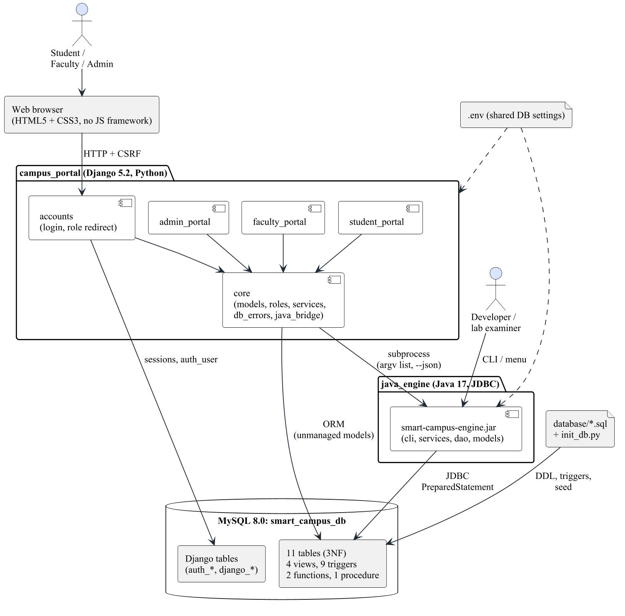
Figure 4.1: System architecture of the Smart Campus & Academic Suite

4.3 High-level design
At high level the system is divided into the modules shown in Figure 4.2. The database tier is built by three SQL scripts run in order (schema.sql, views_triggers.sql, seed_data.sql) by init_db.py. The Java engine is layered as config, models, DAO, services and CLI. The Django project has a core app (models, roles, services, bridge) and four feature apps (accounts, student_portal, faculty_portal, admin_portal).
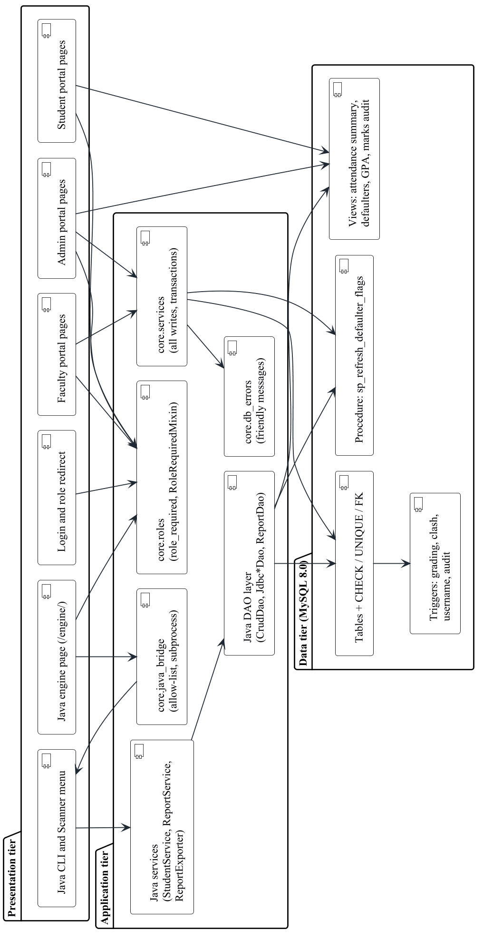
Figure 4.2: High-level design: three tiers and the modules in each (rotated to fit the page)

4.4 Low-level design
The low-level design fixes the responsibility of each package or app, the interfaces between them and the data contract of the bridge.
Table 4.1: Java engine packages
Java package | Files | Responsibility
config | 2 | DatabaseConfig reads DB_* from environment variables, then .env; ConnectionFactory opens one JDBC connection per call.
models | 15 | Abstract Person with Student and Faculty; Course, Enrollment, AttendanceRecord, Marks; records for view rows.
dao | 18 | Generic CrudDao<T, ID> and entity DAO interfaces; Jdbc*Dao implementations; JdbcDaoSupport with queryList / queryOne; ReportDao for views and procedure.
services | 5 | StudentService (profile, whois, enroll with semester rule), ReportService (defaulters, GPA, concurrent dashboard), ReportExporter (CSV).
exceptions | 8 | Checked hierarchy rooted at SmartCampusException.
cli | 11 | Argument parsing, command registry, text tables, JsonWriter, interactive menu.

Table 4.2: Django apps
Django app | Responsibility
core | Unmanaged models for 10 tables and 4 views (marks_audit is read through v_marks_audit); roles.py (role derivation and checks); services.py (all writes, transactions); db_errors.py (friendly messages); java_bridge.py and the /engine/ view; listing.py (search and pagination); Django admin.
accounts | Login, logout, password change, / role redirect, seed_demo_users command.
student_portal | /student/: own profile, attendance, marks, CGPA, warning, timetable.
faculty_portal | /faculty/: own courses, timetable, roster, attendance sheet, marks sheet.
admin_portal | /admin-portal/: dashboard, CRUD, enrollments, timetable, reports, marks audit.

Bridge contract. The portal runs java -Dfile.encoding=UTF-8 -jar smart-campus-engine.jar <command> [args] --json. On success the engine prints one line {"ok":true,"command":...,"data":...} on stdout with exit code 0; on failure it prints {"ok":false,...,"error":{"type":...,"message":...}} on stderr with exit code 1 (runtime/database error) or 2 (bad usage). The portal branches on error.type, never on the message.

4.5 UML diagrams
All UML diagrams were written as PlantUML text in docs/src/diagrams/ and rendered to PNG (see 4.5.10). Class names, methods and values match the source code and the database.

4.5.1 Use Case Diagram
Three human actors use the portal. The MySQL database appears as a system actor, because its triggers and procedure compute grades, record the audit trail, check timetable clashes and declare defaulters.
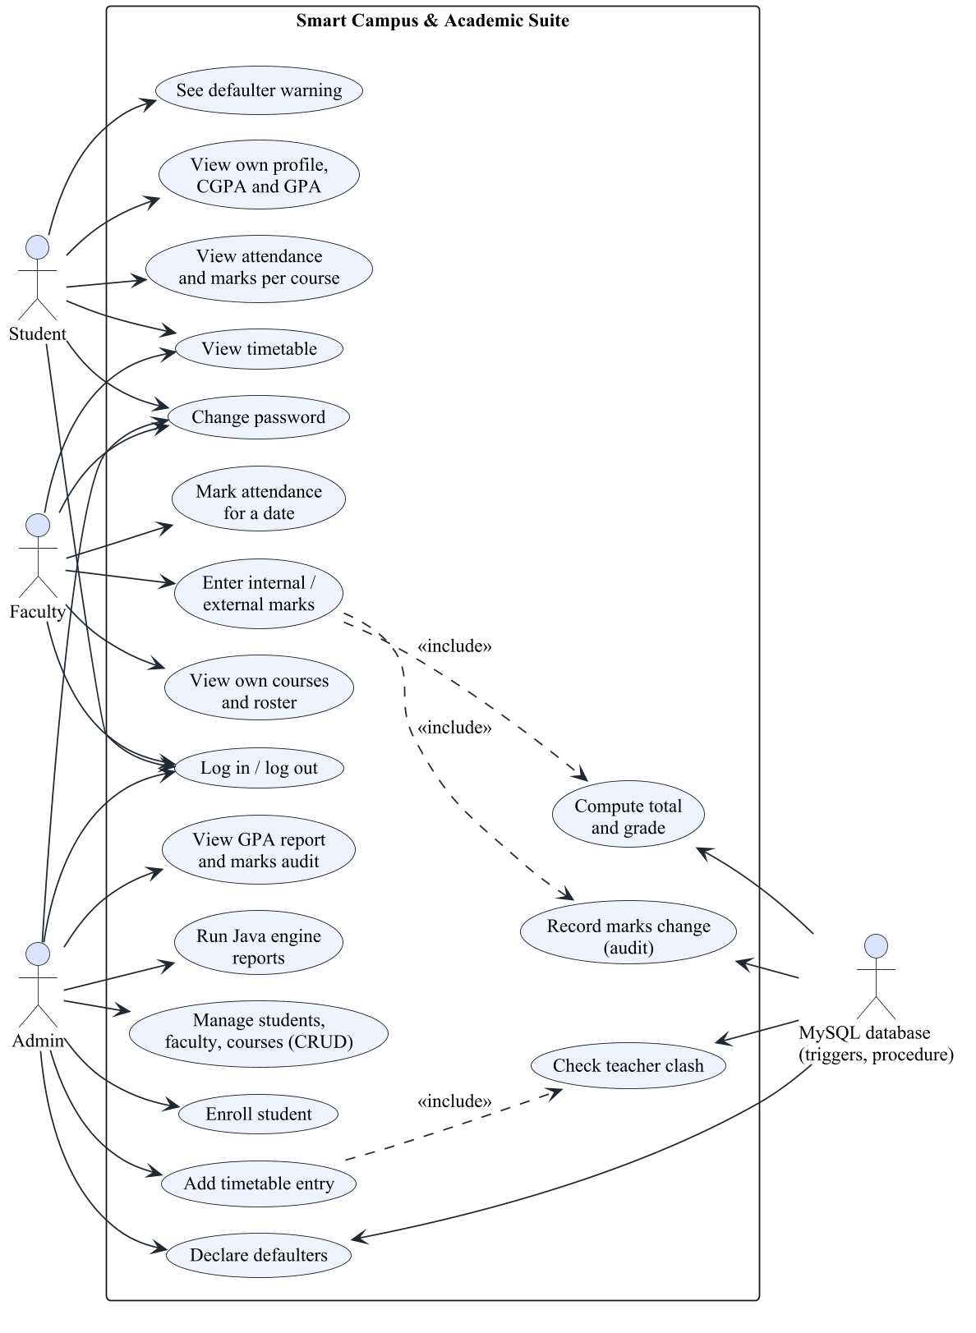
Figure 4.3: Use case diagram

4.5.2 Class Diagram
The domain model shows abstraction and inheritance (Person to Student/Faculty, with describe() overridden), encapsulation (private fields validated in constructors) and Java records for read-only view rows.
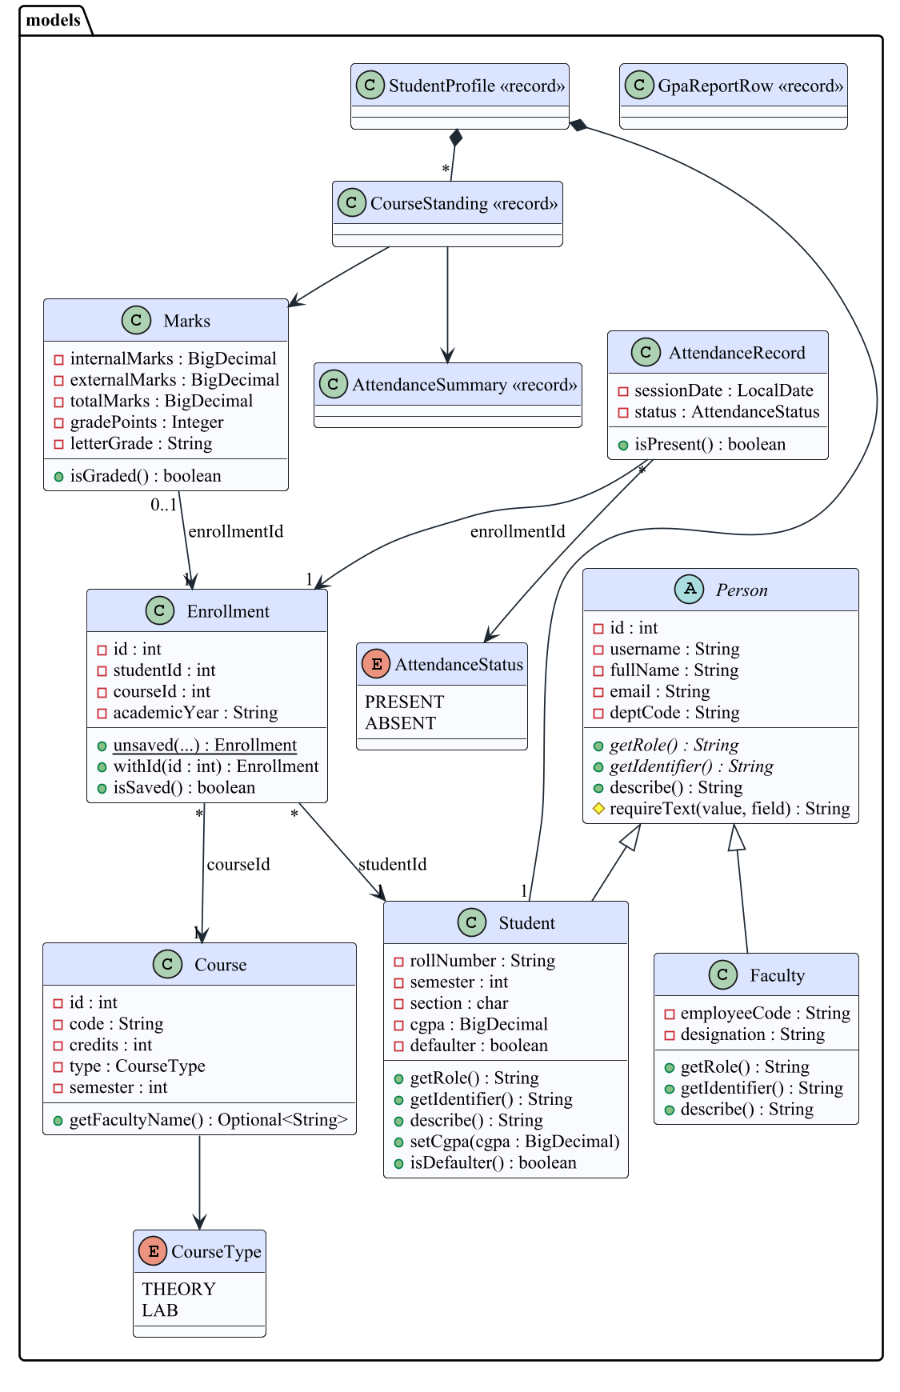
Figure 4.4: Class diagram: Java domain model (package com.smartcampus.models)
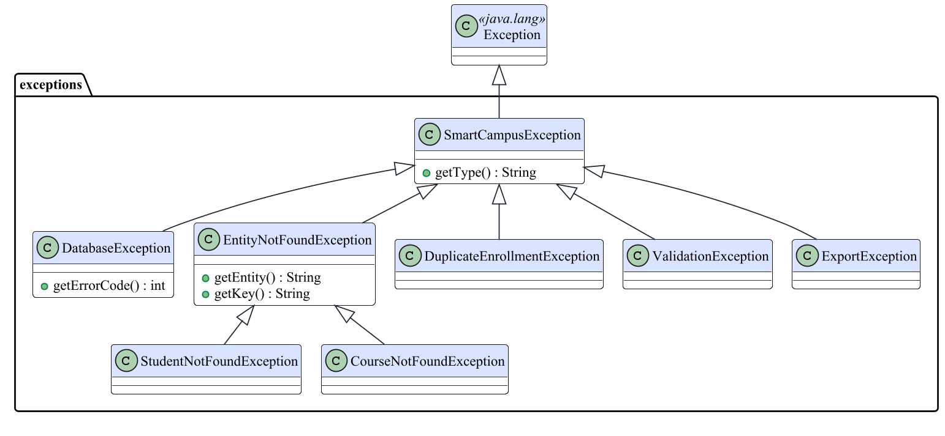
Figure 4.5: Class diagram: checked exception hierarchy (package com.smartcampus.exceptions)
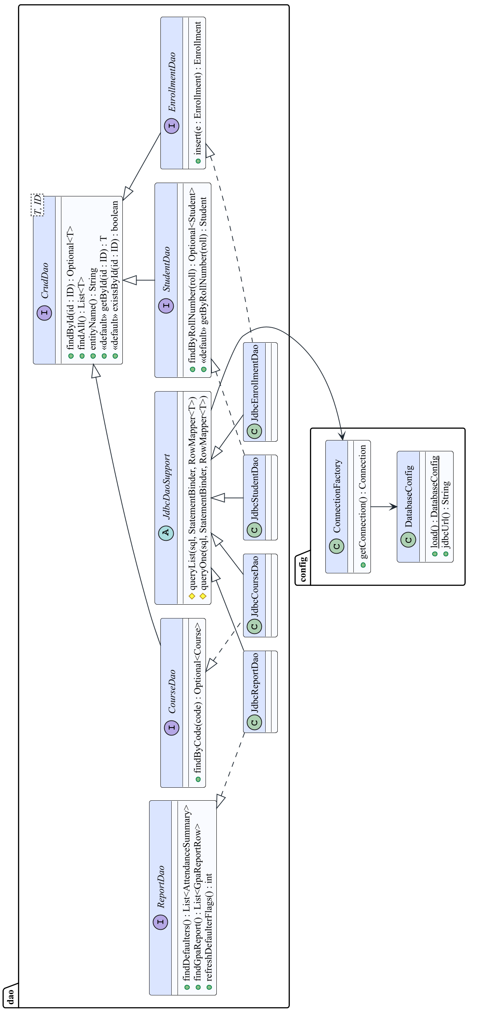
Figure 4.6: Class diagram: configuration and DAO layer of the Java engine (generic CrudDao, JDBC implementations) (rotated to fit the page)
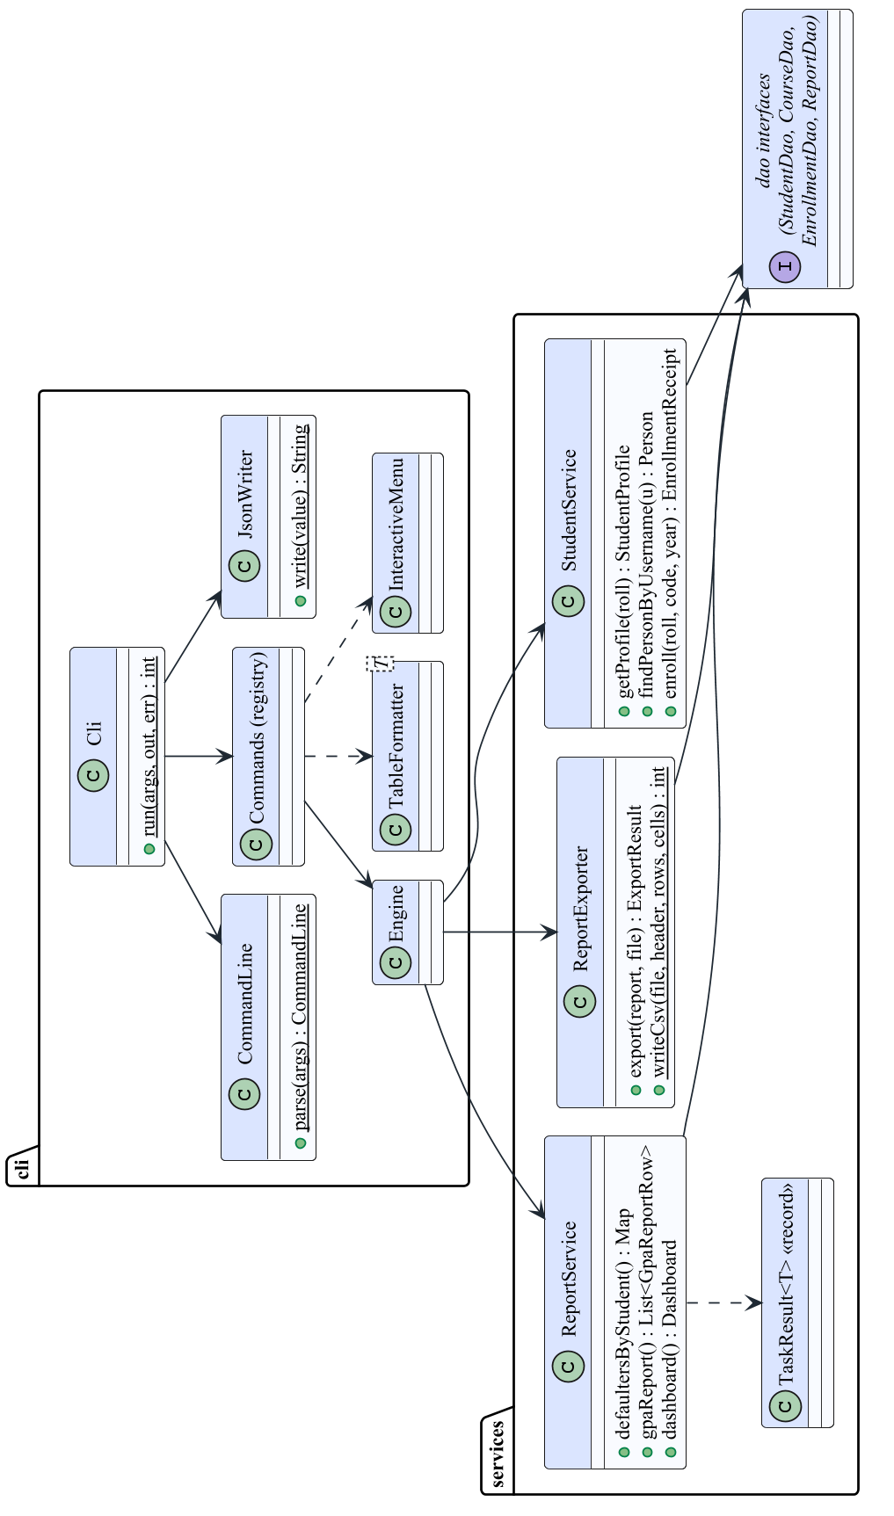
Figure 4.7: Class diagram: service and CLI layers of the Java engine (rotated to fit the page)

4.5.3 Object Diagram
The object diagram is a snapshot of real rows: defaulter 25CSE004's CS301 enrollment, its attendance summary and marks, as read from smart_campus_db.
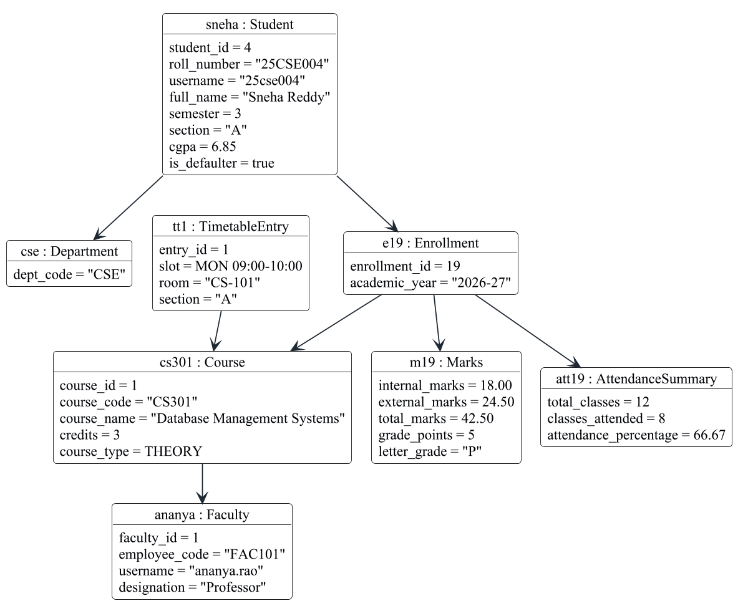
Figure 4.8: Object diagram: one defaulter's CS301 record (values read from smart_campus_db)

4.5.4 Sequence Diagram
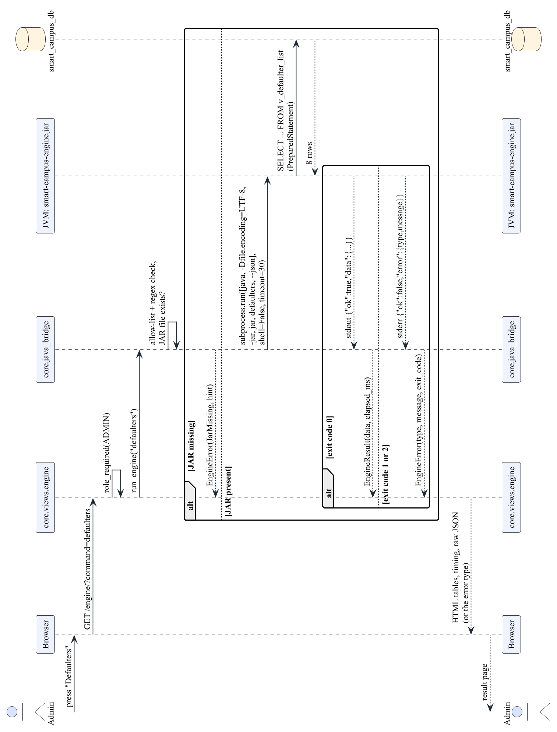
Figure 4.9: Sequence diagram: Admin runs a Java report from the portal (rotated to fit the page)
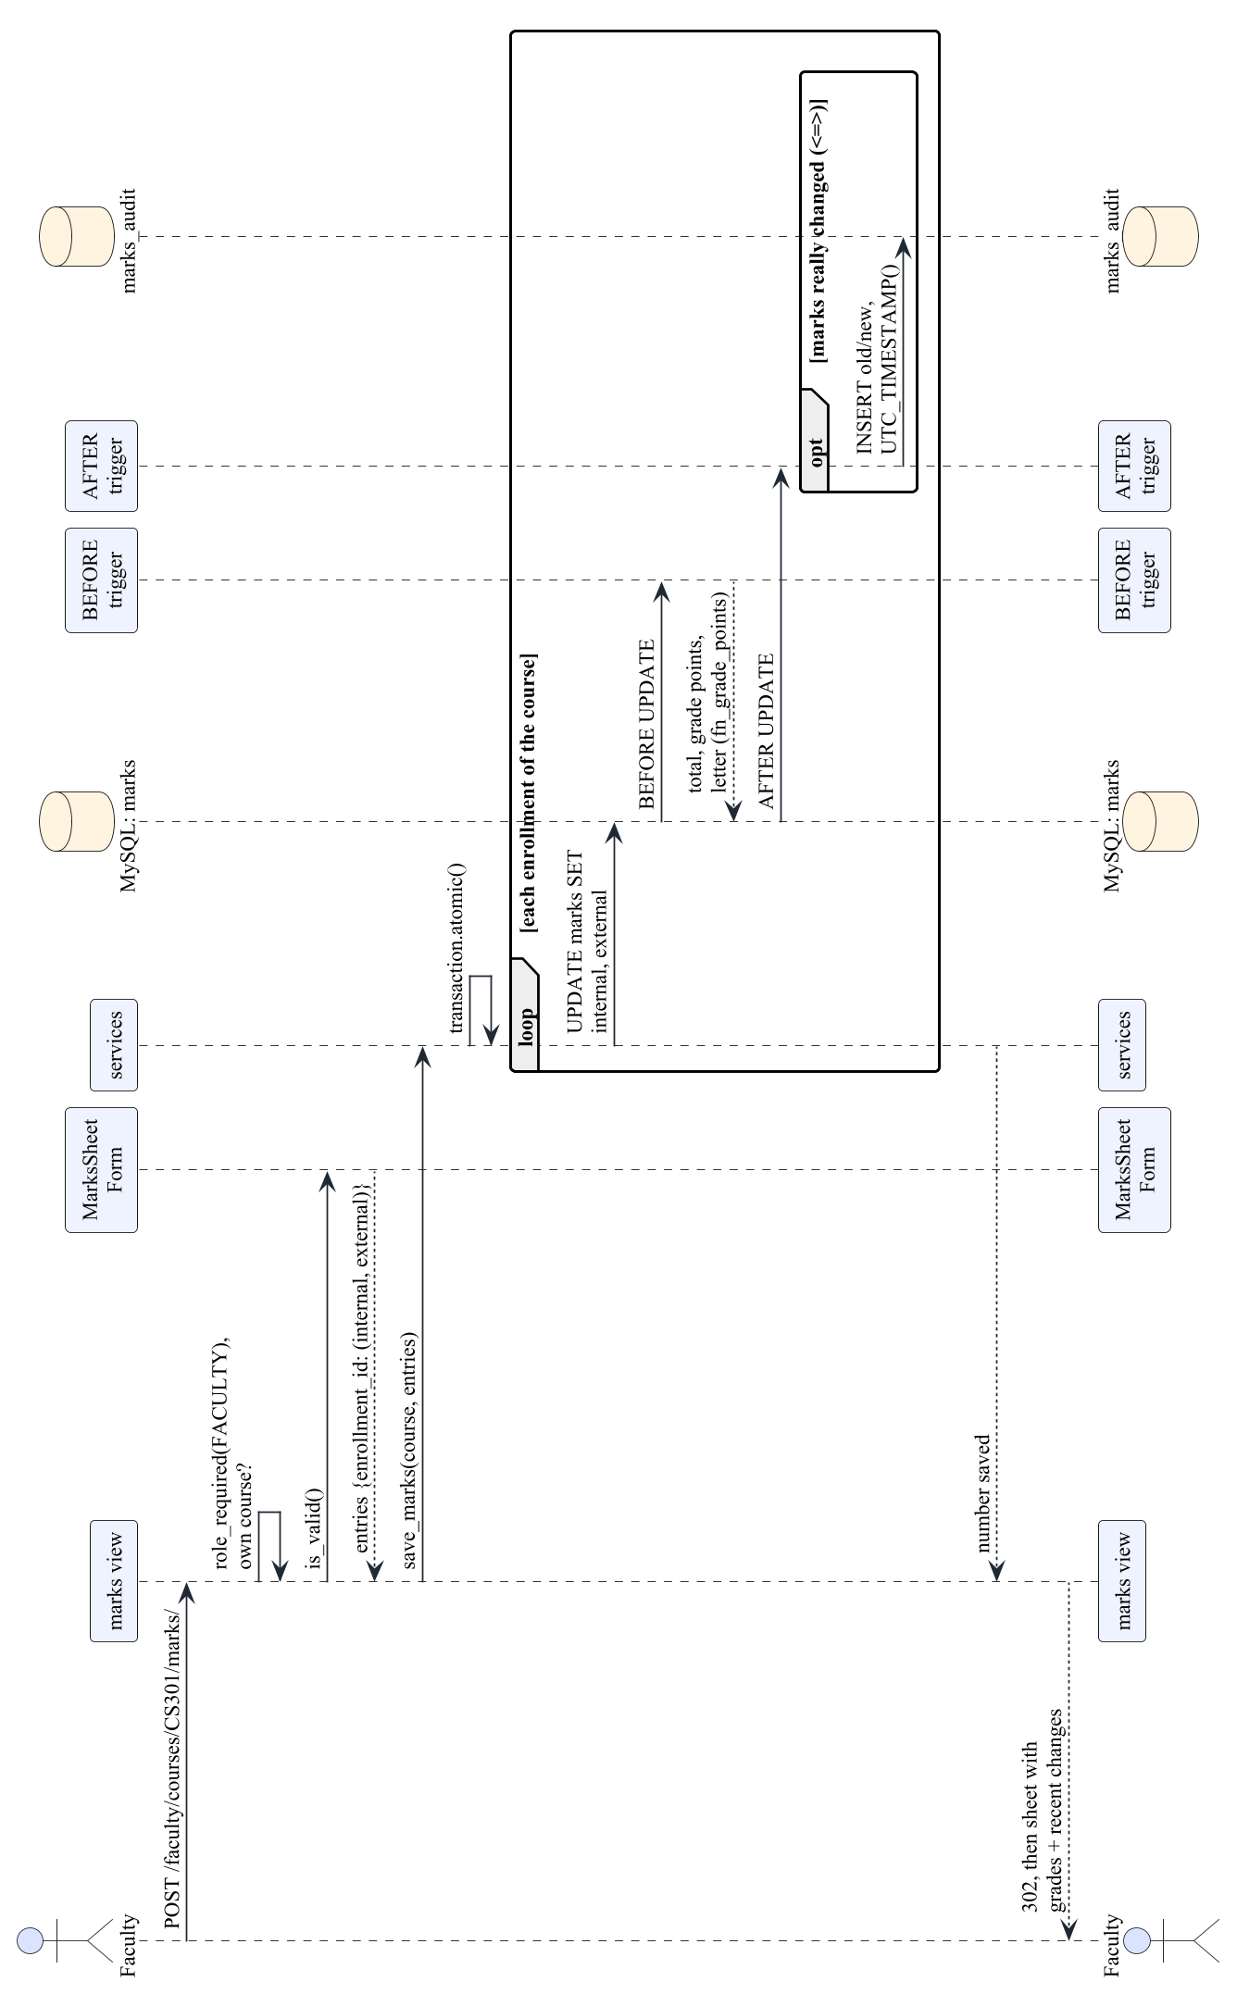
Figure 4.10: Sequence diagram: faculty saves marks; the database grades and audits them (rotated to fit the page)

4.5.5 Collaboration Diagram
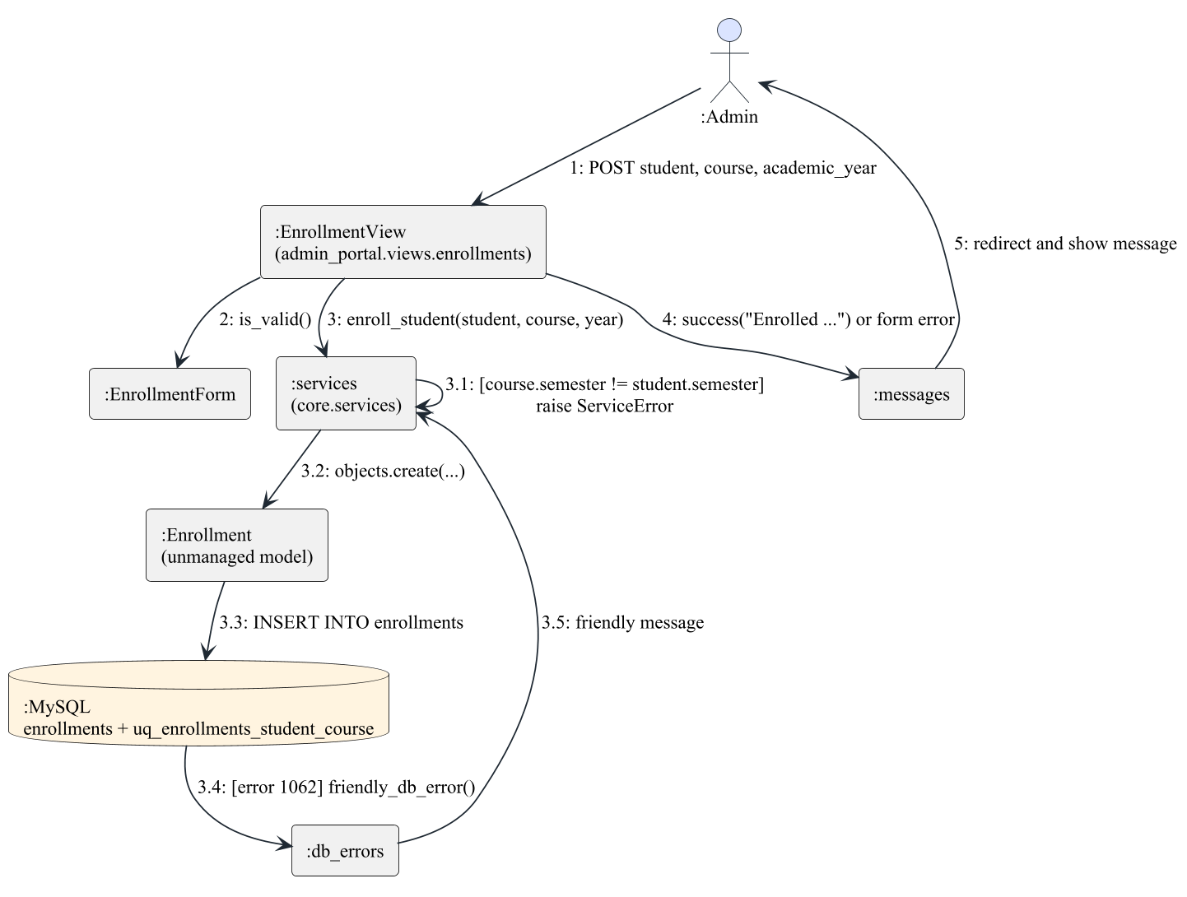
Figure 4.11: Collaboration (communication) diagram: admin enrolls a student

4.5.6 Activity Diagram
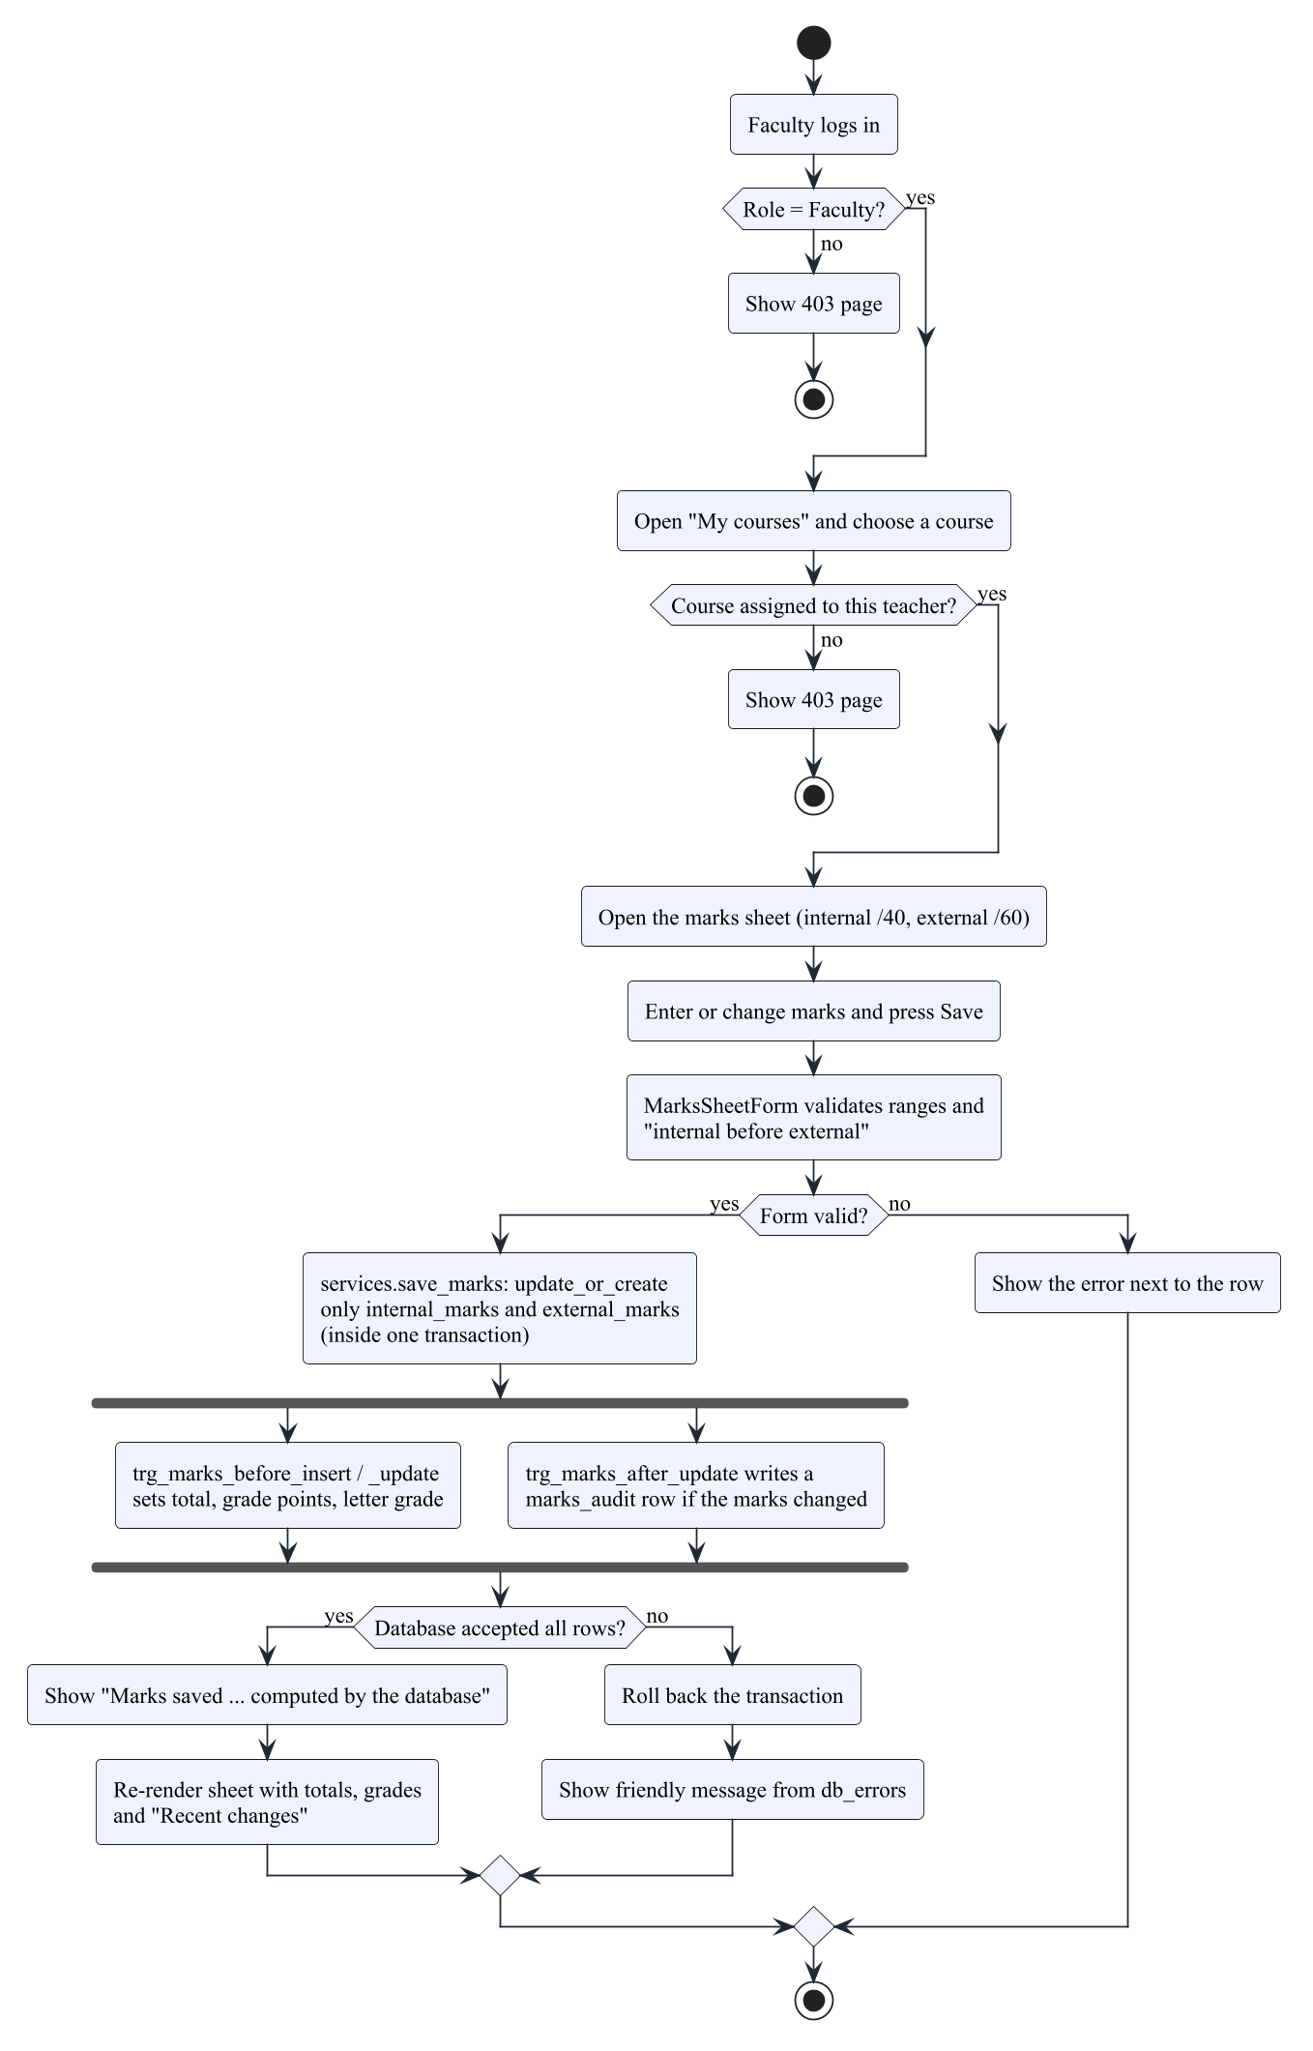
Figure 4.12: Activity diagram: faculty marks entry and grading
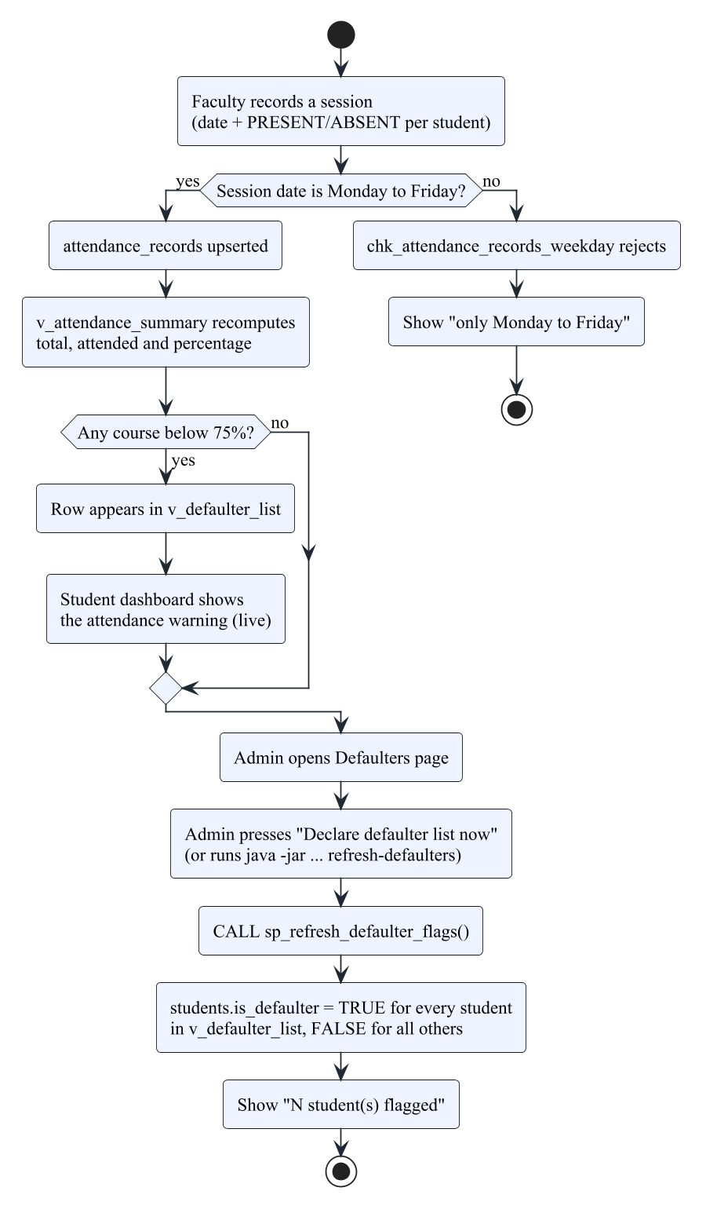
Figure 4.13: Activity diagram: from attendance to a declared defaulter

4.5.7 State Diagram
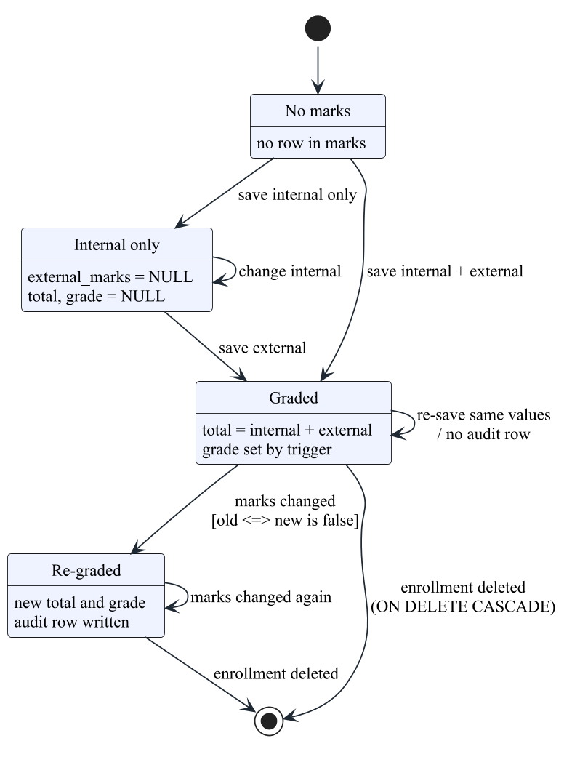
Figure 4.14: Statechart diagram: life cycle of a marks record
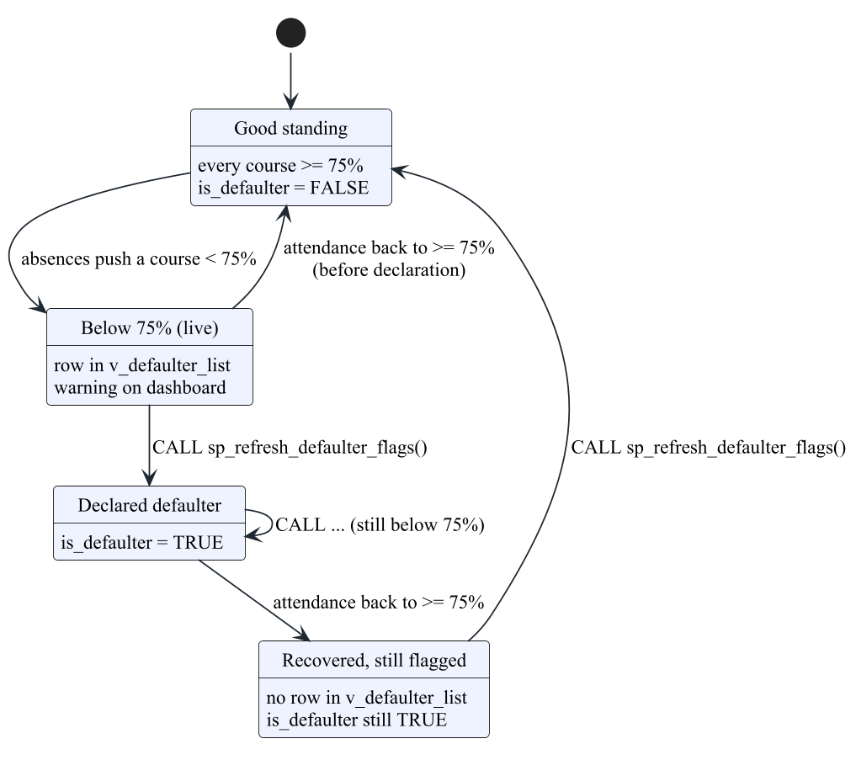
Figure 4.15: Statechart diagram: attendance status of a student

4.5.8 Component Diagram
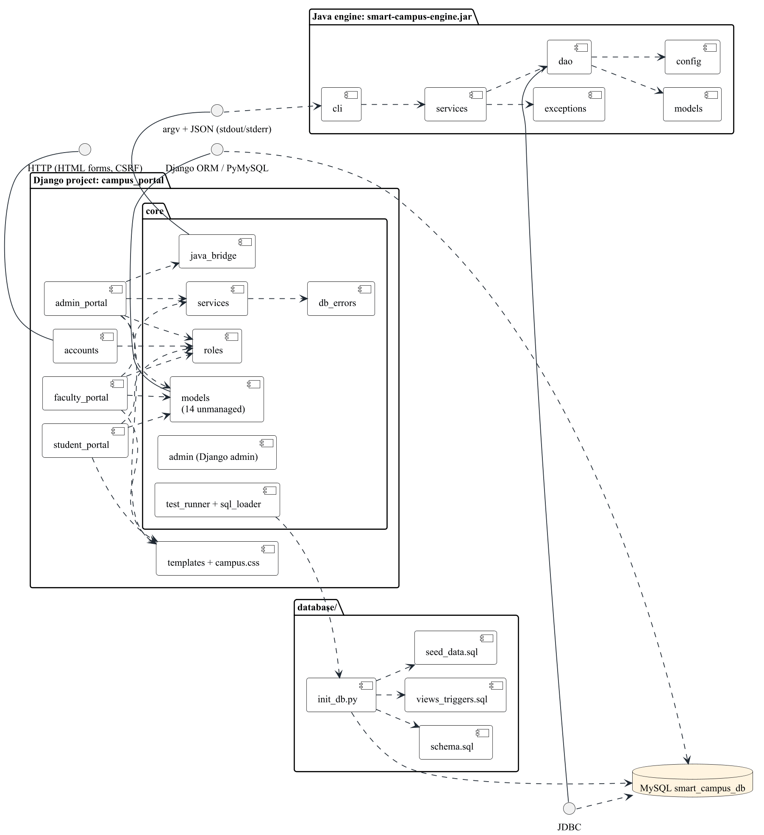
Figure 4.16: Component diagram

4.5.9 Deployment Diagram
For the lab the whole system runs on one machine: the browser, the Django development server, the JVM started per request and the MySQL server all communicate over localhost.
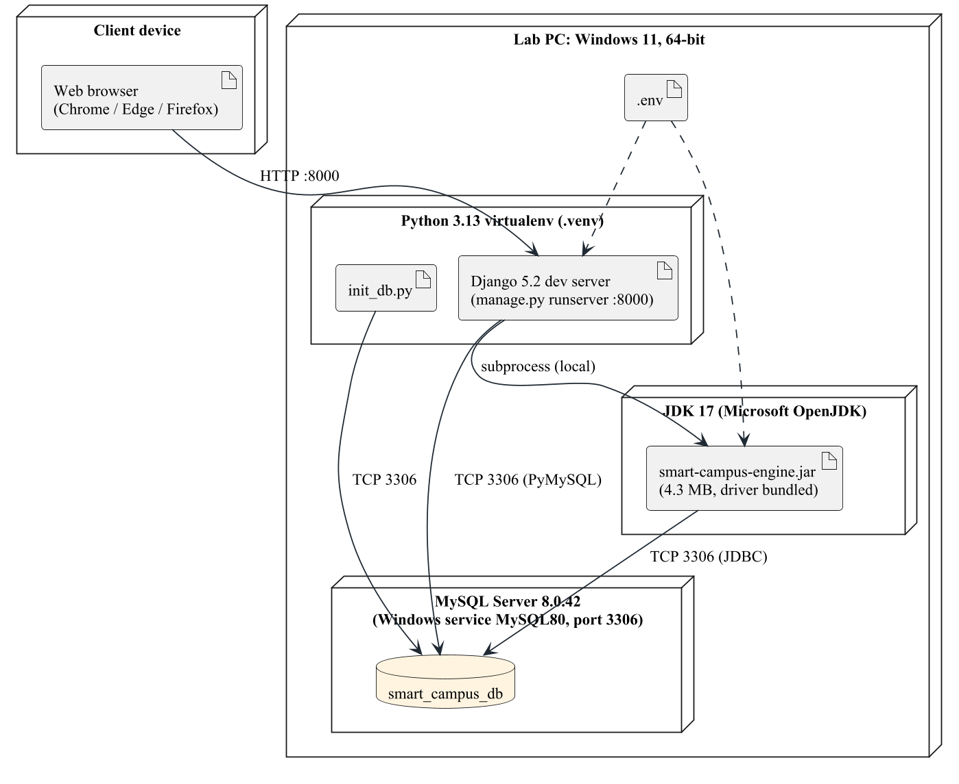
Figure 4.17: Deployment diagram (as run for this project)

4.5.10 CASE tools used
The diagrams were not drawn with StarUML or Rational Rose. They were written as plain-text PlantUML 1.2026.9 sources (docs/src/diagrams/*.puml, with a shared style file _style.iuml) and rendered to PNG at 170 dpi by docs/src/render_diagrams.py, using PlantUML's built-in Smetana layout engine so that Graphviz is not needed. The project's own design notes in docs/database_design.md and docs/django_portal.md use Mermaid, which GitHub and VS Code render directly. Text-based diagrams were chosen because they are kept in Git next to the code, show clear differences when changed, and can be regenerated with one command.
Table 4.3: CASE and support tools
Tool | Used for
PlantUML 1.2026.9 (Smetana layout) | All 21 report diagrams: UML, ERD, DFD
Mermaid (GitHub / VS Code preview) | ER, flow and sequence diagrams in docs/*.md
Visual Studio Code 1.143.1 | Editing code, SQL and diagram sources
Git 2.53.0 and GitHub | Version control (Appendix A)
Maven Wrapper, JUnit 6, JaCoCo 0.8.16 | Java build, unit tests and coverage
Django test runner, coverage.py 7.17.0 | Django tests and coverage
Playwright 1.64.1 (Chromium) | Screenshots and page timings
python-docx 1.2.0, LibreOffice 26.8.2 | Building and checking this report

4.6 Data Flow Diagrams
The data flow diagrams use the Gane-Sarson notation: external entities as rectangles, processes as numbered rounded boxes and data stores as open-ended boxes named after the real tables.
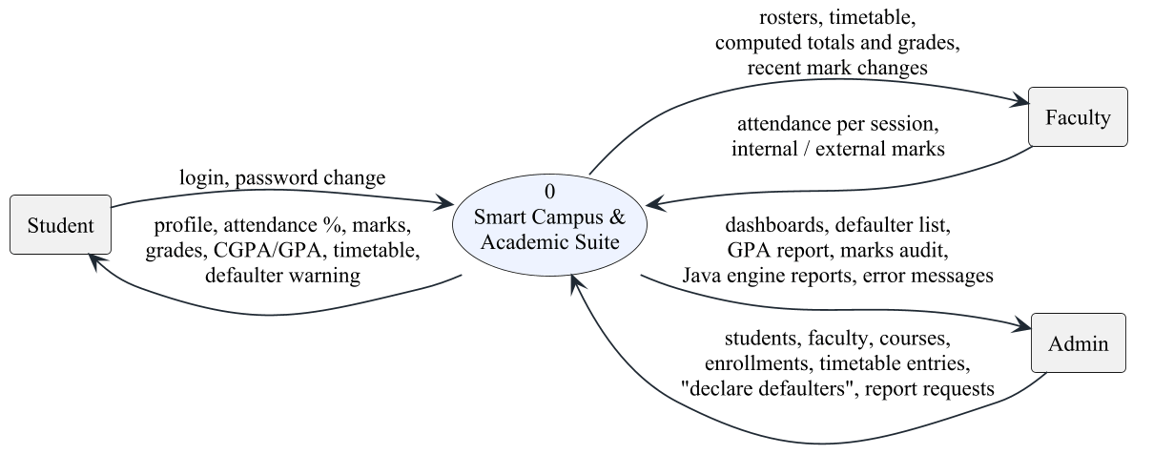
Figure 4.18: Data flow diagram, level 0 (context diagram)
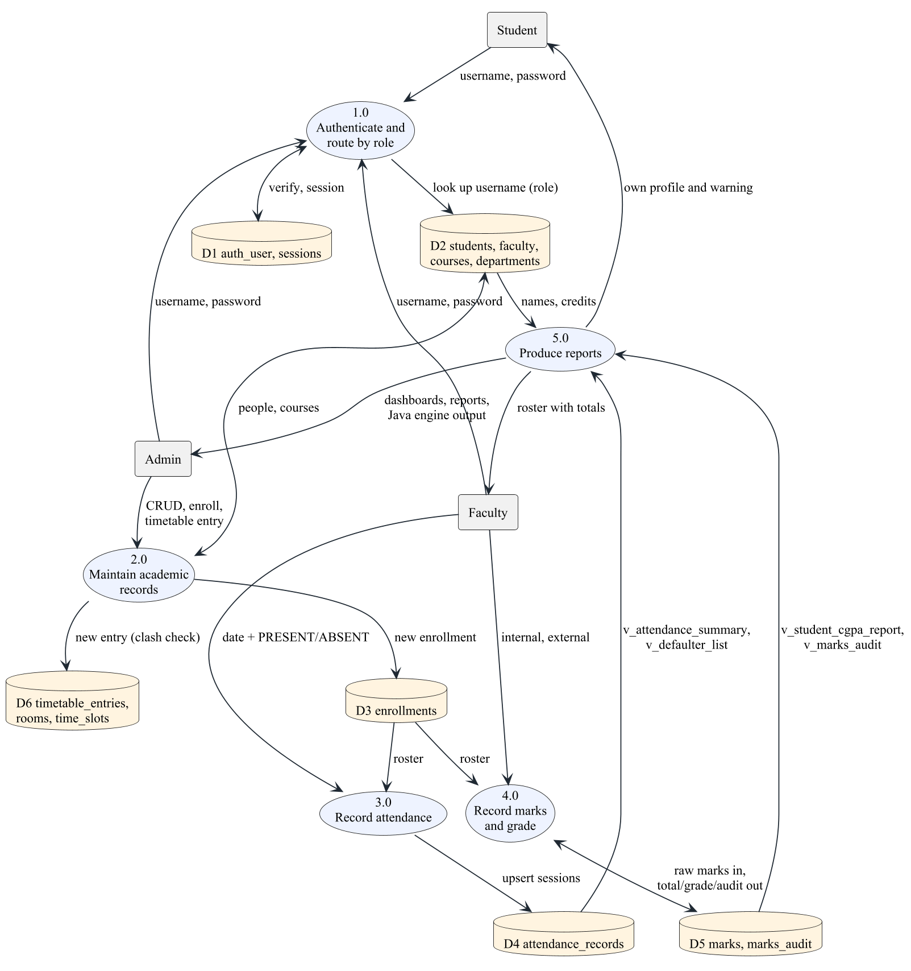
Figure 4.19: Data flow diagram, level 1
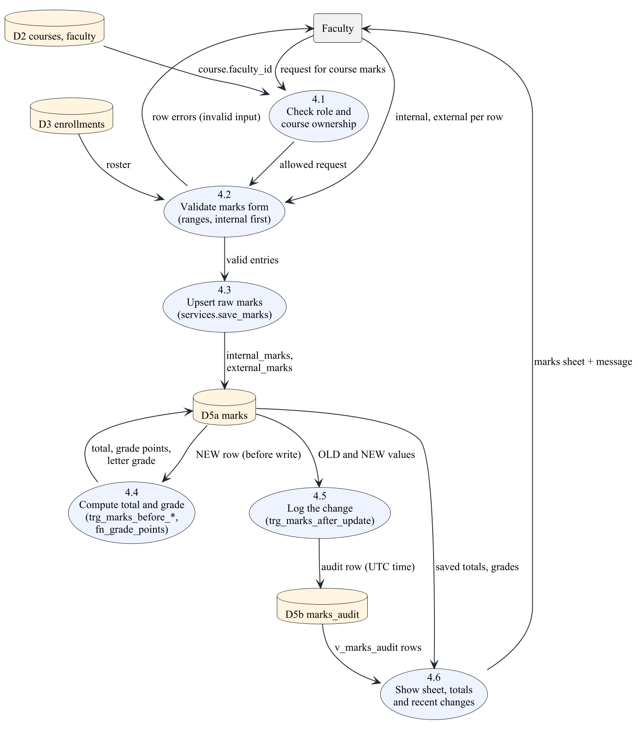
Figure 4.20: Data flow diagram, level 2: process 4.0 "Record marks and grade"

4.7 Entity Relationship Diagram (ERD)
The ERD shows the 11 domain tables with their primary keys, foreign keys and cardinalities. marks_audit deliberately has no foreign key, so the history survives when a marks row is deleted.
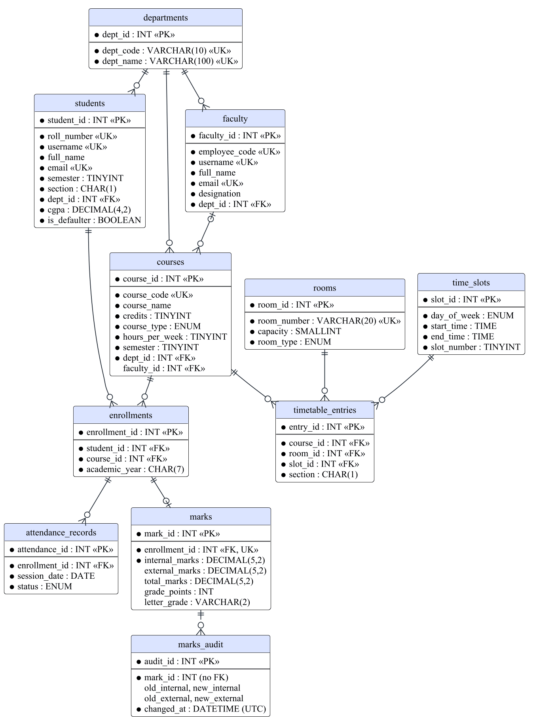
Figure 4.21: Entity relationship diagram (11 tables of smart_campus_db)

4.8 Database design
The database smart_campus_db runs on MySQL 8.0.42 with InnoDB and utf8mb4. It has 11 domain tables, 4 views, 9 triggers, 2 stored functions and 1 stored procedure, with 11 foreign keys, 17 UNIQUE constraints and 23 CHECK constraints. Every table has a single-column surrogate primary key; natural keys (roll number, course code, student + course, room + slot, slot + section) are UNIQUE constraints.
Normalisation. Every column is atomic (1NF). Every table has a single-column key, so no attribute can depend on part of a key (2NF). Non-key attributes depend only on the key: for example a student row stores dept_id, not the department name, and a course stores faculty_id, not the teacher's name (3NF). The full functional dependencies are recorded in docs/database_design.md.
Table 4.4: Main functional dependencies
Table | Key functional dependencies
students | student_id -> roll_number, username, email, full_name, semester, section, dept_id, cgpa, is_defaulter; roll_number -> student_id
courses | course_id -> course_code, course_name, credits, course_type, hours_per_week, semester, dept_id, faculty_id
enrollments | enrollment_id -> student_id, course_id, academic_year; (student_id, course_id) -> enrollment_id
attendance_records | attendance_id -> enrollment_id, session_date, status; (enrollment_id, session_date) -> attendance_id
marks | mark_id -> enrollment_id, internal_marks, external_marks; total_marks, grade_points and letter_grade are maintained by triggers (documented exception)
timetable_entries | entry_id -> course_id, room_id, slot_id, section; (room_id, slot_id) -> entry_id; (slot_id, section) -> entry_id

Derived values. Attendance percentage, defaulter status and GPA are computed in views. Three stored copies are documented exceptions: marks.total_marks / grade_points / letter_grade (kept by triggers so they can never disagree with the raw marks), students.cgpa (the official CGPA, which includes earlier semesters) and students.is_defaulter (set only when the defaulter list is declared).
Table 4.5: Triggers in smart_campus_db
Trigger | Timing | Event | Table | Purpose
trg_faculty_before_insert | BEFORE | INSERT | faculty | Username must not exist in students
trg_faculty_before_update | BEFORE | UPDATE | faculty | Same rule on update
trg_marks_after_update | AFTER | UPDATE | marks | Write old/new marks to marks_audit
trg_marks_before_insert | BEFORE | INSERT | marks | Compute total, grade points, letter grade
trg_marks_before_update | BEFORE | UPDATE | marks | Recompute total and grade
trg_prevent_timetable_faculty_clash | BEFORE | INSERT | timetable_entries | Refuse a teacher double-booking
trg_prevent_timetable_faculty_clash_update | BEFORE | UPDATE | timetable_entries | Same rule on update
trg_students_before_insert | BEFORE | INSERT | students | Username must not exist in faculty
trg_students_before_update | BEFORE | UPDATE | students | Same rule on update

Table 4.6: Views, functions and procedure
View / routine | Purpose
v_attendance_summary | Classes held, attended and percentage per enrollment
v_defaulter_list | Enrollments below 75% attendance
v_student_cgpa_report | Credit-weighted GPA of graded courses, next to the official CGPA
v_marks_audit | Audit rows joined with roll number, course and old/new grades
fn_grade_points(total) | Grade points 10/9/8/7/6/5/0 from the total
fn_letter_grade(points) | Letter grade O, A+, A, B+, B, P, F
sp_refresh_defaulter_flags() | Sets students.is_defaulter from v_defaulter_list

4.9 Database tables and attributes
The following tables were generated from MySQL's information_schema for the running database, so they match database/schema.sql exactly.
Table 4.7: Table departments
Attribute | Data type | Null | Key / notes
dept_id | int | No | PK, auto increment
dept_code | varchar(10) | No | UNIQUE
dept_name | varchar(100) | No | UNIQUE

Table 4.8: Table faculty
Attribute | Data type | Null | Key / notes
faculty_id | int | No | PK, auto increment
employee_code | varchar(20) | No | UNIQUE
username | varchar(150) | No | UNIQUE
full_name | varchar(100) | No
email | varchar(254) | No | UNIQUE
designation | varchar(50) | No
dept_id | int | No | FK -> departments (on delete restrict)

Table 4.9: Table students
Attribute | Data type | Null | Key / notes
student_id | int | No | PK, auto increment
roll_number | varchar(20) | No | UNIQUE
username | varchar(150) | No | UNIQUE
full_name | varchar(100) | No
email | varchar(254) | No | UNIQUE
semester | tinyint | No
section | char(1) | No
dept_id | int | No | FK -> departments (on delete restrict)
cgpa | decimal(4,2) | No | default 0.00
is_defaulter | tinyint(1) | No | default 0

Table 4.10: Table courses
Attribute | Data type | Null | Key / notes
course_id | int | No | PK, auto increment
course_code | varchar(10) | No | UNIQUE
course_name | varchar(100) | No
credits | tinyint | No
course_type | enum('THEORY','LAB') | No
hours_per_week | tinyint | No
semester | tinyint | No
dept_id | int | No | FK -> departments (on delete restrict)
faculty_id | int | Yes | FK -> faculty (on delete set null)

Table 4.11: Table enrollments
Attribute | Data type | Null | Key / notes
enrollment_id | int | No | PK, auto increment
student_id | int | No | FK -> students (on delete cascade)
course_id | int | No | FK -> courses (on delete restrict)
academic_year | char(7) | No

Table 4.12: Table attendance_records
Attribute | Data type | Null | Key / notes
attendance_id | int | No | PK, auto increment
enrollment_id | int | No | FK -> enrollments (on delete cascade)
session_date | date | No
status | enum('PRESENT','ABSENT') | No

Table 4.13: Table marks
Attribute | Data type | Null | Key / notes
mark_id | int | No | PK, auto increment
enrollment_id | int | No | FK -> enrollments (on delete cascade), UNIQUE
internal_marks | decimal(5,2) | No
external_marks | decimal(5,2) | Yes
total_marks | decimal(5,2) | Yes
grade_points | int | Yes
letter_grade | varchar(2) | Yes

Table 4.14: Table marks_audit
Attribute | Data type | Null | Key / notes
audit_id | int | No | PK, auto increment
mark_id | int | No
old_internal | decimal(5,2) | Yes
new_internal | decimal(5,2) | Yes
old_external | decimal(5,2) | Yes
new_external | decimal(5,2) | Yes
changed_at | datetime | No

Table 4.15: Table rooms
Attribute | Data type | Null | Key / notes
room_id | int | No | PK, auto increment
room_number | varchar(20) | No | UNIQUE
capacity | smallint | No
room_type | enum('LECTURE','LAB') | No

Table 4.16: Table time_slots
Attribute | Data type | Null | Key / notes
slot_id | int | No | PK, auto increment
day_of_week | enum('MON','TUE','WED','THU','FRI') | No
start_time | time | No
end_time | time | No
slot_number | tinyint | No

Table 4.17: Table timetable_entries
Attribute | Data type | Null | Key / notes
entry_id | int | No | PK, auto increment
course_id | int | No | FK -> courses (on delete cascade)
room_id | int | No | FK -> rooms (on delete restrict)
slot_id | int | No | FK -> time_slots (on delete restrict)
section | char(1) | No

Table 4.18: CHECK constraints
Table | CHECK constraint | Rule (as stored by MySQL)
attendance_records | chk_attendance_records_weekday | (dayofweek(session_date) between 2 and 6)
courses | chk_courses_credits | (credits between 1 and 6)
courses | chk_courses_hours | (hours_per_week between 1 and 10)
courses | chk_courses_semester | (semester between 1 and 8)
departments | chk_departments_dept_code | regexp_like(dept_code,_utf8mb4\'^[A-Z]{2,10}$\',_utf8mb4\'c\')
enrollments | chk_enrollments_academic_year | regexp_like(academic_year,_utf8mb4\'^[0-9]{4}-[0-9]{2}$\')
faculty | chk_faculty_designation | (designation in (_utf8mb4\'Professor\',_utf8mb4\'Associate Professor\',_utf8mb4\'Assistant Professor\',_utf8mb4\'Lecturer\'))
faculty | chk_faculty_email | (email like _utf8mb4\'_%@_%._%\')
faculty | chk_faculty_username | regexp_like(username,_utf8mb4\'^[A-Za-z0-9.@+_-]+$\')
marks | chk_marks_external | (external_marks between 0 and 60)
marks | chk_marks_grade_points | (grade_points in (0,5,6,7,8,9,10))
marks | chk_marks_internal | (internal_marks between 0 and 40)
marks | chk_marks_letter_grade | (letter_grade in (_utf8mb4\'O\',_utf8mb4\'A+\',_utf8mb4\'A\',_utf8mb4\'B+\',_utf8mb4\'B\',_utf8mb4\'P\',_utf8mb4\'F\'))
marks | chk_marks_total | (total_marks between 0 and 100)
rooms | chk_rooms_capacity | (capacity between 1 and 500)
students | chk_students_cgpa | (cgpa between 0.00 and 10.00)
students | chk_students_email | (email like _utf8mb4\'_%@_%._%\')
students | chk_students_section | regexp_like(section,_utf8mb4\'^[A-Z]$\',_utf8mb4\'c\')
students | chk_students_semester | (semester between 1 and 8)
students | chk_students_username | regexp_like(username,_utf8mb4\'^[A-Za-z0-9.@+_-]+$\')
time_slots | chk_time_slots_order | (end_time > start_time)
time_slots | chk_time_slots_slot_number | (slot_number between 1 and 10)
timetable_entries | chk_timetable_entries_section | regexp_like(section,_utf8mb4\'^[A-Z]$\',_utf8mb4\'c\')

4.10 Input design
All input goes through Django forms, which validate types and ranges before the database checks them again. Inputs are kept short and use choices where possible.
Table 4.19: Input forms
Form | Fields | Validation
Login | Username, password | Django authentication; error on wrong credentials
Attendance sheet | Date; Present/Absent per student | Date picker; weekday CHECK in MySQL
Marks sheet | Internal (0-40), external (0-60) per student | Decimal ranges; external needs internal; CHECK in MySQL
Student / faculty / course | All master-data fields | ModelForm; UNIQUE, CHECK and username triggers
Enrollment | Student, course, academic year | Semester match (app rule); UNIQUE key
Timetable entry | Course, slot, room, section | Clash trigger; UNIQUE (slot, room) and (slot, section)
Engine command | Command, roll number, course code | Allow-list and regex in form and bridge
Search | Free text q | ORM icontains (parameterised)

4.11 Output design
Table 4.20: Outputs of the system
Output | Shown to | Source
Attendance and marks cards, warning banner | Student | v_attendance_summary, marks, v_defaulter_list
Course roster, marks sheet with grades | Faculty | enrollments, marks (trigger-computed)
Dashboard counts and averages | Admin | tables and views
Defaulter list, GPA report, marks audit | Admin | v_defaulter_list, v_student_cgpa_report, v_marks_audit
Engine result tables and error cards | Admin | JSON from the Java engine
Text tables, JSON, CSV files | Terminal user | Java engine CLI

4.12 User interface design
The interface is written in semantic HTML5 (header, nav, main, section, table, form, label) with one hand-written stylesheet, static/css/campus.css. Colours and spacing are CSS custom properties defined once; layouts use Flexbox and Grid, and media queries stack the cards and make tables scroll at phone width. No CSS framework or JavaScript framework is used. Every role has the same header with the user's name and role, a navigation bar and a log-out button. Messages appear as coloured banners; tables show a clear "no records" row when empty. The login page is shown below; the other screens appear in Sections 5.10 and 9.3.
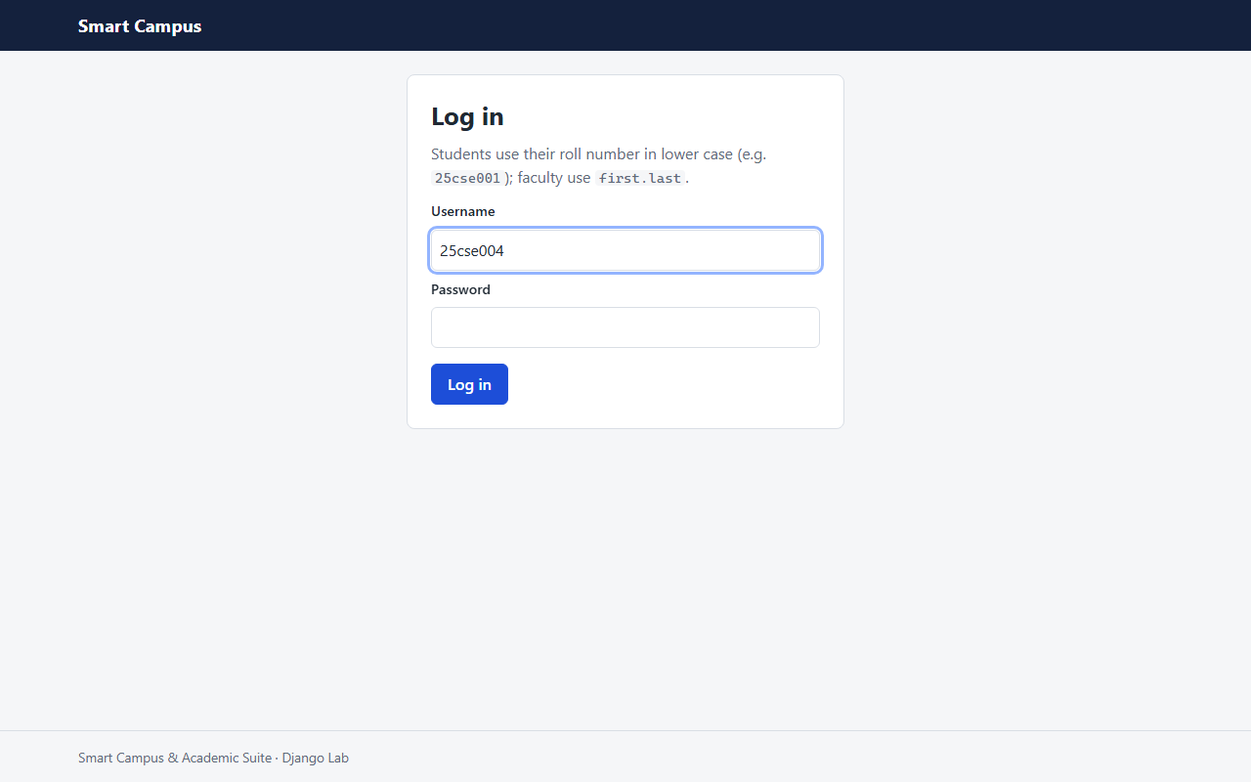
Figure 4.22: Login page

4.13 Module design
Table 4.21: Module design
Module | Inputs | Processing | Outputs
Authentication & roles | Username, password | Django auth; role derived from tables | Session, redirect
Student portal | Session | Read own rows only | Record page
Attendance | Date, statuses | update_or_create in one transaction | attendance_records
Marks & grading | Internal, external | Triggers compute grade; AFTER trigger audits | marks, marks_audit
Master data (CRUD) | Form fields | services.save_form / delete_object | Rows or friendly error
Enrollment | Student, course, year | Semester check, insert | enrollments
Timetable | Course, slot, room, section | Clash trigger + UNIQUE | timetable_entries
Reports & defaulters | None / declare button | Views; CALL procedure | Report pages, flags
Java engine | Command, args | DAO -> views/tables; concurrent dashboard | Text, JSON, CSV
Bridge | Command form | Validate, run JAR, parse JSON | Result or typed error

4.14 Security and access control design
Access control follows role-based access control [2]: permissions belong to the three roles, and a user's role is derived on every request, never stored or taken from the URL.
Table 4.22: Role and access matrix (HTTP status returned)
URL prefix | Student | Faculty | Admin | Anonymous
/student/ | 200 | 403 | 403 | 302 to login
/faculty/ (own courses only) | 403 | 200 | 403 | 302 to login
/admin-portal/ | 403 | 403 | 200 | 302 to login
/engine/ | 403 | 403 | 200 | 302 to login
/accounts/password/ | 200 | 200 | 200 | 302 to login
/django-admin/ | - | - | 200 (superuser) | login

Table 4.23: Security threats and measures
Threat | Design measure
Unauthorised page access | @role_required / RoleRequiredMixin on every view; a test walks the whole URL configuration
Reading another person's data | Person found from the login (get_person); no ids from the URL; faculty course pages check the teacher
SQL injection | Django ORM and Java PreparedStatement only
Cross-site scripting | Django template auto-escaping
Cross-site request forgery | CSRF token on every POST form; logout is POST only
Command injection via the bridge | Argument list, shell=False, allow-list of 6 commands, regex per argument, 30 s timeout
Credential leaks | Credentials only in git-ignored .env; hashed passwords; demo password refused when DEBUG is off
Session theft | HttpOnly cookies, SameSite=Lax; secure cookies and HSTS when DJANGO_HTTPS=True
Silent marks tampering | AFTER UPDATE trigger records every change in marks_audit

CHAPTER 5: SYSTEM DEVELOPMENT AND IMPLEMENTATION

5.1 Introduction
This chapter describes how the design of Chapter 4 was implemented: the development environment, the technologies, the database implementation, each module, the main algorithms and real code from the repository, followed by screenshots of the running system. The source code is version-controlled with Git; configuration management is described in Appendix A.

5.2 Development environment
Table 5.1: Development environment
Item | Details
Processor | AMD Ryzen 5 3550H (4 cores, 8 threads)
Memory | 13.9 GB usable RAM
Operating system | Windows 11 Home Single Language, 64-bit, build 26200
Editor / IDE | Visual Studio Code 1.143.1
Version control | Git 2.53.0 with a GitHub remote
Database server | MySQL Community Server 8.0.42
Java | OpenJDK 17.0.20.1 (LTS); build with 3.9.16 (Maven Wrapper)
Python | 3.13.3 in a virtual environment (.venv)
Shell | Windows PowerShell 5.1 and Git Bash

5.3 Technologies used
Table 5.2: Technologies
Layer | Technology | Why it was chosen
Database | MySQL 8.0 (InnoDB, utf8mb4) | CHECK constraints, triggers, views, stored routines and transactions; required by the DBMS lab
Engine | Java 17 + JDBC | Core OOP and raw JDBC are what the Java lab assesses; LTS release
Web | Django 5.2 LTS (MVT) | Built-in authentication, forms, CSRF, ORM and admin; LTS until 2028
Front end | HTML5 + CSS3 (no framework) | Semantic markup and hand-written responsive CSS
Integration | subprocess + JSON | Language-neutral contract between Django and the JAR
Documentation | Markdown, Mermaid, PlantUML | Text sources versioned with the code

5.4 Programming languages
Table 5.3: Source size by language (counted from the repository)
Language / file type | Files | Lines
SQL (database/*.sql) | 4 | 833
Python: database/init_db.py | 1 | 243
Java (main) | 60 | 2846
Java (tests) | 5 | 282
Python: Django (excluding tests) | 44 | 1564
Python: Django tests | 6 | 572
HTML templates | 26 | 830
CSS | 1 | 155

5.5 Frameworks and libraries
Table 5.4: Frameworks and libraries
Name | Version | Purpose
Django | 5.2.18 | Web framework (portal)
PyMySQL | 1.2.3 | Pure-Python MySQL driver, installed as MySQLdb
python-dotenv | 1.2.4 | Loads the shared .env file
cryptography | 50.0.2 | MySQL 8 caching_sha2_password authentication
MySQL Connector/J | 9.7.0 | JDBC driver for the Java engine
JUnit Jupiter | 6.1.3 | Java unit tests
maven-shade-plugin | 3.6.2 | Builds the runnable fat JAR

5.6 Database implementation
The database is created by three re-runnable scripts executed in order by database/init_db.py, which reads the credentials from .env, splits the scripts (it understands DELIMITER, quotes and comments) and prints the row counts:
• schema.sql: CREATE DATABASE, then DROP TABLE IF EXISTS and CREATE TABLE for the 11 tables with named PK, FK, UNIQUE and CHECK constraints.
• views_triggers.sql: 2 functions, 4 views, 9 triggers and 1 procedure (each dropped and re-created).
• seed_data.sql: demo data: 2 departments, 5 faculty, 10 students, 6 courses, 5 rooms, 20 time slots, 20 timetable entries, 60 enrollments, 720 attendance records and 60 marks rows.
• queries.sql: lab demonstration queries (joins, subqueries, window functions, transactions); not run by init_db.py.
Django's own tables (auth_*, django_*) are created by manage.py migrate in the same database; init_db.py never touches them, so logins survive a rebuild.

5.7 Module-wise implementation

5.7.1 Authentication and roles
accounts uses Django's login view. core/roles.py derives the role (superuser, else a students.username match, else a faculty.username match) and caches the person per request. role_required and RoleRequiredMixin guard every view.

5.7.2 Student portal
student_portal/views.py loads the student from the login, then reads v_attendance_summary, the marks, v_student_cgpa_report and the timetable for that student only. The warning banner appears when the student has rows in v_defaulter_list.

5.7.3 Faculty portal
Course pages check that course.faculty is the logged-in teacher. The attendance sheet and marks sheet are formsets; saving calls services.save_attendance or services.save_marks, which write only the raw columns inside one transaction.

5.7.4 Admin portal
Class-based list, create, update and delete views for students, faculty and courses with search and pagination; enrollment and timetable forms; reports that read the views; the "declare" button calls the stored procedure; the marks audit page reads v_marks_audit.

5.7.5 Java engine
Main delegates to cli.Cli, which parses the arguments, looks the command up in the registry and calls a service. Services depend on DAO interfaces; cli.Engine wires the JDBC implementations. Output goes through a text renderer or JsonWriter.

5.7.6 Django to Java bridge
core/java_bridge.py validates the command against an allow-list, builds the argument list, checks that the JAR exists, runs it with a timeout and parses the single JSON line. The /engine/ view renders the result or a typed error card.

5.7.7 Team contributions
The system was designed, implemented, tested and documented jointly by the four members of the project team; the work is held in one repository (Appendix A).
Table 5.5: Project team
S.No | Name | Roll number
1 | V. Sai Rishi | 25911A67B7
2 | Mummadisetty Advyth | 25911A67A3
3 | P.V.S Sebareesh | 25911A67C4
4 | K. Bharath Reddy | 25911A6784

5.8 Algorithm or pseudocode

5.8.1 Grading (database trigger)
BEFORE INSERT/UPDATE ON marks:
IF internal IS NULL OR external IS NULL THEN total, points, letter := NULL
ELSE total := internal + external
points := fn_grade_points(total) -- >=90:10, >=80:9, >=70:8, >=60:7, >=50:6, >=40:5, else 0
letter := fn_letter_grade(points) -- O, A+, A, B+, B, P, F
AFTER UPDATE ON marks:
IF NOT (old.internal <=> new.internal AND old.external <=> new.external) THEN
INSERT INTO marks_audit(old/new internal, old/new external, changed_at = UTC_TIMESTAMP())

5.8.2 Defaulter detection and declaration
v_attendance_summary: for each enrollment
held := COUNT(records); attended := COUNT(status = 'PRESENT')
percentage := ROUND(100 * attended / held, 2) (NULL when no classes held)
v_defaulter_list := rows of v_attendance_summary with percentage < 75
sp_refresh_defaulter_flags():
UPDATE students SET is_defaulter = (student_id IN v_defaulter_list)

5.8.3 Role check on every request
role_required(roles)(view):
if user not authenticated: redirect to login with ?next=
role := superuser ? ADMIN : (username in students ? STUDENT : (username in faculty ? FACULTY : NONE))
if role not in roles: raise PermissionDenied -> 403 page
return view(request)

5.8.4 Bridge call
run_engine(command, args):
if command not in ALLOWED or any arg fails its regex: raise EngineError(NotAllowed/BadArgument)
if JAR file missing: raise EngineError(JarMissing)
proc := subprocess.run([java, -Dfile.encoding=UTF-8, -jar, JAR, command, args..., --json],
shell=False, timeout=30)
if exit code 0: return data from the JSON line on stdout
else: raise EngineError(error.type from the JSON line on stderr)

5.9 Important code snippets
The snippets below are copied from the repository without changes.

5.9.1 Grade points function (database/views_triggers.sql)
CREATE FUNCTION fn_grade_points(p_total DECIMAL(5, 2))
RETURNS INT
DETERMINISTIC
NO SQL
BEGIN
RETURN CASE
WHEN p_total IS NULL THEN NULL
WHEN p_total >= 90 THEN 10
WHEN p_total >= 80 THEN 9
WHEN p_total >= 70 THEN 8
WHEN p_total >= 60 THEN 7
WHEN p_total >= 50 THEN 6
WHEN p_total >= 40 THEN 5
ELSE 0
END;
END$$

5.9.2 Timetable clash trigger (database/views_triggers.sql)
CREATE TRIGGER trg_prevent_timetable_faculty_clash
BEFORE INSERT ON timetable_entries
FOR EACH ROW
BEGIN
DECLARE v_faculty_id INT;
DECLARE v_clash_course VARCHAR(10);
DECLARE v_msg VARCHAR(255);

SET v_faculty_id = (SELECT faculty_id FROM courses WHERE course_id = NEW.course_id);

IF v_faculty_id IS NOT NULL THEN
SET v_clash_course = (
SELECT c.course_code
FROM timetable_entries te
JOIN courses c ON c.course_id = te.course_id
WHERE te.slot_id = NEW.slot_id
AND c.faculty_id = v_faculty_id
LIMIT 1);

IF v_clash_course IS NOT NULL THEN
SET v_msg = CONCAT('Timetable clash: faculty_id ', v_faculty_id,
' already teaches ', v_clash_course,
' in slot_id ', NEW.slot_id);
SIGNAL SQLSTATE '45000' SET MESSAGE_TEXT = v_msg;
END IF;
END IF;
END$$

5.9.3 Declaring defaulters (database/views_triggers.sql)
CREATE PROCEDURE sp_refresh_defaulter_flags()
BEGIN
UPDATE students s
LEFT JOIN (SELECT DISTINCT student_id FROM v_defaulter_list) d
ON d.student_id = s.student_id
SET s.is_defaulter = (d.student_id IS NOT NULL)
WHERE s.student_id > 0;
END$$

5.9.4 Role check decorator (campus_portal/core/roles.py)
def role_required(*roles):
"""
View decorator: anonymous users go to the login page, logged-in users with another role get
a 403 page (templates/403.html), never a crash.

@role_required(STUDENT)
def dashboard(request): ...
"""
def decorator(view):
@wraps(view)
def wrapper(request, *args, **kwargs):
if not request.user.is_authenticated:
return redirect_to_login(request.get_full_path())
if get_role(request.user) not in roles:
raise PermissionDenied("This page is for: " + ", ".join(ROLE_LABELS[r] for r in roles))
return view(request, *args, **kwargs)
return wrapper
return decorator

5.9.5 Saving marks (campus_portal/core/services.py)
def save_marks(course, entries):
"""
Saves internal/external marks. ``entries`` maps enrollment_id -> (internal, external or None).
Only the two raw columns are written: trg_marks_before_insert/update compute total_marks,
grade_points and letter_grade, so Python never does.
"""
valid_ids = set(course.enrollments.values_list("enrollment_id", flat=True))
saved = 0
with db_write():
for enrollment_id, (internal, external) in entries.items():
if enrollment_id in valid_ids:
Marks.objects.update_or_create(
enrollment_id=enrollment_id,
defaults={"internal_marks": internal, "external_marks": external})
saved += 1
return saved

5.9.6 Running the engine (campus_portal/core/java_bridge.py)
def run_engine(command, *args, year=None):
"""Runs one allowed command and returns its parsed ``data``; raises EngineError on failure."""
argv = build_command(command, args, year)
jar = Path(settings.JAVA_ENGINE_JAR)
if not jar.is_file():
raise EngineError("JarMissing", f"The engine JAR was not found at {jar}.", hint=BUILD_HINT)

started = time.monotonic()
try:
proc = subprocess.run(
argv,
capture_output=True,
text=True,
encoding="utf-8",
errors="replace",
timeout=settings.JAVA_ENGINE_TIMEOUT,
cwd=settings.REPO_ROOT,
shell=False,
check=False,
)
except FileNotFoundError:
raise EngineError("JavaMissing", f"Java was not found (tried '{settings.JAVA_BIN}').",
hint="Install JDK 17+ or set DJANGO_JAVA_BIN in .env.") from None
except subprocess.TimeoutExpired:
raise EngineError("Timeout", f"The engine did not answer within {settings.JAVA_ENGINE_TIMEOUT} s.",
hint="Check that MySQL is running.") from None
elapsed_ms = int((time.monotonic() - started) * 1000)

if proc.returncode == 0:
document = _parse(proc.stdout)
if not document or document.get("ok") is not True or "data" not in document:
raise EngineError("BadOutput", "The engine exited successfully but did not print a JSON result.",
exit_code=0)
return EngineResult(command=document.get("command", command), data=document["data"], elapsed_ms=elapsed_ms)

document = _parse(proc.stderr)
error = document.get("error") if isinstance(document, dict) else None
if isinstance(error, dict) and "type" in error:
raise EngineError(error["type"], error.get("message", ""), exit_code=proc.returncode)
raw = (proc.stderr or proc.stdout or "").strip()
raise EngineError("Internal", raw[:500] or f"The engine failed with exit code {proc.returncode}.",
exit_code=proc.returncode)

5.9.7 Concurrent dashboard (java_engine/.../services/ReportService.java)
public Dashboard dashboard() throws DatabaseException {
AtomicInteger threadNumber = new AtomicInteger(1);
ExecutorService pool = Executors.newFixedThreadPool(3, runnable -> {
Thread thread = new Thread(runnable, "report-worker-" + threadNumber.getAndIncrement());
thread.setDaemon(true);
return thread;
});
long start = System.nanoTime();
try {
CompletableFuture<TaskResult<List<AttendanceSummary>>> attendance =
CompletableFuture.supplyAsync(() -> timed(reports::findAllAttendance), pool);
CompletableFuture<TaskResult<List<AttendanceSummary>>> defaulters =
CompletableFuture.supplyAsync(() -> timed(reports::findDefaulters), pool);
CompletableFuture<TaskResult<List<GpaReportRow>>> gpa =
CompletableFuture.supplyAsync(() -> timed(reports::findGpaReport), pool);

CompletableFuture.allOf(attendance, defaulters, gpa).join();
long wallClock = (System.nanoTime() - start) / 1_000_000;
return summarise(attendance.join(), defaulters.join(), gpa.join(), wallClock);
} catch (CompletionException e) {
if (e.getCause() instanceof DatabaseException db) {
throw db;
}
throw e;
} finally {
pool.shutdown();
}
}

5.9.8 Transaction in JDBC (java_engine/.../dao/JdbcReportDao.java)
public int refreshDefaulterFlags() throws DatabaseException {
try (Connection conn = openConnection()) {
conn.setAutoCommit(false);
try (CallableStatement call = conn.prepareCall(REFRESH_DEFAULTERS);
PreparedStatement count = conn.prepareStatement(COUNT_DEFAULTERS)) {
call.execute();
int flagged;
try (ResultSet rs = count.executeQuery()) {
rs.next();
flagged = rs.getInt(1);
}
conn.commit();
return flagged;
} catch (SQLException e) {
conn.rollback();
throw e;
}
} catch (SQLException e) {
throw new DatabaseException("Could not refresh defaulter flags", e);
}
}

5.10 Implementation screenshots
The screenshots were captured with Playwright (Chromium, 1280 px wide) from the running development server, logged in as each demo role. No password or .env content is visible.
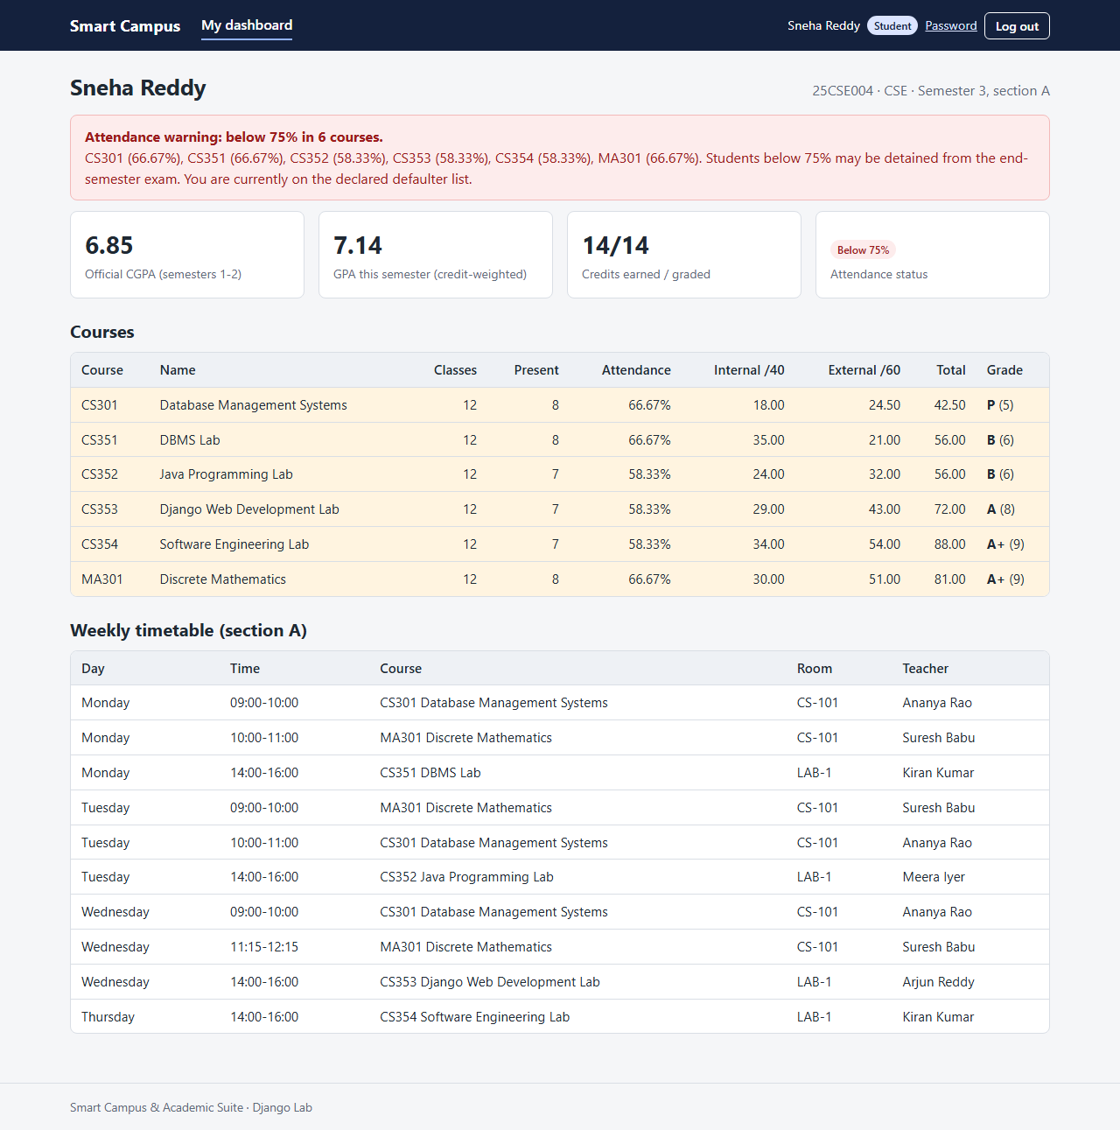
Figure 5.1: Student dashboard of a defaulter (25cse004) with the 75% warning
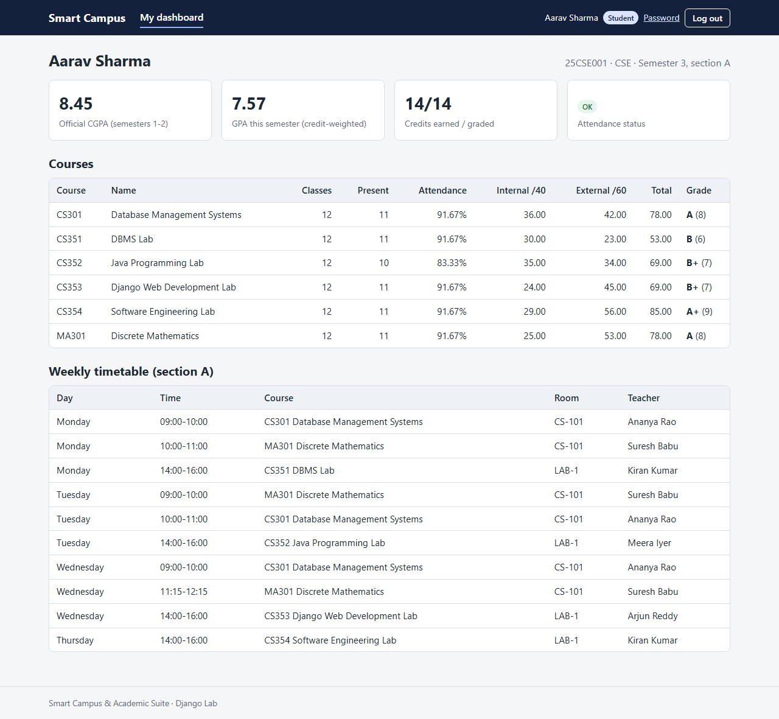
Figure 5.2: Student dashboard of a student in good standing (25cse001)
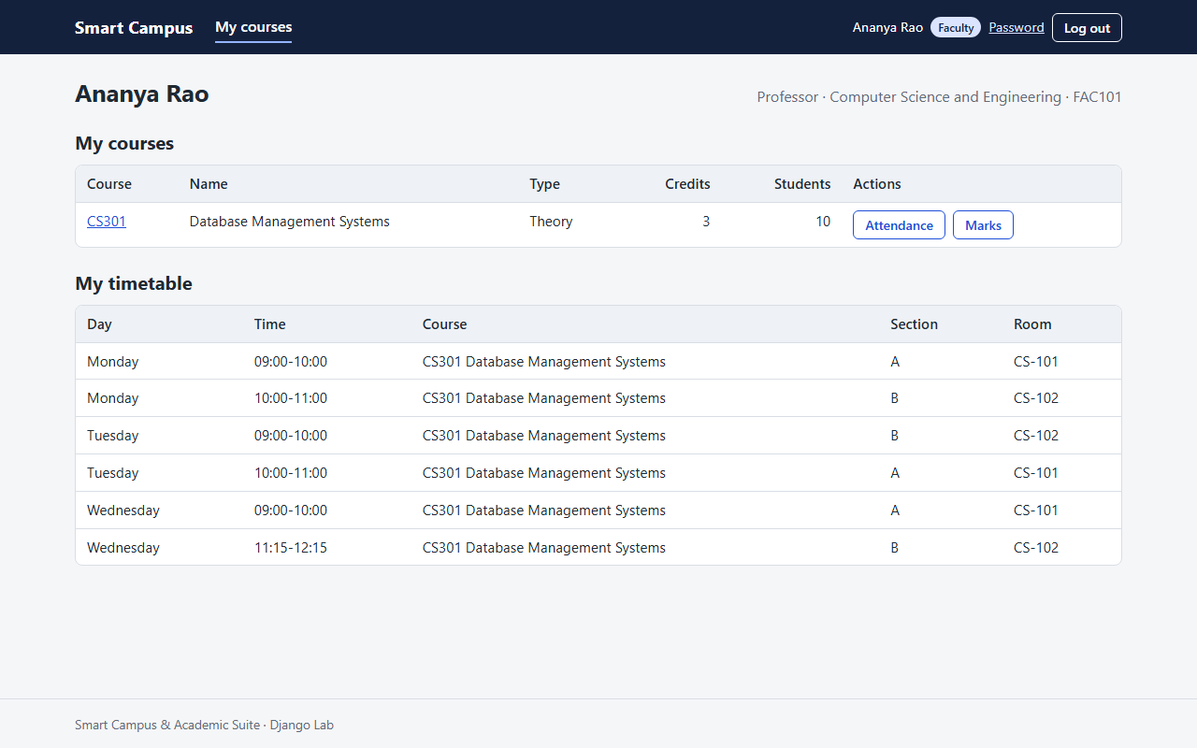
Figure 5.3: Faculty dashboard: own courses and weekly timetable (ananya.rao)
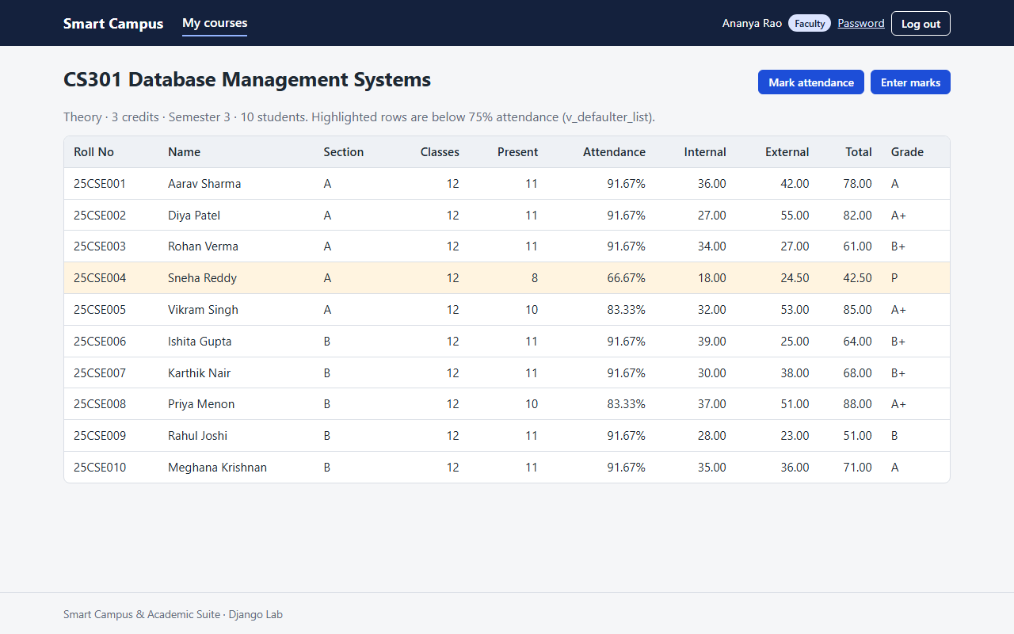
Figure 5.4: Faculty course roster for CS301
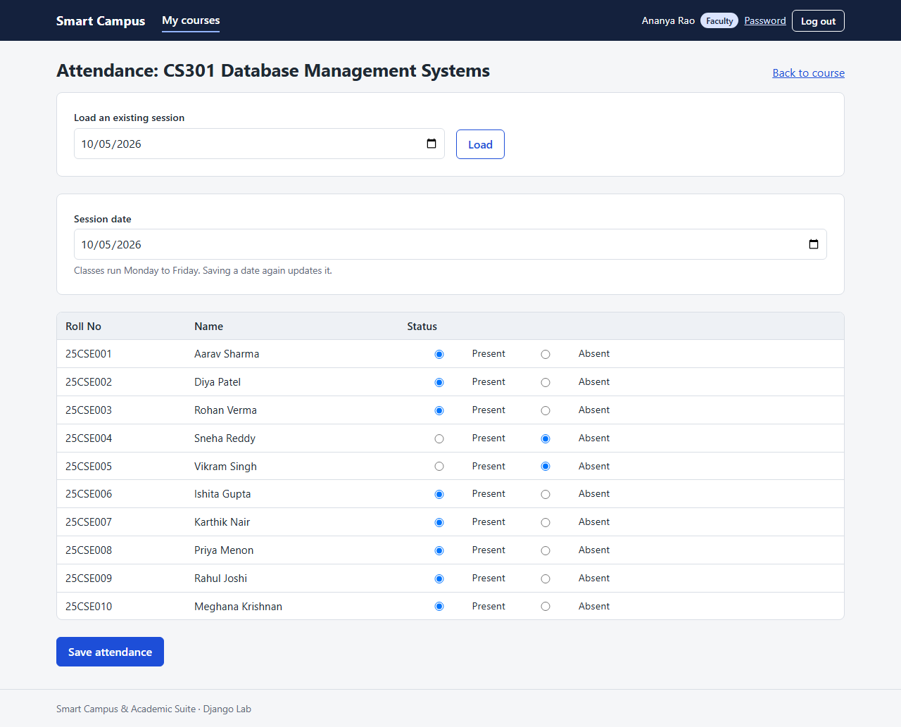
Figure 5.5: Faculty attendance sheet for a date
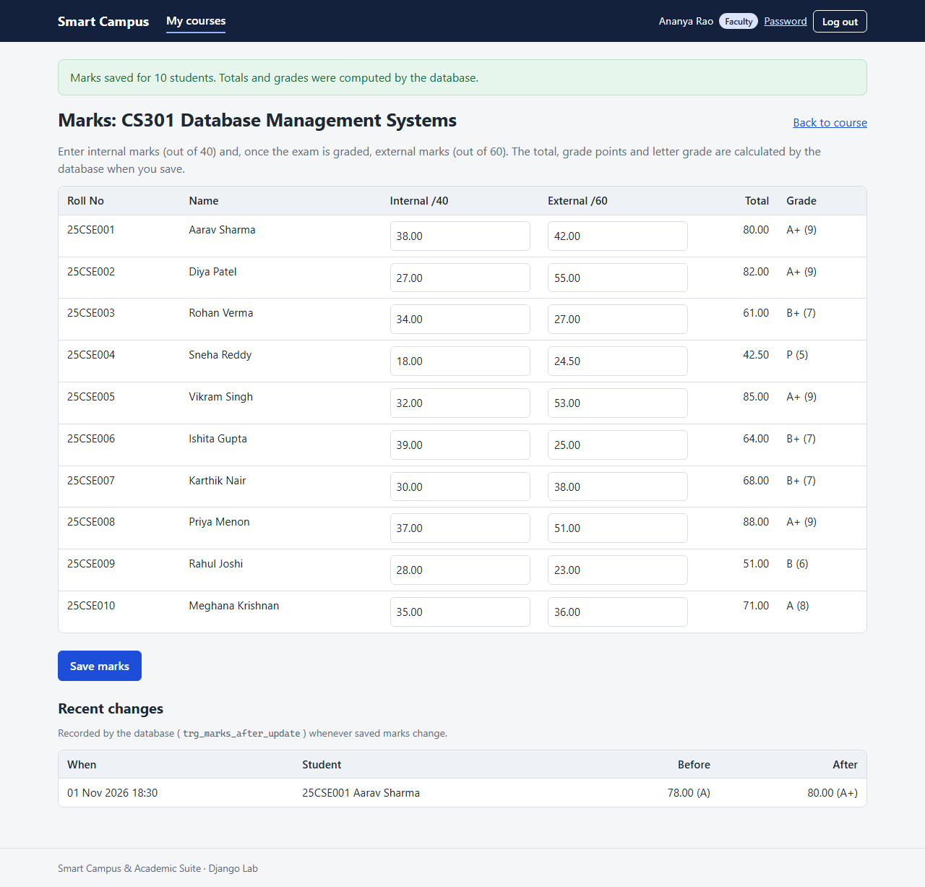
Figure 5.6: Faculty marks sheet; totals and grades come from the database
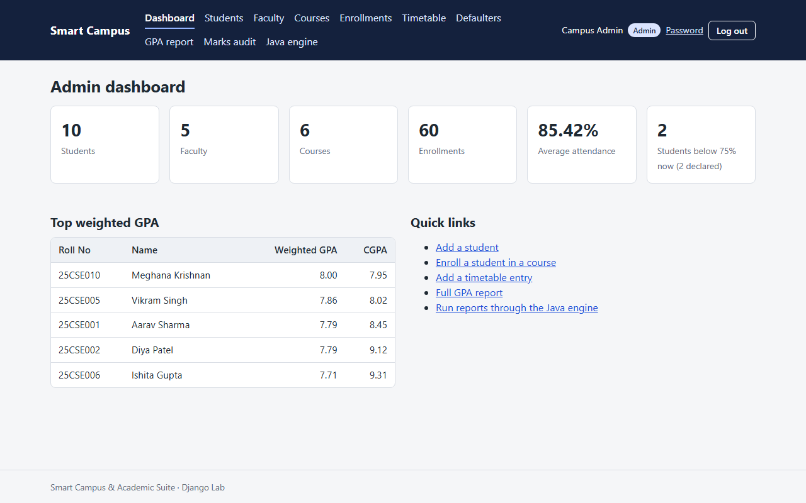
Figure 5.7: Admin dashboard
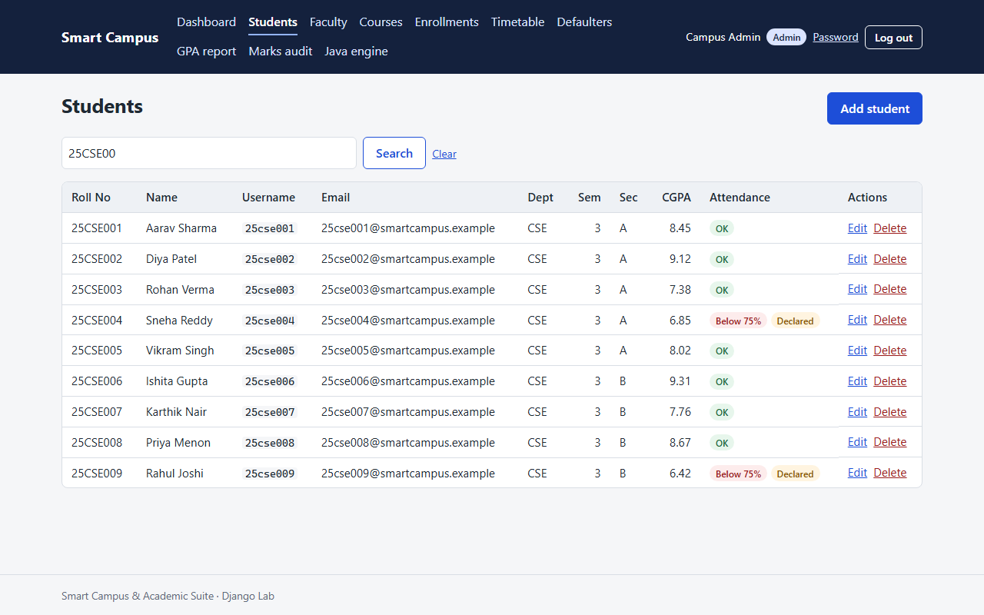
Figure 5.8: Admin student list with search and pagination
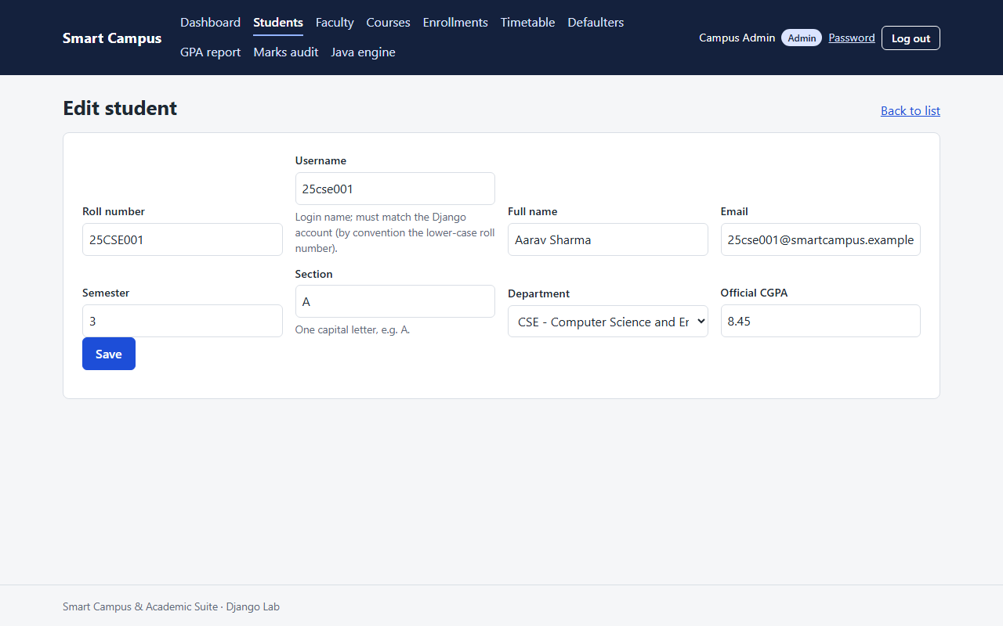
Figure 5.9: Admin student form
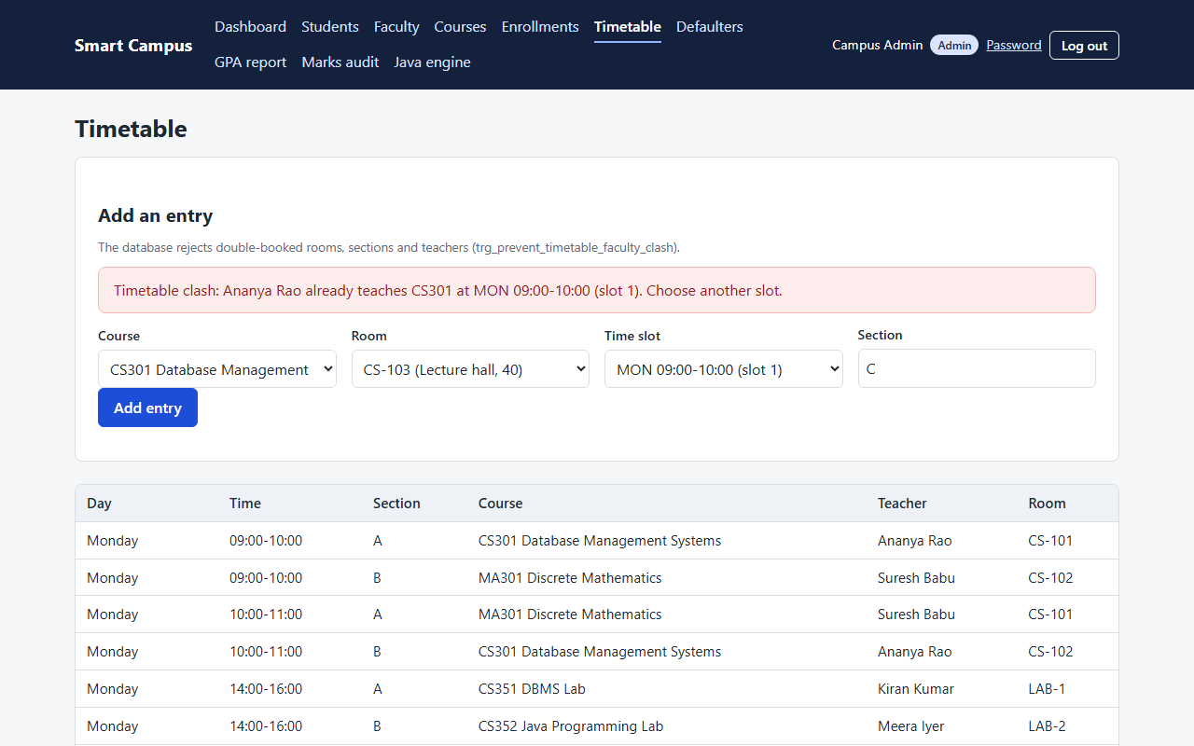
Figure 5.10: Timetable clash refused by the trigger, shown as a readable message

5.11 Integration of modules
The modules are integrated through the shared database and one process boundary:
• Portal and database: unmanaged Django models map 10 tables and the 4 views; all writes go through core/services.py, which wraps them in transaction.atomic() and converts database rejections into friendly messages.
• Engine and database: DAOs use PreparedStatement on the same tables and views; the configuration is read from the same .env.
• Portal and engine: core/java_bridge.py starts the JAR with an argument list and parses one line of JSON; the child process inherits the DB_* variables, so no extra configuration is needed.
• Rules in one place: grades, the 75% rule, clash checks and audit live in MySQL, so the two applications cannot disagree. Integration cases IT01-IT10 (Section 6.5) verify each path.

5.12 Challenges faced during development
Table 5.6: Development challenges and solutions
Challenge | How it was solved
REGEXP CHECK constraints accepted lower-case sections because the column collation is case-insensitive | Rewrote them as REGEXP_LIKE(col, pattern, 'c') and added a regression test (commit c96e1f6)
Java 17 on Windows wrote Cp1252 to a pipe, corrupting JSON text | The bridge passes -Dfile.encoding=UTF-8
Building mysqlclient needs a C compiler on Windows | Used PyMySQL installed as MySQLdb
Connector/J refused to connect: "Public Key Retrieval is not allowed" | Added allowPublicKeyRetrieval=true to the local JDBC URL
PowerShell 5.1 adds a UTF-8 BOM to piped stdin | The interactive menu strips the BOM
AUTO_INCREMENT leaves gaps, so ids differ from expectations | Tests look rows up by natural key
Django 6.1 needs MySQL 8.4 | Stayed on Django 5.2 LTS
JVM start-up plus a new connection costs about 0.7 s per call | At most one engine call per page

5.13 Summary
The system was implemented in about 7325 lines of SQL, Java, Python, HTML and CSS. The database holds the rules, the Java engine and the Django portal share it, and a guarded bridge connects them. The next chapter shows how this implementation was tested.

CHAPTER 6: SOFTWARE TESTING

6.1 Introduction
Testing was done at four levels (unit, integration, system and acceptance) and with both white-box and black-box techniques. Two automated suites run on every build: 29 JUnit tests for the Java engine and 71 Django tests for the portal. In addition, 78 documented test cases were executed by a script (docs/src/evidence/collect_cases.py) against the real MySQL database, the real JAR and the Django test client. Every "Actual result" and "Status" in this chapter was produced by actually running the tests on 2026-11-01; nothing was typed in by hand. Test writes were made inside transactions that were rolled back, and the database was rebuilt from the seed afterwards.

6.2 Testing objectives
• Verify every functional requirement FR1-FR20 at least once.
• Show that the database rejects invalid data even when the application is bypassed.
• Show that every page enforces its role and that users see only their own records.
• Exercise every branch of the grading function and the main decision points in the code.
• Measure response times of pages and engine commands.
• Find and fix defects before the final submission.

6.3 Testing methodology
Table 6.1: Test levels and tools
Level / technique | Tool | What was run
Unit (Java) | JUnit 6 via Maven Wrapper; JaCoCo | 29 tests, no database
Unit + integration (Django) | Django test runner; coverage.py | 71 tests on a throwaway test_smart_campus_db built from the real SQL scripts
Documented cases (UT, IT, WB, BB) | collect_cases.py | 78 cases on the real database, JAR and Django client
System and performance | Playwright + dev server; CLI timing | 17 live pages, 6 CLI commands
Acceptance | Manual walk-through per role | Section 6.10

6.4 Unit testing
Unit tests check one function or class in isolation. The documented unit cases are listed first, followed by the automated suites grouped by test class.
Table 6.2: Unit test cases
ID | Module | Objective | Input | Expected result | Actual result | Status
UT01 | core.services | Academic year rolls over in July | current_academic_year(2026-10-31) and (2026-06-30) | 2026-27 and 2025-26 | 2026-27 and 2025-26 | Pass
UT02 | core.db_errors | Duplicate-enrollment error becomes a sentence | MySQL error 1062 on uq_enrollments_student_course | This student is already enrolled in that course. | This student is already enrolled in that course. | Pass
UT03 | core.java_bridge | Allowed command builds a safe argument list | build_command('student', ['25CSE001']) | List ending student, 25CSE001, --json with -Dfile.encoding | ['student', '25CSE001', '--json'] (list) | Pass
UT04 | core.java_bridge | Command outside the allow-list is refused | build_command('rm') | EngineError NotAllowed | EngineError NotAllowed: 'rm' is not an allowed engine command. | Pass
UT05 | core.roles | Role is derived from the login | admin, ananya.rao, 25cse001 | admin, faculty, student | admin, faculty, student | Pass
UT06 | fn_grade_points / fn_letter_grade | Grading function maps 85 marks | SELECT fn_grade_points(85), fn_letter_grade(...) | 9, A+ | 9, A+ | Pass

Table 6.3: JUnit results (mvnw clean package, build SUCCESS)
JUnit test class | Tests | Passed | Failed | Time (s)
cli.CliTest | 7 | 7 | 0 | 0.172
cli.InteractiveMenuTest | 6 | 6 | 0 | 0.090
cli.JsonWriterTest | 9 | 9 | 0 | 0.042
config.DatabaseConfigTest | 4 | 4 | 0 | 0.271
services.ReportExporterTest | 3 | 3 | 0 | 0.067

Table 6.4: Django test results (71 tests, result: OK)
Django test module | Tests | Passed | Failed
core.tests.test_access | 11 | 11 | 0
core.tests.test_java_bridge | 23 | 23 | 0
core.tests.test_polish | 18 | 18 | 0
core.tests.test_portals | 19 | 19 | 0

6.5 Integration testing
Integration tests follow data across module boundaries: portal to database to trigger to another portal, and portal to bridge to JAR to view.
Table 6.5: Integration test cases
ID | Module | Objective | Input | Expected result | Actual result | Status
IT01 | accounts + core.roles | Login lands each role on its own portal | POST /accounts/login/ for admin, ananya.rao, 25cse001 | /admin-portal/, /faculty/, /student/ | admin -> /admin-portal/; ananya.rao -> /faculty/; 25cse001 -> /student/ | Pass
IT02 | faculty_portal -> trg_marks_before_update -> student_portal | Marks entered by faculty are graded by the trigger and shown to the student | Faculty saves 38 + 57 for 25CSE001 in CS301 | 95.00, 10, O stored and visible on /student/ | DB: 95.00, 10, O; student page shows grade: True | Pass
IT03 | faculty_portal -> attendance_records -> v_attendance_summary | A saved session updates the attendance view | Mark all CS301 students PRESENT on Mon 2026-10-12 | total_classes increases by 1 | total_classes 12 -> 13; attendance 92.31% | Pass
IT04 | admin_portal -> core.services -> enrollments | Admin enroll form creates an enrollment | New semester-3 student 25CSE061 + CS301, 2026-27 | Success message and new enrollments row | message shown: True; row exists: True | Pass
IT05 | admin_portal -> trg_prevent_timetable_faculty_clash -> core.db_errors | A teacher double-booking is refused with a readable message | CS301 (Ananya Rao) in MON 09:00 slot for section C | Clash message naming the teacher; no new row | Timetable clash: Ananya Rao already teaches CS301 at MON 09:00-10:00 (slot 1). Choose another slot.; entries 20 -> 20 | Pass
IT06 | faculty_portal -> trg_marks_after_update -> v_marks_audit -> admin_portal | A marks change is audited and visible to the admin | Change 25CSE002 CS301 marks to 40 + 60 | One audit row with old and new grade, listed on /admin-portal/marks-audit/ | 1 audit row: 82.00 (A+) -> 100.00 (O); on admin page: True | Pass
IT07 | admin_portal -> sp_refresh_defaulter_flags() | Declaring defaulters re-computes every flag | Stale flag on 25CSE001, then 'Declare defaulter list now' | Only 25CSE004 and 25CSE009 flagged | flagged after CALL: 25CSE004, 25CSE009; message: True | Pass
IT08 | core.java_bridge -> Java JAR -> v_defaulter_list | Django runs the real JAR and parses its JSON | run_engine('defaulters') | 25CSE004 and 25CSE009 in the parsed data | 2 students (25CSE004, 25CSE009), 8 course rows, 844 ms | Pass
IT09 | Java CLI -> JDBC -> v_student_cgpa_report | Engine reads the GPA view and sorts it | java -jar smart-campus-engine.jar gpa-report --json | Exit 0, 10 rows, 25CSE010 first | exit 0, 10 rows, first 25CSE010 (8.0), 741 ms | Pass
IT10 | Java CLI -> enrollments UNIQUE constraint | Duplicate enrollment is reported by the database through the engine | enroll 25CSE001 CS301 --json | Exit 1, error type DuplicateEnrollment | exit 1, type DuplicateEnrollment: 25CSE001 is already enrolled in CS301 | Pass

6.6 System testing
The complete system was started (MySQL, the Django development server and the built JAR) and every main page was requested as the role that owns it, using Playwright. All returned HTTP 200 with real data; the screenshots in Sections 5.10 and 9.3 were taken in the same run.
Table 6.6: System test: live pages
Logged in as | Page | HTTP status
25cse004 | /student/ | 200
ananya.rao | /faculty/ | 200
ananya.rao | /faculty/courses/CS301/ | 200
ananya.rao | /faculty/courses/CS301/attendance/ | 200
ananya.rao | /faculty/courses/CS301/marks/ | 200
admin | /admin-portal/ | 200
admin | /admin-portal/students/ | 200
admin | /admin-portal/faculty/ | 200
admin | /admin-portal/courses/ | 200
admin | /admin-portal/enrollments/ | 200
admin | /admin-portal/timetable/ | 200
admin | /admin-portal/defaulters/ | 200
admin | /admin-portal/gpa-report/ | 200
admin | /admin-portal/marks-audit/ | 200
admin | /engine/ | 200
admin | /engine/?command=dashboard | 200
admin | /engine/?command=defaulters | 200

6.7 Functional testing
Each functional requirement is traced to the tests that exercise it:
Table 6.7: Requirement traceability
Requirement | Test cases | Result
FR1, FR2 (login, role) | IT01, UT05, WB09-WB11 | Pass
FR3 (password, logout) | Django tests in test_access / test_polish | Pass
FR4-FR7 (student views, warning) | IT02, Django test_portals, live page /student/ | Pass
FR8-FR9 (faculty courses, attendance) | IT03, BB13-BB15, BB35 | Pass
FR10 (marks, grading) | IT02, BB01-BB12, BB23-BB27, WB01-WB08, WB15-WB18 | Pass
FR11 (CRUD) | BB16-BB18, BB31, Django test_polish | Pass
FR12 (enroll) | IT04, WB12-WB14, BB19-BB22, IT10 | Pass
FR13 (timetable clash) | IT05 | Pass
FR14 (defaulters) | IT07, BB28 | Pass
FR15, FR17 (GPA report, audit) | IT06, IT09, WB19-WB21 | Pass
FR16 (engine page) | IT08, BB30, UT03, UT04 | Pass
FR18-FR20 (engine commands, CSV, dashboard) | JUnit CliTest, ReportExporterTest; WB22-WB27 | Pass

6.8 Performance testing
Each page was requested five times per role on the development server (Section 5.2 hardware) and the median, minimum and maximum response times were recorded. Each engine command was run five times from the command line.
Table 6.8: Page response times (5 requests each)
Page | User | Median (ms) | Min (ms) | Max (ms)
/student/ | 25cse004 | 69.2 | 66.3 | 86.6
/faculty/ | ananya.rao | 59.0 | 56.0 | 87.0
/faculty/courses/CS301/ | ananya.rao | 67.3 | 62.8 | 86.1
/faculty/courses/CS301/attendance/ | ananya.rao | 62.8 | 58.7 | 88.8
/faculty/courses/CS301/marks/ | ananya.rao | 65.9 | 63.6 | 94.4
/admin-portal/ | admin | 68.5 | 64.9 | 68.7
/admin-portal/students/ | admin | 59.5 | 59.1 | 60.1
/admin-portal/faculty/ | admin | 53.0 | 49.7 | 77.0
/admin-portal/courses/ | admin | 54.8 | 52.3 | 60.0
/admin-portal/enrollments/ | admin | 63.8 | 58.8 | 76.5
/admin-portal/timetable/ | admin | 66.4 | 64.3 | 71.6
/admin-portal/defaulters/ | admin | 62.7 | 54.7 | 83.1
/admin-portal/gpa-report/ | admin | 52.6 | 48.2 | 60.8
/admin-portal/marks-audit/ | admin | 50.3 | 48.1 | 52.8
/engine/ | admin | 47.4 | 46.6 | 70.3
/engine/?command=dashboard | admin | 750.4 | 737.3 | 785.2
/engine/?command=defaulters | admin | 668.7 | 632.5 | 708.5

Table 6.9: Java engine command times (5 runs each, including JVM start-up)
Command | Median (ms) | Min (ms) | Max (ms)
java -jar ... help | 168 | 154 | 201
java -jar ... courses | 697 | 608 | 816
java -jar ... student 25CSE001 | 813 | 701 | 1139
java -jar ... defaulters | 636 | 589 | 858
java -jar ... gpa-report | 707 | 665 | 816
java -jar ... dashboard | 773 | 703 | 873

All ordinary pages answered in under 70 ms (median). Pages that call the engine took about 0.67-0.75 s, almost all of it JVM start-up and a new MySQL connection, which is why the design allows at most one engine call per page (NFR2). NFR1 (under 1 s) is met.

6.9 Security testing
Security tests tried the attacks a student or outsider is most likely to attempt (error guessing). In addition, core/tests/test_polish.py walks the whole URL configuration and checks that every route redirects anonymous users to the login page and returns 403 to every role outside its own prefix.
Table 6.10: Security test cases (error guessing)
ID | Module | Objective | Input | Expected result | Actual result | Status
BB29 | Security / robustness | Guess: sqli | Search q = 25CSE001' OR '1'='1 | HTTP 200, 0 rows (treated as text) | HTTP 200, 0 rows | Pass
BB30 | Security / robustness | Guess: bridge | Engine roll number '25CSE001; dir' | Form error, engine not called | HTTP 200, form error shown: True | Pass
BB31 | Security / robustness | Guess: username | New student with faculty username ananya.rao | Trigger message shown | message shown: True | Pass
BB32 | Security / robustness | Guess: xss | Student name <script>alert(1)</script> | Name rendered escaped | rendered escaped: True | Pass
BB33 | Security / robustness | Guess: csrf | POST /admin-portal/defaulters/ without CSRF token | HTTP 403 | HTTP 403 | Pass
BB34 | Security / robustness | Guess: role | Student opens /admin-portal/students/ | HTTP 403 | HTTP 403 | Pass
BB35 | Security / robustness | Guess: other_teacher | kiran.kumar opens CS301 marks (not his course) | HTTP 403 | HTTP 403 | Pass

6.10 User Acceptance Testing (UAT)
UAT was carried out as a team walk-through: each scenario below was performed on the running system with the demo accounts, following the use cases of Section 3.9. No external users took part, so this is not a formal UAT with real staff and students; that remains future work (Section 8.7).
Table 6.11: User acceptance walk-through
ID | Role | Scenario | Acceptance criterion | Evidence | Result
UAT1 | Student | Open the dashboard as 25cse004 | Warning for courses below 75% | Figure 5.1 | Accepted
UAT2 | Student | Open the dashboard as 25cse001 | No warning; grades and CGPA shown | Figure 5.2 | Accepted
UAT3 | Faculty | Record CS301 attendance on a weekday | Saved; percentage changes | IT03 | Accepted
UAT4 | Faculty | Enter CS301 marks | Total and grade computed | IT02, Figure 5.6 | Accepted
UAT5 | Faculty | Open another teacher's course | 403 page | BB35 | Accepted
UAT6 | Admin | Double-book a teacher in the timetable | Readable clash message | IT05, Figure 5.10 | Accepted
UAT7 | Admin | Declare defaulters | 25CSE004 and 25CSE009 flagged | IT07 | Accepted
UAT8 | Admin | Run the engine dashboard | Counts, averages and thread timings | Figure 9.6 | Accepted

6.11 Test cases and test results
This section groups the documented cases by technique. White-box cases were designed from the code and SQL; black-box cases from the requirements only.

6.11.1 White-box testing: statement and branch coverage
fn_grade_points has eight branches (NULL, seven grade bands). One input per branch executes every statement and every branch.
Table 6.12: Statement and branch coverage of fn_grade_points
ID | Module | Objective | Input | Expected result | Actual result | Status
WB01 | fn_grade_points (CASE) | Execute every CASE branch once | total = 95 | 10, O | 10, O | Pass
WB02 | fn_grade_points (CASE) | Execute every CASE branch once | total = 85 | 9, A+ | 9, A+ | Pass
WB03 | fn_grade_points (CASE) | Execute every CASE branch once | total = 75 | 8, A | 8, A | Pass
WB04 | fn_grade_points (CASE) | Execute every CASE branch once | total = 65 | 7, B+ | 7, B+ | Pass
WB05 | fn_grade_points (CASE) | Execute every CASE branch once | total = 55 | 6, B | 6, B | Pass
WB06 | fn_grade_points (CASE) | Execute every CASE branch once | total = 45 | 5, P | 5, P | Pass
WB07 | fn_grade_points (CASE) | Execute every CASE branch once | total = 30 | 0, F | 0, F | Pass
WB08 | fn_grade_points (CASE) | Execute every CASE branch once | total = None | None, None | None, None | Pass

Table 6.13: Branch coverage of role_required
ID | Module | Objective | Input | Expected result | Actual result | Status
WB09 | core.roles.role_required | Anonymous branch | anonymous GET /student/ | HTTP 302 | HTTP 302 | Pass
WB10 | core.roles.role_required | Wrong-role branch | ananya.rao GET /student/ | HTTP 403 | HTTP 403 | Pass
WB11 | core.roles.role_required | Allowed branch | 25cse001 GET /student/ | HTTP 200 | HTTP 200 | Pass

6.11.2 White-box testing: path coverage
core.services.enroll_student has three independent paths: semester mismatch, database rejection (duplicate) and success.
Table 6.14: Path coverage of enroll_student
ID | Module | Objective | Input | Expected result | Actual result | Status
WB12 | core.services.enroll_student | Execute path: mismatch | Semester-3 student, semester-5 course | ServiceError (semester rule) | ServiceError: CS501 is a semester 5 course, but 25CSE001 is in semester 3. | Pass
WB13 | core.services.enroll_student | Execute path: duplicate | 25CSE001 + CS301 (already enrolled) | ServiceError (duplicate, from MySQL 1062) | ServiceError: This student is already enrolled in that course. | Pass
WB14 | core.services.enroll_student | Execute path: ok | New semester-3 student + CS301 | Enrollment created | created enrollment for 25CSE062 in CS301 | Pass

6.11.3 White-box testing: condition coverage
Each atomic condition of the compound decisions was made true and false at least once.
Table 6.15: Condition coverage of MarksSheetForm.clean and trg_marks_after_update
ID | Module | Objective | Input | Expected result | Actual result | Status
WB15 | MarksSheetForm.clean | internal is None AND external is not None | internal='', external='' | valid | valid | Pass
WB16 | MarksSheetForm.clean | internal is None AND external is not None | internal='', external='50' | error: Enter internal marks before external marks. | error: Enter internal marks before external marks. | Pass
WB17 | MarksSheetForm.clean | internal is None AND external is not None | internal='30', external='' | valid | valid | Pass
WB18 | MarksSheetForm.clean | internal is None AND external is not None | internal='30', external='50' | valid | valid | Pass
WB19 | trg_marks_after_update | NOT(old <=> new internal AND old <=> new external) | internal same, external same | 0 audit row(s) | 0 audit row(s) | Pass
WB20 | trg_marks_after_update | NOT(old <=> new internal AND old <=> new external) | internal 20, external same | 1 audit row(s) | 1 audit row(s) | Pass
WB21 | trg_marks_after_update | NOT(old <=> new internal AND old <=> new external) | internal same, external NULL | 1 audit row(s) | 1 audit row(s) | Pass

6.11.4 White-box testing: loop testing
The argument-parsing loop was run with zero, one and many arguments, and the .env search loop with zero, one and two parent-directory steps.
Table 6.16: Loop testing
ID | Module | Objective | Input | Expected result | Actual result | Status
WB22 | cli.CommandLine.parse (argument loop) | Loop over 0 arguments (shows help) | java -jar ... | exit 0 | exit 0: Smart Campus Java engine | Pass
WB23 | cli.CommandLine.parse (argument loop) | Loop over 1 argument | java -jar ... courses | exit 0 | exit 0: Code Name Type Credits Sem Faculty | Pass
WB24 | cli.CommandLine.parse (argument loop) | Loop over 6 arguments incl. options | java -jar ... enroll 25CSE001 CS301 --year 2026-27 --json | exit 1 | exit 1: {"ok":false,"command":"enroll","error":{"type":"DuplicateEnrollment"," | Pass
WB25 | config.DatabaseConfig.findEnvFile (walk-up loop) | Find .env after 0 parent steps (repo root) | java -jar ... courses (cwd=3rdSemLabProject) | exit 0 (connected) | exit 0 | Pass
WB26 | config.DatabaseConfig.findEnvFile (walk-up loop) | Find .env after 1 parent step | java -jar ... courses (cwd=3rdSemLabProject\java_engine) | exit 0 (connected) | exit 0 | Pass
WB27 | config.DatabaseConfig.findEnvFile (walk-up loop) | Find .env after 2 parent steps | java -jar ... courses (cwd=3rdSemLabProject\java_engine\target) | exit 0 (connected) | exit 0 | Pass

6.11.5 Code coverage
Table 6.17: JaCoCo coverage of the Java engine by the JUnit suite
Java package | Lines | Line coverage | Branch coverage
(root) | 2 | 0.0% | n/a
cli | 599 | 41.1% | 66.7%
config | 57 | 61.4% | 70.0%
dao | 170 | 0.0% | 0.0%
exceptions | 29 | 27.6% | 0.0%
models | 167 | 0.0% | 0.0%
services | 161 | 20.5% | 38.7%
Total | 1185 | 27.2% | 42.6%

The JUnit suite deliberately needs no database, so the JDBC DAO classes are exercised by the integration cases (IT08-IT10, WB22-WB27) and live runs rather than by unit tests. This is why the dao and models packages show 0% unit-test coverage and the total is low; the CLI, configuration and export code that the unit tests target is covered much better.
Table 6.18: coverage.py results for the Django suite
Django app | Statements | Line coverage | Branch coverage
accounts | 66 | 95.5% | 75.0%
admin_portal | 185 | 98.9% | 92.9%
campus_portal | 67 | 77.6% | 50.0%
core | 625 | 99.2% | 89.6%
faculty_portal | 125 | 96.0% | 91.7%
student_portal | 20 | 100.0% | n/a
Total | 1088 | 97.2% | 87.5%

6.11.6 Black-box testing: equivalence partitioning and boundary value analysis
Internal marks have one valid class (0-40) and invalid classes below 0, above 40 and non-numeric. Boundaries were tested just outside, on and just inside each limit, and the grade scale at its boundaries.
Table 6.19: Equivalence partitioning and boundary value test cases
ID | Module | Objective | Input | Expected result | Actual result | Status
BB01 | Faculty marks entry (internal, 0-40) | Validate internal marks | internal = 25 | accepted | accepted, stored 25.00 | Pass
BB02 | Faculty marks entry (internal, 0-40) | Validate internal marks | internal = -5 | rejected | rejected (form error), stored value unchanged 36.00 | Pass
BB03 | Faculty marks entry (internal, 0-40) | Validate internal marks | internal = 45 | rejected | rejected (form error), stored value unchanged 36.00 | Pass
BB04 | Faculty marks entry (internal, 0-40) | Validate internal marks | internal = abc | rejected | rejected (form error), stored value unchanged 36.00 | Pass
BB05 | Faculty marks entry (internal, 0-40) | Validate internal marks | internal = -0.01 | rejected | rejected (form error), stored value unchanged 36.00 | Pass
BB06 | Faculty marks entry (internal, 0-40) | Validate internal marks | internal = 0 | accepted | accepted, stored 0.00 | Pass
BB07 | Faculty marks entry (internal, 0-40) | Validate internal marks | internal = 40 | accepted | accepted, stored 40.00 | Pass
BB08 | Faculty marks entry (internal, 0-40) | Validate internal marks | internal = 40.01 | rejected | rejected (form error), stored value unchanged 36.00 | Pass
BB09 | Grade scale via trg_marks_before_update | Grade at a scale boundary | 39.99 + 0 | 0, F | 39.99 -> 0, F | Pass
BB10 | Grade scale via trg_marks_before_update | Grade at a scale boundary | 40 + 0 | 5, P | 40.00 -> 5, P | Pass
BB11 | Grade scale via trg_marks_before_update | Grade at a scale boundary | 30 + 59.99 | 9, A+ | 89.99 -> 9, A+ | Pass
BB12 | Grade scale via trg_marks_before_update | Grade at a scale boundary | 30 + 60 | 10, O | 90.00 -> 10, O | Pass
BB13 | Attendance date (weekday rule, CHECK) | Friday session | 2026-10-16 | saved | saved | Pass
BB14 | Attendance date (weekday rule, CHECK) | Saturday session | 2026-10-17 | rejected (weekend) | rejected: Attendance can only be recorded for Monday to Friday. | Pass
BB15 | Attendance date (weekday rule, CHECK) | Monday session | 2026-10-19 | saved | saved | Pass
BB16 | Student section (REGEXP_LIKE CHECK) | Validate section | section = 'A' | created | created | Pass
BB17 | Student section (REGEXP_LIKE CHECK) | Validate section | section = 'a' | rejected | rejected: Section must be a single capital letter | Pass
BB18 | Student section (REGEXP_LIKE CHECK) | Validate section | section = 'AB' | rejected | rejected: at most 1 character | Pass

6.11.7 Black-box testing: decision tables
Table 6.20: Decision table: enrollment
Rule | Semester matches | Already enrolled | Expected action
R1 | Y | N | Enroll
R2 | Y | Y | Refuse: already enrolled
R3 | N | N | Refuse: wrong semester
R4 | N | Y | Refuse: wrong semester

Table 6.21: Decision table: marks entry
Rule | Internal given | External given | Expected action
R1 | N | N | Nothing written
R2 | Y | N | Store; no total or grade yet
R3 | Y | Y | Store; total and grade computed
R4 | N | Y | Form error

Table 6.22: Decision table test cases
ID | Module | Objective | Input | Expected result | Actual result | Status
BB19 | Enroll (semester match x already enrolled) | Rule: semester match=Y, enrolled=N | match=Y, enrolled=N | enrolled | enrolled | Pass
BB20 | Enroll (semester match x already enrolled) | Rule: semester match=Y, enrolled=Y | match=Y, enrolled=Y | refused: This student is already enrolled | refused: This student is already enrolled in that course. | Pass
BB21 | Enroll (semester match x already enrolled) | Rule: semester match=N, enrolled=N | match=N, enrolled=N | refused: CS502 is a semester 5 course | refused: CS502 is a semester 5 course, but 25CSE064 is in semester 3. | Pass
BB22 | Enroll (semester match x already enrolled) | Rule: semester match=N, enrolled=Y | match=N, enrolled=Y | refused: CS502 is a semester 5 course | refused: CS502 is a semester 5 course, but 25CSE064 is in semester 3. | Pass
BB23 | Marks entry (internal given x external given) | Rule from the marks decision table | internal='', external='' | no marks row written | no marks row written | Pass
BB24 | Marks entry (internal given x external given) | Rule from the marks decision table | internal='30', external='' | stored; total=None, grade=None | stored; total=None, grade=None | Pass
BB25 | Marks entry (internal given x external given) | Rule from the marks decision table | internal='30', external='50' | stored; total=80.00, grade=A+ | stored; total=80.00, grade=A+ | Pass
BB26 | Marks entry (internal given x external given) | Rule from the marks decision table | internal='', external='50' | form error | form error: Enter internal marks before external marks. | Pass

6.11.8 Black-box testing: state transition
The marks record moves through the states of Figure 4.14 and a student's defaulter flag through those of Figure 4.15.
Table 6.23: State transition test cases
ID | Module | Objective | Input | Expected result | Actual result | Status
BB27 | Marks life cycle | No marks -> internal -> graded -> re-graded | Save internal 30; then 30+50; then 35+50 | No marks -> Internal only -> Graded (A+) -> Re-graded (A+, 2 audit rows) | No marks -> Internal only -> Graded (A+) -> Re-graded (A+, 2 audit rows) | Pass
BB28 | Defaulter declaration (25CSE004, 66.67% / 58.33%) | Not declared -> Declared on 'declare' | Clear the flag, then CALL sp_refresh_defaulter_flags() | False -> True | declared flag False -> True | Pass

6.12 Defect identification and correction
Table 6.24: Defects found and corrected
ID | Defect | Found by | Correction | Status
D1 | CHECK constraints for section and department code used REGEXP, which is case-insensitive under utf8mb4_unicode_ci, so 'a' was accepted | Django test test_check_constraint_message_for_bad_section | REGEXP_LIKE(col, pattern, 'c') in schema.sql (commit c96e1f6); test BB17 now passes | Fixed
D2 | Paginated faculty and course lists had no stable order (Django UnorderedObjectListWarning) | Warning seen while collecting test evidence for this report | .order_by() added in admin_portal/views.py (commit 6de2bea) | Fixed
D3 | Engine JSON written as Cp1252 when Java ran under a pipe on Windows | Integrating the bridge on Windows | -Dfile.encoding=UTF-8 added to the argv | Fixed
D4 | Menu misread the first command when input was piped from PowerShell (BOM) | Piping commands into menu | BOM stripped in InteractiveMenu.readLine() | Fixed
D5 | Test assumed the next enrollment id would be 61; InnoDB left a gap (64) | Testing enroll against MySQL | Tests look rows up by roll number and course code | Fixed

No open defects remained when the final test run was made.

6.13 Test summary
Table 6.25: Test summary
Category | Executed | Passed | Failed
Unit | 6 | 6 | 0
Integration | 10 | 10 | 0
White-box | 27 | 27 | 0
Black-box (incl. security) | 35 | 35 | 0
JUnit suite | 29 | 29 | 0
Django suite | 71 | 71 | 0
System test pages | 17 | 17 | 0
Total | 195 | 195 | 0

All 195 executed tests and cases passed in the final run (78 of 78 documented cases, 29 JUnit tests, 71 Django tests and 17 live pages). Five defects found earlier were corrected before this run.

CHAPTER 7: DEPLOYMENT AND INSTALLATION

7.1 Introduction
This chapter explains how the system is installed and run. For the lab it is deployed on one Windows laptop; the same steps work on macOS and Linux with the shell commands adjusted.

7.2 Deployment architecture
All components run on one machine (deployment diagram, Figure 4.17): the browser, the Django development server on port 8000, a JVM started for each engine call, and MySQL Server on port 3306. For a real deployment Django would run behind a production web server with TLS and DJANGO_HTTPS=True.

7.3 Deployment environment
Table 7.1: Deployment environment
Component | Deployed as
Database | MySQL Community Server 8.0.42, database smart_campus_db, localhost:3306
Engine | java_engine/target/smart-campus-engine.jar (fat JAR with the JDBC driver)
Portal | Django 5.2.18 development server, http://127.0.0.1:8000/
Configuration | Repository-root .env (git-ignored), copied from .env.example
Client | Any browser on the same machine

7.4 System installation procedure
1. Install MySQL Server 8.0.16+, JDK 17+ and Python 3.10+ (Maven is downloaded by the wrapper).
2. Clone the repository and copy .env.example to .env; set DB_PASSWORD.
3. Create the virtual environment: python -m venv .venv, then .venv\Scripts\python.exe -m pip install -r requirements.txt.
4. Build the database: .venv\Scripts\python.exe database\init_db.py --yes.
5. Build the engine: cd java_engine; .\mvnw.cmd clean package (runs the 29 JUnit tests).
6. Prepare Django: cd campus_portal, then manage.py migrate and manage.py seed_demo_users.
7. Start the portal: manage.py runserver and open http://127.0.0.1:8000/.

7.5 Configuration details
All configuration is read from the repository-root .env file, which is git-ignored; only the template .env.example is committed. The values are not reproduced here.
Table 7.2: Configuration variables
Variable | Used by | Meaning
DB_HOST, DB_PORT, DB_NAME | Django, Java, init_db.py | MySQL server and database name
DB_USER, DB_PASSWORD | Django, Java, init_db.py | MySQL account (never committed)
DJANGO_SECRET_KEY | Django | Signing key (required when DEBUG is off)
DJANGO_DEBUG, DJANGO_ALLOWED_HOSTS | Django | Debug mode and host names
DJANGO_HTTPS | Django | Turns on secure cookies, SSL redirect and HSTS
DJANGO_DEMO_PASSWORD | seed_demo_users | Shared demo password (demo only)
DJANGO_JAVA_BIN, DJANGO_JAVA_ENGINE_JAR, DJANGO_JAVA_ENGINE_TIMEOUT | Bridge | Java executable, JAR path and timeout (default 30 s)

7.6 Database setup
init_db.py creates smart_campus_db, runs the three scripts and prints the row counts. On the development machine it completed in 1.3 s. It asks for confirmation unless --yes is given, because it drops and recreates every domain table (Django's tables are not touched).
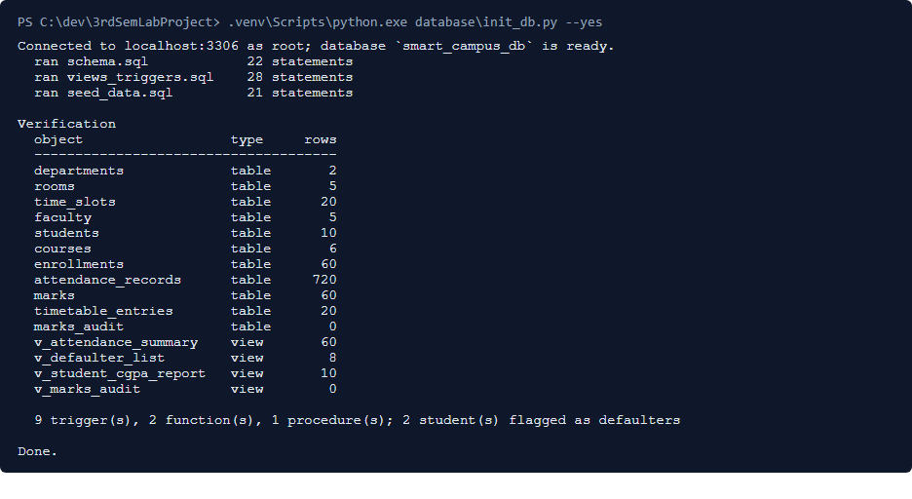
Figure 7.1: Database build with init_db.py

7.7 Application deployment steps
mvnw.cmd clean package compiled the engine, ran the JUnit suite and built the fat JAR in 13.7 s. manage.py migrate and manage.py check then completed with exit code 0, and the development server was started.
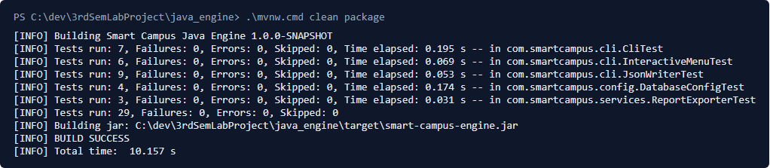
Figure 7.2: Maven build of the engine JAR

7.8 User access and credentials management
• Logins are Django users; passwords are stored only as salted hashes.
• manage.py seed_demo_users creates one login per student and faculty row with the same username, plus an admin superuser. The shared demo password is documented in the README for evaluators and is not repeated here. The command refuses to run when DEBUG is off unless --force is given.
• The role is never stored: it is derived from the username on each request (Section 4.14).
• Every user can change their own password at /accounts/password/.
• Database credentials live only in the git-ignored .env; a secret scan is run before every push.

7.9 User manual

7.9.1 Student
1. Log in with your roll number (for example 25cse001).
2. The dashboard shows each course with attendance %, marks, grade and your GPA and CGPA.
3. A red banner means at least one course is below 75% attendance.
4. Use "Change password" in the header; log out with the header button.

7.9.2 Faculty
1. Log in with your username (first.last).
2. Choose a course to see the roster.
3. Attendance: pick a weekday date, mark each student, save.
4. Marks: enter internal (0-40) and external (0-60) marks, save; totals and grades appear.

7.9.3 Admin
1. Log in as admin; the dashboard shows counts and averages.
2. Students / Faculty / Courses: search, add, edit or delete (a confirmation page is shown).
3. Enrollments and Timetable: add entries; clashes and duplicates are explained.
4. Defaulters: review the live list, then "Declare defaulter list now".
5. GPA report and Marks audit: read-only reports.
6. Java engine: choose a command, run it, read the tables or the error card.

7.9.4 Command line
java -jar java_engine/target/smart-campus-engine.jar help
java -jar java_engine/target/smart-campus-engine.jar student 25CSE001
java -jar java_engine/target/smart-campus-engine.jar dashboard
java -jar java_engine/target/smart-campus-engine.jar export gpa-report gpa.csv
java -jar java_engine/target/smart-campus-engine.jar menu

7.10 Deployment screenshots
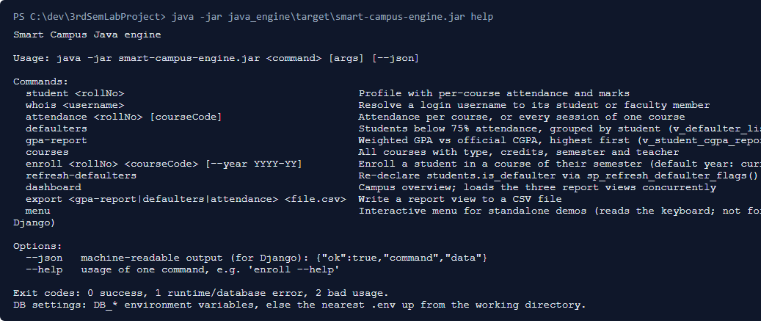
Figure 7.3: Engine help output after deployment
Figure 7.4: Portal running after deployment (admin dashboard)

7.11 Deployment challenges
• PowerShell's execution policy can block Activate.ps1; the steps call .venv\Scripts\python.exe directly so no system setting has to change.
• PowerShell has no < redirection, so the SQL scripts are run through init_db.py.
• A stale DB_* variable in the shell overrides .env for the JAR; the variables must be cleared.
• Django runs the last built JAR, so the engine must be rebuilt after any Java change.
• A fresh clone was tested end-to-end in Phase 4.5 to confirm that the six setup commands are enough.

CHAPTER 8: MAINTENANCE AND FUTURE ENHANCEMENTS

8.1 Introduction
Maintenance keeps the system correct and useful after delivery. This chapter classifies the maintenance work already done, describes how future changes will be handled, and lists the current limitations and planned enhancements. Change control and release practice are given in Appendix A, and the project risks in Appendix B.

8.2 Types of maintenance

Corrective maintenance
Fixing defects after they are found. Examples from this project: case-sensitive CHECK constraints (commit c96e1f6) and stable ordering of paginated lists (commit 6de2bea). Each fix comes with a test.

Adaptive maintenance
Adapting to a changed environment. The project stays on Django 5.2 LTS because Django 6.1 needs MySQL 8.4; moving to MySQL 8.4 will allow the upgrade. HTTPS settings are switched on by DJANGO_HTTPS=True when the portal moves behind TLS.

Perfective maintenance
Adding features or improving usability. Phase 4.5 added the marks audit trail, CSV export, the interactive menu, delete pages, search and pagination, password change and the Django admin.

Preventive maintenance
Preventing future faults: the URL-wide access test fails if a new page forgets its role check; rules live in the database so a new client cannot bypass them; scripts are re-runnable; dependency versions are pinned.

8.3 Bug fixing and updates
A bug is first reproduced with a failing test, then fixed in the layer that owns the rule (SQL, Java or Django), and committed together with the test. Schema changes are made in one commit that updates the SQL, the unmanaged Django model, the Java model/DAO and the ER diagram (Appendix A.4).

8.4 Performance improvement
• Reports read the database views instead of re-implementing joins in Python or Java.
• The engine dashboard loads its three views concurrently on a 3-thread pool.
• At most one engine call per page; most pages need none (about 50-70 ms).
• Future: a connection pool or a long-running engine service would remove the 0.6-0.8 s cost of each engine call.

8.5 Security updates
• Follow Django 5.2 LTS security releases (supported until April 2028) and MySQL 8.0 updates.
• Keep cryptography and the JDBC driver current.
• Before production: set DEBUG off, a real secret key, allowed hosts and HTTPS; replace the demo logins.
• Run manage.py check --deploy after every settings change.

8.6 User feedback and enhancements
Feedback from the guide and lab evaluators will be recorded as GitHub issues, prioritised, and handled through the change-control steps in Appendix A. Usability feedback during development already led to readable error messages with names instead of ids (for example in timetable clashes).

8.7 Limitations of the current system
• Single department and a single active academic year in the demo data.
• No e-mail or SMS notifications to students or parents.
• Runs on the Django development server on localhost; not hardened for the internet.
• Demo accounts share one password.
• Each engine call starts a new JVM (about 0.7 s).
• No bulk import of students or marks from spreadsheets.
• Acceptance testing was done by the project team, not by real staff and students.

8.8 Future enhancements
• Bulk CSV import of students, enrollments and marks.
• E-mail alerts to students who fall below 75% attendance.
• Multiple departments and academic years with history.
• Charts of attendance trends on the dashboards.
• Production deployment with Gunicorn/Nginx, TLS and a managed MySQL.
• A REST API for a mobile app.

8.9 Maintenance plan
Table 8.1: Maintenance plan
Activity | Frequency | Responsibility
Back up smart_campus_db (mysqldump) | Daily during the semester | Admin
Run both test suites | Before every commit | Project team
Apply Django / MySQL security releases | Monthly | Project team
Review marks_audit | End of each assessment | Admin
Declare defaulters | At each attendance cut-off | Admin
Review risks (Appendix B) | Each semester | Project team and guide

CHAPTER 9: RESULTS AND DISCUSSION

9.1 Introduction
This chapter presents what was built and how it performed. All numbers were measured on the development machine described in Section 5.2.

9.2 Results obtained
Table 9.1: Results obtained
Result | Value
Domain tables / views / triggers / functions / procedures | 11 / 4 / 9 / 2 / 1
Seed data | 10 students, 5 faculty, 6 courses, 60 enrollments, 720 attendance records
Live defaulter rows (v_defaulter_list) | 8 course rows for 2 students (25CSE004, 25CSE009)
Java engine commands | 13 (incl. help, menu, export)
Portal roles / main pages | 3 roles; 17 pages measured
JUnit tests | 29 run, 0 failures
Django tests | 71 run, result OK
Django line coverage | 96.0%
Documented test cases | 78 executed, all passed

9.3 Output screenshots
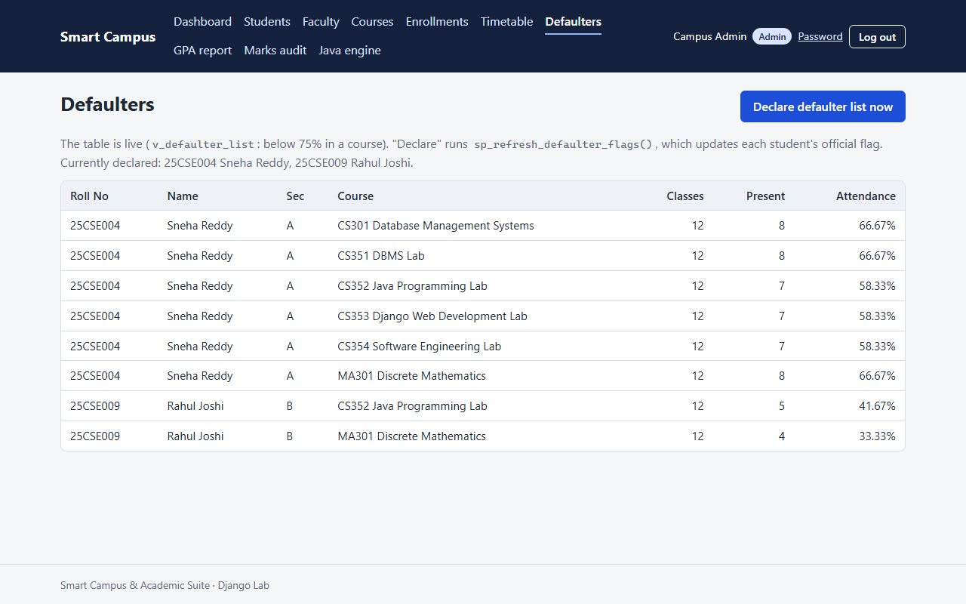
Figure 9.1: Admin defaulter list with the declare button
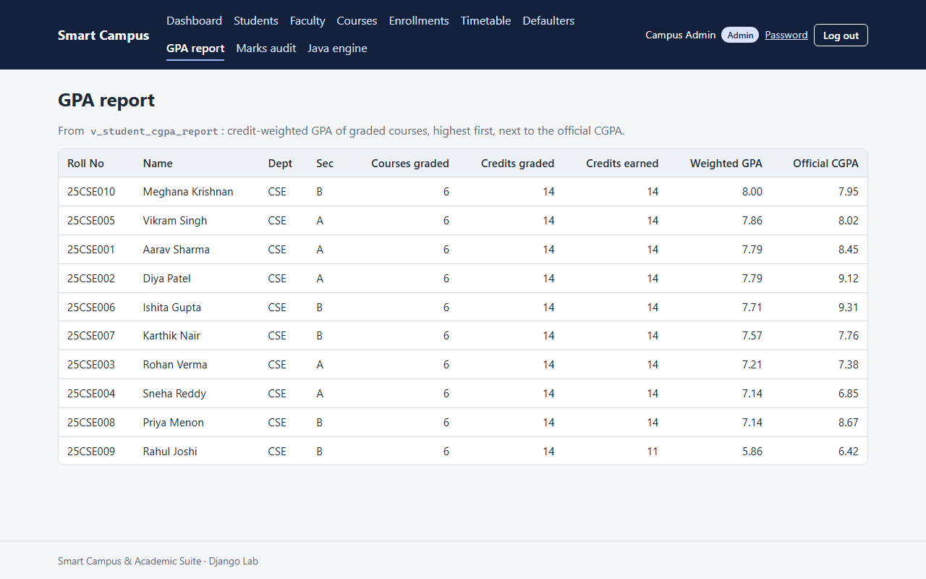
Figure 9.2: GPA report: weighted GPA next to the official CGPA
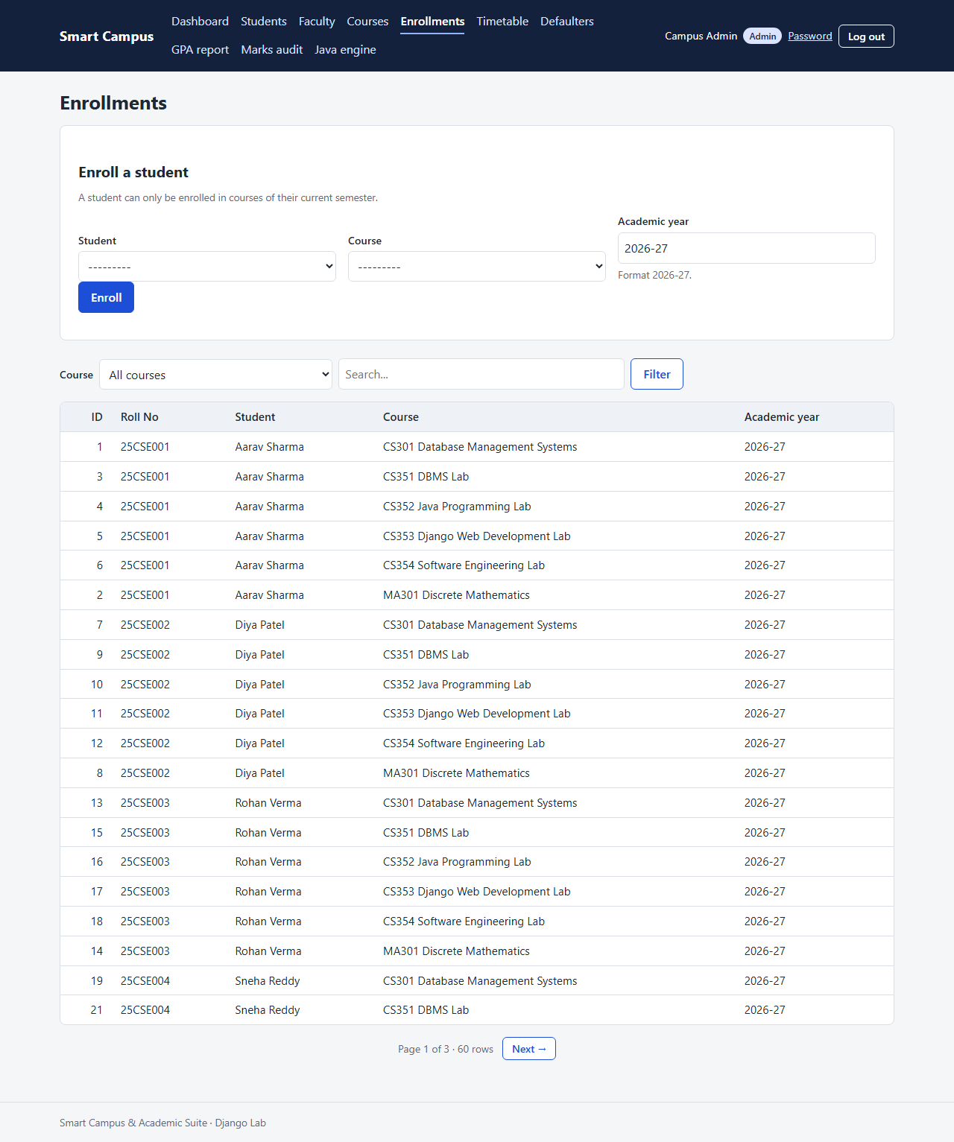
Figure 9.3: Enrollments list and enroll form
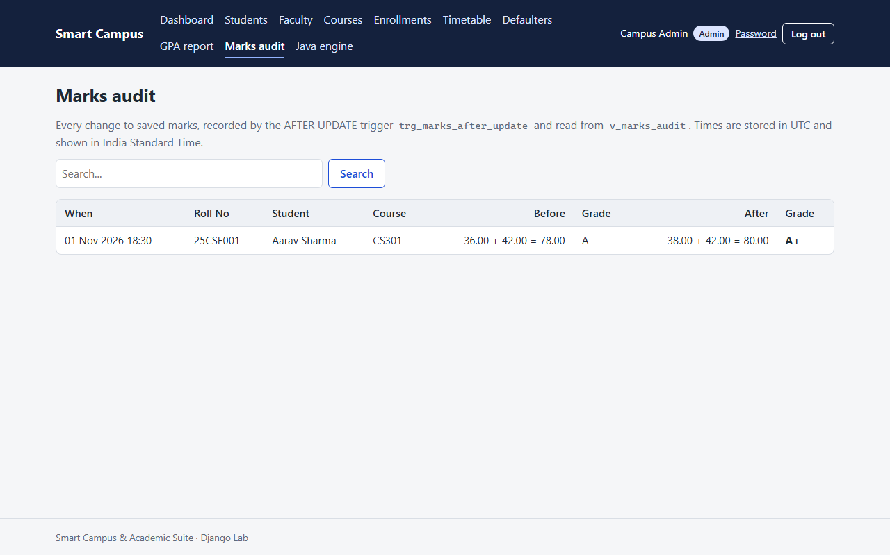
Figure 9.4: Marks audit history written by the AFTER UPDATE trigger
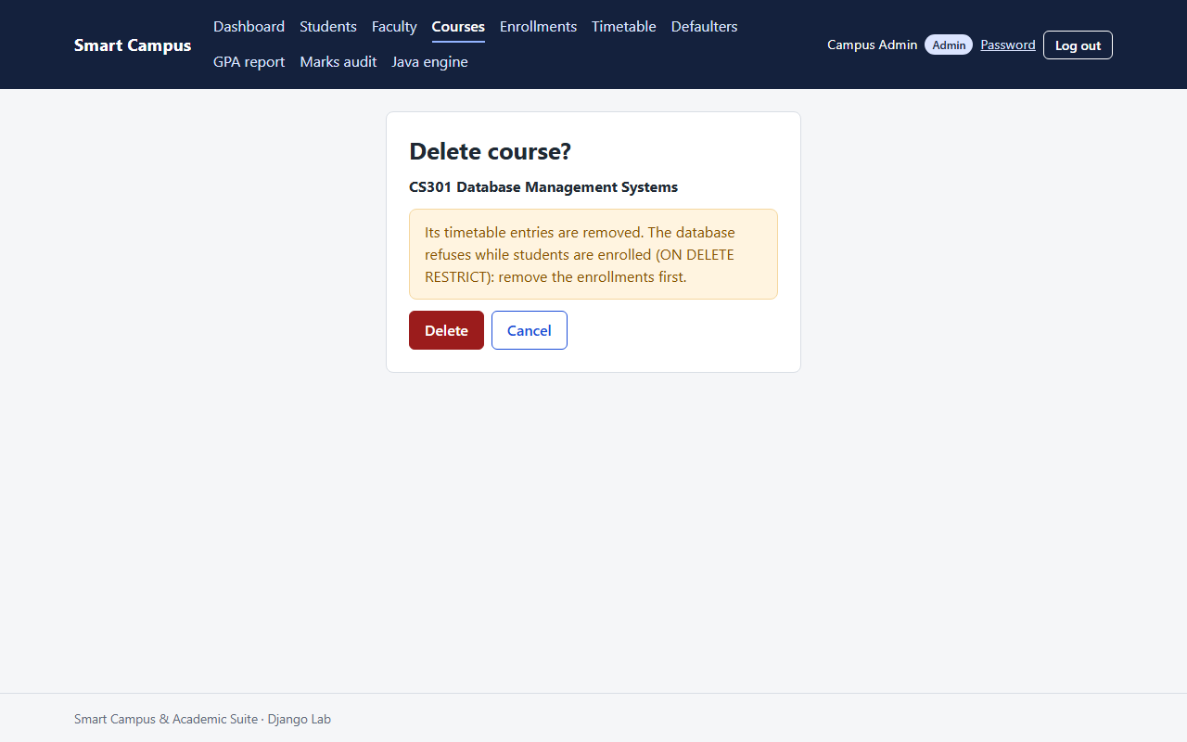
Figure 9.5: Delete confirmation page
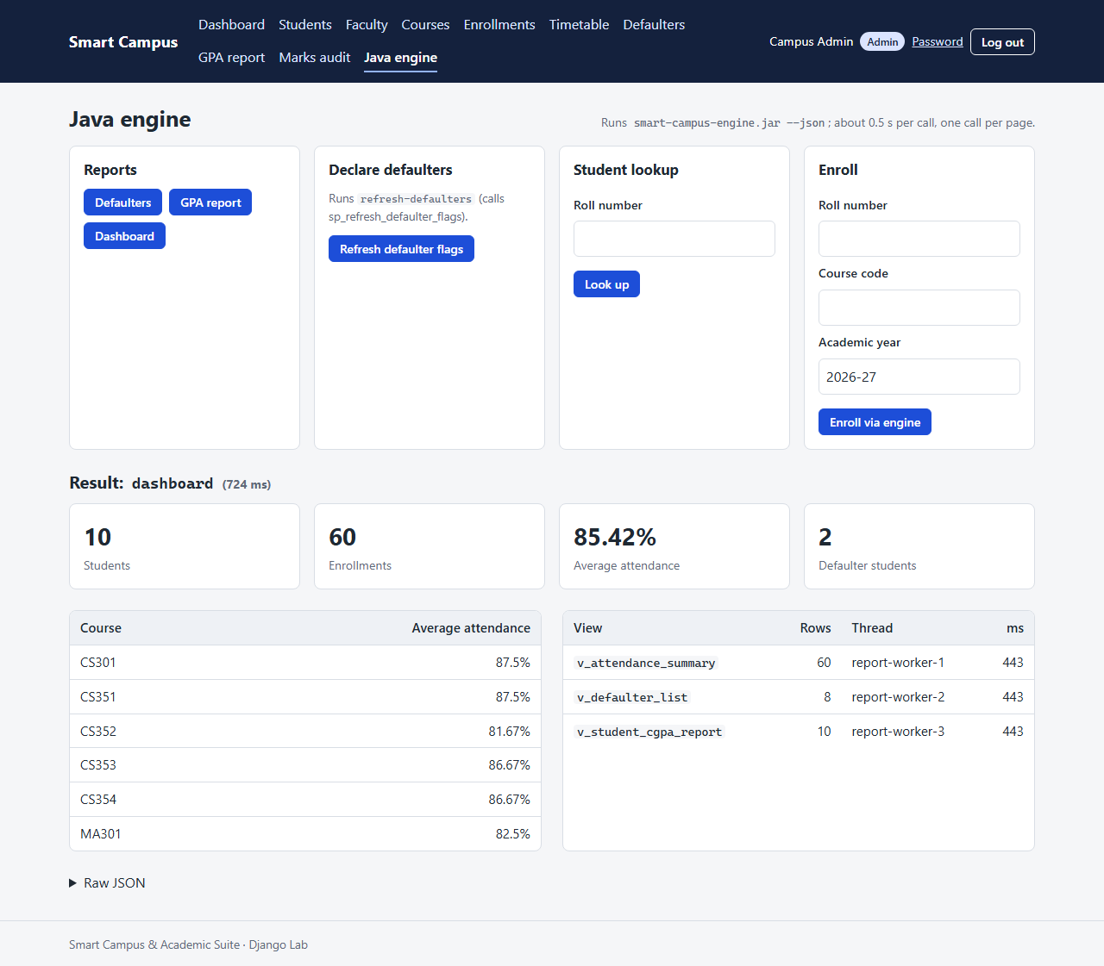
Figure 9.6: Java engine dashboard run from the portal, with thread names and timings
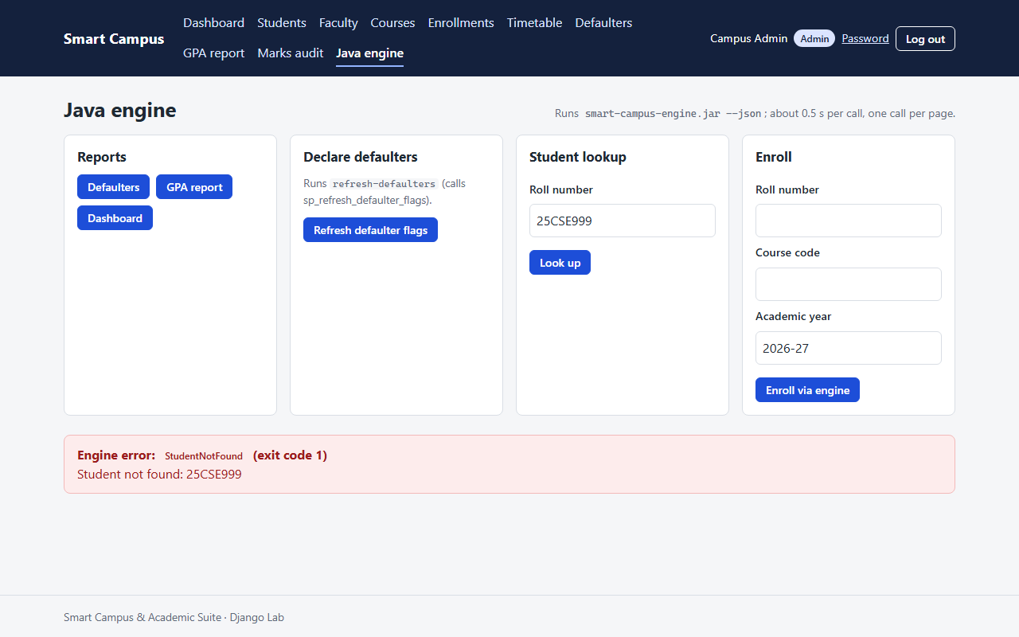
Figure 9.7: Typed error card from the engine page
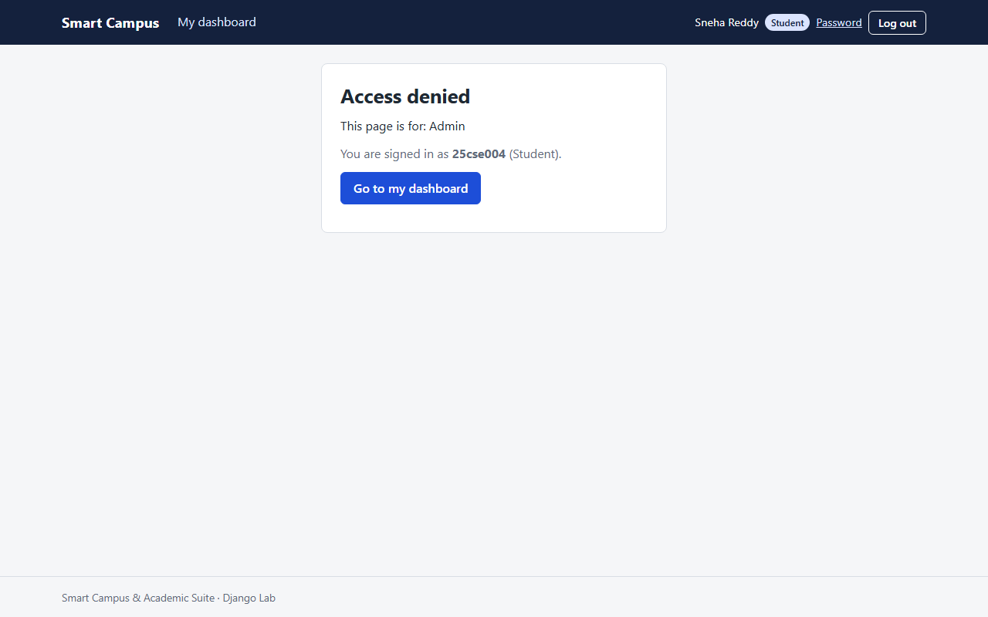
Figure 9.8: Access denied (403) page for a wrong role
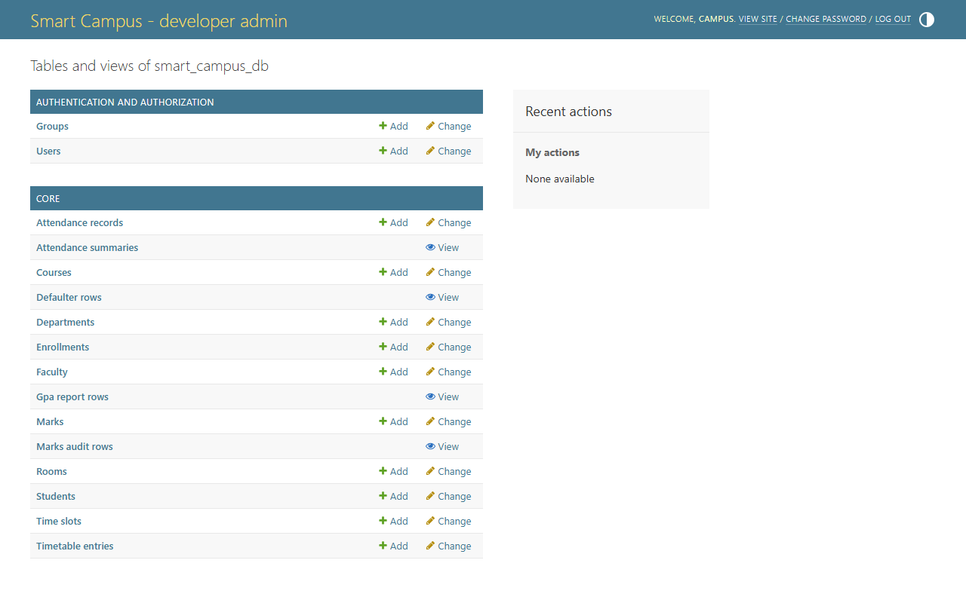
Figure 9.9: Django admin over the domain tables and the four views
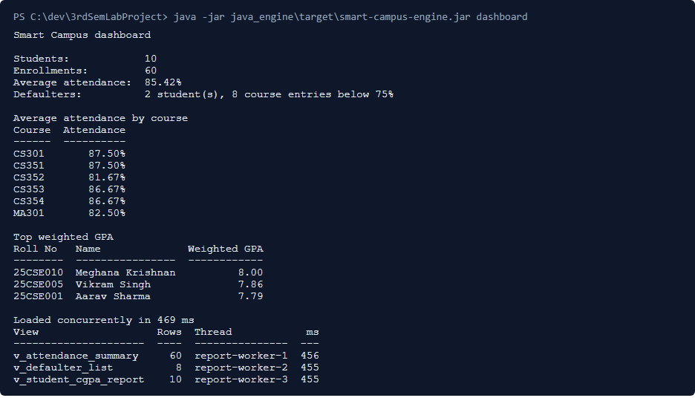
Figure 9.10: Engine dashboard in the terminal
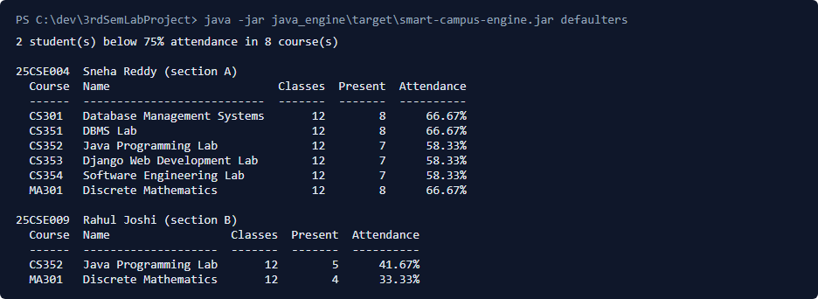
Figure 9.11: Engine defaulter report in the terminal
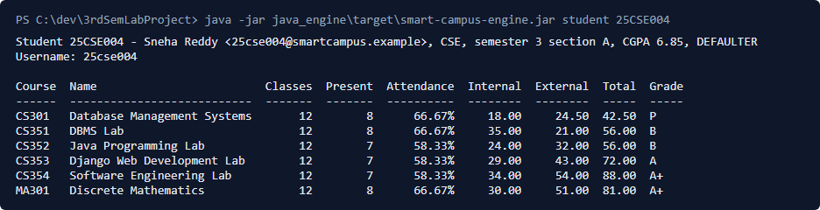
Figure 9.12: Engine student lookup in the terminal

9.4 Performance evaluation
Table 9.2: Performance evaluation
Measurement | Result
Ordinary portal pages (median of medians, 15 pages) | 62.7 ms (range 47.4-69.2 ms)
Engine page: dashboard (median) | 750.4 ms
Engine page: defaulters (median) | 668.7 ms
CLI help (JVM start-up only) | 168 ms
CLI commands that query MySQL | 636-813 ms
Database rebuild (init_db.py) | 1.3 s
Engine build with tests (mvnw clean package) | 13.7 s
Django test suite (71 tests) | 9.4 s test time, 16.7 s total

The difference between help (no database) and the other commands, about 0.5 s, is the cost of loading the JDBC driver and opening a MySQL connection; the JVM itself starts in about 0.17 s.

9.5 Comparison with the existing system
Table 9.3: Existing system vs proposed system
Aspect | Existing (manual) | Proposed system
Data storage | Registers and spreadsheets, duplicated | One 3NF database
Grade calculation | By hand or ad-hoc formulas | Trigger, identical for everyone
Attendance % | Totalled near the cut-off | Live from a view
Defaulter list | Prepared manually, late | Live list; declared with one click
Timetable clashes | Found when they happen | Refused when entered
Access control | Whoever holds the file | Role checked on every page
Change history | None | Automatic marks audit
Report time | Days | Under 1 s (Table 9.2)

9.6 Discussion of results
Placing the rules in the database proved to be the key design decision. Tests IT02, IT05 and IT06 show that a change made through one application is graded, checked and audited without that application doing any of the work, and IT09-IT10 show the Java engine receiving the same answers and errors. Security tests showed no way for a student or teacher to reach another person's data, and the URL-wide test guarantees this for pages added later. The main cost is the engine's start-up time, which is acceptable for one call per page but would need a resident service for heavy use. Unit-test coverage of the Java DAO layer is low by design (no database in unit tests); that layer is covered by the integration and loop cases instead.

9.7 Achievement of project objectives
Table 9.4: Achievement of objectives
Objective | Achieved | Evidence
O1 Normalised database with rules | Yes | Section 4.8-4.9; CHECK/UNIQUE/FK tests
O2 Derived values in the database | Yes | WB01-WB08, BB09-BB12, IT02, IT03
O3 Role-based portal | Yes | IT01, WB09-WB11, BB34-BB35, test_polish
O4 OOP Java engine with JDBC | Yes | Class diagrams; 29 JUnit tests; IT09-IT10
O5 Safe portal-engine bridge | Yes | UT03-UT04, IT08, BB30
O6 Tests and design documents | Yes | Chapters 4 and 6; Appendix C

9.8 Summary
The system meets all six objectives and every non-functional requirement that was measured. Pages respond in tens of milliseconds, engine reports in under a second, and all automated tests and documented cases pass.

CHAPTER 10: CONCLUSION

10.1 Conclusion
Smart Campus & Academic Suite replaces registers and spreadsheets with one consistent database and role-based access for students, faculty and the administrator. By enforcing grading, attendance, enrollment and timetable rules inside MySQL, it guarantees that the Django portal, the Java engine and any future client always agree. The system was designed, implemented, tested and documented following the SDLC, and all planned objectives were achieved.

10.2 Summary of the project
• A 3NF MySQL schema with 11 tables, 4 views, 9 triggers, 2 functions and 1 procedure.
• A Java 17 engine with an OOP domain model, JDBC DAOs, services, a concurrent dashboard, CSV export and a CLI with JSON output.
• A Django 5.2 portal with Student, Faculty and Admin roles, CRUD, reports, an audit view and a bridge to the engine.
• Requirements, UML, DFD and ER design; 78 documented test cases and 100 automated tests, all passing.

10.3 Contribution of the project
The project is the joint work of a four-member team (Section 5.7.7), which together built the database, the Java engine, the Django portal and the Software Engineering documentation. Its main contributions are:
• Shows how one database can serve two applications in different languages with identical rules.
• Provides an automatic, tamper-evident history of marks changes.
• Gives students early warning of attendance shortfalls.
• Serves as a single worked example for the DBMS, Java, Django and Software Engineering labs.

10.4 Learning outcomes
• Normalising a real schema and expressing business rules as constraints, triggers and views.
• Applying OOP (abstraction, inheritance, interfaces, generics, exceptions) and JDBC transactions in Java.
• Building a secure MVT web application with role-based access in Django.
• Integrating programs across languages through a process boundary and a JSON contract.
• Writing an SRS, drawing UML/DFD/ER diagrams as code, designing white- and black-box tests, and managing the work with Git.

10.5 Scope for future work
Future work includes bulk import, notifications, multi-department support, charts, a REST API for a mobile app and a production deployment with TLS (Section 8.8), as well as a formal acceptance test with real faculty and students.

REFERENCES
[1] E. F. Codd, "A relational model of data for large shared data banks," Commun. ACM, vol. 13, no. 6, pp. 377-387, Jun. 1970, doi: 10.1145/362384.362685.
[2] R. S. Sandhu, E. J. Coyne, H. L. Feinstein, and C. E. Youman, "Role-based access control models," Computer, vol. 29, no. 2, pp. 38-47, Feb. 1996, doi: 10.1109/2.485845.
[3] D. F. Ferraiolo, J. F. Barkley, and D. R. Kuhn, "A role-based access control model and reference implementation within a corporate intranet," ACM Trans. Inf. Syst. Secur., vol. 2, no. 1, pp. 34-64, Feb. 1999, doi: 10.1145/300830.300834.
[4] M. N. F. Hidayah and H. Sofyan, "Design and implementation of an integrated web-based academic management and student admission monitoring system using Django framework," CODEX: J. Softw. Eng., vol. 1, no. 1, 2026, doi: 10.33650/codex.v1i01.14454.
[5] J. Thilagavathi, G. P. Narasimha, S. Yasaswini, and E. Aiswarya, "College management system using Python & Django," Shanlax Int. J. Arts, Sci. Humanities, vol. 11, no. S3, Jul. 2024, doi: 10.34293/sijash.v11iS3-July.7911.
[6] M. J. Davis and Z. Huang, "ERP in higher education: A case study of SAP and Campus Management," Issues Inf. Syst., vol. VIII, no. 1, pp. 120-126, 2007. [Online]. Available: https://iacis.org/iis/2007/Davis_Huang.pdf
[7] OS4ED, "openSIS Classic: Open-source student information system," GitHub repository. [Online]. Available: https://github.com/OS4ED/openSIS-Classic (accessed Nov. 1, 2026).
[8] Foradian Technologies, "Fedena: School management software," [Online]. Available: https://fedena.com/ (accessed Nov. 1, 2026).
[9] D. Marsden et al., "Attendance (mod_attendance)," Moodle Plugins Directory. [Online]. Available: https://moodle.org/plugins/mod_attendance (accessed Nov. 1, 2026).
[10] R. S. Pressman and B. R. Maxim, Software Engineering: A Practitioner's Approach, 9th ed. New York, NY, USA: McGraw-Hill, 2019.
[11] I. Sommerville, Software Engineering, 10th ed. Boston, MA, USA: Pearson, 2015.
[12] G. Booch, J. Rumbaugh, and I. Jacobson, The Unified Modeling Language User Guide, 2nd ed. Boston, MA, USA: Addison-Wesley, 2005.
[13] Django Software Foundation, "Django 5.2 documentation," [Online]. Available: https://docs.djangoproject.com/en/5.2/ (accessed Nov. 1, 2026).
[14] Oracle Corporation, "MySQL 8.0 reference manual," [Online]. Available: https://dev.mysql.com/doc/refman/8.0/en/ (accessed Nov. 1, 2026).
[15] PlantUML, "PlantUML language reference guide," [Online]. Available: https://plantuml.com/ (accessed Nov. 1, 2026).
[16] The JUnit Team, "JUnit user guide," [Online]. Available: https://docs.junit.org/ (accessed Nov. 1, 2026).
[17] Microsoft, "Playwright for Python," [Online]. Available: https://playwright.dev/python/ (accessed Nov. 1, 2026).
[18] IEEE Recommended Practice for Software Requirements Specifications, IEEE Std 830-1998, 1998, doi: 10.1109/IEEESTD.1998.88286.

APPENDIX A: SOFTWARE CONFIGURATION MANAGEMENT
Software Configuration Management (SCM) identifies the items that make up the system, controls changes to them, and records how each version was built and released. This appendix describes the SCM actually used in the project and is referred to from Chapters 5 and 8.

A.1 Configuration identification
Table A.1: Configuration items
Configuration item | Location | Identified by
Database scripts | database/*.sql, init_db.py | Git path + commit
Java engine source and build | java_engine/ (pom.xml, src/) | Maven version 1.0.0-SNAPSHOT + commit
Django portal | campus_portal/ | Git path + commit
Dependencies | requirements.txt, pom.xml | Pinned versions
Configuration template | .env.example (real .env is git-ignored) | Git path
Design documents | docs/*.md, docs/src/diagrams/*.puml | Git path + commit
Test evidence | docs/src/evidence/*.json | Generated by scripts; committed
Project guide | CLAUDE.md, README.md | Updated when each phase lands

A.2 Version control
The repository is managed with Git and hosted on GitHub; all work is on the main branch. Commit messages follow the Conventional Commits style (feat, fix, docs, test, chore with a scope such as database, java or django). Table A.2 lists all 28 commits up to the conversion of this report into a group report (249 tracked files at that point); only the commit that stores the regenerated document itself comes after it.
The repository (rishi-ventrapragada/3rdSemLabProject) is hosted on V. Sai Rishi's GitHub account, and every commit in the history was made from that account; the team's work was integrated through this single repository.
Table A.2: Git history of the project
Commit | Date | Message
4ae9dc0 | 2026-10-15 | chore: scaffold 4-lab project structure, Maven fat-JAR setup, and CLAUDE.md
c62e999 | 2026-10-16 | feat(database): add 3NF schema, views, triggers, seed data and init_db.py
30445ca | 2026-10-31 | feat(java): add DB config loader and checked exception hierarchy
c9efb16 | 2026-10-31 | feat(java): add domain models with Person -> Student/Faculty hierarchy
0b1d670 | 2026-10-31 | feat(java): add DAO interfaces and JDBC implementations
ecf5b18 | 2026-10-31 | feat(java): add student and report services
f7aa6bb | 2026-10-31 | feat(java): add CLI commands with text and --json output
5937f1f | 2026-10-31 | docs: document Phase 3 Java engine commands and pitfalls in CLAUDE.md
2177c9d | 2026-10-31 | feat(django): create campus_portal project with unmanaged models
af5e1b5 | 2026-10-31 | feat(django): add login, role routing, demo users and base UI
9d320e0 | 2026-10-31 | feat(django): add student and faculty portals with DB-backed writes
fea3450 | 2026-10-31 | feat(django): add admin portal with reports and CRUD
d523464 | 2026-10-31 | feat(django): add admin-only Java engine bridge page
8442463 | 2026-10-31 | test(django): add role, bridge and real-database tests
6f74e2b | 2026-10-31 | docs: document the Django portal, demo logins and Phase 4 pitfalls
c96e1f6 | 2026-11-01 | fix(database): make section and dept_code CHECKs case-sensitive
e586990 | 2026-11-01 | feat(database): add marks audit trail (AFTER trigger) and lab query examples
d0d4413 | 2026-11-01 | feat(java): add CSV export (file I/O) and an interactive Scanner menu
eee70ad | 2026-11-01 | feat(django): complete CRUD, Django admin, audit pages and UX polish
659f320 | 2026-11-01 | feat(django): harden session/cookie settings and add URL-wide access tests
dd549b1 | 2026-11-01 | docs: add README and document the Phase 4.5 changes
6de2bea | 2026-11-01 | fix(django): give paginated faculty and course lists a stable order
7f90322 | 2026-11-01 | docs(report): add evidence collectors and their real-run results
e7eec24 | 2026-11-01 | docs(report): add PlantUML sources and rendered diagrams
ebc6299 | 2026-11-01 | docs(report): add portal and CLI screenshots from the live run
cac55d6 | 2026-11-01 | docs(report): add the python-docx report builder
896a2bd | 2026-11-01 | docs: add the SE Lab project report (Phase 5)
be5c1de | 2026-11-04 | docs(report): convert the report sources to a group report

A.3 Baselines
Table A.3: Baselines
Baseline | Commit | Contents
Phase 1: scaffolding | 4ae9dc0 | Folder structure, Maven fat-JAR setup, project guide
Phase 2: database | c62e999 | Schema, views, triggers, seed data, init_db.py
Phase 3: Java engine | 5937f1f | Config, models, DAOs, services, CLI, tests, docs
Phase 4: Django portal | 6f74e2b | Three portals, bridge, tests, docs
Phase 4.5: polish | 6de2bea | Audit trail, CSV export, menu, CRUD, security, fixes
Phase 5: SE report | 896a2bd | Evidence scripts, diagrams, screenshots, report builder, report

A.4 Change control
1. A change starts from a requirement, a defect (Chapter 6.12) or review feedback.
2. Its impact is checked against the rule "the SQL scripts are the source of truth": a schema change must update, in one commit, the SQL, the unmanaged Django model, the Java model and DAO, and the ER diagram.
3. The change is made with a test that fails before and passes after.
4. Both suites are run; then a secret scan checks that no .env content or password is staged.
5. The commit is pushed only after the scan is clean; database fixes were approved by the team before database/ was touched.

A.5 Build and release management
Table A.4: Build and release
Artifact | Built by | Release check
smart_campus_db | python database/init_db.py --yes | Row counts printed; Django tests load the same scripts
smart-campus-engine.jar | mvnw clean package (Maven 3.9.16 pinned by the wrapper) | 29 JUnit tests must pass
Django portal | pip install -r requirements.txt; migrate | manage.py check; 71 tests must pass
Project report | docs/src/report/build_report.py | Rendered with LibreOffice and checked page by page

A.6 SCM tools
Table A.5: SCM tools
Tool | Use
Git 2.53.0 | Version control, history, baselines
GitHub | Remote repository and backup
.gitignore | Keeps .env, build output, virtual environments and downloaded tools out of Git
.gitattributes | Forces LF line endings for mvnw
Maven Wrapper | Reproducible Maven version for every build
requirements.txt / pom.xml | Pinned dependency versions

APPENDIX B: RISK MANAGEMENT
Risks were identified at the start of each phase, rated for probability and impact (Low, Medium, High), and tracked until closed. This appendix is referred to from Chapter 8.
Table B.1: Risk register
ID | Risk | Prob. | Impact | Mitigation | Status
R1 | Database password or .env committed to GitHub | Medium | High | .env git-ignored; secret scan in a separate step before every push | Controlled
R2 | Rules implemented differently in Django and Java | High | High | Rules placed in MySQL triggers, views and constraints | Closed
R3 | init_db.py run against real data and erases it | Low | High | Confirmation prompt unless --yes; Django tables never touched | Controlled
R4 | Engine JAR missing or Java not installed on the server | Medium | Medium | Bridge checks the JAR first; typed errors with a build hint; never a 500 page | Closed
R5 | Command injection through the bridge | Low | High | Argument list, shell=False, allow-list, regex, timeout | Closed
R6 | Framework incompatibility (Django 6.1 needs MySQL 8.4) | Medium | Medium | Stay on Django 5.2 LTS | Closed
R7 | Platform differences (Windows encodings, BOM, line endings) | High | Medium | -Dfile.encoding=UTF-8, BOM stripping, .gitattributes for mvnw | Closed
R8 | A new page added without a role check | Medium | High | URL-wide access test fails the suite | Controlled
R9 | Schedule slip near the semester end | Medium | Medium | Phased plan; each phase committed and usable on its own | Closed
R10 | Slow engine calls if used per table row | Medium | Medium | Design rule: one engine call per page | Controlled
R11 | Loss of the laptop or disk | Low | High | Code pushed to GitHub after each phase; database rebuilt from scripts | Controlled

Risk exposure was highest in Phase 3 and 4 (R2, R5, R7), when the two applications were connected; all three were closed by design decisions that are verified by tests in Chapter 6.

APPENDIX C: AUTOMATED TEST LOG
Every automated test from the final run on 2026-11-01, as reported by Maven Surefire and the Django test runner.
Table C.1: JUnit tests
# | JUnit class | Test | Time (s) | Status
1 | cli.CliTest | academicYearRollsOverInJuly | 0.123 | Pass
2 | cli.CliTest | wrongArgumentCountIsAUsageErrorBeforeAnyDatabaseCall | 0.026 | Pass
3 | cli.CliTest | optionsAreCheckedPerCommand | 0.004 | Pass
4 | cli.CliTest | usageErrorsAreJsonOnStderrWhenRequested | 0.006 | Pass
5 | cli.CliTest | unknownCommandIsAUsageError | 0.002 | Pass
6 | cli.CliTest | noArgumentsShowsHelp | 0.008 | Pass
7 | cli.CliTest | helpListsEveryCommandAndExitsZero | 0.003 | Pass
8 | cli.InteractiveMenuTest | listsChoicesAndExitsOnZero | 0.046 | Pass
9 | cli.InteractiveMenuTest | blankAnswerCancelsWithoutRunningTheCommand | 0.004 | Pass
10 | cli.InteractiveMenuTest | endOfInputExitsCleanly | 0.002 | Pass
11 | cli.InteractiveMenuTest | leadingByteOrderMarkFromPowerShellPipesIsIgnored | 0.003 | Pass
12 | cli.InteractiveMenuTest | rejectsUnknownChoices | 0.004 | Pass
13 | cli.InteractiveMenuTest | menuRefusesJson | 0.031 | Pass
14 | cli.JsonWriterTest | escapesBackslash | 0.002 | Pass
15 | cli.JsonWriterTest | writesAWholeStudentRecordWithAHostileName | 0.008 | Pass
16 | cli.JsonWriterTest | writesNullsNumbersAndNestedCollections | 0.006 | Pass
17 | cli.JsonWriterTest | escapesQuoteInAName | 0.003 | Pass
18 | cli.JsonWriterTest | rejectsValuesJsonCannotRepresent | 0.011 | Pass
19 | cli.JsonWriterTest | leavesOrdinaryUnicodeAndApostrophesAlone | 0.003 | Pass
20 | cli.JsonWriterTest | escapesLineAndParagraphSeparators | 0.003 | Pass
21 | cli.JsonWriterTest | escapesOtherControlCharactersAsUnicode | 0.004 | Pass
22 | cli.JsonWriterTest | escapesNewlinesTabsAndShortEscapes | 0.002 | Pass
23 | config.DatabaseConfigTest | findsEnvFileInAParentDirectory(Path) | 0.225 | Pass
24 | config.DatabaseConfigTest | parsesEnvFileSkippingCommentsAndBlankLines(Path) | 0.018 | Pass
25 | config.DatabaseConfigTest | reportsMissingAndInvalidSettings | 0.011 | Pass
26 | config.DatabaseConfigTest | buildsJdbcUrlWithRequiredOptionsAndHidesPassword | 0.017 | Pass
27 | services.ReportExporterTest | writesHeaderAndRowsAndCreatesParentFolders(Path) | 0.056 | Pass
28 | services.ReportExporterTest | quotesFieldsWithCommasQuotesAndLineBreaks | 0.002 | Pass
29 | services.ReportExporterTest | reportNamesAreCaseInsensitiveAndUnknownOnesAreRejected | 0.009 | Pass

Table C.2: Django tests
# | Module.Class | Test | Status
1 | test_access.LoginRedirectTests | test_each_role_lands_on_its_dashboard | Pass
2 | test_access.LoginRedirectTests | test_login_honours_next | Pass
3 | test_access.LoginRedirectTests | test_login_not_linked_to_a_person_gets_403_not_a_crash | Pass
4 | test_access.LoginRedirectTests | test_logout_requires_post | Pass
5 | test_access.LoginRedirectTests | test_wrong_password_stays_on_login | Pass
6 | test_access.RoleAccessTests | test_admin_reaches_only_the_admin_portal_and_engine | Pass
7 | test_access.RoleAccessTests | test_anonymous_users_are_sent_to_login | Pass
8 | test_access.RoleAccessTests | test_faculty_reaches_only_the_faculty_portal | Pass
9 | test_access.RoleAccessTests | test_student_reaches_only_the_student_portal | Pass
10 | test_access.RoleAccessTests | test_teacher_cannot_open_another_teachers_course | Pass
11 | test_access.RoleAccessTests | test_unknown_course_is_404 | Pass
12 | test_java_bridge.EngineViewTests | test_engine_error_type_is_shown | Pass
13 | test_java_bridge.EngineViewTests | test_enroll_form_passes_year | Pass
14 | test_java_bridge.EngineViewTests | test_gpa_report_renders_a_table_with_one_call | Pass
15 | test_java_bridge.EngineViewTests | test_invalid_roll_number_never_reaches_the_engine | Pass
16 | test_java_bridge.EngineViewTests | test_missing_jar_shows_build_instructions | Pass
17 | test_java_bridge.EngineViewTests | test_non_admins_get_403 | Pass
18 | test_java_bridge.EngineViewTests | test_page_without_a_command_makes_no_call | Pass
19 | test_java_bridge.EngineViewTests | test_student_lookup_passes_the_validated_roll_number | Pass
20 | test_java_bridge.EngineViewTests | test_writes_require_post | Pass
21 | test_polish.DeleteTests | test_confirm_page_then_cascading_delete_of_a_student | Pass
22 | test_polish.DeleteTests | test_course_with_enrollments_is_protected_by_restrict | Pass
23 | test_polish.DeleteTests | test_delete_requires_post | Pass
24 | test_polish.DeleteTests | test_deleting_a_teacher_unassigns_their_courses | Pass
25 | test_polish.DjangoAdminTests | test_deletes_are_routed_to_the_portal | Pass
26 | test_polish.DjangoAdminTests | test_every_registered_model_has_a_working_changelist | Pass
27 | test_polish.ErrorPageAndHeaderTests | test_custom_404_page | Pass
28 | test_polish.ErrorPageAndHeaderTests | test_custom_500_page_needs_no_context | Pass
29 | test_polish.ErrorPageAndHeaderTests | test_security_headers_and_session_cookie | Pass
30 | test_polish.EveryUrlIsProtectedTests | test_anonymous_requests_redirect_to_login | Pass
31 | test_polish.EveryUrlIsProtectedTests | test_each_role_is_refused_outside_its_own_portal | Pass
32 | test_polish.MarksAuditTests | test_changed_marks_are_audited_by_the_after_trigger | Pass
33 | test_polish.PasswordChangeTests | test_user_can_change_password_and_log_in_with_it | Pass
34 | test_polish.PasswordChangeTests | test_weak_or_mismatched_passwords_are_rejected | Pass
35 | test_polish.SearchAndPaginationTests | test_active_navigation_link | Pass
36 | test_polish.SearchAndPaginationTests | test_empty_search_result_shows_an_empty_state | Pass
37 | test_polish.SearchAndPaginationTests | test_enrollments_are_paginated | Pass
38 | test_polish.SearchAndPaginationTests | test_search_filters_and_keeps_other_filters | Pass
39 | test_portals.AdminPortalTests | test_check_constraint_message_for_bad_section | Pass
40 | test_portals.AdminPortalTests | test_declaring_defaulters_calls_the_procedure | Pass
41 | test_portals.AdminPortalTests | test_duplicate_enrollment_is_explained | Pass
42 | test_portals.AdminPortalTests | test_enroll_enforces_the_semester_rule_and_succeeds_otherwise | Pass
43 | test_portals.AdminPortalTests | test_gpa_report_is_ordered_by_weighted_gpa | Pass
44 | test_portals.AdminPortalTests | test_room_double_booking_uses_the_unique_constraint_message | Pass
45 | test_portals.AdminPortalTests | test_student_can_be_added_and_edited | Pass
46 | test_portals.AdminPortalTests | test_student_cannot_take_a_faculty_username | Pass
47 | test_portals.AdminPortalTests | test_teacher_double_booking_shows_a_friendly_message | Pass
48 | test_portals.AdminPortalTests | test_valid_timetable_entry_is_added | Pass
49 | test_portals.FacultyPortalTests | test_attendance_is_saved_and_updated | Pass
50 | test_portals.FacultyPortalTests | test_internal_only_leaves_the_grade_empty | Pass
51 | test_portals.FacultyPortalTests | test_marks_are_graded_by_the_trigger_not_python | Pass
52 | test_portals.FacultyPortalTests | test_out_of_range_marks_are_rejected_per_row | Pass
53 | test_portals.FacultyPortalTests | test_weekend_attendance_shows_the_database_rule | Pass
54 | test_portals.SeedDemoUsersTests | test_rerunning_updates_instead_of_duplicating | Pass
55 | test_portals.StudentPortalTests | test_defaulter_sees_the_warning_from_v_defaulter_list | Pass
56 | test_portals.StudentPortalTests | test_student_in_good_standing_sees_no_warning | Pass
57 | test_portals.StudentPortalTests | test_student_sees_only_their_own_courses | Pass
58 | test_java_bridge.BuildCommandTests | test_arguments_are_validated | Pass
59 | test_java_bridge.BuildCommandTests | test_argv_is_a_list_with_json_flag_and_utf8 | Pass
60 | test_java_bridge.BuildCommandTests | test_commands_off_the_allow_list_are_refused | Pass
61 | test_java_bridge.BuildCommandTests | test_enroll_with_year | Pass
62 | test_java_bridge.BuildCommandTests | test_year_is_validated_and_only_for_enroll | Pass
63 | test_java_bridge.RunEngineTests | test_engine_error_type_comes_from_stderr_json | Pass
64 | test_java_bridge.RunEngineTests | test_jar_missing_never_starts_java | Pass
65 | test_java_bridge.RunEngineTests | test_java_missing | Pass
66 | test_java_bridge.RunEngineTests | test_json_after_jvm_warnings_is_still_parsed | Pass
67 | test_java_bridge.RunEngineTests | test_non_json_failure_is_internal | Pass
68 | test_java_bridge.RunEngineTests | test_success_parses_stdout_and_runs_without_a_shell | Pass
69 | test_java_bridge.RunEngineTests | test_success_without_json_is_bad_output | Pass
70 | test_java_bridge.RunEngineTests | test_timeout | Pass
71 | test_java_bridge.RunEngineTests | test_usage_error_keeps_exit_code_2 | Pass

