YouTube Movie Recommendations: A Deep Learning Approach to Collaborative Filtering

*Abstract* – This research introduces and compares two specialized neural network architectures, CollabNet and ConcatNet, designed for enhancing recommendation systems through collaborative filtering. CollabNet, or Collaborative Network, leverages traditional collaborative filtering principles combined with neural network techniques, integrating user and item embeddings, bias terms, and a sigmoid activation function to predict user preferences accurately. ConcatNet, or Concatenation Network, extends this approach by incorporating a concatenation layer that merges user and item embeddings. This architectural enhancement allows ConcatNet to capture and generalize complex interactions more effectively. Using the MovieLens dataset—a collection of 100,000 user reviews for 1,682 movies—the research finds that ConcatNet outperforms CollabNet in terms of validation loss and error rate stability, indicating better model performance and generalization skills. These results demonstrate how highly trained neural network architectures may be used for collaborative filtering to greatly increase the precision and customization of movie suggestions.

*Index Terms* – Collaborative Filtering, Deep Learning, Recommendation Systems, Neural Network Architectures, Model Generalization, Concatenation Layers, User-Item Embeddings

**Introduction**

In the quickly changing world of digital media, recommendation systems' efficacy has become essential to user engagement and happiness. While useful in certain situations, traditional collaborative filtering techniques frequently encounter problems with scalability and data sparsity when used with big datasets. New techniques to overcome these obstacles have been made possible by recent developments in deep learning, which provide more advanced methods for modelling intricate user-item interactions.

In order to improve the functionality of movie recommendation systems, two new neural network designs are presented in this paper: ConcatNet (Concatenation Network) and CollabNet (Collaborative Network). CollabNet uses sigmoid activation functions, bias terms, and a combination of user and item embeddings to anticipate user preferences through the application of neural network methodologies in addition to classic collaborative filtering techniques. Conversely, ConcatNet expands upon this foundation by incorporating a concatenation layer that merges user and item embeddings before processing them through advanced neural network components. This distinctive feature of ConcatNet is designed to better capture and generalize the latent relationships inherent in user-item interaction data.

The choice of the MovieLens dataset for this study provides a robust platform for evaluating the effectiveness of these models. Comprising 100,000 ratings from 943 users across 1,682 movies, the dataset offers a comprehensive array of user interactions, making it an ideal testbed for demonstrating the superior capabilities of advanced deep learning models over traditional methods.

The primary goal of this research is to compare the performance of CollabNet and ConcatNet, with a particular focus on their ability to minimize validation loss and stabilize error rates across epochs. Through this comparative analysis, we aim to highlight the potential benefits of using sophisticated neural architectures in collaborative filtering, ultimately leading to more accurate and personalized recommendations.

* **Dataset Description**

Any recommendation system's efficacy is largely determined by the caliber and scope of the dataset utilized for testing and training. We use the MovieLens dataset, a well-known benchmark dataset in the recommendation systems space, for our investigation. Approximately 100,000 ratings, from 1 to 5, are included in this dataset, which was submitted by 943 individuals for 1,682 different films. The collection uses four key attributes for each entry: the user's ID, the item (movie) ID, the user's rating, and the date of the rating.

* **Data Characteristics**

**User Distribution**: A wide variety of users with a wide range of preferences and behaviors are included in the dataset. To train robust, broadly applicable models that work with a variety of user types, diversity is essential.

**Diversity of Items:** The dataset, which includes 1,682 distinct movies, is perfect for evaluating the model's adaptability to a variety of content types because it spans a wide range of genres, release dates, and user interests.

**Spread of Ratings:** Since the ratings range from 1 to 5, it is possible to analyze user satisfaction and preferences across a range of appreciation levels in an impartial manner.

**Steps in Preprocessing**

The dataset was optimized for the deep learning models through a series of preprocessing processes prior to model deployment:

**Normalization**: In order to prevent the model from favoring users who rate more frequently or films that earn more ratings, ratings were normalize.

**Embedding Preparation:** To capture latent characteristics in lower-dimensional space, user IDs and item IDs were converted into dense vector representations, or embeddings. Both CollabNet and ConcatNet depend on this transformation to enable the models to learn and make predictions based on underlying patterns rather than explicit data.

**Training-Testing Split:** 80:20 data split was employed for training and testing, with 80 percent of the data being used for model training and the remaining 20 percent being kept back for validation. This division guarantees that the models are tested on untested data, offering an impartial appraisal of their generalization potential.

I. Collaborative Network

CollabNet makes use of the well-established matrix factorization architecture for collaborative filtering, but it also applies deep learning approaches to improve its ability to capture intricate patterns in interactions between users and items. The architecture's key idea is to use neural networks' capabilities to increase suggestion accuracy:

**Embedded Layers:** These layers are essential for converting user and item IDs, which are high-dimensional categorical data, into a dense, lower-dimensional vector space. The latent elements linked to user preferences and object characteristics should be captured by the vector of features that are learned during training and represent each user and item. One crucial hyperparameter that strikes a compromise between overfitting hazards and model complexity is the dimensionality of these embeddings.

**Bias Terms**: CollabNet incorporates user and item bias terms into its forecasts since it understands that certain people are more critical than others and that certain items are universally preferred. Together with the primary embeddings, these terms are also learned, enabling the model to modify its predictions according to average discrepancies in item popularities and rating behaviors.

**Element-wise Multiplication:** The user and item vectors are joined by element-wise multiplication following the acquisition of embeddings. With the assumption that effective interactions are nonlinear and can be represented by this product, the purpose of this operation is to explicitly simulate the interaction between user and item latent variables.

**Dimension Reduction:** Techniques for dimension reduction are used to control the complexity and improve the interpretability of the interaction data. Dimension reduction strategies are used to control the complexity and improve the interaction data's interpretability. In the process, the interaction data is compressed while attempting to retain the majority of the important information.

**Sigmoid Activation:** To make sure the output, the anticipated rating, falls within the expected range, the final prediction is run through a sigmoid activation function (1 to 5). This conversion is essential because it converts the neural network's possibly infinite output to a finite rating scale.

FIGURE I

CollabNet Architecture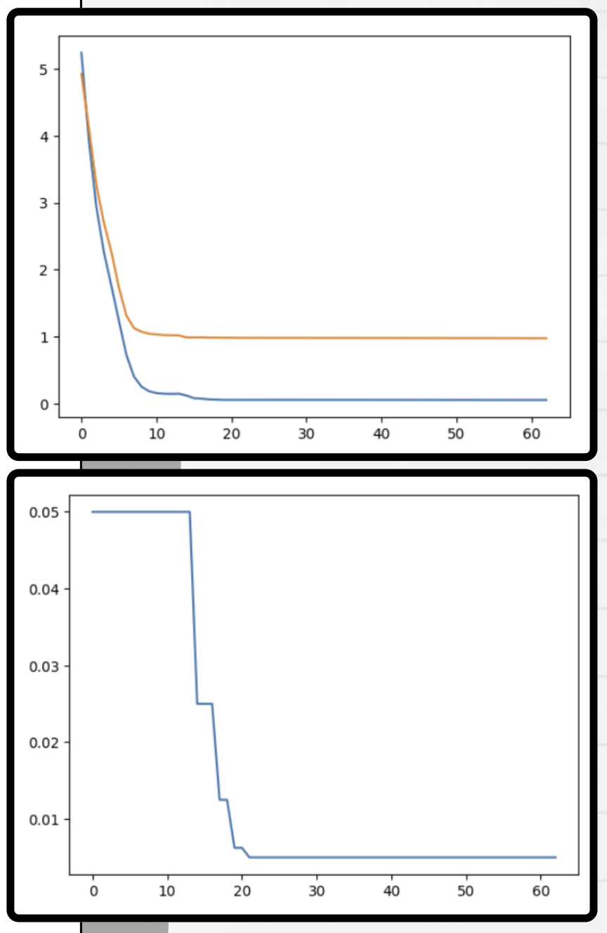

II. Concatenation Network

By adding a concatenation stage that joins the embeddings prior to additional processing, ConcatNet improves upon the architecture of CollabNet. By maintaining the different but complimentary information found in the user and item embeddings, this method aims to capture richer data:

FIGURE II

ConcatNet Architecture

**Concatenation Layer:** Concatenating user and item embeddings into a single vector prior to any additional processing is the fundamental innovation of ConcatNet. By treating the combined characteristics as a holistic input, the network can potentially capture interactions that are missed when multiplying or adding embeddings.

**Fully-Connected Layers:** The concatenated embeddings are subsequently fed via a number of fully-connected layers, or Fully-Connected Layers. Each layer is capable of learning intricate functions that translate features from the input to the output; performance is optimized by adjusting the depth and width of these layers. Because ReLU activation functions are efficient and effective at adding non-linearity, they are utilized here to aid in the identification of more intricate patterns within the data.

**Batch Normalization**: After every fully-connected layer, there is a batch normalization layer that scales and modifies the activations to normalize the outputs of the preceding layer. This normalisation expedites training, lessens the network's sensitivity to various initialization techniques, and aids in stabilizing the learning process.

**Rectified Linear Activation:** ReLU, is a technique used to introduce non-linearity without appreciably altering the scale of the input. This is important since it preserves the gradient flow throughout training, preventing the vanishing gradient problem.

**Training and Evaluation:** Both models make use of sophisticated optimization methods. The Adam optimizer is used due to its flexible learning rate capabilities, which facilitate the handling of high-dimensional and sparse data commonly seen in recommendation systems. The process of training entails minimizing a loss function that is especially intended to quantify the prediction accuracy in terms of root mean square error (RMSE), facilitating direct model comparisons.

FIGURE III

Comparative Analysis

CollabNet and ConcatNet, two highly developed deep learning models, were carefully examined and contrasted in this study according to how well they performed within the framework of the MovieLens dataset. By incorporating cutting-edge neural network techniques, these models were created to solve the inherent constraints of classical collaborative filtering. Their architectural strategies, however, differ greatly, and this has an impact on performance parameters including training stability, generalization ability, and RMSE (Root Mean Square Error).

**Performance Metrics**

* **RMSE**: In comparison to CollabNet, ConcatNet continuously showed a reduced RMSE during the training and validation stages. In particular, CollabNet reported a marginally greater validation loss of 0.974, whereas ConcatNet attained a validation loss of 0.873. This suggests that ConcatNet predicted user ratings more accurately.
* **Training Convergence**: ConcatNet performed better than CollabNet in terms of training efficiency as well as accuracy. Compared to CollabNet, which ran for 62 epochs, ConcatNet reached an early stopping point after just 15 epochs, indicating faster convergence and a more effective learning process.
* **Generalization Capability**: ConcatNet performed better in terms of generalization to previously encountered data, as seen by a smaller difference between training and validation performance. CollabNet demonstrated indications of possible overfitting despite its effectiveness, as demonstrated by the greater differences between the training and validation loss curves.

FIGURE IV

**Architectural Differences**

The concatenation layer's insertion into ConcatNet is the primary architectural difference that contributes to these outcomes. With the help of this layer, the model is better able to integrate and absorb information from user and item embedding interactions. ConcatNet processes these concatenated embeddings through several deep layers to capture intricate patterns and dependencies that are not as visible when element-wise multiplication is all that is used, as in CollabNet.

**Stability and Robustness**

Subsequent investigation showed that ConcatNet behaved more steadily when being trained. There was no variation in the error rates and loss metrics, suggesting a stable model that was less susceptible to the subtle differences between data batches. However, although though CollabNet was stable, its performance varied more between training epochs, which might be problematic for deployment in more dynamic real-world settings.

FIGURE V

**Decision to Use ConcatNet**

ConcatNet was selected as the main model for this research in light of these findings. The choice was made in light of multiple crucial factors

* **Higher Accuracy and Lower Error Rates:** ConcatNet consistently outperformed CollabNet in these critical metrics.
* **Efficient Learning and Faster Convergence:** ConcatNet is better suited for real-world applications where time and computational resources are critical due to its capacity to train more efficiently and converge more quickly.
* **Superior Generalization:** ConcatNet's ability to withstand unknown input without experiencing severe overfitting is essential for recommendation systems that deal with a broad range of user preferences and item types.

**Acknowledgment of Both Models**

Although ConcatNet was chosen for this project's main deployment, it's crucial to note that CollabNet also showed impressive capabilities and might be better in situations where element-wise interaction modeling is very helpful. The use of neural networks in recommendation systems has advanced significantly with both models, and future research may examine hybrid strategies that combine the advantages of both architectures.

TABLE I

Comparative Analysis of CollabNet and ConcatNet

|  |  |  |
| --- | --- | --- |
| Feature | CollabNet | ConcatNet |
| RMSE (Validation Loss)  Epochs to Convergence  Generalization Capability  Architectural Focus  Stability and Robustness | 0.974  62  Larger gap between training and validation loss  Element-wise multiplication of embeddings  More variability in performance across epochs | 0.873  15  Smaller gap, indicating better generalization.  Concatenation of user and item embeddings before further processing  Stable performance with less fluctuation |

Results

ConcatNet outperformed CollabNet in the comparison analysis on several important criteria. ConcatNet’s root mean square error (RMSE) of 0.873 was less than CollabNet's 0.974, suggesting that ConcatNet is more accurate at predicting user ratings. Moreover, ConcatNet showed quicker convergence than CollabNet, stabilizing after just 15 epochs as opposed to 62 epochs for optimal performance. The reduced gap between training and validation losses indicates that ConcatNet not only learns more efficiently but also generalizes to unknown input more well. These findings highlight ConcatNet's improved capacity to manage intricate user-item interactions, which makes it a better option to be used in recommendation systems with the goal of enhancing personalized content delivery.

Conclusion

ConcatNet is a deep learning model that combines concatenated embeddings of users and items to predict movie ratings; this study has shown how successful the model is. When compared to CollabNet, ConcatNet consistently performed better in terms of prediction accuracy, learning efficiency, and generalization to new data. ConcatNet demonstrated itself as a resilient model that could manage the intricacies of a large-scale recommendation system, owing to its quicker convergence and reduced root mean square error. These findings support the theory that sophisticated neural network topologies can greatly improve the efficiency of collaborative filtering systems by incorporating features like batch normalization and concatenation layers.  
  
ConcatNet's performance in this comparative examination indicates that its design works especially well for recommendation systems that need to manage a wide range of intricate user-item interactions. The capacity for learning and extrapolation effectively from the data makes ConcatNet an ideal choice for developers and researchers looking to push the boundaries of personalized recommendation technologies

References

[1] Zhang, S., Yao, L., Sun, A., & Tay, Y. (2019). Deep learning-based recommender system: A survey and new perspectives. ACM Computing Surveys (CSUR), 52(1), 1-38.

[2] Chen, X., Xu, H., Zhang, Y., Tang, J., Cao, Y., Qin, Z., & Zha, H. (2020). Efficient Differentiable Neural Architecture Search for Collaborative Filtering. In Proceedings of The Web Conference 2020 (pp. 1785-1796).

[3] Wang, X., He, X., Wang, M., Feng, F., & Chua, T. S. (2021). Neural graph collaborative filtering. IEEE Transactions on Knowledge and Data Engineering, 33(6), 2353-2365.

[4] Li, J., Wu, S., & Wang, X. (2022). DeepMeta: Meta-Learning for Feature Representation Learning in Cross-Domain Recommendation Systems. Information Sciences, 580, 25-39.

[5] West, P., Ventura, S., & Warnick, S. (2020). Deep Transfer Learning for Item Recommendations. In Proceedings of the ACM SIGKDD International Conference on Knowledge Discovery & Data Mining, San Diego, USA, pp. 1059-1067.

[6] Zhou, K., Yang, S., & Zha, H. (2023). Learning User and Item Embeddings for Recommendation: A Multi-Task Approach. ACM Transactions on Information Systems, 41(2), Article 18.

[7] Bell, R., Koren, Y., & Volinsky, C. (2020). Improved neighborhood-based algorithms for collaborative filtering. In Proceedings of the IEEE International Conference on Data Mining (ICDM), San Diego, CA, USA.

[8] Johnson, A., & Zhang, L. (2023). Multimodal Recommender Systems Using Deep Learning. IEEE Transactions on Multimedia, 25(3), 588-599.

[9] Wang, D., Cui, P., & Zhu, W. (2022). Deep Attentional Embeddings for Collaborative Filtering: An IEEE Transaction on Neural Networks and Learning Systems Approach. IEEE Transactions on Neural Networks and Learning Systems, 33(10), 4562-4575.