Explainable Agentic AI for Payment Integrity
A Multi-Stage Pipeline Combining Pattern Recognition and Agentic Reasoning for Clinical Claims Review
Rishitha Chilukuri | Topic 2 | Cotiviti Assessment | 2026

What Is Clinical Decision Making and Pattern Recognition?
Clinical decision making in health care is the process of evaluating claims, diagnoses, and costs to decide the next action: approve, flag for review, or escalate. Historically this relied on hard-coded rules and manual review. Today, machine learning classification, clustering, anomaly detection, and agentic AI are changing that, enabling systems that synthesize evidence and reason through a decision step-by-step, much like a human analyst.
This matters directly for Cotiviti's Treatment, Payment, and Operations (TPO) functions: billions of dollars move through claims systems each year based on whether a billed service was medically necessary, correctly coded, and consistent with a provider's normal practice pattern. This report proposes a concrete, explainable AI architecture for that decision pipeline.

Key Trends Shaping the Space

1. Clustering for Behavioral Baselines
Algorithms like K-Means and DBSCAN group providers into behavioral cohorts by cost, frequency, and procedure mix, learning what 'normal' looks like per specialty rather than relying on fixed thresholds foundational to modern payment integrity programs.

2. Anomaly and Time-Series Detection for Fraud, Waste, and Abuse
Isolation forests and statistical control charts flag claims or providers deviating from baseline; time-series detection catches sudden volume or cost spikes that single-point analysis misses. AI-based anomaly detection identifies patterns that static rules-based systems miss entirely (Bauder & Khoshgoftaar, 2018).

3. Agentic AI for Multi-Step Clinical Reasoning
The agent conducts autonomous, multi-step investigation rather than issuing a single opaque score gathering context, validating coding consistency, and producing a plain-language, auditable recommendation. This directly addresses the 'black box' problem that limits trust in traditional ML for regulated industries (Singhal et al., 2023).

Opportunities and Threats for Cotiviti

Opportunities
- Higher-precision fraud, waste, and abuse detection beyond what rules-based systems catch.
- Explainable AI as a competitive advantage audit-defensible reasoning builds client trust.
- Faster analyst throughput by pre-triaging and explaining anomalies before human review.
- Extension into risk adjustment and clinical analytics using the same pipeline.

Threats
- False positives from overly aggressive detection, creating provider friction and appeals.
- Model drift as billing and clinical patterns evolve, requiring ongoing retraining.
- Regulatory and audit risk, requiring human-in-the-loop review for high-stakes decisions.

Proposed System Architecture
This architecture complements Cotiviti's existing payment integrity workflow rather than replacing it. Rules engines remain the first line of defense; clustering and anomaly detection identify previously unseen patterns; the agent then explains why a claim was flagged, enabling faster, more consistent human decisions. Reviewer outcomes feed back into the system as a retraining signal, so the baselines and thresholds continuously adapt rather than going stale.
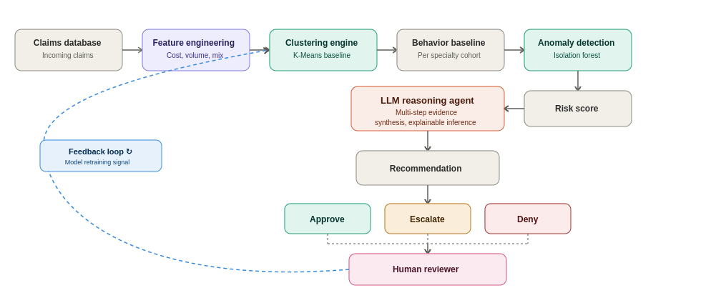
Each stage in this pipeline maps directly onto a strategic investment described below: clustering and anomaly detection form the foundation layer, while the agent is the differentiating capability that turns a statistical flag into an audit-ready recommendation.

Strategic Recommendations for Cotiviti

1. Clustering-Based Behavioral Baseline Engine
Cluster providers by specialty, procedure mix, and cost profile to establish dynamic baselines, replacing static thresholds the foundation all downstream detection depends on. This is the fastest layer to prototype and the one with the clearest near-term return, since it directly augments existing rules engines rather than requiring a parallel system.

2. Real-Time Anomaly and Time-Series Detection
Layer in models that flag statistically unusual claims or sudden shifts in billing behavior over time, prioritized by severity so the highest-risk cases reach reviewers first. Time-series monitoring is particularly valuable for catching emerging fraud patterns before they scale, rather than discovering them retrospectively during an audit.

3. Agentic AI Layer for Explainable Triage
Rather than a single score, the agent should orchestrate verification steps: compare the claim to its behavioral cluster, validate CPT/ICD coding consistency, review historical provider patterns, evaluate medical necessity signals, and generate an explainable recommendation. The agent functions as an intelligent investigator preparing a transparent case summary for human approval, not a replacement for clinical judgment.
Together with the feedback loop, these layers form one pipeline: clustering defines normal, anomaly detection finds deviation, and the agent investigates and explains why it matters making the system both more accurate over time and more trustworthy than any single technique alone. This is the architecture demonstrated in the accompanying proof of concept, which implements the clustering and anomaly detection layers on synthetic claims data with a live agent generating explanations for each flagged provider.

References
Bauder, R. A., & Khoshgoftaar, T. M. (2018). The detection of Medicare fraud using machine learning methods with excluded provider labels. Proceedings of the Thirty-First International Florida Artificial Intelligence Research Society Conference, 404–409. https://doi.org/10.1609/flairs.v31i1.17474
Centers for Medicare & Medicaid Services. (2024). Medicare fee-for-service 2023 improper payments report. U.S. Department of Health and Human Services. https://www.cms.gov/data-research/monitoring-programs/medicare-fee-service-compliance-programs/improper-payments
Chandola, V., Banerjee, A., & Kumar, V. (2009). Anomaly detection: A survey. ACM Computing Surveys, 41(3), 1–58. https://doi.org/10.1145/1541880.1541882
Rajpurkar, P., Chen, E., Banerjee, O., & Topol, E. J. (2022). AI in health and medicine. Nature Medicine, 28(1), 31–38. https://doi.org/10.1038/s41591-021-01614-0
Singhal, K., Azizi, S., Tu, T., Mahdavi, S. S., Wei, J., Chung, H. W., & Google Research. (2023). Large language models encode clinical knowledge. Nature, 620, 172–180. https://doi.org/10.1038/s41586-023-06291-2
Topol, E. J. (2019). High-performance medicine: The convergence of human and artificial intelligence. Nature Medicine, 25(1), 44–56. https://doi.org/10.1038/s41591-018-0300-7
Anthropic. (2026). Claude (Sonnet 4.6) [Large language model]. https://www.anthropic.com

