

STUDENT CASE STUDY EXECUTION REPORT

Department | FED
Subject | DSA-2
Academic Year | I-III Semester (2025-26)
Faculty Name | Mohd Razia Alangir Banu
Student Name | G. Rishitha
Roll Number | 2520030101
Branch | CSE
Course Outcome | CO3 — Apply BFS and DFS graph traversal algorithms and construct Minimum Spanning Trees using Kruskal's and Prim's algorithms to solve infrastructure design, network connectivity,  and cluster analysis problems in weighted undirected graphs.

Case Study Topic: SkillBridge – Content Similarity Recommendations Using Graph BFS and DFS Traversals.

Work Done Summary:
In this case study, we implemented a structural content similarity recommendation
framework for SkillBridge using an undirected graph data structure. Vertices within this structure map to distinct domain learning modules or certification listings, while linking edges indicate contextual similarity metrics or prerequisite relationships between them.
Both Breadth-First Search (BFS) and Depth-First Search (DFS) strategies were integrated over an adjacency list graph configuration.
BFS traversal is utilized to explore immediate node connections for instant recommendations, identifying courses closely aligned with a student's current selection.
In contrast, DFS is used to traverse deeper structural pathways, identifying broader topic domains and prerequisite tracks. Both traversal methods explore the system without looping or duplication, keeping path exploration efficient within an optimal
$O(V + E)$ complexity constraint.

Implementation Details:
- Graph creation using content items as vertices and similarity relationships as edges.
- Adjacency list representation for efficient storage of content connections.
- BFS traversal for discovering and recommending related content level by level.
- DFS traversal for exploring deep content similarity paths and clusters.
- Visited node tracking to prevent repeated traversal of content records.
- Content recommendation generation based on graph traversal results.
- Complexity analysis and performance evaluation of BFS and DFS traversals.

Result: Screenshots / Output:
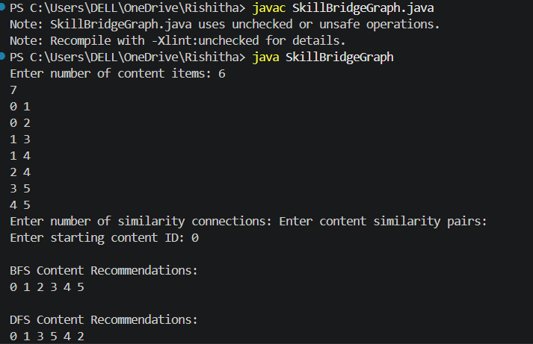

Result & Complexity Discussion:
- Content similarity relationships were successfully represented using a graph structure.
- BFS traversal generated level-wise content recommendations from the selected content item.
- DFS traversal explored deeper content similarity paths and related content clusters.
- BFS traversal was executed with a time complexity of O(V + E).
- DFS traversal was executed with a time complexity of O(V + E).
- The graph required O(V) auxiliary space for visited node tracking.
- The implementation efficiently supports content recommendation and similarity analysis in the SkillBridge platform.

GitHub Link:
https://github.com/rishi07-lab/DSA-2-CASE-STUDIES

Note: The code and github link and screenshots have been uploaded in the above link . Please check it out there.

Student Signature | Faculty Signature
__________________________ | ________________________

