

STUDENT CASE STUDY EXECUTION REPORT

Department | FED
Subject | DSA-2
Academic Year | I-III Semester (2025-26)
Faculty Name | Mohd Razia Alangir Banu
Student Name | G. Rishitha
Roll Number | 2520030101
Branch | CSE
Course Outcome | CO2 — Analyze multi-way search trees (B-Trees, B+ Trees) and Range Query structures (Segment Trees, Fenwick Trees) to  select and justify the appropriate tree variant for database  indexing, storage systems, and interval query problems based on empirical complexity analysis.

Case Study Topic: SkillBridge – Range Queries on Student Assessment Scores Using Segment Tree

Work Done Summary:
In this case study, we developed and implemented a Segment Tree architecture tailored for SkillBridge’s core learning analytics engine. The platform tracks student progress metrics, such as assessment scores and module completion times, which need to be evaluated over specific timeframes or structural index intervals. The Segment Tree
stores these continuous performance records within a balanced, precomputed hierarchy to handle fast interval range queries and instantaneous point updates.
We generated a dataset of student assessment performance records, built the
corresponding segment array framework, and executed interval queries. The segment
tree optimizes system performance, reducing interval processing from an $O(n)$ linear sweep down to an explicit $O(\log n)$ execution boundary. This structure ensures real-time updates and analytics can be performed without system lag or administrative latency.

Implementation Details:
- Segment Tree node creation and tree construction from student assessment scores.
- Array initialization and score data storage.
- Segment Tree building for efficient range query processing.
- Range sum, minimum, and maximum score query operations.
- Point update operation for modifying student assessment scores.
- Recursive traversal and query processing within specified score ranges.
- Complexity analysis and performance evaluation of Segment Tree operations

Result: Screenshots / Output:

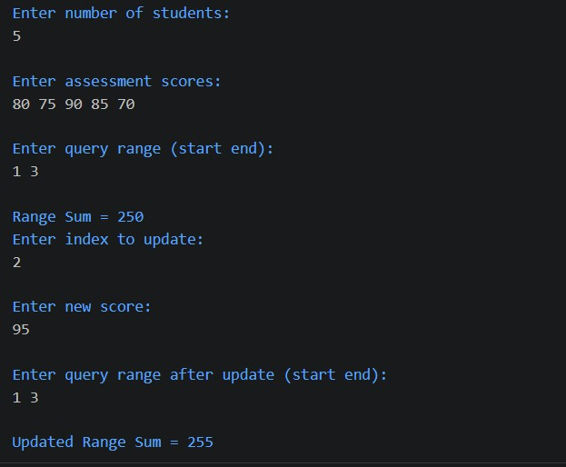

Result & Complexity Discussion
- Student assessment scores were successfully stored and processed using the Segment Tree structure.
- Range queries and score updates were performed efficiently without scanning the entire dataset.
- Segment Tree construction was completed in O(n) time.
- Range query operations were executed in O(log n) time.
- Score update operations were executed in O(log n) time.
- The implementation improved performance compared to linear search methods.
- The Segment Tree demonstrated scalability for real-time assessment analytics in the SkillBridge platform.

GitHub Link:
https://github.com/rishi07-lab/DSA-2-CASE-STUDIES

Note: The code and github link and screenshots have been uploaded in the above link . Please check it out there.

Student Signature | Faculty Signature
__________________________ | ________________________

