TASK DAY-1

Aim:-Registration Form

<!DOCTYPE html>

<html>

<head>

<title>Register form</title>

</head>

<body>

<form>

<center>

<h2>Register form</h2>

<table>

<tr>

<td>

Name:

</td>

<td>

<input type="text" placeholder="Name" name="">

</td>

<tr>

<td>

password:

</td>

<td>

<input type="password" placeholder="password" name="">

</td>

</tr>

<tr>

<td>

Gender:

</td>

<td>

<input type="radio" name="Gender">Male

<input type="radio" name="Gender">Female

</td>

</tr>

<tr>

<td>

Email:

</td>

<td>

<input type="mail" placeholder="Email" name="">

</td>

</tr>

<tr>

<td>

Phone no:

</td>

<td>

<select>

<option>877</option>

<option>878</option>

<option>879</option>

<option>880</option>

<option>881</option>

<option>882</option>

<option>883</option>

</select>

<input type="Phone" placeholder="96554\*\*\*\*\*" name="">

</td>

</tr>

<tr>

<td>

<input type="submit" value="submit" name="">

</td>

</tr>

</table>

</center>

</body>

</html>

OUTPUT:

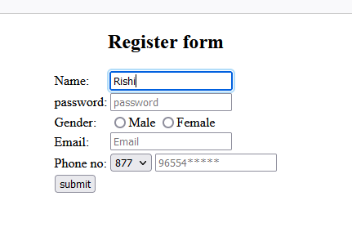

TASKDAY-2

1) 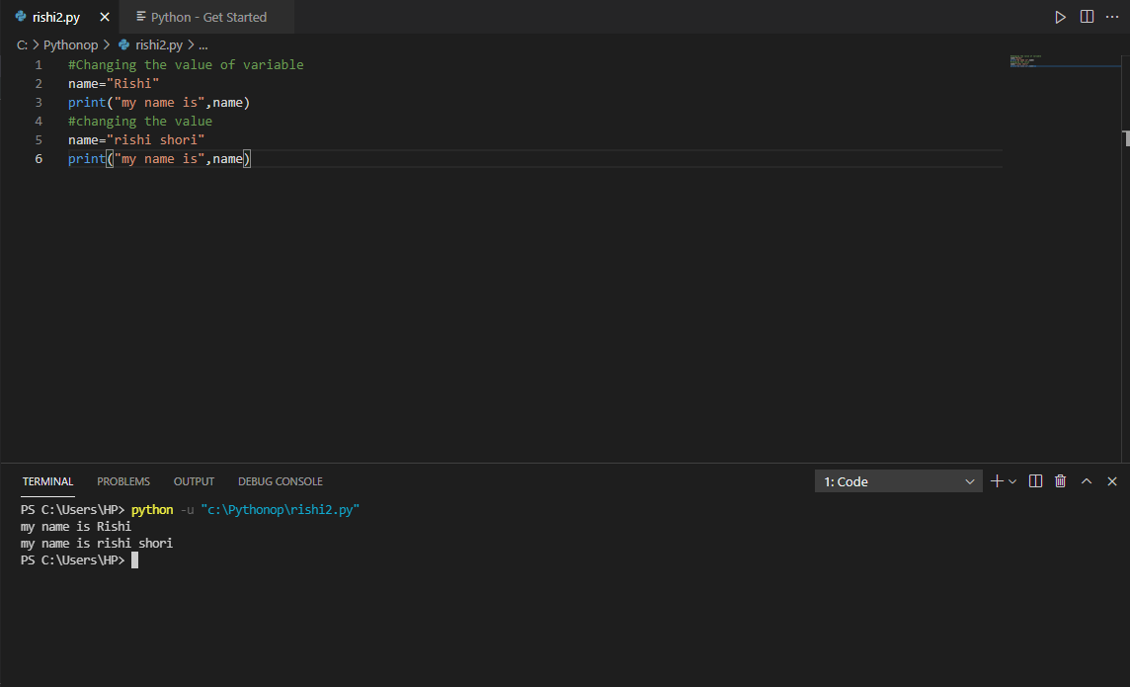

2)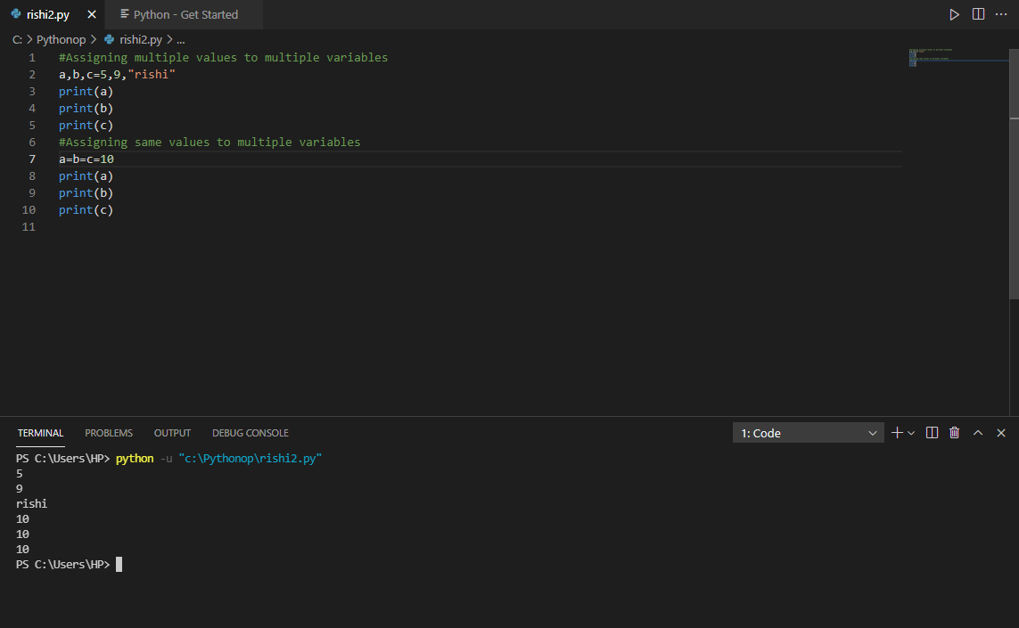

3)

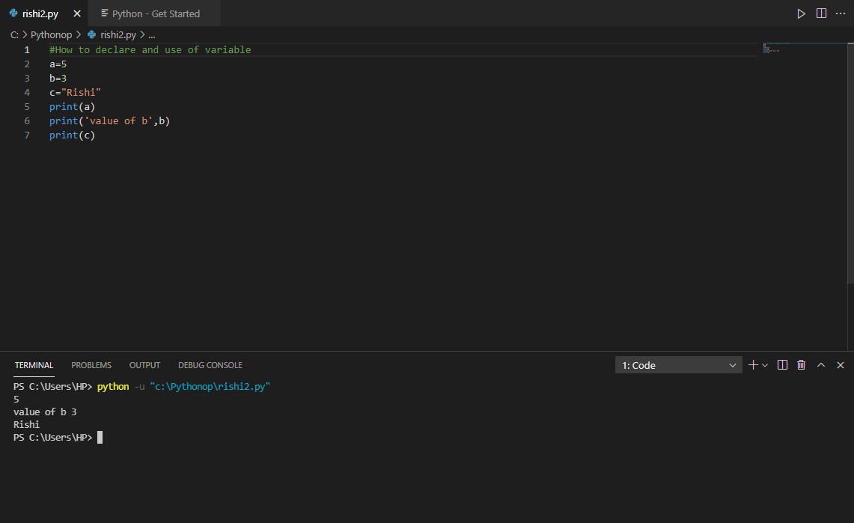

4)

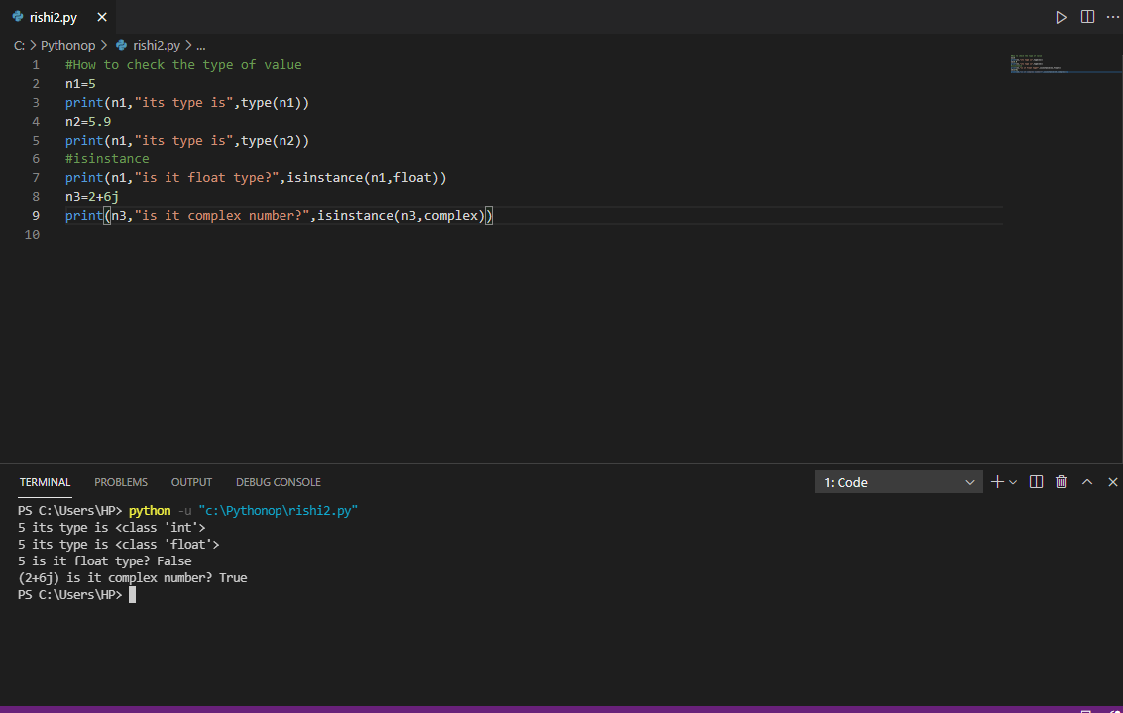

5)

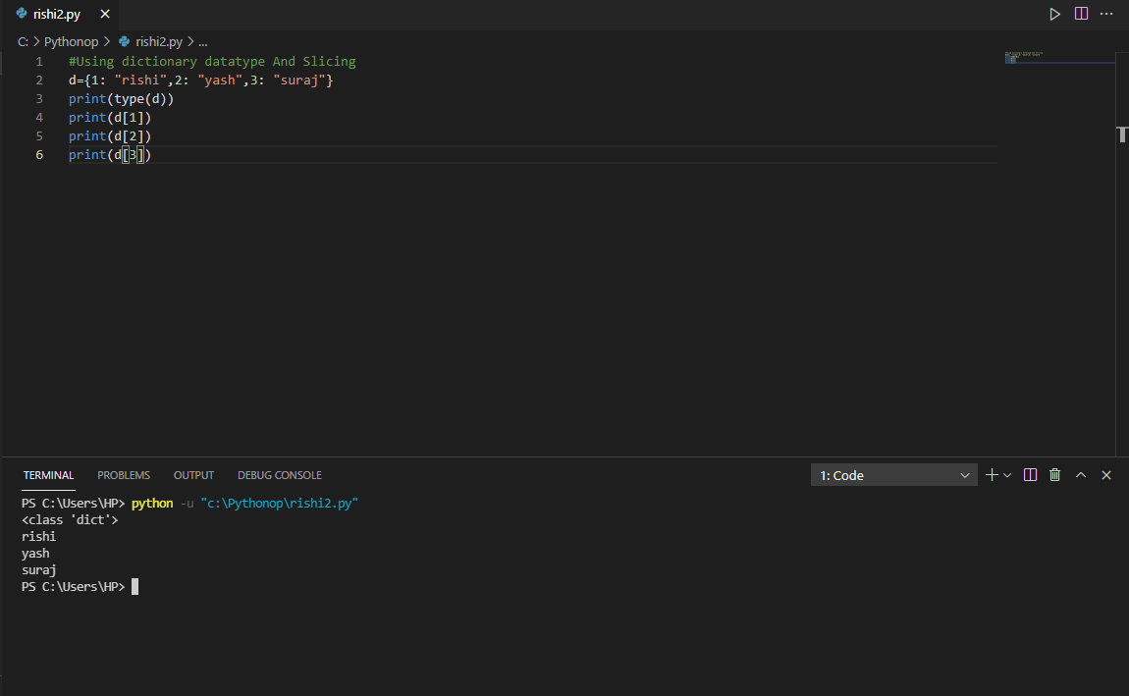

6)

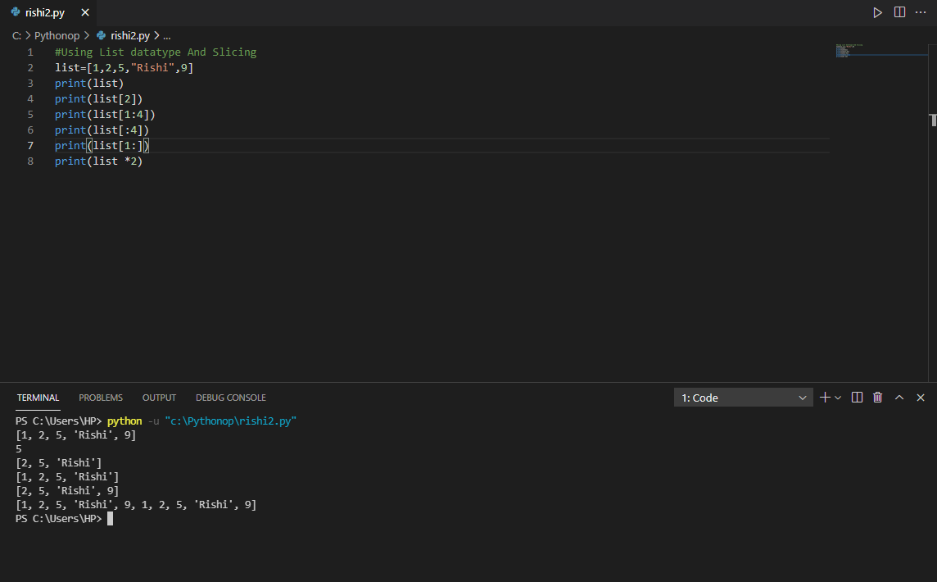

7)

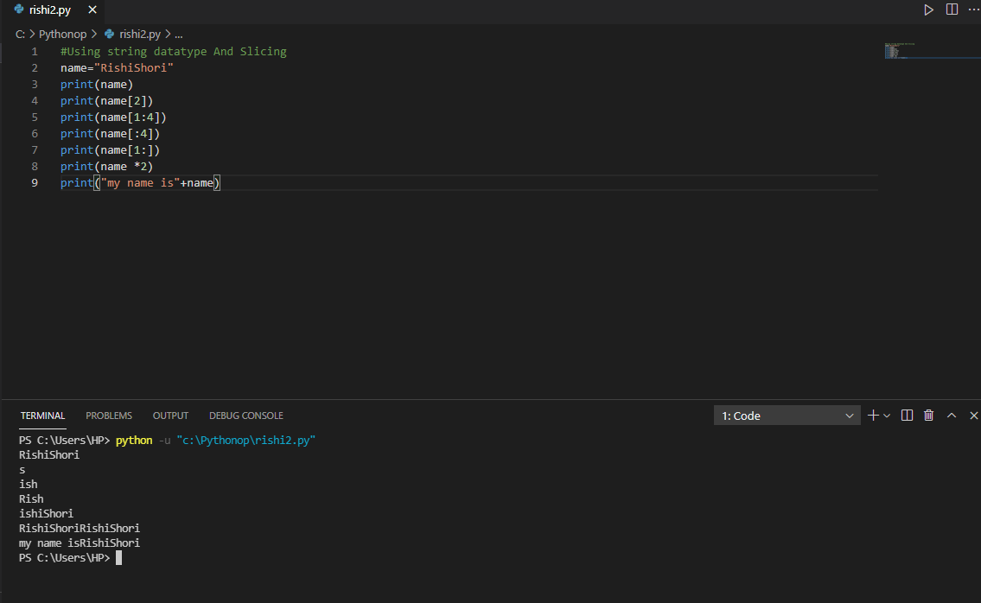

8)

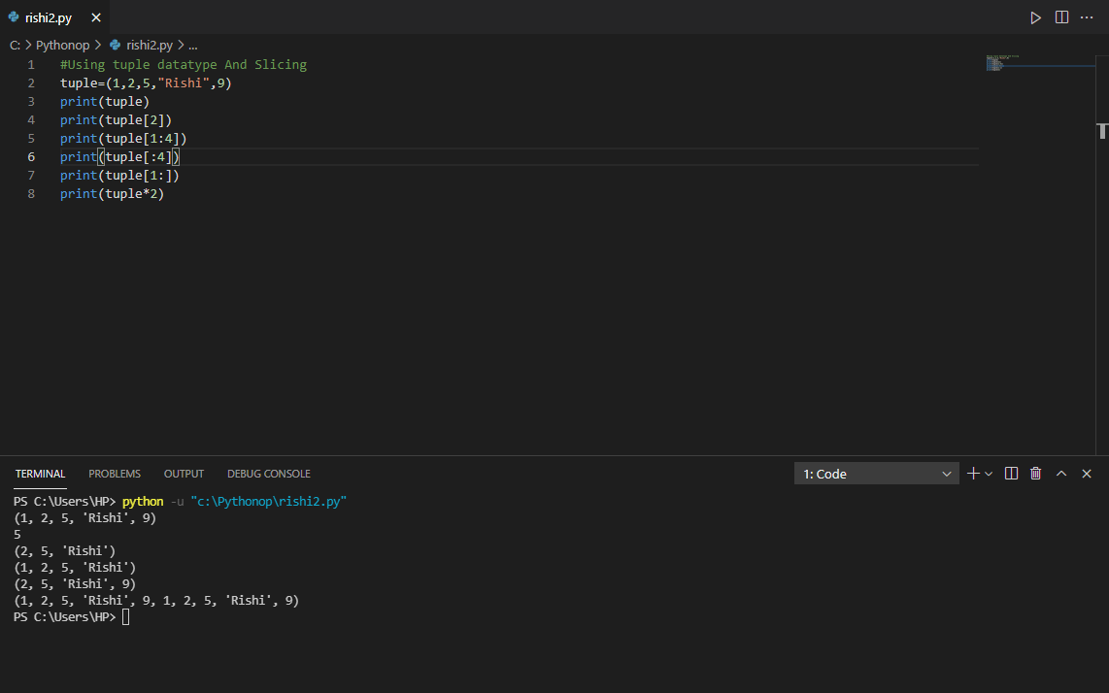

TASKDAY-3

1)

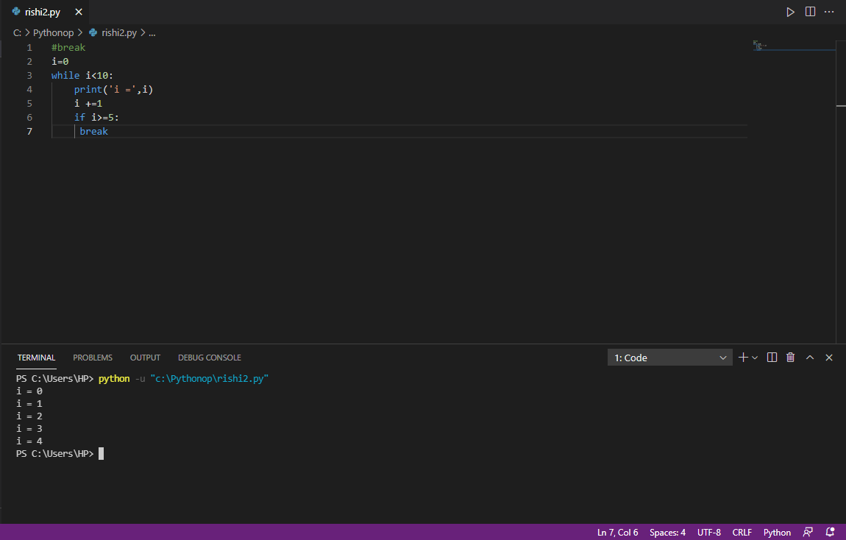

2)

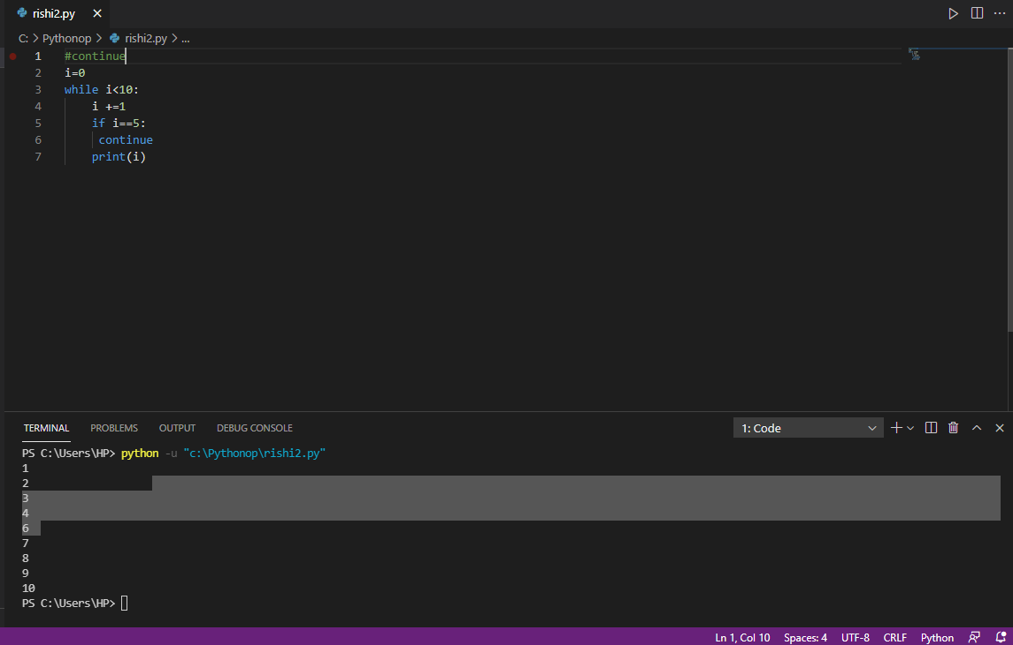

3)

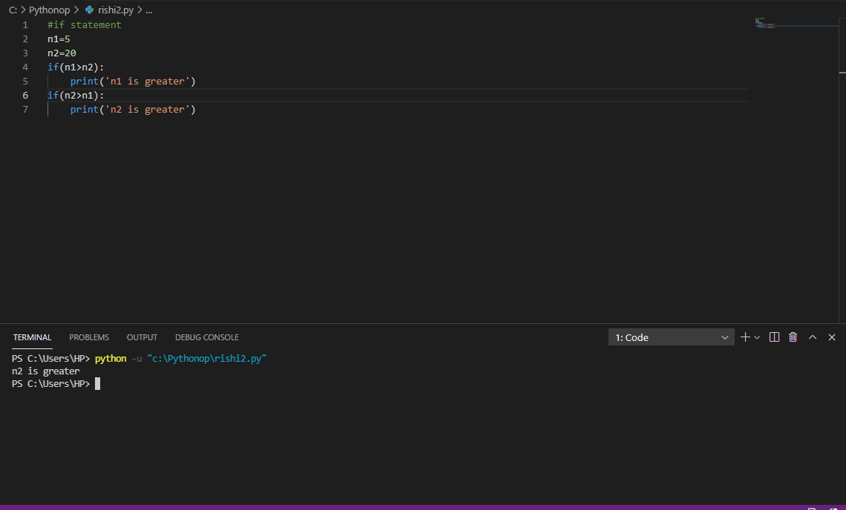

4)

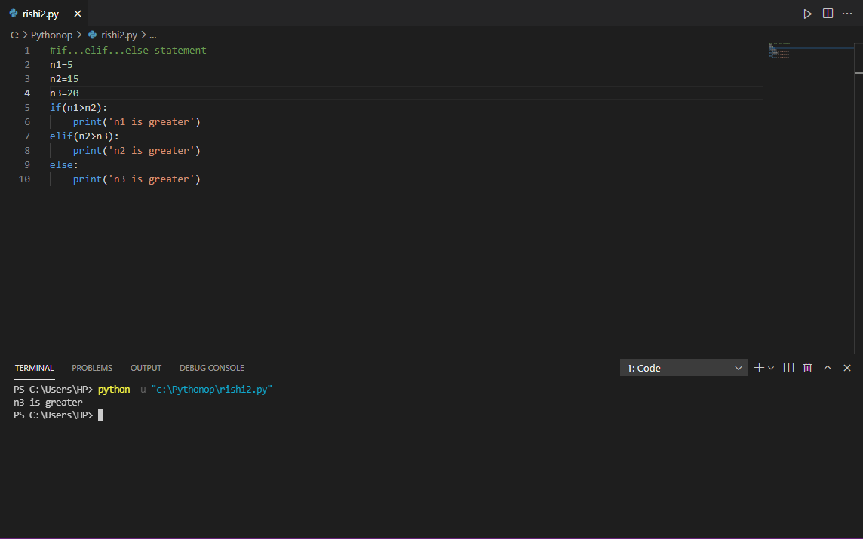

5)

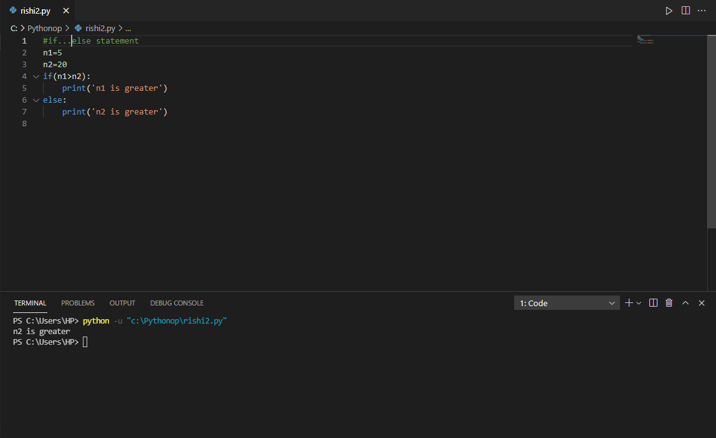

6)

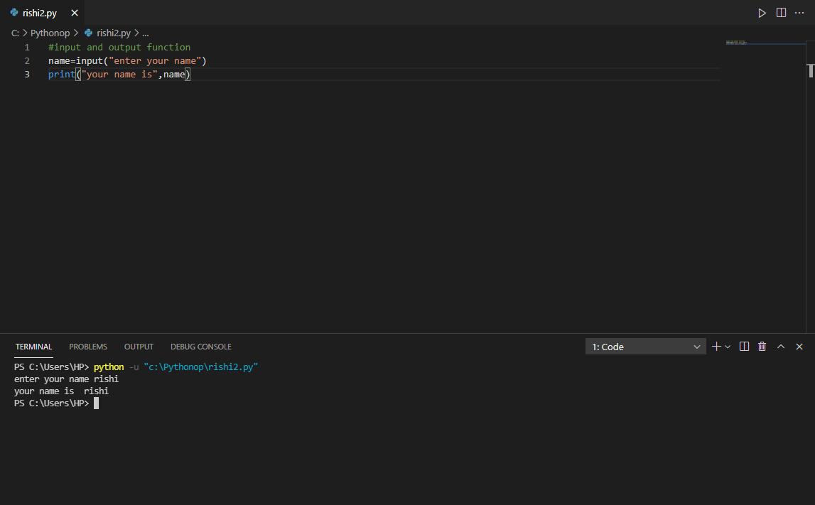

7)

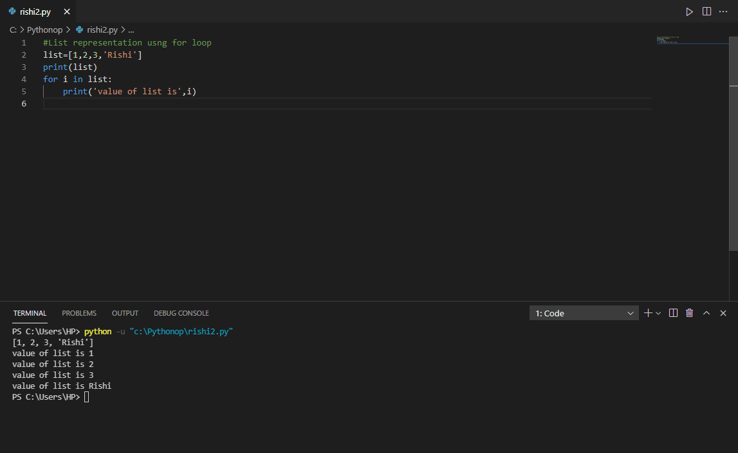

8)

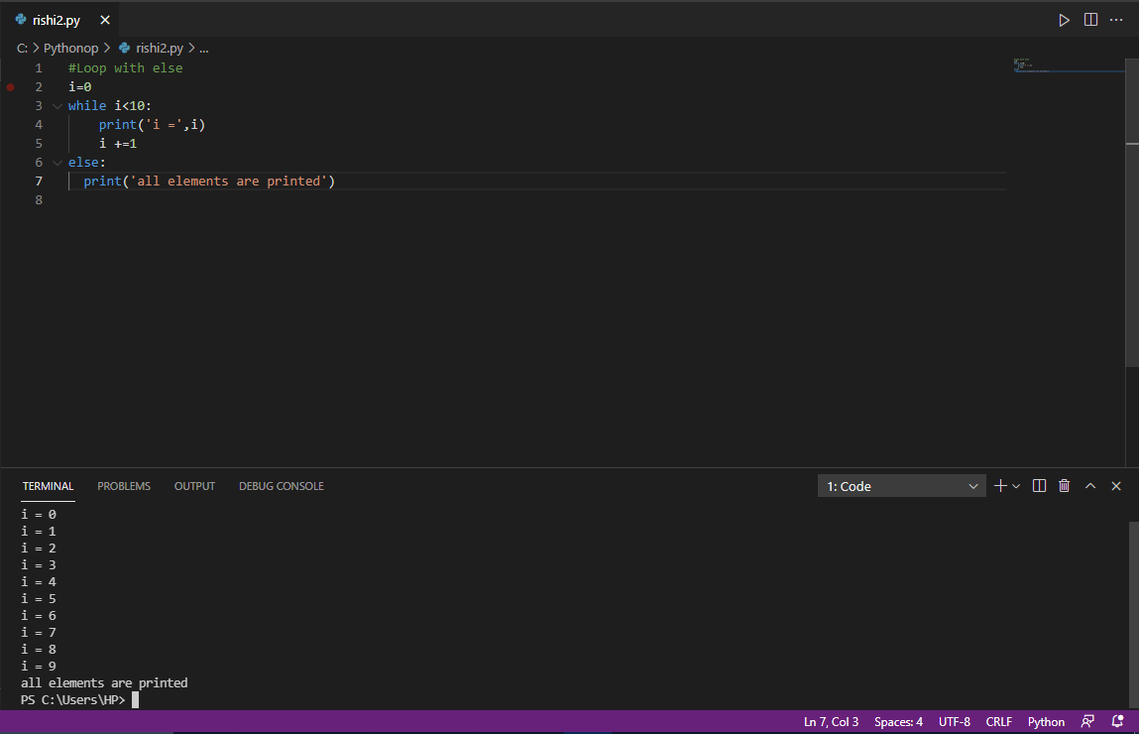

9)

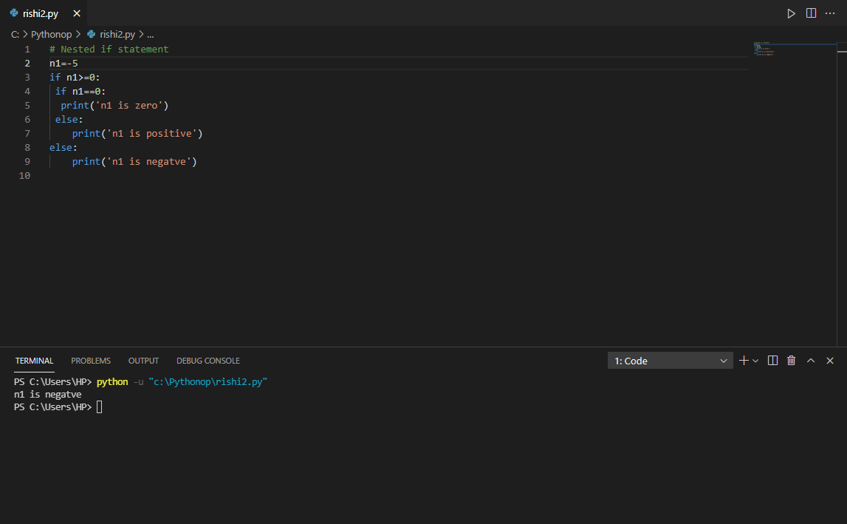

10)

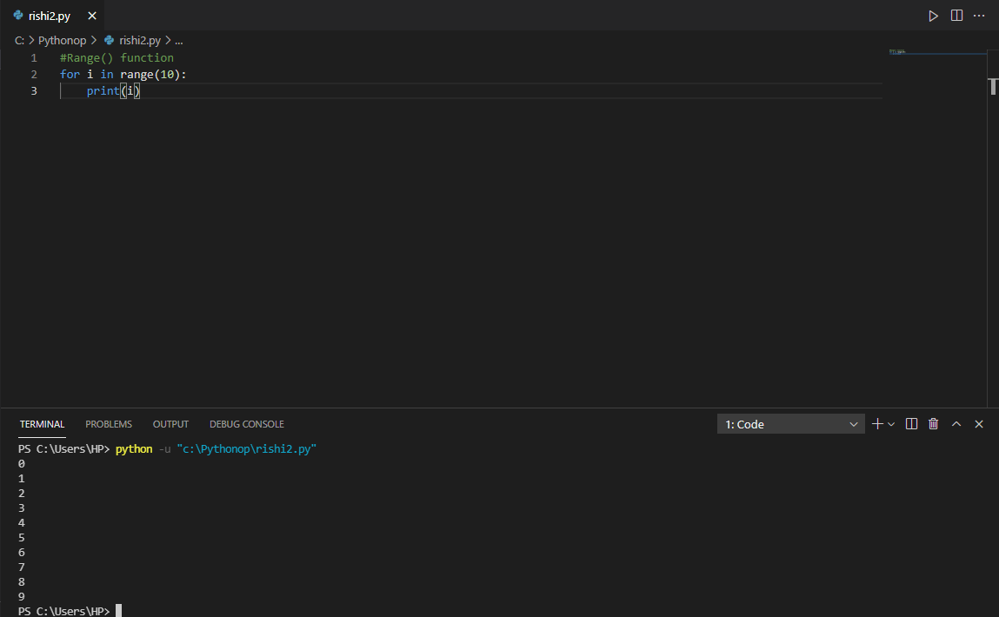

11)

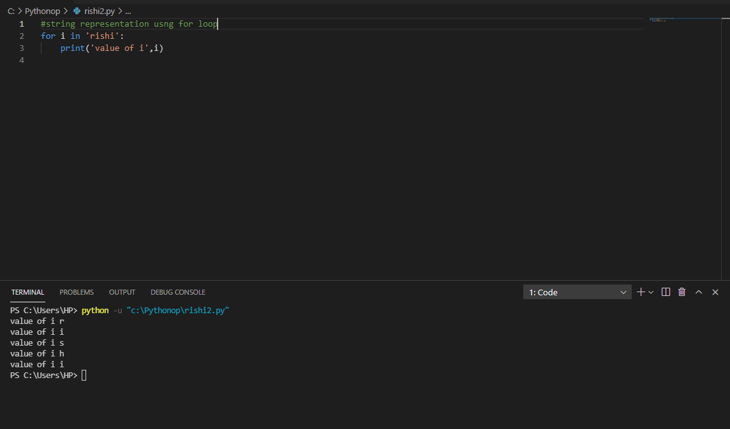

12)

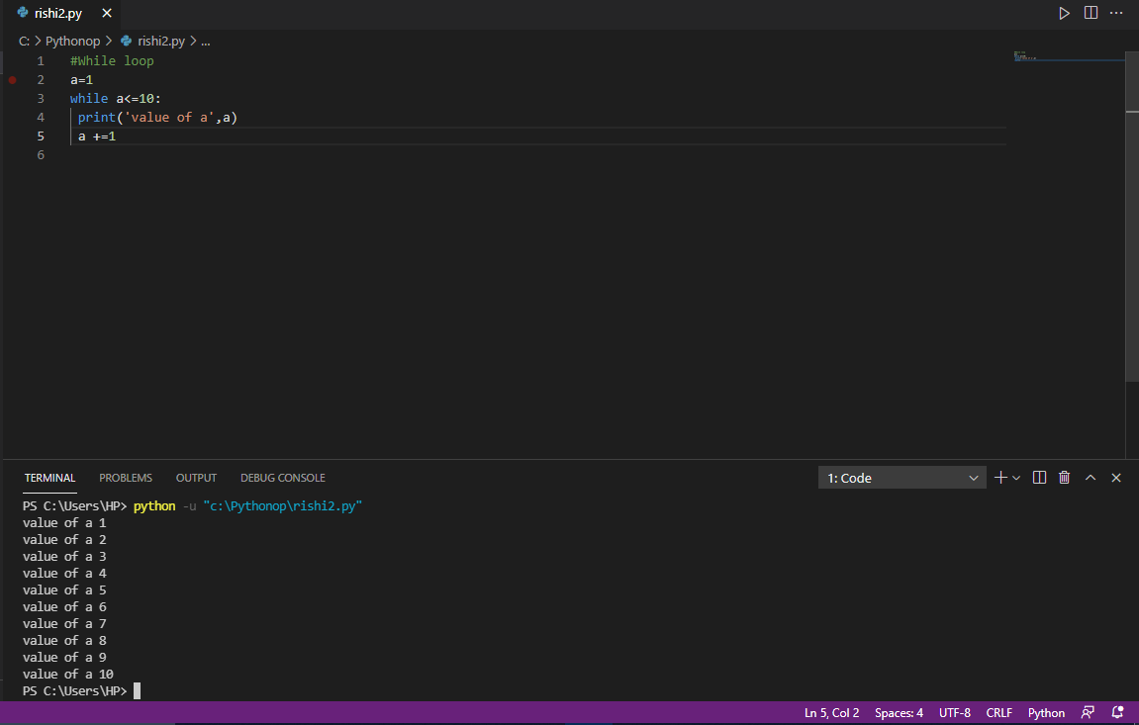

TASKDAY-4

1)

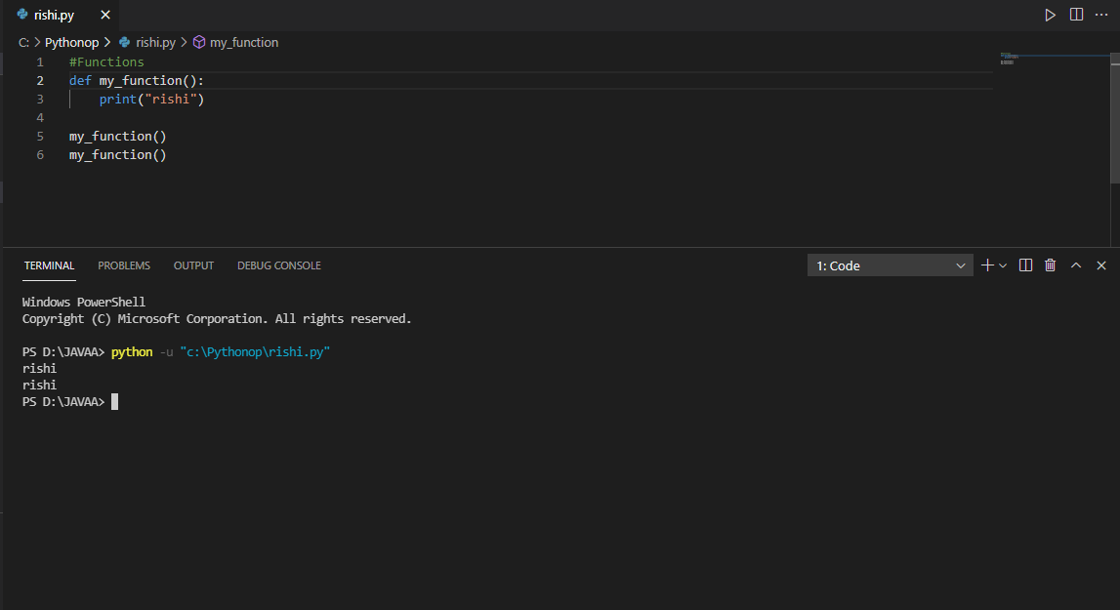

2)

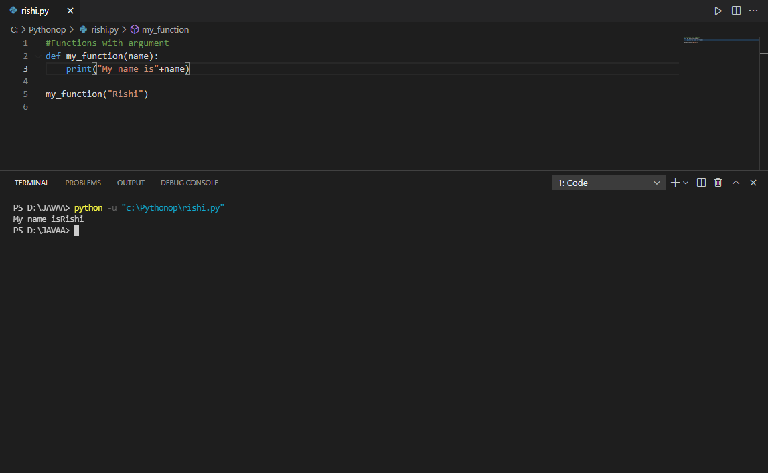

3)

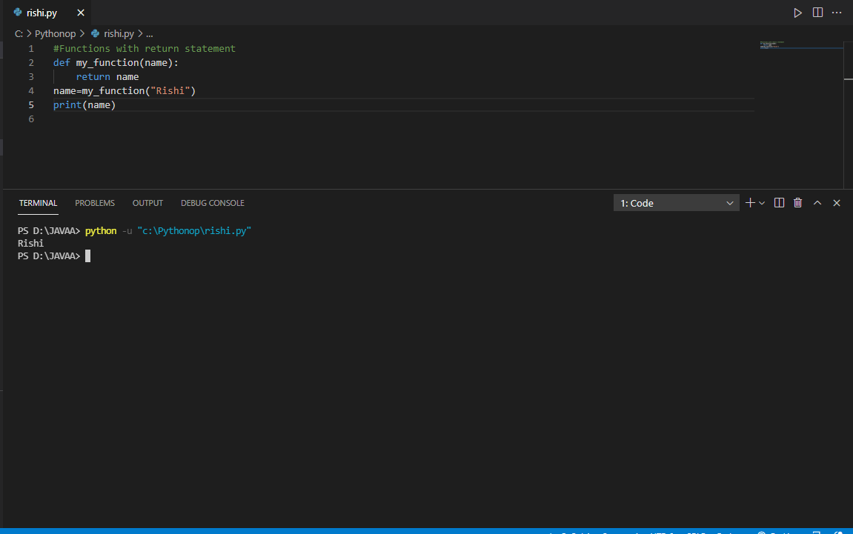

4)

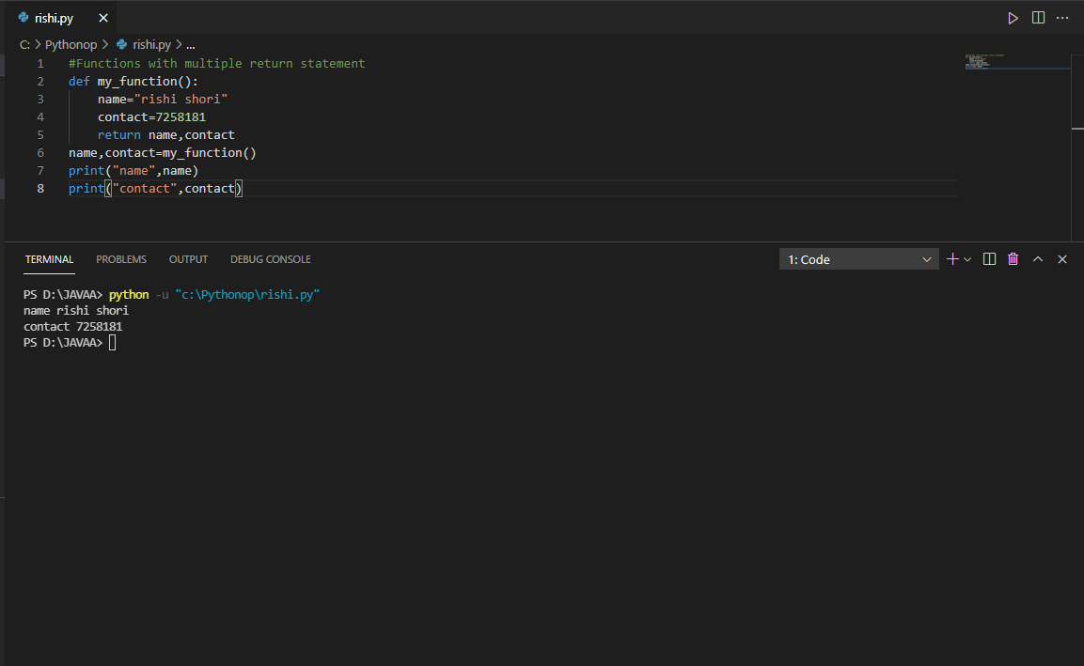

5)

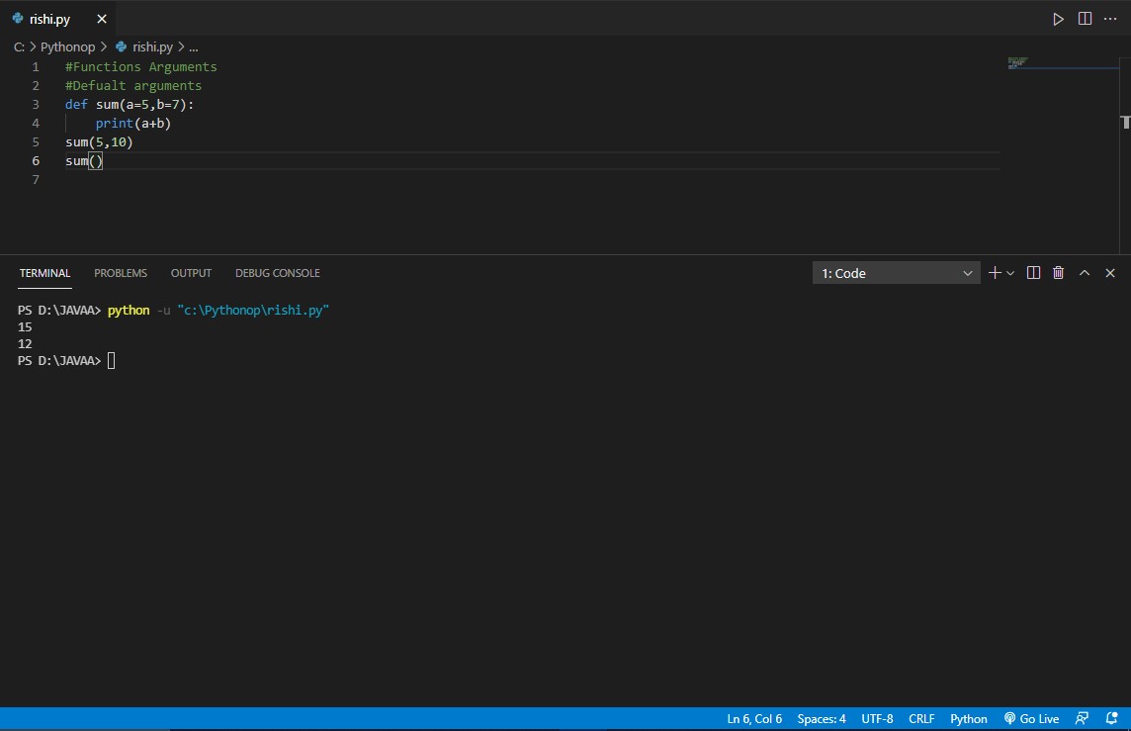

6)

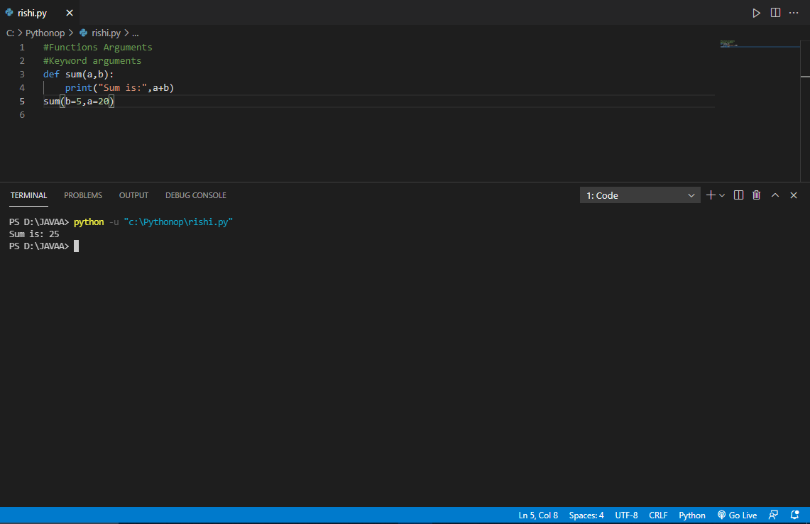

7)

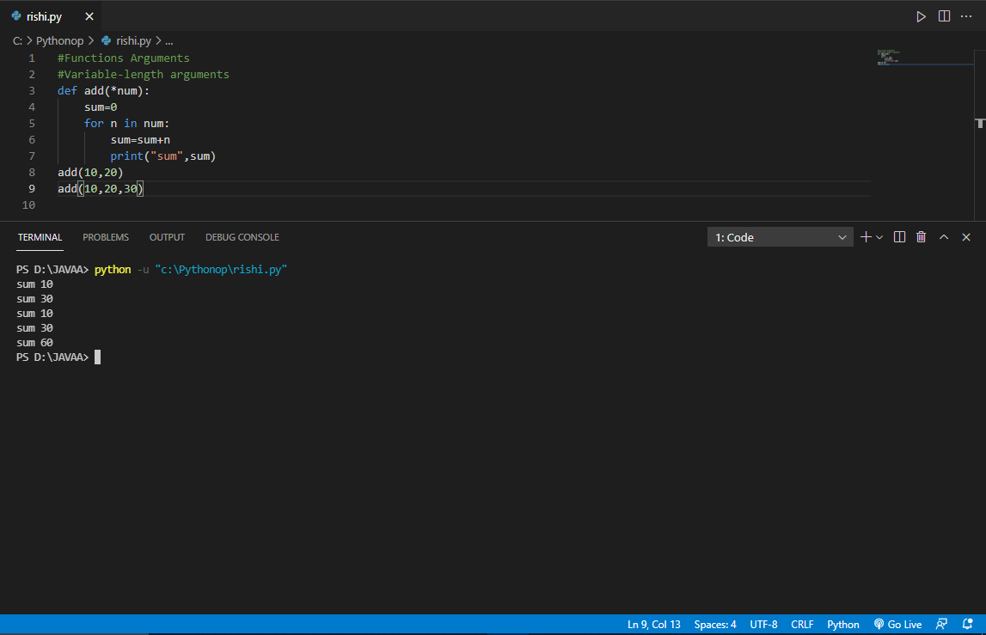

8)

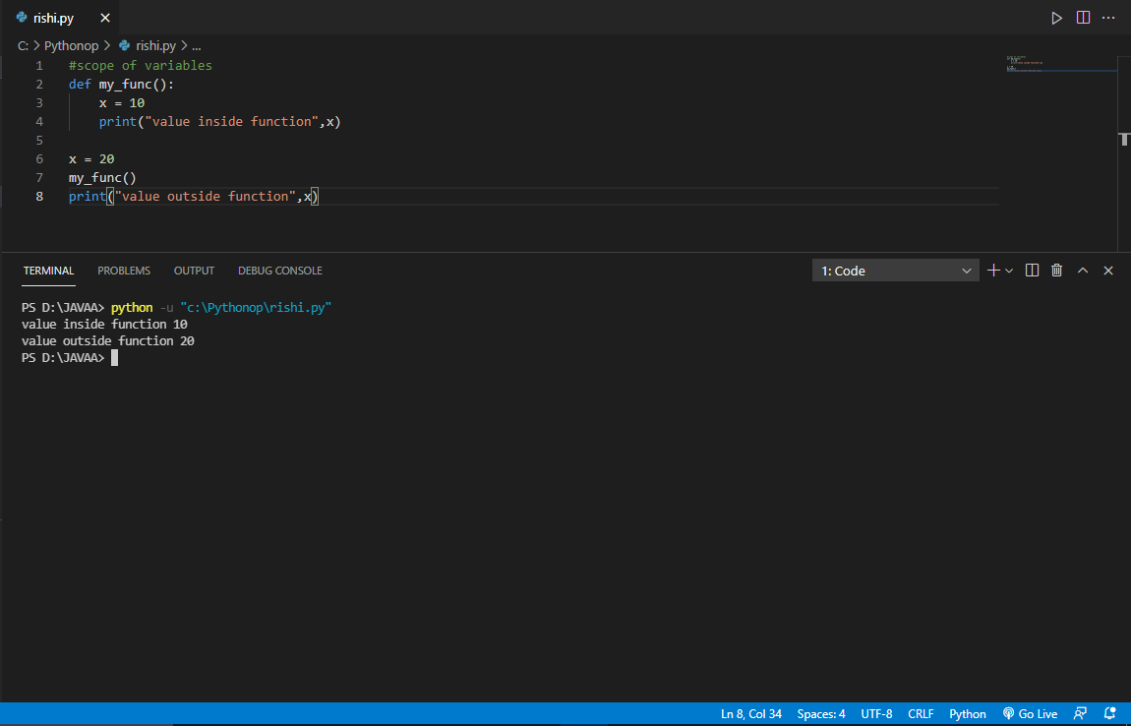

TASKDAY-5

1)

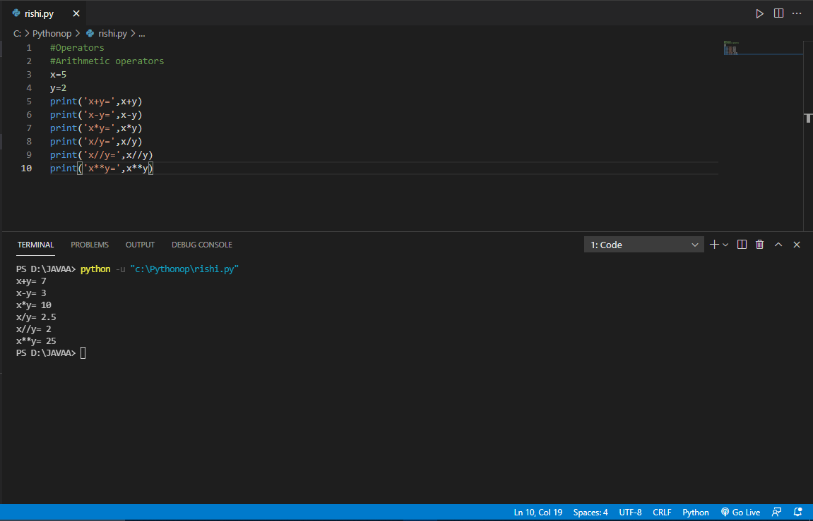

2)

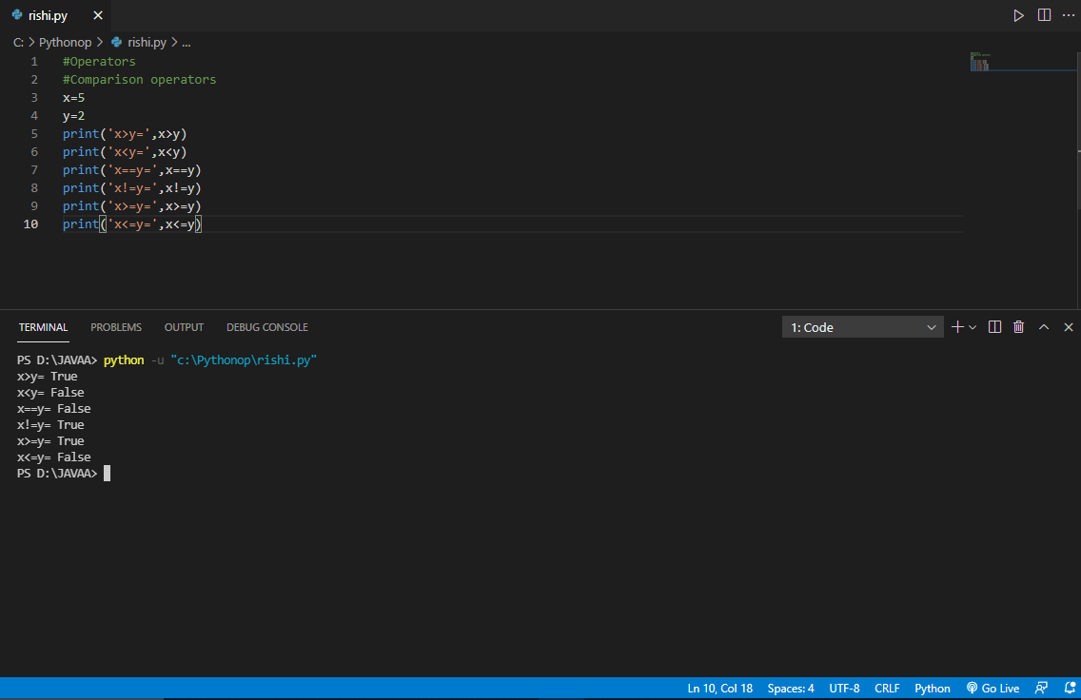

3)

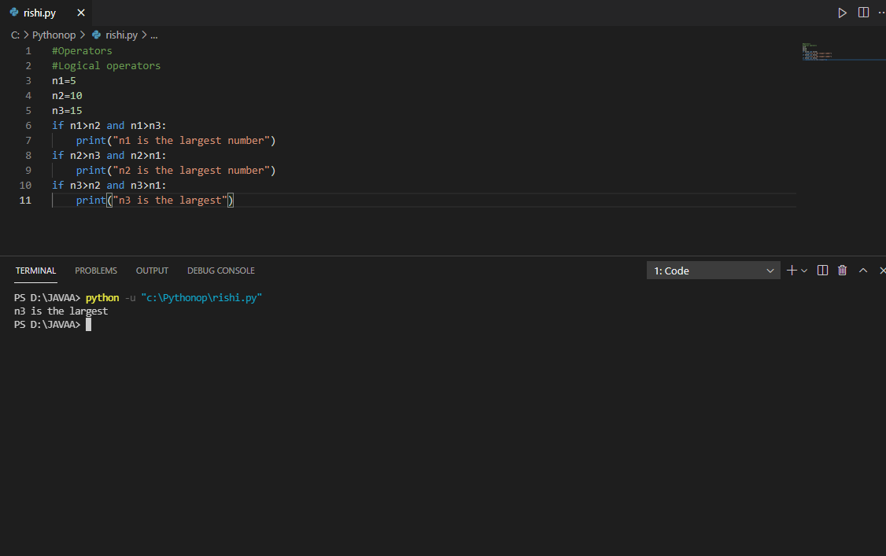

4)

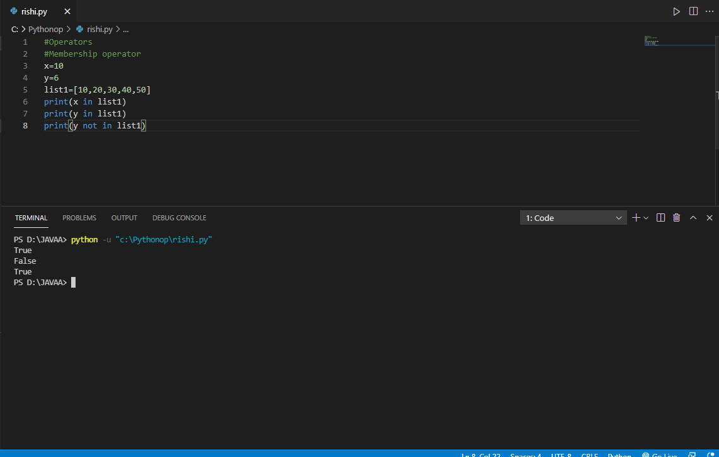

5)

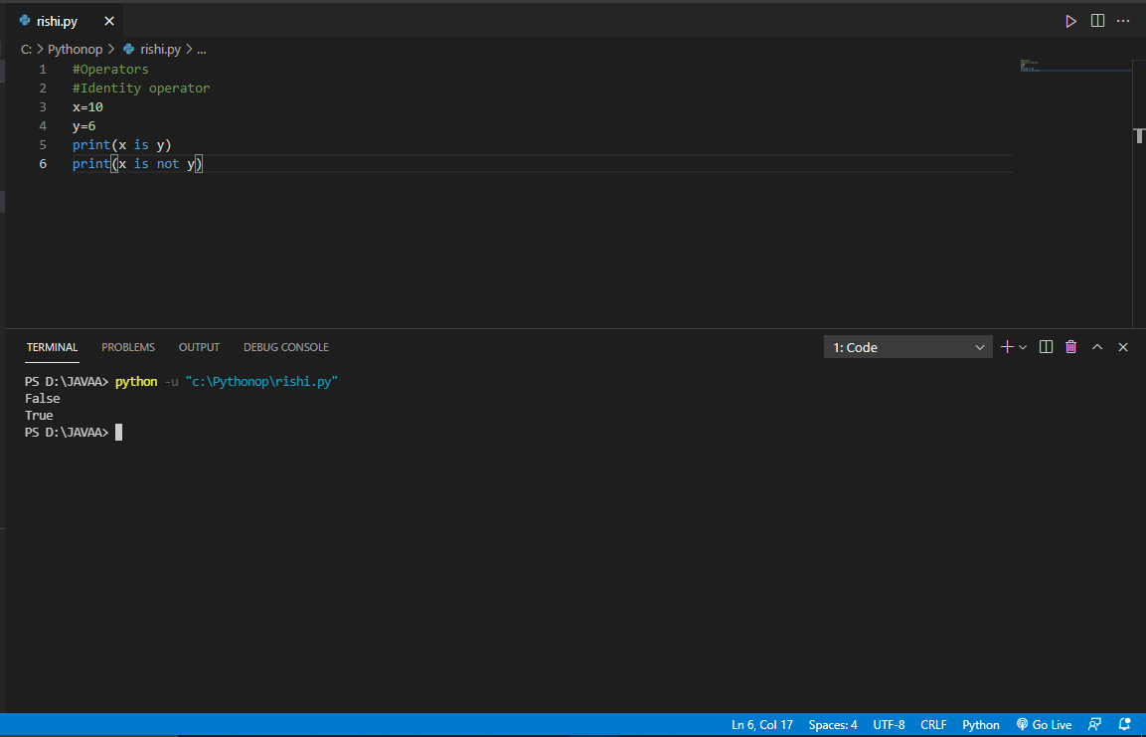

TASKDAY-6

1)

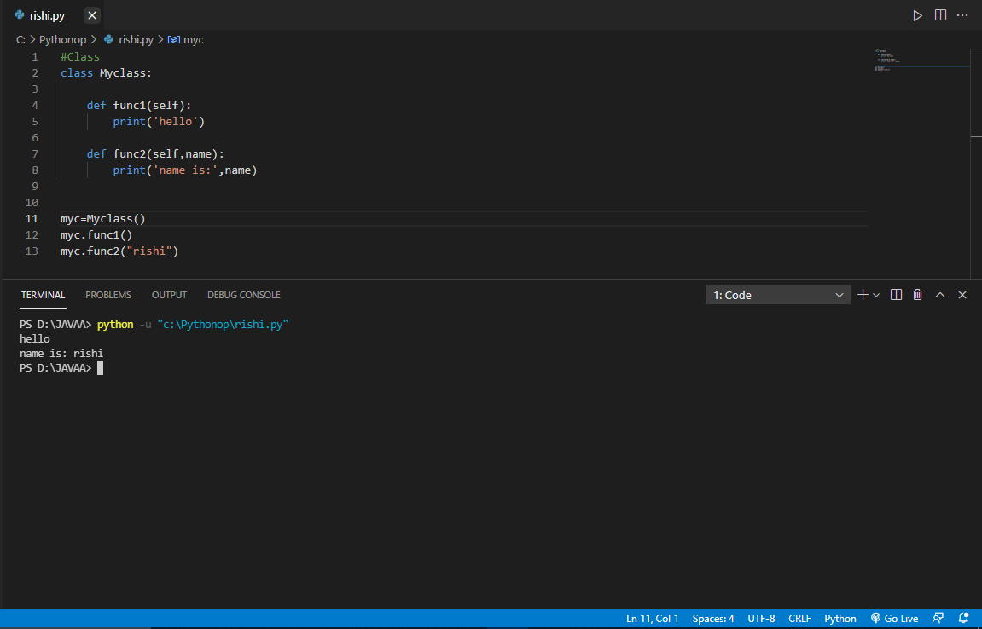

2)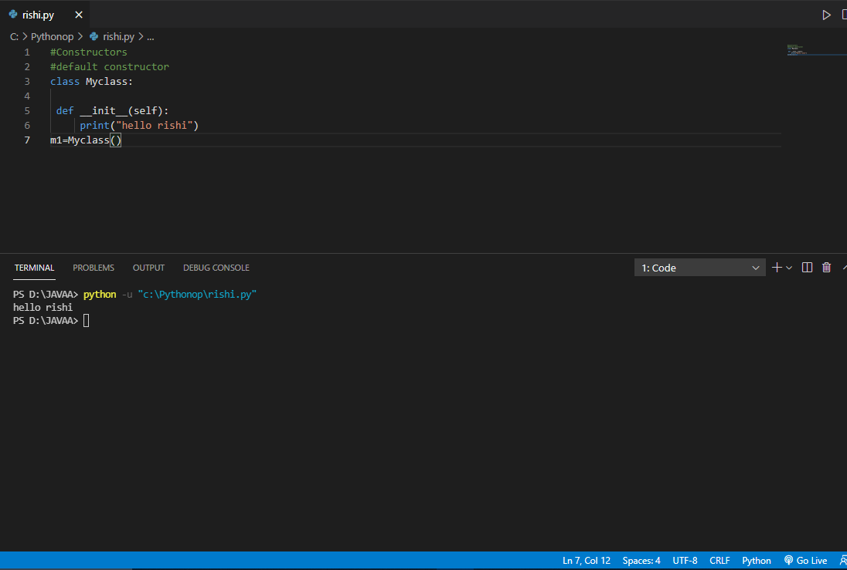

3)

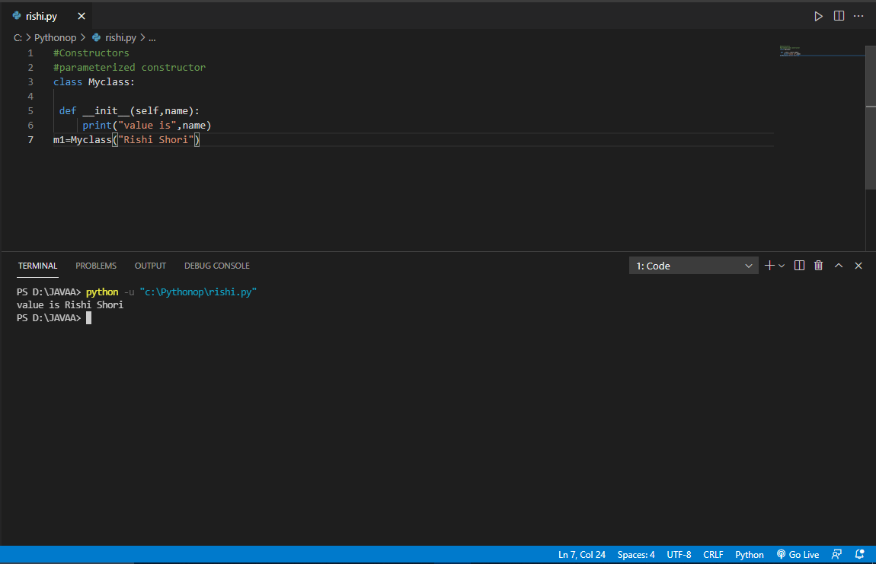

4)

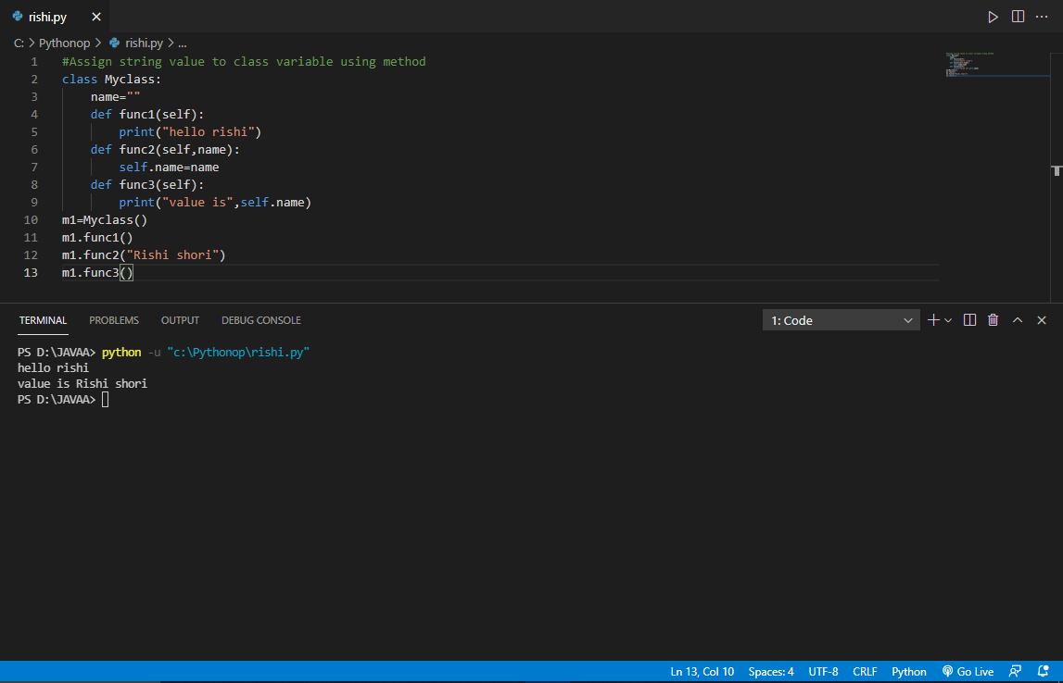

FINAL PYTHON TASKDAY-7

1)

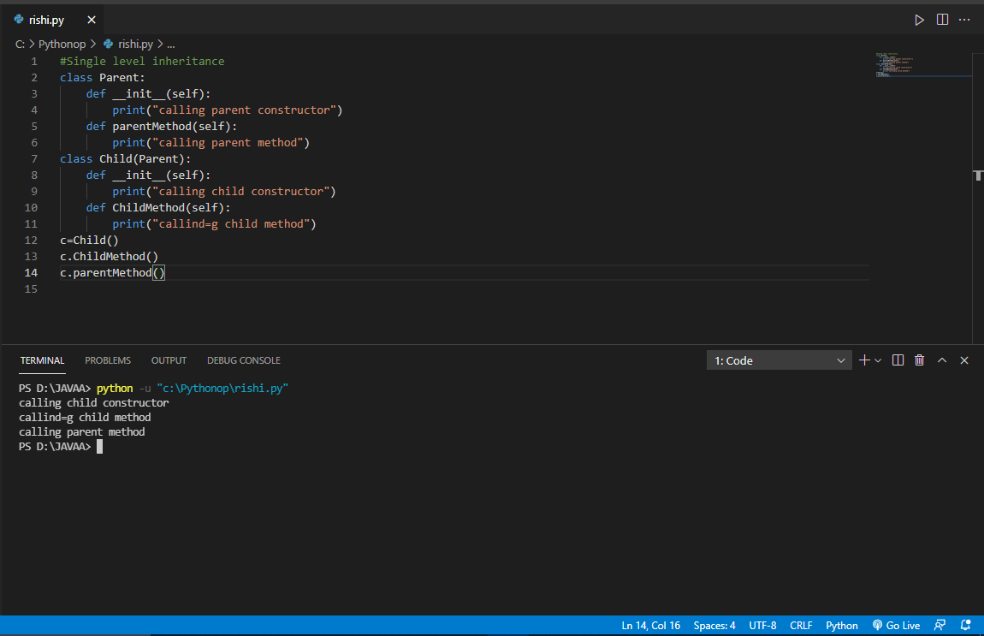

2)

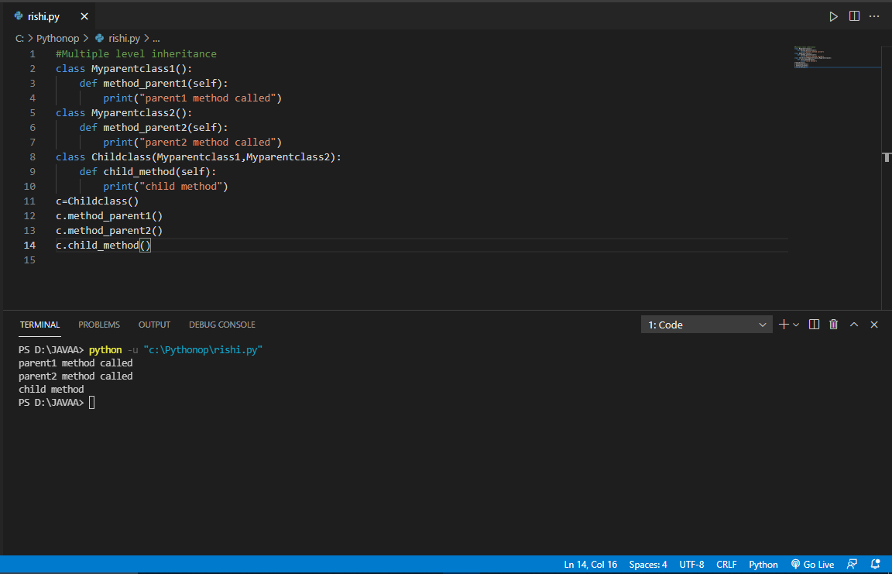

3)

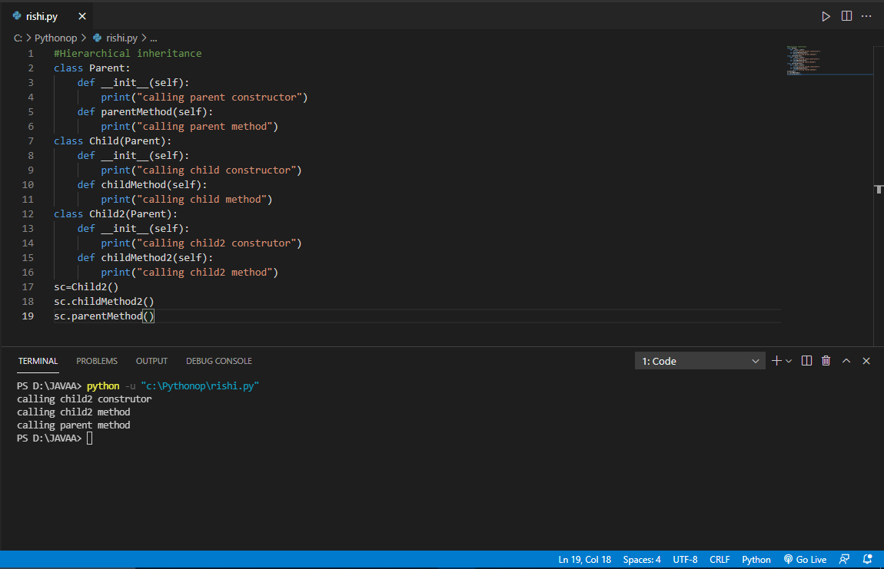

4)

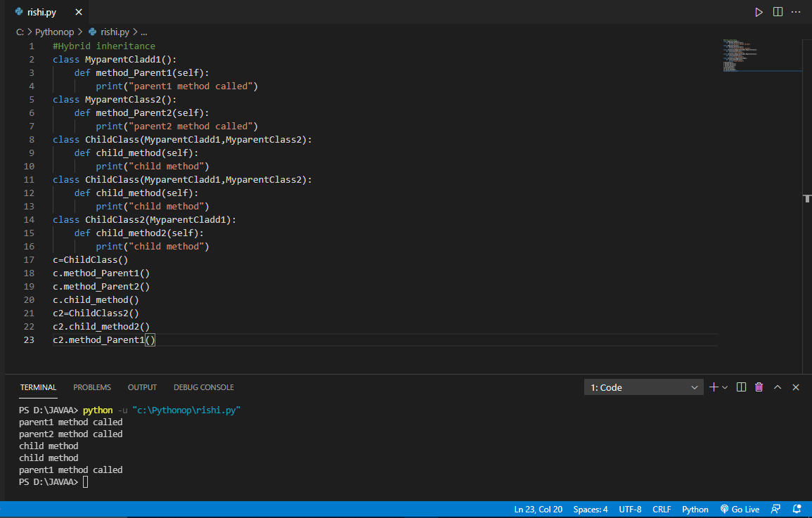

5)

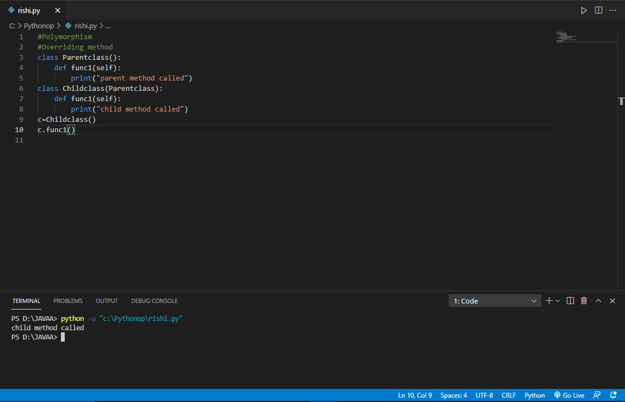

6)

