Detailed Debugging Report for Cloud-Based Racing Game (Rev 2)
Date: 2026-02-26
Author: Manus AI

1. Executive Summary
This report provides a detailed frame-by-frame analysis of the second screen recording (ScreenRecording2026-02-26at1.08.52PM.mov), a 75-second video demonstrating two attempted race sessions in a cloud-based racing game. While the new revision shows significant progress, including the resolution of a UI layering bug and improved initial frame rates, several critical, game-breaking bugs persist.

The most severe issue is a recurring bug that causes the vehicle to spontaneously shift into reverse gear (-1), leading to stalls, collisions, and an unplayable experience. The vehicle also suffers from control issues, frequently driving off-road and colliding with scenery. Furthermore, the transmission remains locked in first gear, and the video stream is plagued by severe rendering artifacts. This report breaks down each issue with timestamped evidence and provides actionable recommendations for debugging.

2. System Architecture Overview
The game appears to use the following architecture:
- Frontend: A web-based interface, likely built with a framework like React, served via a Vite development server on localhost:5173.
- Backend Communication: A WebSocket server on localhost:8765 is used to stream data between the client and the simulation backend.
- Simulation Engine: The backend is powered by the CARLA Simulator, as evidenced by the "CARLA" license plate on the player vehicle and the AI opponent name "CARLA_PILOTNET". Video from the simulator is streamed to the browser.

3. Chronological Analysis of Events
The 75-second recording captured two distinct race attempts. The first was abandoned after approximately 13 seconds of gameplay due to the vehicle becoming stuck. The second attempt, while more successful in terms of distance covered, revealed a host of new and recurring bugs.

Race 1: Startup & Failure (0s - 28s)
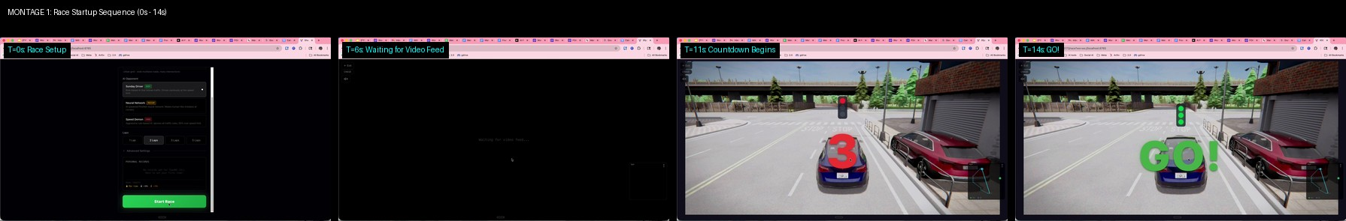
Montage 1: The initial race startup sequence, from the setup screen to the green light.

The first race begins with a familiar startup sequence. The "Waiting for video feed..." message appears for approximately 8 seconds before the countdown begins at T=11s. A notable improvement from the previous revision is that the waiting text no longer bleeds through the countdown UI. The race starts at T=14s, but the vehicle immediately exhibits erratic behavior, accelerating to 103 mph/kph before abruptly stalling. This leads to the critical reverse gear bug.

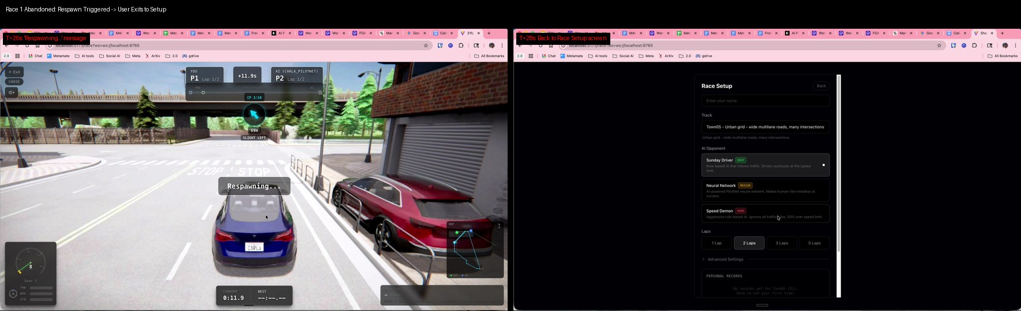
Montage 6: After getting stuck, a respawn is triggered at T=26s, and the user is returned to the main menu at T=28s, abandoning the race.

Race 2: Partial Success & Critical Failures (29s - 75s)
The user initiates a second race, which starts at approximately T=40s. This attempt shows initial promise, with the car successfully navigating the first few checkpoints. However, the same critical bugs resurface, ultimately rendering the race unplayable. The car drives off-road, collides with a building, and repeatedly stalls due to the reverse gear issue before the recording ends.

4. Critical Bug Analysis

BUG #1: Spontaneous Reverse Gear Engagement (GAME-BREAKING)
This is the most critical bug. The vehicle's transmission spontaneously shifts into reverse (Gear -1), often while the player is attempting to accelerate. This occurred four times in the recording. When this happens, the car stalls completely, as the throttle and brake inputs appear to be applied simultaneously.

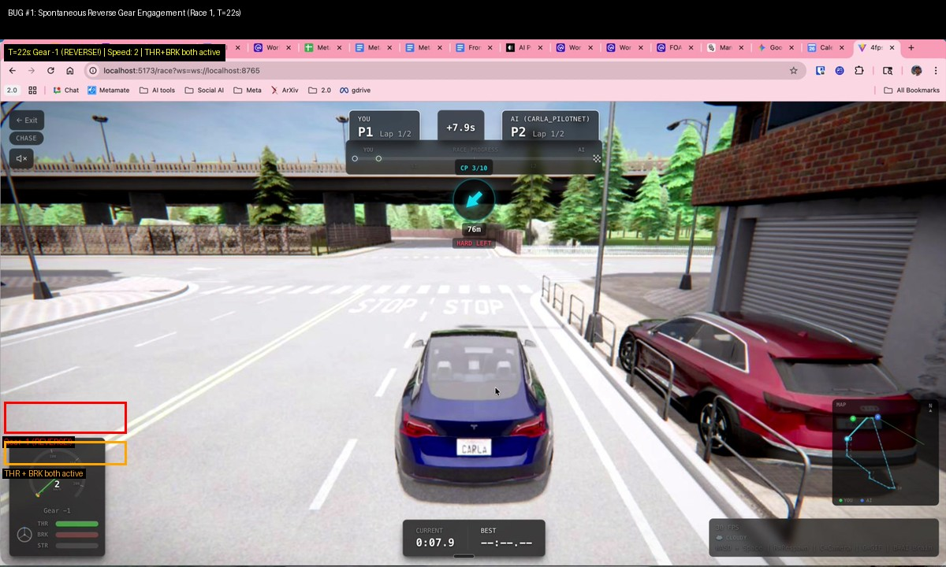
Montage 2: The first occurrence of the bug during Race 1. At T=22s, the gear shifts to -1, and the car, which was briefly moving, comes to a halt. Both the throttle (THR) and brake (BRK) indicators are active.

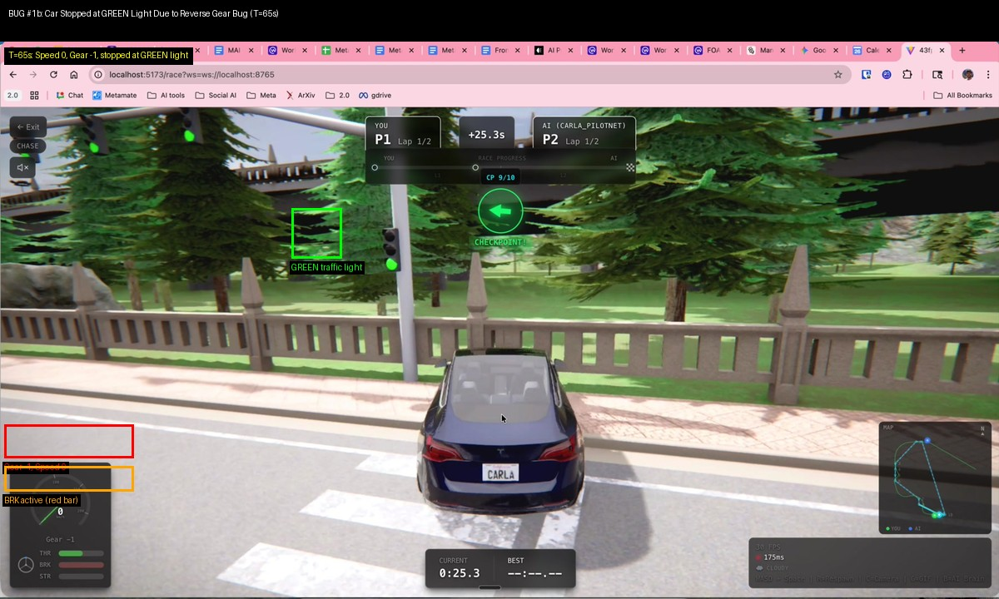
Montage 8: The bug reoccurs during Race 2. At T=65s, the car is stopped at a green light, unable to proceed because it is stuck in reverse gear with the brake applied.

Diagnosis: This is likely a logic error in the vehicle control code. It could be caused by an incorrect state transition, a faulty input mapping (e.g., a key press incorrectly toggling reverse), or a conflict between manual and automatic transmission control signals sent to the CARLA backend. The simultaneous activation of throttle and brake suggests a state management issue where conflicting commands are being sent.

BUG #2: Vehicle Control & Collision Issues
The vehicle has significant difficulty staying on the road. It repeatedly mounts curbs, drives on sidewalks, and collides with scenery. This suggests issues with the steering physics, input handling, or the collision model of the vehicle/environment.

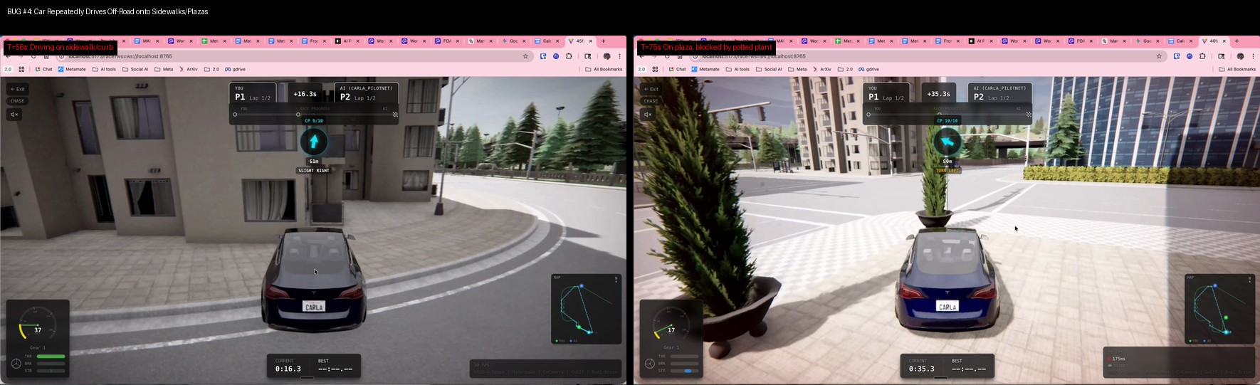
Montage 5: At T=56s, the car is driving on the sidewalk. By T=75s, it has driven onto a pedestrian plaza and is blocked by a potted plant.

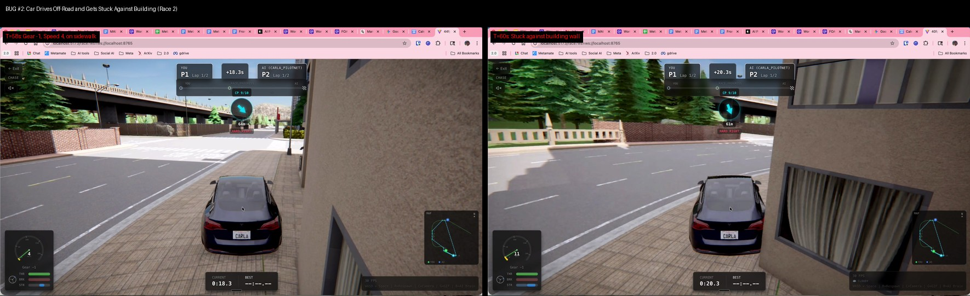
Montage 3: The control issues lead to a collision. At T=58s, the car is on the sidewalk in reverse gear, and by T=60s, it is pressed against a building wall, completely stuck.

Diagnosis: The steering might be too sensitive, or there could be a delay in input processing that causes overcorrection. The fact that the car can easily mount high curbs points to a problem in the physics interaction between the vehicle's wheels and the environment geometry in CARLA.

BUG #3: Severe Video Rendering & Encoding Artifacts
During the second race, the video stream is plagued by severe visual artifacts, most notably chromatic aberration (color fringing). This is visible as a rainbow-like separation of colors, especially on high-contrast edges like road markings and buildings. It is most pronounced at higher speeds.

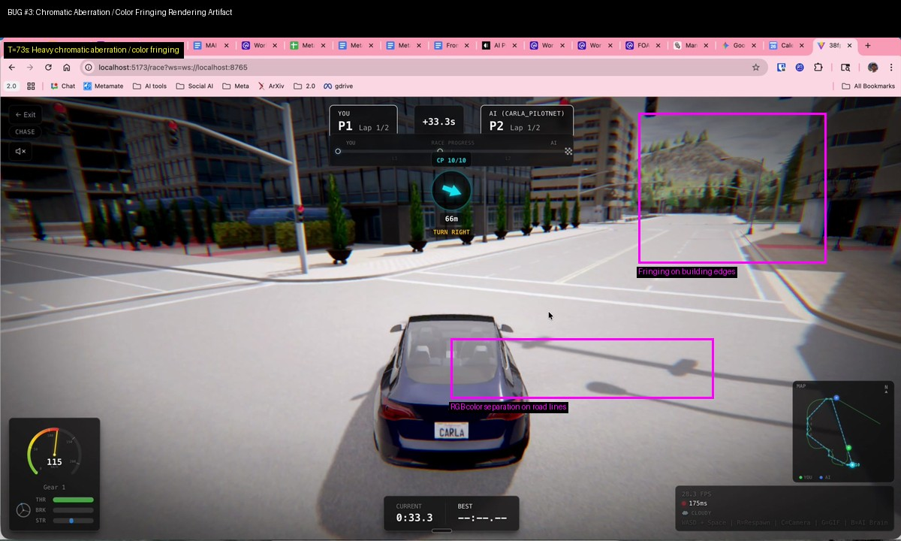
Montage 4: At T=73s, heavy red/cyan color fringing is visible on the road lines and building edges, indicating a rendering or video encoding issue.

Diagnosis: This artifact is not typical of standard gameplay and is likely caused by either a post-processing effect in CARLA that is misconfigured or an issue with the video encoding/decoding pipeline. If you are using a custom post-processing shader, it should be the first place to investigate. Alternatively, check the settings of your video encoder (e.g., FFmpeg, GStreamer) to ensure it is not introducing these artifacts.

BUG #4: Transmission Locked in First Gear
As in the previous revision, the vehicle never shifts out of Gear 1, even when reaching speeds as high as 136 mph/kph. This is unrealistic and severely impacts the driving experience and simulation fidelity.

Diagnosis: The manual_gear_shift flag in the CARLA vehicle control is likely set to True, but no corresponding logic exists in your code to command upshifts. To enable CARLA's automatic transmission, you must ensure manual_gear_shift is set to False when applying control.

5. Performance Analysis
- Frame Rate (FPS): The client-side FPS fluctuates significantly, ranging from 17 to 46 FPS. While improved from the prior revision, the drops to sub-30 FPS contribute to a choppy experience.
- Network Latency: The latency indicator remains red at 175ms throughout the second race. For a real-time cloud gaming application, this level of latency is high and will negatively impact control responsiveness.

6. Prioritized Recommendations
Priority | Bug Description | Severity | Recommended Action
1 | Spontaneous Reverse Gear Engagement | GAME-BREAKING | Review vehicle control logic. Check for state conflicts between forward, reverse, throttle, and brake commands. Ensure inputs are not incorrectly toggling reverse gear.
2 | Vehicle Control & Off-Road Collisions | Critical | Investigate CARLA vehicle physics parameters. Check wheel friction, suspension settings, and steering sensitivity. Review the collision geometry of the environment assets.
3 | Transmission Locked in First Gear | High | In your CARLA vehicle control script, ensure the manual_gear_shift parameter is set to False to enable automatic transmission.
4 | Chromatic Aberration Artifacts | Medium | Disable all custom post-processing effects in CARLA to isolate the cause. If the issue persists, investigate the video encoding and decoding settings.
5 | High Latency (175ms) | Medium | Optimize the video stream. Consider using a lower-latency protocol like WebRTC instead of raw WebSockets. Reduce video resolution or bitrate on the server side.
This detailed analysis should provide a clear path forward for debugging. The reverse gear and control issues are the most critical and should be addressed first to make the game playable.

