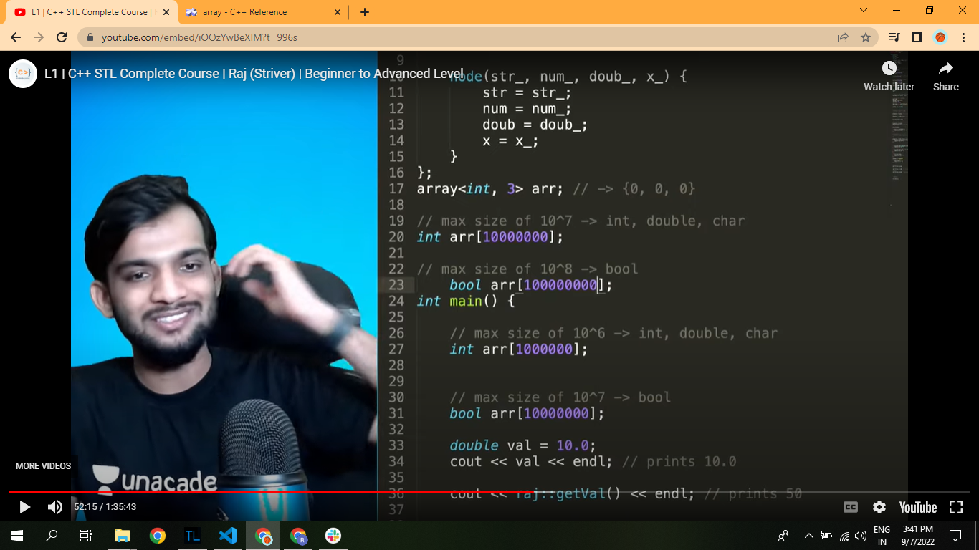

Max size of the array in the main , globally is defined in the pic