**Contacts Management App.**

The App has the following functionality:

1. List all the available contacts.
2. Add a new contact.
3. Edit an existing contact.
4. Delete a contact.

The first page of the app has the list of all the contacts in a tabular format with the feature of edit and delete a particular contact.

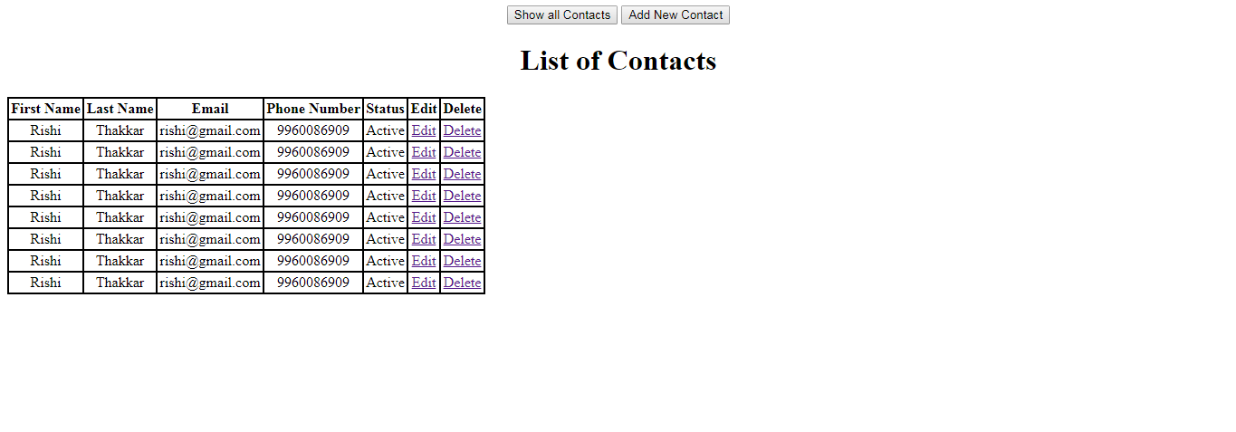

The page also contains two buttons named, Show all contacts which navigates to the initial table and Add new contact which shows the add page as follows:

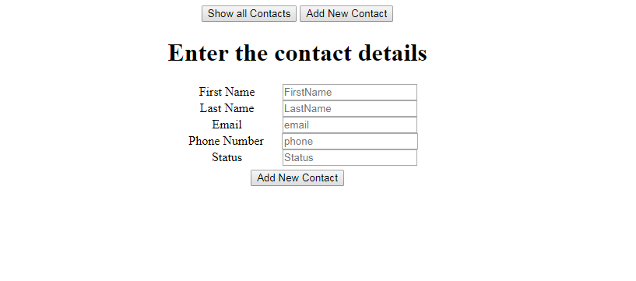

This page after filling the details and clicking add new contact currently gives you the alert as there are no ajax calls to the server, but identically it has to be a service call.

On clicking show all contacts will take back to the list of contacts, where there are option to edit and delete a particular contact.

The edit page has the prepopulated values in the form, and after editing and submitting it shows the alert as there are not ajax calls currently in the project.

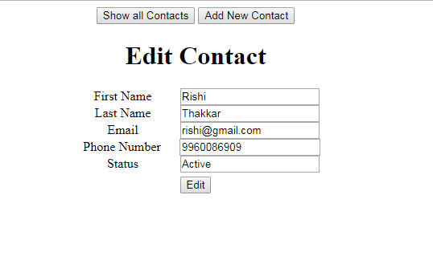

And finally the delete option, the delete option has no view, but the alert directly as the ajax call to the server with the row data to delete can be sent from the home page itself.

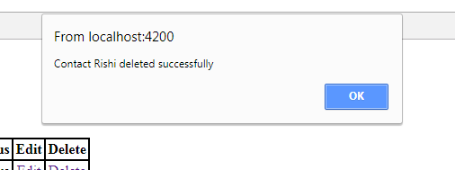

So the app has views, it is a single page application. The URL doesn’t change on navigating the pages.

Navigation to different pages are available through the buttons provided at the top.

Conclusion: So this is how our contacts app can Add, Edit, Delete a contact and list all the contacts respectively.

Technology used: Javascript, Angular 4