Image Generation using stable diffusion & Comfy UI
A Project Report
submitted in partial fulfillment of the requirements
of
AICTE Internship on AI: Transformative Learning
with
TechSaksham – A joint CSR initiative of Microsoft & SAP

by

Rishabh Dubey, rishabhdubey350@gmail.com

Under the Guidance of
Jay Rathod

ACKNOWLEDGEMENT

We would like to take this opportunity to express our deep sense of gratitude to all individuals who helped us directly or indirectly during this thesis work.
Firstly, we would like to thank my supervisor, Jay Rathod Sir, for being a great mentor and the best adviser I could ever have. His advice, encouragement and the critics are a source of innovative ideas, inspiration and causes behind the successful completion of this project. The confidence shown in me by him was the biggest source of inspiration for me. It has been a privilege working with him for the last one year. He always helped me during my project and many other aspects related to the program. His talks and lessons not only help in project work and other activities of the program but also make me a good and responsible professional.
We would also like to express our thanks to our teachers, friends, and family members who always stood by us and provided their support whenever needed. Their motivation and encouragement played a big role in keeping us focused.
Lastly, we appreciate all the authors and researchers whose work contributed to our understanding and helped us in completing this project.
Thank you!

ABSTRACT
This project, "Image Generation using Stable Diffusion & ComfyUI," explores how AI can help in creating images with more control and ease. Stable Diffusion is a powerful AI model that generates images from text prompts, while ComfyUI makes the process even smoother by providing a simple workflow-based interface.
Problem Statement:
Creating good-quality digital images often needs a lot of skill and time. Many people struggle with complexx tools, which makes the process tedius and hard. This project aims to simplify image generation by using Stable Diffusin with ComfyUI, so users can generate images easily even if they are not experts.
Objectives:
- To use Stable Diffusion for making realistic and artistic images.
- To understand how ComfyUI can make the process smoother.
- To improve image quality, details, and customization options.
- To test how well this approach works for different creative needs.
Methodology:
The project follows a strightforward process:
- Installing Stable Diffusion and setting it up.
- Using ComfyUI for a better and user-frindly experience.
- Testing various prompts to analyze image generation.
- Comparing results and making improvements.
Key Results:
- More control over generated images.
- Better image quality with enhanced details.
- A simple and easy-to-use interface.
- More flexibility in modifying and refining images.
Conclusion:
By integrating Stable Diffusion and ComfyUI, this project makes AI-based image generation easier and accessible. It helps designers, artists, and even beginners create AI-generated images without much technical skill. Future improvements can focus on real-time modifications, better automation, and advanced customization options to make the process even more efficient.
TABLE OF CONTENT
Abstract I

Chapter 1. Introduction 1
1.1 Problem Statement 1
1.2 Motivation 1
1.3 Objectives 2
1.4. Scope of the Project 2
Chapter 2. Literature Survey 3
Chapter 3. Proposed Methodology
Chapter 4. Implementation and Results
Chapter 5. Discussion and Conclusion
References

LIST OF FIGURES
Figure No. | Figure Caption | Page No.
 | A vibrant coral reef teeming with life, colorful fish swimming, sea turtles gliding gracefully, and shafts of sunlight penetrating the crystal-clear blue water. | 6
 | A person practicing yoga on a mountain peak during sunrise, overlooking a vast valley covered in mist, symbolizing mental and physical balance in nature’s beauty. | 6
 | A couple walking hand-in-hand on a quiet beach at sunset, with gentle waves washing over the sand and seagulls flying overhead in the orange-hued sky | 7
 | A magical forest at sunrise, with tall ancient trees, soft sunlight filtering through the leaves, a peaceful stream flowing, and glowing fireflies floating in the air. | 7
 | A sustainable eco-village with solar panels, wind turbines on rolling hills, vertical gardens on houses, and people cycling on nature-friendly paths under a clear blue sky. | 8
 | A vibrant cultural festival in a village, people in colorful traditional outfits, folk music and dancing, food stalls, and children playing under festive decorations. | 8
 | A high-tech futuristic city at night, glowing skyscrapers with neon lights, drones flying above, self-driving cars on the streets, and holograms projected in the sky. | 9
 | A serene waterfall cascading down rocky cliffs into a clear pool, surrounded by lush greenery and wildflowers. Soft sunlight filters through the trees, creating gentle rays and a faint rainbow at the misty base." | 9
 | A bustling cyberpunk marketplace, with neon-lit signs, futuristic stalls selling gadgets, robots assisting customers, and people wearing augmented reality gear. | 10

- Animals – Underwater Reef
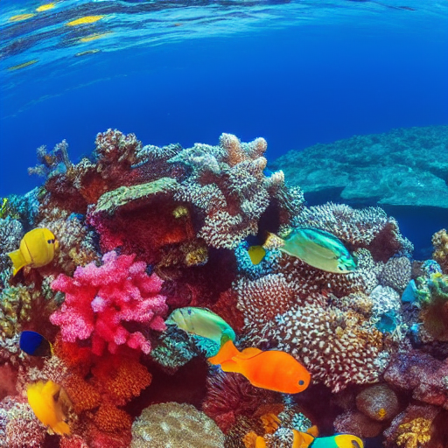
- Health – Yoga in Nature

- Relationship – Beach Walk

- Forest Adventure


- Environment – Green Energy
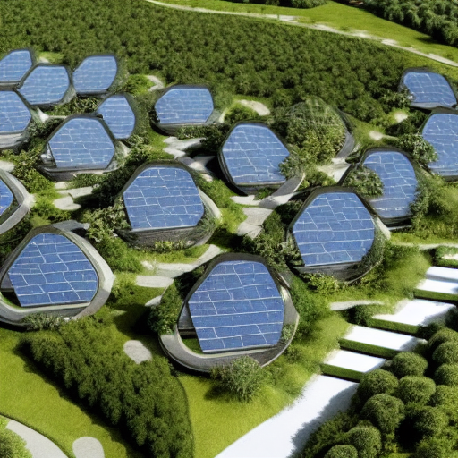

- Society – Community Gathering
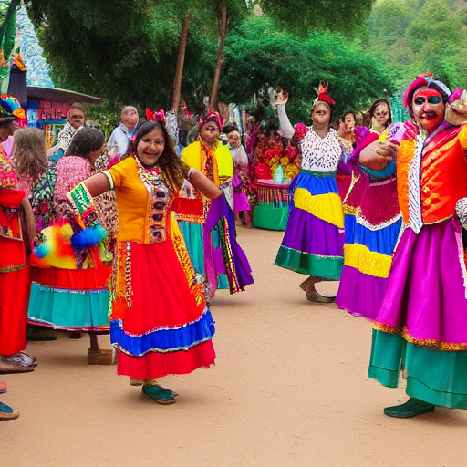
- Technology – Futuristic Smart City
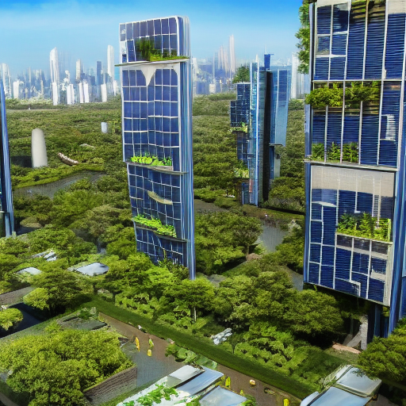

- Nature – Waterfall
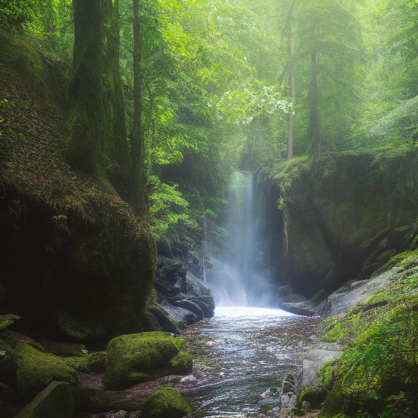
- Technology – Cyberpunk Marketplace
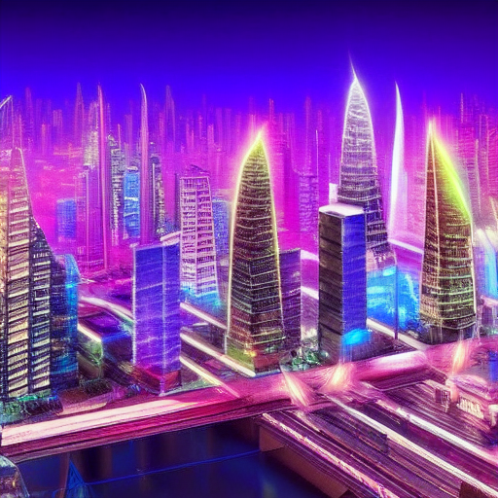

CHAPTER 1
Introduction

  - Problem Statement:
Creating high-quality digital images is time consumng and requires skill. Many people struggle with complex tools like Photoshop, making it hard for begginers to create profesional visuals. While AI models like Stable Diffusion simplify image generation, they often require technical knowledge to set up and use properly.
ComfyUI solves this problem by providing a user-frindly, node-based interface, making AI-powered image creation easire and more accessible. This project focuses on integrating Stable Diffusion with ComfyUI to offer a simpler, faster, and more effecient way to generate images.
Why This Problem Maters
- Makes AI image generation esay for non-techincal users.
- Saves time compared to manual desiging.
- Gives more controll over image quality and style.
- Boosts cretivity by enabling quick content creation.
This project aims to bridge the gap between AI techology and everyday users, making image generation more accsesible and effecient for all.
  - Motivation:
This project was choosen because AI image generation is revolutinizing the way visuals are created, but many people strugle to use complicated tools. Stable Diffusion is a powerfull AI model, but its setup and usage can be confusing, especialy for beginners. ComfyUI makes the process esier and more user-friendly, so we wanted to explore how it can simplify AI-powered image generation.

Potential Applications & Impact
- Graphic Design – Helps designers create high-quality images quickly.
- Content Creation – Bloggers, marketers, and social media creators can generate unique visuals easily.
- Game Development – Can be used for creating character designs and concept arts.
- Advertising & Marketing – Helps brands generate creative ad visuals in minutes.
- Education & Research – Students and researchers can use AI-generated images for projects and presentations.
By making AI-powered image generation more accessible, this project reduces the skill barrier, saves time, and empowers creativity for a wide range of users.

  - Objective:
The main goal of this project is to simplfy AI-based image generation using Stable Diffuson and ComfyUI.
The key objctives are:
- To set up and intigrate Stable Diffusion with ComfyUI for a user-frindly experiance.
- To genrate high-qulity images with better control over detals and custmization.
- To test diffrent prompts and setting to understand how they affect image genration.
- To make AI-powered image creaton accsesible to begginers and non-tech users.
- To analyze performnce and usabillity, comparing it with other AI image-genrating tools.
  - Scope of the Project:
Scope:
- This project focus on image genration using Stable Diffusion and enhancing its usabilty with ComfyUI.
- It covers installtion, setup, and testing of diffrent prompts to produce high-qulity images.
- The project is aimed at designers, artisits, content creaters, and begginers looking for an easy-to-use AI tool.
- It explores custmization options, such as style adjustmets, image resoltion, and fine-tunning outputs.
Limitations:
- The project does not focus on model tranning or creating custome AI models.
- Hardware limtations may affect processng speed and output quality.
- Image genration is depndent on text prompts, and achiving precise results may require exprimentation.
- The project relies on pre-tranied AI models, so it cannot genrate completly unique artistic styles beyond the model’s capablities.
By understanding these objctives and limtations, this project aims to make AI-drivn image creaton more effecient, accsesible, and practcal for varous creative needs.
CHAPTER 2
Literature Survey

2.1 Review of Relevant Literature
AI image genration has been a growing feild, with models like GANs (Generative Adversarial Networks), VAEs (Variational Autoencoders), and Diffusion Models playing a crutial role in creating high-qulity images. Stable Diffuson, which is a diffusion-based model, has gained attention for its ability to generate highly detailed and realistic images from text prompts. Research papers on Deep Learning for Image Synthesis and AI-Assisted Art Creation show how AI can be used to generate, enhance, and modify digital art.
Several studies have explored text-to-image generation, focusing on prompt engineering, resolution enhancement, and fine-tuning for better outputs. While tools like DALL·E, Midjourney, and Runway ML have gained popularity, there is still a need for better control and customization, which is where our project with Stable Diffusion and ComfyUI comes into play.

2.2 Existing Models, Techniques, and Methodologies
- Generative Adversarial Networks (GANs):
  - Used for creating high-quality images but require extensive training and often suffer from mode collapse.
- Variational Autoencoders (VAEs):
  - Good for generative tasks but lack fine details compared to newer diffusion-based models.
- DALL·E & Midjourney:
  - Capable of producing high-quality AI art, but limited customization and expensive APIs.
- Stable Diffusion:
  - An open-source model that generates images from text prompts, but its complexity makes it hard for beginners to use.
- ComfyUI:
  - Provides a workflow-based interface for Stable Diffusion, making it easier for users to create AI-generated images without complex coding.

2.3 Gaps in Existing Solutions & How Our Project Solves Them
Limitations in Existing Models | How Our Project Addresses Them
Many AI models require technical knowledge to use effectively. | ComfyUI makes it simple & beginner-friendly.
Expensive APIs limit accessibility. | Stable Diffusion is open-source & free to use.
Some models lack detailed customization. | Our project allows fine-tuned control over image generation.
Training custom AI models is resource-intensive. | Our approach uses pre-trained Stable Diffusion models for efficiency.

CHAPTER 3
Proposed Methodology

  - System Design
Our proposed system focuses on AI-based image generation using Stable Diffusion and ComfyUI. The system workflow consists of the following main steps:
- User Input (Text Prompt) – The user provides a description of the image they want to generate.
- ComfyUI Processing – The text prompt is processed through ComfyUI’s node-based interface, where users can fine-tune settings like resolution, sampling method, and model selection.
- Stable Diffusion Model – The AI model generates an image based on the input and settings provided.
- Image Refinement – Users can modify and refine the generated image using additional AI filters or upscalers.
- Final Output – The high-quality AI-generated image is displayed and can be saved or further edited.
System Diagram:
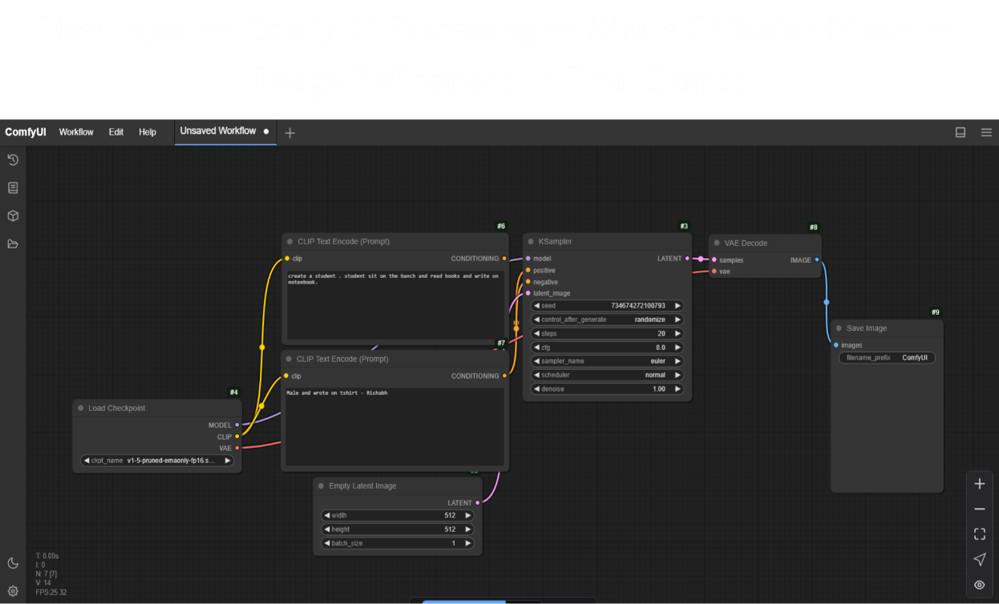
User Input
ComfyUI Process
Stable Diffusion Model
Image Refinement
Final Output

  - Requirement Specification
To implement this project, both hardware and software requirements are considered.
    - Hardware Requirements:
      - GPU: NVIDIA RTX 3060 (or higher) with at least 8GB VRAM
      - CPU: Intel i5 10th Gen / AMD Ryzen 5 or better
      - RAM: Minimum 16GB (32GB recommended for faster processing)
      - Storage: At least 50GB free space (for model files and generated images)
    - Software Requirements:
      - Operating System: Windows 10/11, Linux (Ubuntu), or macOS
      - Stable Diffusion Model: Pre-trained Stable Diffusion v1.5 / v2.1
      - ComfyUI: For workflow-based image generation
      - Python 3.10+ (for AI model execution)
      - CUDA Toolkit & PyTorch (for GPU acceleration)
• Image Editing Tools: GIMP / Photoshop (optional for post-processing)

CHAPTER 4
Implementation and Result

  - Snap Shots of Result:
Snapshot 1: ComfyUI Interface Setup
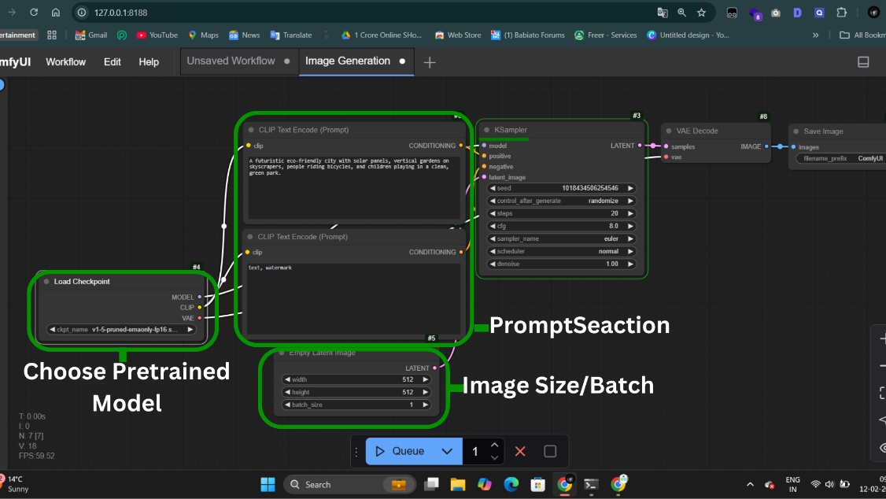
Explanation:
This image shows the ComfyUI interface, where we input text prompts and adjust model settings for image generation. The graph-based workflow makes it easy to manage different aspects of image creation.

Snapshot 2: Image Generation in Progress
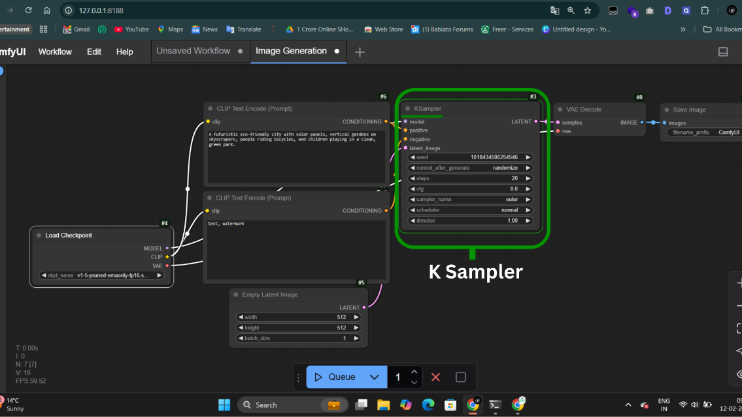
Explanation:
This snapshot captures the image generation process in Stable Diffusion using ComfyUI. It highlights how different settings like resolution, sampling steps, and seed values impact the final output.
Snapshot 3: Final Generated Image
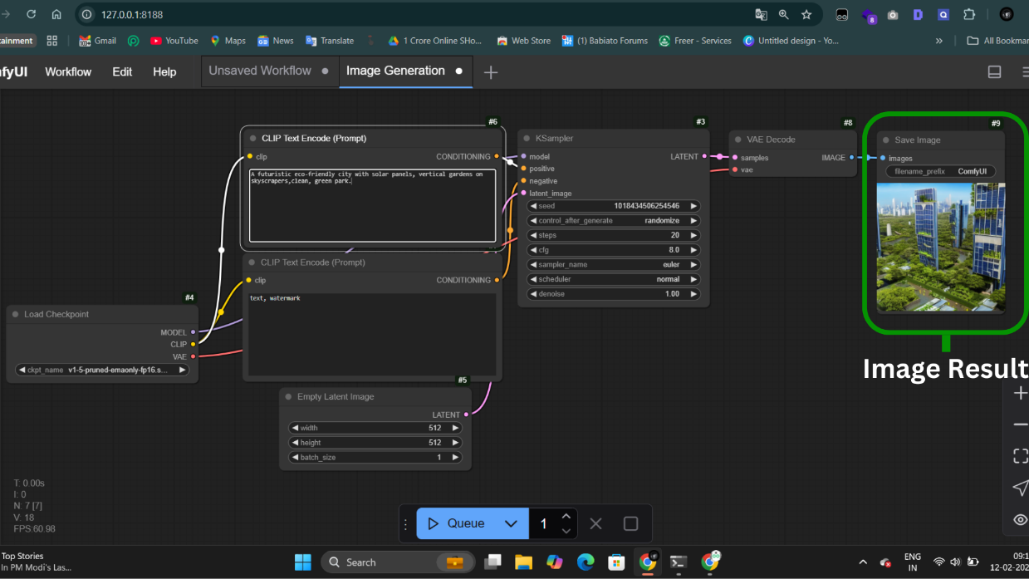
Explanation:
This image represents the final output created by Stable Diffusion. The AI successfully converts the text prompt into a high-quality, detailed image. Users can fine-tune parameters to improve the results further.
  - GitHub Link for Code:
https://github.com/rishi22000/ai-image-genration

CHAPTER 5
Discussion and Conclusion

  - Future Work:
This project works well for generating AI images, but there's still a lot of scope for improvement. Some possible future enhancements include:
- Faster Image Generation – Right now, generating high-quality images takes time. Optimizing the model can make it faster.
- Better Customization – Adding more options like different art styles, lighting effects, or background control can give users more flexibility.
- Higher Resolution Images – Improving the output quality so that the images can be used for printing, professional artwork, or commercial designs.
- Mobile & Web Support – Right now, this setup mostly works on desktops. Developing a mobile-friendly version or a web app will make it easier for more users.
- Fine-Tuned AI Models – Training the AI on specific themes like anime, realism, or fantasy can make it even more useful for different creative needs.
By working on these areas, AI-generated images can become even more efficient, detailed, and accessible to a wider audience.
  - Conclusion:
This project makes AI-based image generation simpler and more user-friendly. Instead of relying on complex software, Stable Diffusion with ComfyUI allows users to create high-quality images easily and with more control.
The results show that AI-generated art is not just random, but can be refined and improved to fit specific needs. This makes it useful for graphic designers, content creators, and even hobbyists who want to experiment with digital art.
With future improvements, this project has the potential to become an even more powerful and creative tool, making AI-generated visuals easier, faster, and more professional for everyone.

REFERENCES

[1] Rombach, R., Blattmann, A., Lorenz, D., et al. (2022). High-Resolution Image Synthesis with Latent Diffusion Models. Computer Vision and Pattern Recognition (CVPR).
[2] Kingma, D. P., & Welling, M. (2013). Auto-Encoding Variational Bayes. arXiv preprint arXiv:1312.6114.
[3] Goodfellow, I., Pouget-Abadie, J., Mirza, M., et al. (2014). Generative Adversarial Nets. Advances in Neural Information Processing Systems (NeurIPS).
[4] ComfyUI Documentation. (2023). A Graph-Based User Interface for Stable Diffusion. Available at: https://github.com/comfyanonymous/ComfyUI
[5] Ho, J., Jain, A., & Abbeel, P. (2020). Denoising Diffusion Probabilistic Models. arXiv preprint arXiv:2006.11239.
[6] Stable Diffusion GitHub Repository. (2022). Stable Diffusion - A State-of-the-Art Text-to-Image Model. Retrieved from: https://github.com/CompVis/stable-diffusion
[7] Saharia, C., Chan, W., Saxena, S., et al. (2022). Photorealistic Text-to-Image Diffusion Models with Deep Learning. Google AI Research.

