import com.mongodb.client.*;
import com.mongodb.client.model.Filters;
import com.mongodb.client.model.Updates;
import org.bson.Document;

public class CRUD_Test {

public static void main(String[] args) {

MongoClient mongoClient =
MongoClients.create("mongodb://localhost:27017");

MongoDatabase database =
mongoClient.getDatabase("CollegeDB");

MongoCollection<Document> collection =
database.getCollection("Students");

// CREATE
Document student = new Document("id", 101)
.append("name", "John")
.append("department", "CSE")
.append("cgpa", 8.7);

collection.insertOne(student);

System.out.println("Document Inserted Successfully");

// READ
System.out.println("\nStudent Records:");

FindIterable<Document> students = collection.find();

for (Document doc : students) {
System.out.println(doc.toJson());
}

// UPDATE
collection.updateOne(
Filters.eq("id", 101),
Updates.set("cgpa", 9.2));

System.out.println("\nDocument Updated Successfully");

// READ UPDATED RECORD
Document updatedStudent =
collection.find(Filters.eq("id", 101)).first();

System.out.println("\nUpdated Record:");
System.out.println(updatedStudent.toJson());

// DELETE
collection.deleteOne(Filters.eq("id", 101));

System.out.println("\nDocument Deleted Successfully");

mongoClient.close();
}
}

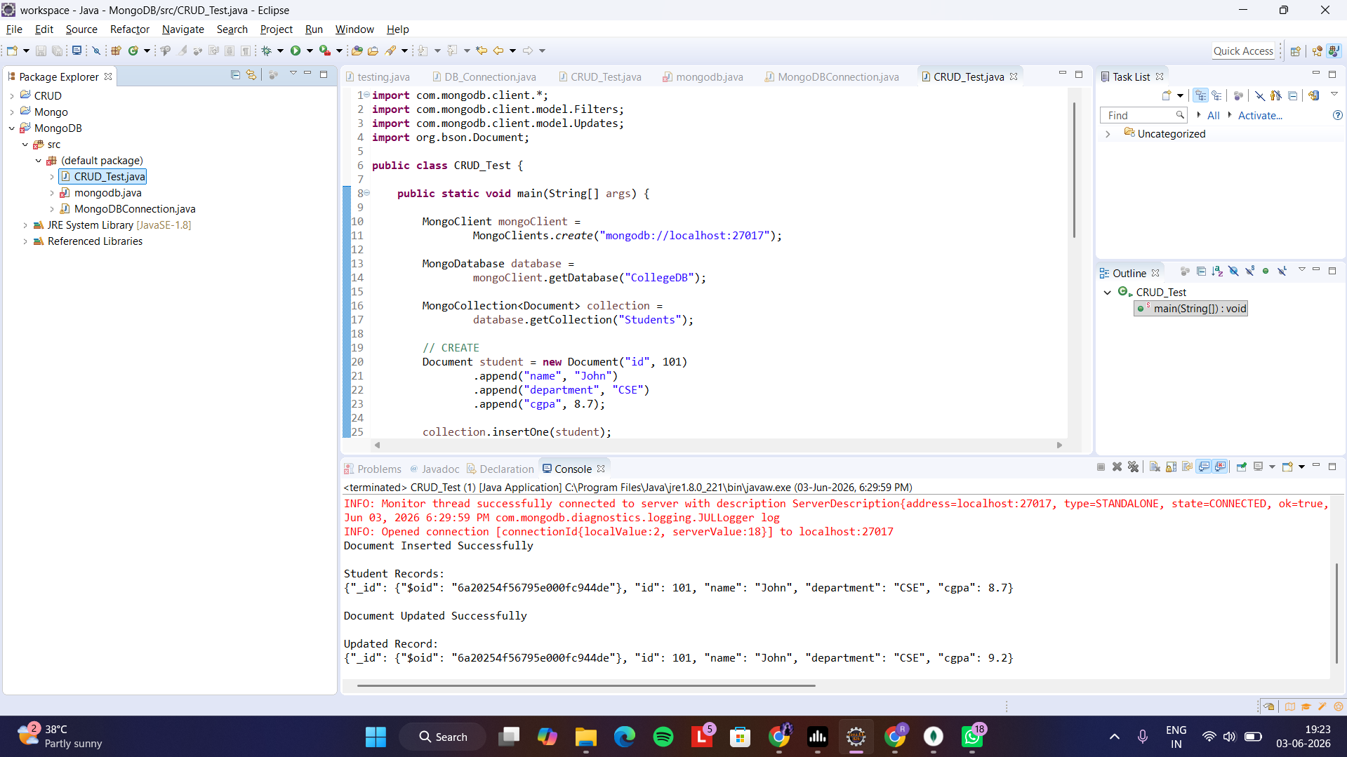

For many:
import com.mongodb.client.*;
import com.mongodb.client.model.Filters;
import com.mongodb.client.model.Updates;
import org.bson.Document;

public class CRUD_Test {

public static void main(String[] args) {

MongoClient mongoClient =
MongoClients.create("mongodb://localhost:27017");

MongoDatabase database =
mongoClient.getDatabase("CollegeDB");

MongoCollection<Document> collection =
database.getCollection("Students");

// CREATE
Document student = new Document("id", 101)
.append("name", "John")
.append("department", "CSE")
.append("cgpa", 8.7);

collection.insertOne(student);

System.out.println("Document Inserted Successfully");

// READ
System.out.println("\nStudent Records:");

FindIterable<Document> students = collection.find();

for (Document doc : students) {
System.out.println(doc.toJson());
}

// UPDATE
collection.updateOne(
Filters.eq("id", 101),
Updates.set("cgpa", 9.2));

System.out.println("\nDocument Updated Successfully");

// READ UPDATED RECORD
Document updatedStudent =
collection.find(Filters.eq("id", 101)).first();

System.out.println("\nUpdated Record:");
System.out.println(updatedStudent.toJson());

// DELETE
//collection.deleteOne(Filters.eq("id", 101));

//System.out.println("\nDocument Deleted Successfully");

mongoClient.close();
}
}

