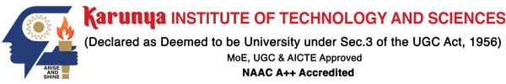

**Division of Electronics and Communication Engineering**

**2023-2024 (EVEN SEM)**

**III IA EVALUATION REPORT**

***for***

**DIGITAL SIGNAL PROCESSING-PROJECT BASED COURSE**

***Title of the project: SPEECH TO TEXT USING PYTHON***

***A report submitted by***

|  |  |
| --- | --- |
| ***Name of the Student*** | ***RISHI CRISPIN J*** |
| ***Register Number*** | ***URK22EC1066*** |
| ***Subject Name*** | ***Digital Signal Processing*** |
| ***Subject Code*** | ***18EC2015*** |
| ***Date of Report submission*** |  |

**Project Rubrics for Evaluation**

**First Review:** Project title selection - PPT should have four slides (Title page, Introduction, Circuit/Block Diagram, and Description of Project).

**Second Review:**  PPT should have three slides (Description of Concept, implementation, outputs, results and discussion)

Rubrics for project (III IA - 40 Marks):

Content - 4 marks (based on Project)

Clarity - 3 marks (based on viva during presentation)

Feasibility - 3 marks (based on project)

Presentation - 10 marks

Project Report - 10 marks

On-time submission - 5 marks (before the due date)

Online submission-GCR - 5 marks

**Total marks: _____/ 40 Marks**

**Signature of Faculty with date:**



**TABLE OF CONTENTS**

|  |  |  |
| --- | --- | --- |
| **CHAPTER** | **TITLE** | **PAGE NO.** |
| 1. **1** | **INTRODUCTION** | **3** |
| 1. **2** | **DESCRIPTION OF THE PROJECT** | **4** |
| 1. **3** | **CONCEPT INVOLVED** | **5** |
| 1. **4** | **TOOLS** | **8** |
| 1. **5** | **IMPLEMENTATION** | **10** |
| 1. **6** | **RESULTS WITH GRAPH/SIMULATION** | **12** |
| 1. **7** | **REFERENCES** | **14** |
| 1. **8** | **CONCLUSION** | **15** |

**CHAPTER 1**

**INTRODUCTION**

Speech-to-text (STT) technology has emerged as a pivotal tool in transforming spoken language into written text, offering immense potential across various domains. Leveraging Python, a versatile and widely-used programming language, facilitates the development of robust and efficient speech-to-text systems. Through Python's rich ecosystem of libraries, such as SpeechRecognition and PyAudio, developers can seamlessly integrate cutting-edge speech recognition capabilities into their applications. By harnessing machine learning algorithms and deep neural networks, Python-based speech-to-text solutions can achieve remarkable accuracy, enabling users to transcribe audio recordings into text with remarkable fidelity. Moreover, Python's flexibility empowers developers to customize and optimize STT pipelines to suit specific requirements, whether in transcription services, voice-controlled applications, or accessibility aids. This introduction sets the stage for exploring the vast possibilities of speech-to-text technology using Python, underscoring its significance in driving innovation and accessibility in the digital era.

**CHAPTER 2**

**DESCRIPTION OF THE PROJECT**

Speech-to-text (STT) technology in Python enables the conversion of spoken language into written text through programming. Utilizing libraries such as SpeechRecognition, developers can create applications capable of transcribing audio input from various sources like microphones or audio files into text. The process typically involves capturing audio input, preprocessing it if necessary, and then passing it through the speech recognition engine. This engine employs advanced algorithms, often based on machine learning techniques, to analyze the audio and produce accurate textual representations. Python's versatility allows for integration with other libraries and frameworks, enhancing functionality such as language detection, noise reduction, and speaker diarization. Furthermore, STT applications can be deployed in diverse fields, including accessibility tools, virtual assistants, transcription services, and more. Through Python's simplicity and robustness, developers can harness the power of speech recognition to automate tasks, improve user experiences, and facilitate communication in a wide range of applications.

Top of Form

**CHAPTER 3**

**CONCEPT INVOLVED**

Speech-to-text (STT) conversion involves converting spoken language into written text. In Python, there are several concepts involved in implementing speech-to-text functionality. Here are some of the key concepts:

1. Audio Input: You need to acquire the audio input from a microphone or an audio file. Python libraries like PyAudio or librosa can be used to capture audio from a microphone or load audio files respectively.

2. Speech Recognition: This is the core functionality where the audio input is processed to recognize spoken words and convert them into text. There are several libraries available for speech recognition in Python, such as:

SpeechRecognition: A library that provides easy-to-use APIs to work with various speech recognition engines, including Google Speech Recognition, IBM Speech to Text, etc.

Google Cloud Speech-to-Text API: Google provides an API for speech recognition which can be used through Python SDK or RESTful API calls. This requires authentication and may have usage charges.

CMU Sphinx: An open-source speech recognition toolkit that can be used for offline speech recognition. It's less accurate than cloud-based solutions but offers privacy benefits and works offline.

3. Language Models and Grammars (optional): Depending on the context and requirements, you may need to employ language models or grammars to improve the accuracy of the speech recognition system. This involves defining rules or constraints on what kind of speech patterns or words are expected.

4. Preprocessing: Preprocessing steps may be necessary to clean up the audio signal, remove noise, or enhance the quality of speech before passing it to the speech recognition engine. Techniques such as noise reduction, normalization, and feature extraction can be used for preprocessing.

5. Post-processing (Optional): After converting speech to text, you may need to perform additional processing such as text normalization, spell checking, or punctuation insertion to improve the quality of the recognized text.

6. Error Handling and Robustness: Handling errors and ensuring robustness of the system is crucial, especially in real-world applications where audio quality can vary widely. Techniques such as handling timeouts, retries, and fallback mechanisms are essential for a reliable speech-to-text system.

7. Integration and Application Development: Finally, integrating the speech-to-text functionality into your application and designing the user experience around it is important. This involves designing user interfaces, error messages, and feedback mechanisms to make the system more user-friendly.

These are some of the key concepts involved in implementing speech-to-text functionality using Python. Depending on the specific requirements and use case, additional concepts and techniques may be necessary.

**CHAPTER 4**

**TOOLS**

There are several tools and libraries available in Python for converting speech to text. Some popular ones include:

1. SpeechRecognition: A library that supports multiple speech recognition engines and APIs, including Google Speech Recognition, IBM Speech to Text, CMU Sphinx, etc. It's a straightforward library to use and integrates well with various APIs.

2. Google Cloud Speech-to-Text: Google provides its own speech-to-text API, which can be accessed through the `google-cloud-speech` library. You'll need to set up a Google Cloud account and enable the Speech-to-Text API to use this service.

3. IBM Watson Speech to Text: IBM Watson offers its speech-to-text service, which can be accessed through the `ibm-watson` Python SDK. Similar to Google Cloud, you'll need an IBM Cloud account and API credentials to use this service.

4. Mozilla DeepSpeech: An open-source implementation of Baidu's DeepSpeech architecture. It's based on machine learning techniques and provides a model for speech-to-text conversion. You can use the `deepspeech` Python library to utilize this model.

5. CMU Sphinx (PocketSphinx): A lightweight, open-source speech recognition system that doesn't require an internet connection for processing. The `pocketsphinx` Python library provides bindings to the CMU Sphinx library.

6. Wit.ai: Developed by Facebook, Wit.ai offers a speech-to-text API along with other natural language processing capabilities. You can use the `wit` Python library to integrate with Wit.ai's speech recognition service.

These are some of the popular tools and libraries available in Python for speech-to-text conversion. Depending on your requirements, you can choose the one that best fits your needs in terms of accuracy, language support, ease of use, and integration capabilities.

**CHAPTER 5**

**IMPLEMENTATION**

Certainly! Here's an explanation of how you can implement speech-to-text functionality using Python without diving into the code:

1. Choose a Speech Recognition Library: Python offers various libraries for speech recognition. One of the most popular ones is `SpeechRecognition`. You can install it using pip (`pip install SpeechRecognition`).

2. Import the Library: Once you've installed the speech recognition library, import it into your Python script. This library provides a simple interface for interacting with different speech recognition APIs, such as Google Web Speech API, CMU Sphinx, etc.

3. Capture Audio: Use the library to capture audio from the microphone or load an audio file. Most libraries support both live audio input and pre-recorded audio files. If capturing live audio, you typically use a microphone.

4. Process Audio: If needed, preprocess the audio data. Some libraries offer built-in noise reduction or ambient noise adjustment functionalities. Preprocessing may improve the accuracy of speech recognition.

5. Perform Speech Recognition: Pass the audio data to the speech recognition engine. The library will analyze the audio and attempt to transcribe it into text. This process usually involves sending the audio data to an external API (like Google's or IBM's) and receiving the transcribed text.

6. Handle Recognition Results: Once the speech recognition engine transcribes the audio, handle the results. If successful, you'll receive the transcribed text. If unsuccessful (due to poor audio quality, background noise, etc.), the library may raise an exception or return an error message.

7. Utilize the Transcribed Text: Once you have the transcribed text, you can use it according to your application's requirements. You might display it to the user, process it further, or store it in a database.

8. Error Handling: Implement error handling to deal with situations where the speech recognition fails or encounters issues. This ensures that your application gracefully handles unexpected scenarios.

Overall, implementing speech-to-text functionality in Python involves choosing a suitable library, capturing audio, performing speech recognition, and handling the results. The specific implementation details may vary depending on the chosen library and your application's requirements.

**CHAPTER 6**

**RESULTS WITH GRAPH/SIMULATION**

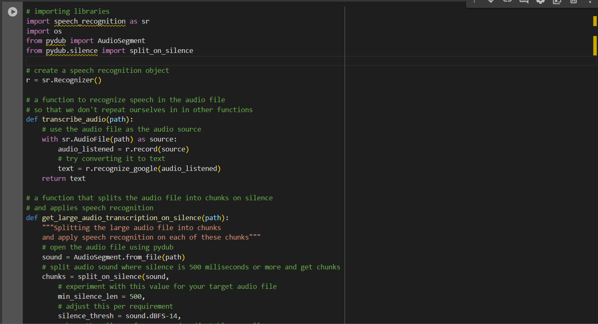

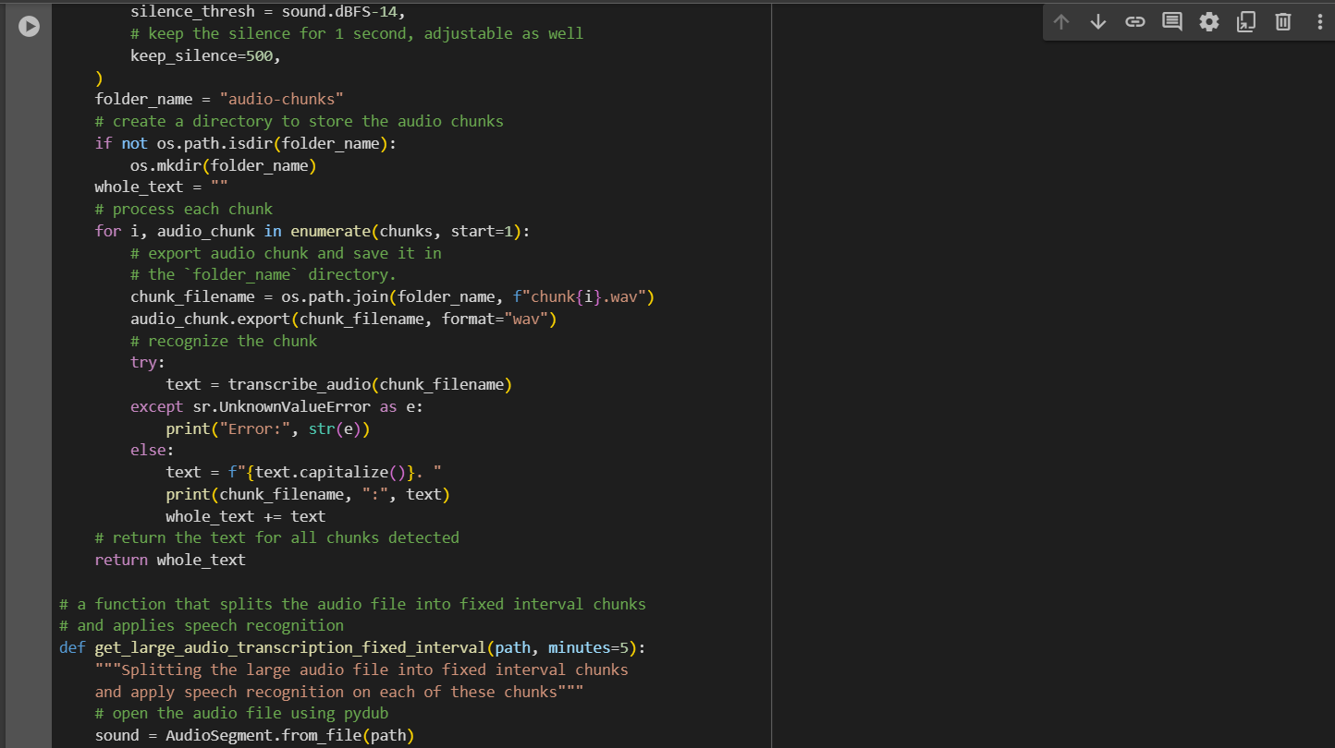

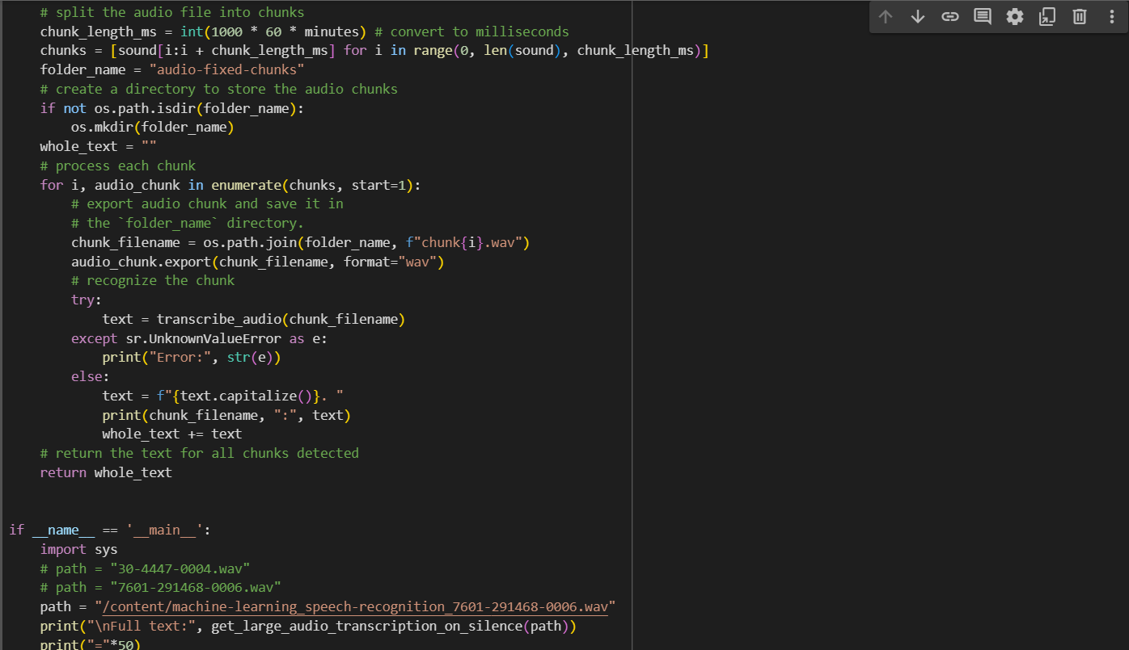

**CHAPTER 7**

**INFERENCE**

<https://realpython.com/python-speech-recognition/>

<https://pythonprogramming.net/speech-recognition-api-recognize-speech-python-tutorial/>

<https://towardsdatascience.com/a-complete-guide-to-speech-recognition-in-python-8664bb5dcd1e>

<https://github.com/Uberi/speech_recognition>

**CHAPTER 8**

**CONCLUSION**

Implementing speech-to-text functionality in Python enables the conversion of spoken language into written text. This technology holds significant implications across various domains, including accessibility, transcription services, and voice-activated applications.

By leveraging Python libraries such as SpeechRecognition, developers can create robust applications capable of transcribing spoken words with ease. This process typically involves capturing audio input, sending it to a speech recognition engine, and receiving the corresponding text output.

Through this implementation, businesses can streamline workflows, improve accessibility for individuals with disabilities, and enhance user experiences in voice-driven applications. As speech recognition technology continues to advance, its integration into Python projects opens up new possibilities for innovation and automation in the digital landscape**.**