Pull the files from Git.
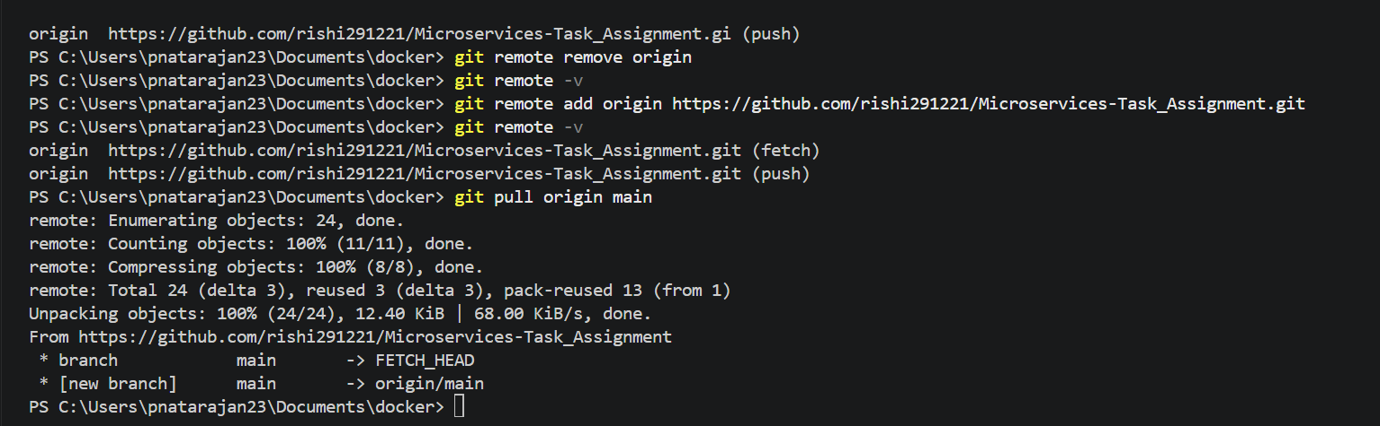

Create a docker file based on service.
Gateway service – 3000

FROM node:20-alpine
WORKDIR /app
COPY package*.json ./
RUN npm install
COPY . .
EXPOSE 3000
CMD ["node", "app.js"]
--------------------------------------------
User service – 3001

FROM node:20-alpine
WORKDIR /app
COPY package*.json ./
RUN npm install
COPY . .
EXPOSE 3001
CMD ["node", "app.js"]
---------------------------------------------
Product service- 3002
FROM node:20-alpine
WORKDIR /app
COPY package*.json ./
RUN npm install
COPY . .
EXPOSE 3002
CMD ["node", "app.js"]

Order service-3003
FROM node:20-alpine
WORKDIR /app
COPY package*.json ./
RUN npm install
COPY . .
EXPOSE 3003
CMD ["node", "app.js"]

Include .dockerignore:
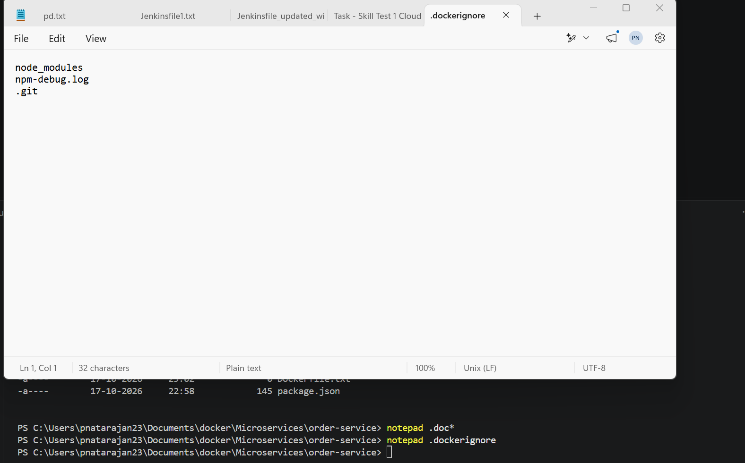

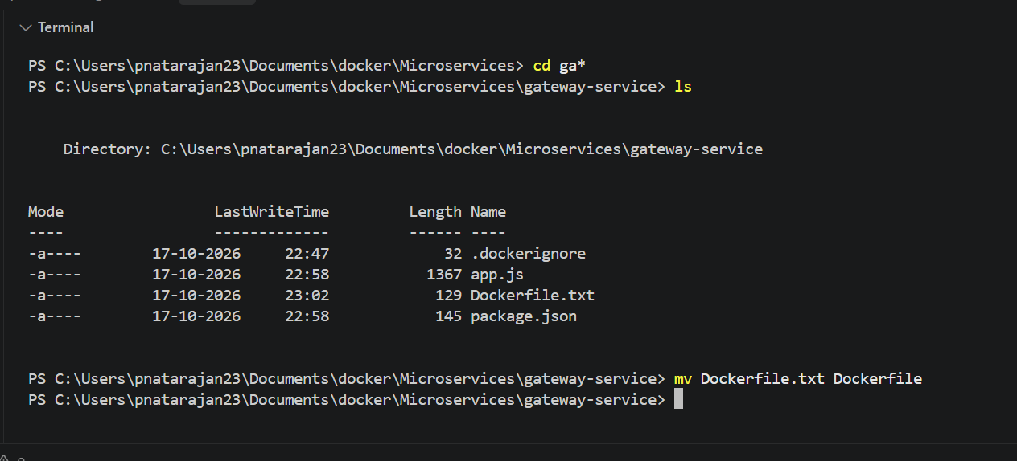

Create docker-compose.yml
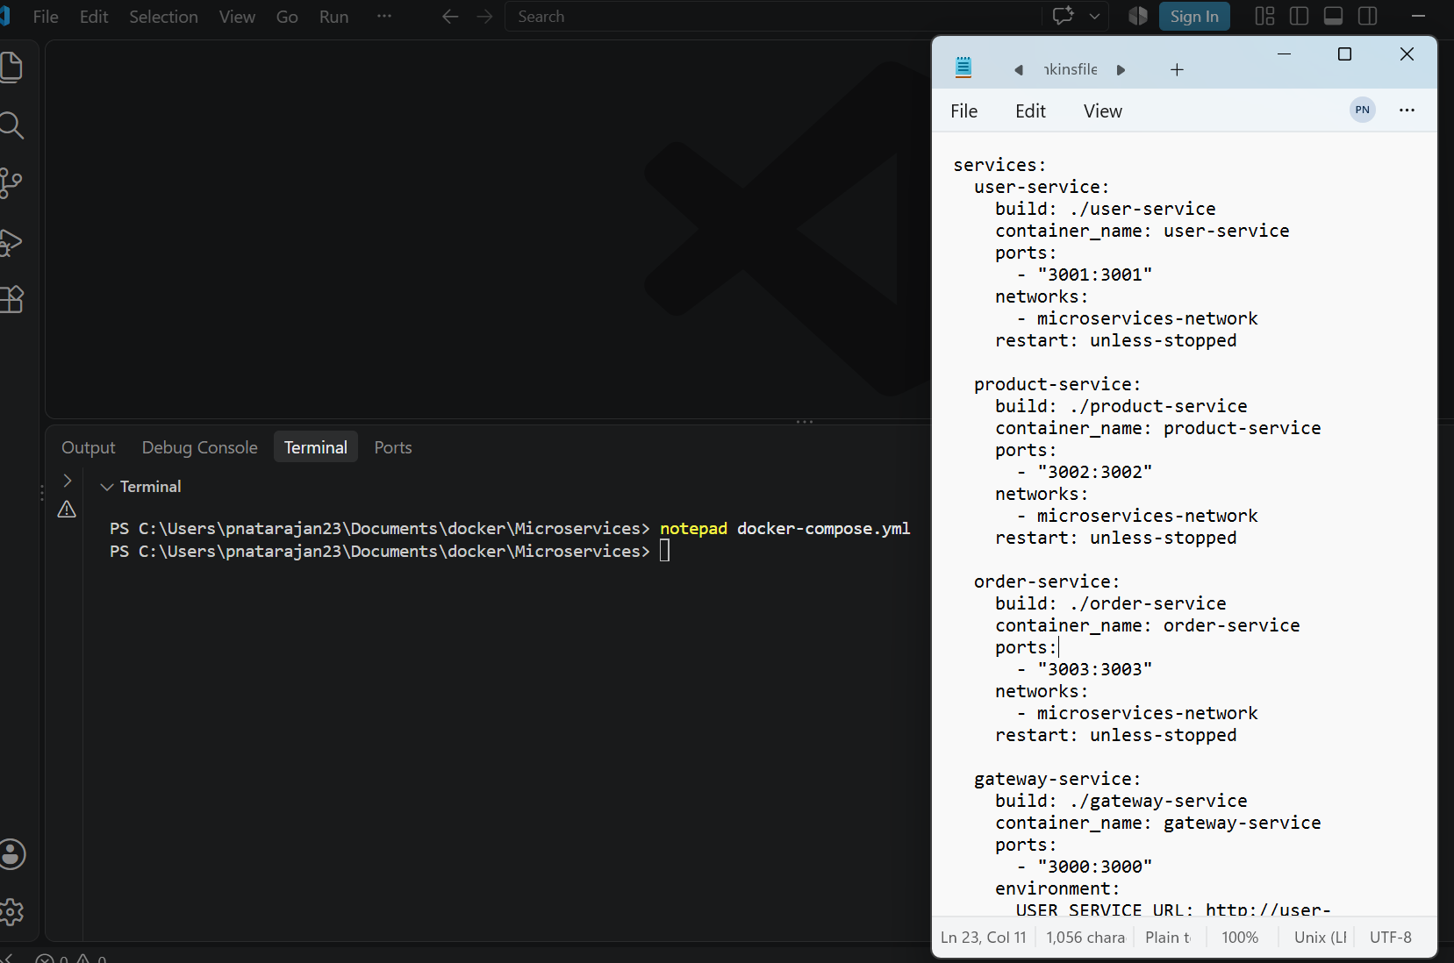

To build images using docker compose.yml
docker compose build --no-cache
To start containers
docker compose up -d
docker ps
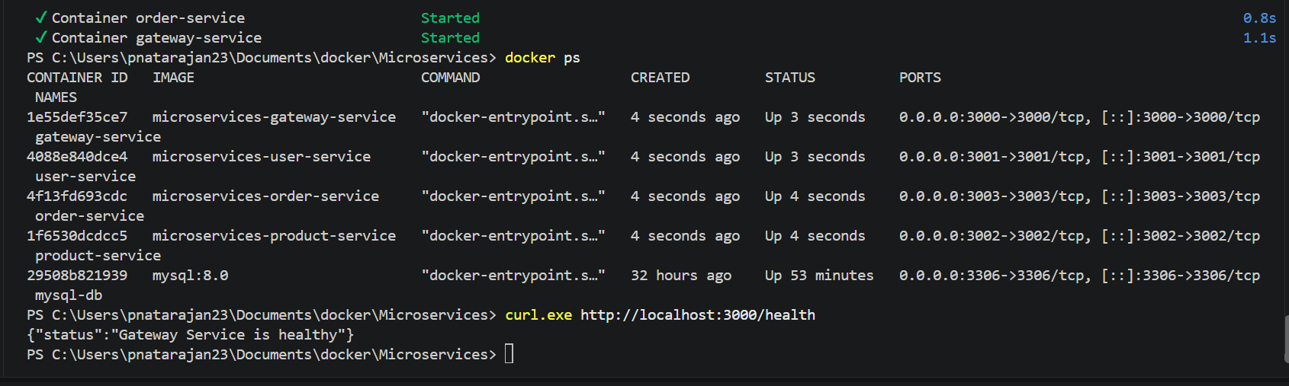

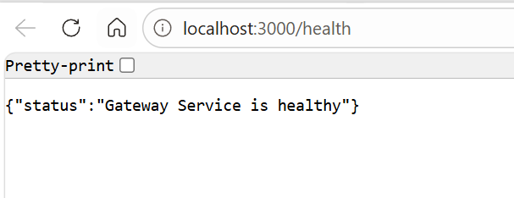
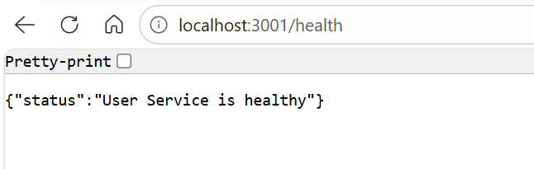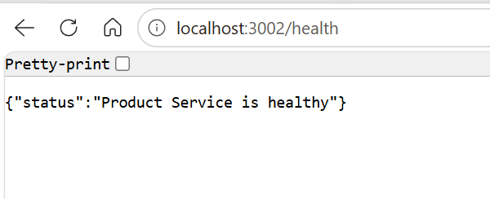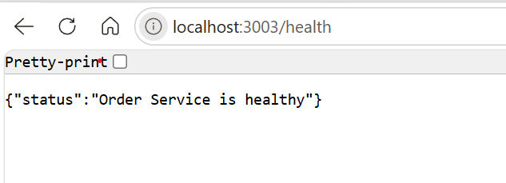

Through Gateway all the services are reachable:
