Veer narmad south Gujarat
University, surat.
Department of Information and
Communication Technology

M.sc. (Information Technology)
5 year Integrated course

Year 2022-2023

B.sc. (Information Technology)
6th semester

PROJECT REPORT

Hotel booking service

Guided by Submitted by
Internal Guide:
Rishi denishbhai patel
Dr.parul patel SPID: 2020049891
S.no | Particulars | Page No.
1 | Proposed System
 | 1.1 Project Profile | 2
 | 1.2 Scope | 3
 | 1.3 Objective | 4
2 | System Environment
 | 2.1 H/W Requirement | 5
 | 2.2 Front-end
 | 2.3 Back-end
3 | System Planning
 | 3.1 feasibility Study | 6
4 | System Analysis
 | 4.1 System Architecture
 | 4.2 Software Requirement Specification
 | 4.3 Entity Relationship Diagram
 | 4.4 DFD
 | 4.5 PSEC
 | 4.6 Data Dictionary
 | 4.7 Use-case Diagram
5 | Designing
 | 5.1 Database Designing
 | 5.2 Interface Designing
6 | Testing

- Proposed system

1.1 project profile

Project Title | Hotel booking service
Project Definition | The project greatly simplifies the booking process of hotels by filters like different states, types, city, etc.. .users can book hotels, make payments, etc.
Project Type | Web Bases Application
Front-end Tool | Visual Studio code
Front-end Technology | PHP
Back-end Tool | Mysql
Development Tool | HTML, CSS,javascript
Project Internal Guide | Mrs.parul patel
Project External Guide
Project Duration | 3 Months
Submitted By | Mr. Rishi patel
Submitted To | J. P. Dawer Institute of Information Science & Technology, surat

1.2 Scope :
1) Admin :-
- admin can login
- admin can add hotels,room types,cities etc..
- admin can update hotel details,prices etc..
- admin can manage user inquiries,hotel bookings and other services
- admin can manage FAQs
- Show reviews and Response to user’s query

2) User :-
- user can sign up and log in
- Reset password
- user can write inquiry for booking hotels
- user can search hotels based on states and cities.
- user can select city,state,price,type of rooms(deluxe room,family room,couple room etc)
- user can give reviews
- user can book hotels
- user can pay online or offline
- user can cancel booking
- user can check terms and condition.
1.3 Objectives :

- A hotel management system aims to streamline and optimize the management of hotel-related activities and services. This includes managing bookings, reservations, customer service, and financial transactions.
- The system should provide a platform for operators to manage their business operations effectively while providing a seamless and enjoyable experience for customers.

- System Environment

  - Hardware environment

- Desktop Computer / Laptop with a modern operating system.
- Most current computers and laptops have high enough specifications to be used to create website.
- A server with sufficient processing power, storage and memory to handle website traffic.
- Templates/API
- Some in-built designing templates are available to make site responsive and attractive. In our website i have used Zegva admin and ThemeForest user template respective.
- There are few API’s available that helps in add on functionalities.
- External Hard Drive for Backing up Purpose.
- A database server, MySQL Server for storing and retrieving data.
- Server to Host Website.
- The Server should also have a reliable internet connection with adequate bandwidth.

  - Software environment

- Operating system
- Any windows version would be required.
- Browser Requirement
- A compatible browser support is essential in order to execute or run the website.
Operating Environment
This proposed software will be used in the Windows platform in the
A version of windows 7, windows 8 and Windows 10.
Design and Implementation Constraints
This system shall be a based application system running in a windows
environment. The system shall be developed using PHP and MySQL
server.
Hardware interfaces
This System doesn’t require any hardware interface.The one used is
monitor, keyboard and mouse.
The system should have these hardware requirements:
- Memory:512MB or above
- Hard Disk Drive:40Gb or above
- Processor:Intel Pentium3 3.2Ghz or above

Software Interfaces
- Operating System:Windows
- Front End:HTML,JS,CSS,Bootstrap
- Back End:MySQL,PHP
Communication is done through internet and intranet.

- System Planning
  - Feasibility Study

- A feasibility study for a tour hotel booking management system involves assessing the practicality and viability of developing and implementing a system that facilitates the management of various hotel booking. The study typically includes evaluating economic feasibility, Technical feasibility, and Operational feasibility. Here's a breakdown of each aspect:

- Economical Feasibility:

- Economic feasibility involves analyzing the financial viability of the hotel booking management system. It includes estimating the costs associated with system development, implementation, ongoing maintenance, and support. Additionally, potential benefits such as increased efficiency, cost savings, and revenue generation should be considered to determine if the system is economically feasible.

- Technical Feasibility:

- As our system is web-bases application, the main tools and technology used are,
- HTML
- CSS
- jQuery
- MySQL Server
- Bootstrap
- As known these technologies are open Source and easy to learn. The technical skills required are manageable.

- Operational Feasibility:

- Operational feasibility assesses the system's compatibility with existing customer/tourism operations and processes. It involves evaluating how the system will integrate into daily operations, its impact on stakeholders (e.g., service providers, customers), and the willingness of stakeholders to adopt and utilize the system. Operational challenges and potential benefits such as improved scheduling, resource allocation, and customer satisfaction should be considered.

4.System Analysis

  - System Architecture

- Admin Side:

Login
Admin
Database
Navigation

Show review & user enquiry
Show total bookings
Add/View/
Delete /Edit FAQs
& admin Contact
Add/View/Delete /Edit
State and cities
Add/View/Delete /Edit
room type
Add/View/Delete /Edit hotel details

- User Side:

Login
User
Database
Navigation Menu

Give rate & review
Show booking
Details
Book hotel
& make payment
Show FAQ
Show room types
Show hotels & states

  - Software Requirement Specification

- Overall Description :

1.1 User Classes and Characteristics
The admin of the company and the customer will be the main users of the system. The System is also designed to be user-friendly.

1.2 Operating Environment
This proposed software will be used in Windows platform in the
version of Windows 7, windows 8, and Windows 10.

1.3 Design and Implementation Constraints
This system shall be a based application system running in a windows
environment. The system shall be developed using SQL server.
A person who has no knowledge of computers will find it difficult to
understand the system. But with a little knowledge it will be very easy to
handle the project.

1.4 General Constraints
-The System must be delivered by deadline.
-The System must be user-friendly.

1.5 Assumption and Dependencies
It is assumed that compatible computers will be available before the
system is installed and tested.

- System Features and Requirements :

2.1 Functional Requirements
The System should have total two modules are Admin
Module user module.

2.1.1 Admin Module :
-Admin can login using email and password.
-Admin can add , delete , update the data of hotels
-Admin can see the data of user via booking.
-Admin can see review and user enquiry
-Admin will response to user according to their query about services.
-Admin can manage and see cancellation.

2.1.2 User Module :
-Users can see the packages according to state, city, room type and hotels, FAQs, and details about website.
-User can add hotels.
-Users can book services.
-User can pay online.
-Users can give reviews.

  - External Interface Requirements:

2.2.1 User Interfaces :
The user interface is designed in php. The developer will have to study
the designing of the project. The user will get very user friendly web page
which will be very easy to work with.

2.2.2.Hardware interfaces :
This System doesn’t require any hardware interface. The one used is
monitor, keyboard and mouse.
The system should have these hardware requirements:
-Memory : 512MB or above
-Hard Disk Drive : 40Gb or above
-Processor : Intel Pentium3 3.2Ghz or above

2.2.3 Software Interfaces :
- Operating System : Windows
- Front End : HTML, JS, CSS, Bootstrap, jQuery
- Back End: SQL, php

2.2.4 Communication Interfaces :
Communication is done through internet .

2.2.5 System Features :
- Authentication for different users.
- Real-time validation of all fields and database to prevent errors.
- LAN compatible.
- Compatible with any platform.

2.3 Non-Functional Requirements

2.3.1 Performance requirements :
System manages facilities required by the users quickly and easily .It
offers to employee through online.

2.3.2 Safety Requirements/Specification :
- In case the admin forgets or loses Passwords, the repair
functionality helps by choosing “Forget password” option in the main
login page.
-To avoid this kind of situations, backups can be done regularly.

2.3.3 Security Requirements/Specification :
This system is provided with authentication feature. So only the legitimate users are allowed to use the application. If the legitimate user’s share the authentication information then the system is open to outsiders.

2.3.4 Software Quality Attributes :
- Reliability : Good validations of user inputs will be done to avoid
incorrect storage of records.
- Maintainability : During the maintenance stage ,SRS document can be referred for any validations.
- Portability : This system can be installed in any personal
computers supporting windows operating system platform.

  - Entity Relationship Diagram

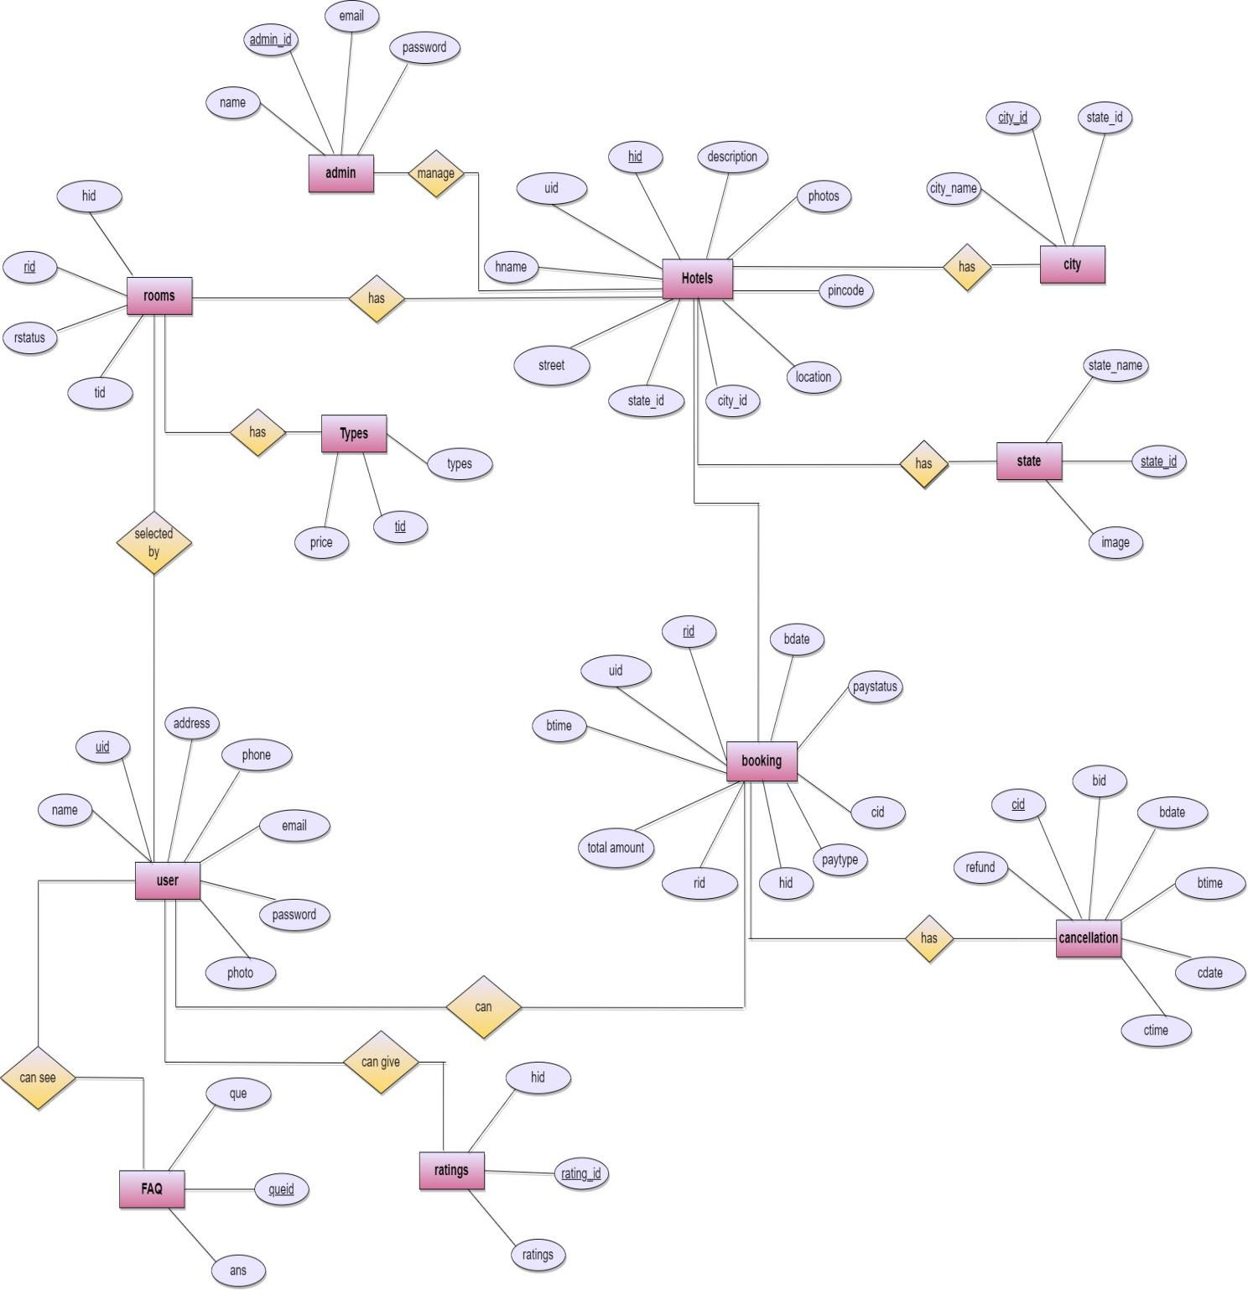

  - data flow diagram

4.4.1 context level dfd

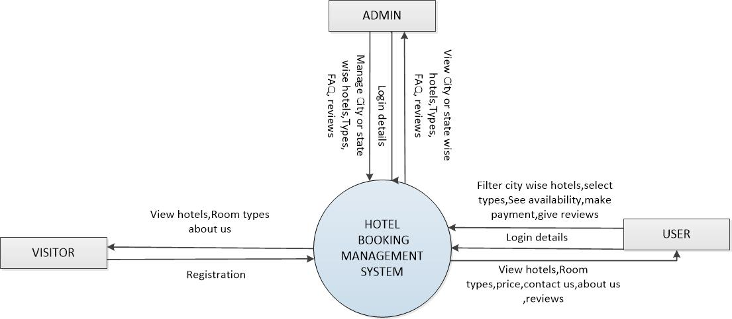

4.4.2 LEVEL-1 dfd(admin) 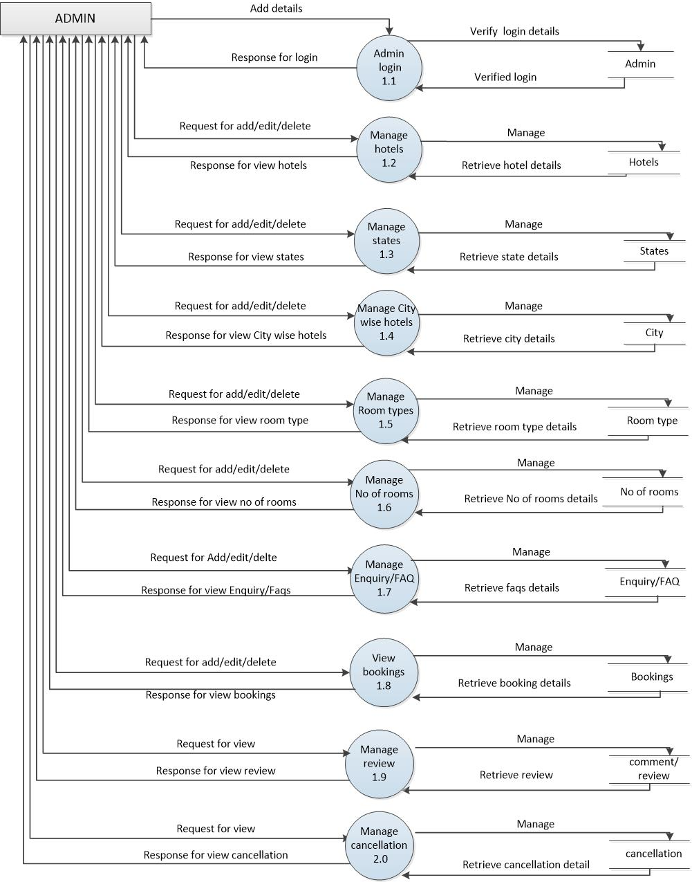

4.2 LEVEL-1 dfd(user) 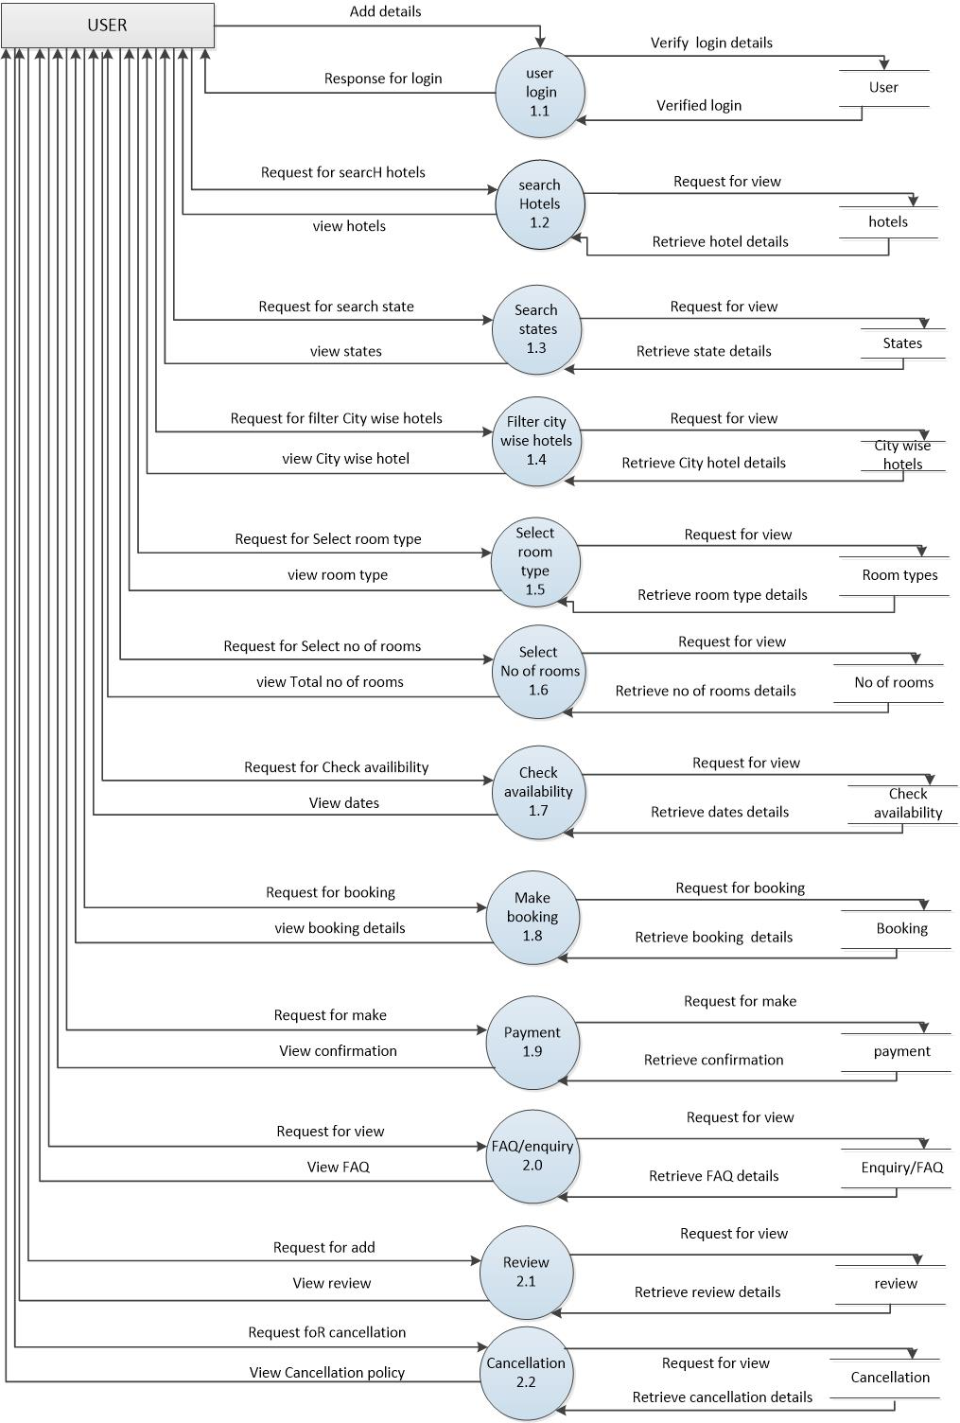

4.4.3 LEVEL-1 dfd(visitor)
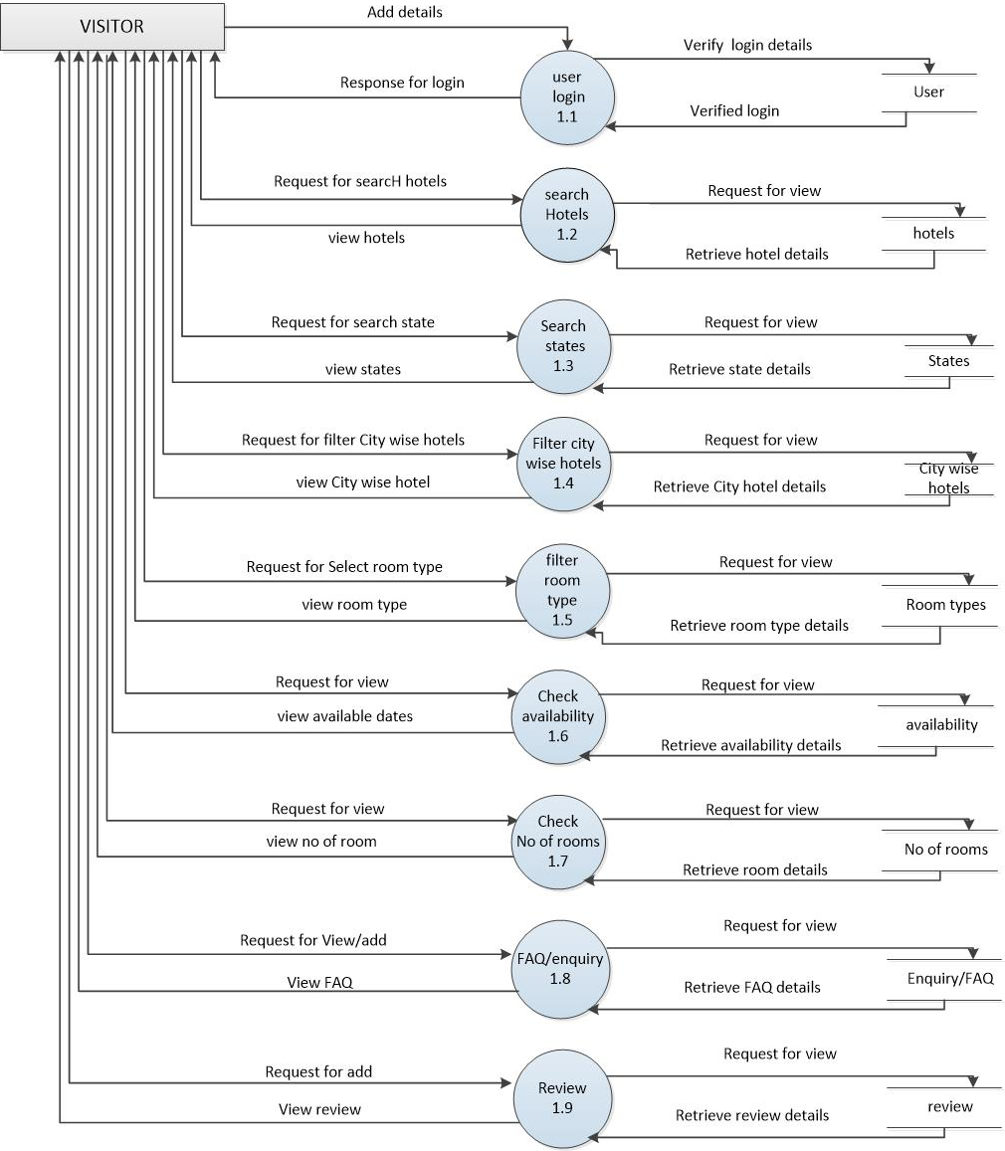

4.4.2.1 LEVEL-2 admin(hotels)

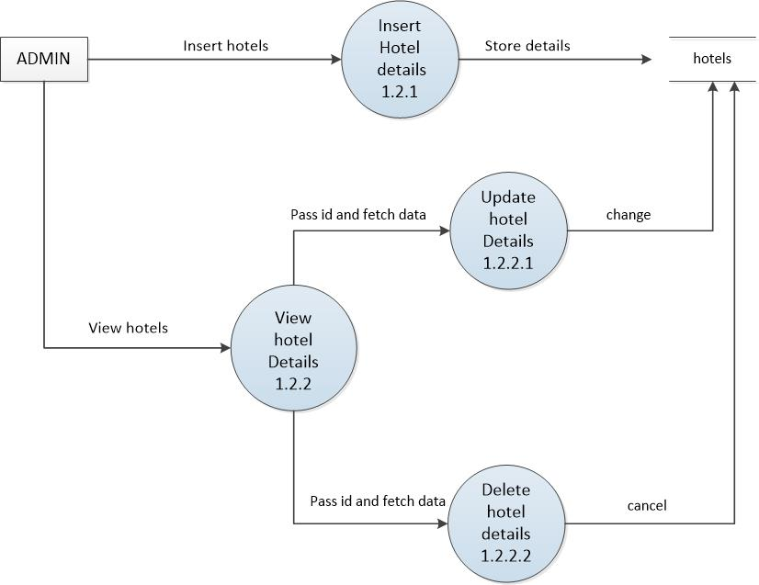

4.4.2.2 LEVEL-2 admin(state)

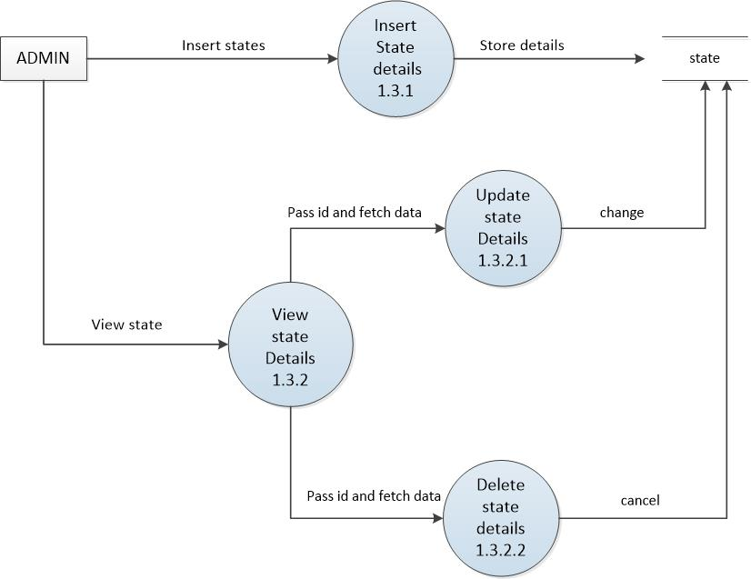

4.4.2.3 LEVEL-2 admin(city)

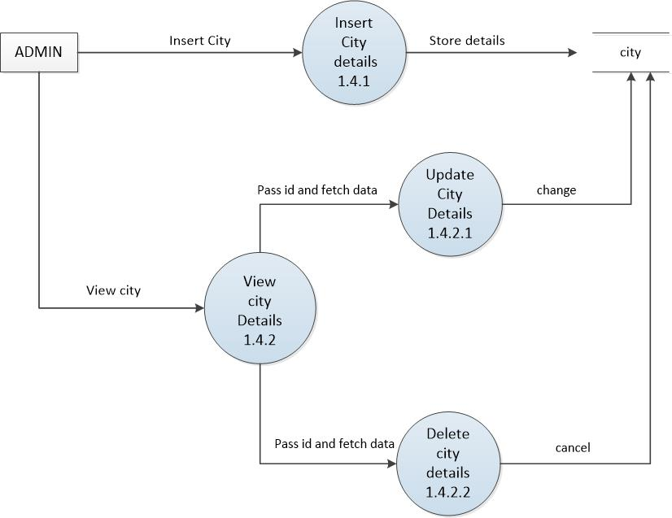

4.4.2.4 LEVEL-2 admin(room type)

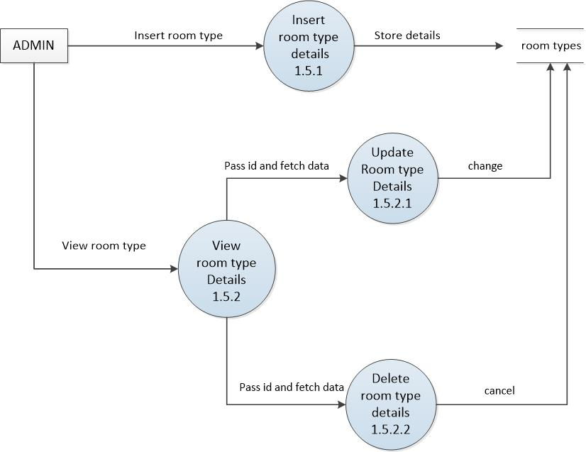

4.4.2.5 LEVEL-2 admin(no of rooms)

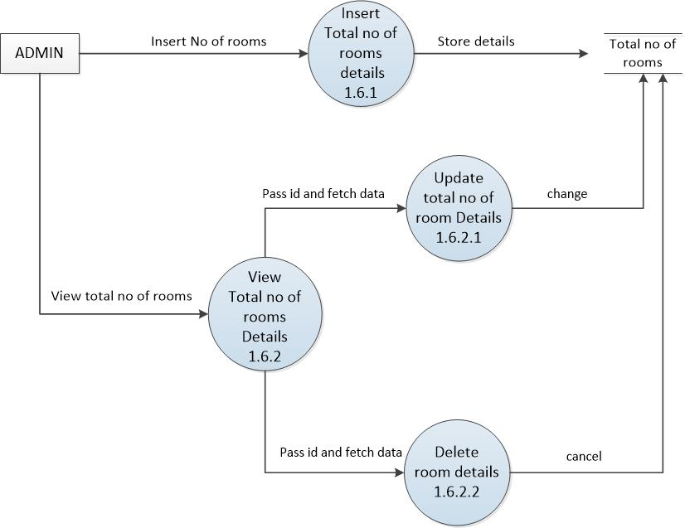

4.4.2.6 LEVEL-2 admin(FAQs)

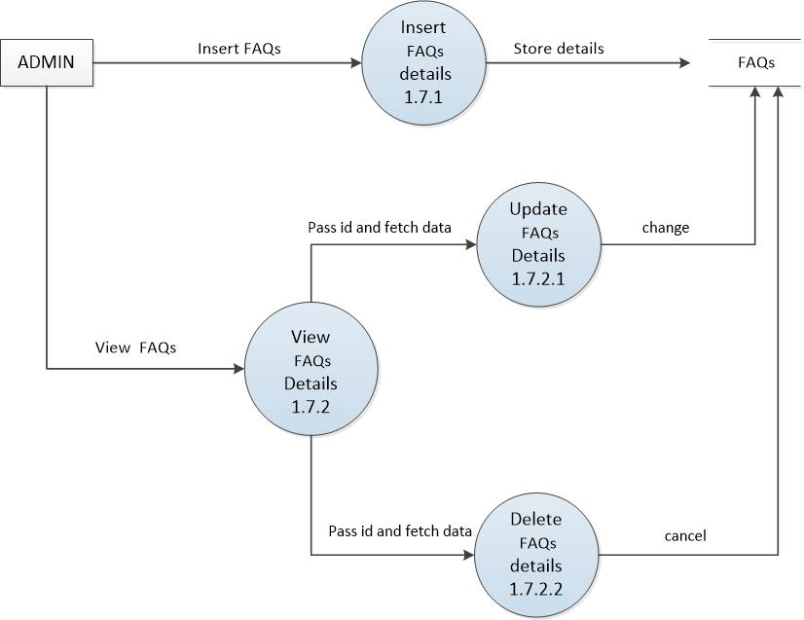

4.4.2.7 LEVEL-2 admin(booking)

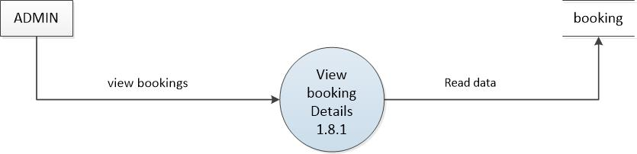

4.4.2.7 LEVEL-2 admin(review)

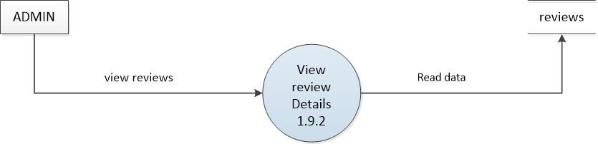

4.4.2.8 LEVEL-2 admin(cancellation)

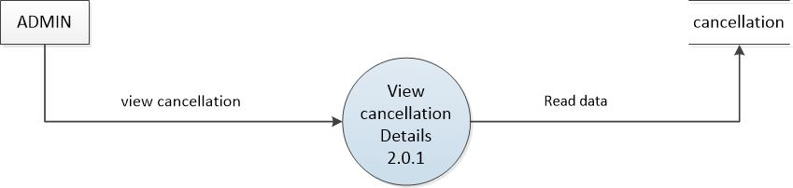

4.4.2.9 LEVEL-2 user(booking)

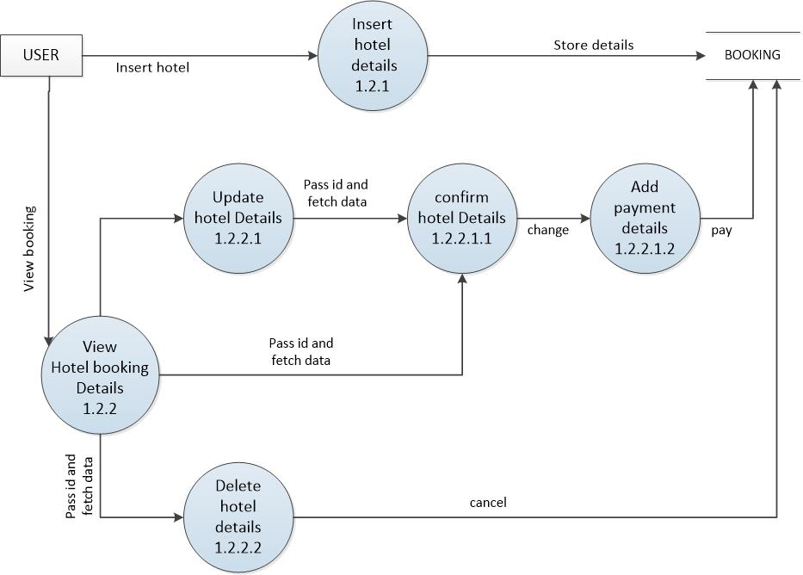

4.4.2.10 LEVEL-2 user(review)

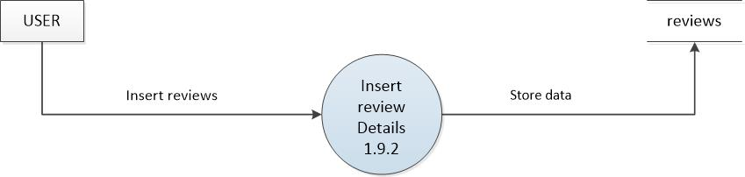

4.4.2.11 LEVEL-2 user(cancellation)

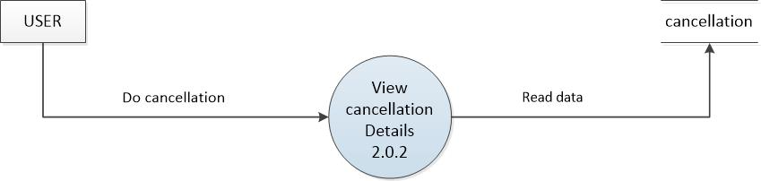

  - Data dictionary
1) Admin_tb

Column | datatype | size | example | description
admin_id | int | 20 | 1,2… | Primary key
admin_name | varchar | 50 | rishi | Name of admin
email | varchar | 50 | rishipatel1@gmail.com | Email of admin
password | varchar | 50 | **** | ***
image | varchar | 100 |  | Image of admin

2) city_tb
field | datatype | size | example | description
city_id | Int | 50 | 1,2… | Primary key
City_name | varchar | 100 | surat | Name of city
state_id | int | 100 | 1,2… | Foreign key  (state)

3)faqTb
field | datatype | size | example | description
queid | int | 100 | 1,2.. | primary key
que | Varchar | MAX | How do I make a booking? | frequenly ask questions
ans | Varchar | MAX | Just log on to our website , click on create trip and choose your preferred flight and hotel… | answers

- State_tb
field | datatype | size | example | description
state_id | int | 100 | 1,2,3.. | primary key
state_name | Varchar | MAX | Himachal pradesh | name of state

- Booking tb
field | datatype | size | example | description
booking_id | Int | 100 | 1,2.. | primary key
busername | varchar | 100 | kirti | name of user
bemail | varchar | MAX | Kirti1@gmail.com | email of user
bphone | Varchar | 100 | 8898965023 | user's number
bcity | varchar | 100 | kerala | city of user
paymentkey | varchar | 100 |  | Payment key
paystatus | varchar | 50 | pending | Status of payment
Pay type | varchar | 100 | Online/offline | Type of payment
hid | int | 100 | 1,2,3,4.. | Id of the hotel
Check in_date | Date | 10 | 12/04/2024 | Date of the check in
Check out date | date | 10 | 16/04/2024 | Date of check out
Total amount | int |  | 15000 | Total amount of hotel
uid | int | 10 | 1,2,3.. | User id

- Cancellation
field | datatype | size | example | description
booking_id | Int | 100 | 1,2.. | foreign key
bdate | date | 12 | 12/3/2023 | Date of booking
cdate | date | 12 | 14/3/2023 | Date of cancellation
cid | int | 10 | 1,2,3…0 | Primary key
refundstatus | Varchar | MAX | pending or done | Status of refund

- Facility_master

field | datatype | size | example | description
fdescription | varchar | 100 | Hotel provides this.. | Hotel description
fid | int | 100 | 1,2,3.. | Primary key
fname | varchar | 50 | food | Facility name

- Coverpic_tb
field | datatype | size | example | description
hid | Int | 100 | 1,2.. | foreign key
image | varchar | MAx |  | Image
pid | int | 100 | 1,2.. | Primary key

- Hotel_master
field | datatype | size | example | description
hid | Int | 100 | 1,2.. | primary key
City_id | int | 100 | 1,2..
hname | varchar | 100 | The royal hotel | Name of hotel
location | varchar | max | mumbai | Location of hotel
photos | varchar | 100 |  | Photos of hotel
pincode | int | 100 | 395004 | Pincode of city
State_id | int | 100 | 1,2.. | Foreign key
street | varchar | 100 | mazgaon | Strret of city

- Hotel_facility_master
field | datatype | size | example | description
fid | Int | 100 | 1,2.. | foreign key
hfid | int | 100 | 1,2.. | Primary key
hid | int | 100 | 1,2.. | Foreign key

4.7 Use case
