Measuring How Preprocessing Choices Affect Reported Accuracy in Introvert-Extrovert Classification
Rishi Vora
Northside College Prep
Chicago, Illinois
rishihvora@gmail.com
ORCID: [add before publishing]
Abstract
Reported accuracies for classifying introverts and extroverts from self-report data vary widely. Fieri et al. [13] report 73.5% and 95.5% on the same dataset depending on how it was prepared before training. I measure how much four preparation decisions move that number, holding the data and the models fixed. Using a public Kaggle dataset of 2,900 responses to seven behavioral questions and the Multidimensional Introversion-Extraversion Scales (MIES; 7,188 respondents, 91 items), each condition is evaluated with 5-fold cross-validation repeated 10 times, and differences are reported in percentage points of balanced accuracy with 95% intervals. Dropping respondents who identify as neither introvert nor extrovert raises balanced accuracy by 22.8 to 23.5 points, although this changes the classification task rather than only the preprocessing. Applying SMOTE to the full dataset before splitting, rather than within each training fold, raises it by 18.3 to 20.7 points on the imbalanced dataset and by under 0.5 points on the balanced one. Keeping duplicate rows changes it by about one point. Selecting the top 15 features by ANOVA F-score before splitting shows no evidence of a systematic effect, with all three intervals containing zero. My three-class MIES results fall within a third of a point of two published studies that retained the ambivert group. Accuracies for this task are therefore not comparable across studies unless these choices are stated.
Keywords: introversion, extroversion, personality classification, machine learning, data leakage, reproducibility
1 Introduction
Studies that classify introverts and extroverts from self-report data report very different accuracies. Fieri et al. [13] report 73.5% and 95.5% for the same dataset, depending on how the data were prepared before training. So [12] reports 73.81% on the same questionnaire. Numbers like these are often compared as though they describe the same problem.
Leakage and preprocessing errors are known to inflate reported performance across many fields. Kapoor and Narayanan [11] found them in 294 papers spanning 17 disciplines and sorted them into eight types. Personality classification was not one of the fields they surveyed, and I could not find a study that measures how much these choices matter for this particular task.
Psychologists have studied the distinction between introversion and extroversion for decades because of its obvious presence in daily life [1, 2]. Some individuals will be more energized after a day of being alone, while others will become restless if they do not see other people on a regular basis. One individual may leave a long social gathering exhausted; another will be energized to participate in more social activities [3]. Researchers have used formal assessments such as the Big Five Inventory [4] and shorter self-report measures [6] to place people along this dimension. More recently, personality traits have been predicted from social media activity [7], and computer models have judged personality more accurately than a person’s own friends [8]. This work suggests that introverts and extroverts differ in measurable ways, although it has often relied on large and detailed digital records rather than a few simple, self-reported behaviors.
In this study, I measure how much four common preparation decisions move the reported accuracy for this task. The decisions are whether to keep respondents who identify as neither introvert nor extrovert, whether to resample before or inside cross-validation folds, whether to remove duplicate rows, and whether to select features before or inside folds. Each is tested on the same datasets with the same models, so that the only thing changing is the decision itself.
2 Methods
2.1 Datasets
The first dataset is a public Kaggle dataset called “Extrovert vs Introvert Behavior Data” [10]. It contains 2,900 responses. Each person answered seven questions about their daily habits and provided a label indicating whether they were an introvert or an extrovert. The questions were: how many hours they spent alone on a typical day, how often they attended social events, how often they went outside, how many close friends they had, how often they posted on social media, whether they got stage fright, and whether socializing made them feel drained. The two classes are close to even, at 1,491 extroverts and 1,409 introverts.
The second is the Multidimensional Introversion-Extraversion Scales development data [14], collected by the Open-Source Psychometrics Project in 2019. It contains 7,188 responses to 91 agree-disagree statements rated on a five-point scale. At the end of the survey each respondent was asked whether they identify as an introvert, an extrovert, or neither. Of the 7,163 who answered, 4,404 said introvert, 990 said extrovert, and 1,769 said neither. This dataset is strongly imbalanced, which matters for the resampling condition below.
The third is the IPIP Big Five Factor Markers data [15], 19,719 responses to 50 items. It carries no self-reported introvert or extrovert label. A label would have to be derived from the extraversion items themselves, and predicting that label from those same items would be circular, so this dataset is not used for classification. It appears only in Section 3.5 as a reference point for how much the items of an established extraversion scale overlap with one another.
2.2 Cleaning
For the Kaggle dataset, the five numerical questions were rounded to the nearest whole number. For stage fright and feeling drained, 1 was used to represent “Yes” and 0 to represent “No.” Personality labels were set to 0 for introvert and 1 for extrovert.
The file contains 486 rows that are exact duplicates of another row. Unless a condition states otherwise, these are removed before analysis, leaving 2,414 unique rows. Section 3.4 reports what happens when they are kept.
For MIES, a response of 0 marks a skipped question rather than a rating, and is treated as missing.
2.3 Models and evaluation
Three classifiers were used: a random forest with 100 trees, a logistic regression, and an XGBoost model with a maximum depth of 3 and 100 trees. All use random_state = 42 so that the results can be repeated.
Every preprocessing step runs inside a scikit-learn [18] pipeline, so imputation and scaling are fitted on training data only. This matters here for a specific reason: fitting a scaler on the full dataset before splitting is itself a small version of the leakage this paper measures, so the code should not commit it.
The baseline results in Table 1 use a single 80/20 stratified split. Every condition comparison in Section 3 instead uses 5-fold cross-validation repeated 10 times, giving 50 fits per condition. Differences between conditions are reported in percentage points of balanced accuracy, with a 95% interval computed from the pooled fold variance of the two conditions being compared.
Balanced accuracy is used rather than raw accuracy because MIES is strongly imbalanced. A model that always predicts “introvert” on the three-class version reaches 61.5% raw accuracy while learning nothing. Balanced accuracy scores each class separately and averages them, so the same model scores 33%.
2.4 Conditions
Each condition is a pair of pipelines that differ in exactly one step.
Class structure. Three classes (introvert, extrovert, neither) against two classes, with the neither group removed. This changes the prediction task and the population being classified, not only the preprocessing. Section 3.1 discusses that directly.
Resampling order. In the leaky version, SMOTE [16] is applied to the entire dataset and cross-validation is run on the result. In the correct version, SMOTE is applied inside each training fold only, using an imbalanced-learn pipeline, leaving every test fold untouched.
Duplicate rows. Kept against removed, as described in Section 2.2.
Feature selection order. In the leaky version, the top 15 features by ANOVA F-score are chosen using the entire dataset, and cross-validation is run on those features. In the correct version, the same selection is performed separately inside each training fold. Fifteen was chosen because it matches the number of items selected by Fieri et al. [13].
3 Results
Table 1 gives baseline accuracy for each dataset and model on a single split, and Table 2 gives the effect of each condition measured across 50 fits. Figure 1 shows the same four effects with their intervals.
Dataset | Random forest | Logistic regression | XGBoost
Kaggle (7 items) | 0.910 | 0.912 | 0.921
MIES, three classes | 0.736 | 0.734 | 0.728
MIES, two classes | 0.918 | 0.920 | 0.916
Table 1. Accuracy on a held-out 20% test set, single stratified split. The Kaggle rows and the two-class MIES rows are close to one another, while the three-class MIES rows sit roughly 18 points lower.
Condition | Model | Difference | 95% interval
Ambiverts dropped | Random forest | +23.46 | 22.94 to 23.99
 | Logistic regression | +22.76 | 22.20 to 23.33
 | XGBoost | +22.88 | 22.29 to 23.46
Resampling before split | Random forest | +20.69 | 20.28 to 21.11
 | Logistic regression | +5.68 | 5.19 to 6.17
 | XGBoost | +18.33 | 17.90 to 18.77
Duplicates kept | Random forest | -1.47 | -1.85 to -1.10
 | Logistic regression | -1.41 | -1.83 to -1.00
 | XGBoost | -0.50 | -0.88 to -0.12
Selection before split | Random forest | +0.08 | -0.46 to 0.63
 | Logistic regression | -0.00 | -0.46 to 0.46
 | XGBoost | +0.10 | -0.43 to 0.62
Table 2. Effect of each condition, in percentage points of balanced accuracy, from 5-fold cross-validation repeated 10 times. Intervals are 95%. Only the selection-order intervals contain zero.
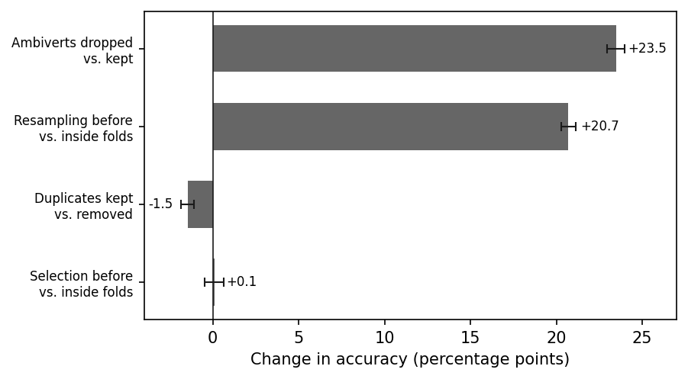
Figure 1. The four conditions, random forest, with 95% intervals. The interval for selection order crosses zero; the others do not.
3.1 Class structure
Removing the 1,769 respondents who identify as neither introvert nor extrovert raises balanced accuracy by 22.76 to 23.46 points depending on the model. This is the largest effect measured here.
It is important to be clear about what this comparison is. Dropping the neither group does not simply clean the data; it converts a three-class problem into a two-class problem and removes the respondents whose self-description is least definite. Accuracy rises partly because the remaining population is easier to separate. The point is not that removing this group is wrong, since a two-class problem is a reasonable thing to study. The point is that a two-class result and a three-class result describe different tasks and cannot be placed side by side.
This matters for reading the existing literature. My three-class results, at 0.728 to 0.736 raw accuracy, fall close to two published studies using the same instrument: So [12] reports 73.81% and Fieri et al. [13] report 73.5% before resampling. Both studies retained the neither group. Fieri et al. state class counts of 4,404, 989, and 1,768, which include all three groups. So reports a no-information rate of 61.51%, which matches the majority-class share of the three-class version of this data (61.48%) rather than the two-class version (81.6%).
3.2 Resampling order
Applying SMOTE to the whole dataset before splitting, rather than inside each training fold, raises balanced accuracy on MIES by 20.69 points for the random forest, 18.33 for XGBoost, and 5.68 for logistic regression. On the Kaggle dataset the same change moves accuracy by less than 0.5 points in every case.
The mechanism is straightforward. SMOTE creates new minority-class rows by interpolating between existing ones. If those rows are created before the split, a synthetic row in a test fold can be an interpolation of two rows that are in the training fold, so the model is scored on points partly built from data it trained on. Resampling inside the training fold avoids this, because the test fold is never used to create anything.
Two things have to hold for the effect to appear. The classes have to be imbalanced enough for SMOTE to generate a large number of synthetic rows, which is why the Kaggle dataset shows almost nothing at 51/49 while MIES shows 20 points at 61/14/25. And the model has to be able to memorize individual rows. A logistic regression on seven features has seven coefficients and cannot store a particular row, which is why it gains 5.68 points where the random forest gains 20.69.
For comparison, Fieri et al. [13] report 73.5% before resampling and 95.5% after. The size of the change I measure from ordering alone is close to the size of the change they report, though I have not inspected their code and make no claim about what produced their numbers.
3.3 Duplicate rows
Keeping the 486 duplicate rows in the Kaggle file changes balanced accuracy by -1.47 points for the random forest, -1.41 for logistic regression, and -0.50 for XGBoost. All three intervals exclude zero, so the effect is real but small, and it runs in the opposite direction to what might be expected: keeping duplicates makes performance slightly worse rather than better.
The duplicates do produce overlap between training and test data. On a single 80/20 split of the raw file, 27.9% of test rows appear identically somewhere in the training set. That overlap exists in the file as published, before any analysis is performed. It does not translate into inflated balanced accuracy at this scale, but it is worth removing on principle, and worth knowing about for anyone using the dataset.
3.4 Feature selection order
Selecting the top 15 features by ANOVA F-score using the whole dataset, rather than inside each training fold, changes balanced accuracy by +0.08, -0.00, and +0.10 points for the three models. All three 95% intervals contain zero, the widest running from -0.46 to +0.63. There is no evidence of a systematic effect under these conditions.
This is worth stating because feature-selection order looks like the same category of mistake as resampling order. Both involve using the full dataset for a step that should be confined to training data. One produces a 20-point difference and the other produces nothing measurable.
3.5 Why selection order has so little effect
The reason appears to be that the items in these datasets carry heavily overlapping information, so which subset is chosen matters less than it might.
Item set | Items | Mean overlap | Lowest | Highest
Kaggle behaviors | 7 | 0.784 | 0.69 | 0.957
MIES | 91 | 0.196 | 0.00 | 0.823
BIG5 extraversion | 10 | 0.454 | 0.32 | 0.631
Table 3. Absolute correlation between every pair of items within each set. The Kaggle behaviors overlap far more than either questionnaire scale.
In the Kaggle dataset, the least related pair of the seven behaviors correlates at 0.69, which is higher than the most related pair in the BIG5 extraversion scale (0.631). That scale was written to measure a single trait through ten items, so it is a reasonable upper reference point for how much a set of deliberately similar questions should overlap. The seven behaviors exceed it.
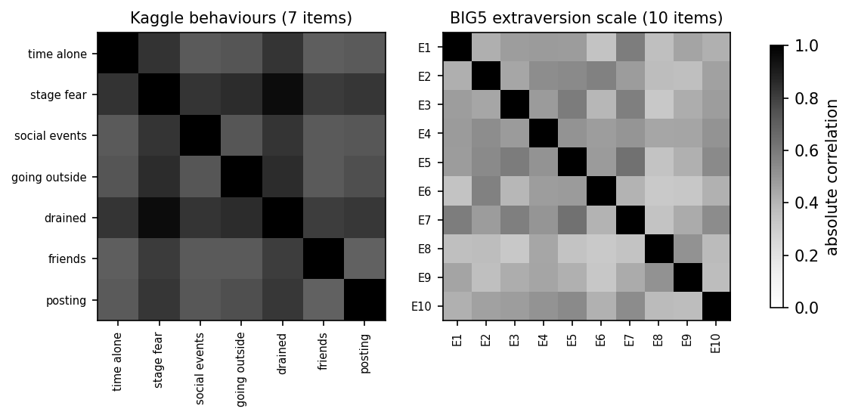
Figure 2. Absolute correlation between item pairs. Left: the seven Kaggle behaviors. Right: the ten BIG5 extraversion items. Darker is more overlap.
A direct consequence is that removing the single highest-ranked item barely changes anything. On the Kaggle dataset all three models rank stage fright first, and removing it changes balanced accuracy by -0.005 for the random forest, +0.002 for logistic regression, and +0.004 for XGBoost. Two of the three models improve slightly without their most important feature.
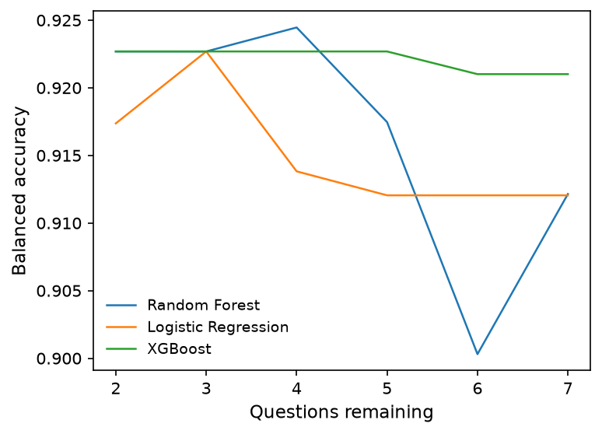
Figure 3. Balanced accuracy as items are removed one at a time in order of increasing importance, Kaggle dataset. Performance is flat from seven items down to two.
4 Discussion
The four conditions do not behave alike. Two of them move reported accuracy by roughly 20 points, one moves it by about one point, and one produces nothing measurable. That spread is the main practical result, because it means the choices cannot be treated as interchangeable methodological details.
The class-structure result is the one most likely to be misread. It is not a claim that dropping ambiverts is an error. It is a claim that two-class and three-class results are answers to different questions, and that the difference between them is large enough to account for most of the range seen in published work on this instrument. When a paper reports accuracy for introvert-extrovert classification, the class structure should be stated somewhere a reader will see it.
The resampling result is a textbook leakage effect, but its size depends on conditions that are easy to overlook. It requires class imbalance, and it requires a model flexible enough to memorize individual rows. A study that resamples before splitting on balanced data with a linear model would see almost nothing, and might reasonably conclude the practice is harmless.
Several limitations apply. Only two datasets were used for classification, and both are self-report instruments, so nothing here speaks to behavioral or digital-trace data. The resampling effect was measured with SMOTE only, and other resampling methods may behave differently. The intervals reported here describe variation across cross-validation folds, not across independent samples, so they should be read as a measure of stability rather than as a full account of uncertainty. Finally, the item-overlap comparison in Section 3.5 is descriptive; it offers a plausible reason for the null selection-order result but does not establish it.
5 Conclusion
I measured how much four data preparation decisions change the reported accuracy of introvert-extrovert classification, holding the datasets and models fixed. Dropping respondents who identify as neither raises balanced accuracy by about 23 points, though it also changes the task. Resampling before rather than inside cross-validation folds raises it by up to 21 points on imbalanced data and by almost nothing on balanced data. Keeping duplicate rows changes it by about one point. The order of feature selection produces no measurable change.
Two conclusions follow. Reported accuracies for this task are not directly comparable across studies unless the class structure and the preprocessing order are stated. And the choices are not equally consequential, so a reader checking a reported number should know which ones to ask about.
Code availability
All code used to clean the data, run the conditions, and generate the figures is available at https://github.com/rishi3qrw43/introvert-extrovert. The datasets are not redistributed; the repository documents where to download each one.
References
[1] C. G. Jung. Psychological Types. Translated by H. G. Baynes, revised ed., Princeton University Press, 1971.
[2] H. J. Eysenck. The Biological Basis of Personality. Charles C. Thomas, 1967.
[3] S. Cain. Quiet: The Power of Introverts in a World That Can’t Stop Talking. Crown, 2012.
[4] P. T. Costa and R. R. McCrae. Revised NEO Personality Inventory (NEO-PI-R) and NEO Five-Factor Inventory (NEO-FFI) Professional Manual. Psychological Assessment Resources, 1992.
[5] I. B. Myers et al. MBTI Manual: A Guide to the Development and Use of the Myers-Briggs Type Indicator. 3rd ed., Consulting Psychologists Press, 1998.
[6] S. D. Gosling et al. A very brief measure of the Big-Five personality domains. Journal of Research in Personality, 37(6):504-528, 2003.
[7] M. Kosinski, D. Stillwell, and T. Graepel. Private traits and attributes are predictable from digital records of human behavior. Proceedings of the National Academy of Sciences, 110(15):5802-5805, 2013.
[8] W. Youyou, M. Kosinski, and D. Stillwell. Computer-based personality judgments are more accurate than those made by humans. Proceedings of the National Academy of Sciences, 112(4):1036-1040, 2015.
[9] S. C. Matz et al. Psychological targeting as an effective approach to digital mass persuasion. Proceedings of the National Academy of Sciences, 114(48):12714-12719, 2017.
[10] R. Kapilavai. Extrovert vs Introvert Behavior Data. Kaggle, 2024.
[11] S. Kapoor and A. Narayanan. Leakage and the reproducibility crisis in machine-learning-based science. Patterns, 4(9):100804, 2023.
[12] C. So. Are you an introvert or extrovert? Accurate classification with only ten predictors. In 2020 International Conference on Artificial Intelligence in Information and Communication (ICAIIC), pages 1-5. IEEE, 2020.
[13] B. Fieri, J. La’la, and D. Suhartono. Introversion-extraversion prediction using machine learning. JOIV: International Journal on Informatics Visualization, 7(4):2153-2159, 2023.
[14] Open-Source Psychometrics Project. Development of the Multidimensional Introversion-Extraversion Scales, 2019.
[15] Open-Source Psychometrics Project. IPIP Big Five Factor Markers, 2014.
[16] N. V. Chawla, K. W. Bowyer, L. O. Hall, and W. P. Kegelmeyer. SMOTE: Synthetic minority over-sampling technique. Journal of Artificial Intelligence Research, 16:321-357, 2002.
[17] S. M. Lundberg and S.-I. Lee. A unified approach to interpreting model predictions. Advances in Neural Information Processing Systems, 30:4765-4774, 2017.
[18] F. Pedregosa et al. Scikit-learn: Machine learning in Python. Journal of Machine Learning Research, 12:2825-2830, 2011.

