💻 Advanced Web Technologies – Lab Report
NAME : RISHABH JADLI SAP ID : 590010052 — ## Table of Contents 1. Experiment 1 – Basic HTML & CSS 2. Experiment 2 – JavaScript DOM Manipulation 3. Experiment 3 – Form Validation / JS Logic 4. Experiment 4 – External JS & CSS Integration 5. Experiment 5 – jQuery Effects & DOM Traversal 6. Experiment 6 – Node.js Basics 7. Experiment 7 – Express Application 8. Cookies & Sessions in Node.js 9. Node.js Lab Programs 10. My Project 11. Rick Project —

Experiment 1 – Basic Jquery implementation
Files: exp1/index.html, exp1/style.css, exp1/jquery.js index.html creates a structure while css adds style to it
Objective:
Disable right click menu in html page jquery to click on image to scroll to top jquery to change the color of any paragrpah to red on mouseover event diplay and hide message shown in div tag on click on button
What I Learned: - IDs for Interactivity: Assigning id attributes (e.g., toggleBtn, message, scrollTopImg) to elements, which is crucial for targeting them specifically with CSS and JavaScript/jQuery. - Linking and styling with external CSS. - Basics of layout, colors, and text formatting.
Challenges Faced:
- Understanding CSS selectors and positioning elements properly. - The code won’t work if you forget to include the jQuery script before your custom exp1.js script in the HTML. - Initially, the right-click menu might still appear even after attaching the event handler.
EXPERIMENT 1 HTML 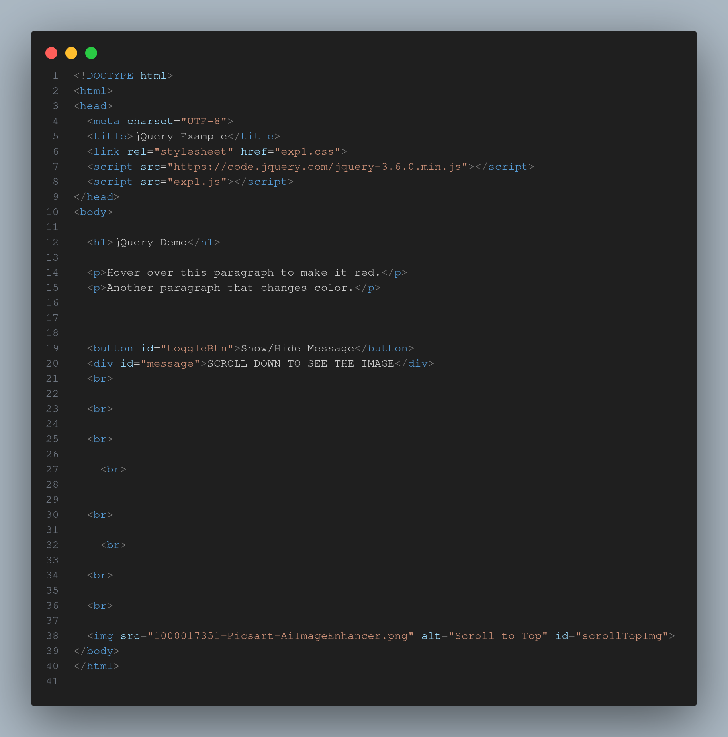 EXPERIMENT 1 CSS 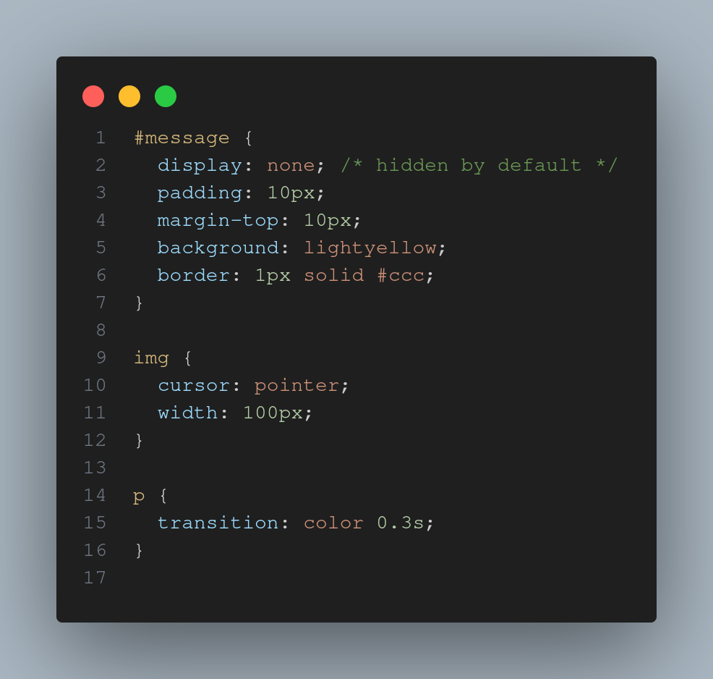 EXPERIMENT 1 JS 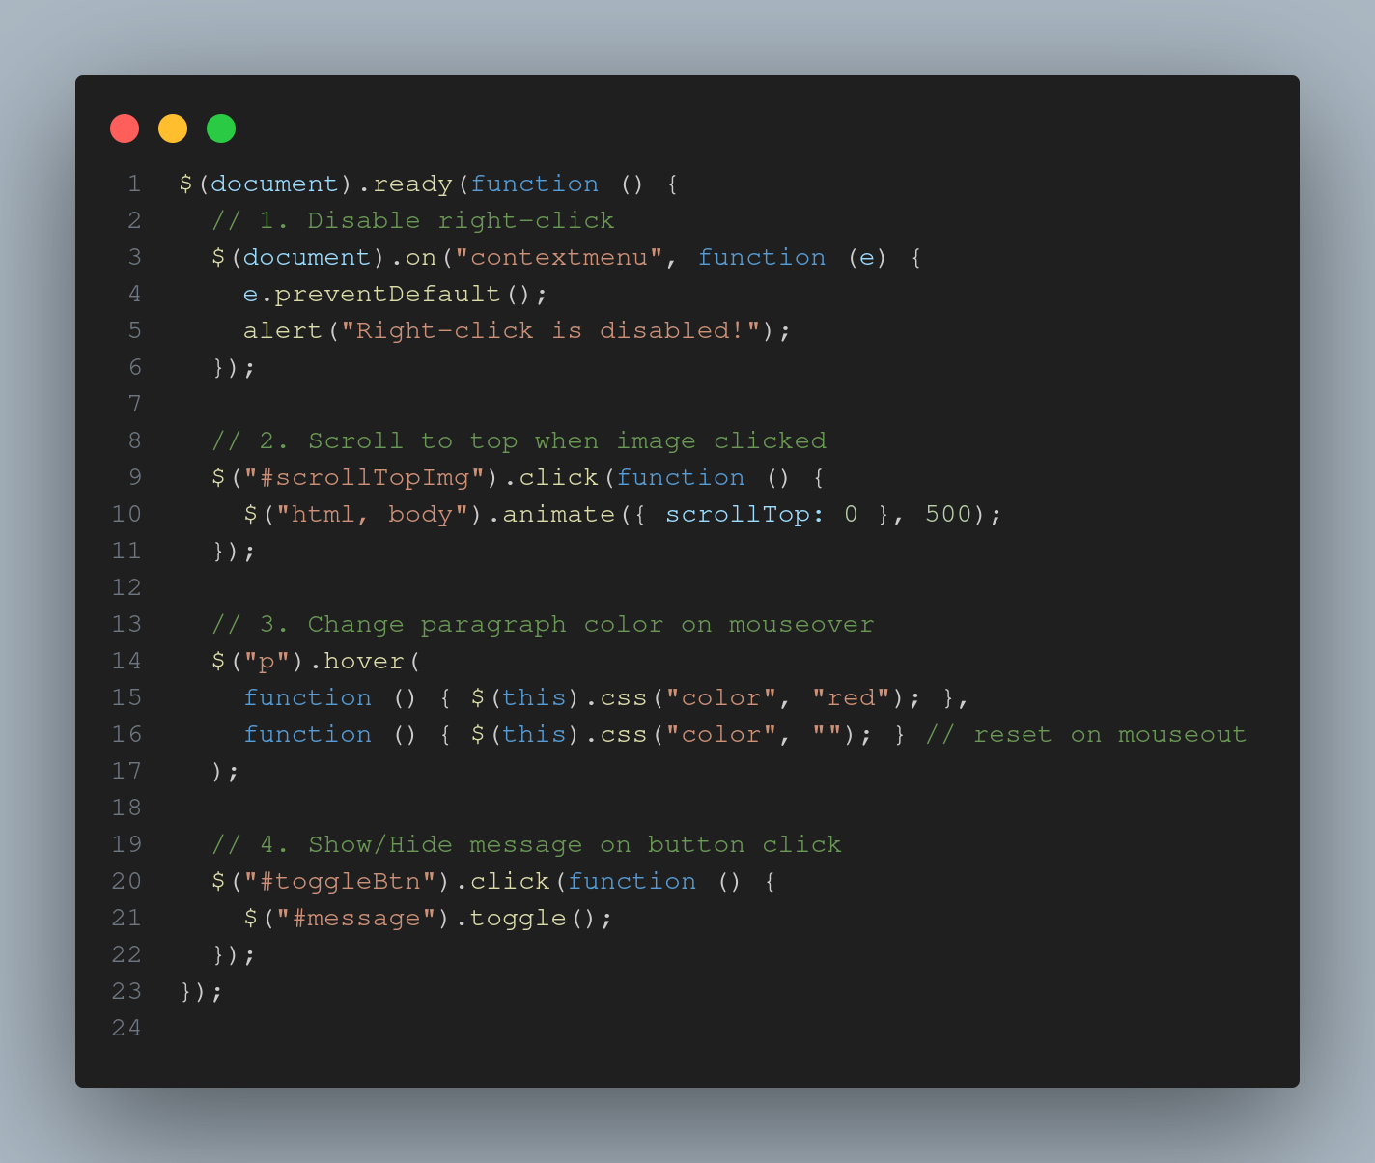 EXPERIMENT 1 OUTPUT 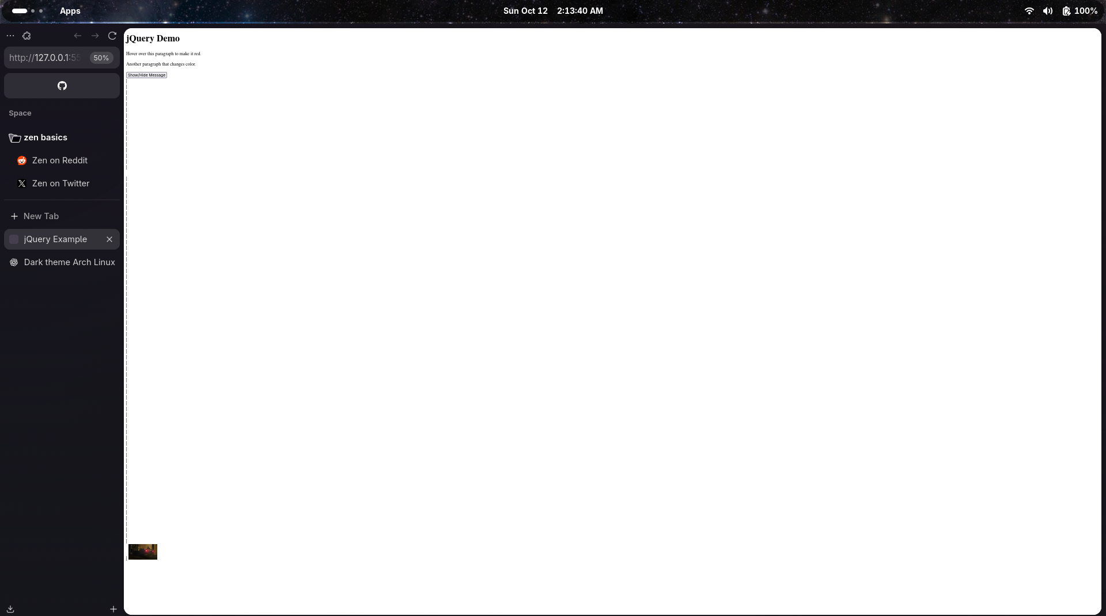 —

Experiment 2 – Jquery and css events
Files: exp2/index.html, exp2/style.css
Objective:
jquery to add class to an element jquery to access position of an element jquery animation to manipulate multiple CSS properties like padding, color etc
What I Learned: - used IDs (id=“btn-add”, id=“pos-box”, id=“btn-pos”, id=“anim-box”, id=“btn-animate”) to create clear hooks for your jQuery code, making it easy to target both the interactive element (the button) and the element that will be affected. - Accessing and modifying DOM elements. - Using getElementById() and querySelector(). - Handling events like onclick and onchange.
Challenges Faced:
- Debugging event listeners and ensuring scripts loaded after DOM. - It can be confusing why one element has different top and left values for position() versus offset().
EXPERIMENT 2 HTML 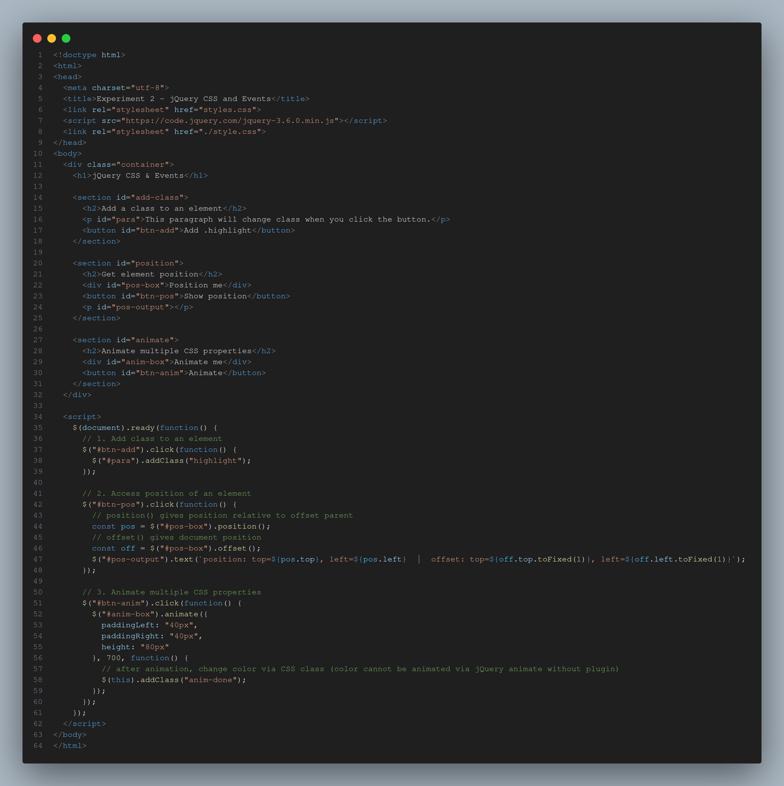 EXPERIMENT 2 CSS 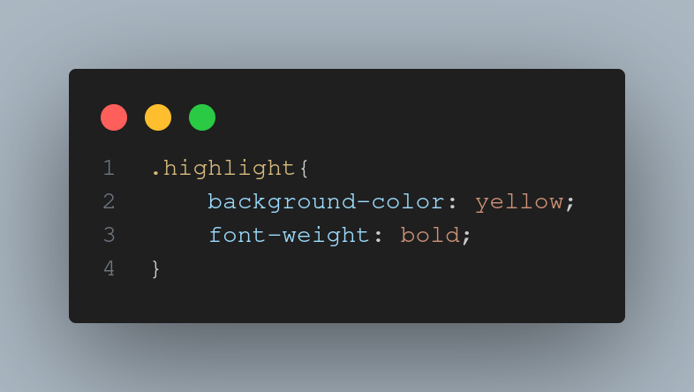 EXPERIMENT 2 OUTPUT 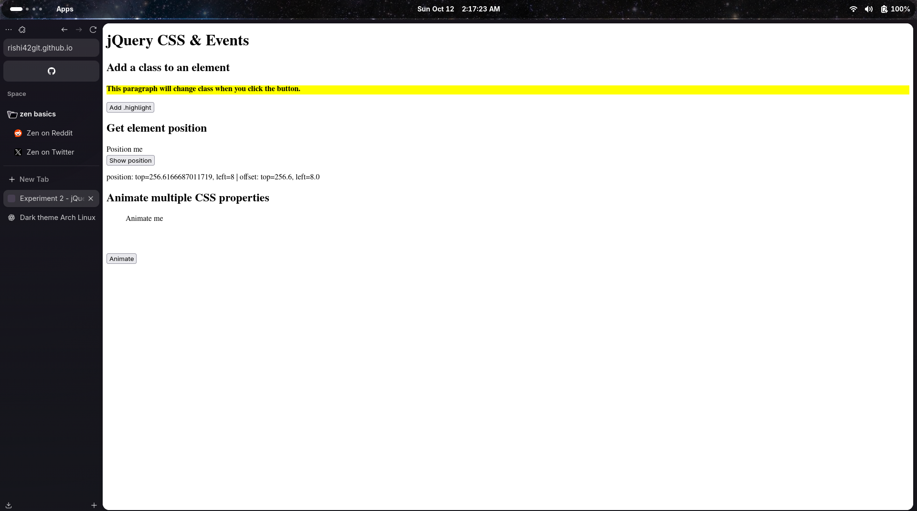 —

Experiment 3 – Front End development sing Angularjs
Files: exp3/index.html, exp3/app.js
Objective:
Use Angularjs to perform the following- Display a table Display content of table with Order by filter Display Table with even and odd
What I Learned: - used ng-repeat to dynamically generate table rows (
) for each object in the vm.students array. This is the cornerstone of displaying lists of data in Angular. - set up an Angular application by defining a module (tableApp) and a controller (TableController) to manage the application’s data and logic. - implemented client-side sorting using the built-in orderBy filter (| orderBy:ctrl.sortKey:ctrl.reverse). This demonstrates how to sort data by a specific key (ctrl.sortKey) and control the sort direction (ctrl.reverse).
Challenges Faced:
- Understanding how ng-controller=“TableController as ctrl” works and why you need to reference your variables as ctrl.students, ctrl.sortKey, etc., instead of just students, can be tricky for newcomers to Angular. Forgetting the ctrl. prefix is a very common error. - ng-repeat directive is powerful but requires precise syntax, especially when adding track-by-key, conditional styling, and filters.
EXPERIMENT 3 HTML 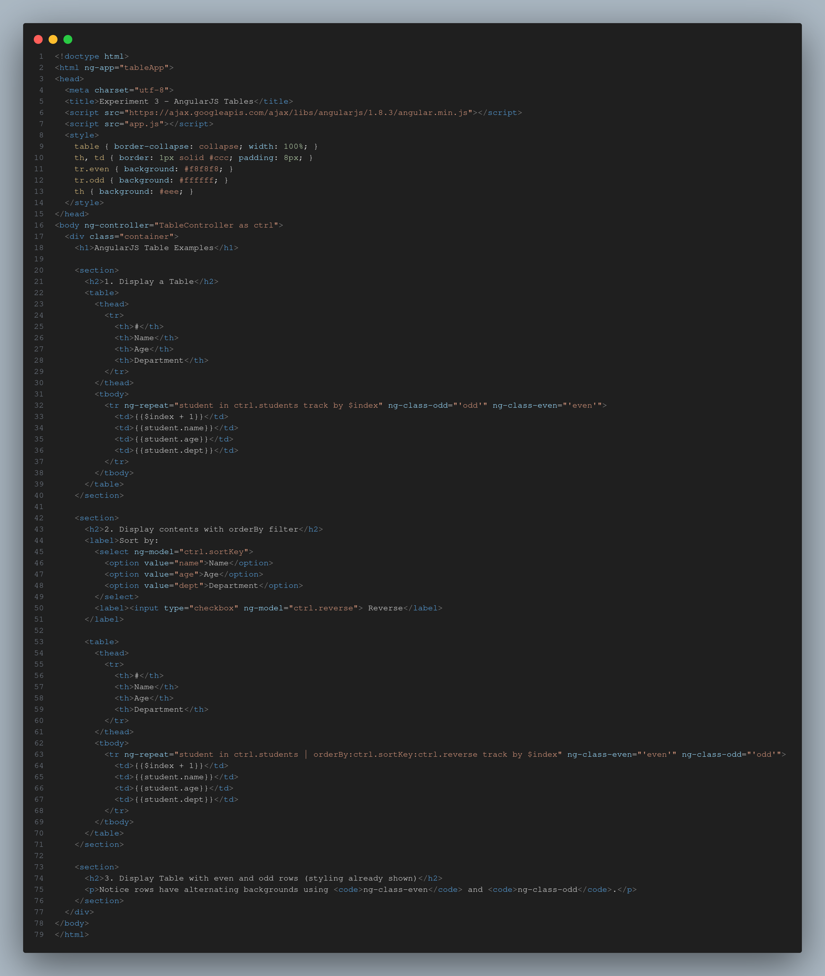 EXPERIMENT 3 CSS 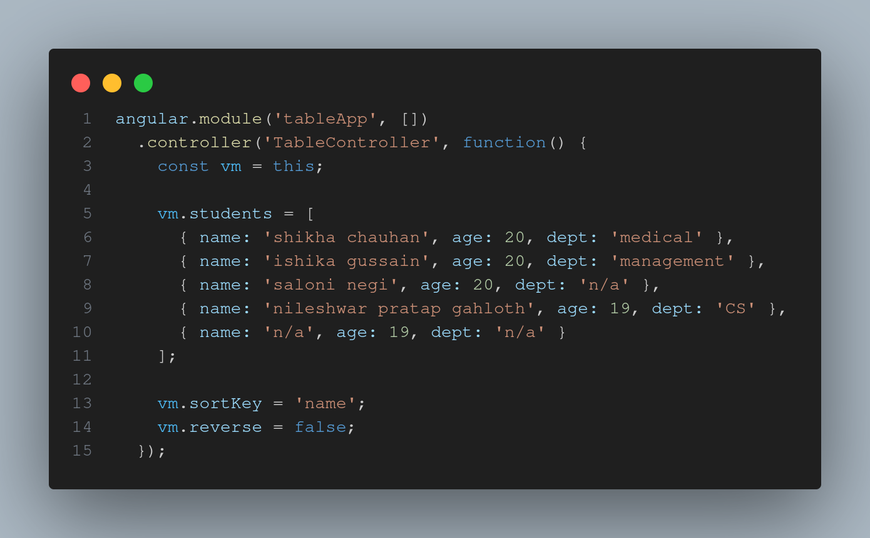 EXPERIMENT 3 OUTPUT 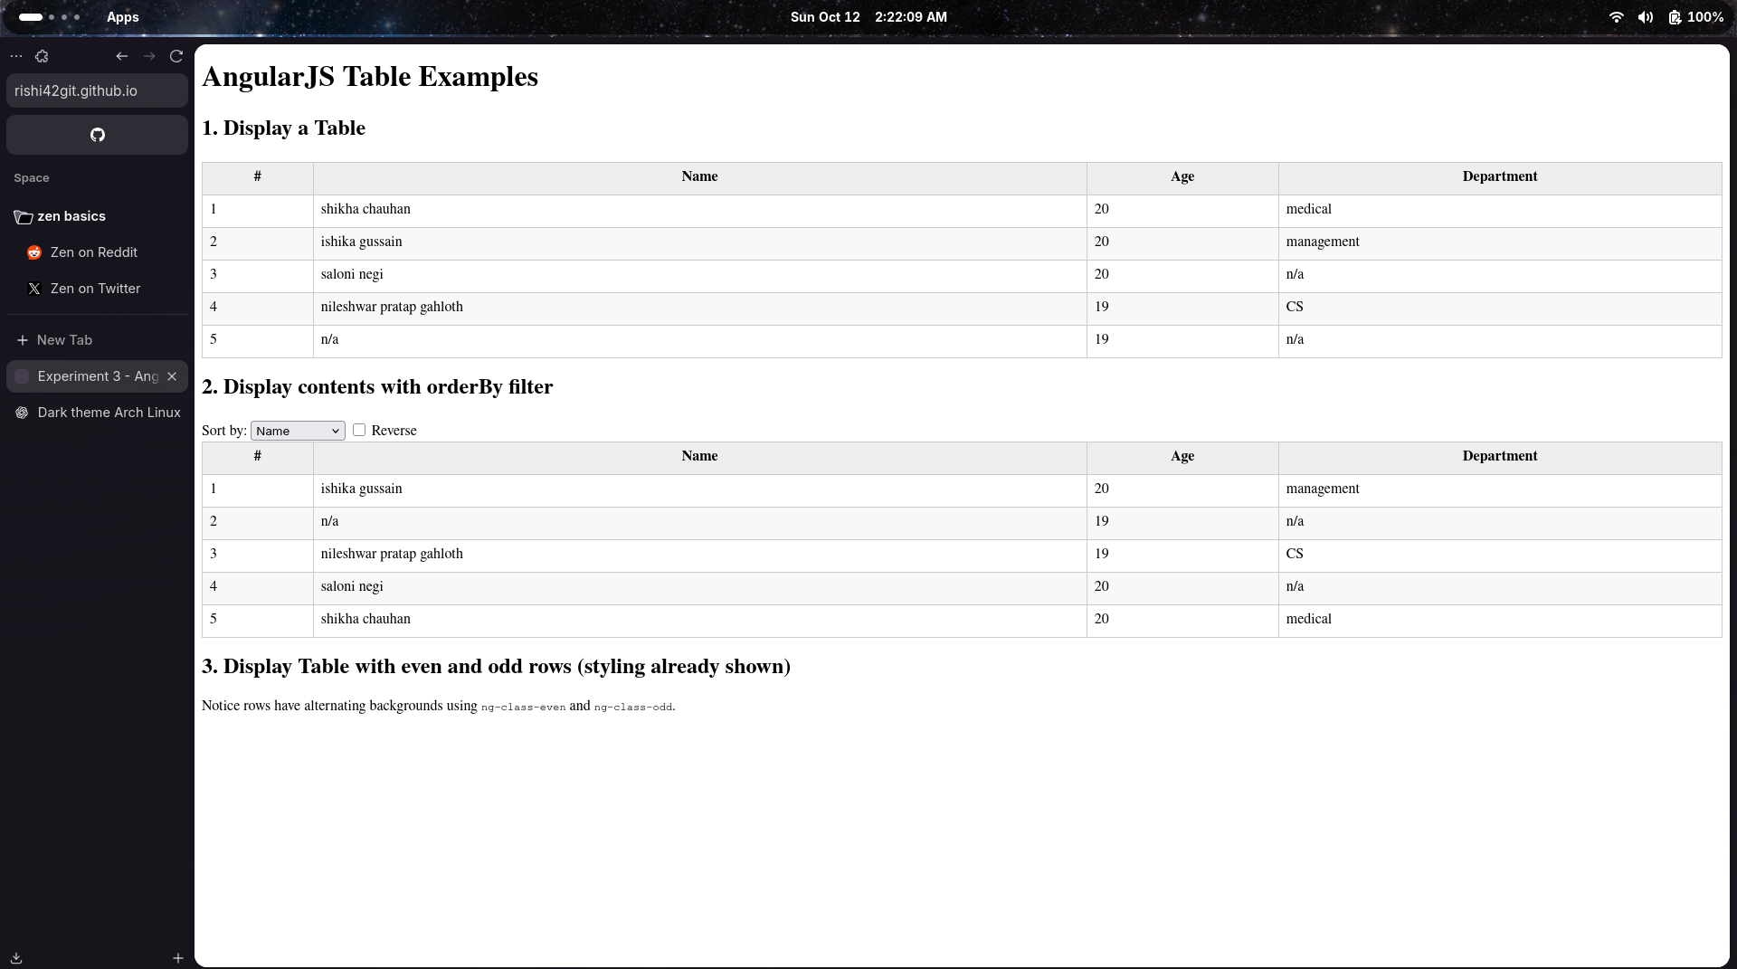 —

Experiment 4 – Angular form and event
Files: exp4/index.html, exp4/exp4.css, exp4/exp4.js
Objective:
User registration form and perform input validation using angularjs application for bill payment record using angularjs
What I Learned: - used the ng-submit directive on the form to call a controller function (addRecord(billForm)) when the user submits the form, which is cleaner than using traditional HTML form submission. - Maintaining cleaner project structure. - used ng-model to link form input values (Name, Amount, Date) directly to properties on the $scopeobject($scope.newRecord.name, etc.). This automatically updates the model when the user types, and vice-versa. Challenges Faced:
- Handling file paths and ensuring all resources loaded correctly. - Manually managing the newId by incrementing the array length ($scope.records.length + 1) is simple but could lead to issues (like duplicate IDs) if records were ever deleted. Realizing the limitation of this simple ID strategy might have been a learning point.
BILL PAYMENT RECORD EXPERIMENT 4 HTML 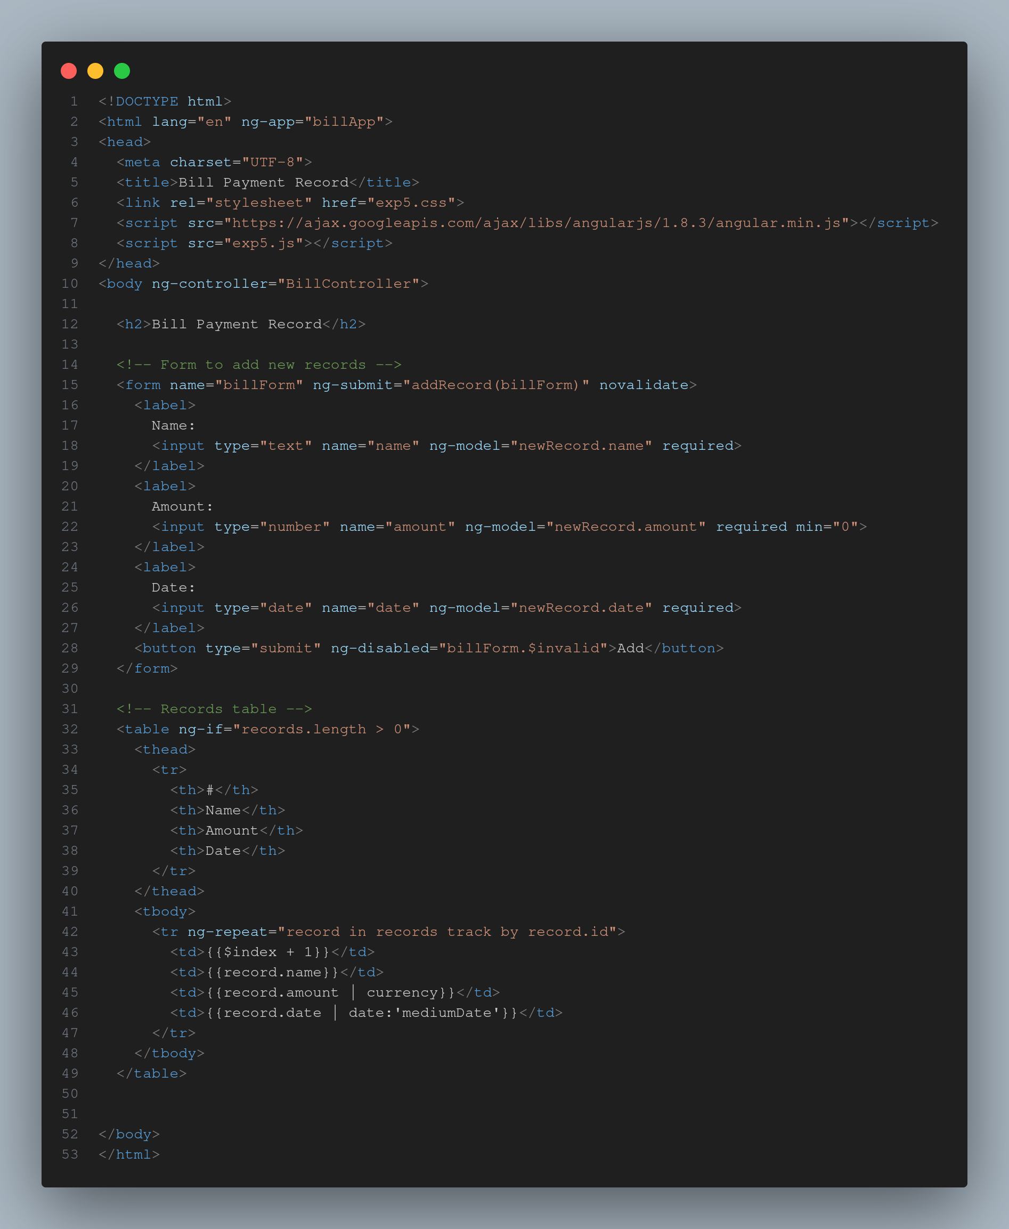 EXPERIMENT 4 CSS 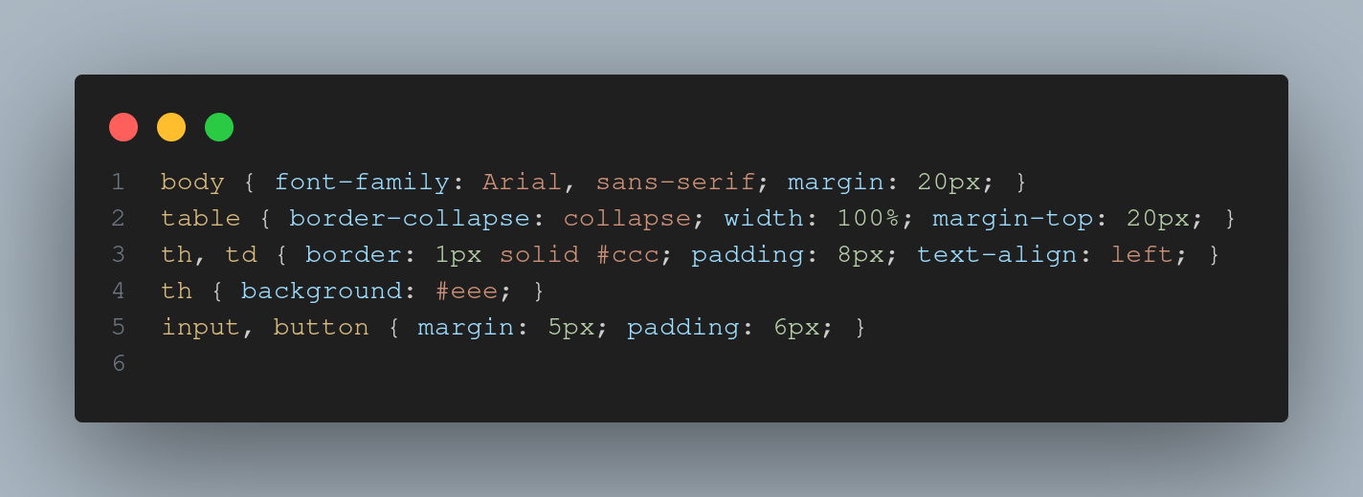 EXPERIMENT 4 JS 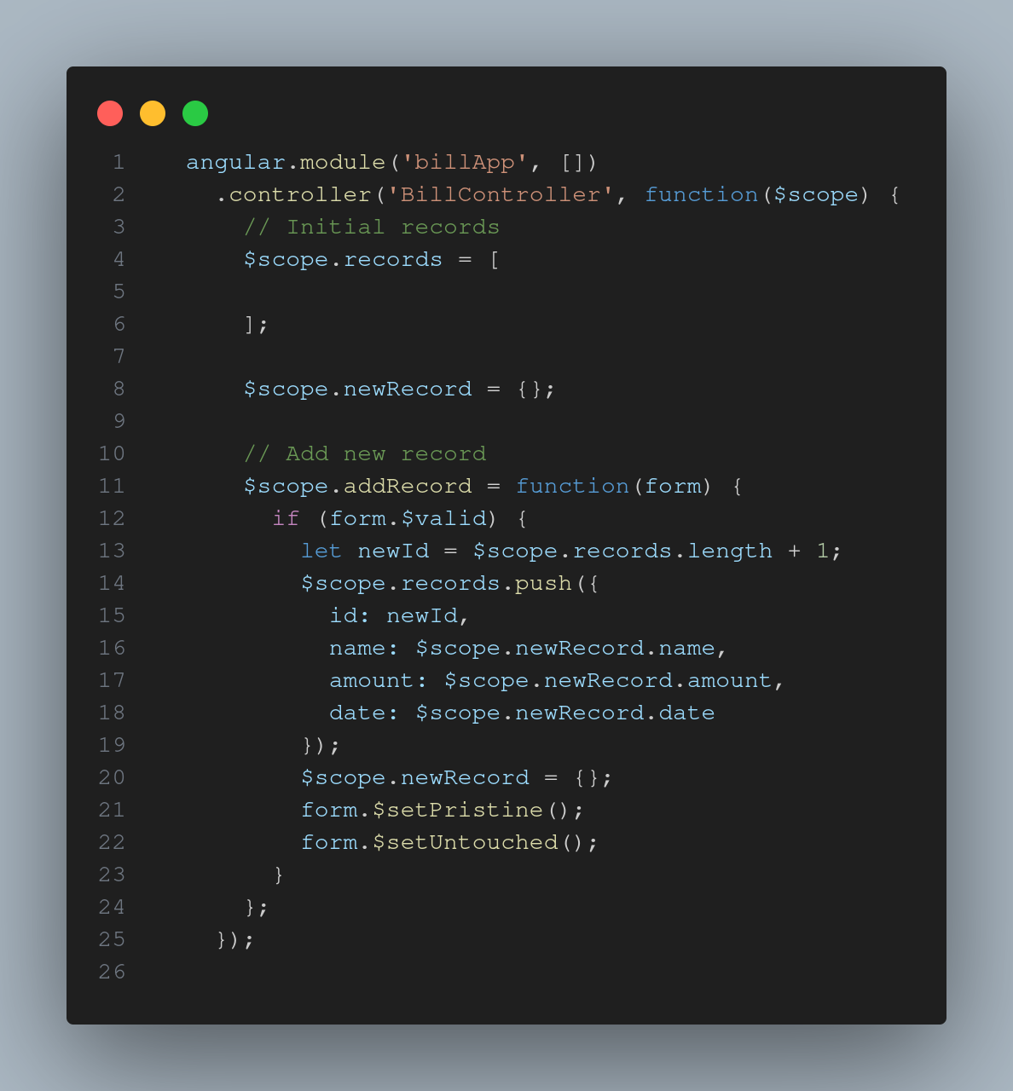 EXPERIMENT 4 OUTPUT 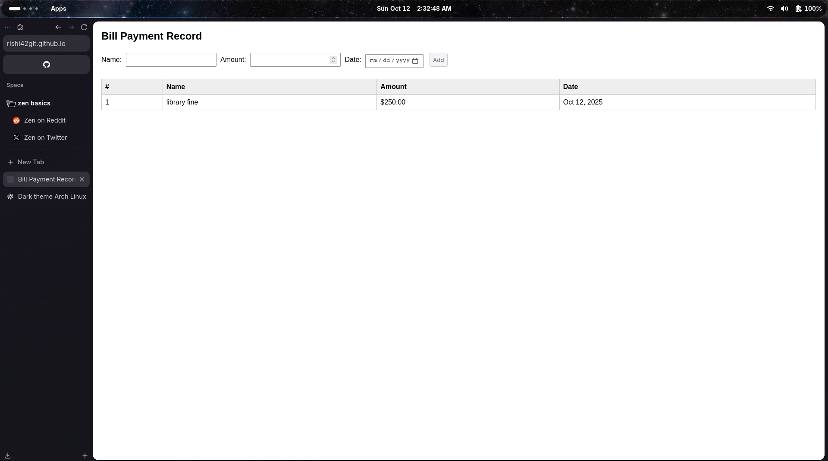
REGISTRATION FORM EXPERIMENT 4.1 HTML 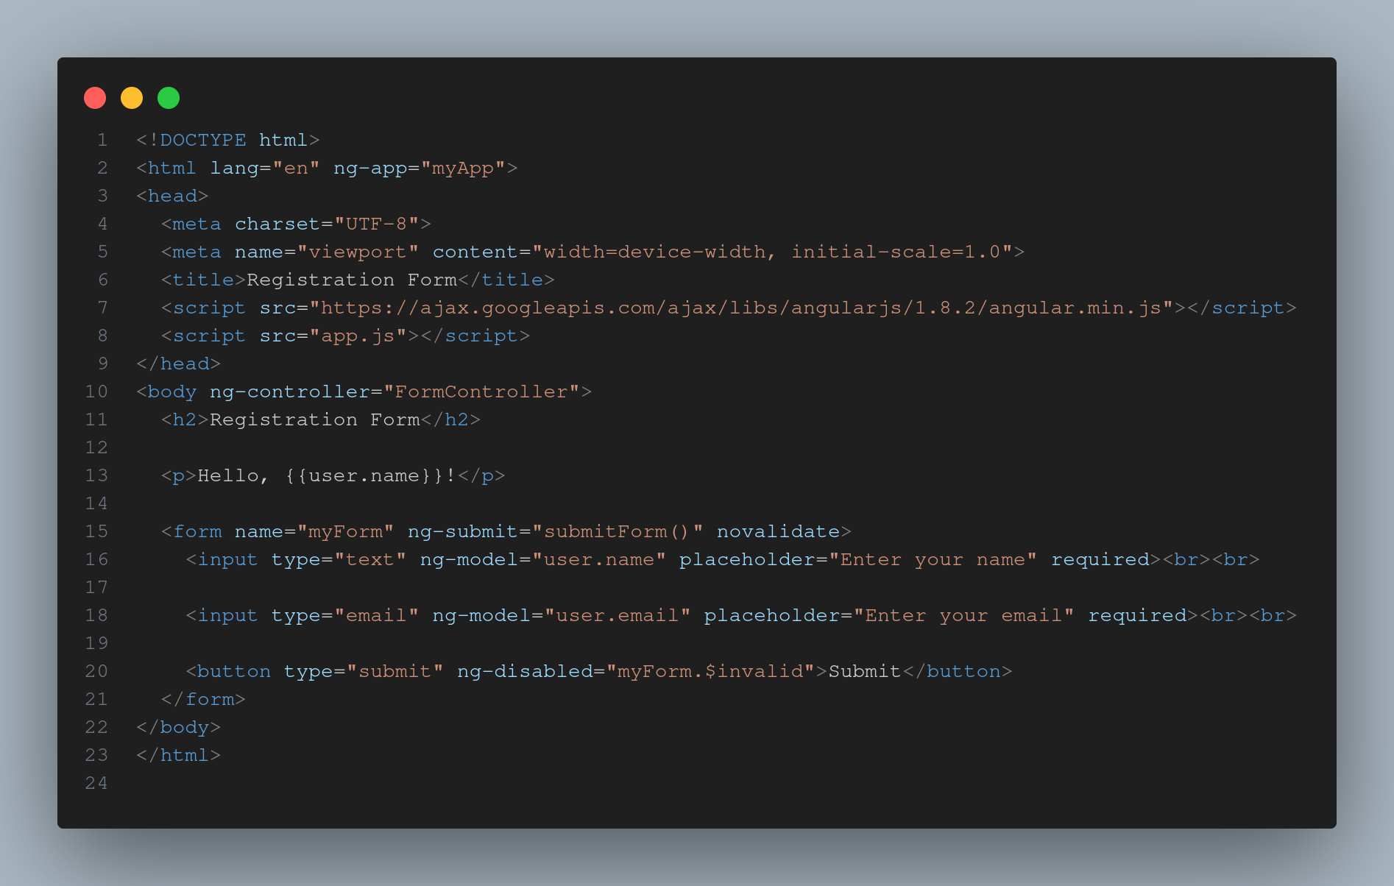 EXPERIMENT 4.1 CSS 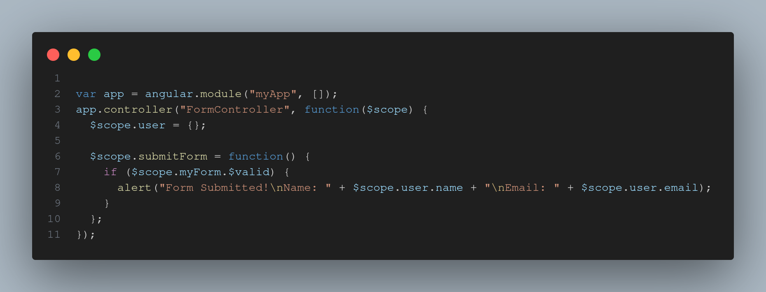 EXPERIMENT 4.1 OUTPUT 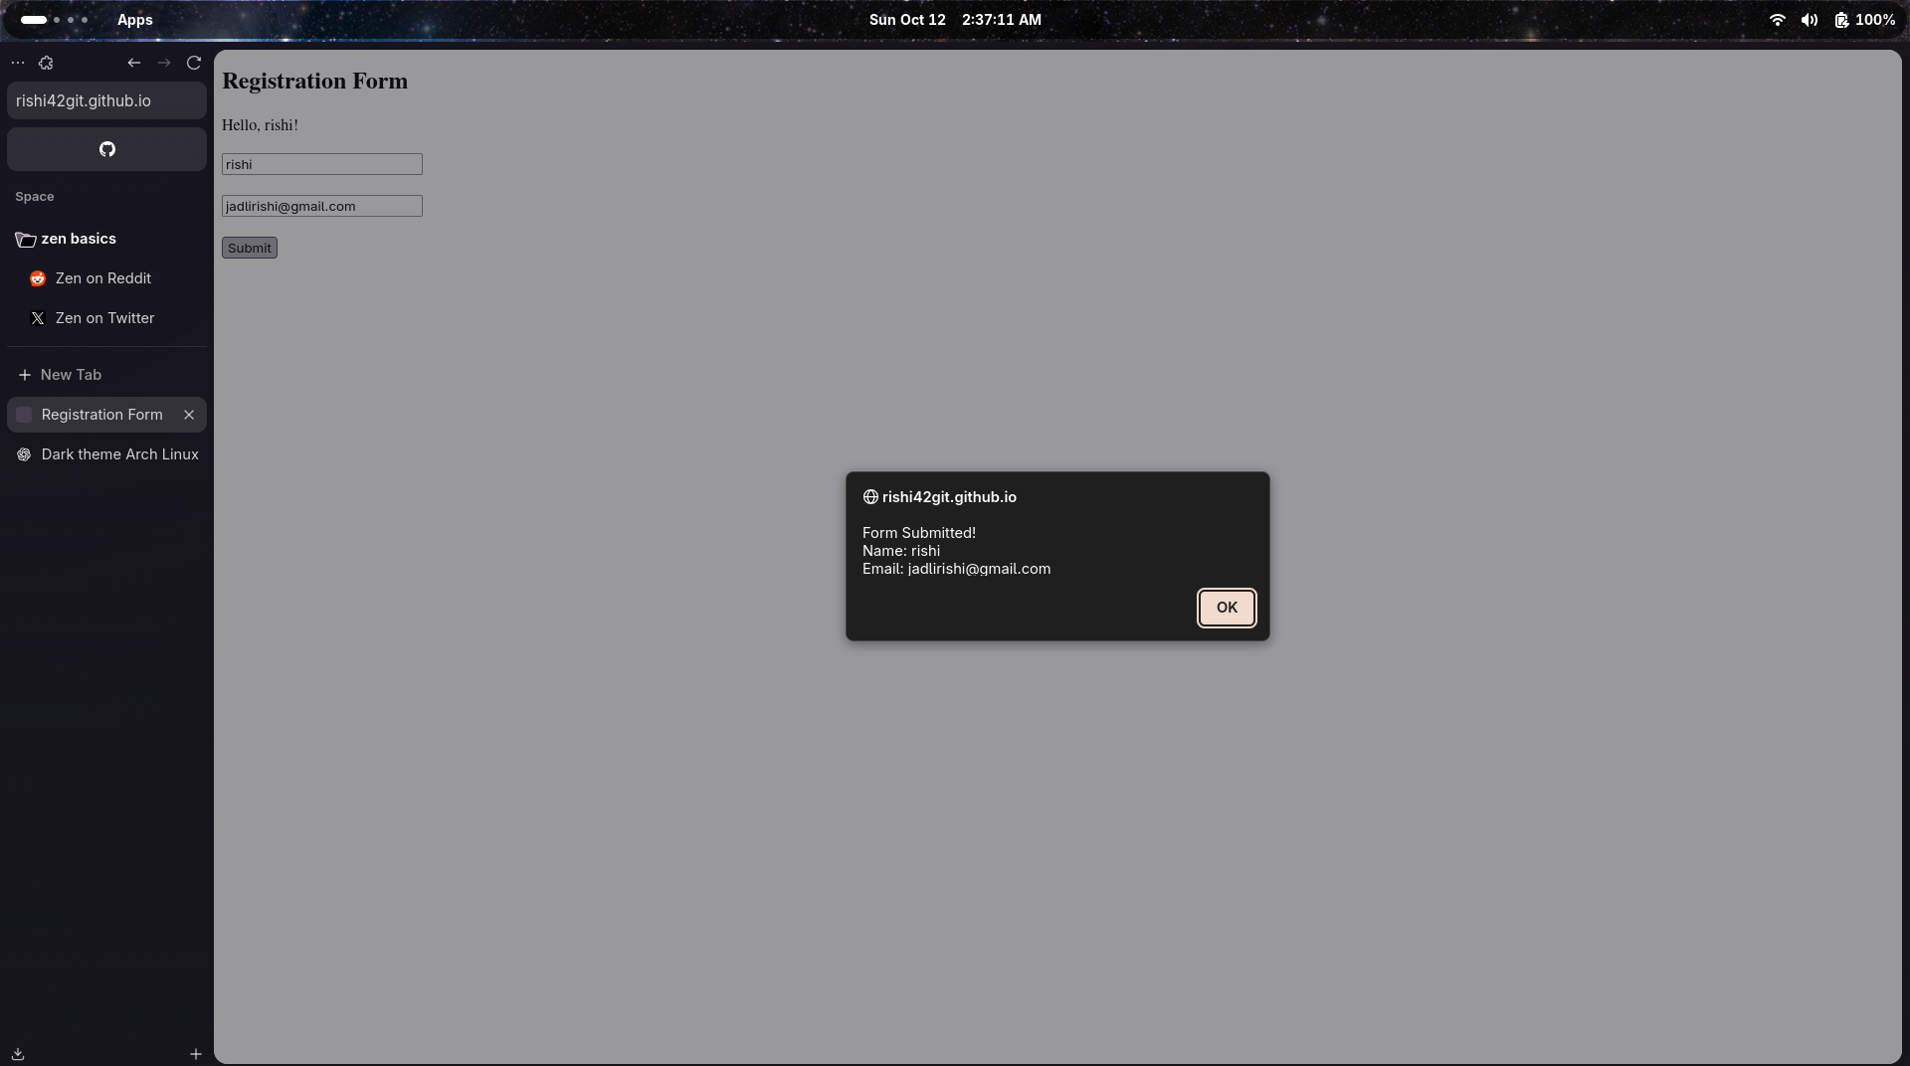 —

Experiment 5_6 - Basic NODEJS exercise
Files: exp5/index.html, exp5/exp5.css, exp5/exp5.js Files: exp6/test1.js, exp6/test2.js
Objective:
Create a simple “Hello, World!” server using Node.js and Express. Write a node.js program to replace two or more a’s with the letter b on the given string using Regular Expression. Create a basic calculator that can nerform arist e a basic calculator that can perform arithmetic operations (addition, subtraction, multiplication, and division) through HTTP request Write a node.js code to iterate over the given array.
What I Learned: - Data binding, displaying data, filtering and sorting, conditionl styling, adding records, error handling Challenges Faced:
- Correctly identifying and handling all potential errors in the server endpoints (e.g., division by zero, missing required query parameters, invalid operation strings) and returning meaningful error messages. - error handling Skills Gained:
Simplified DOM handling — “Write less, do more!” (not that efficient but working on it) EXPERIMENT 5_6 SERVER 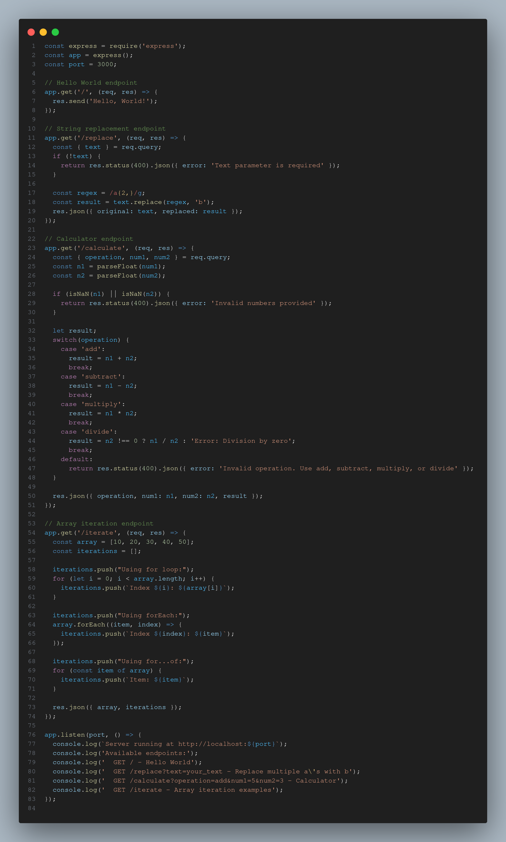 EXPERIMENT OUTPUT 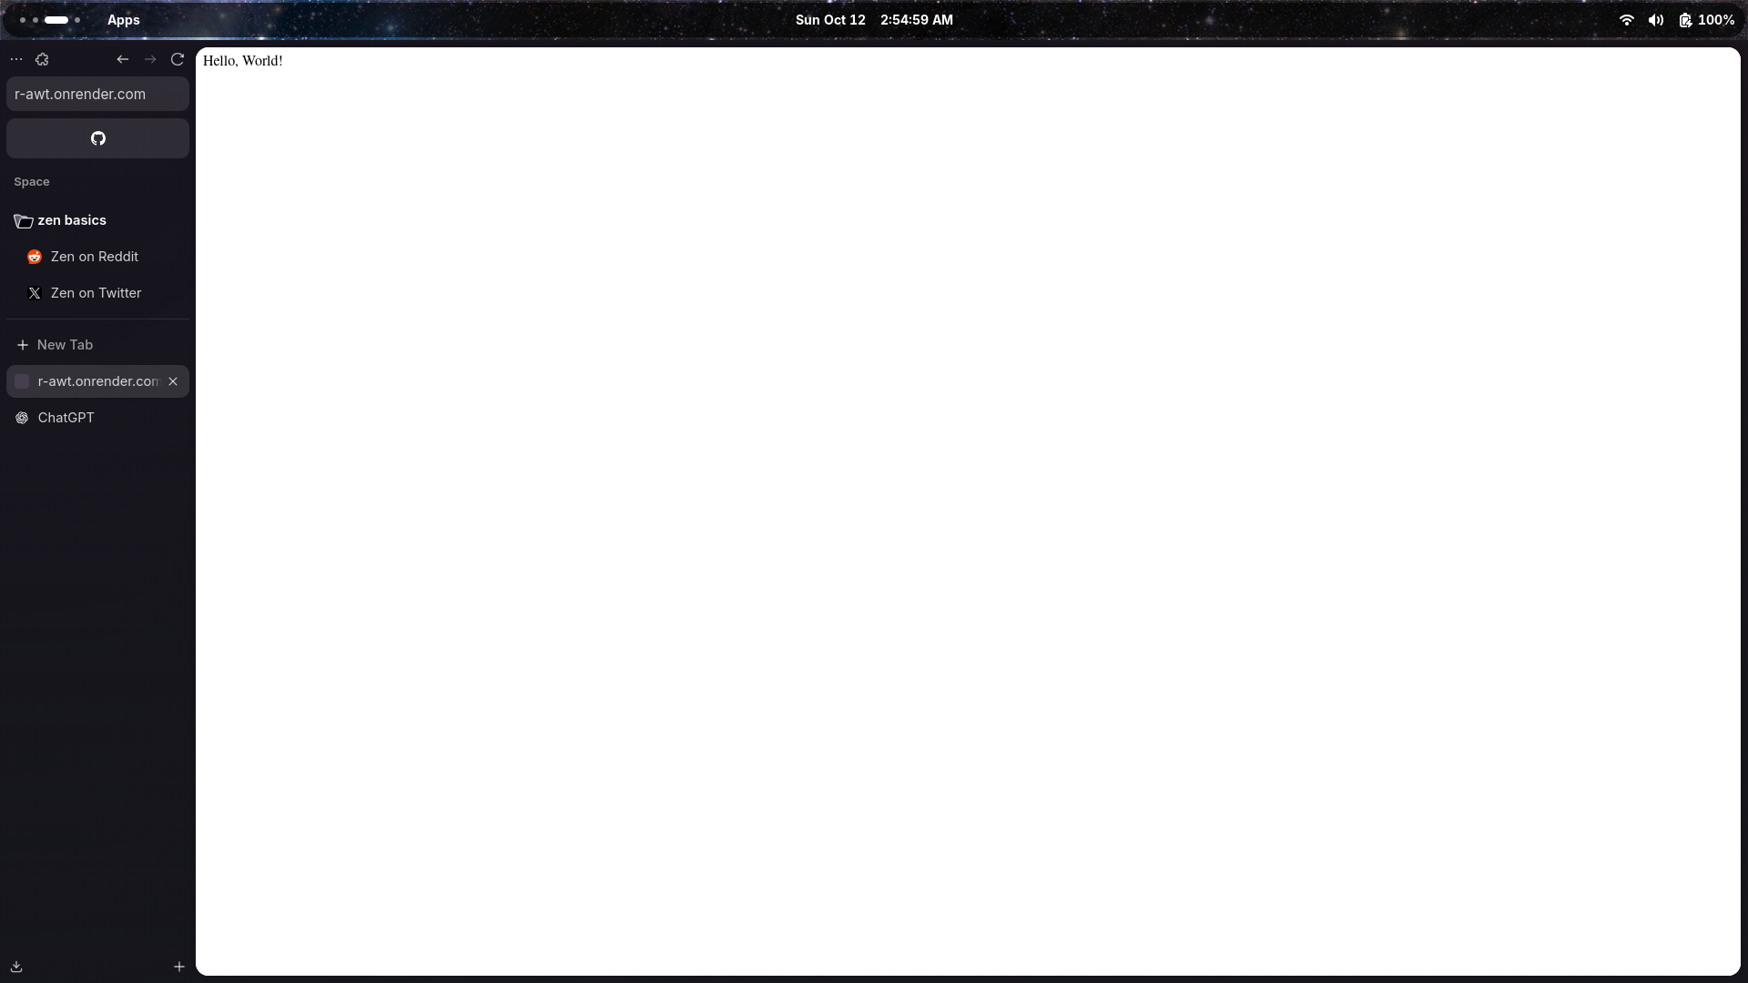 EXPERIMENT OUTPUT 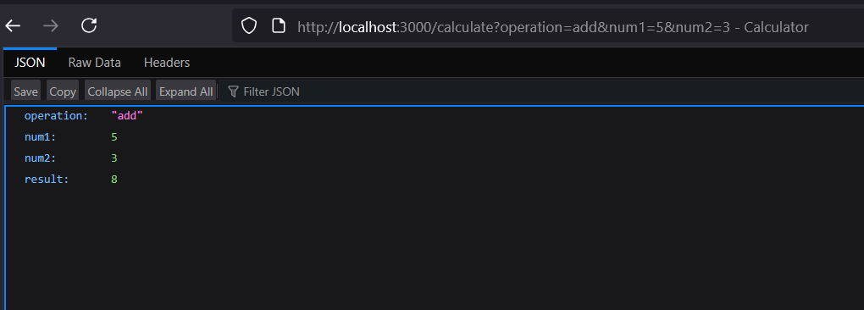 EXPERIMENT OUTPUT 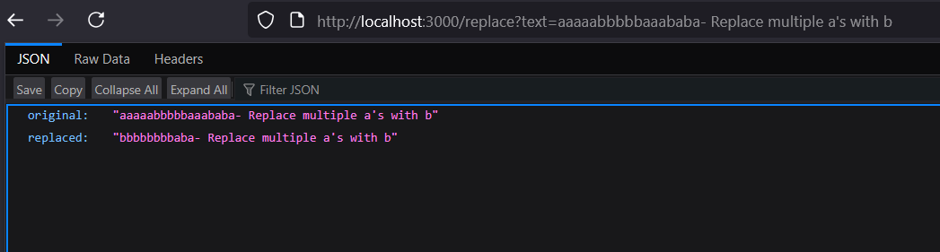 —

Experiment 7 – State management
Files:
- exp7/server.js
- exp7/public/index.html, style.css, app.js
- exp7/package.json
Objective:
show session management using node.js show method for creating and destroying session create and delete cookie using nodejs
What I Learned: - Setting up an Express server. - Serving static files from the public/ directory. - Handling basic routes and responses.
Challenges Faced:
- Configuring Express routing and managing dependencies via npm.
Cookie-example.js
const express = require('express');
const cookieParser = require('cookie-parser');
const app = express();
app.use(cookieParser());
app.get('/set-cookie', (req, res) => {
res.cookie('username', 'JohnDoe', { maxAge: 900000 });
res.send('Cookie has been set');
});
app.get('/get-cookie', (req, res) => {
const user = req.cookies['username'];
res.send(`Cookie Retrieved: ${user}`);
});
app.get('/delete-cookie', (req, res) => {
res.clearCookie('username');
res.send('Cookie deleted');
});
const PORT = process.env.PORT || 3000;
app.listen(PORT, () => {
console.log(`Server started on http://localhost:${PORT}`);
});
Session-example.js
const express = require('express');
const session = require('express-session');
const app = express();
app.use(session({
secret: 'mysecretkey',
resave: false,
saveUninitialized: true
}));
app.get('/', (req, res) => {
if (req.session.views) {
req.session.views++;
res.send(`Welcome back! You visited ${req.session.views} times.`);
} else {
req.session.views = 1;
res.send('Welcome to the session demo. Refresh to count visits.');
}
});
app.get('/destroy', (req, res) => {
req.session.destroy(err => {
if (err) {
return res.send('Error destroying session');
}
res.send('Session destroyed');
});
});
const PORT = process.env.PORT || 3000;
app.listen(PORT, () => {
console.log(`Server started on http://localhost:${PORT}`);
});
Package.json
{
"name": "experiment_7",
"version": "1.0.0",
"description": "",
"main": "index.js",
"scripts": {
"test": "echo \"Error: no test specified\" && exit 1"
},
"keywords": [],
"author": "",
"license": "ISC",
"dependencies": {
"cookie-parser": "^1.4.7",
"express": "^5.1.0",
"express-session": "^1.18.2"
}
}
EXPERIMENT 7 : COOKIES 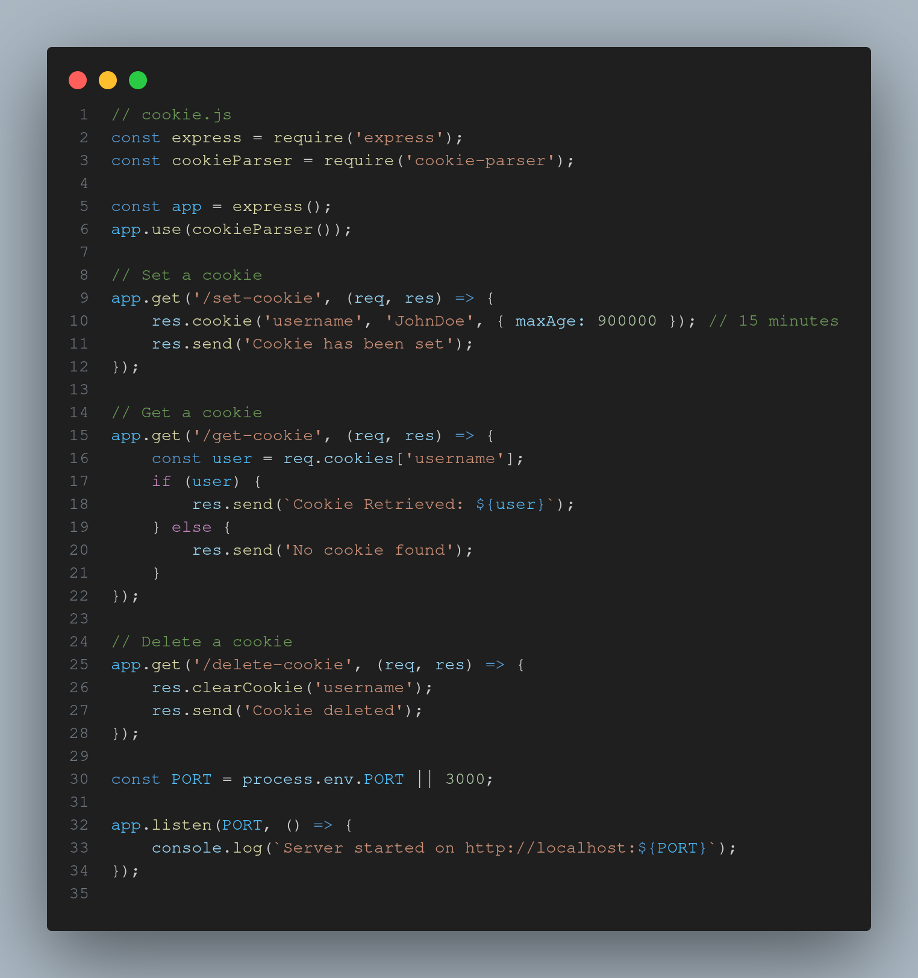 OUTPUT 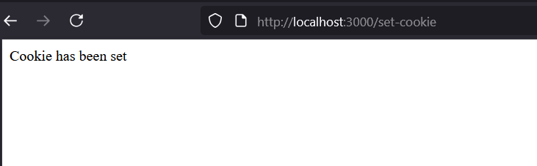 COOKIE RETRIEVAL 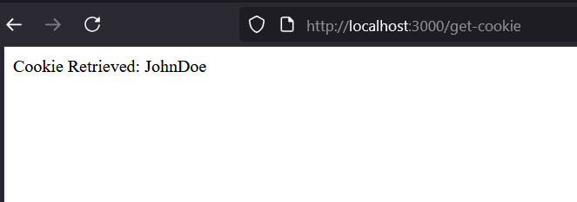 EXPERIMENT 7.2 SERVER 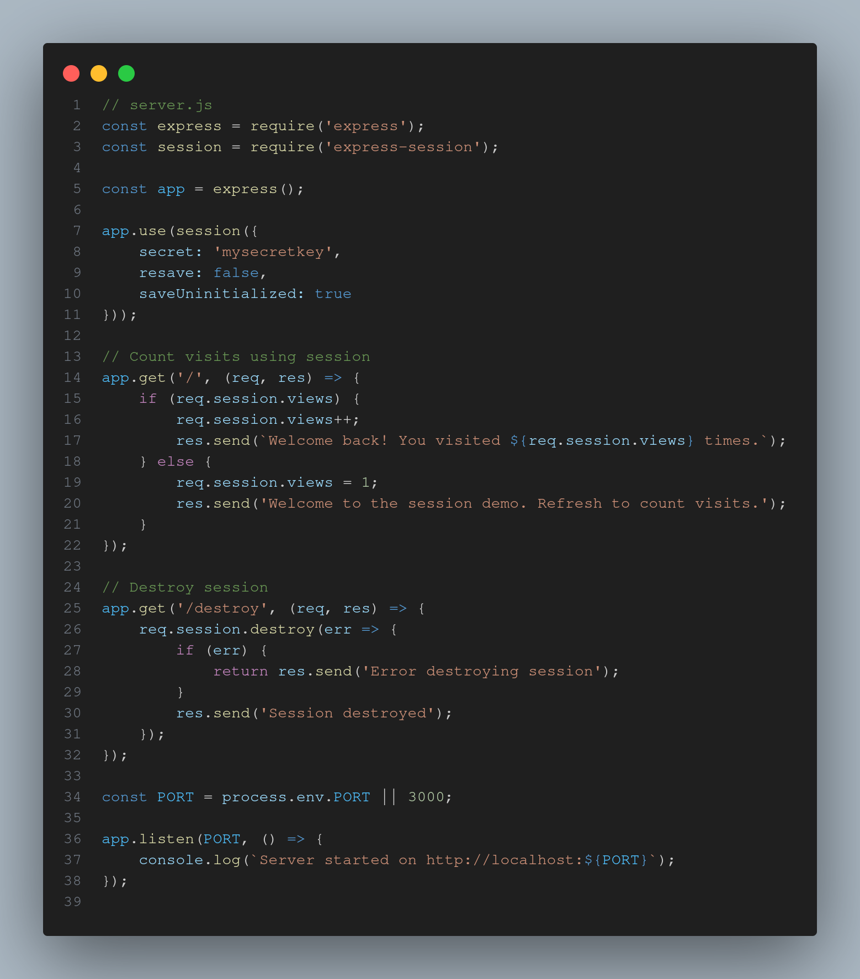 EXPERIMENT 7 SESSION COUNT 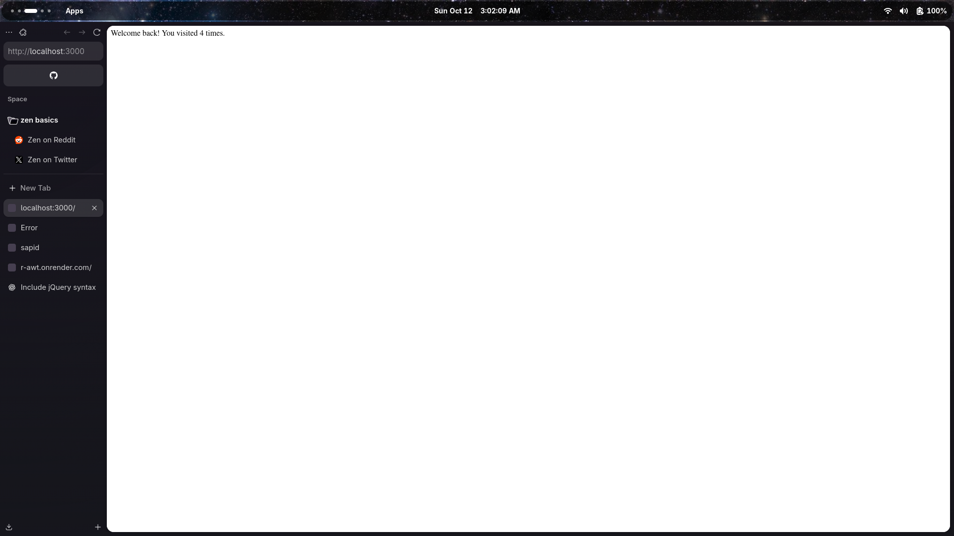 EXPERIMENT 7 SESSION DESTROY 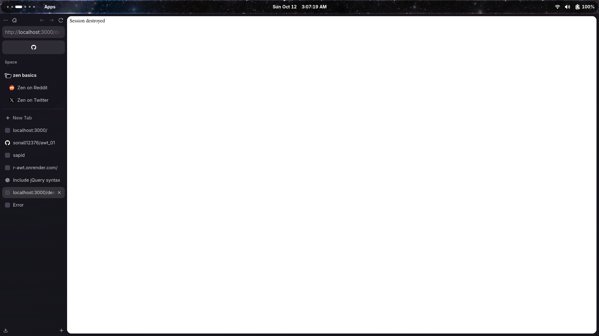
Run Instructions: ```bash cd exp7 npm install node server.js
Experiment 8
## MongoDB + Mongoose + Express — Student Management System

Overview
This project implements a Student Management Web Application using:
- Node.js + Express for backend APIs
- MongoDB Atlas for cloud database
- Mongoose for schema & database operations
- Vanilla HTML/CSS/JS for frontend
Key Concepts Learned Connecting to MongoDB using Mongoose Creating data schema & models Hashing passwords with bcrypt User registration & login flow Session management / Cookies Storing users securely Handling authentication errors Structuring MVC-like project folders
Challenges faced:
Understanding how async/await works with database operations. Forgetting to use express.urlencoded() which caused form data to not reach the backend. Schema mistakes like missing fields or wrong data types. Difficulty connecting to MongoDB Cloud due to IP access settings. CODE: INDEX FILE 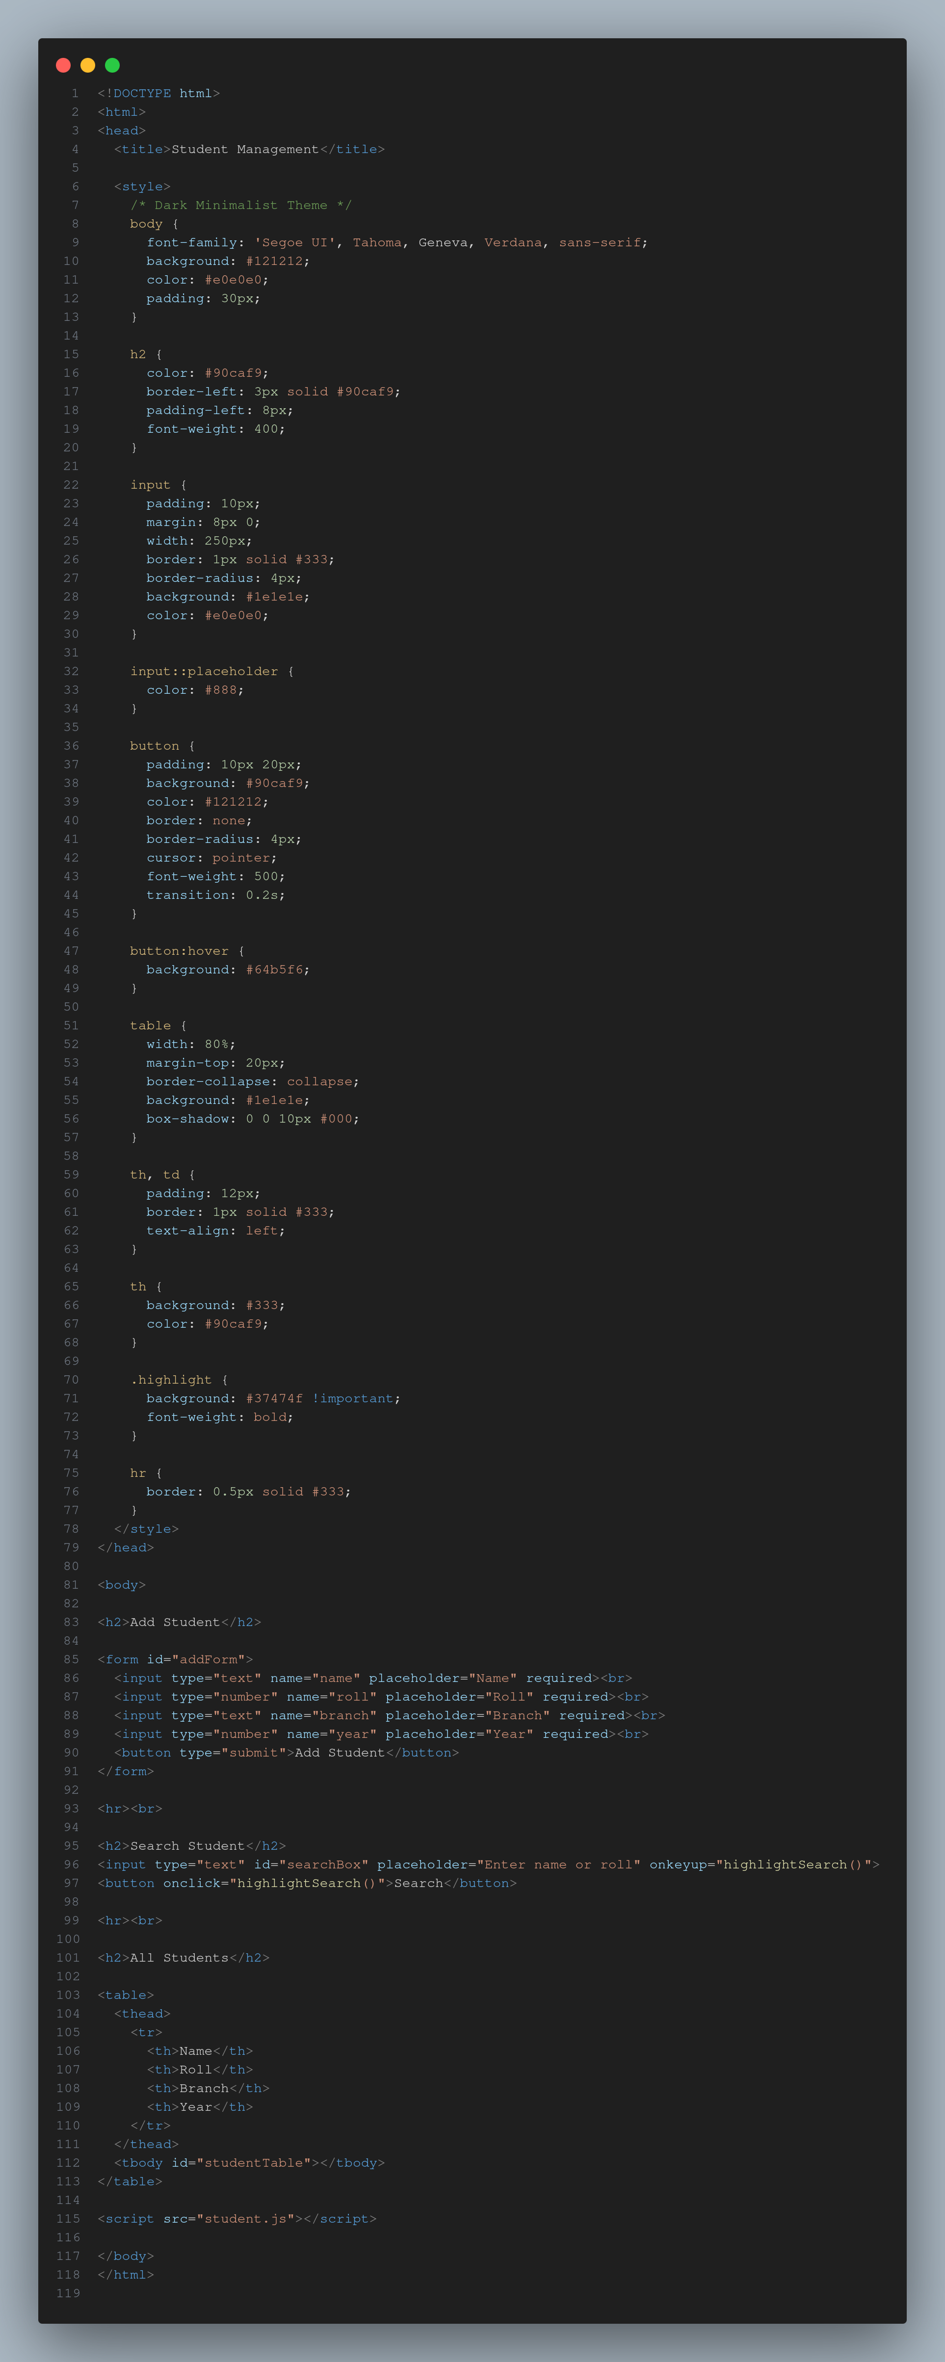 SERVER.JS 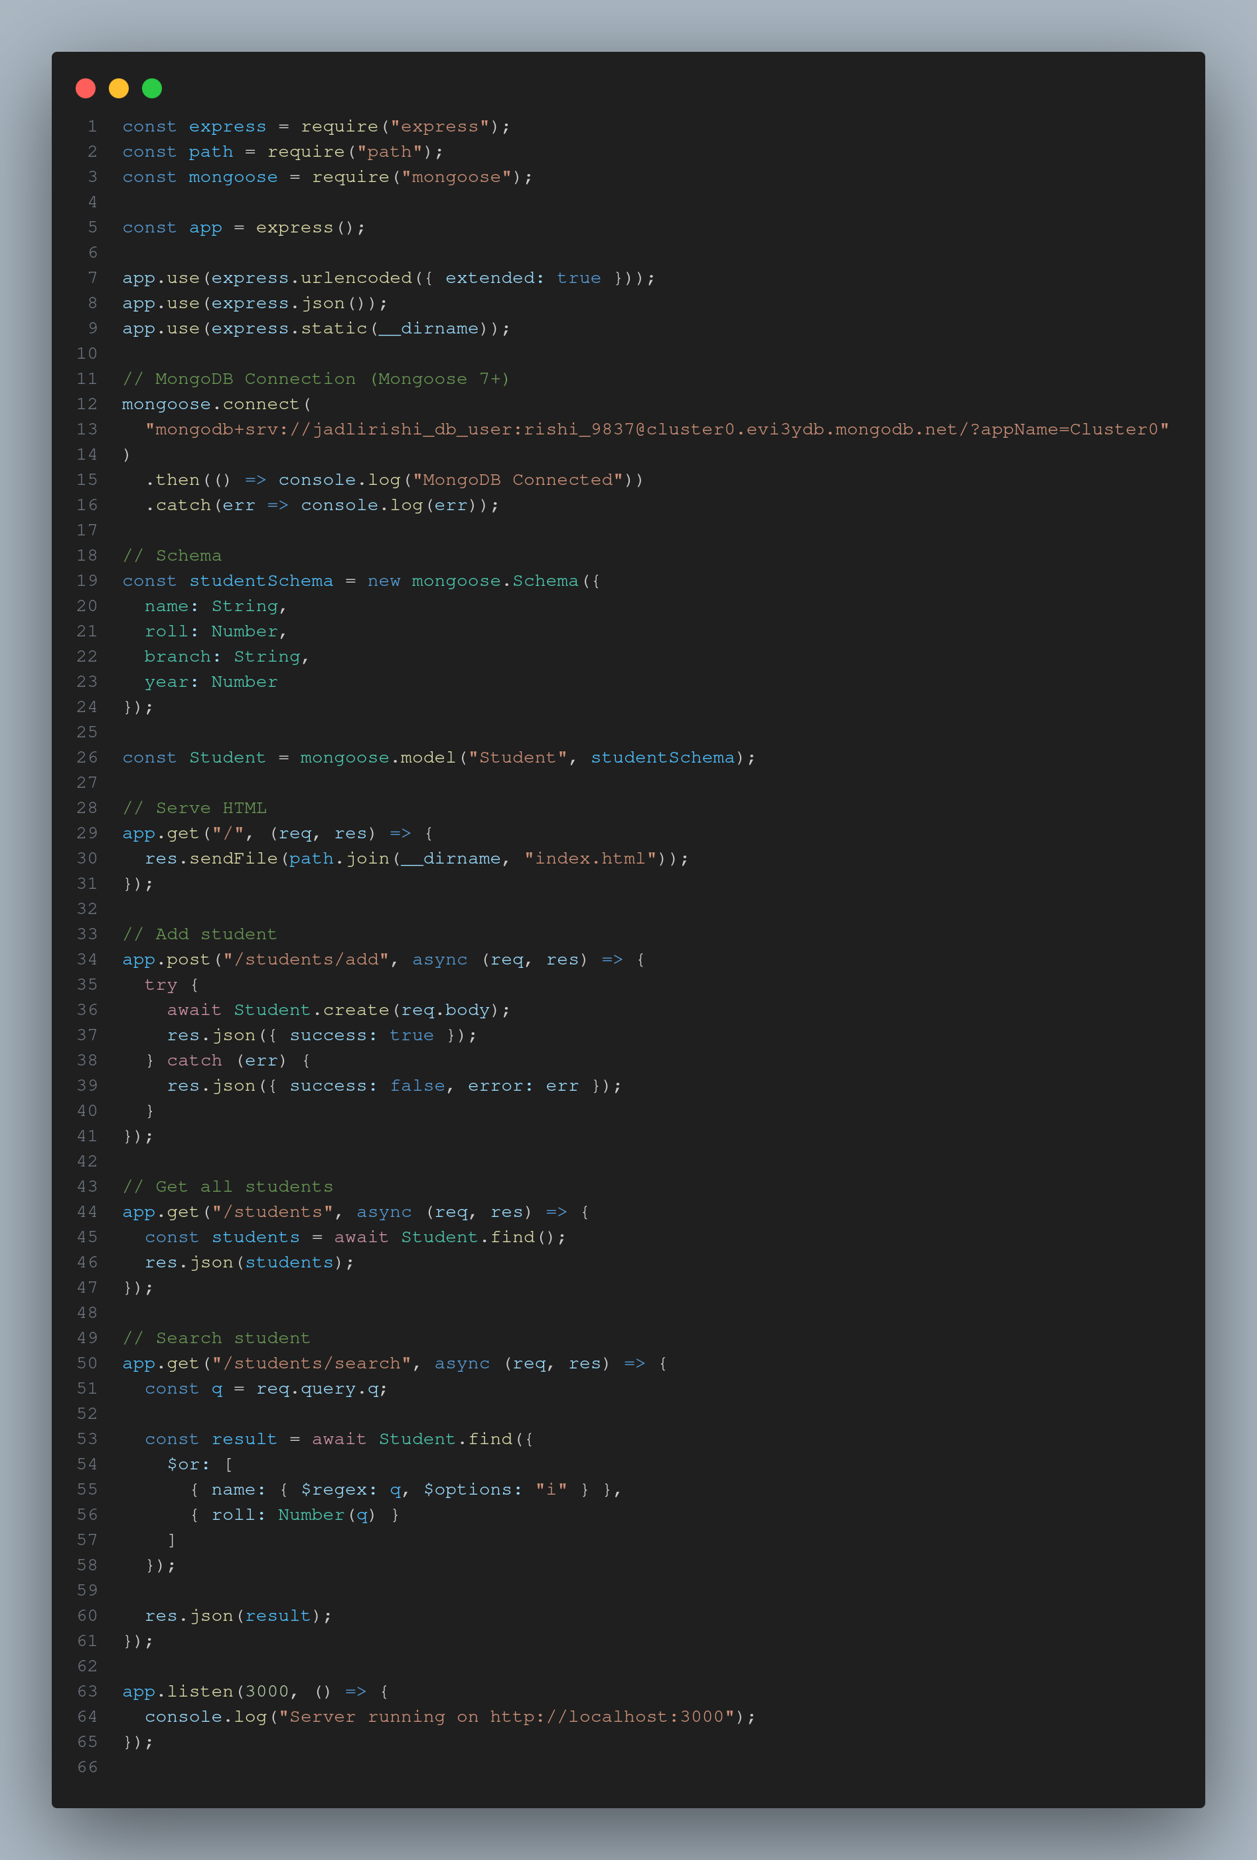 STUDENT.JS 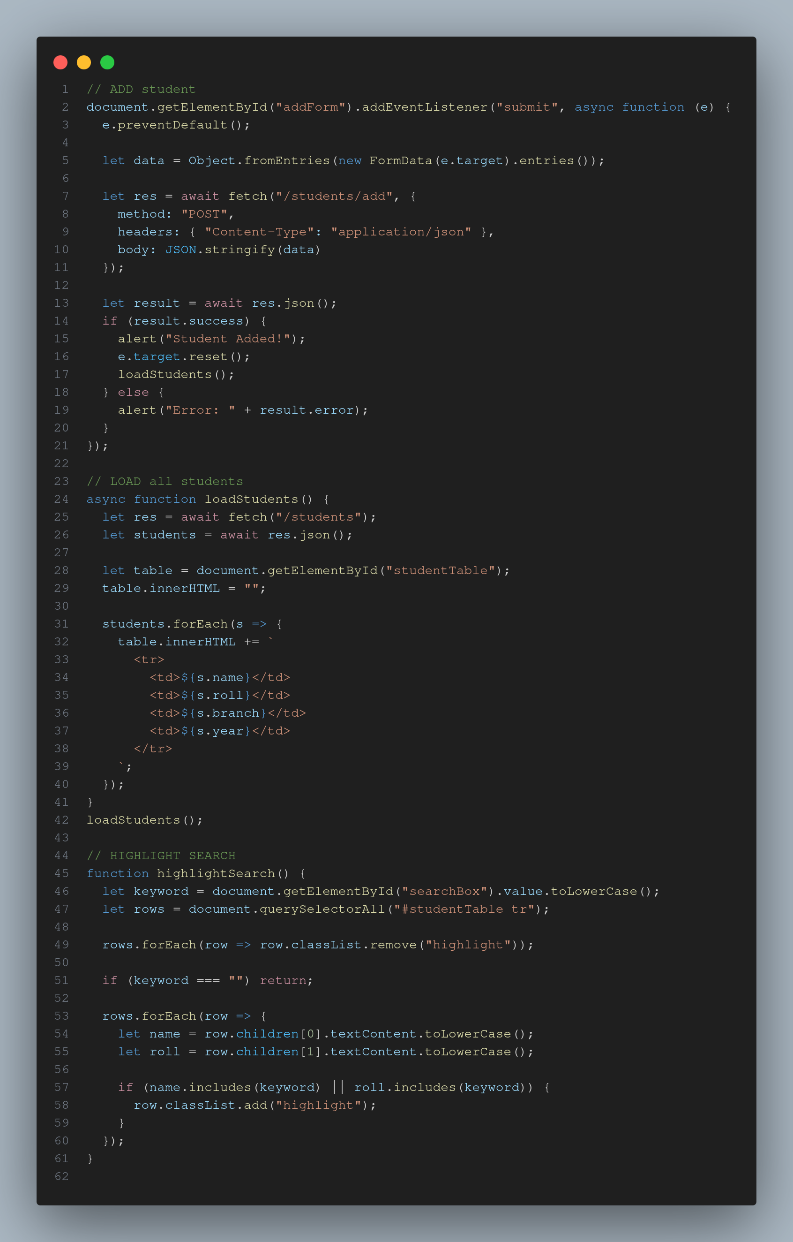 OUTPUT: 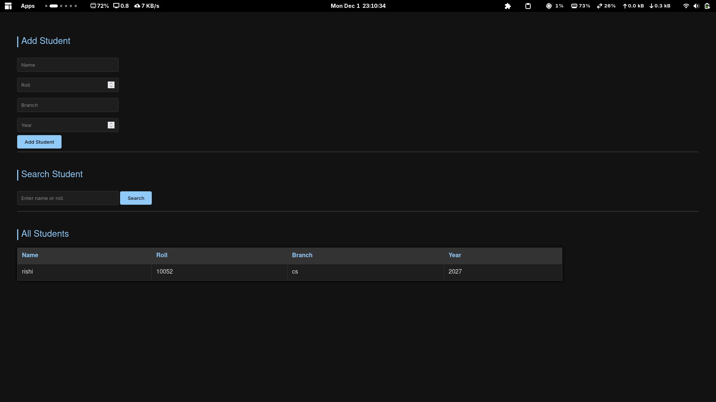 Run Instructions: ```bash npm install node server.js
click render link if on the git index page of Rishi42git
Experiment 8 : Shopping centre managemet system CODE: INDEX.HTML 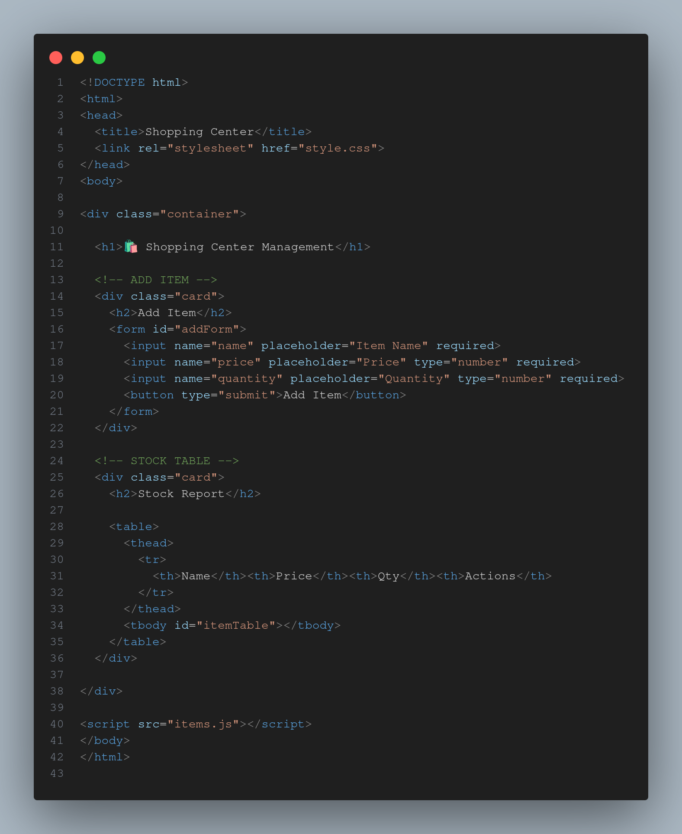 SERVER.JS 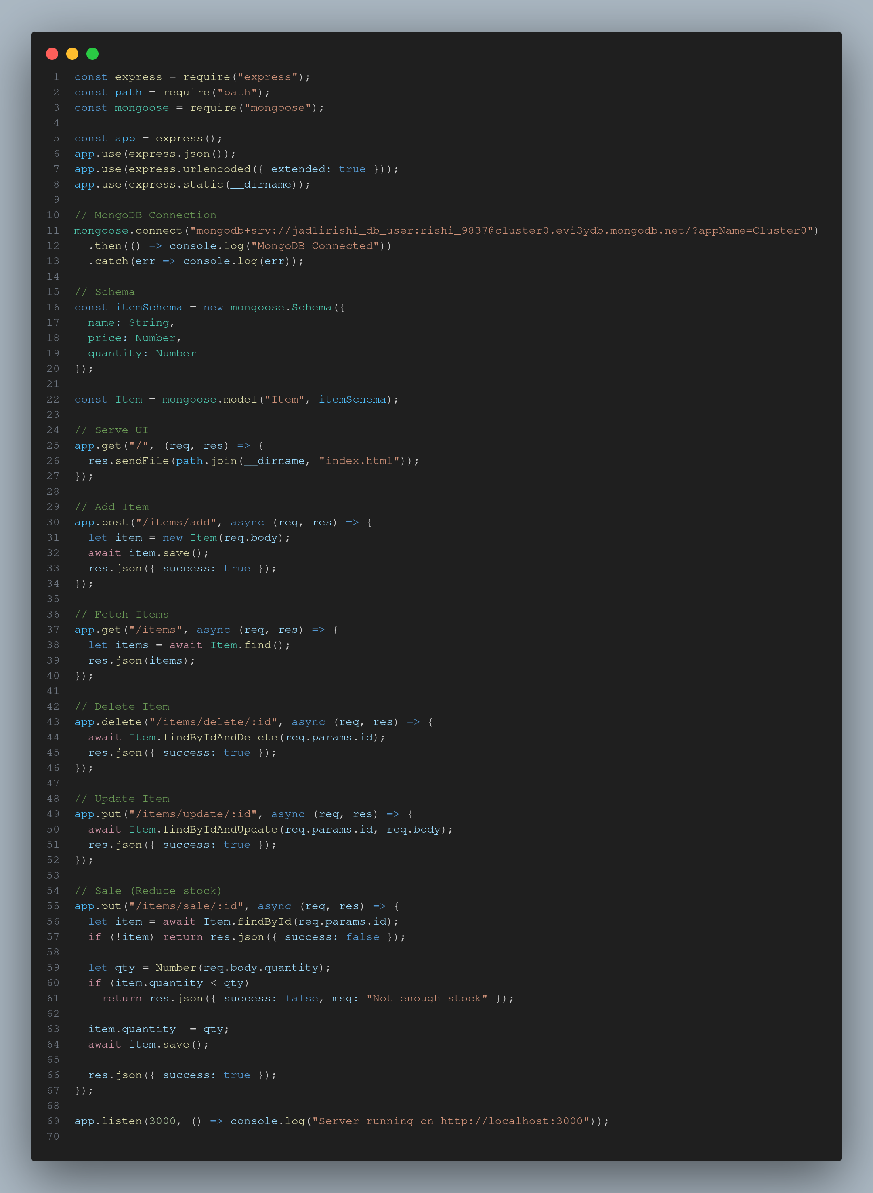 BACKEND ITEMS.JS 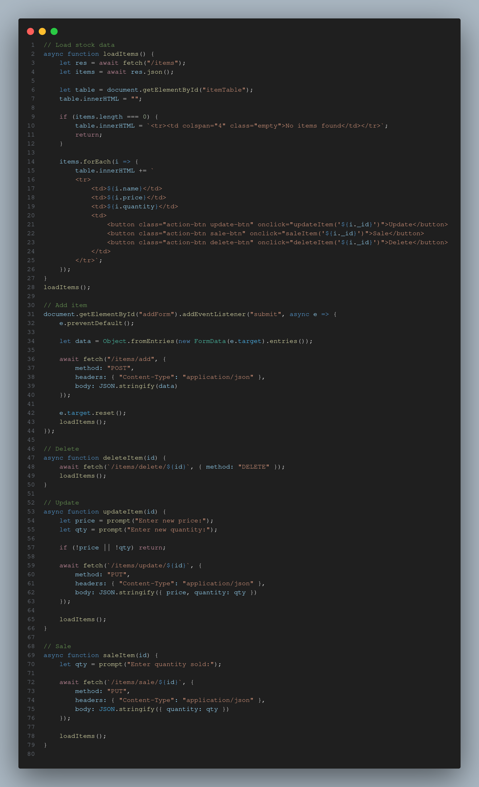 STYLE.CSS 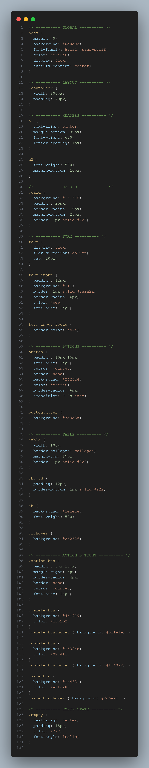 OUTPUT: 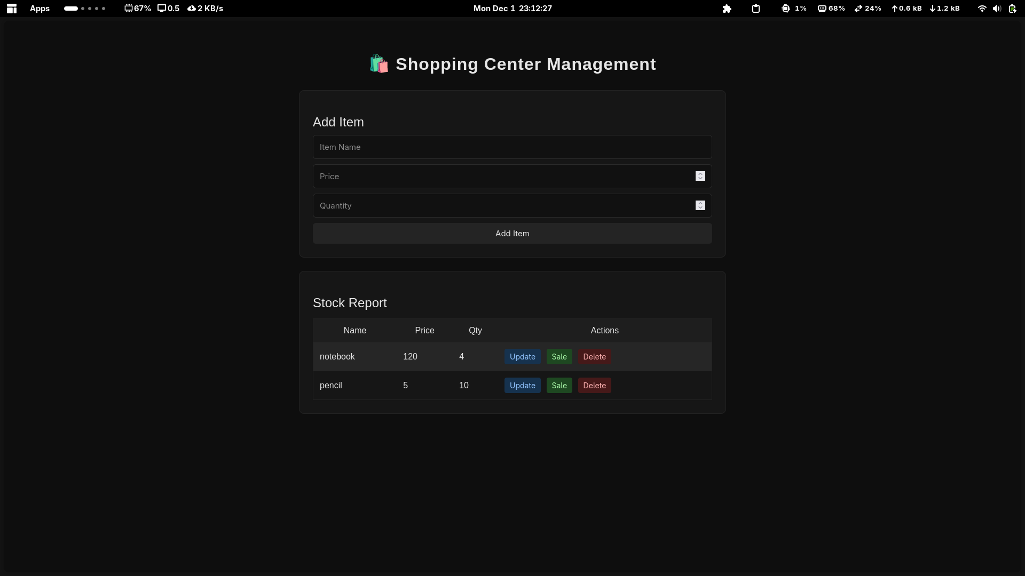 Run Instructions: ```bash npm install node server.js
click render link if on the git index page of Rishi42git
Experiment 9&10 Topic: SVG Basics, D3.js Visualizations, Interactive Graphics, CSV Data Handling Files: csv.html,data.csv,exp.htm,index.html
What I learned:
Creating a bar chart using SVG and D3.js Selecting and modifying particular elements using D3 Creating circles and rectangles as interactive controls Fetching data from CSV and creating a graph Code CSV.HTML 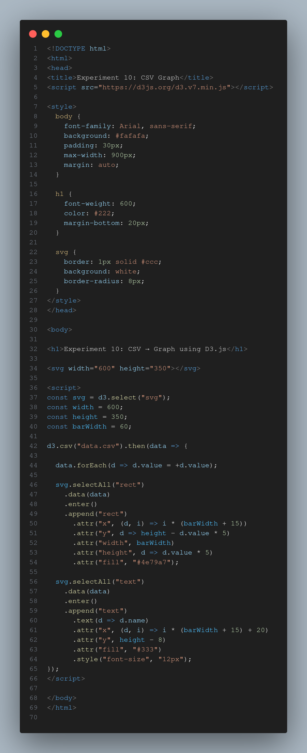 DATA.CSV 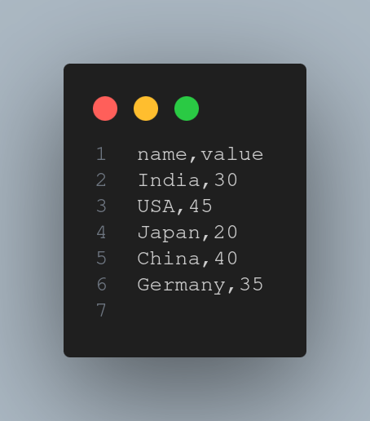 INDEX.HTML 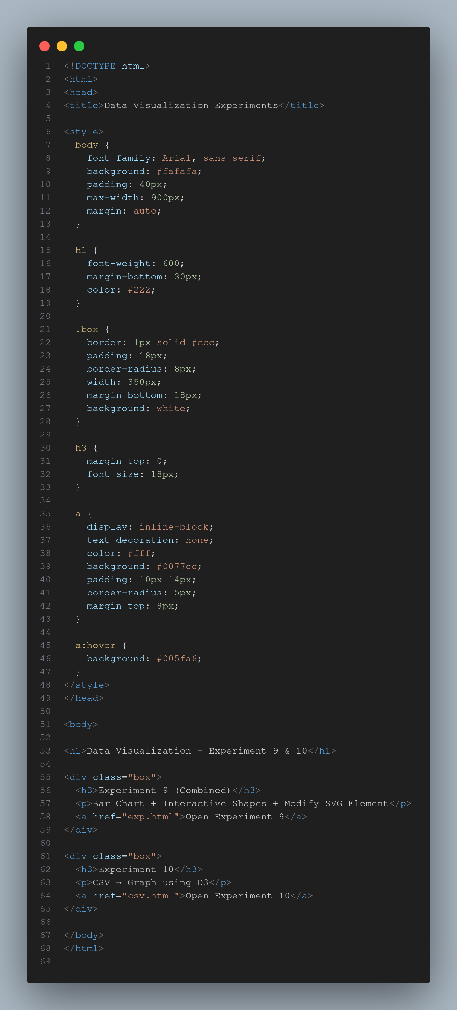 EXP.HTML 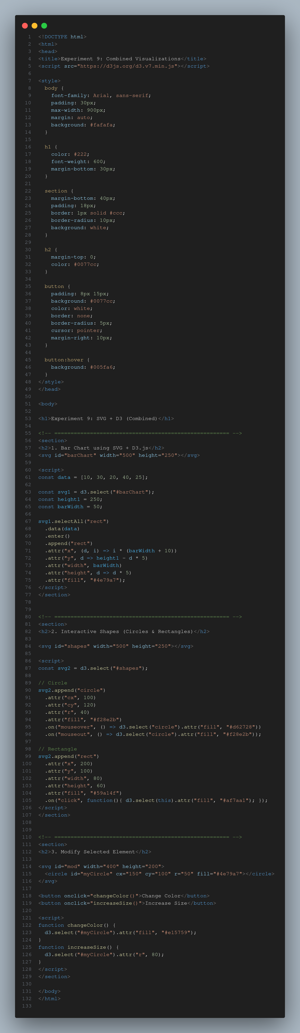
OUTPUT: 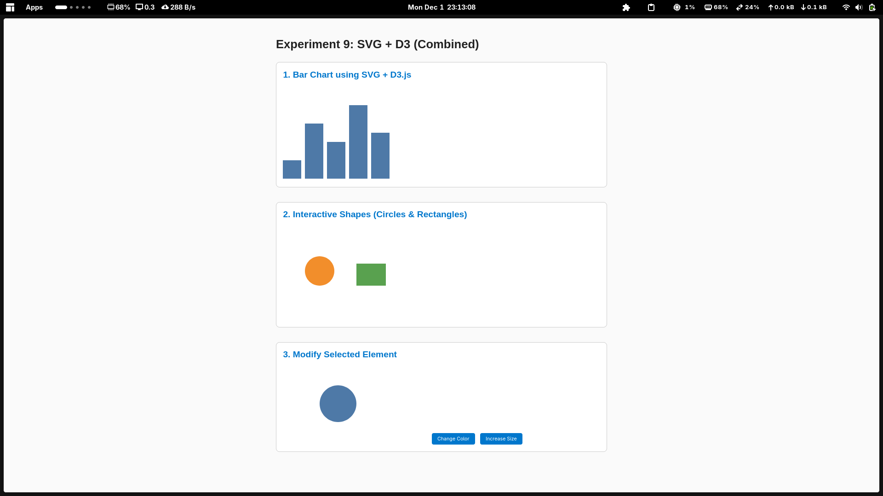 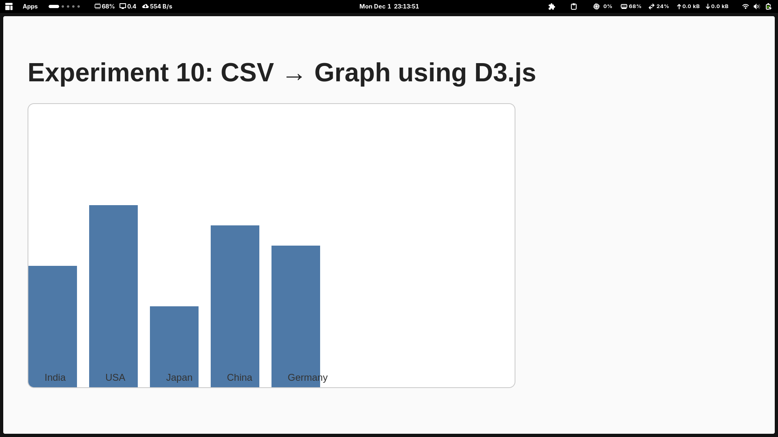
Challenges faced: Understanding the enter-update-exit pattern of D3.js Forgetting to include the D3 script link (leading to “d3 is not defined” errors). Getting confused between pixel values and scale values. -Difficulty in making interactions (click/hover) work correctly. Conclusion This lab helped me gain hands-on experience in front-end and back-end web development.
I learned how to: Design interactive front-end applications (HTML, CSS, JS, jQuery, Angular). Build and deploy backend applications using Node.js and Express. Handle user sessions, cookies, and server routing.
Submitted by: RISHABH JADLI Course: Advanced Web Technology Lab Tools Used: VS Code, Node.js, GitHub.

