[Rest_Api testing With RestAssured]
1.Introduction of Rest api testing
-->Application programming Interface
ex-problem one
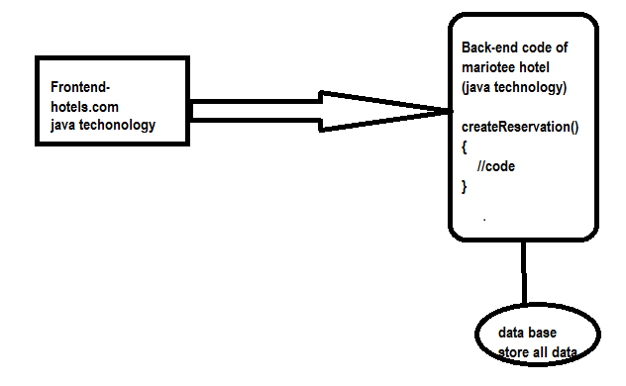
2.Real time Usageof Apis in Industry with example:-

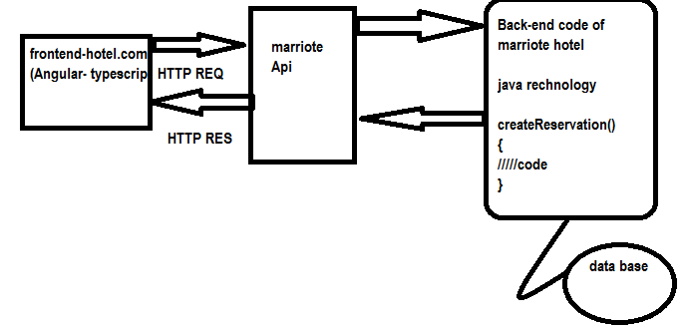

#Understanding GET, POST, PUT, DELETE, Header in Rest Api
Api _status code…
Successful response
- 200à0hk
- 201àcreated
- 202 àAccepted
Redirection message:-
- 300 àMutiple choice
- 301àmoved permanently
- 302àfound
Client error response---
- 400--àBad request
- 401-àUnauthorized
- 402-àPayment required
- 403-àforbidden
- 404 --ànot found
- Server error response
- 500---àInternal server error
- 501--ànot implemented
- 502---à bad gateway
- 503 -àService unavailable
End point /base uri:- Address where api is hosted on the server
GET , POST ,PUT , AND delete -----------à CRUD—OPERATION
#what are path query paramater & header in REST API
Ans:-Path parameters are variable part of a url path .they are typically used to point to a specfic resource with in a location such as user identified by ID.
https://www.google.com/images/1123343
Https://www.amazon.com/orders/112

#Query_Parameter..
Query parameter is used to sort/filter the resource
Query parameter are identified with?-
Ex:-
Https://www.amazon.com/orders?sort by=2/20/2020

# END POINT Request URL can be constructed as below
Base URL/resource/(Query/path paramters

Resources:
Resources represent API/Collection which can be accessed from the server
1.Goggle.com/maps
2.Goggle.com/search
3.google.com/images

Google Maps Add API (POST):
This API Will add new place into Server

Complete URL : https://rahulshettyacademy.com/maps/api/place/add/json?key= qaclick123

Base URL: https://rahulshettyacademy.com
Resource: /maps/api/place/add/json
Query Parameters: key =qaclick123
Http Method: POST
Sample Body :
{
"location": {
"lat": -38.383494,
"lng": 33.427362
},
"accuracy": 50,
"name": "Frontline house",
"phone_number": "(+91) 983 893 3937",
"address": "29, side layout, cohen 09",
"types": [
"shoe park",
"shop"
],
"website": "http://google.com",
"language": "French-IN"
}

Sample Response

{
"status": "OK",
"place_id": "928b51f64aed18713b0d164d9be8d67f",
"scope": "APP",
"reference": "736f3c9bec384af62a184a1936d42bb0736f3c9bec384af62a184a1936d42bb0",
"id": "736f3c9bec384af62a184a1936d42bb0"
}

Google Maps Delete API (POST):
This API Will delete existing place from Server

Complete URL: https://rahulshettyacademy.com/maps/api/place/delete/json?key=qaclick123

Base URL: https://rahulshettyacademy.com
Resource: /maps/api/place/delete/json
Query Parameters: key
Http request : DELETE

Sample Body :
{
"place_id":"928b51f64aed18713b0d164d9be8d67f"
}
Sample Response
{
"status": "OK"
}

Google Maps get Place API (GET):
This API Will get existing place details from Server

Complete URL : http://rahulshettyacademy.com/maps/api/place/get/json?place_id=xxxx&key=qaclick123

Base URL: https://rahulshettyacademy.com
Resource: /maps/api/place/get/json
Query Parameters: key, place_id //( place_id value comes from Add place response)
Http request: GET
Note: Key value is hardcoded and it is always qaclick123
Sample Response for the Provided Place_Id
{

"location":{

"lat" : -38.383494,

"lng" : 33.427362

},

"accuracy":50,

"name":"Frontline house",

"phone_number":"(+91) 983 893 3937",

"address" : "29, side layout, cohen 09",

"types": ["shoe park","shop"],

"website" : "http://google.com",

"language" : "French-IN"

}

Google Maps Put Place API (PUT):
This API Will update existing place in Server with new values

Complete URL : http://rahulshettyacademy.com/maps/api/place/get/json?place_id=xxxx&key=qaclick123

Base URL : https://rahulshettyacademy.com
Resource: /maps/api/place/update/json
Query Parameters: key
Http Method: PUT -
Note: Key value is hardcoded and it is always qaclick123

Sample Request:
{
"place_id":"8d2573bdf6ceec0e474c5f388fa917fb",
"address":"70 Summer walk, USA",
"key":"qaclick123"
}

Sample Response for the Provided Place_Id
{

"location":{

"lat" : -38.383494,

"lng" : 33.427362

},

"accuracy":50,

"name":"Frontline house",

"phone_number":"(+91) 983 893 3937",

"address" : "29, side layout, cohen 09",

"types": ["shoe park","shop"],

"website" : "http://google.com",

"language" : "French-IN"

}

#Rest Assured:-
Rest Assured is java DSL for simplyfing testing of rest based services buit ion top of http builder.it support POST,GET,PUT,DELETE ,PATCH ,OPTION AND HEAD request and can be used to validate and verify the response of these request..

#Diving In Depth Automation Rest Apis…
Understanding structure of complex nested Json and its array notations.
{
"dashboard": {
"PurchaseAmount ": 910,
"website": "shubhamAutomation.com"
},
"courses": [
{
"title": "Selenium Python",
"price": 50,
"copies": 6
},
{
"title": "Cypress",
"price": 40,
"copies": 4
},
{
"title": "RPA",
"price": 45,
"copies": 10
}
]
}1. Print No of courses returned by Api
2. Print Purchase Amount
3. Print title of the first course
4. Print all courses title and their respective prices
5. Print no of copies sold by RPA courses
6. Verify id sum of all course prices matches with purchase amount

Rest API Automation Framework from SCRATCH
- Create maven project with cucumber and rest assured dependencies
- Define Project Structure with cucumber framework setup
- Create feature file with the test case you want to automate
- Implement smart step definition files with supported code
- Build utlis file to define all reusable request and response specification
- Build pojo classes for serializing and deserializing json payload.
- Implement logging into framework to log request and response details
- Develop End to End Functionality Test with all validation and Assertions
- Define global properties and drive all the global variable from properties file
- Define Enum class with constant to centralize all resource details.
- Implement data driven mechanism to driver the data dynamically from feature file .
- Implement parameterize to run tests with multiple data sets using cucumber Example keyword
- Add more Test and implement tagging Mechanism to run selected test from test runner file.
- Implement pre and post condition for test with cucumber hooks
- Execute Complete framework from maven commands
- Implements Maven driven global vauesinto test for dynamic execution
- Generate Reports for test Execution result.
- Integrate the framework into Jenkins CI/CD tool
- Implement Parameterized Jenkins job into chose the global values at run

