Chatbot_conversion :

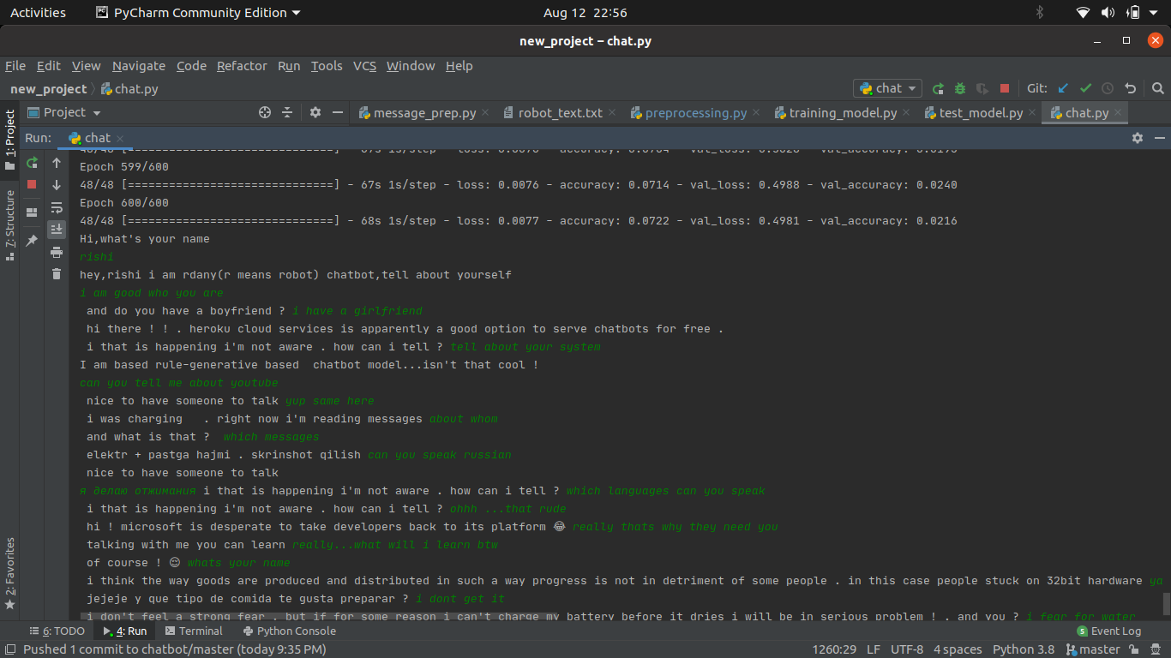

Green ones are user_response(my _responses) rest are replies by chatbot.