Bootstrap

# Part 1: Download bootstrap

## Method 1

In this method you need to include these files in all your web sites, kind of redundant.

1. Download bootstrap from <https://getbootstrap.com/docs/4.5/getting-started/download/>
2. 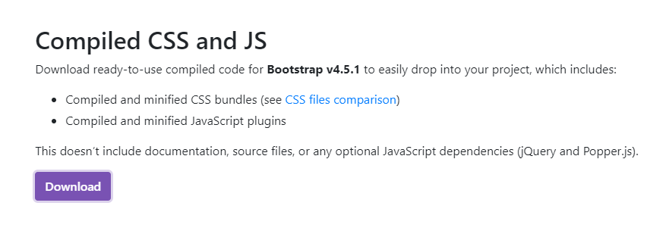Extract the files

## Method 2

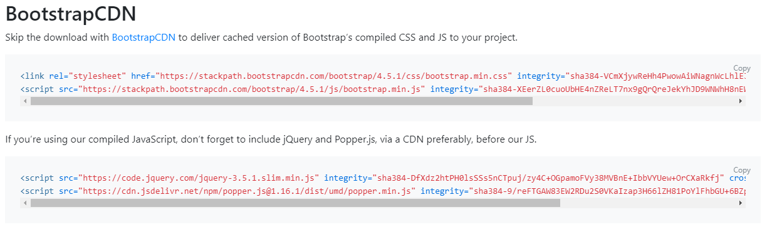This method uses CDN that loads the required scripts in runtime

## Building a page

* Create a new repo in git hub <https://github.com/rishiCSE17/bootstrap_pro1>
* Link it with pycharm
* Crate a new html file **index.html**

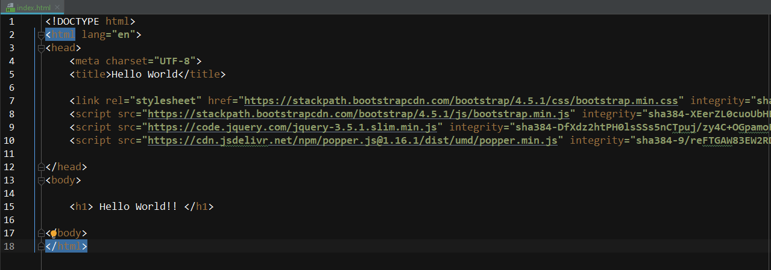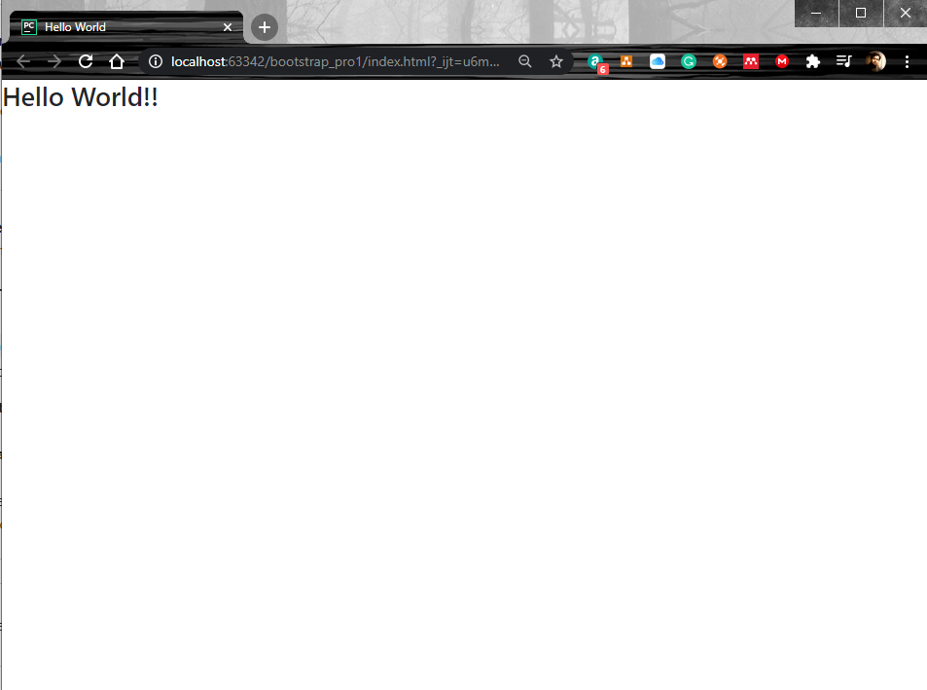

* There are two option in putting your contents. **Container** for fixed width, **container-fluid** for using entire with of the device

div class**="container"**>  
 Hello world !  
</div>

<body>  
 <div class**="container-fluid"**>  
 <h1>Hello world !</h1>  
 <p>this is where it all starts</p>  
 </div>  
</body>

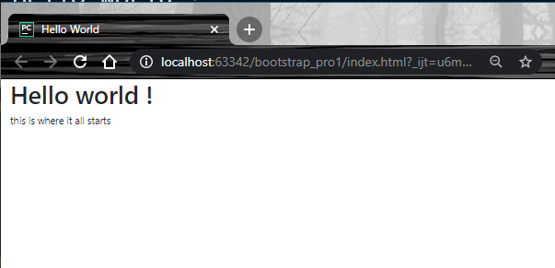

# Part 2: Grid layout

* A grid is a matrix layout with rows as columns.
* In bootstrap there can be at the most 12 columns
* There are 4 different classes in Bootstrap grid system based on your target device

1. **xs :** extra small for phones
2. **sm:** small for tablets
3. **md:** medium for desktops
4. **lg:** large for larger desktops