DBSE&DBS
Roll No: 25200300268
Name: Rishi Alapati
Query-1:
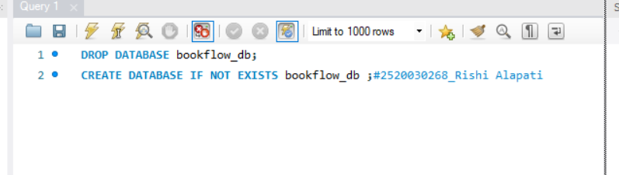
Query-2:
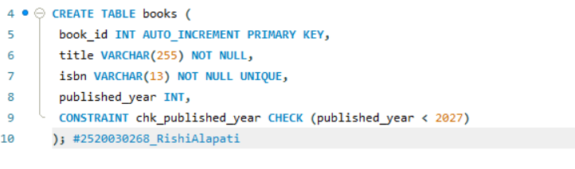
Query-3:
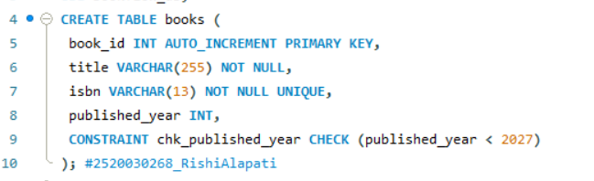
Query-4:
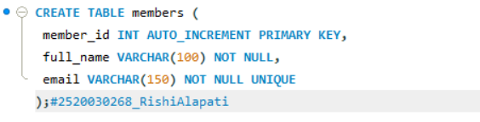
Query-5:
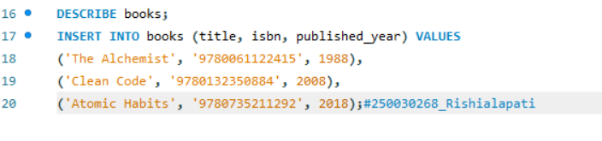
Books2:

Query-6:

Members3:

Query-7:
