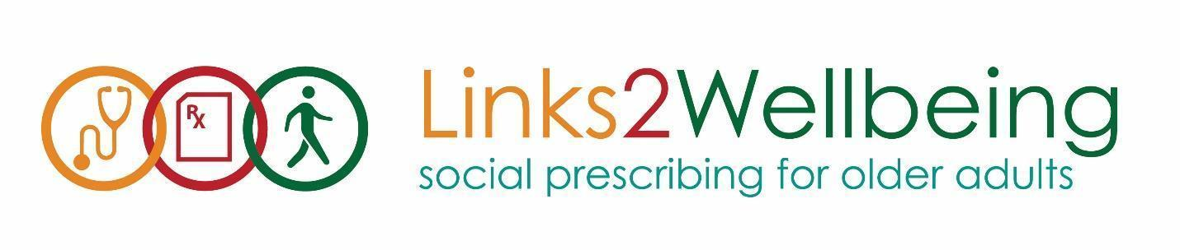
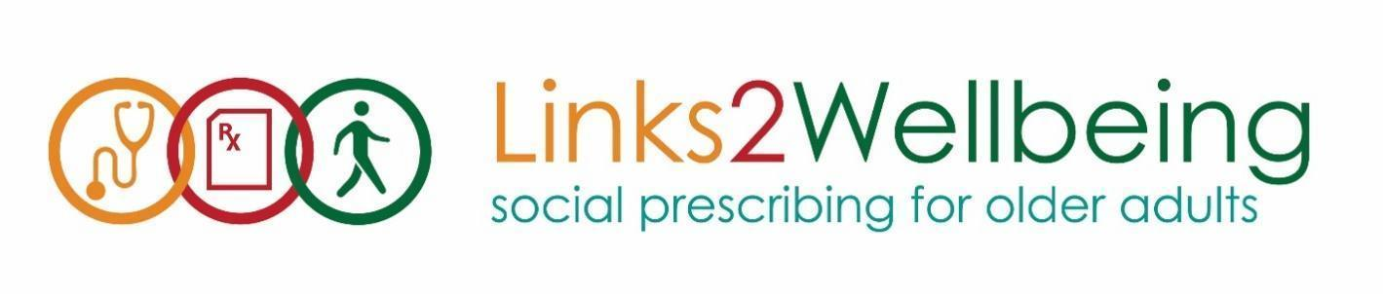
Verbal Client Consent
Client name: ______________________________
Client code: ______________________________

My name is [enter name], and I am a volunteer (or staff member) with the Links2Wellbeing: Social Prescribing for Older Adults Project at the [enter centre name]. Links2Wellbeing is a collaboration between healthcare providers and local seniors centres and aims to connect older adults to social activities and connections that will improve health and wellness through social connection. We are partnering with the OACAO to conduct an evaluation of the Links2Wellbeing program to see how participating at the centre impacts your health and wellbeing.

As we begin to talk about your program interests and what we offer at the centre, I have a few questions to help us get to know each other better. Answering these questions is totally voluntary, and you can skip any questions you do not want to answer. Any answers you do provide are confidential and will be kept in a secure location.

Throughout the year we report to our partner SALC and the OACAO on participation numbers, subsidy utilization and client feedback. All of this information is reported anonymously and combined with responses from other people across the province who participate in this project. Group results may be included in annual reports to the funder and partner organizations. No individual identifying information will be shared.

Your participation today will have no impact on your membership at [insert centre name] or your participation in our Links2Wellbeing program.

At this time may I confirm that I have your consent to share your anonymous participation information with our Links2Wellbeing partner SALC and the OACAO?

- Verbal Consent Confirmed
Date: ___________________
VLA or DCC Signature: ___________________________________________________

