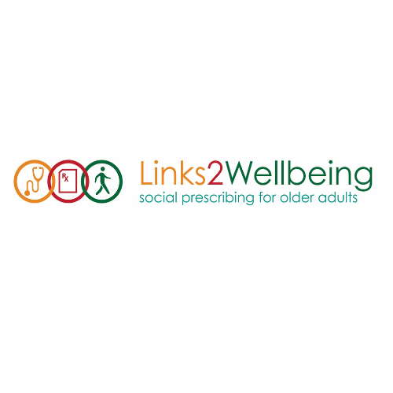
Client Referral Form
Date: __________________________
Client name: ______________________________________________
Client phone #: ________________________________________
Client email address (if applicable): _____________________________
Program interests/other notes: __________________________________________
_____________________________________________________________________
Please note that these social and recreational programs are not able to serve clients requiring clinical interventions or those individuals who are living with significant cognitive impairments.
Referring organization: ______________________________________
Select one:
CHC | FHT | Community Paramedic | Solo Physician | Nurse Practitioner  Led Clinic | Hospital | Pharmacist | Other
Referrer name: ____________________________________________
Referrer position: ______________________________
Direct phone #: ________________________________
E-mail: _______________________________________
Please fax or e-mail* this referral form to:
*Where fax or e-referral is unavailable, you are responsible for obtaining your client's consent to transmit their information via e-mail. By checking this box, you verify that the client consented to the use of e-mail to share the above information for the purposes of connecting them with programs at the referral partner(s) below.

Centre A Name
Centre A Fax
Centre A Phone number
Centre A E-mail

Centre B Name
Centre B Fax
Centre B Phone number
Centre B E-mail

Centre C Name
Centre C Fax
Centre C Phone number
Centre C E-mail


