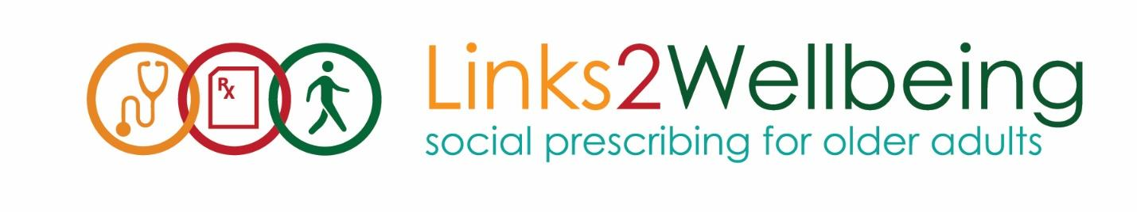
Links2Wellbeing HUB-Satellite Implementation Guidelines
The Links2Wellbeing HUB centre model is intended to support the participation of Seniors Active Living and Older Adult centres with smaller operating capacities. HUB centres manage the flow of funding and the administrative needs of the project, while Satellite centres welcome referred clients to their centre and ensure a smooth transition into program participation.
HUB Centre Role
- Conducts outreach in the local area to develop health care partnerships and referral relationships
- Connects with smaller local seniors organizations to develop Satellite participation, in coordination with the L2W team
- Conducts outreach in the local area to develop health care partnerships and referral relationships for your organization and satellite centres
- Accepts referrals for their own centre, completing full intake and surveys with clients as per the regular L2W Survey process (see main Tools and Resources document)
- Informs the OACAO when a new satellite centre is brought on board, share contact information in order for OACAO to share outreach materials and design Centre specific prescription pads
- Accepts referrals on behalf of Satellite centres, assigns client codes, and sends referral information to relevant Satellite within 1-2 business days for follow-up and intake
- Completes all reporting documentation for their own centre, including the Common Tracking Tool and Financial Report
- Holds funding in trust for Satellite centres, transferring money as needed
- Completes separate reporting documentation for Satellite centres in the form of a consolidated Common Tracking Tool and Financial report for all Satellite
- Develops communication plan and feedback loop between their centre and the satellites their HUB supports

Satellite Centre Role
- Assigns a main contact person to communicate with the HUB centre and to perform the primary outreach to referrals
- Accepts referrals through the HUB, following up with clients within 2-3 business days
- Contacts the referral for initial follow up. Invites for an initial meeting, centre visit or tour
  - Utilizes the modified client information form to guide intake and provides a welcoming and supportive environment for new referrals to engage in programs of interest
  - Shares calendar of events for your centre with the client
  - Completes membership if individual is ready to attend or try a program
  - Follows up with HUB centre re: referral outcomes
- Identifies volunteers who can support new referrals and participating members
- Keeps track of key data required by HUB for year-end reporting (i.e., # referrals that resulted in participation, # clients not interested, # clients that dropped out, # clients receiving subsidies) - refer to Satellite Centre report back sheet
- Meets regularly as determined with HUB centre to review referral outcomes, participation, and other needs
- Requests outreach materials or prescription pads through HUB centre
- Communicates opportunities for outreach or presentations with HUB centre
Funding
Satellite centres hold no funding of their own. HUB centres will hold funding in trust for Satellite centres. With approval from the L2W project team, the HUB and Satellite centres may determine the best method of transferring funds (e.g., monthly or quarterly billing cycle, one referral at a time, etc.).
L2Wellbeing will cover any costs associated with the client attending programs. This includes:
- Membership fees
- Transportation costs
- Program Costs (meals, bus trips, any program cost)
- Supplies for take home bags

