Objectives
Core objectives of this project:
- Use the dataset (images + metadata) and develop a highly accurate and fast computer vision model to verify if the items with their respective quantities are present in the image of the bin.
For example: You get an order for 3 items and their quantities as mentioned below.
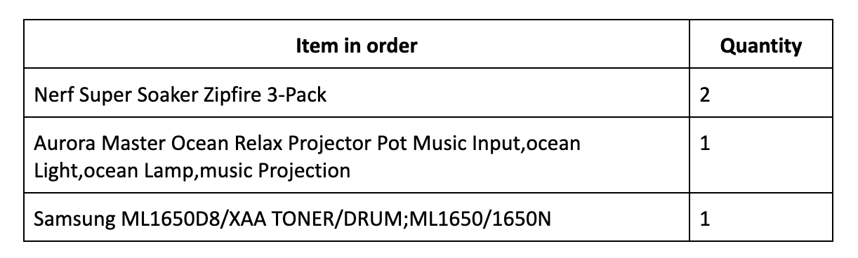
Now you get an image of the bin where items in the order are present. The objective for you is to validate if the items in the order are the ones that are present in the bin.

- Demonstrate creativity and innovative mindset while working on EDA, data preparation, model selection, application and evaluation, etc.

- Develop a simple UI using tools/frameworks of your choice for:
- Allowing the user to select an item and its quantity he/she wants to order.
- Selecting the most appropriate image from the dataset which corresponds to order and displaying in the UI.
- Using the CV model for inferencing and displaying the results of the model to validate if items and its respective quantity in order exists in the bin image.

- Create a comprehensive presentation and documentation that explains the understanding of objectives, methodology, architecture, decisions, milestones, model selection, hyperparameter tuning and evaluation performed, UI functionality and considerations for MLOps (model deployment, model monitoring and re-training).

Stretch objectives of the project (Optional):
- Inventory management: Use the dataset (images + metadata) and create a database to store item dimensions - height, length, width, weight, etc. and build functionality for inventory management.

Dataset for inventory availability, you can build your synthetic dataset using the items that are available in images in the dataset. For example, for the items available, you can assign initial availability as some random number between 20 to 100.

- Develop a user-friendly, highly responsive and intuitive UI and integrate it with camera, and inventory availability database for:
- Capturing the information from images taken of the bin in real-time by integrated camera and storing them in a database.
- Displaying real-time inventory availability dashboard.

- MLOps: Integrate MLOps frameworks to automate the monitoring of the model in real time, and deployment of model at regular intervals when data drifts are detected.
- Create a further more comprehensive documentation that explains the considerations for building a database, database schema, functionalities in UI, user manuals for UI, MLOps strategy, etc..
*Choose cost-effective options to meet the above objectives

Deliverables
Working prototype:
- Code for a fully functional and working prototype of a computer vision based system which performs item and quantity validation with high accuracy.
- The working prototype could be a web interface (HTML/react/streamlit/gradio/etc.), a mobile app, or a combination of both.
- Multi-user support (Optional): Allow multiple users to login and use the product at the same time.
Model and EDA notebooks artifacts:
- Saved model file for keras/tf models and state dictionaries for pytorch models.
- Step by step code and visualization which explains the EDA done and decisions taken before data preparation for modeling.
- Detailed step by step code and comments which explain selection of CV models, hyper parameter tuning done for various models, evaluation performed, etc.
- Annotated data (Optional): Annotated image data if annotation is done for applying object identification and localization models like YOLO, Faster-RCNN, etc.

Documentation:
- A comprehensive presentation and documentation that explains the understanding of objectives, methodology, architecture, decisions, milestones, model selection, hyperparameter tuning and evaluation performed, UI functionality and considerations for MLOps (model deployment, model monitoring and re-training).
- Stretch goal documentation (Optional): User manuals, FAQ and guides for explaining different functionalities of UI, MLOps, etc.

Cloud and GPU usage:
For downloading the dataset and training CNN models, you need:
- AWS account credentials to download dataset from S3 bucket,
- at least 2 T4 GPU instances,
- at least 30 GB RAM,
- EC2 M4 instance for deployment

Evaluation criteria

Primary Criteria
- Understanding of objectives
Demonstrate a clear and thorough understanding of the objectives and emphasizes on building an highly accurate, efficient and productionized CV based system for detecting if the item with its respective quantity is present in the bin image.

- Selection and application of CV models
Perform EDA and research on the CV models which are most suitable for this problem. Demonstrate a well-designed experimental plan to select and apply various CV models on the data.

- Evaluation of CV models
Select and use the classification/regression metrics judiciously. Justify the metric choices and ensure that they are insightful and align with the objectives and characteristics of the dataset and expected results.

- Innovation and creativity
Demonstrate highly innovative approaches and showcase creativity in integrating existing technologies and proposing an innovative solution, breaking away from traditional methods. Suggest thoughtful and highly feasible enhancements, considering the project's context.

- Presentation and Documentation
Clear and well-organized presentation of the project, including detailed documentation, code comments, and visual aids (charts, graphs) for understanding results. Comments and documentation should be comprehensive and crystal clear, facilitating easy understanding for the reader/user.

Secondary criteria
- UI/UX
Develop an intuitive, fast and easy to use interface which takes the inputs from the user and responds back with analysis/results and exceptions/errors which are easy for the user to understand.

- MLOps
Develop an efficient and automated deployment process with minimal downtime. The model monitoring should be comprehensive and should track the performance. Logging should be done for predictions, errors, and system behavior.

Similar business cases in other domains:
- E-commerce: Counterfeit and tamper detection of listings. Recommending similar products to customers.
- Medical/Healthcare: Validate if the medicines prescribed for patients are the ones that are being consumed.
- Manufacturing: Product inspection to identify quality issues in products during manufacturing.
- Surveillance and monitoring: Tracking changes in conditions of objects under surveillance.

Future considerations:
- When you train the models, they will only be trained on certain items. In the real world, a new item may get added, or the packaging could change for an existing item.
- If the camera is integrated in the system, then calibration is needed for the camera to know the distance from the bin, which would then help calculate the items' size in real-time. This must be done when this system is deployed in fulfillment centers, etc.

Weekly plan:
Week 1: Understanding the project objectives, and how to collect the data. Summarizing the understanding about CV techniques, and defining a project plan to achieve the objectives of upcoming weeks.
Week 2 & 3: Perform Exploratory data analysis(EDA) after downloading the dataset.
Week 4 & 5: Building various CV models, fine tuning and evaluating them.
Week 6: Deployment of models
Week 7: Performing end-to-end testing for the model, developing interactive and robust UI/UX.
Week 8: Preparing detailed project documentation with system architecture, model comparisons, end-to-end testing and UI/UX functionality details.

