**Password Generator**

User Guide

Landing Page – Default password length = 12

You will be presented with password options when you click – Generate Password

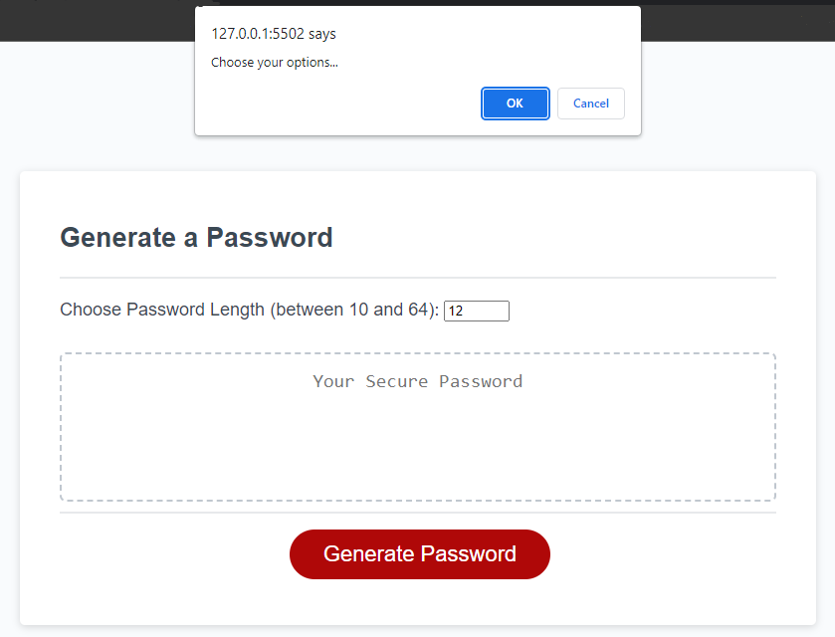

Result Page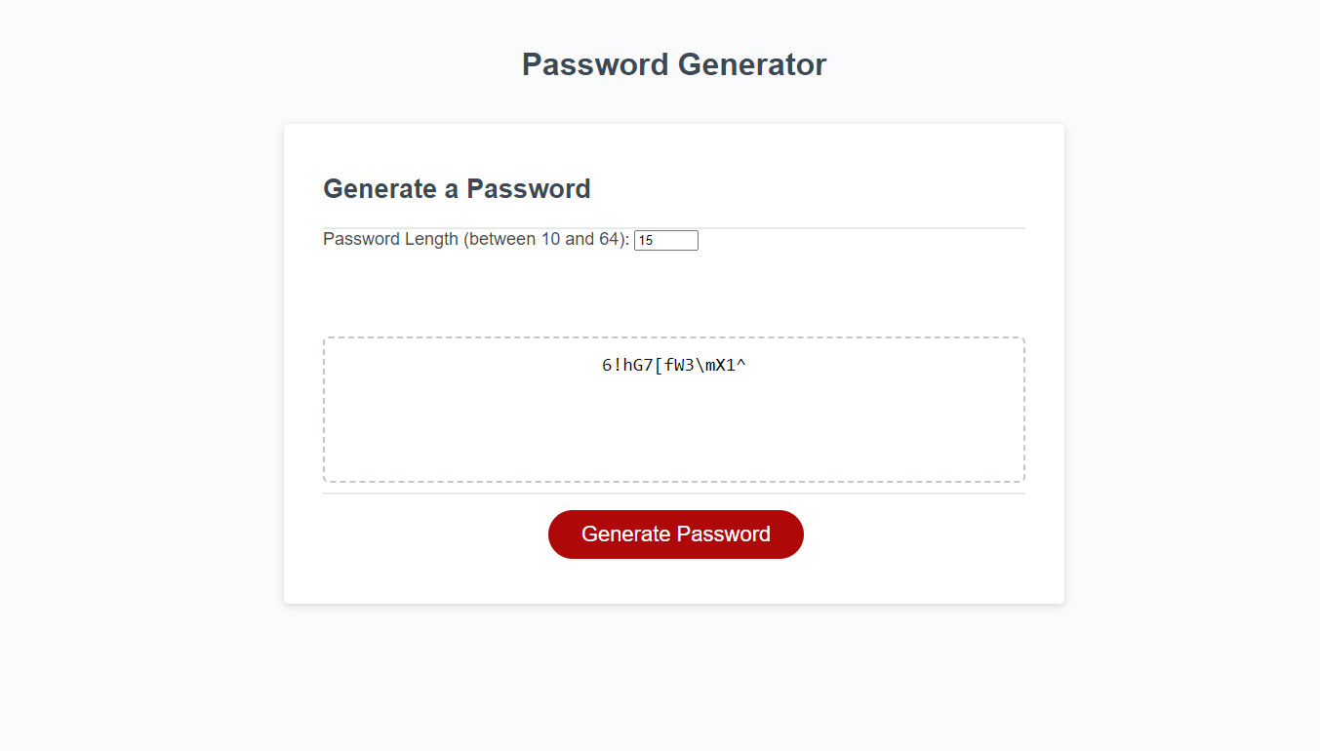

Error – In case you choose invalid password length

