Step by Step Registration Procedure for GREENCON 2025 Registration

Login to <https://vitchennaievents.com>

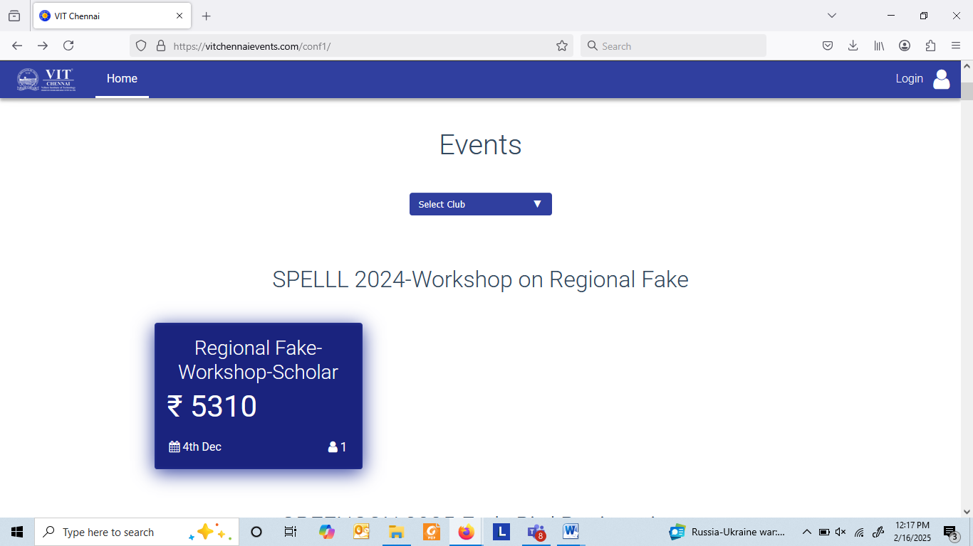

Click on ‘Login’ available on the right top corner, screen will appear as below.

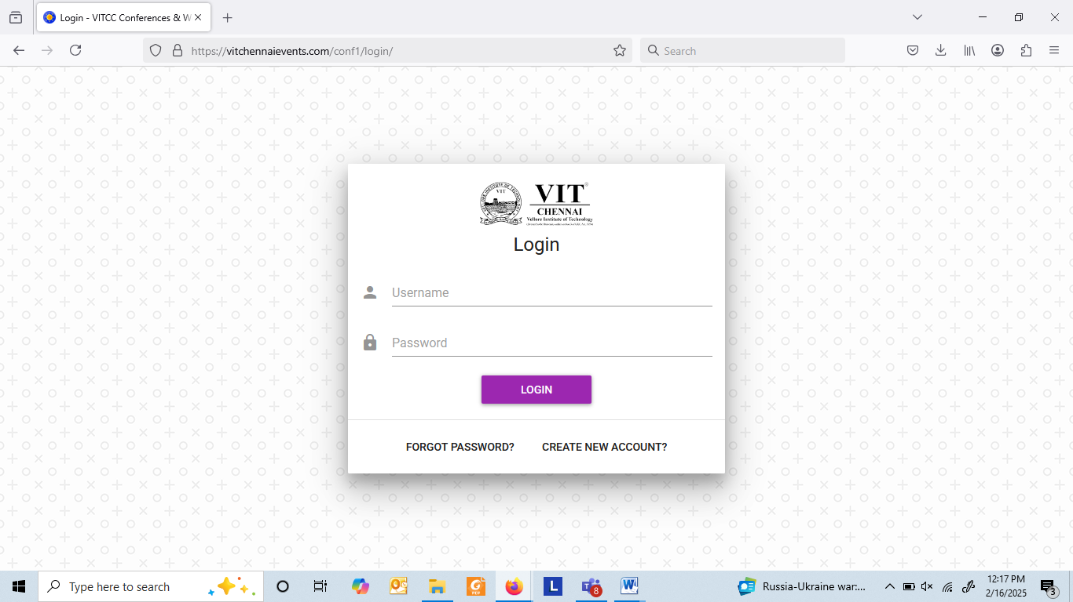

Click on ‘Create new account’ and register to the portal by providing the details as requested. 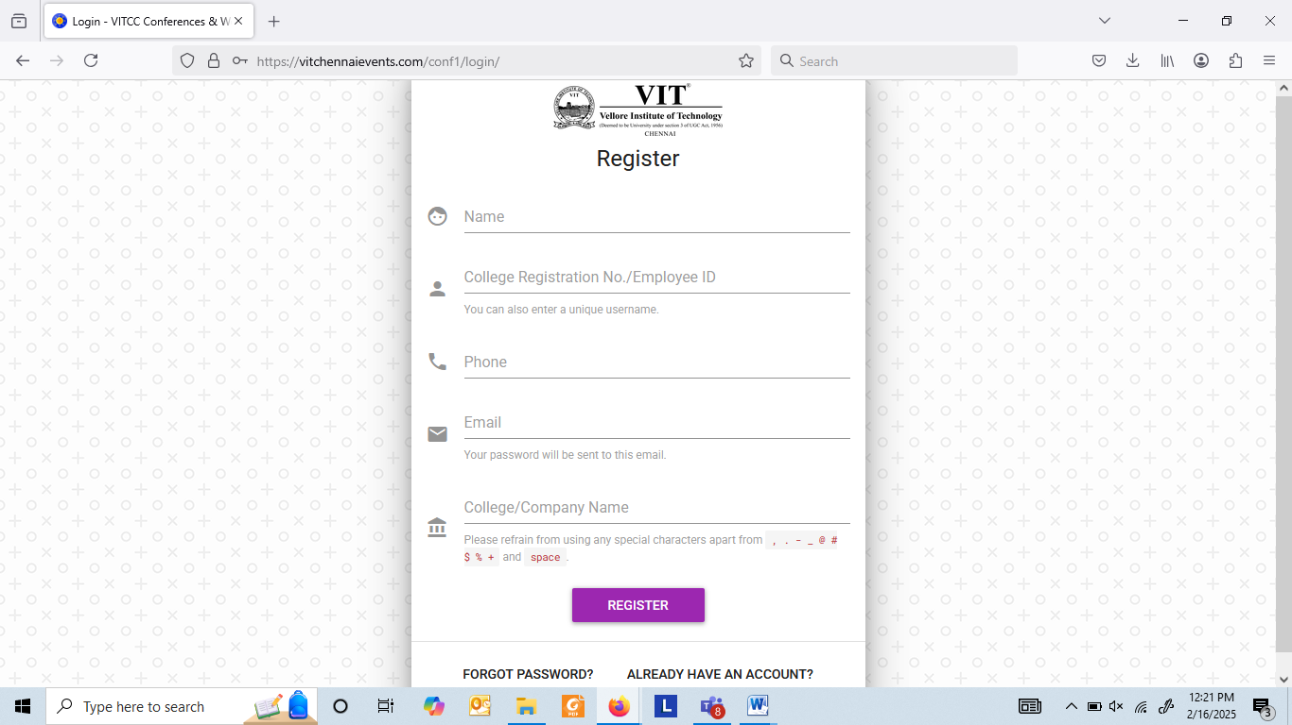

When successfully registered, a password will be sent to the mail ID used for registration.

Login to the portal using the registered username and the received password.

Search for ‘GREENCON 2025-EARLYBIRD REGISTRATION’,

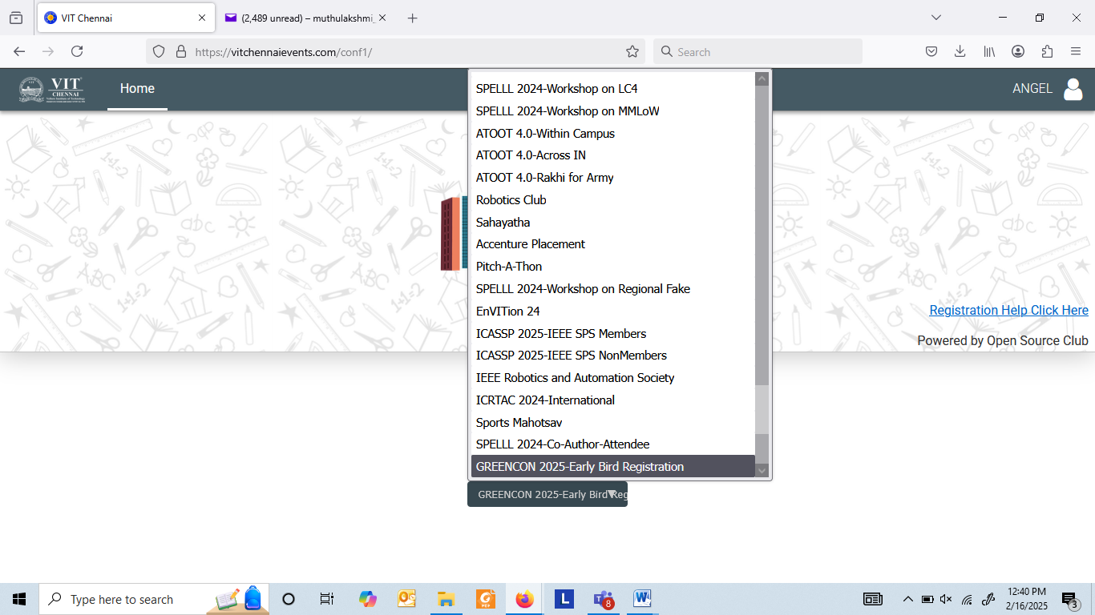

Select an appropriate category to register for the conference and proceed for payment as directed in the screen.

