WEEK 3 INTERNSHIP REPORT
Advanced Data Analysis and Visualization in Logistics
Food Delivery Time Analytics Project
Prepared by: Rishi Raj
Internship Track: Data Analytics
Week 3 Submission | September 2026

1. Objective
Week 3 focuses on exploratory data analysis (EDA), statistical summarization, relationship analysis, and visualization of the cleaned food-delivery dataset. The purpose is to identify patterns in delivery time and understand how distance, preparation time, traffic, weather, time of day, vehicle type, and courier experience relate to logistics performance.

2. Dataset Used
The analysis uses the cleaned dataset produced during Week 2. It contains 1,000 delivery records and the original nine project variables. The preprocessing stage retained all records, handled missing predictor values, and flagged delivery-time outliers. For Week 3, the original analytical columns are used to keep the interpretation directly connected to the source variables.

3. Descriptive Statistics
The average delivery time is 56.73 minutes and the median is 55.50 minutes. The 90th percentile is 86.00 minutes, providing an indication of the upper end of typical delivery duration. Average delivery distance is 10.06 km and average preparation time is 16.98 minutes.
Variable | Mean | Median | Std Dev | Min | Max
Distance_km | 10.06 | 10.19 | 5.70 | 0.59 | 19.99
Preparation_Time_min | 16.98 | 17.00 | 7.20 | 5.00 | 29.00
Courier_Experience_yrs | 4.59 | 5.00 | 2.87 | 0.00 | 9.00
Delivery_Time_min | 56.73 | 55.50 | 22.07 | 8.00 | 153.00

4. KPI View
KPI | Result | Interpretation
Average Delivery Time | 56.73 min | Overall baseline delivery duration.
Median Delivery Time | 55.50 min | Typical central delivery duration.
90th Percentile Delivery Time | 86.00 min | Upper-end duration for 90% of observations.
Average Distance | 10.06 km | Typical delivery distance.
Analytical On-Time Rate | 33.6% | Share at or below 45 minutes; 45 min is an analysis assumption, not a stated company SLA.

5. Correlation Analysis
The strongest absolute Pearson correlation among the four numerical variables is between Delivery_Time_min and Distance_km, with a coefficient of 0.781. Correlation describes association, not causation. The matrix is therefore used to guide further investigation rather than to claim that one variable directly causes changes in delivery time.
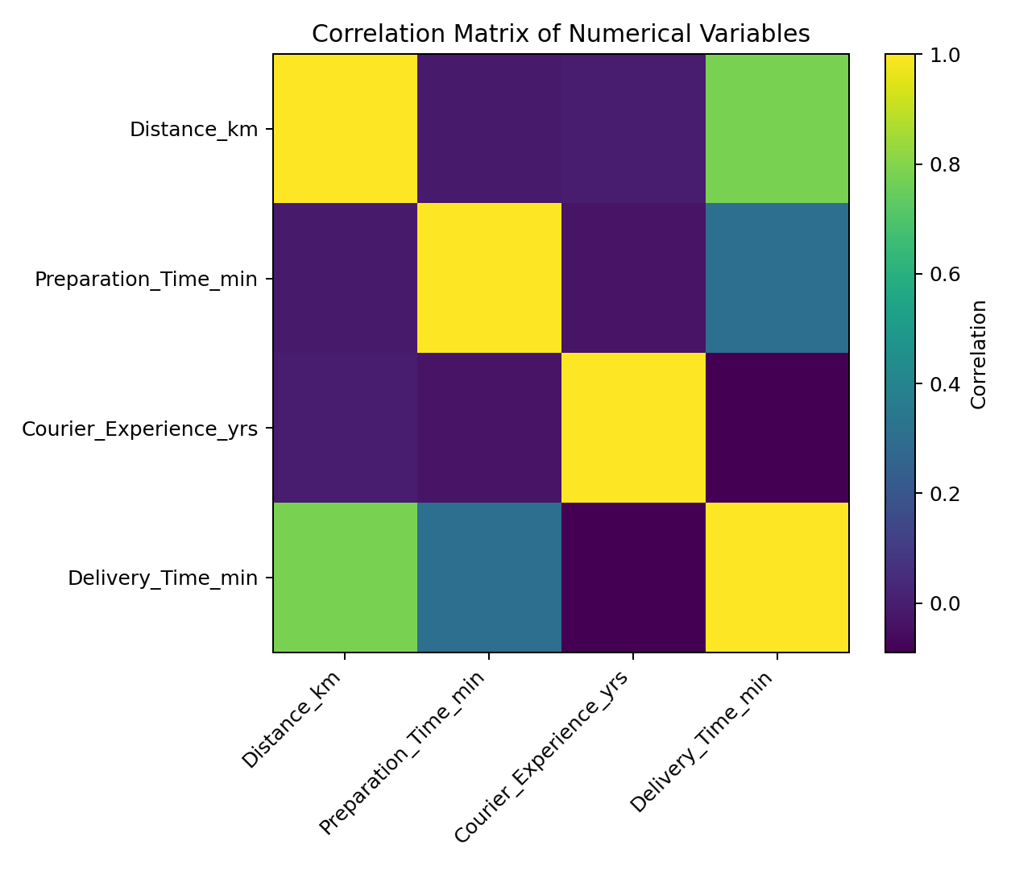
Figure 1. Correlation matrix of numerical variables.

6. Visualization and Findings

6.1 Delivery-Time Distribution
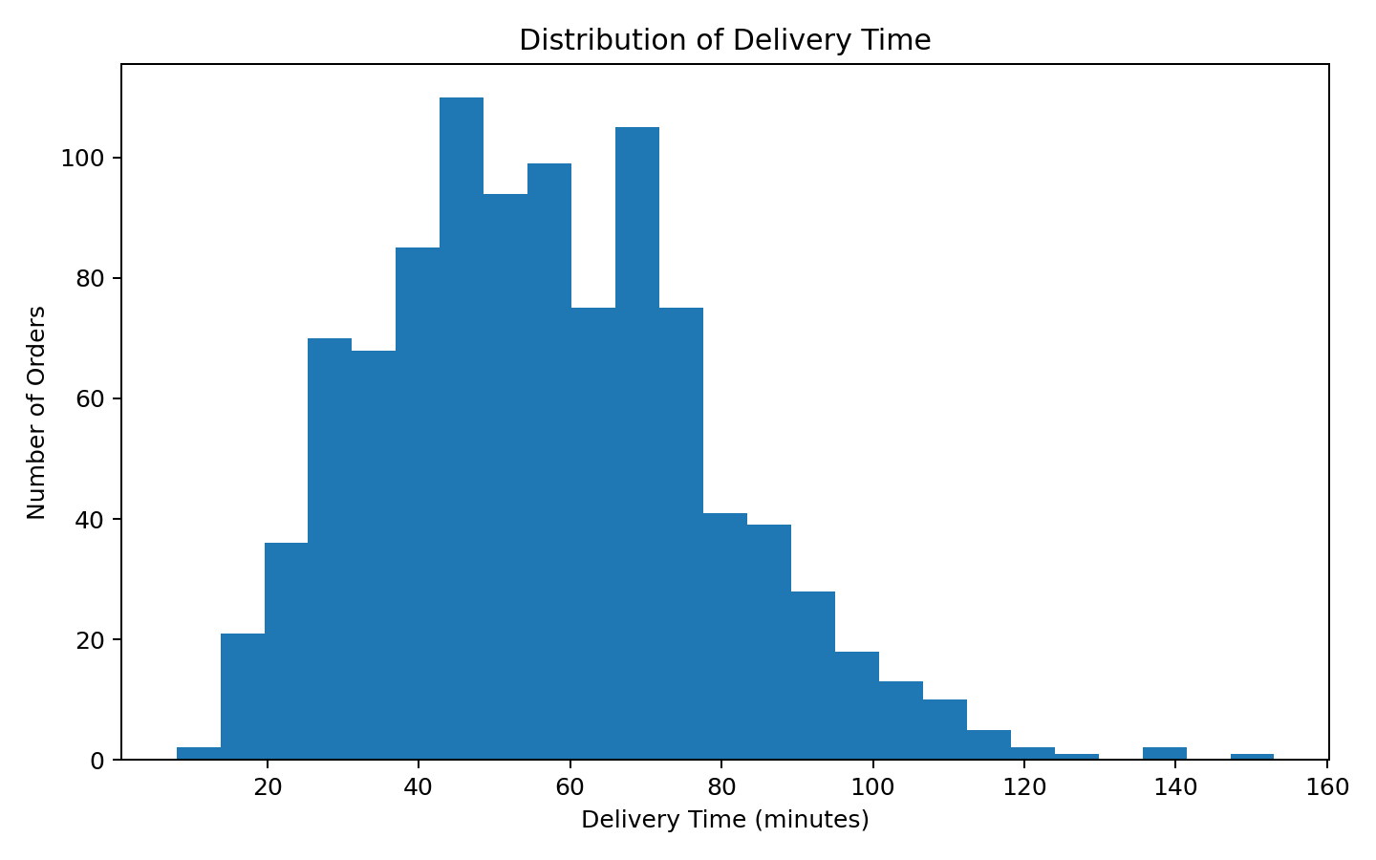
The distribution shows how delivery durations are spread across the dataset. The median of 55.50 minutes is below the mean of 56.73 minutes, indicating that the distribution is not perfectly symmetric and that longer deliveries influence the average.

6.2 Distance and Delivery Time
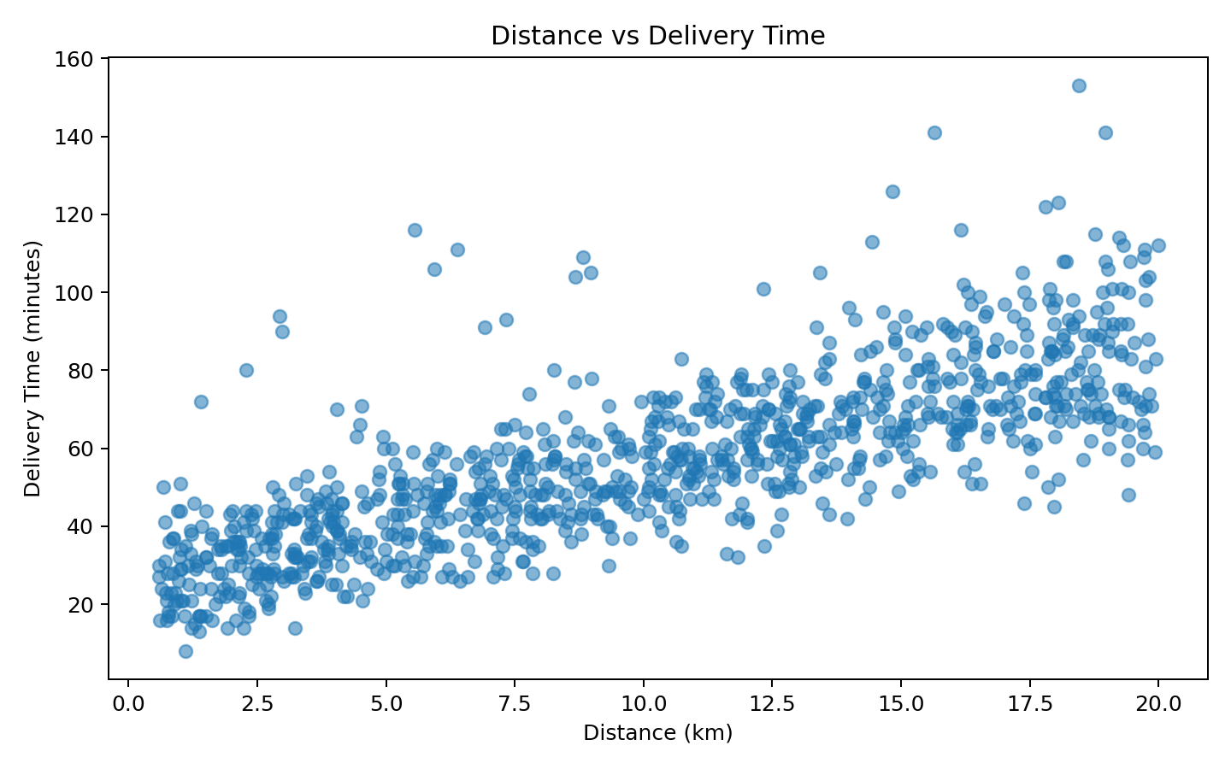
The distance-versus-delivery plot provides a direct view of whether longer trips tend to coincide with longer delivery durations. The Pearson correlation between distance and delivery time is 0.781. This relationship should be interpreted together with preparation time and traffic because delivery duration is influenced by multiple operational factors.

6.3 Traffic Level
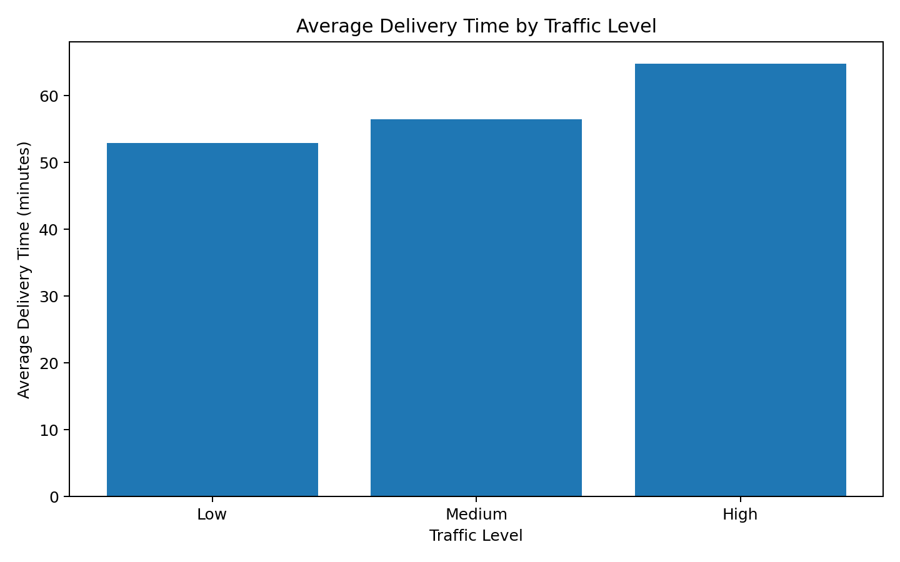
Average delivery times are compared across the observed traffic categories. This visualization is useful for identifying whether operational congestion conditions correspond with different delivery-time levels. The group means should be considered descriptive because the dataset does not establish causal traffic effects.

6.4 Weather
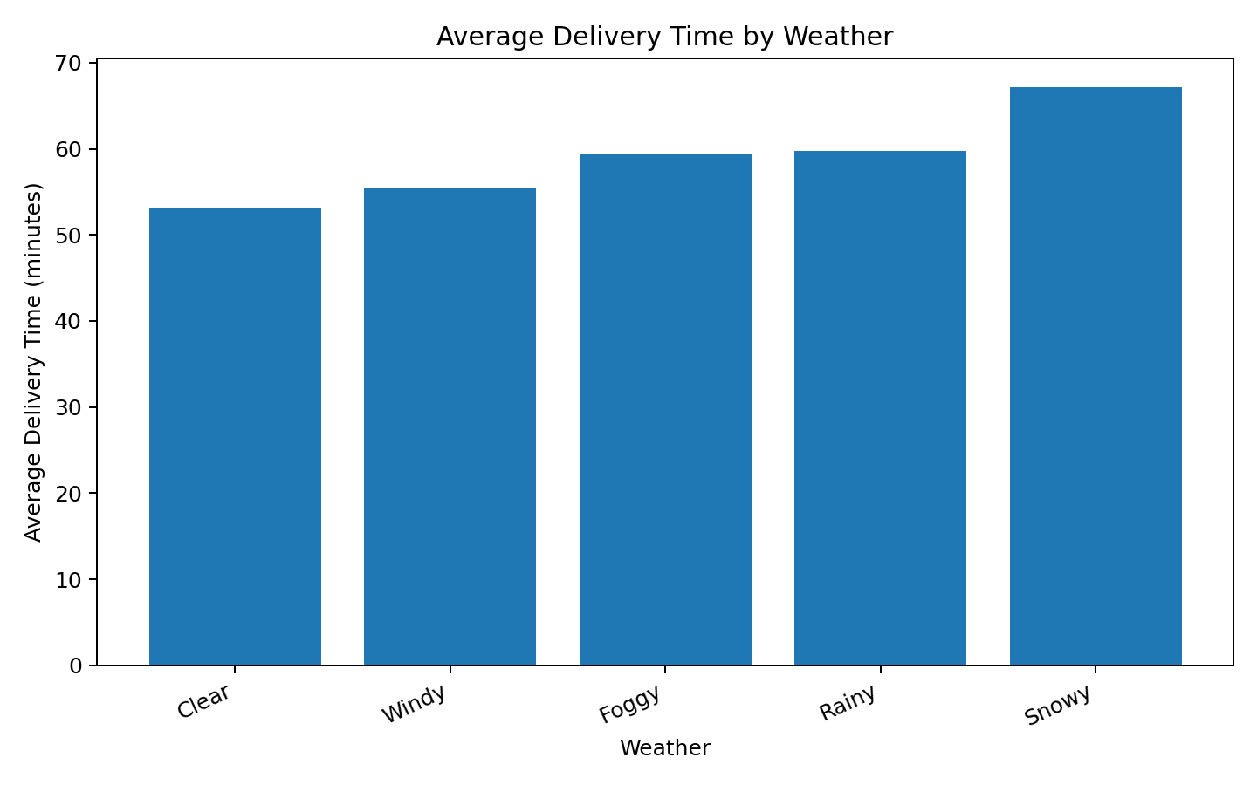
Weather categories are compared using average delivery time. This can reveal whether some observed weather conditions coincide with slower delivery performance and can guide deeper investigation in the predictive stage.

6.5 Time of Day
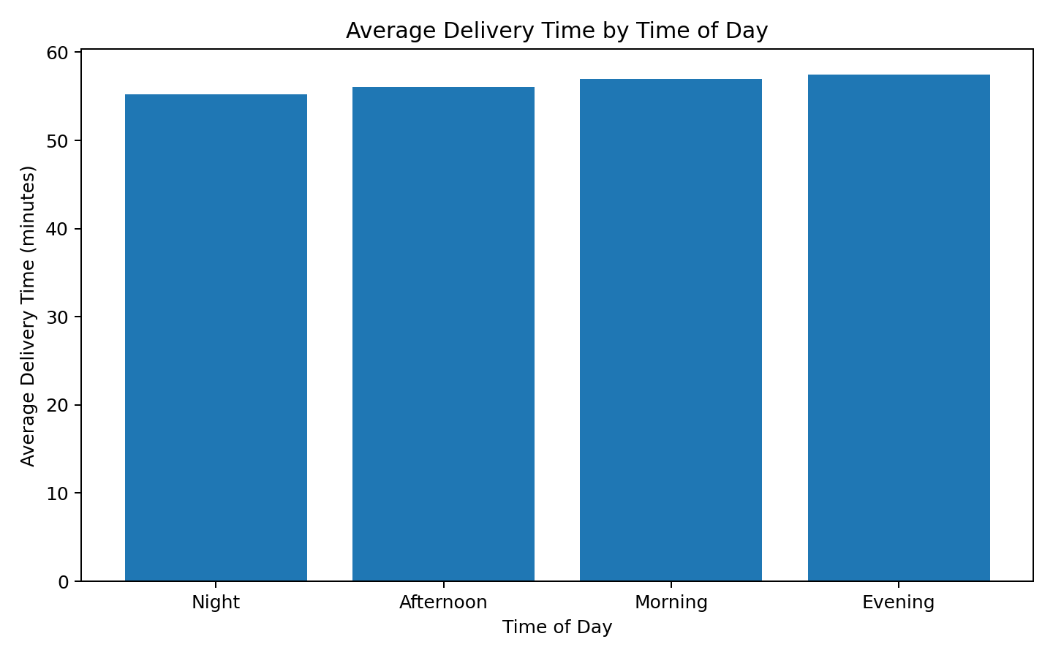
Time-of-day comparisons help identify operational periods with different average delivery durations. This can support later capacity planning if the pattern remains after controlling for other variables.

6.6 Vehicle Type
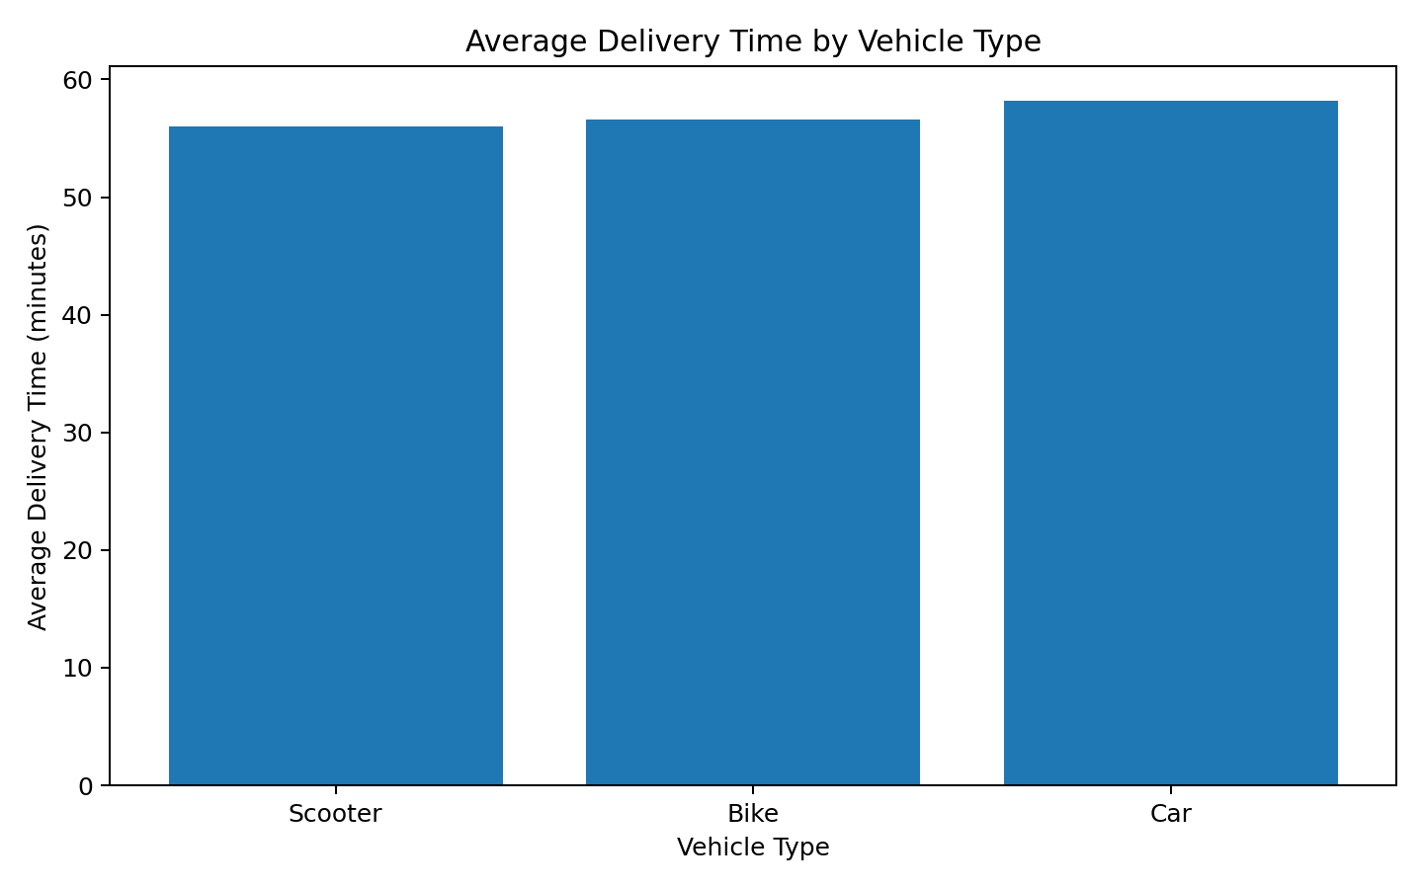
Vehicle categories are compared by mean delivery duration. Differences may reflect vehicle characteristics or differences in the types of deliveries assigned to each vehicle. Therefore, vehicle comparisons are descriptive and should not be interpreted as proof that one vehicle type causes faster or slower deliveries.

6.7 Preparation Time
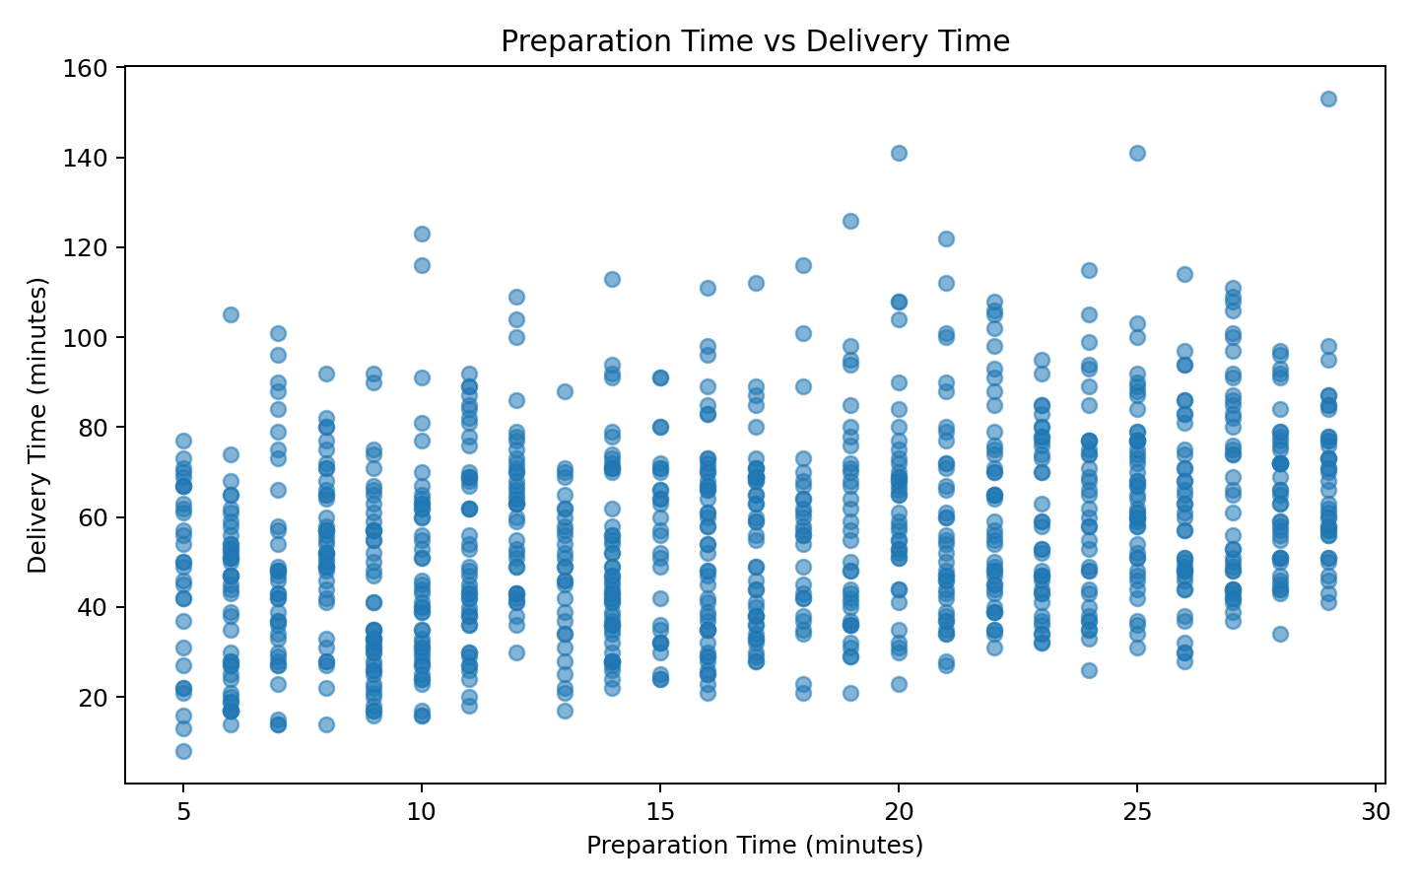
The preparation-time scatter plot evaluates another operational component of the delivery process. The correlation between preparation time and delivery time is 0.307. The relationship can help determine whether upstream preparation contributes materially to end-to-end delivery duration.

7. Group-Level Results

Traffic Level
Group | Count | Mean Delivery (min) | Median Delivery (min)
High | 197 | 64.81 | 65.00
Medium | 420 | 56.45 | 54.00
Low | 383 | 52.89 | 51.00

Weather
Group | Count | Mean Delivery (min) | Median Delivery (min)
Snowy | 97 | 67.11 | 66.00
Rainy | 204 | 59.79 | 57.50
Foggy | 103 | 59.47 | 59.00
Windy | 96 | 55.46 | 55.00
Clear | 500 | 53.15 | 52.00

Time of Day
Group | Count | Mean Delivery (min) | Median Delivery (min)
Evening | 293 | 57.48 | 56.00
Morning | 338 | 57.01 | 56.50
Afternoon | 284 | 56.08 | 56.00
Night | 85 | 55.21 | 52.00

Vehicle Type
Group | Count | Mean Delivery (min) | Median Delivery (min)
Car | 195 | 58.20 | 56.00
Bike | 503 | 56.57 | 56.00
Scooter | 302 | 56.05 | 54.50

8. Key Analytical Insights
- Delivery duration averages 56.73 minutes, while the median is 55.50 minutes, showing that the mean is influenced by the upper tail.
- The 90th percentile is 86.00 minutes, which provides a useful operational reference for understanding longer delivery runs.
- Distance and preparation time should both be considered when explaining delivery duration because they represent different parts of the delivery process.
- Traffic, weather, time of day, and vehicle type show different group-level delivery-time patterns; these differences are useful candidates for deeper modeling.
- The six IQR outliers identified in Week 2 remain available for investigation instead of being removed, preserving potentially meaningful difficult-delivery cases.
- Correlation results identify statistical associations but do not establish causality; a multivariable predictive model is required for a stronger assessment.

9. Business/Logistics Interpretation
The EDA provides a bridge between raw records and operational decision-making. If longer distances and higher preparation times are associated with longer delivery durations, the company could consider using these variables when setting delivery expectations. If particular traffic, weather, or time-of-day groups show elevated average durations, planners could investigate whether additional capacity or adjusted delivery windows are appropriate. Vehicle-level differences can also be examined together with workload and distance before making allocation decisions.
These recommendations are deliberately conditional. The EDA identifies patterns in the supplied dataset; it does not by itself prove that changing a logistics policy will improve performance. Week 4 predictive modeling will test whether the observed variables can produce useful delivery-time predictions.

10. Python Visualization Code
The following code illustrates the core EDA workflow used to generate the analysis.
import pandas as pd
import matplotlib.pyplot as plt
df = pd.read_csv("Food_Delivery_Times_Cleaned_Week2.csv")
# Descriptive statistics
print(df.describe())
# Correlation
numeric = [
"Distance_km", "Preparation_Time_min",
"Courier_Experience_yrs", "Delivery_Time_min"
]
print(df[numeric].corr())
# Distribution
plt.hist(df["Delivery_Time_min"], bins=25)
plt.xlabel("Delivery Time (minutes)")
plt.ylabel("Number of Orders")
plt.title("Distribution of Delivery Time")
plt.show()
# Relationship
plt.scatter(df["Distance_km"], df["Delivery_Time_min"])
plt.xlabel("Distance (km)")
plt.ylabel("Delivery Time (minutes)")
plt.title("Distance vs Delivery Time")
plt.show()
# Group comparison
df.groupby("Traffic_Level")["Delivery_Time_min"].mean().plot(kind="bar")
plt.ylabel("Average Delivery Time (minutes)")
plt.title("Average Delivery Time by Traffic Level")
plt.show()

11. Conclusion
Week 3 transformed the cleaned logistics dataset into interpretable statistical and visual evidence. The analysis examined delivery-time distributions, numerical relationships, traffic, weather, time of day, vehicle type, and preparation time. The results provide a structured understanding of where delivery-time variation occurs and which variables should be considered in the predictive modeling stage.
The next stage will use these findings to construct and evaluate predictive models for delivery time. Model performance will be assessed with appropriate regression metrics such as MAE, RMSE, and R², and the results will be translated into practical logistics optimization recommendations.

12. Submission Description (250 Words)
This Week 3 report presents the exploratory data analysis and visualization stage of the logistics data analytics project. The analysis uses the cleaned Food_Delivery_Times dataset prepared during Week 2 and examines 1,000 food-delivery records. The objective is to understand delivery-time behavior and identify relationships between delivery performance and operational variables such as distance, preparation time, traffic level, weather, time of day, vehicle type, and courier experience.
The report begins with descriptive statistics to establish baseline values for the main numerical variables. Average, median, standard deviation, minimum, maximum, and percentile-based measures are used to understand the distribution of delivery times and other important features. Correlation analysis is also performed to identify statistical relationships among numerical variables. The report clearly distinguishes correlation from causation so that the findings are not overstated.
Several visualizations are included to communicate the results effectively. These include a delivery-time distribution, distance versus delivery-time scatter plot, traffic-level comparison, weather comparison, time-of-day comparison, vehicle-type comparison, preparation-time relationship, and a numerical correlation matrix. Group-level summaries are also calculated to compare average and median delivery times across important operational categories.
The analysis provides practical logistics insights that can guide the next phase of the project. Patterns identified across distance, preparation time, traffic, weather, timing, and vehicle categories can be used as candidate predictors for delivery-time forecasting. The findings also help identify potential operational conditions that may require additional planning attention. Overall, Week 3 converts the cleaned dataset into meaningful evidence and establishes the analytical foundation for Week 4 predictive modeling and optimization.

