WEEK 4 INTERNSHIP REPORT
Predictive Modeling and Optimization in Logistics Systems
Food Delivery Time Analytics Project
Prepared by: Rishi Raj
Internship Track: Data Analytics
Week 4 Submission | September 2026

1. Objective
Week 4 converts the findings from Weeks 2 and 3 into a predictive logistics model. The goal is to estimate delivery duration from operational and environmental variables and evaluate whether the resulting predictions are accurate enough to support planning. A second objective is to translate model findings into practical resource-allocation and operational strategies.

2. Prediction Problem
The target variable is Delivery_Time_min. The predictor set contains Distance_km, Weather, Traffic_Level, Time_of_Day, Vehicle_Type, Preparation_Time_min, and Courier_Experience_yrs. The model therefore estimates delivery duration using information that can reasonably be available before or during the delivery process.

3. Data Preparation and Validation Design
The cleaned Week 2 dataset contains 1,000 records. An 80/20 train-test split with random_state=42 was used, creating 800 training records and 200 test records. Numerical variables were median-imputed and standardized inside the modeling pipeline, while categorical variables were most-frequent imputed and one-hot encoded. Putting preprocessing inside the pipeline prevents information from the test set from being used during training.
Five-fold cross-validation was additionally performed on the full dataset for model comparison. The cross-validation results provide a more stable view of generalization than relying on one test split alone.

4. Model Selection
Four regression approaches were evaluated: Linear Regression as an interpretable baseline, Ridge Regression as a regularized linear alternative, Random Forest as a nonlinear ensemble model, and Gradient Boosting as another nonlinear ensemble approach. The models were selected to provide a progression from simple and interpretable to more flexible nonlinear methods.

5. Test-Set Performance
Model | MAE (min) | RMSE (min) | R²
Linear Regression | 5.90 | 8.83 | 0.826
Ridge Regression | 5.90 | 8.83 | 0.826
Gradient Boosting | 6.37 | 9.20 | 0.811
Random Forest | 7.50 | 10.05 | 0.774
On the held-out test set, Linear Regression produced the lowest RMSE among the evaluated models (8.83 minutes). Its MAE was 5.90 minutes and R² was 0.826. The model comparison is reported rather than assuming a model choice in advance.

6. Five-Fold Cross-Validation
Model | CV MAE | CV RMSE | CV R²
Ridge Regression | 6.55 | 10.48 | 0.773
Linear Regression | 6.55 | 10.48 | 0.773
Gradient Boosting | 7.15 | 11.02 | 0.749
Random Forest | 8.18 | 11.81 | 0.712
The five-fold results provide an additional validation check. Ridge Regression has the lowest mean cross-validation RMSE at 10.48 minutes. Cross-validation performance is used alongside, rather than as a replacement for, the held-out test result.

7. Prediction Performance
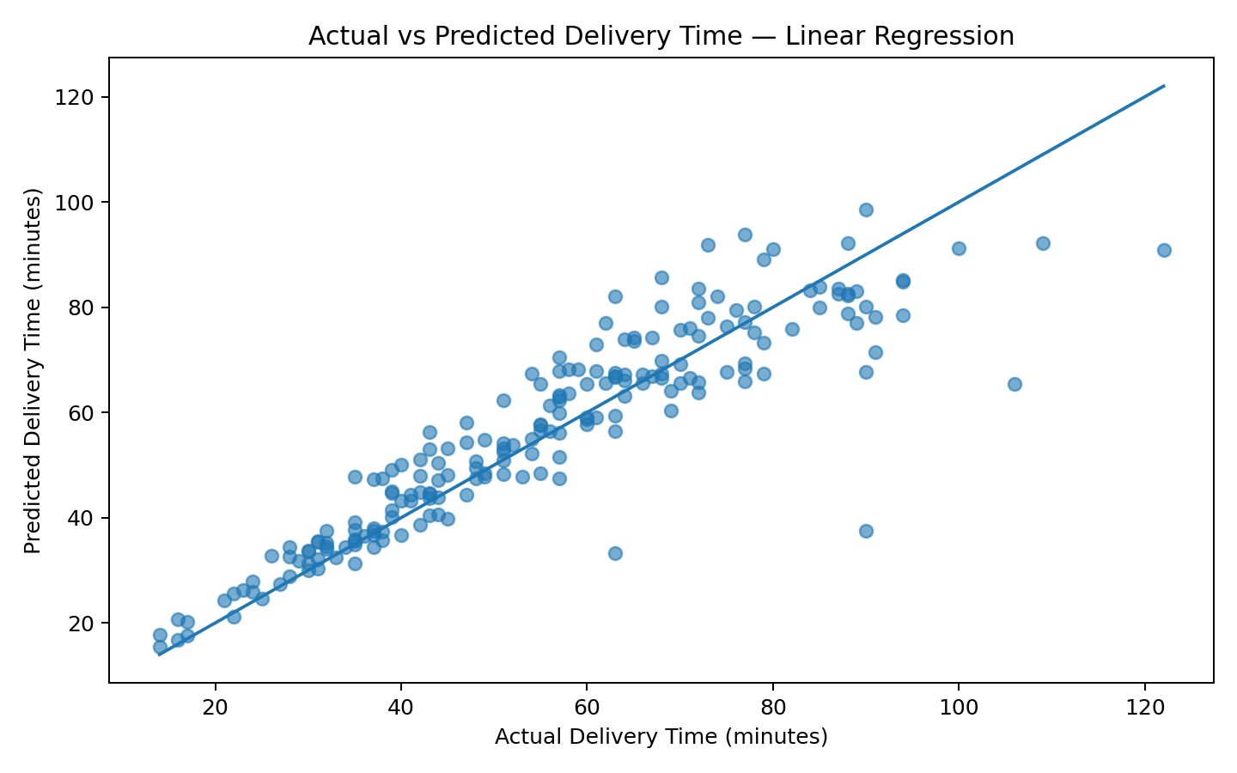
The selected test-set model has a mean absolute error of 5.90 minutes. 57.0% of test predictions are within ±5 minutes of the actual delivery time, and 83.0% are within ±10 minutes. These measures provide an intuitive view of practical prediction accuracy.

8. Feature Contribution Analysis
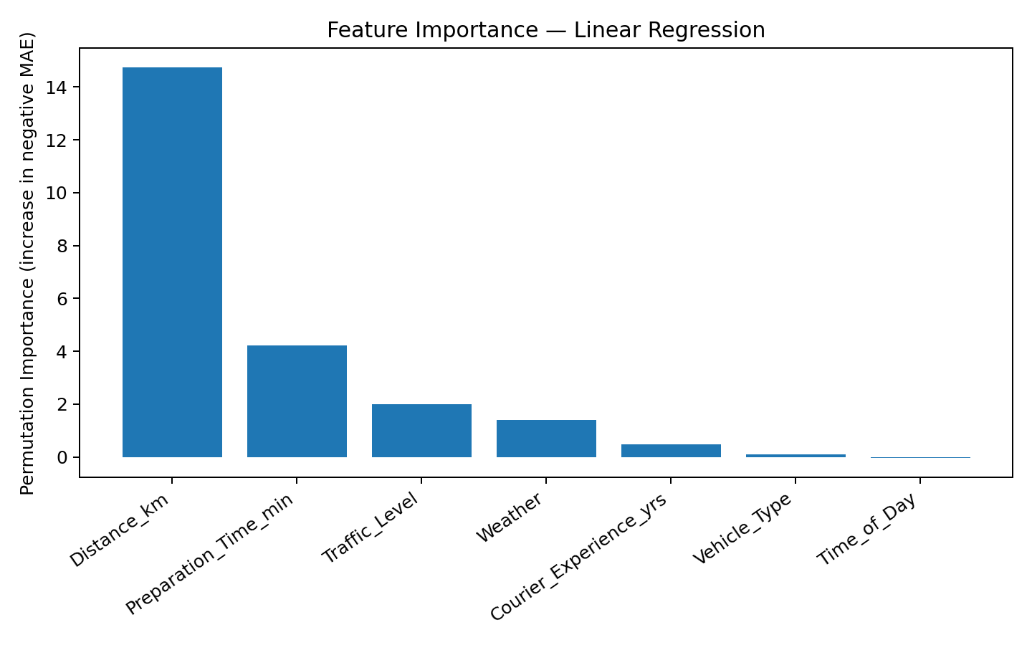
Permutation importance was calculated on the held-out test set for the selected model. A larger positive importance indicates that shuffling the feature reduced predictive performance more strongly. This analysis helps identify which available variables are most useful for prediction, but it should not be interpreted as proof of causation.
Top features by permutation importance:
- Distance_km: 14.7294
- Preparation_Time_min: 4.2320
- Traffic_Level: 1.9905
- Weather: 1.3916
- Courier_Experience_yrs: 0.4873

9. Optimization Strategies
The model itself predicts delivery time; it does not automatically optimize a fleet or route network. Therefore, the following recommendations are proposed as decision-support strategies based on the observed predictive variables and Week 3 EDA.
- Dynamic delivery-time estimates: use predicted duration to provide more realistic delivery windows and identify orders likely to require additional time.
- Workload-aware allocation: combine predicted delivery duration with distance and preparation time when assigning delivery capacity.
- Traffic-aware planning: use traffic category as an input to identify periods where additional planning buffer may be appropriate.
- Preparation-time coordination: prioritize coordination between food preparation and courier dispatch when preparation time contributes materially to predicted duration.
- Exception management: route unusually high predicted-duration orders for additional review instead of treating every order with the same service expectation.
- Capacity planning: aggregate predictions by operational period to estimate expected workload and support staffing or vehicle allocation decisions.

10. Optimization Framework for Future Deployment
A production optimization layer could minimize a weighted objective such as delivery delay and operating cost subject to vehicle capacity, service-window, staffing, and geographic constraints. The current internship project does not claim to have solved a vehicle-routing optimization problem because the dataset does not provide a complete route network, depot structure, vehicle capacity, or real-time traffic network. The recommendations above therefore represent a feasible next step rather than a completed routing solver.

11. Python Implementation
import pandas as pd
from sklearn.model_selection import train_test_split
from sklearn.compose import ColumnTransformer
from sklearn.pipeline import Pipeline
from sklearn.preprocessing import OneHotEncoder, StandardScaler
from sklearn.impute import SimpleImputer
from sklearn.ensemble import RandomForestRegressor
from sklearn.metrics import mean_absolute_error, mean_squared_error, r2_score
import numpy as np
df = pd.read_csv("Food_Delivery_Times_Cleaned_Week2.csv")
features = [
"Distance_km", "Weather", "Traffic_Level",
"Time_of_Day", "Vehicle_Type",
"Preparation_Time_min", "Courier_Experience_yrs"
]
target = "Delivery_Time_min"
X = df[features]
y = df[target]
numeric = [
"Distance_km", "Preparation_Time_min",
"Courier_Experience_yrs"
]
categorical = [
"Weather", "Traffic_Level",
"Time_of_Day", "Vehicle_Type"
]
preprocess = ColumnTransformer([
("num", Pipeline([
("imputer", SimpleImputer(strategy="median")),
("scaler", StandardScaler())
]), numeric),
("cat", Pipeline([
("imputer", SimpleImputer(strategy="most_frequent")),
("onehot", OneHotEncoder(handle_unknown="ignore"))
]), categorical)
])
model = RandomForestRegressor(
n_estimators=300,
max_features="sqrt",
min_samples_leaf=2,
random_state=42,
n_jobs=-1
)
pipeline = Pipeline([
("preprocess", preprocess),
("model", model)
])
X_train, X_test, y_train, y_test = train_test_split(
X, y, test_size=0.20, random_state=42
)
pipeline.fit(X_train, y_train)
pred = pipeline.predict(X_test)
mae = mean_absolute_error(y_test, pred)
rmse = np.sqrt(mean_squared_error(y_test, pred))
r2 = r2_score(y_test, pred)
print("MAE:", mae)
print("RMSE:", rmse)
print("R2:", r2)

12. Limitations
- The dataset represents food deliveries and may not capture every condition in a larger logistics network.
- Real-time traffic, route geometry, depot location, vehicle capacity, fuel cost, and driver scheduling constraints are not available in the supplied variables.
- Random train-test splitting is appropriate for this project, but a time-based split could be preferable for deployment when future prediction is the objective.
- Feature importance indicates predictive usefulness, not causal impact.
- Optimization recommendations require operational constraints and cost information before they can be implemented as a mathematical optimization model.

13. Conclusion
Week 4 completes the analytical pipeline by moving from descriptive insights to predictive modeling. Multiple regression approaches were compared using a held-out test set and five-fold cross-validation. The best test-set model by RMSE was Linear Regression, with an RMSE of 8.83 minutes, MAE of 5.90 minutes, and R² of 0.826. The results demonstrate that the available operational variables can be used to estimate delivery duration and support data-driven logistics planning.
The project also translates prediction into operational decision support through delivery-window estimation, workload-aware allocation, traffic-aware planning, exception management, and capacity planning. A complete vehicle-routing optimization system would require additional operational data and constraints, so it is identified as a future extension rather than claimed as a completed component.

14. Submission Description (250 Words)
This Week 4 report presents the predictive modeling and optimization stage of the logistics data analytics project. The objective is to forecast delivery time using operational and environmental variables from the Food_Delivery_Times dataset and evaluate how predictive insights can support logistics decision-making. The analysis uses the cleaned dataset developed in Week 2 and the findings identified through exploratory analysis in Week 3.
Delivery_Time_min is used as the target variable, while distance, weather, traffic level, time of day, vehicle type, preparation time, and courier experience are used as predictors. Four regression approaches were evaluated: Linear Regression, Ridge Regression, Random Forest, and Gradient Boosting. The data was divided into training and test sets using an 80/20 split, while five-fold cross-validation was used as an additional validation method. Model performance was assessed using Mean Absolute Error (MAE), Root Mean Squared Error (RMSE), and R-squared (R²).
On the held-out test set, Linear Regression achieved the lowest RMSE among the evaluated models, with an RMSE of 8.83 minutes, MAE of 5.90 minutes, and R² of 0.826. Feature contribution analysis was also performed using permutation importance to identify variables that were most useful for prediction.
The report then proposes practical optimization strategies including dynamic delivery-time estimates, workload-aware allocation, traffic-aware planning, preparation-time coordination, exception management, and capacity planning. These are presented as decision-support recommendations rather than as a completed vehicle-routing optimization system because the available dataset does not contain all required routing and operational constraints. Overall, Week 4 completes the internship's analytical workflow from data preparation and EDA through predictive modeling and logistics optimization planning.

