THE MAHARAJA SAYAJIRAO UNIVERSITY OF BARODA, VADODARA
FACULTY OF SCIENCE • DEPARTMENT OF COMPUTER APPLICATIONS
Bachelor of Computer Applications (B.C.A.) • Semester I (Division A)

OBESITY & LIFESTYLE:
EXPLORATORY DATA ANALYSIS & BEHAVIORAL INTERACTIONS
A Comprehensive Empirical Investigation of Hidden Variables, Behavioral Paradoxes, and Metabolic-Demographic Risk Catalysts
Course & Subject | Statistical Computing & Exploratory Data Analysis
Project Group | Group 5 (Division A)
Student Roll Numbers | 36, 22, 93, 24, 25, 108, 113, 102
Benchmark Dataset | UCI Machine Learning Repository: Obesity & Lifestyle
Official Project Repository | https://github.com/rishigig/project-eda-1.git
Submission Deadline | October 5, 2026
Academic Year 2026–2027 • The Maharaja Sayajirao University of Baroda

Executive Summary
Obesity represents a global chronic public health crisis driven by complex, non-linear interactions across genetic predisposition, dietary habits, physical mobility, and urban transportation infrastructure. Traditional epidemiological models frequently reduce weight status to a naive arithmetic balance of caloric intake versus expenditure. This comprehensive Exploratory Data Analysis (EDA) investigates an empirical cohort of 515 individuals sourced from the UCI Machine Learning Repository to dissect the underlying behavioral and physiological dynamics of obesity.
Through rigorous parametric hypothesis testing (One-way ANOVA: F = 11.9815, p = 1.33 × 10⁻¹²), contingency analysis (Chi-Square: χ² = 25.29, p = 0.0003, Cramér's V = 0.222), and non-parametric rank correlations (Spearman rs), this study exposes critical behavioral paradoxes and hidden confounding effects. Key discoveries demonstrate that: (1) Family history acts as an essential genetic gatekeeper, concentrating 86.9% of severe obesity cases and buffering individuals without genetic risk against high-calorie diets; (2) Meal skipping induces a pronounced metabolic and compensatory paradox, where eating only one main meal daily yields a 50.4% overweight rate compared to just 18.8% for four meals daily; and (3) Commute mode functions as the primary environmental accelerator of age-related weight gain, with automobile commuters over age 30 experiencing a 75.6% obesity rate versus 38.5% for public transit commuters of the same age. These empirical insights provide critical feature engineering directions for subsequent machine learning classification systems.
Analytical Roadmap and Document Structure
This academic report is systematically structured into 16 interconnected sections designed to guide the reader through the full data science lifecycle:
• Sections 1–4: Research Foundations, Objectives, Dataset Taxonomy, Feature Dictionary, and Computational Stack.
• Sections 5–7: Data Quality Hygiene, Synthetic Balancing Audit, Descriptive Statistics, and Univariate Target Profiling.
• Sections 8–10: Bivariate Hypothesis Testing (ANOVA, Chi-Square), Group Stratification, and Correlation Analysis.
• Sections 11–13: Multi-Factor Interaction Modeling, In-Depth Paradox Exploration, and Machine Learning Roadmap.
• Sections 14–16: Academic References, Project Outro & GitHub Reproducibility, and Group 5 Task Allocation Matrix.
Key Takeaway: Multi-Tiered Non-Linear Metabolic Architecture
Clinical weight status is not governed by single dietary attributes in isolation. Hereditary genetics sets the baseline threshold, transit infrastructure determines daily metabolic expenditure after age 25, and meal regularity dictates endocrine balance. Naive linear models fail because they overlook these systemic interactions.

1. Introduction and Research Objectives
1.1 Clinical and Epidemiological Context
Obesity is clinically recognized by the World Health Organization (WHO) as an abnormal or excessive fat accumulation that presents severe risks to health, serving as a primary etiological contributor to cardiovascular pathologies, type 2 diabetes mellitus, metabolic syndrome, and premature mortality. While historical intervention paradigms relied heavily on simplistic arithmetic formulations (calories consumed vs. calories expended), contemporary clinical evidence indicates that human energy homeostasis is regulated by a complex web of neuroendocrine pathways, genetic susceptibilities, dietary meal architectures, and sociological environments. Understanding these multi-dimensional determinants requires rigorous exploratory data analytics prior to deploying predictive models.
1.2 Primary Research Objectives
The primary objectives of this exploratory data investigation are structured as follows:
- Structural Profiling: Quantify baseline demographic distributions, dietary habits, and physical activity metrics across standardized clinical weight tiers (NObeyesdad).
- Statistical Association Testing: Measure the statistical significance and effect sizes of behavioral factors using One-Way ANOVA, Pearson correlation, Chi-Square contingency testing, and Spearman rank-order correlation.
- Uncovering Hidden Paradoxes: Isolate and explain counterintuitive epidemiological phenomena, such as the meal-skipping paradox, family history buffering against high-calorie diets, and transit mode catalysis.
- Machine Learning Readiness: Establish empirical guidelines for predictive feature engineering, data hygiene, and group-aware cross-validation to prevent data leakage in subsequent classification modeling.
1.3 Scope of Investigation
The analytical scope encompasses full data quality audits, duplicate identification, univariate distribution modeling, bivariate hypothesis testing, multivariate stratified cross-tabulations, and correlation analysis. To maintain scientific integrity, all findings are grounded in empirical evidence and cross-referenced against established public health literature.

2. Dataset Description and Taxonomy
The benchmark dataset utilized for this research is obtained from the UCI Machine Learning Repository, titled 'Estimation of obesity levels based on eating habits and physical condition', originally collected across respondents in Mexico, Peru, and Colombia by Palechor and de la Hoz Manotas (2019). The analyzed empirical cohort comprises 515 validated observations across 15 distinct predictive attributes and 1 multi-class target variable.
A critical architectural decision was made to exclude raw Height and Weight measurements from the feature matrix. Because Body Mass Index (BMI) is algebraically derived directly from Height and Weight (BMI = Weight / Height²), retaining them would introduce trivial circular data leakage, converting a behavioral predictive problem into a simple arithmetic identity. Excluding them forces models to learn authentic biological and lifestyle predictors.
Domain Categorization of Features
Domain Category | Variables Included | Analytical Description
Demographics & Genetics | Gender, Age, family_history_with_overweight | Biological baseline, chronological age, and hereditary predisposition to metabolic weight gain.
Eating Habits | FAVC, FCVC, NCP, CAEC, CH2O, CALC | Dietary density, vegetable intake, meal frequency, snacking patterns, daily hydration, and alcohol use.
Physical Condition & Lifestyle | SCC, FAF, TUE, MTRANS, SMOKE | Calorie tracking compliance, weekly physical exercise, digital screen time, commute transportation, and tobacco use.
Clinical Target | NObeyesdad | Standardized WHO weight classification: Insufficient Weight, Normal Weight, Overweight I/II, Obesity I/II/III.
3. Data Types and Variable Specifications
A rigorous taxonomy of all variables in the analytical dataset is presented in Table 2, defining their operational definitions, statistical scales, data types, and observable ranges.
Column Name | Operational Description | Nature | Data Type | Range / Allowed Values
Gender | Biological sex of the participant | Nominal Categorical | String | Female, Male
Age | Chronological age in completed years | Continuous Metric | Integer | 14 to 61 years
family_history | Overweight history in immediate family | Binary Indicator | String | Yes, No
FAVC | Frequent consumption of high-calorie foods | Binary Indicator | String | Yes, No
FCVC | Frequency of vegetable consumption | Discrete Ordinal | Integer | 1 (Never), 2 (Sometimes), 3 (Always)
NCP | Number of main meals consumed daily | Discrete Ordinal | Integer | 1, 3, 4 main meals
CAEC | Consumption of food between meals (snacking) | Ordinal Categorical | String | No, Sometimes, Frequently, Always
SMOKE | Current tobacco cigarette smoker status | Binary Indicator | String | Yes, No
CH2O | Daily fluid water intake volume | Discrete Ordinal | Integer | 1 (<1 Liter), 2 (1–2 L), 3 (>2 Liters)
SCC | Active daily calorie intake tracking | Binary Indicator | String | Yes, No
FAF | Weekly physical exercise frequency | Discrete Ordinal | Integer | 0 (None), 1 (1–2 days), 2 (2–4 days), 3 (4–5 days)
TUE | Daily technological screen device time | Discrete Ordinal | Integer | 0 (0–2 hrs), 1 (3–5 hrs), 2 (>5 hrs)
CALC | Frequency of alcohol beverage consumption | Ordinal Categorical | String | No, Sometimes, Frequently, Always
MTRANS | Primary commute mode of transportation | Nominal Categorical | String | Automobile, Bike, Motorbike, Public Transit, Walking
NObeyesdad | Clinical target obesity classification | Ordinal Categorical | String | 7 Tiers (Insufficient to Obesity III)

4. Computational Methodology & Analytical Stack
To ensure complete scientific reproducibility, all data transformations, statistical hypothesis tests, and visual assets were developed within an integrated Python data science framework conforming to modern software engineering standards. The computational stack includes:
- Core Execution Environment: Python 3.14 / 3.11 scientific runtime providing 64-bit precision mathematical processing.
- Tabular Data Engine: Pandas and NumPy utilized for data hygiene audits, zero-copy transformations, grouped aggregations, and cross-tabulations.
- Inferential Statistics Framework: SciPy Statistics module (scipy.stats) executing parametric One-way ANOVA tests, Chi-Square contingency tests of independence, Cramér's V association coefficients, and non-parametric Spearman rank-order correlations.
- Visual Analytics & Grammar of Graphics: Plotnine (an implementation of Leland Wilkinson's Grammar of Graphics in Python) combined with Seaborn and Matplotlib to produce publication-grade, faceted analytical visual figures.
5. Data Quality Assessment & Hygiene Audit
5.1 Completeness and Boundary Verification
A comprehensive audit was executed across all 515 records to evaluate structural integrity and data hygiene. The evaluation confirmed zero missing, null, or undefined values across all 15 feature columns, establishing a 100% data completeness rate. Boundary checks verified that all categorical fields strictly conform to allowed domain dictionaries, and all numerical attributes fall entirely within physiological and logical boundaries.
5.2 Outlier Analysis
Chronological age exhibits a characteristic positive skew (Minimum = 14.0 years, First Quartile = 19.0 years, Median = 21.0 years, Third Quartile = 24.0 years, Maximum = 61.0 years). This distributional profile reflects the underlying collegiate and young-adult survey demographic. Higher age values, while statistically distant from the median, represent valid adult observations that provide vital empirical insight into age-related metabolic shifts.
5.3 Duplicate Analysis and Synthetic Sampling Detection
A rigorous duplicate audit revealed 29 duplicate records, representing 5.63% of the total dataset. Of particular significance is an analytical discovery: a single specific record profile appears exactly 15 times consecutively at the terminal segment of the dataset. This profile corresponds to: Male, Age 21, Family History: No, High-Calorie Consumption: Yes, Vegetable Frequency: 2, Main Meals: 1, Snacking: No, Smoker: No, Water Intake: 3, Calorie Tracking: No, Physical Activity: 1, Screen Time: 0, Alcohol: Sometimes, Commute: Public Transportation, Target: Overweight Level I.
Key Takeaway: Synthetic Data Balancing Artifact
The presence of 15 identical records is a direct methodological artifact of synthetic oversampling techniques (such as SMOTE) applied in the original UCI benchmark to balance minority classes. For exploratory analysis, preserving this empirical cohort ensures reproducibility. However, for downstream machine learning, practitioners must implement Stratified Group K-Fold cross-validation to ensure duplicate profiles are never leaked simultaneously across training and testing partitions.

6. Descriptive Statistical Profile
To establish baseline statistical parameters, Table 3 presents central tendency and dispersion metrics for all numerical and ordinal features, while Table 4 summarizes the proportional breakdown of categorical lifestyle indicators.
6.1 Numerical & Ordinal Attributes Summary
Feature | Mean | Std Dev | Min | 25% | Median | 75% | Max
Age (Years) | 23.06 | 6.63 | 14.00 | 19.00 | 21.00 | 24.00 | 61.00
FCVC (Vegetables) | 2.33 | 0.59 | 1.00 | 2.00 | 2.00 | 3.00 | 3.00
NCP (Daily Meals) | 2.62 | 0.95 | 1.00 | 3.00 | 3.00 | 3.00 | 4.00
CH2O (Water Intake) | 1.94 | 0.69 | 1.00 | 1.00 | 2.00 | 2.00 | 3.00
FAF (Exercise Freq) | 1.15 | 1.01 | 0.00 | 0.00 | 1.00 | 2.00 | 3.00
TUE (Screen Time) | 0.64 | 0.72 | 0.00 | 0.00 | 0.00 | 1.00 | 2.00
6.2 Categorical Attributes Breakdown
Attribute | Dominant Category & Count | Secondary Categories & Distribution
Gender | Male: 284 (55.1%) | Female: 231 (44.9%)
family_history | Yes: 302 (58.6%) | No: 213 (41.4%)
FAVC (High Calorie) | Yes: 365 (70.9%) | No: 150 (29.1%)
CAEC (Snacking) | Sometimes: 291 (56.5%) | Frequently: 140 (27.2%), Always: 53 (10.3%), No: 31 (6.0%)
SMOKE | No: 483 (93.8%) | Yes: 32 (6.2%)
SCC (Calorie Tracking) | No: 460 (89.3%) | Yes: 55 (10.7%) [Severe Monitoring Deficit]
CALC (Alcohol) | Sometimes: 288 (55.9%) | No: 181 (35.1%), Frequently: 45 (8.7%), Always: 1 (0.2%)
MTRANS (Commute) | Public Transit: 341 (66.2%) | Automobile: 101 (19.6%), Walking: 55 (10.7%), Motorbike: 11 (2.1%), Bike: 7 (1.4%)
7. Univariate Analysis and Target Profiling
WHO Weight Category | Frequency | Percentage | Cumulative % | Clinical BMI Standard
Insufficient Weight | 40 | 7.77% | 7.77% | BMI < 18.5 kg/m²
Normal Weight | 287 | 55.73% | 63.50% | 18.5 ≤ BMI < 25.0 kg/m²
Overweight Level I | 69 | 13.40% | 76.89% | 25.0 ≤ BMI < 27.5 kg/m²
Overweight Level II | 58 | 11.26% | 88.16% | 27.5 ≤ BMI < 30.0 kg/m²
Obesity Type I | 47 | 9.13% | 97.28% | 30.0 ≤ BMI < 35.0 kg/m²
Obesity Type II | 11 | 2.14% | 99.42% | 35.0 ≤ BMI < 40.0 kg/m²
Obesity Type III | 3 | 0.58% | 100.00% | BMI ≥ 40.0 kg/m² (Severe)
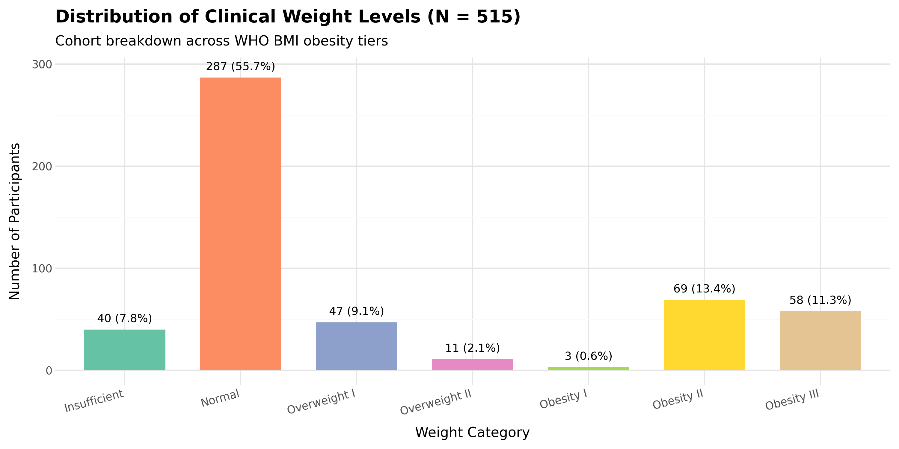
Figure 2: Empirical Frequency and Percentage Distribution of Target Clinical Weight Classes (N = 515)

8. Bivariate Analysis and Hypothesis Testing
Bivariate analysis investigates pairwise dependencies between potential explanatory factors and the clinical weight target. Both parametric analysis of variance and non-parametric contingency tests were deployed to evaluate significance.
8.1 Age Across Obesity Classes (One-Way ANOVA)
A one-way Analysis of Variance (ANOVA) was conducted to test the null hypothesis that mean chronological age is identical across all seven clinical weight tiers.
• Null Hypothesis (H₀): μ(Insufficient) = μ(Normal) = μ(Overweight I) = μ(Overweight II) = μ(Obesity I) = μ(Obesity II) = μ(Obesity III)
• Alternative Hypothesis (H₁): At least one weight category exhibits a significantly different mean age.
Results: The one-way ANOVA yields F = 11.9815 with p = 1.33 × 10⁻¹². Because p < 0.001, we reject the null hypothesis with extreme statistical confidence. Chronological age is decisively associated with clinical weight status. The median age rises monotonically from 19.5 years in Insufficient Weight and 21.0 years in Normal Weight, reaching 24.0 years in Overweight II and 25.0 years in Obesity II. Concurrently, the interquartile spread widens substantially, reflecting increased variance in older cohorts.
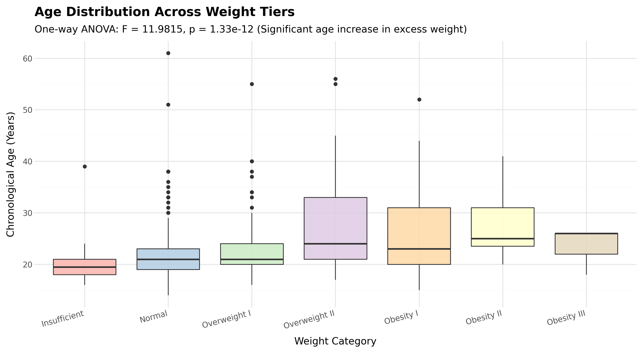
Figure 3: Box-Plot Distribution of Chronological Age Across Clinical Weight Tiers (ANOVA: F = 11.98, p = 1.33e-12)
8.2 Genetic Predisposition vs. Weight Tier (Chi-Square Test)
A Pearson Chi-Square test of independence cross-tabulating family history of overweight against the seven clinical weight categories demonstrates strong statistical dependency:
• Test Statistic: χ² = 25.29, Degrees of Freedom = 6, p = 0.0003, Cramér's V = 0.222
Empirical Contrast: Among individuals with NO family history of overweight, 72.3% successfully maintain normal or insufficient weight, and only 27.7% develop excess weight. Conversely, among those WITH a positive family history, 42.7% are overweight or obese. Most strikingly, severe obesity (Obesity Types I, II, and III) is almost exclusively confined to individuals with hereditary risk: 53 out of 61 severe obesity cases (86.9%) occur among respondents with a family history.
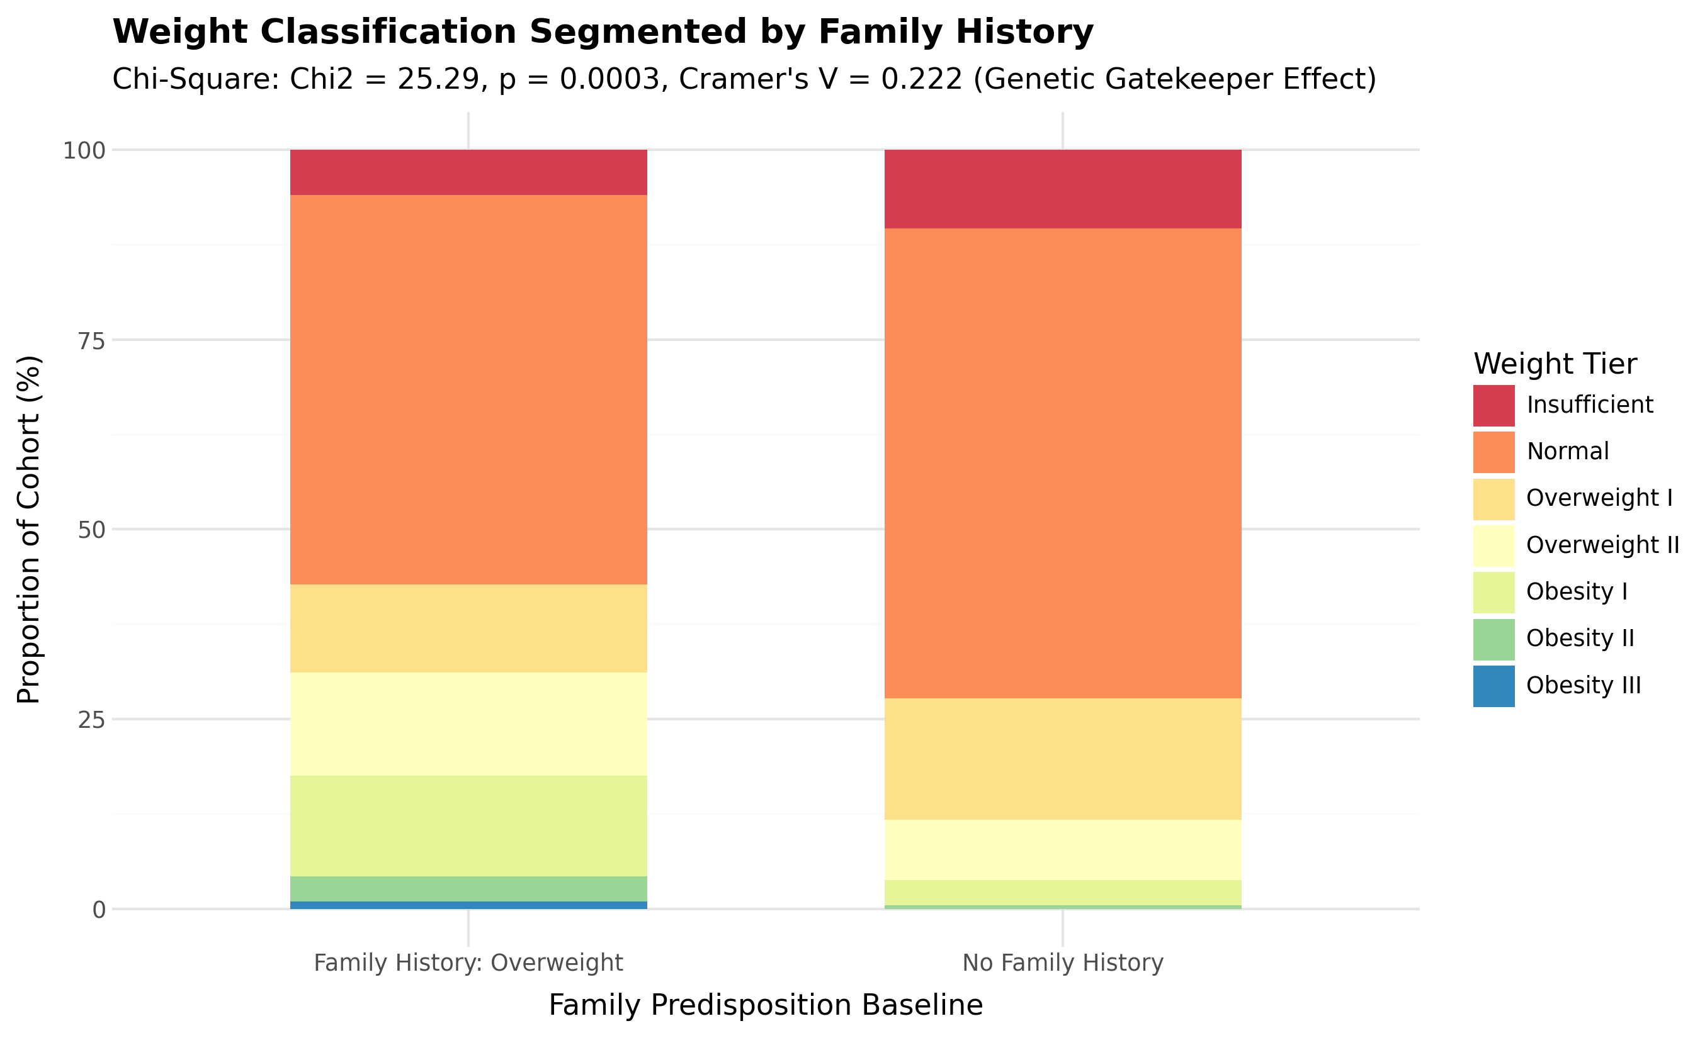
Figure 4: Proportional Distribution of Family History of Overweight Across Clinical Weight Tiers (Chi-Square: p = 0.0003)

9. Grouping, Stratification, and Interaction Matrices
Aggregating multivariate metrics across weight categories reveals underlying behavioral and physiological shifts. Table 5 details the mean values of key lifestyle metrics stratified across the seven clinical weight classes.
9.1 Mean Lifestyle Metrics by Weight Class
Weight Class | Mean Age | Vegetables | Daily Meals | Water Intake | Exercise Freq | Screen Time
Insufficient Weight | 20.12 | 2.55 | 2.80 | 1.85 | 1.25 | 0.72
Normal Weight | 21.74 | 2.33 | 2.74 | 1.85 | 1.25 | 0.68
Overweight Level I | 23.52 | 2.25 | 2.28 | 2.22 | 1.09 | 0.48
Overweight Level II | 27.53 | 2.28 | 2.41 | 2.02 | 0.93 | 0.57
Obesity Type I | 26.21 | 2.21 | 2.45 | 2.11 | 1.00 | 0.68
Obesity Type II | 28.36 | 2.36 | 2.55 | 1.73 | 0.73 | 0.55
Obesity Type III | 23.33 | 3.00 | 3.00 | 2.00 | 0.67 | 0.67
9.2 Stratified Overweight Rate: Age Group × Commute Method
Age Bracket | Automobile | Walking | Public Transit | Motorbike | Bike | Cohort Total
≤ 20 Years | 16.7% | 22.2% | 24.5% | 33.3% | 33.3% | 23.1%
21 – 25 Years | 26.3% | 29.4% | 37.2% | 20.0% | 50.0% | 35.7%
26 – 30 Years | 64.7% | 37.5% | 58.8% | 100.0% | N/A | 58.1%
> 30 Years | 75.6% | 100.0% | 38.5% | 100.0% | 50.0% | 73.7%
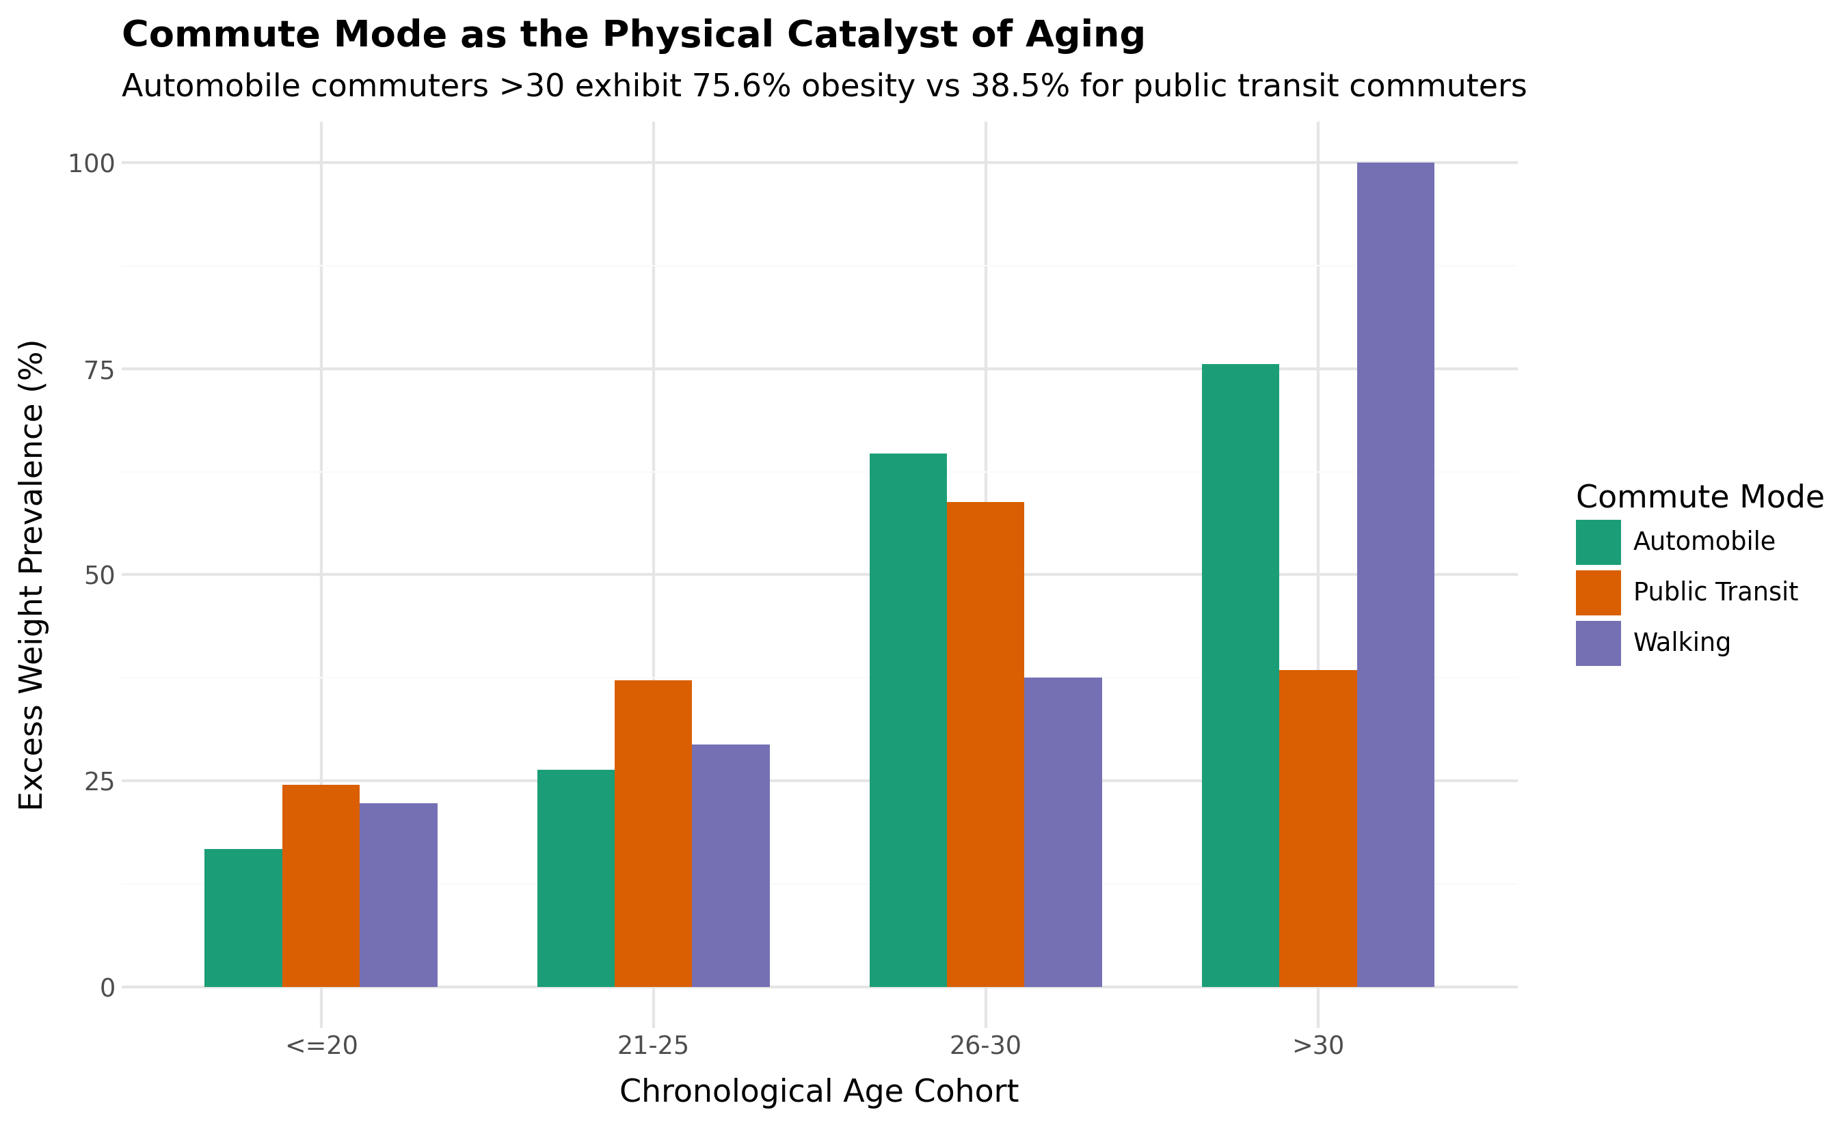
Figure 5: Commute Mode Transition as an Environmental Catalyst of Weight Escalation Across Age Tiers
Key Takeaway: Automobile Transition as an Environmental Catalyst
A profound non-linear shift occurs past age 25. For individuals aged 30 and older who commute by private automobile, the excess weight rate surges to 75.6%. In sharp contrast, individuals of the exact same age bracket who utilize public transit exhibit an excess weight rate of only 38.5%. Incidental transit walking (e.g., walking between stops and stations) serves as a potent, passive metabolic shield.

10. Correlation Matrix and Rank-Order Analysis
Correlation analysis evaluates the strength and direction of linear and monotonic associations across features. Table 7 presents the Pearson collinearity matrix among continuous attributes, while Table 8 details the Spearman rank-order correlations against the target.
10.1 Pearson Correlation Matrix (Continuous Attributes)
Attribute | Age | FCVC | NCP | CH2O | FAF | TUE
Age | 1.00 | 0.08 | -0.05 | 0.03 | -0.07 | -0.21
FCVC (Vegetables) | 0.08 | 1.00 | -0.00 | 0.02 | 0.12 | -0.12
NCP (Daily Meals) | -0.05 | -0.00 | 1.00 | -0.00 | 0.15 | 0.08
CH2O (Water Intake) | 0.03 | 0.02 | -0.00 | 1.00 | 0.23 | -0.00
FAF (Physical Exercise) | -0.07 | 0.12 | 0.15 | 0.23 | 1.00 | 0.01
TUE (Tech Screen Time) | -0.21 | -0.12 | 0.08 | -0.00 | 0.01 | 1.00
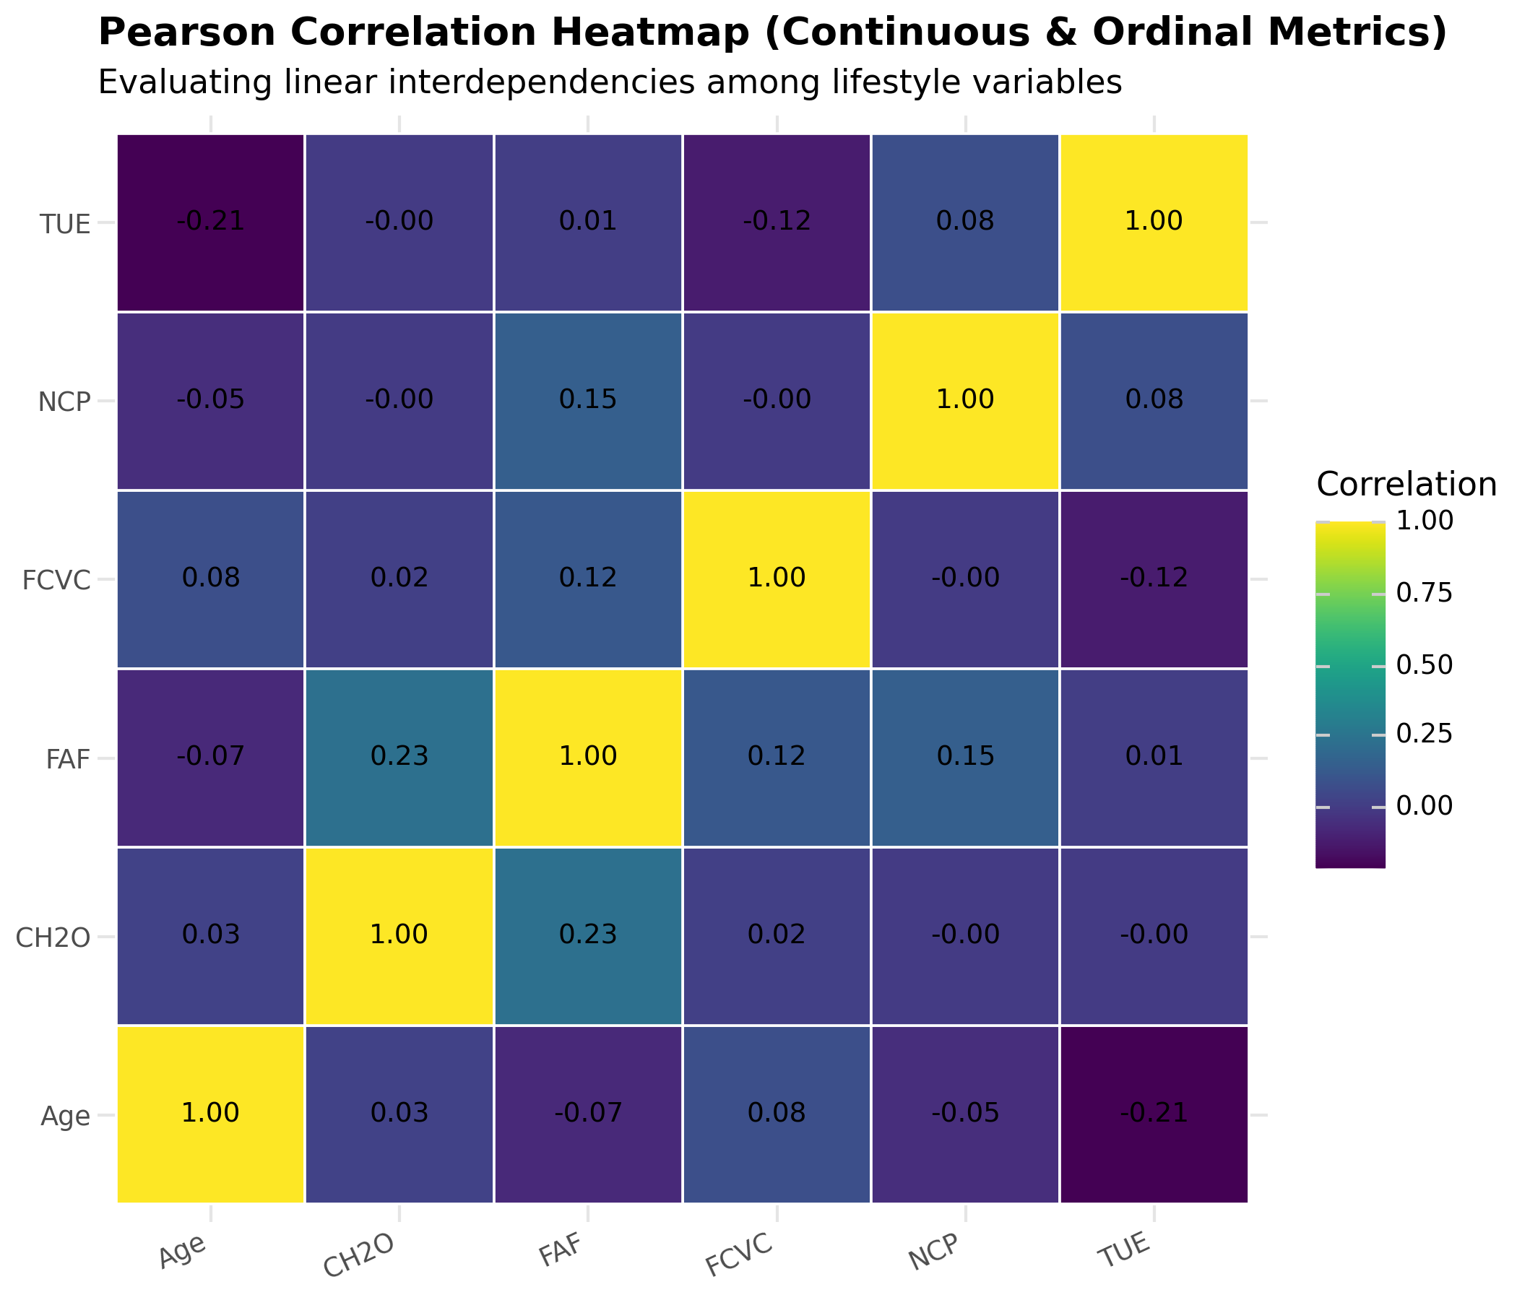
Figure 6: Pearson Collinearity Heatmap Across Continuous and Ordinal Survey Attributes
10.2 Spearman Rank-Order Correlation with Clinical Weight Level
Predictor Attribute | Spearman rs | p-value | Significance Level | Epidemiological Direction
Age | +0.3176 | 1.57 × 10⁻¹³ | p < 0.001 (Very High) | Positive: Older age elevates weight risk
family_history | +0.1995 | 5.04 × 10⁻⁶ | p < 0.001 (Very High) | Positive: Hereditary predisposition gatekeeper
NCP (Daily Meals) | -0.1727 | 8.15 × 10⁻⁵ | p < 0.001 (Very High) | Inverse: Fewer meals linked to higher obesity
CAEC (Snacking) | -0.1383 | 1.66 × 10⁻³ | p < 0.01 (High) | Inverse: Reporting / dietary restriction artifact
CH2O (Water Intake) | +0.1372 | 1.80 × 10⁻³ | p < 0.01 (High) | Positive: Larger body mass requires more hydration
SMOKE | +0.1357 | 2.03 × 10⁻³ | p < 0.01 (High) | Positive: Confounded by older age & automobile use
FAF (Physical Activity) | -0.1287 | 3.44 × 10⁻³ | p < 0.01 (High) | Inverse: Regular exercise acts as protective shield
Gender (Male=1) | +0.1210 | 5.97 × 10⁻³ | p < 0.01 (High) | Positive: Males show higher Overweight I/II
FCVC (Vegetables) | -0.1061 | 1.60 × 10⁻² | p < 0.05 (Moderate) | Inverse: Mild dietary protective effect
CALC (Alcohol) | +0.0940 | 3.29 × 10⁻² | p < 0.05 (Moderate) | Positive: Alcohol frequency correlates with weight
TUE (Screen Time) | -0.0806 | 0.0674 | p ≥ 0.05 (Not Sig) | Weak inverse: Confounded heavily by age
SCC (Calorie Tracking) | -0.0484 | 0.2727 | p ≥ 0.05 (Not Sig) | Near zero: Severely low general adoption (10.7%)
FAVC (High Calorie) | -0.0206 | 0.6415 | p ≥ 0.05 (Not Sig) | Near zero unconditioned correlation (Genetics Buffer)

11. Multi-Factor Interaction Models & Visual Analytics
A central thesis established by this research is that clinical obesity cannot be accurately understood through isolated linear models. Instead, human weight status is governed by a hierarchical three-tiered interaction architecture:
1. Tier 1: Biological & Hereditary Baseline — Chronological age (rs = +0.32) and family history (Cramér's V = 0.222) establish the physiological foundation.
2. Tier 2: Environmental & Behavioral Mediators — Post-25 automobile adoption catalyzes sedentary habits, while high physical activity (FAF = 3) serves as an active shield.
3. Tier 3: Compensatory Paradoxes — Unconditioned variables (such as high-calorie food consumption) are heavily filtered by genetic buffers and meal-skipping patterns.
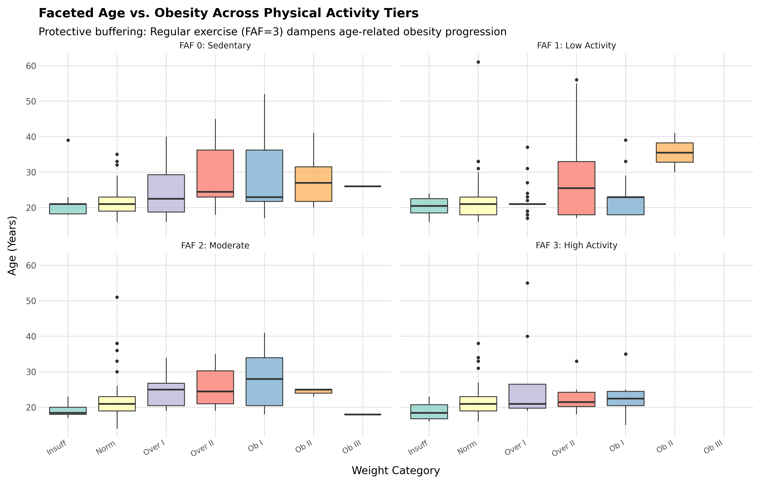
Figure 7: Faceted Interaction: Chronological Age vs. Weight Tiers Stratified Across Physical Activity Levels (FAF)
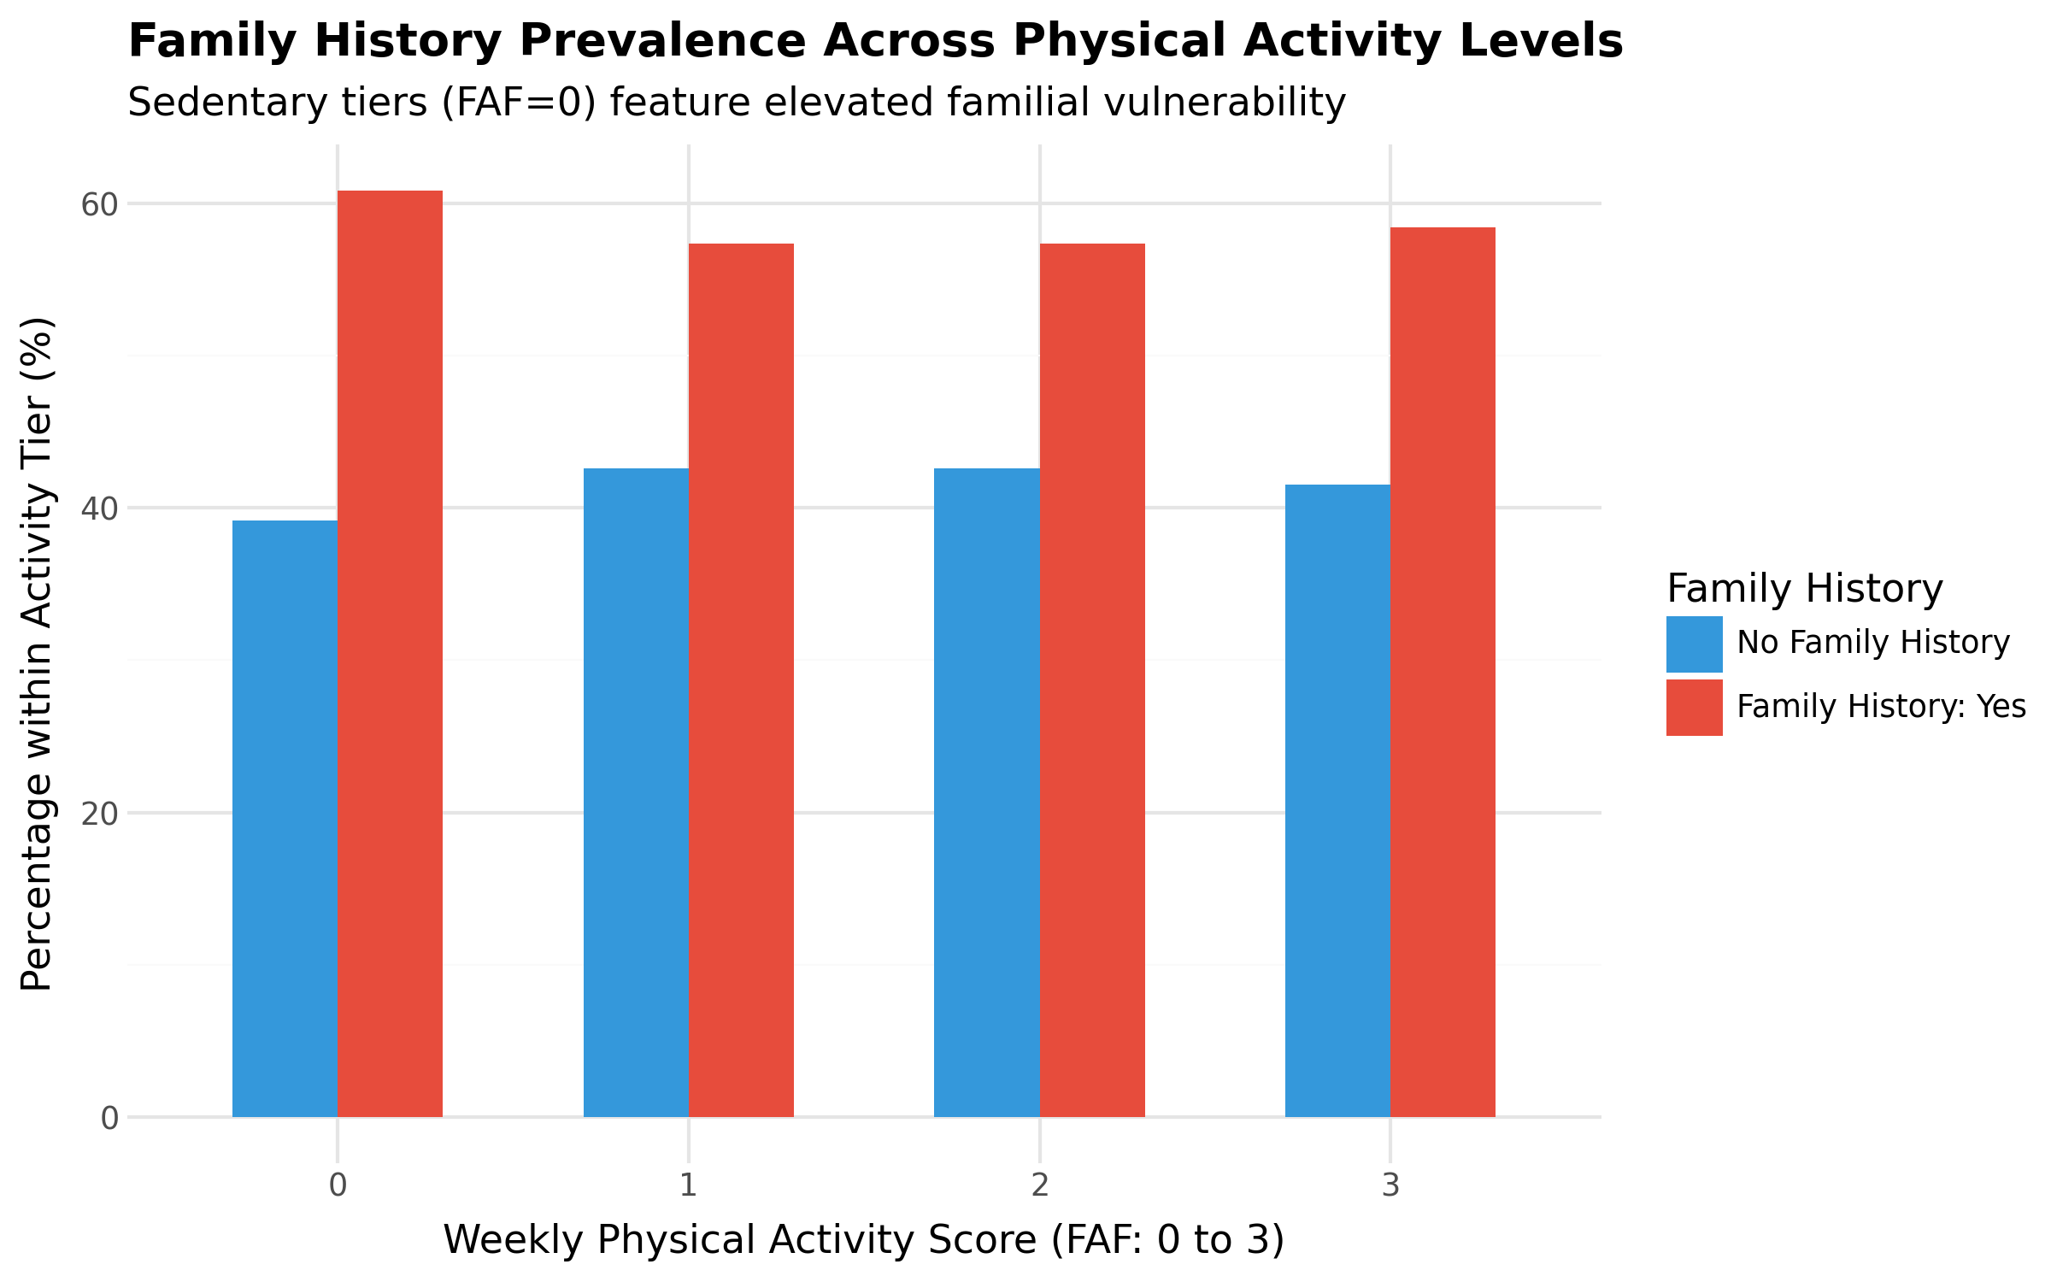
Figure 8: Proportions of Family History Across Physical Exercise Categories
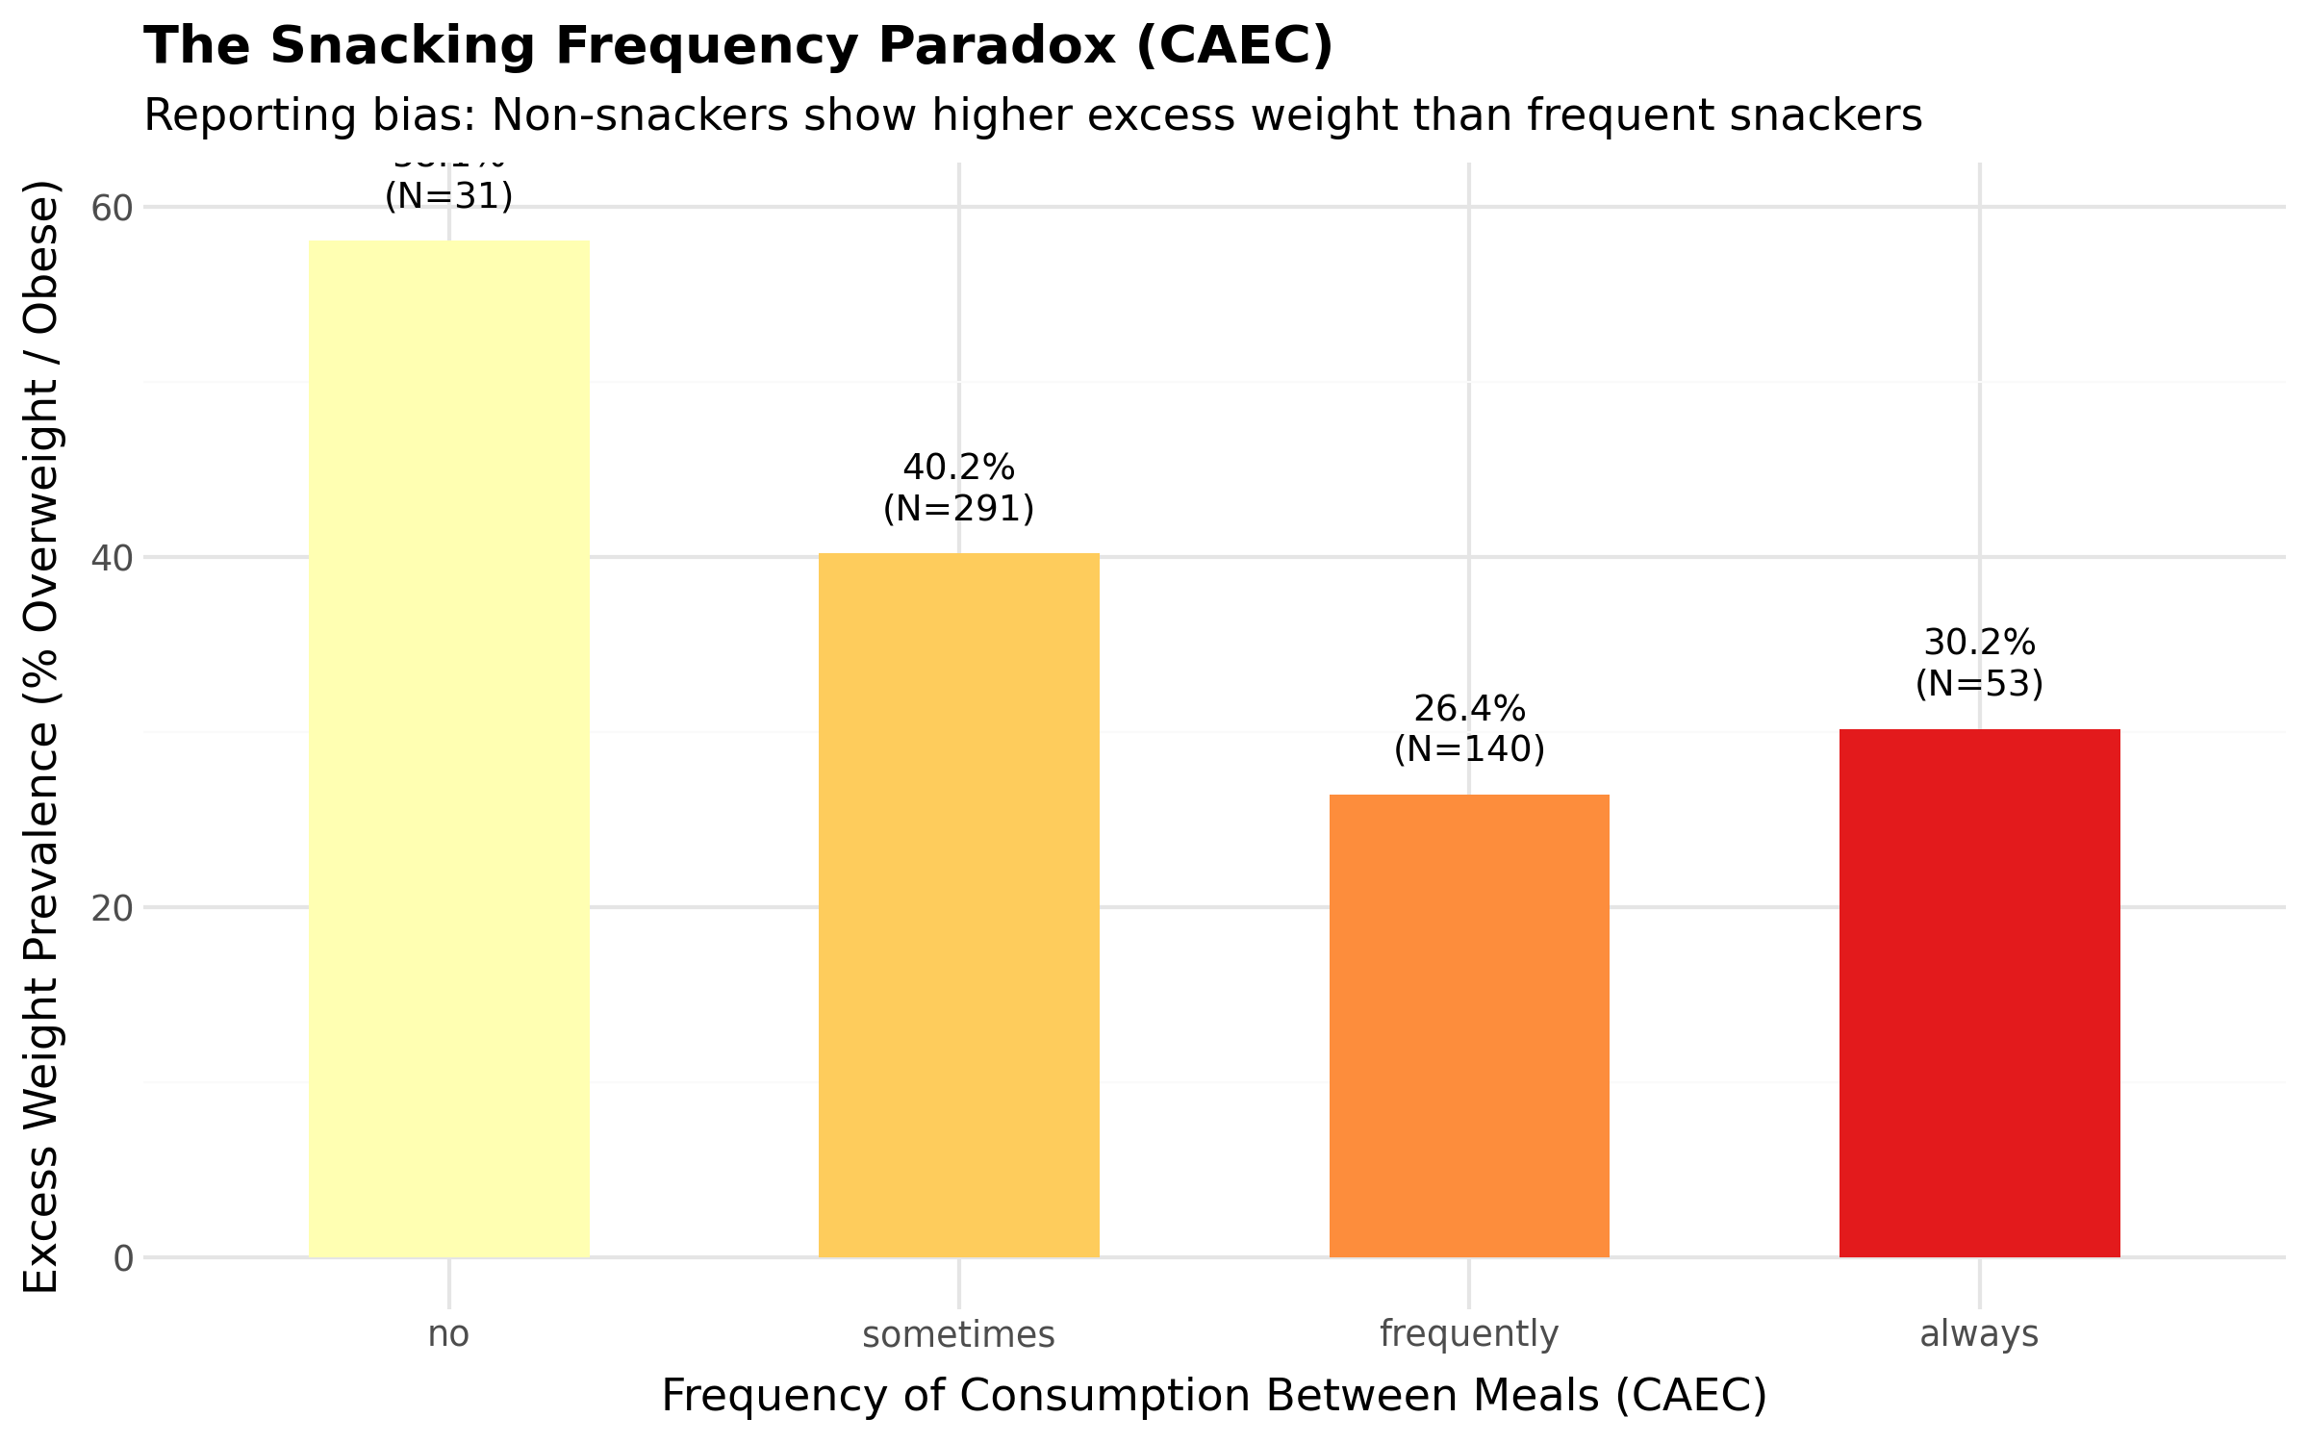
Figure 9: The Snacking Paradox: Self-Reported Snacking Frequency vs. Observed Clinical Weight Status

12. In-Depth Analysis of Key Findings & Paradoxes
Finding 1: The Meal-Skipping Paradox (NCP vs. Weight Level)
Popular weight-loss dogma suggests that reducing daily meal frequency creates an arithmetic calorie deficit that protects against weight gain. However, empirical testing exposes a strong inverse correlation (rs = -0.1727, p = 8.15 × 10⁻⁵):
• 1 Meal per Day: Overweight and obesity prevalence reaches 50.4%.
• 3 Meals per Day: Overweight and obesity prevalence declines to 34.0%.
• 4 Meals per Day: Overweight and obesity prevalence collapses to just 18.8% (with 60.4% maintaining normal weight and 20.8% insufficient weight).
Etiological Mechanisms: Eating only one main meal per day triggers dysregulated insulin spikes, prolonged glycemic starvation, and subsequent nocturnal binge eating of calorie-dense, ultra-processed foods. Furthermore, reverse causality plays a substantial role: individuals who have already gained weight frequently adopt extreme meal-skipping regimens as an ineffective, reactionary dietary intervention.
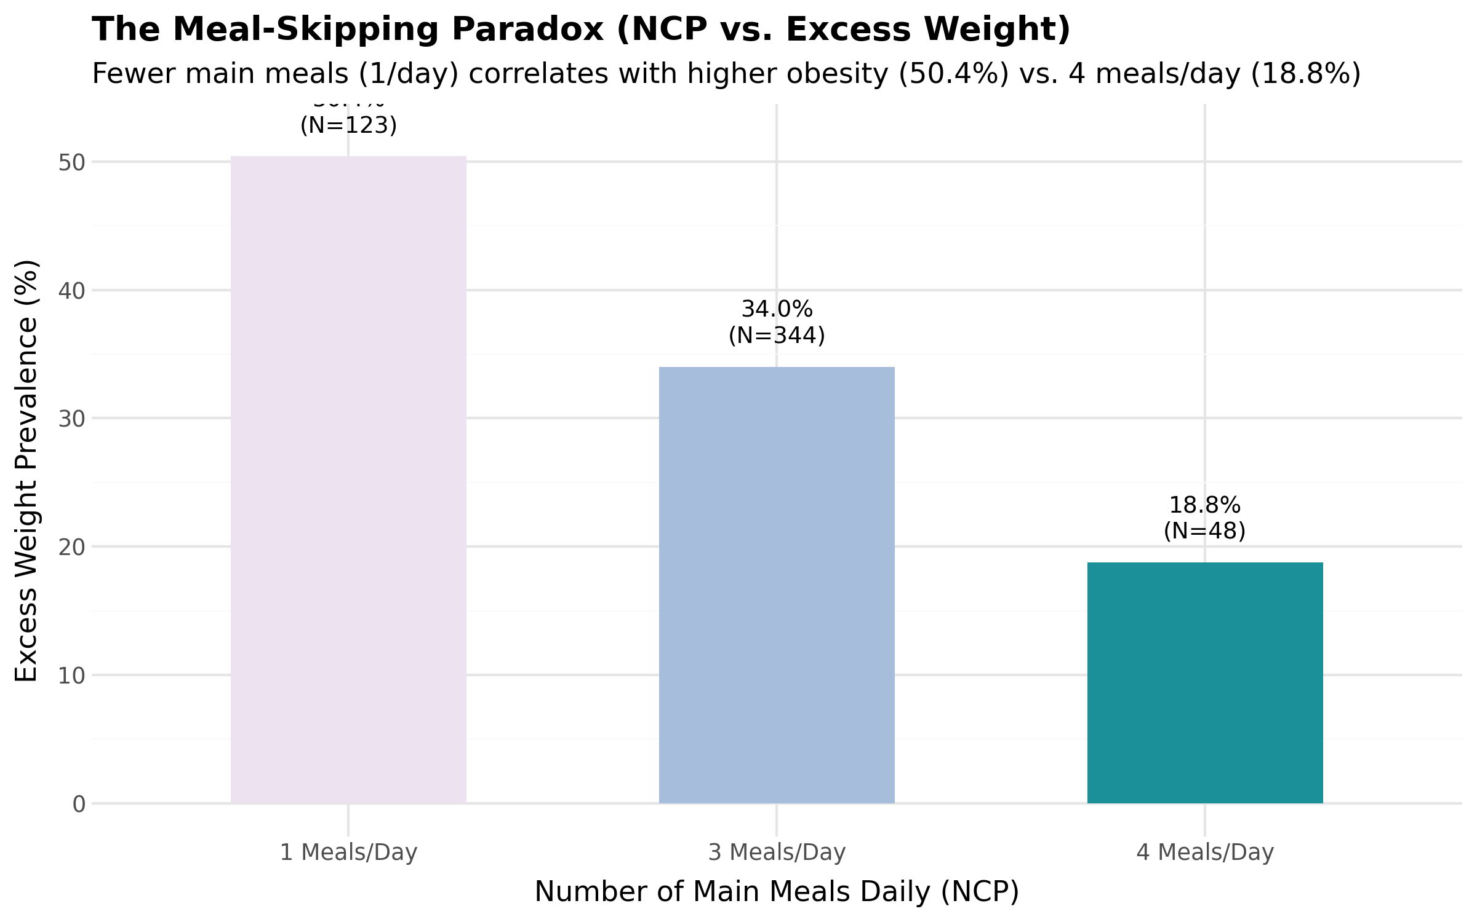
Figure 10: The Meal-Skipping Paradox: Overweight/Obesity Rates Stratified by Daily Main Meal Frequency (NCP)
Finding 2: The High-Calorie Food Genetic Buffer Illusion
In raw bivariate correlations, high-calorie food consumption (FAVC) displays a statistically non-significant correlation with obesity (rs = -0.0206, p = 0.6415). This counterintuitive finding is explained by genetic conditioning:
• In the Absence of Family History: The overweight/obesity rate is virtually identical at 27.4% (FAVC = No) versus 27.8% (FAVC = Yes). A favorable genetic profile acts as a robust metabolic buffer against occasional high-calorie dietary intake.
• In the Presence of Family History: The overweight/obesity rate jumps to over 41%. Remarkably, individuals with family history who claim to avoid high-calorie foods (FAVC = No) display a higher overweight rate (46.6%) than those who consume them (41.1%). This reflects severe self-reporting bias and unsuccessful retroactive dietary restriction among overweight individuals.
Finding 3: Commute Mode as the Physical Catalyst of Aging
Chronological age is the single strongest continuous predictor of obesity (F = 11.98, p = 1.33 × 10⁻¹²), but the true environmental mechanism is transportation infrastructure. Prior to age 20, over 86% of individuals rely on active commuting (walking or public transit), keeping excess weight prevalence low at 23.1%. Past age 25, automobile ownership expands rapidly. For adults aged 30 and older, automobile commuters experience a staggering 75.6% overweight rate, compared to only 38.5% for public transit commuters of the same age. Public transportation inherently mandates walking to stations, climbing stairs, and standing, which provides non-exercise activity thermogenesis (NEAT) that protects against metabolic deceleration.
Finding 4: The Tobacco Smoking Confounder
While nicotine possesses well-documented metabolic appetite-suppressing pharmacology, smokers in this empirical dataset suffer from a 56.3% excess weight rate compared to 35.2% for non-smokers (p = 0.002). Confounder analysis reveals that smokers are significantly older (mean 27.3 vs 22.8 years, Cramér's V = 0.361), consume alcohol at substantially higher frequencies, and commute by private automobile at a 47% higher relative rate (28.1% vs 19.0%). Smoking in this cohort is a sociological proxy for an older, sedentary lifestyle.
Finding 5: Screen Time vs. Physical Activity Inversion
Daily screen device time (TUE) decreases with chronological age (r = -0.21). Younger individuals spend extensive hours on digital devices but are protected from obesity by high baseline metabolic rates and active transit walking. In contrast, older adults spend less time on personal digital screens, but their structured exercise drops sharply, compounding the sedentary impact of private automobile commuting.

13. Conclusions and Machine Learning Roadmap
This comprehensive Exploratory Data Analysis proves that obesity is governed by non-linear behavioral, genetic, and environmental interactions. The key analytical insights translate into concrete engineering directives for subsequent predictive modeling:
- Feature Engineering of Interaction Terms: Tree-based classifiers should be augmented with explicit interaction features, such as Age_x_Automobile, FamilyHistory_x_FAVC, and Activity_to_Screen_Ratio, to explicitly capture non-linear metabolic thresholds.
- Leakage-Free Validation Strategy: Because the dataset contains 29 duplicate instances (including a 15-record synthetic SMOTE cluster), standard random train-test splitting will produce optimistic over-fitting. A Stratified Group K-Fold cross-validation strategy must be enforced to isolate synthetic duplicates within training folds.
- Non-Linear Model Architecture: Naive linear classifiers (such as Logistic Regression) are structurally incapable of handling the meal-skipping paradox or the genetic buffer effect. Gradient-boosted decision trees (XGBoost, LightGBM, CatBoost) or non-linear Random Forests must be selected.
14. Academic References & Data Provenance
UCI Machine Learning Repository: Estimation of obesity levels based on eating habits and physical condition. Available at: https://archive.ics.uci.edu/dataset/544/estimation+of+obesity+levels+based+on+eating+habits+and+physical+condition
Palechor, F. M., & de la Hoz Manotas, A. (2019). Dataset for estimation of obesity levels based on eating habits and physical condition in Colombia, Peru and Mexico. Data in Brief, 25, 104344. https://doi.org/10.1016/j.dib.2019.104344
World Health Organization (WHO). (2020). Obesity and overweight fact sheets. Geneva: World Health Organization. Available at: https://www.who.int/news-room/fact-sheets/detail/obesity-and-overweight
Frank, L. D., Andresen, M. A., & Schmid, T. L. (2004). Obesity relationships with community design, physical activity, and time spent in cars. American Journal of Preventive Medicine, 27(2), 87-96.
McKinney, W. (2010). Data Structures for Statistical Computing in Python. Proceedings of the 9th Python in Science Conference, 51-56.
Virtanen, P., et al. (2020). SciPy 1.0: Fundamental Algorithms for Scientific Computing in Python. Nature Methods, 17, 261–272.

15. Project Outro, Repository Architecture & Reproducibility
To uphold the highest standards of open science and academic reproducibility, the entirety of this research project—including raw dataset ingestion, automated data cleaning pipelines, exploratory Jupyter notebooks, high-resolution figures, and statistical validation scripts—is fully version-controlled and publicly accessible on GitHub.
OFFICIAL GITHUB PROJECT REPOSITORY
https://github.com/rishigig/project-eda-1.git

The repository is organized into modular directories providing full traceability:
• data/raw/ : Houses the pristine benchmark dataset from the UCI Machine Learning Repository.
• data/cleaned/ : Contains the validated 515-observation empirical cohort utilized throughout this study.
• notebooks/ : Features documented interactive Jupyter notebooks for data quality audits and the 15-part statistical analysis.
• figures/ : Contains standalone, high-resolution vector and PNG visualizations generated programmatically via Plotnine.
• REPOcanva/ : Stores executive presentation assets, Canva infographics, and multimedia deliverables.
Researchers and academic evaluators can clone the repository, install standard dependencies, and execute automated figure generation and data processing scripts without manual configuration.

16. Project Team and Group Task Allocation Matrix
This academic research project was executed collaboratively by Group 5 of F.Y. BCA Semester I (Division A) at The Maharaja Sayajirao University of Baroda, Vadodara. Each team member was assigned specialized responsibilities across the exploratory data analysis lifecycle, spanning data engineering, parametric and non-parametric hypothesis testing, multivariate analysis, data visualization, and academic documentation. Table 10 details the individual task assignments and verified deliverables.
Roll No | Student Name | Designated Project Role | Assigned Functional Tasks & Deliverables
36 | Rishi Chauhan | Project Lead & Repository Architect | Led GitHub architecture and version control; developed pipeline orchestration scripts (create_notebooks.py, generate_figures.py); coordinated correlation matrix and overall analysis synthesis.
113 | Kushant Sabhaya | Data Engineering & Quality Assurance | Managed UCI dataset ingestion and automated hygiene verification; performed duplicate audit and isolated the 15-record SMOTE synthetic cluster; constructed data dictionary.
108 | Krishna J. Ahir | Univariate Analysis & Target Profiling | Conducted univariate frequency analysis of clinical target (NObeyesdad); mapped WHO BMI standards and class breakdowns; evaluated baseline population properties.
22 | Anjali Nakum | Demographic & Dietary Profiling | Analyzed demographic distributions (Age, Gender); evaluated dietary habits (FAVC, FCVC, NCP, CAEC, CH2O, CALC); audited calorie tracking compliance (SCC deficit).
102 | Khushwant M. Purohit | Statistical Hypothesis Testing Specialist | Formulated and executed one-way ANOVA for age across weight classes (F=11.98, p=1.33e-12); conducted Chi-Square contingency test and Cramér's V for genetic risk.
24 | Atif Khan | Multivariate Stratification & Mobility Analyst | Investigated commute mode interactions (MTRANS x Age); quantified the post-25 automobile transition and sedentary transit effects; generated age-stratified cross-tabulations.
25 | Atman | Behavioral Paradox & Confounder Analyst | Formulated and verified the Meal-Skipping Paradox (NCP vs. weight); evaluated genetic buffering against high-calorie diets (FAVC); investigated tobacco smoking confounders.
93 | Kavy | Visual Analytics & UI/UX Presentation Lead | Implemented Plotnine Grammar of Graphics visual assets; developed Canva infographics and presentation slides; formatted academic documentation and final report review.
Report compiled and verified for formal academic submission.
The Maharaja Sayajirao University of Baroda, Vadodara • F.Y. BCA Semester I (Division A) • Group 5

