1. **Autoscaling**

* Creating autoscaling group of ec2 instances that can scale up and down depending on condition you set.
* Enable elastic by scaling horizontally through adding and terminating ec2 instances.
* Auto scaling ensure that you have the right number of aws ec2 instances for you need at all time.
* It is help you save cost by cutting down the no of ec2 instances when not needed and scaling out to add more instances only when it is required.

**1.1 Auto scaling component**

* Launch configuration - Like instances type, AMI, keypair, security group.
* Auto scaling group - Group name, group size, vpc, subnet,health check

period

* Scaling policy - Metric type, target value.

**1.2 How to launch instance template**

Login aws root account .**>** services **>** ec2 **>** instance **>** launch template

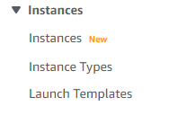



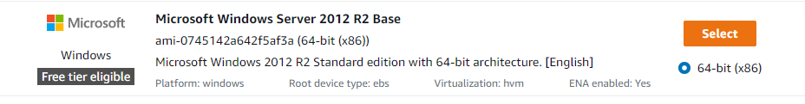

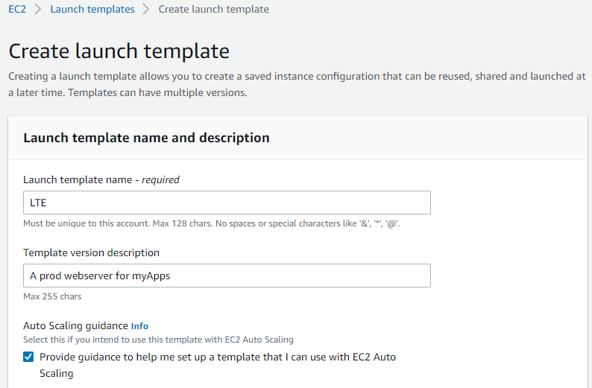

My template name is LTE

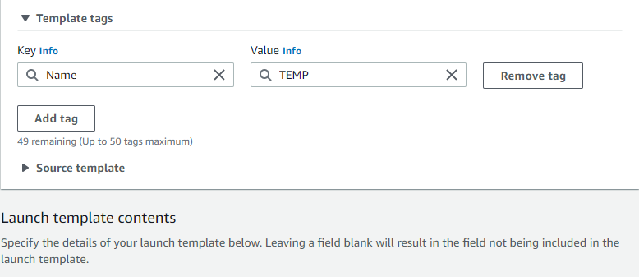

Tag name is TEMP

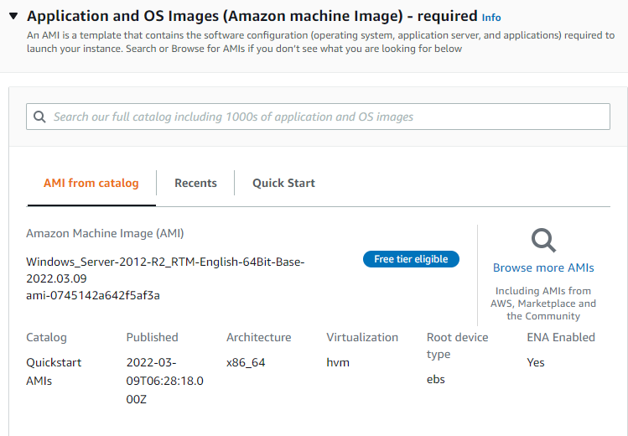

I choose windows server 2012-R2 base which is eligible for free tier account.

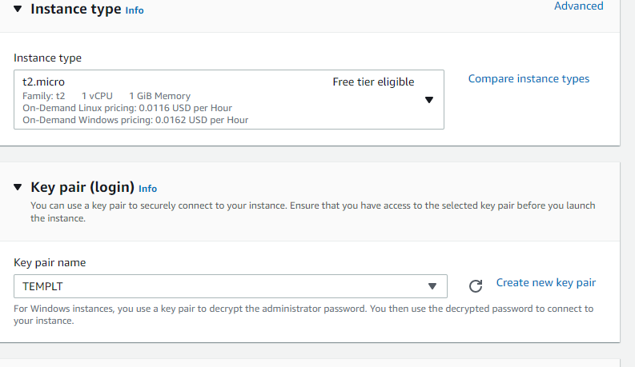

Instances type t2 micro 1cpu, 1gb ram.

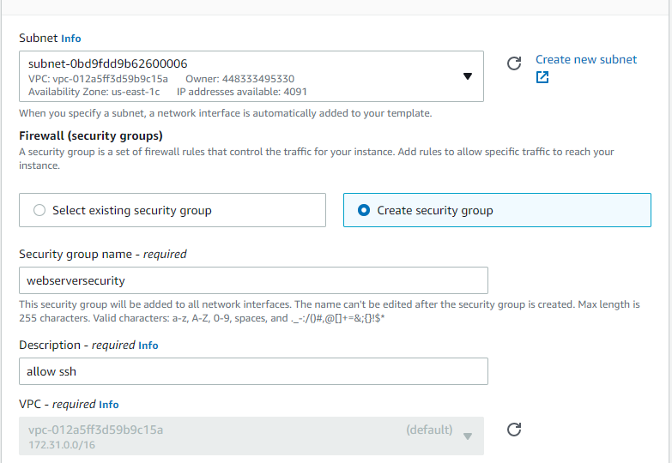

I choose default subnet and make new security group as ‘websecurity’

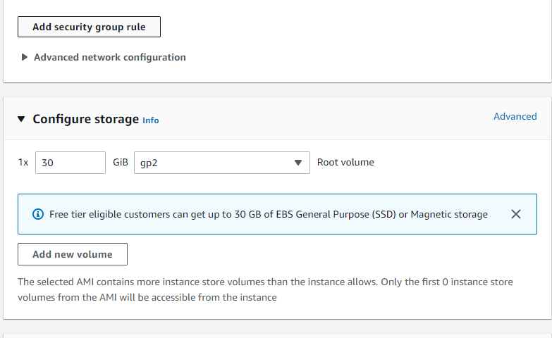

To do all configuration we have to check out all thing is correct then click on create template.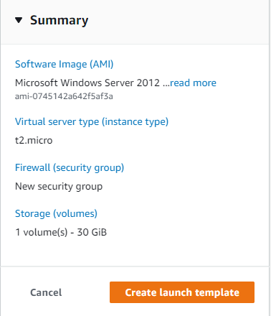

It successfully done creation of template.

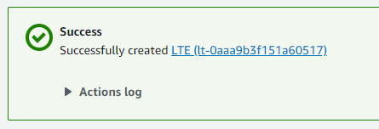

**1.3 To create autoscaling group**

Service **>** ec2 **>** auto scaling group

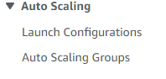

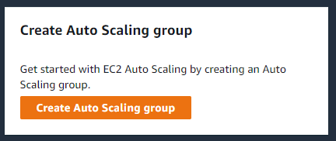

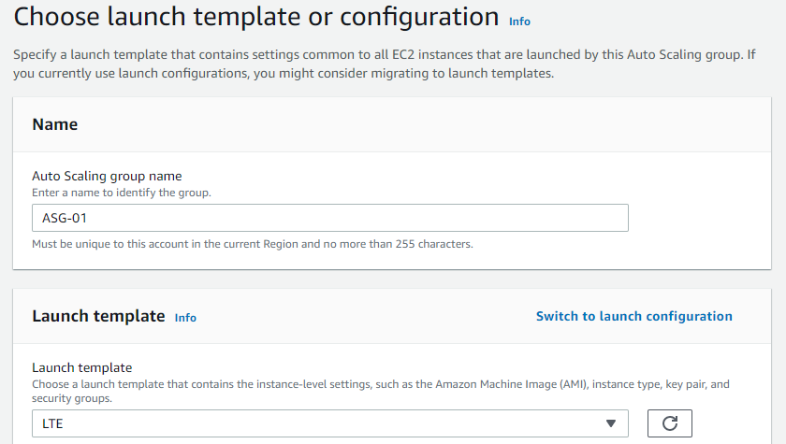

Here we can choose our template or configuration which i created but i create template.

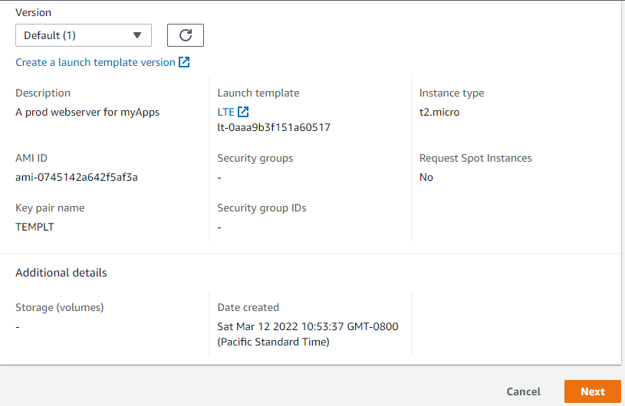

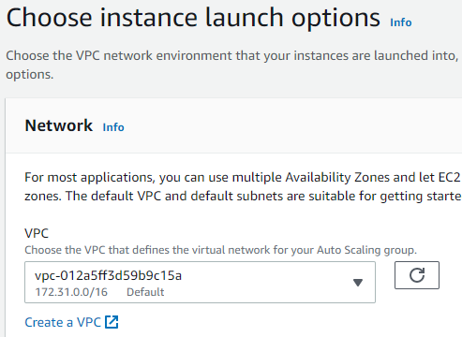

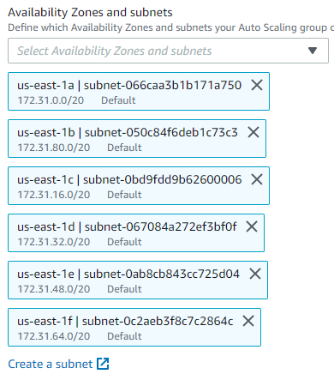

Here i choose us-east-1 availability zone and running there are five availability zone and select all that.

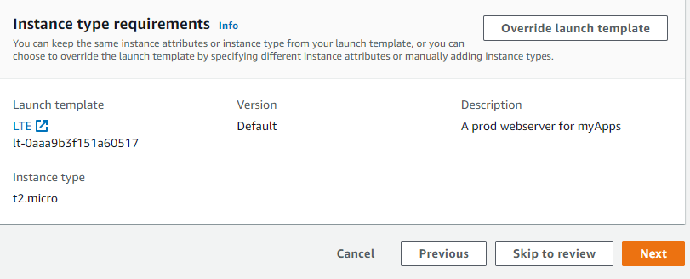

Load balance is actually checking health of instance interval of 5 minutes regularly .

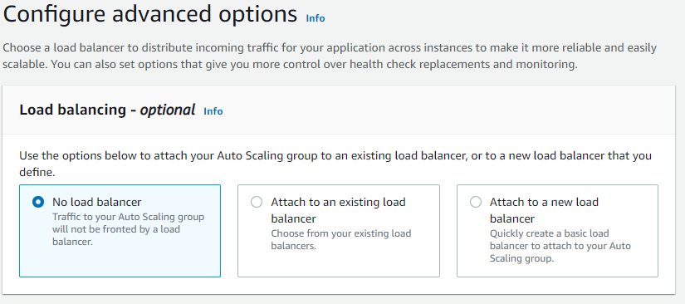

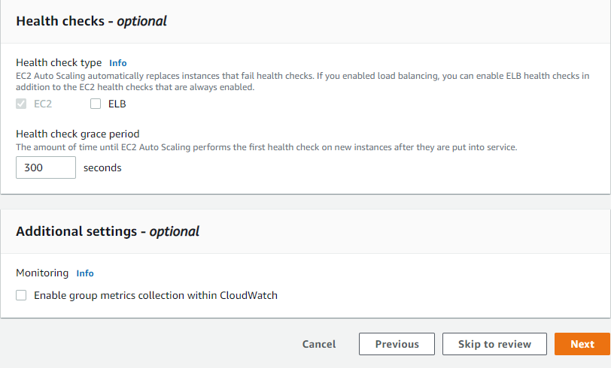

There is set to instances actually what we need initial and maximum desire, i choose 2

instances initially and minimum 2 instance to run when i launch autoscaling group and

maximum 8 instances when traffic is 60 percentage utilization of cpu. 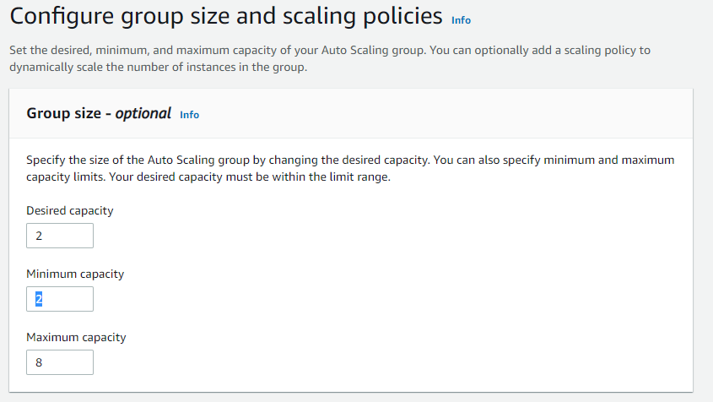

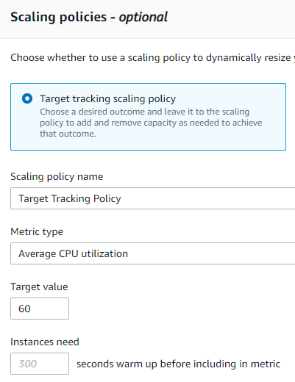

I choose target tracking policy i set of target value 60 percentage.

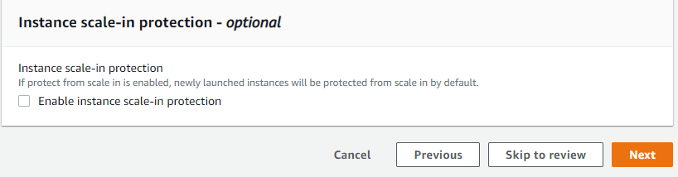

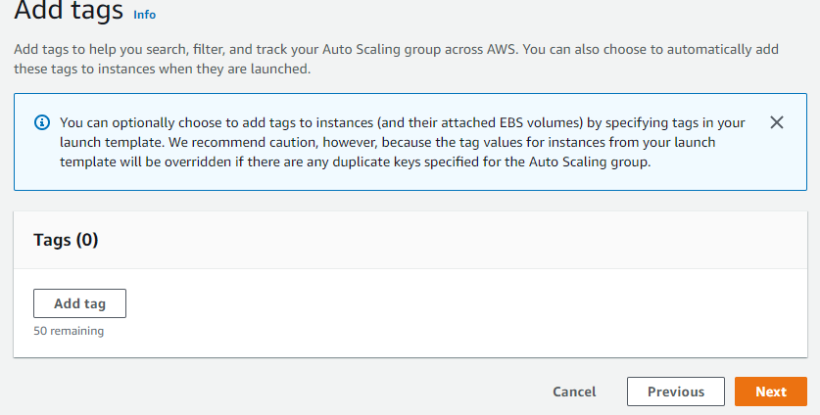

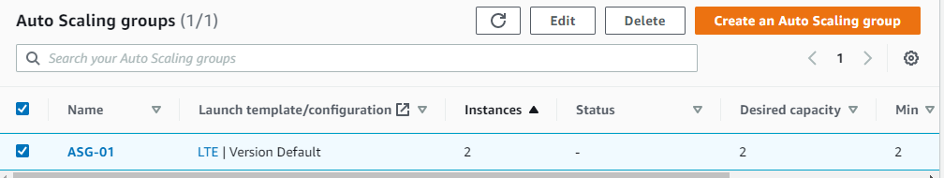

Here successfully done of creating auto scaling group which is located as ASG-01.

And we go for check to running instances which is selected 2 instances at initially.

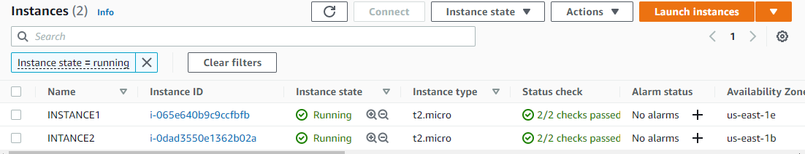

As instance 1 and instance 2 we can see here.

Now we go for configuration security group to take rdp otherwise we can’t take rdp .

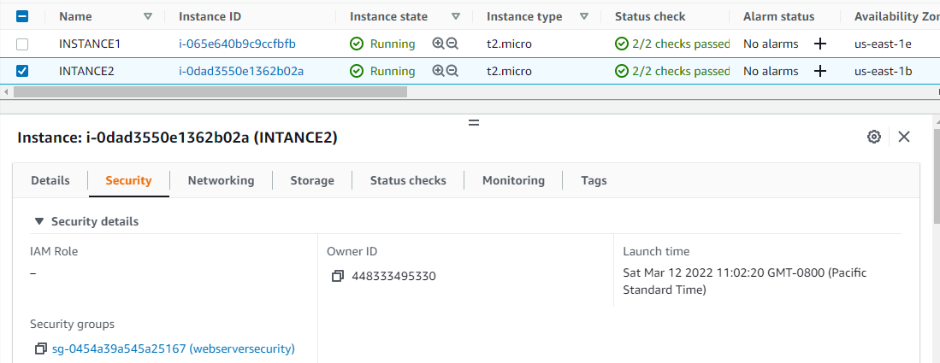

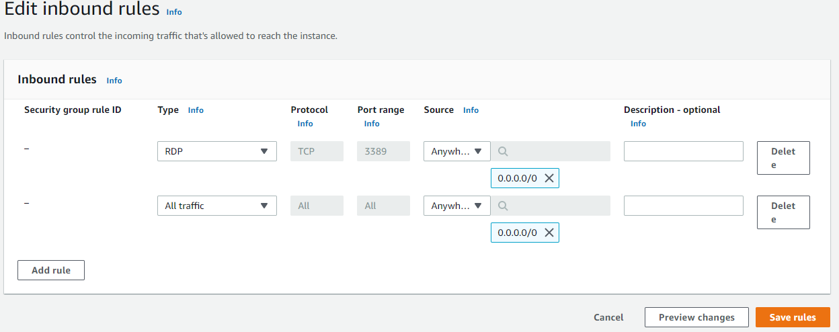

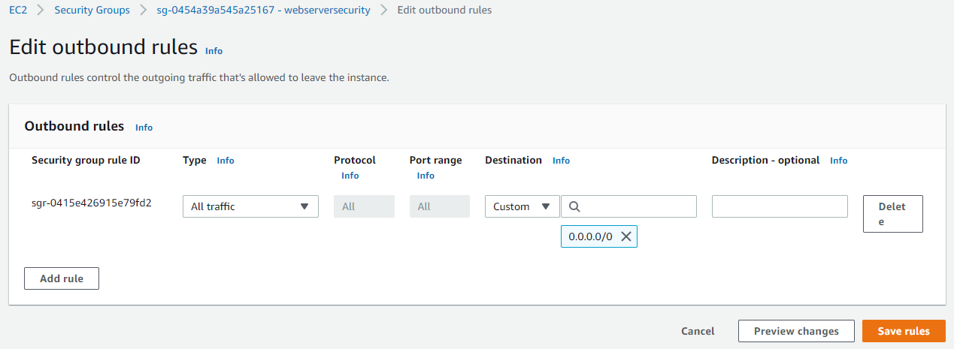

I choose inbound type rdp and destination anywhere And same outbound too.

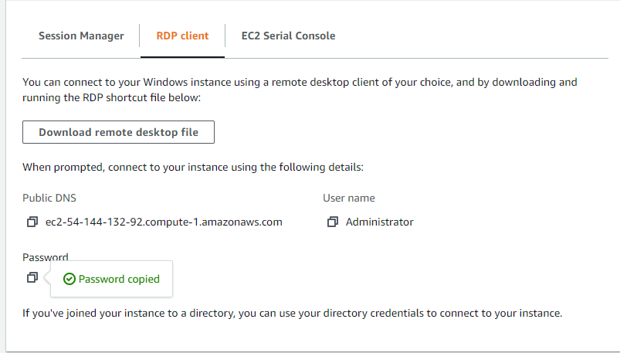

After configuration security group we go for take RDP and download RDP file and decrypt password and connect our instance to server.

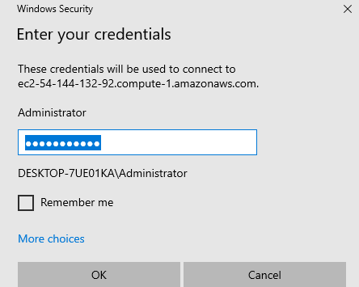

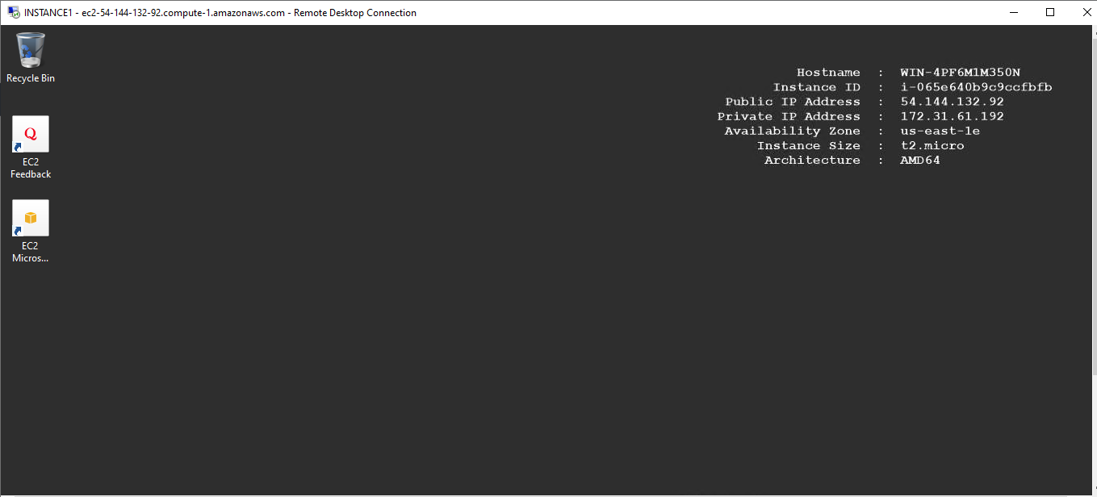

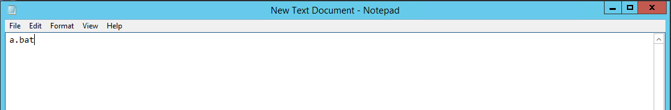

Do same thing to another instance

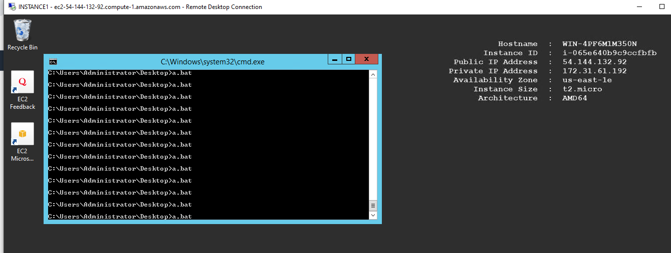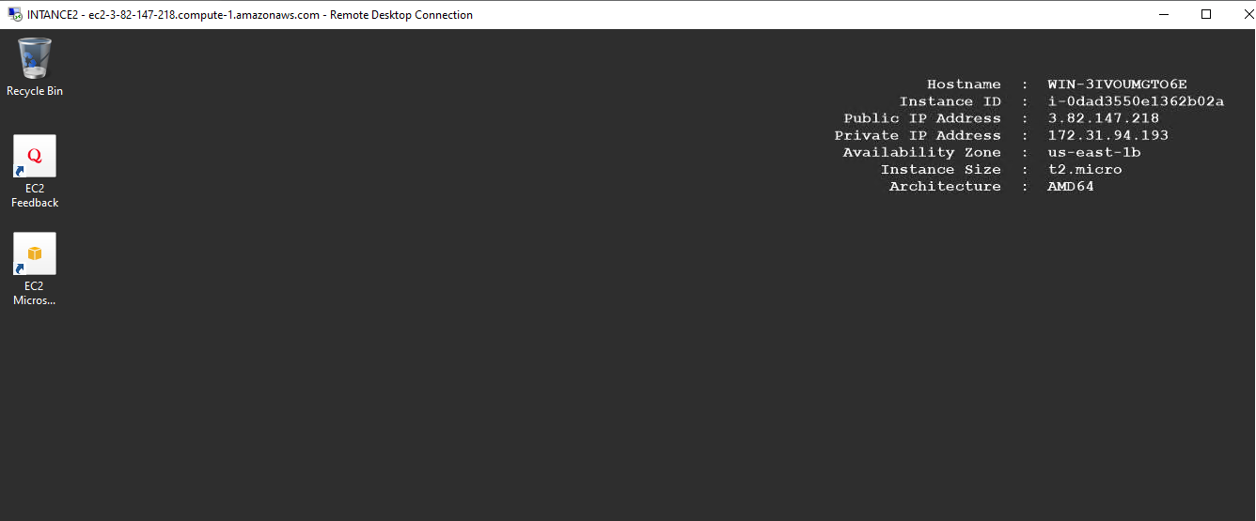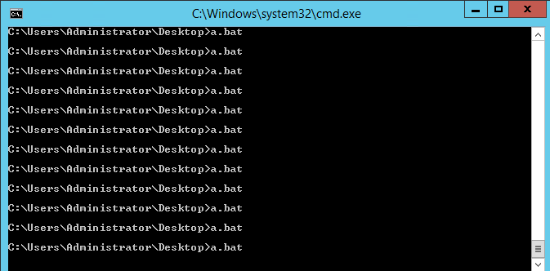

Perfect it is reach 60% utilization of cpu and auto scaling create a 1 new instance

Here we can see it. It’s status initializing.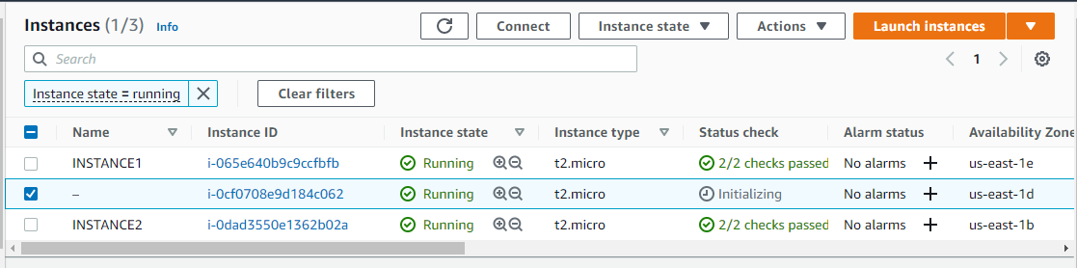

My lab is successfully done to creating autoscaling group.