**1. Cloudfront**

* Amazon Cloudfront is a web service that gives businesses and web application developers an easy and cost effective way to distribute content with low latency and high data transfer speed.

**1.1 Edge Location and Regional Edge Cache**

* Cloudfront is a global service.
* Amazon cloudfront is a webservice that speeds up distribution of our static and dynamic web content,such as html,css,js,and image files to users .
* Cloudfront delivers our content through a worldwide network of data centers called edge locations.
* When a user request content that we are serving with with cloudfront,the user is routed(via dns resolution) to the edge location that provides the lowest latency,So that content is delivered with the best possible performance.
* If the content is already in th edge location with the lowest latency,cloudfront delivers it immediately.
* This dramatically reduces the number of networks that our users request must pass through, which improves performance.
* If not,cloudfront retrieves it from an amazon s3 bucket or an HTTP/webserver that we have identified as the source for the definitive version of our content(origin server).
* Cloudfront also keeps persistent connection with origin server so files are fetched from the origin as quickly as possible.

**1.2 We can Access Amazon Cloudfront in the following ways**

* AWS management console
* AWS SDK
* Cloudfront API
* AWS CLI

**1.3 Cloudfront Edge Locations**

* Edge locations are not tied to available zones or regions.
* Amazon Cloudfront has 216 point of presence(205 edge locations and 11 regional edge caches) 84 cities across 42 countries.

**1.4 Regional Edge Caches**

* Amazon cloudfront has added several regional edge cache locations globally at close proximity to our viewers.
* They are located between our origin webserver and the global edge locations that serve content directly to our viewers.
* As objects become less popular individual edge locations may remove those objects to make room for more popular content.
* Regional edge cache working as a alternative of origin to reduce the burden of origin.
* Regional edge cache have a large cache width than any individual edge location,so object remain in the cache longer at the nearest regional edge caches.

**1.4 Cloudfront Regional Edge Cache -Working**

* • When a viewer makes a request on our website or through our application,DNS routes the request to the cloudfront edge location that can best serve the users request.
* This location is typically the nearest cloudfront edge location in terms of latency.
* In the edge location,cloudfront checks its cache for the requested files.
* If the files are in the cache,cloudfront returns them to the user.
* If the files are not n the cache,the edge servers go to the nearest regional edge cache to fetch 2/2 the object.
* Regional edge cache have feature parity with edge locations .EX : a cache invalidation request removes an object from both edge caches and regional edge caches before it expires.
* The next time a viewer request the object,cloudfront returns to the origin to fetch the latest version of the object.
* Proxy method PUT/POST/PATCH/OPTIONS/DELETE go directly to the origin from the edge locations and do not proxy through the regional edge caches.
* Dynamic content as determined at request time,does not flow through regional edge cache,but goes directly to the origin.

**LAB**

1. **Create S3 bucket and upload a file.**



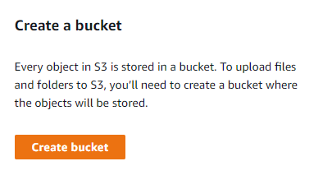



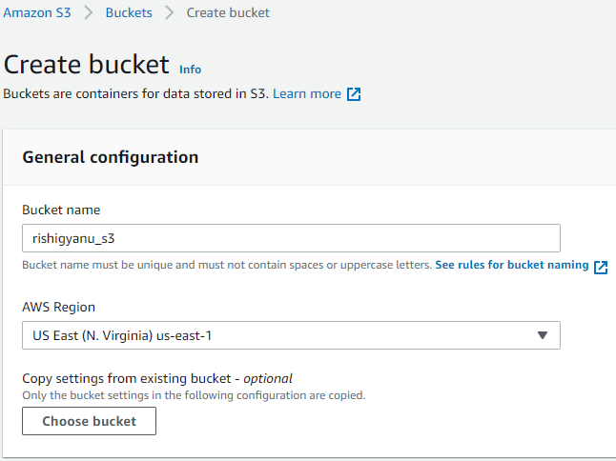



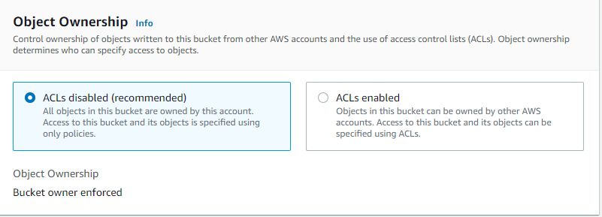

1. Have to enable public access.

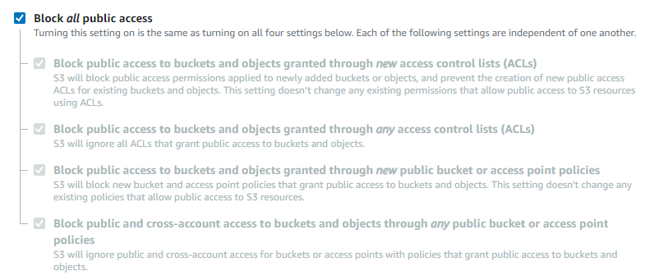



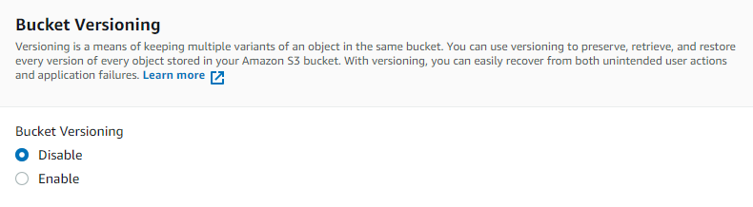



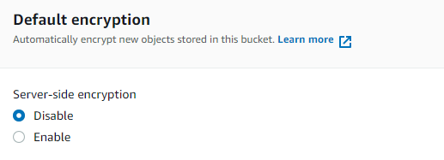



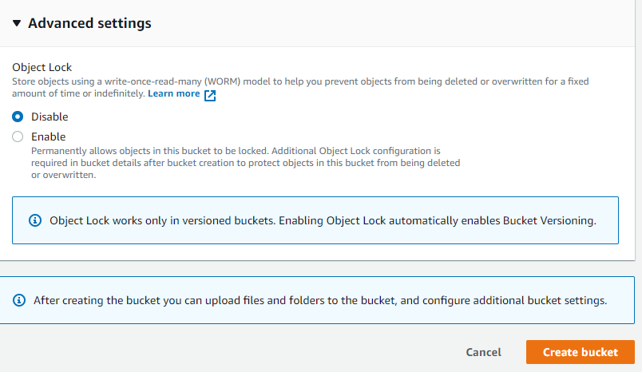



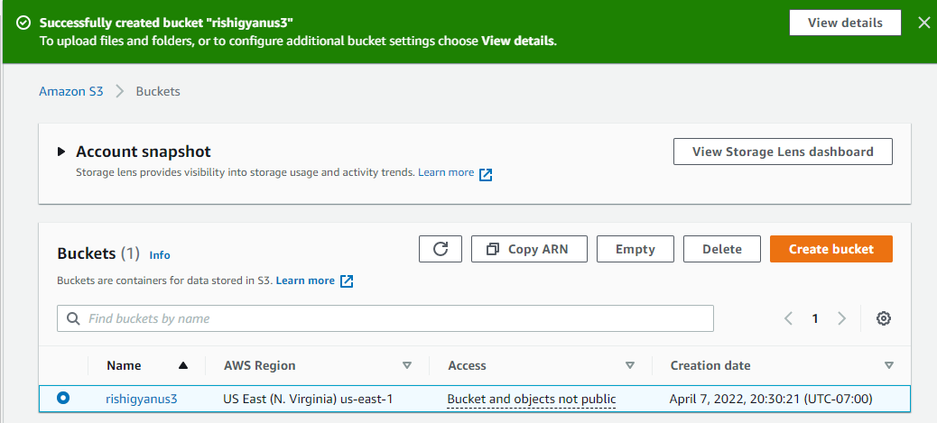



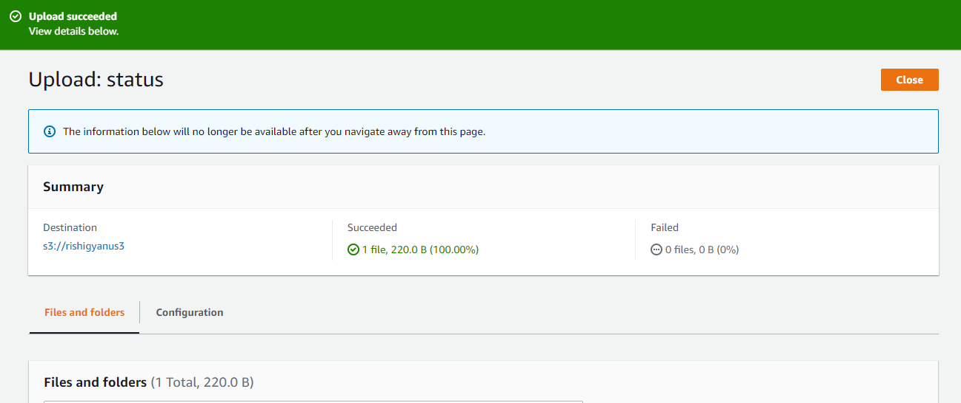

**1.2 Now i have to create cloudfront .**



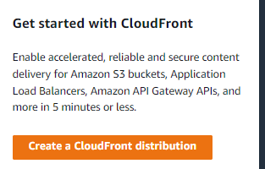

1. Origin domain name is same s3 bucket name which i created “rishigyanus3.s3.us-east-1.amazonaws.com”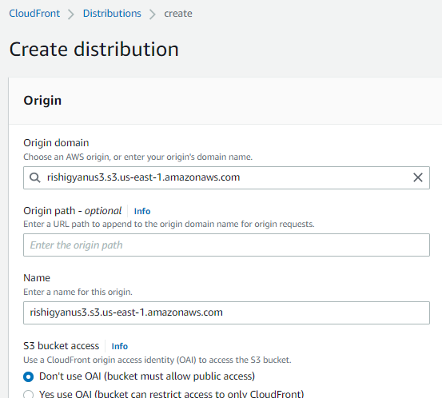

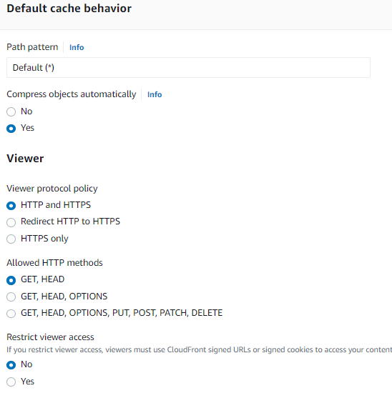



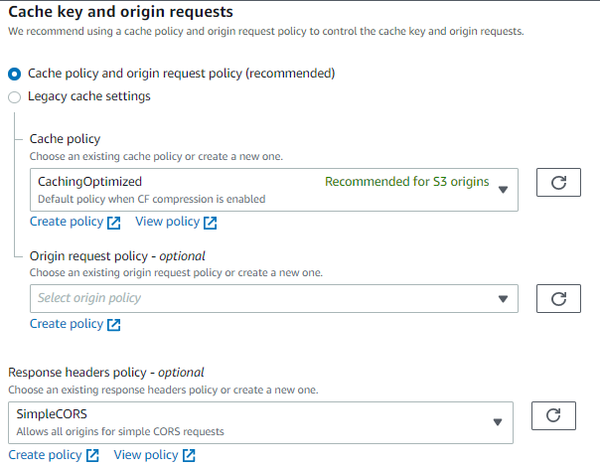



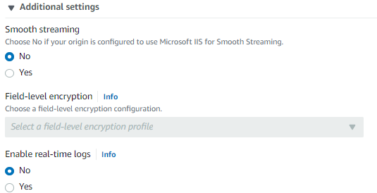











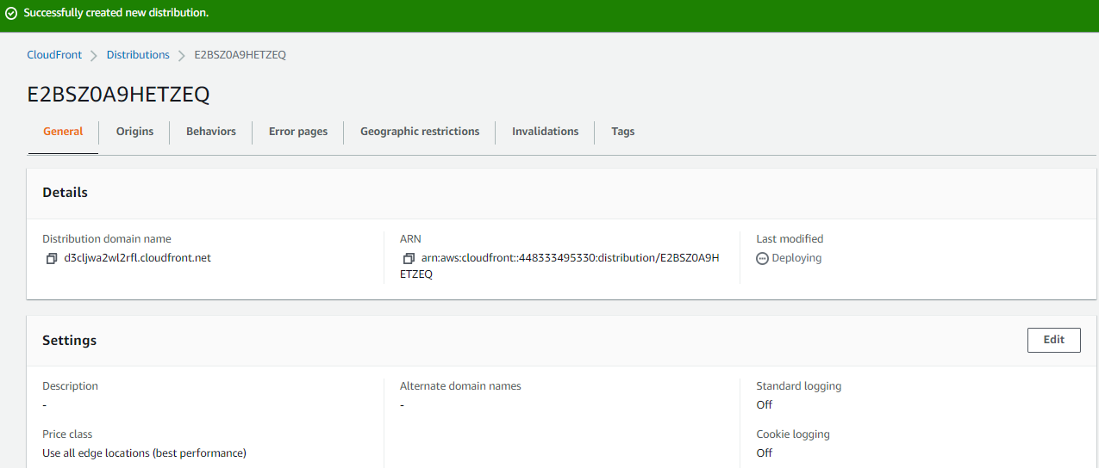



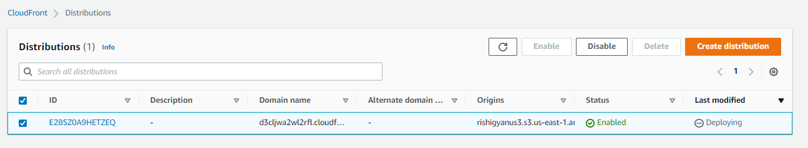

1. Error page is when somebody search wrong then it show which we creates.

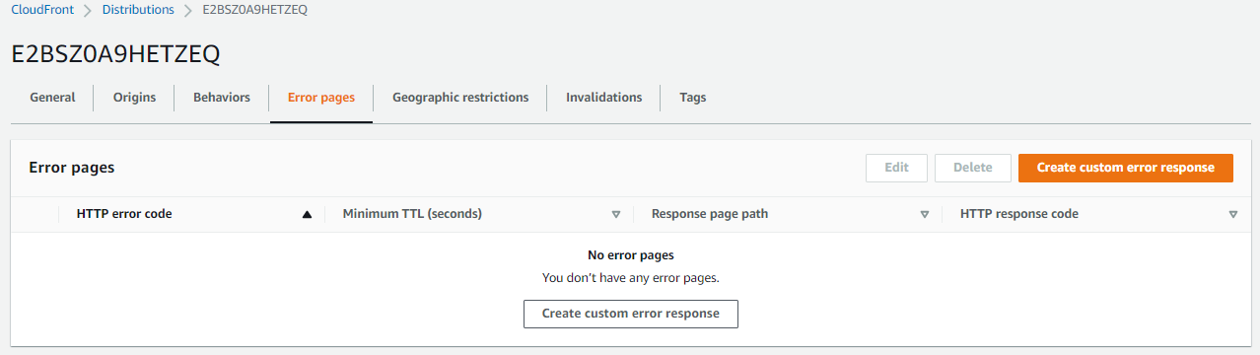

1. Geographic restriction it allow to access from the country which country allow or denied.

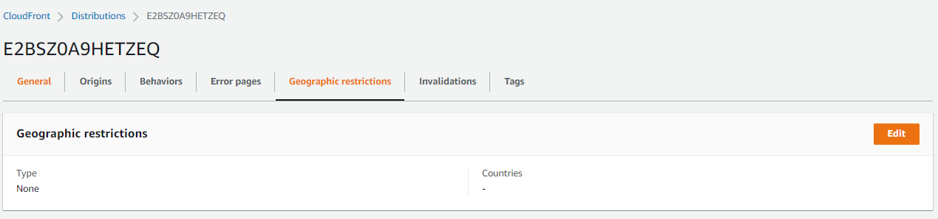



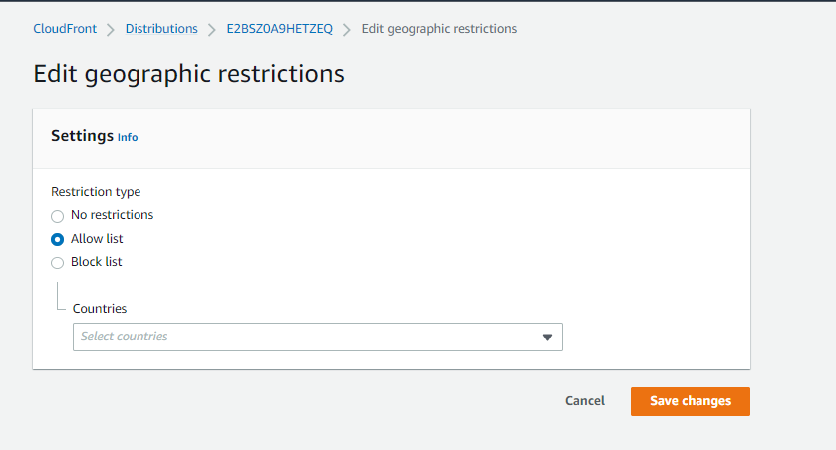



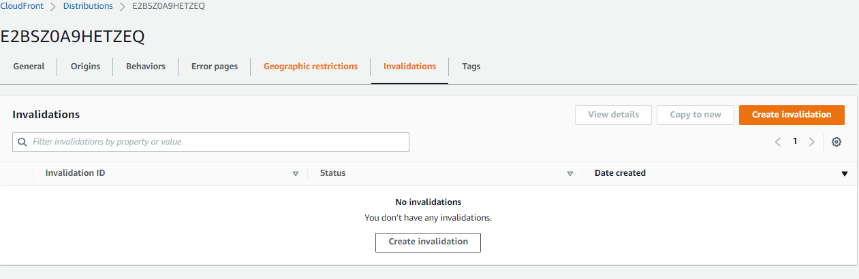

1. 