1. **Network Load balancer**

* We prefer a Network Load Balancer when we need ultra-high performance, TLS offloading at scale, centralized certificate deployment, support for UDP, and static IP addresses for your applications.
* Operating at the connection level, Network Load Balancers are capable of handling millions of requests per second securely while maintaining ultra-low latencies.

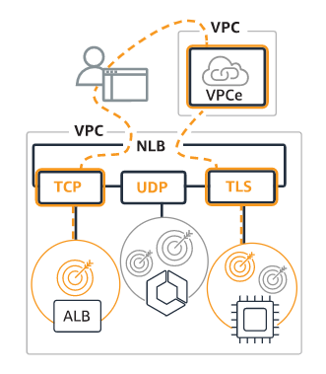

**1.1 Target group**

* Target groups in this list that do not yet have a load balancer associated can be

associated to either a new or existing load balancer using those actions in the

actions menu.

* Associating to a new load balancer will take you to a load balancer creation

form prefilled with the corresponding VPC, Zones, subnets, and listener default

* target group.
* Associating to an existing load balancer takes you to the list of load balancers

you can choose from based on your target group’s protocol. From there, you will need to check the load balancer’s listeners and routing and either add a new

listener or edit an existing listener to route traffic to the target group.

* If you need to adjust which load balancer is routing traffic to a target group, you will first need to remove the target group from the existing load balancer’s routing (via listeners and rules) and then add the target group to the desired load balancer via its listeners or listener rules.

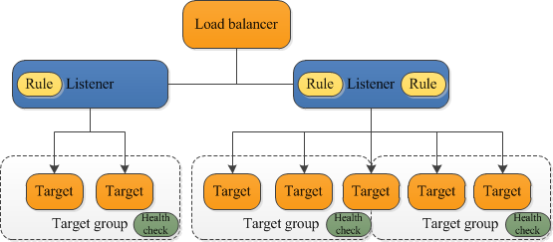

**1.2** **First of all i am going to launch two instances at different availability**

**zone but in same region.**

* login aws account  **>** ec2 management console **>** services **>** ec2





1. 

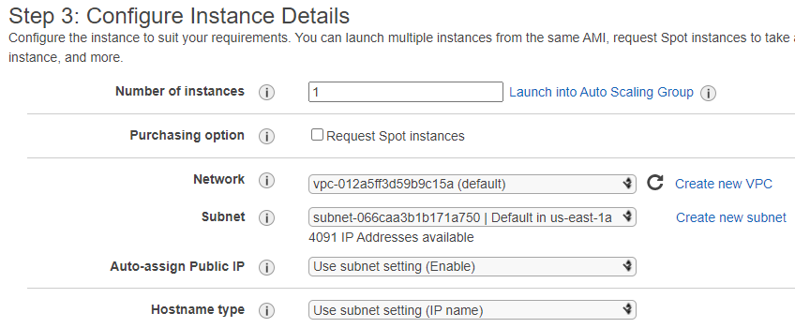



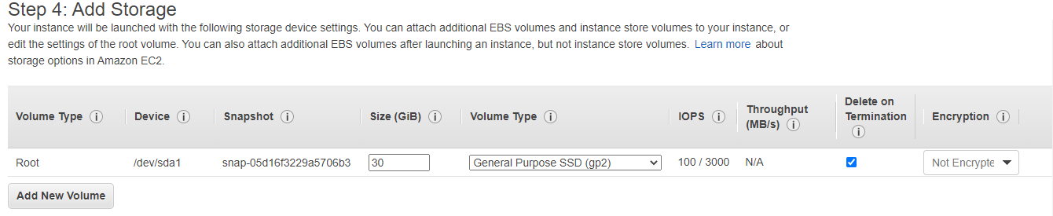



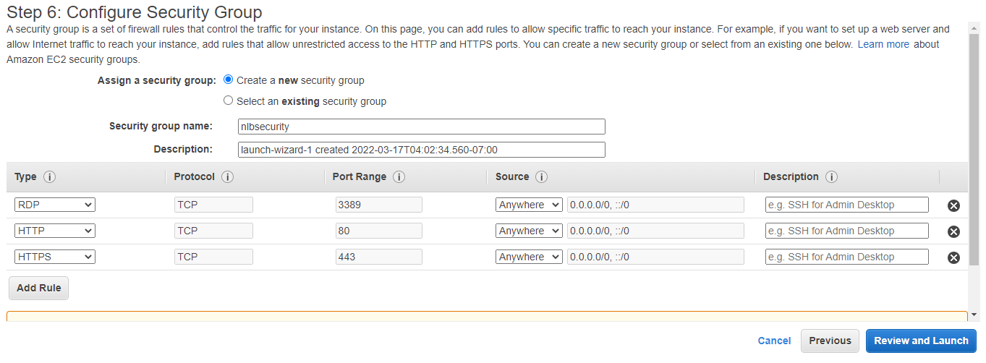



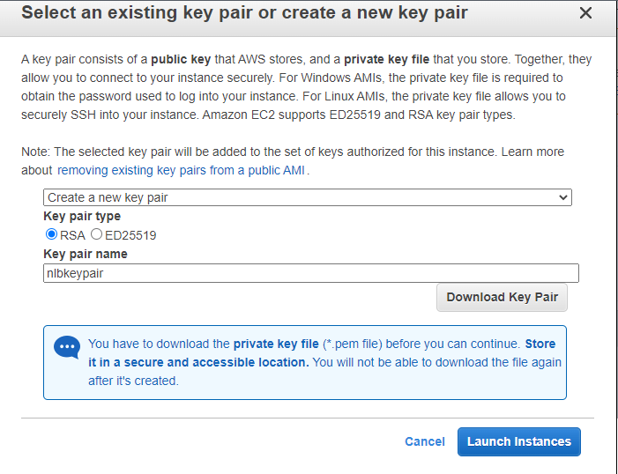

1. First instance is successfully done it status show running .



1. Now i am going to take RDP to connect to the webserver.

* Select instance **>** action **>** RDP client **>** download rdp file **>**  Get password **>** select from where it located in file **>** decrypt **>** open rdp file **>** open **>** connect **>** put password which decrypted **>** and again connect.
* After connect to the server install window server IIS
* Server manager **>** add rules and features **>** installation type **>** add window server IIS **>**  make a index.html file in root volume.

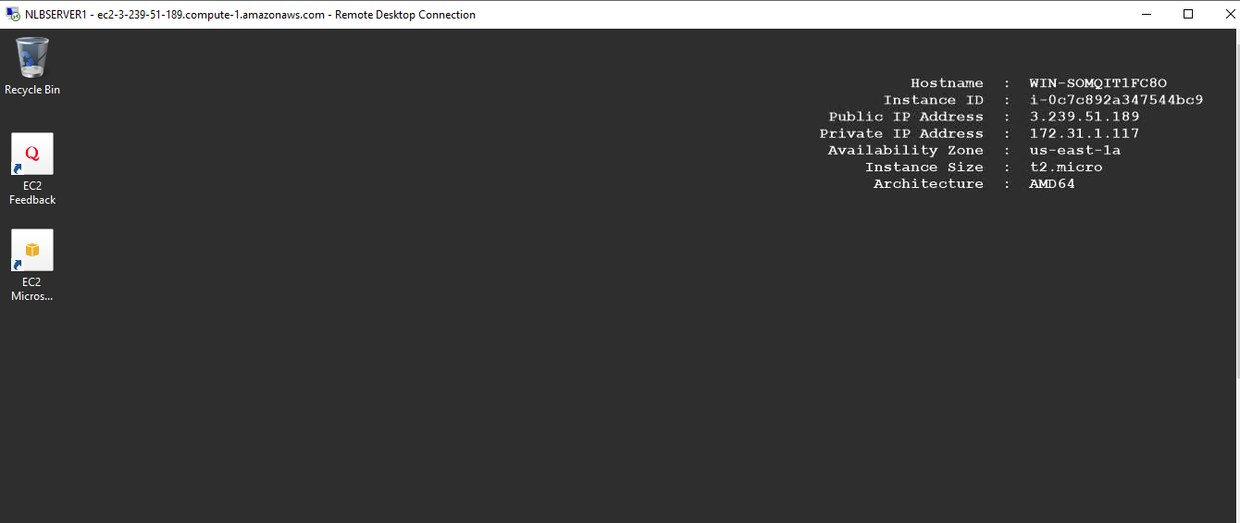



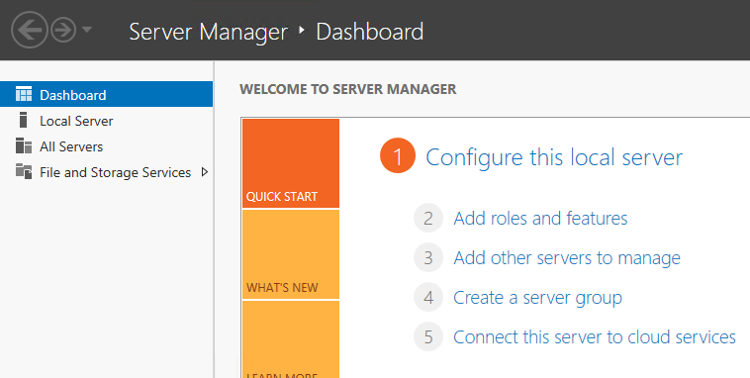



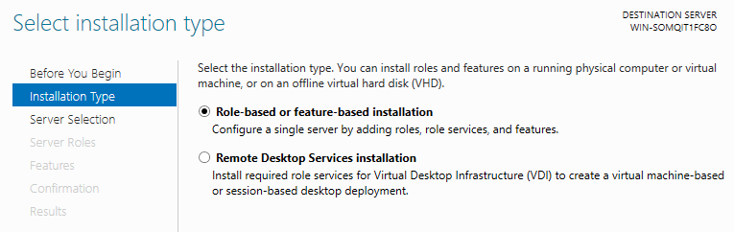



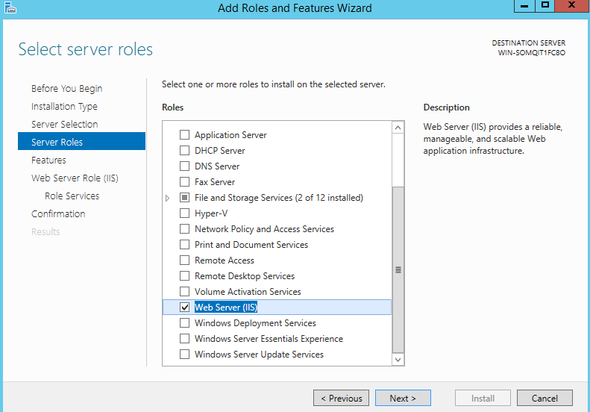



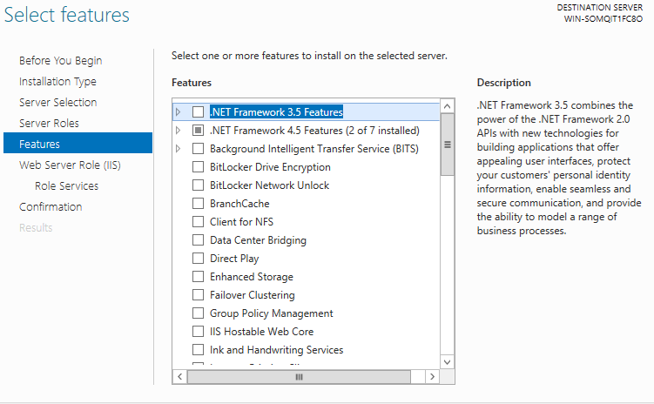



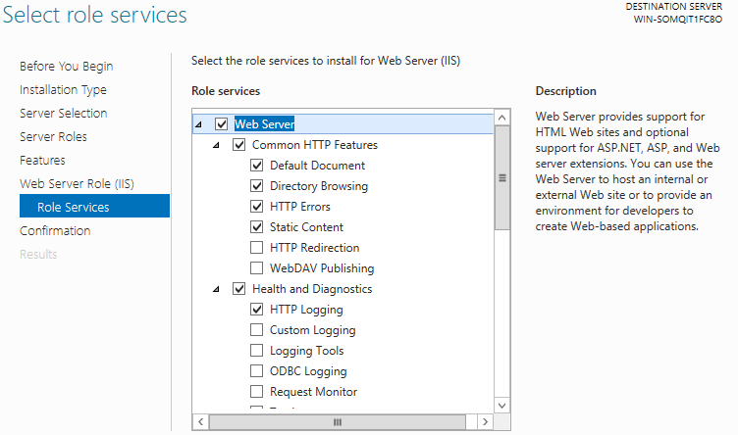



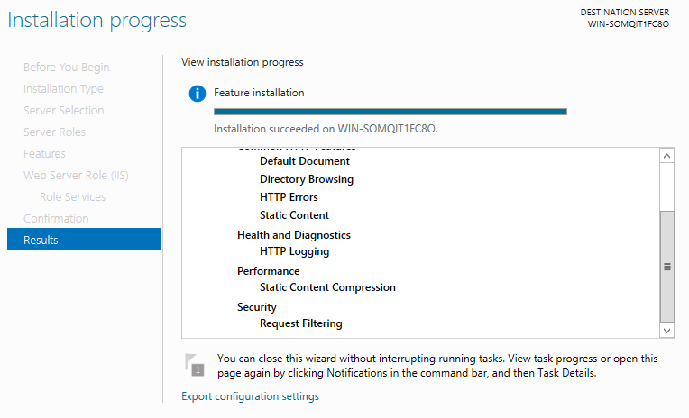



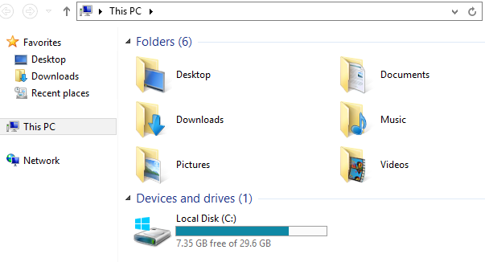



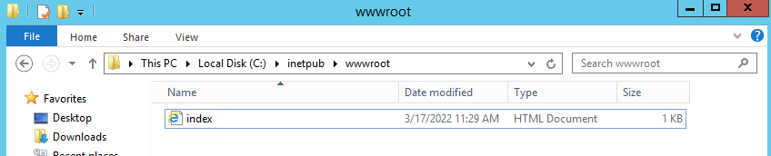

**1.3 Now i am going to launch second instance at availability zone us-east-1b**





1. 

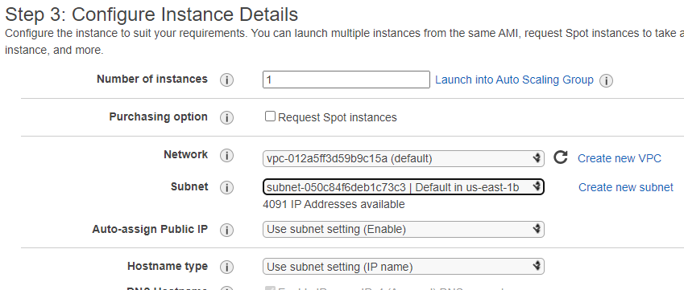



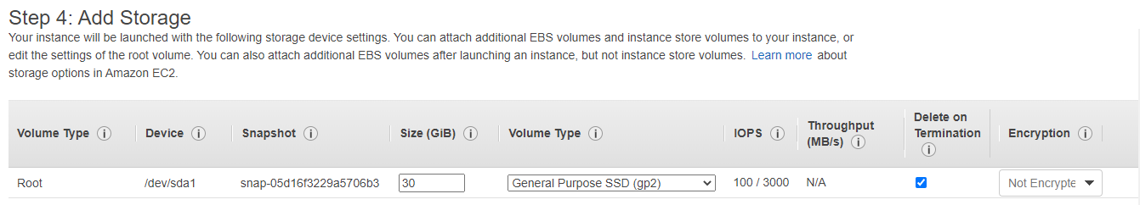



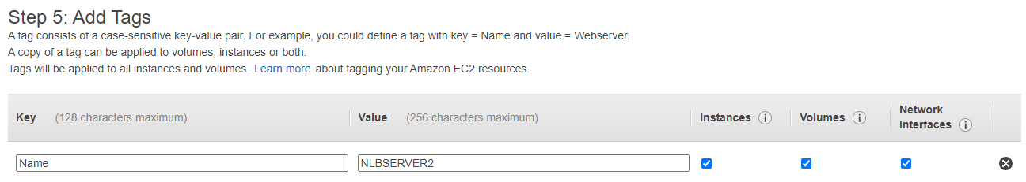

2. 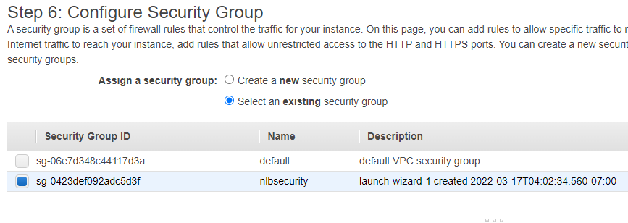

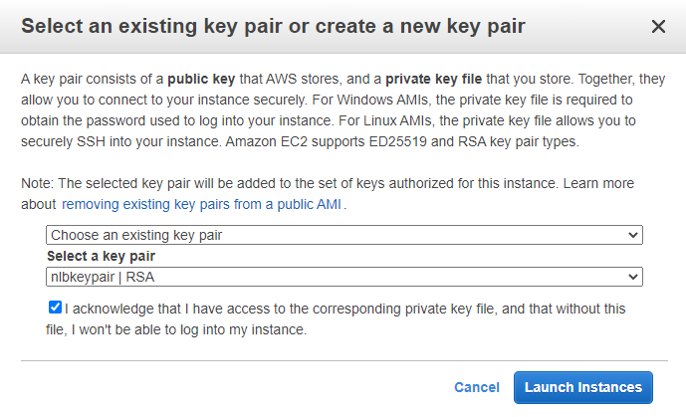

1. Second instance is successfully done.

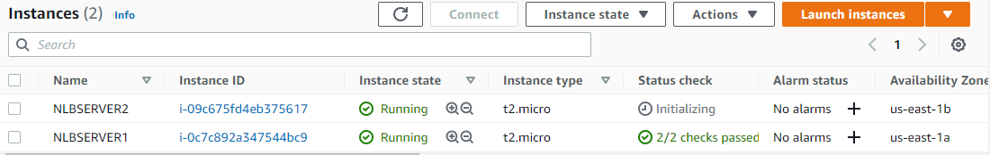

1. Now i am going to take RDP to connect to the webserver.

* Select instance **>** action **>** RDP client **>** download rdp file **>**  Get password **>** select from where it located in file **>** decrypt **>** open rdp file **>** open **>** connect **>** put password which decrypted **>** and again connect.
* After connect to the server install window server IIS
* Server manager **>** add rules and features **>** installation type **>** add window server IIS **>**  make a index.html file in root volume.

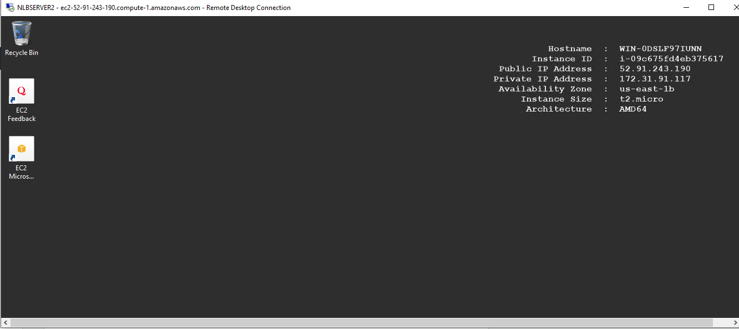



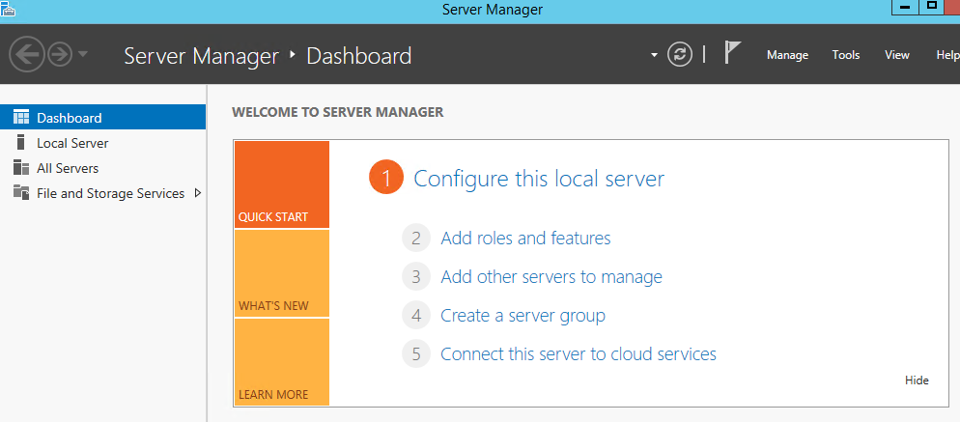



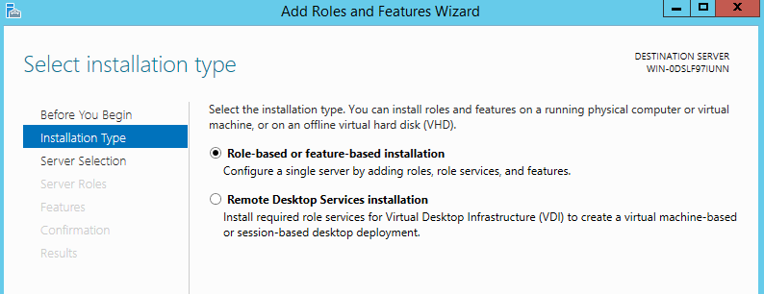

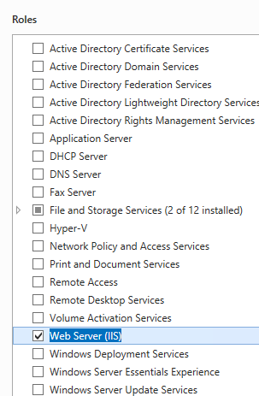



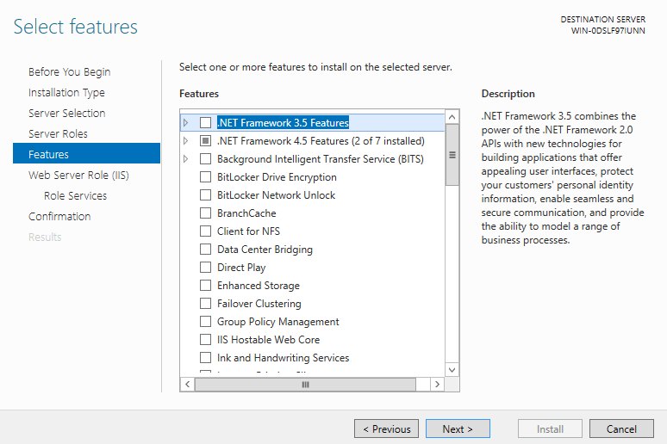



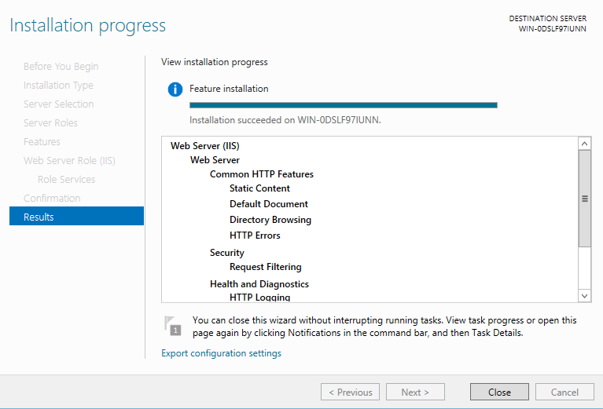



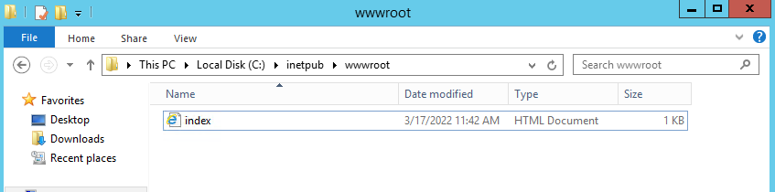

**1.4 Network load balancer**

* Service **>** ec2 **>** load balancer **>** create elastic load balancer **>** network load balancer



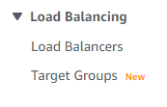



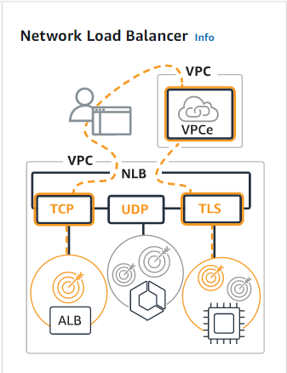



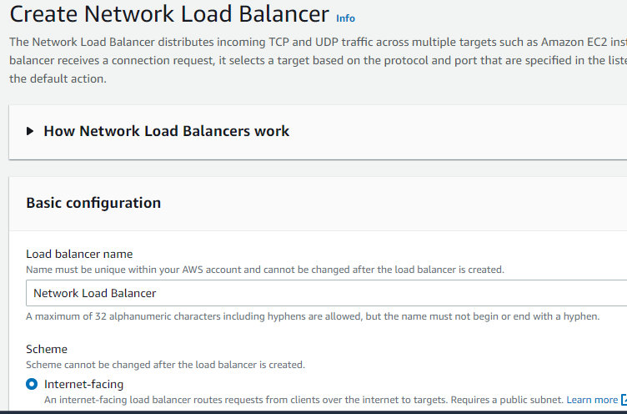



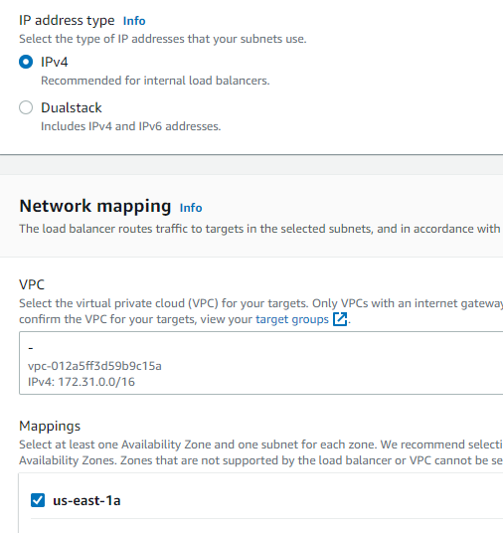

1. I selected two availability zone us-east-1a and us-east-1b

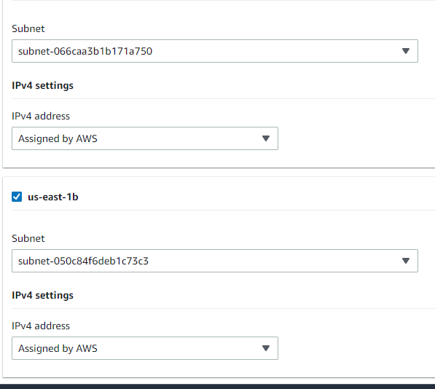

1. Its protocol TCP port no 80 .

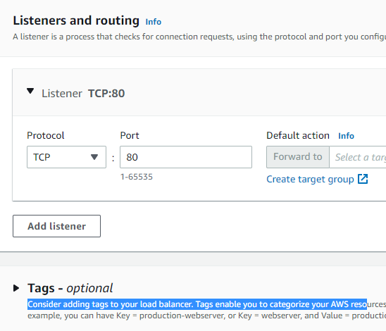



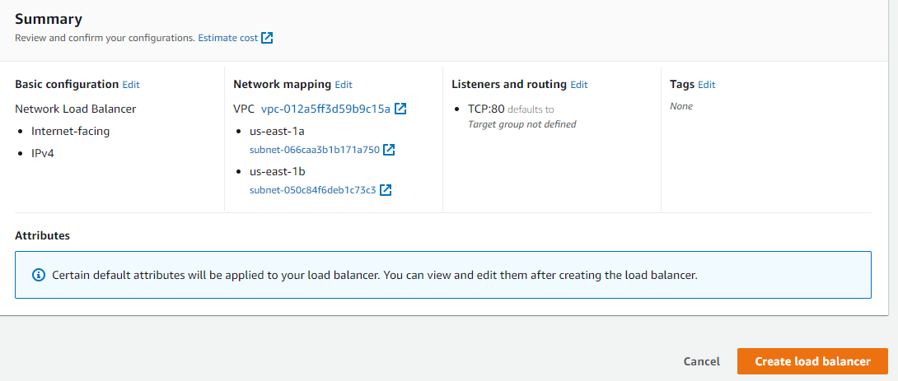

1. It successfully done of creation network load balancer.



1. Its status show active.

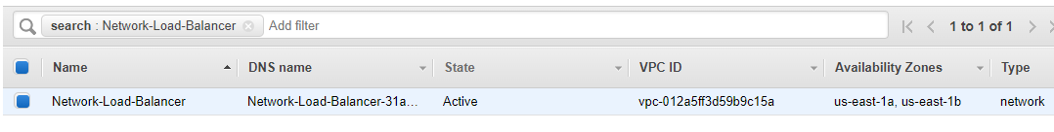

**1.5 Have to create target group and register target instances in target group.**

1. I selected IP address .

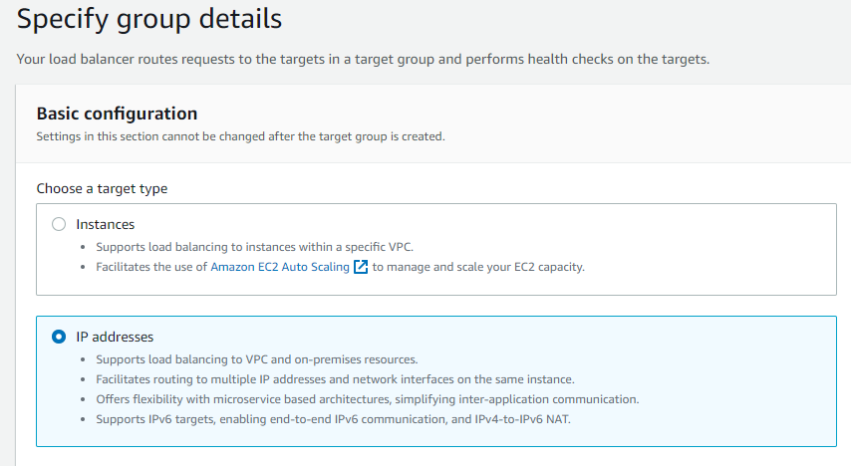

1. I selected IPv4 and default vpc.

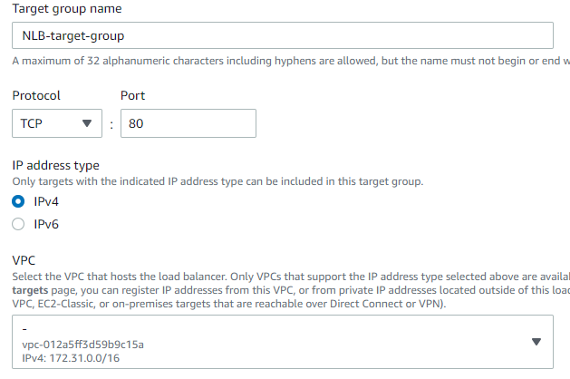

1. 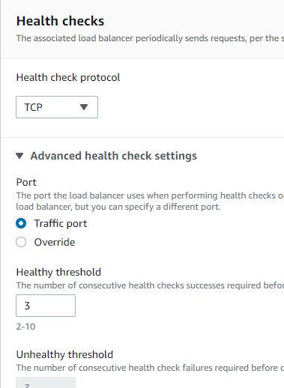
2. 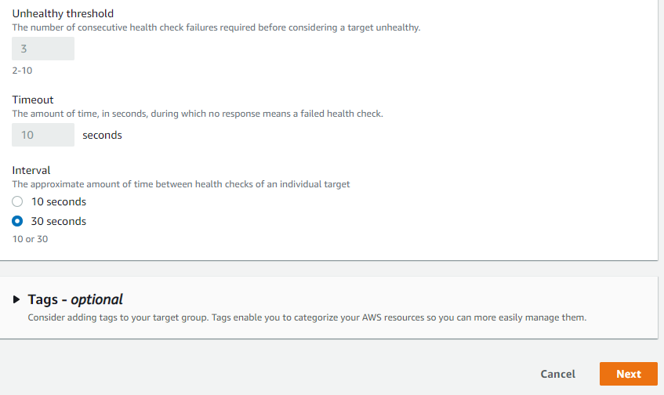
3. 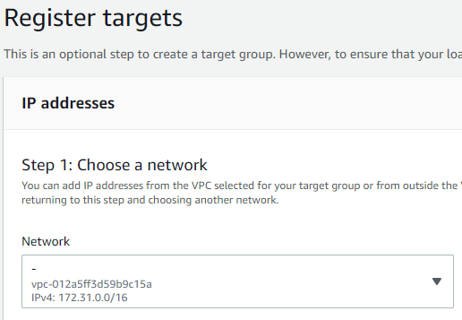
4. I selected private ip address of both instances as

server no 1 - 172.31.1.117

Server no 2- 172.31.91.117

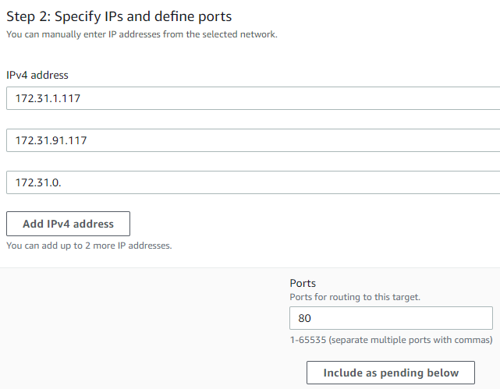

1. After to configure all this basic configuration click on create target group.

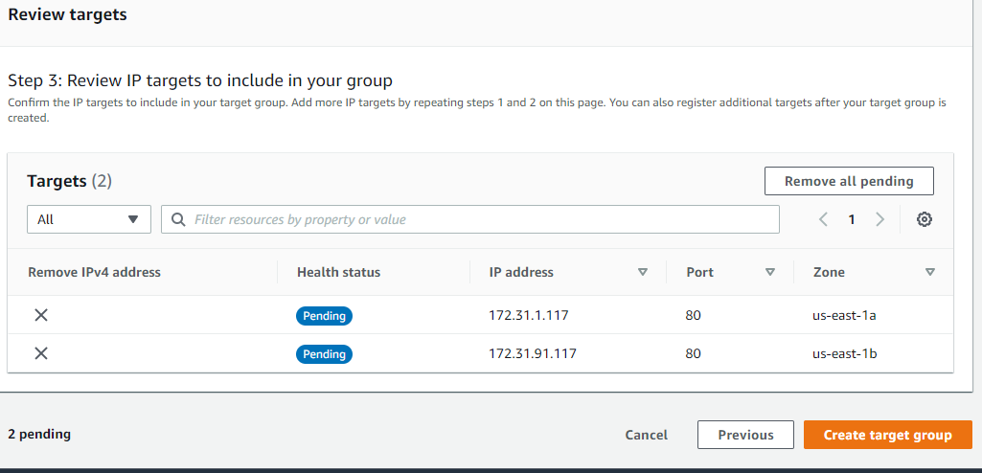

1. It is successfully done of creation target group.

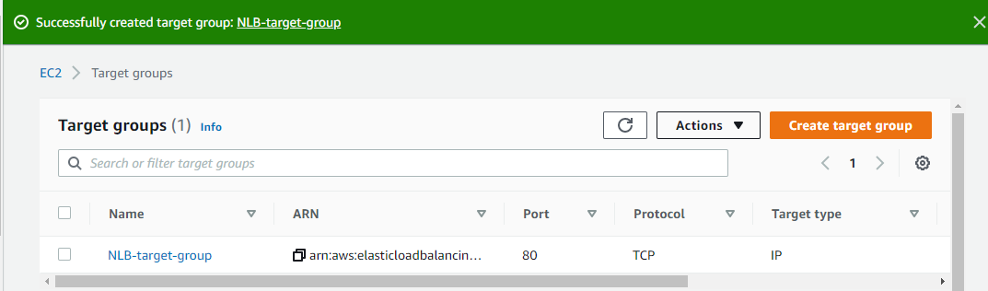

**1.6 Now i am going to copy DNS name of load balancer and open new window**

**to search. here we check NLB does it send the request to the both**

**availability zone or not**

1. Elb sent the request at us-east-1b

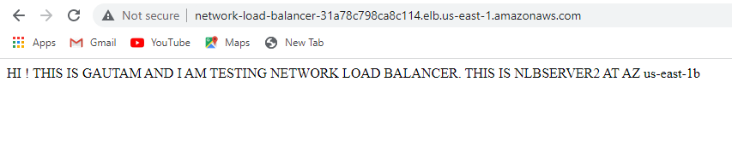

1. Perfect it sent the request at us-east-1a

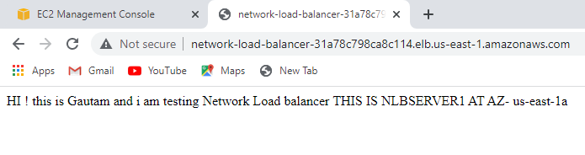

Lab successfully have done