* **Github**
* It is a provider of Internet hosting for software development and version control using Git. It offers the distributed version control and source code management functionality of Git, plus its own features.
* Everyone maintain a local repository of their own which contains all the files and metadata present in main repository.

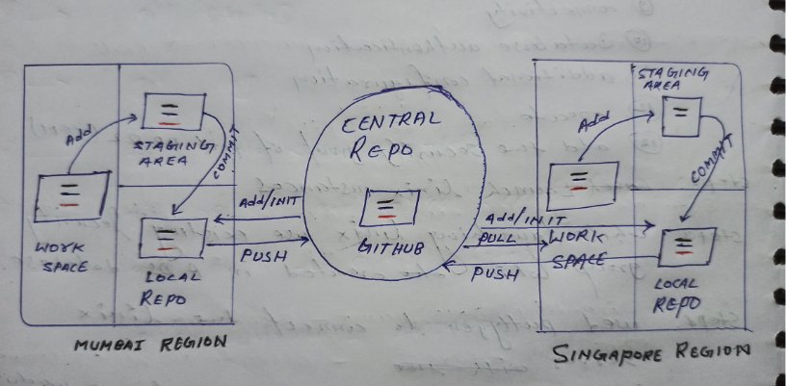

1. **Create two ec2 linux instances at two different region and connect to them with the help of putty.**
2. First Instance at mumbai region.

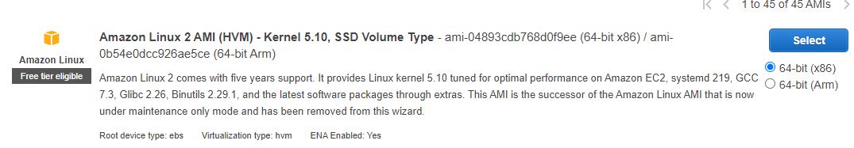





2. 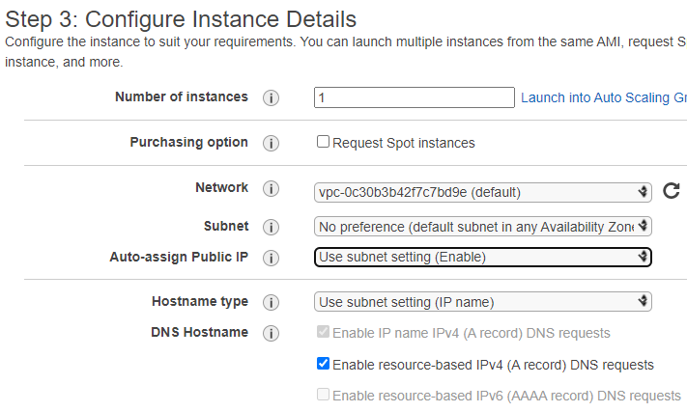
3. 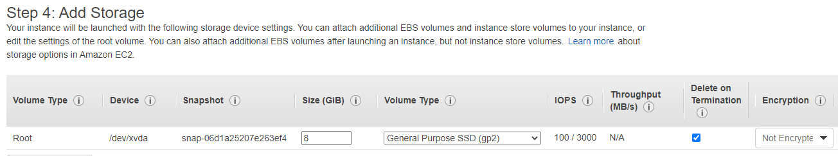

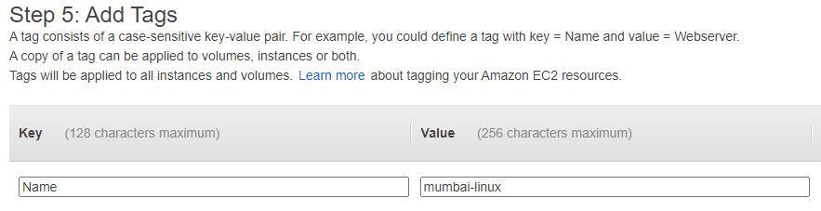



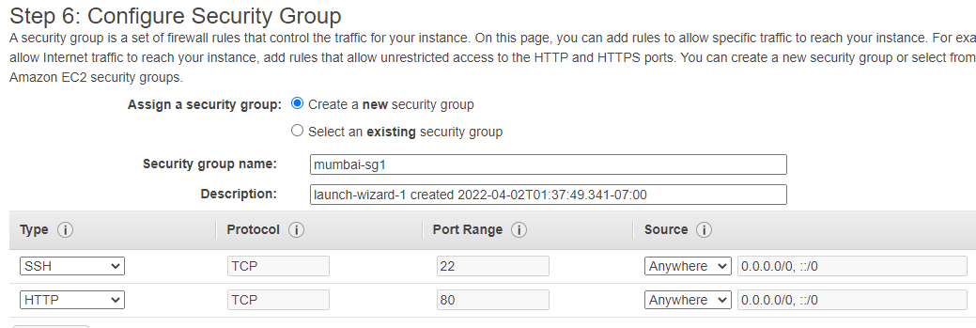

2. My first instance successfully launched.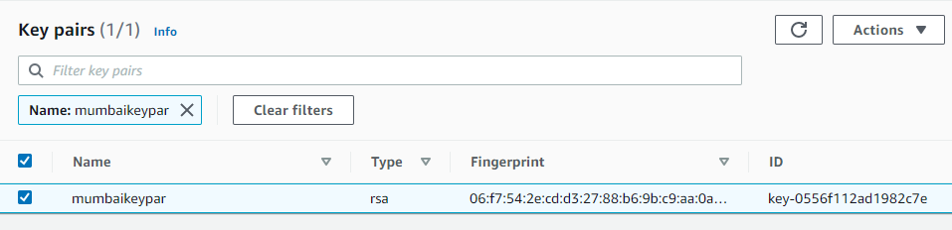

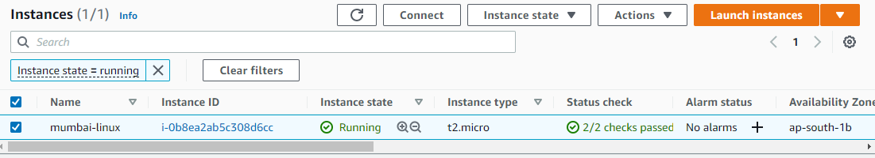

**1.1 Puttygen**

1. Now i am going to connect to the server.



2. Open puttygen **>** load **>** select the keypair .PEM file **>** load **>** save the private key.

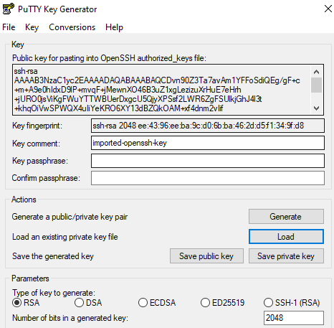

**1.2 Putty**





1. Put the public ip on putty.



1. Open putty > put public ip > SSH > auth > browse .ppk file which get from puttygen.

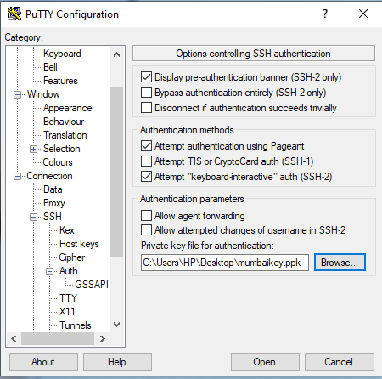

1. Click on accept .

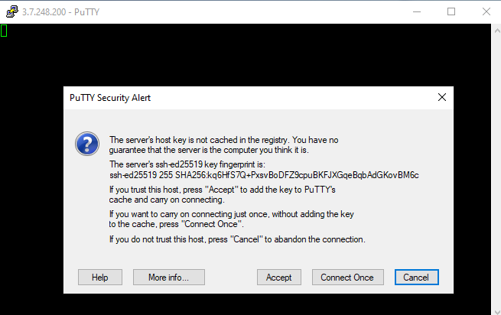

1. Successfully one text file push on github .

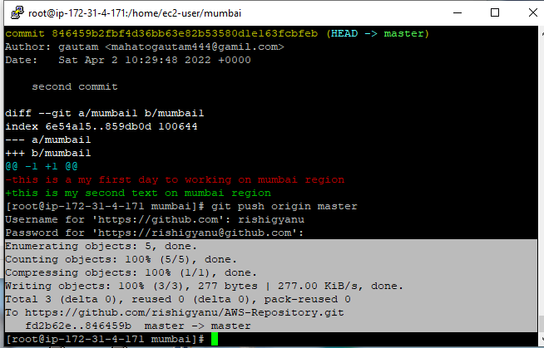

**Command line**

* Ec2-user (login)
* sudo su (as root user)
* yum update -y (to update the package)
* yum install git -y (to install git on server)
* which git ( to check is it install or not )
* git --version ( to check git version )
* git config --global user.name “gautam”
* Git config --global user.email “[mahatogautam444@gmail.com](mailto:mahatogautam444@gmail.com)”
* mkdir mumbai ( to create a directory)
* Cd mumbai ( to get in side)
* git init ( to connect directory with github )
* cat >mumbai1 ( to create a mumbai1 file and write something or

code )

* cntrld ( to exit)
* git status ( to check status )
* git add . ( to add or recognise the file which created )
* git commit -m “description about commit”
* git log ( to check what is committed )
* git show<commit id more than 7 no>
* git remote add origin <central git url>
* git push origin master
* User id
* personal access token instead of password.

**1.3 Second linux instance at singapore region.**



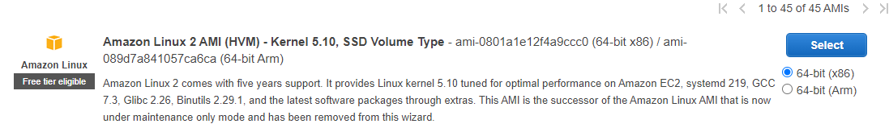







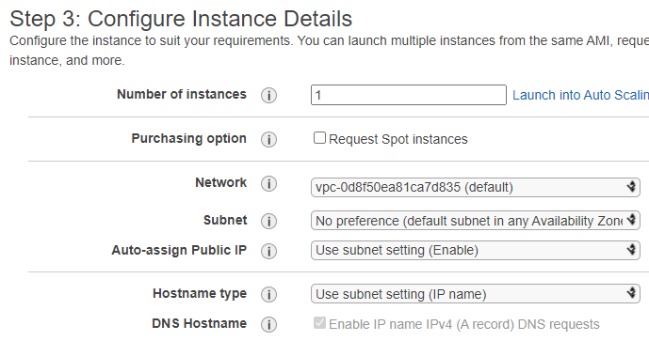



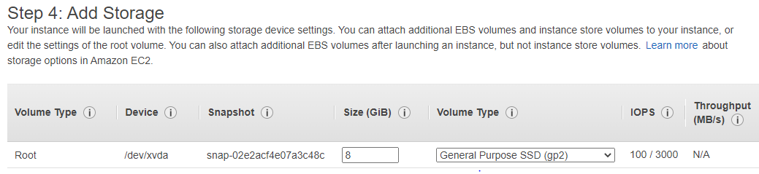



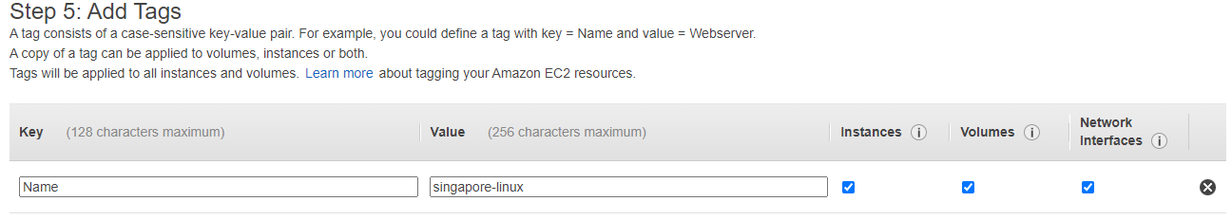



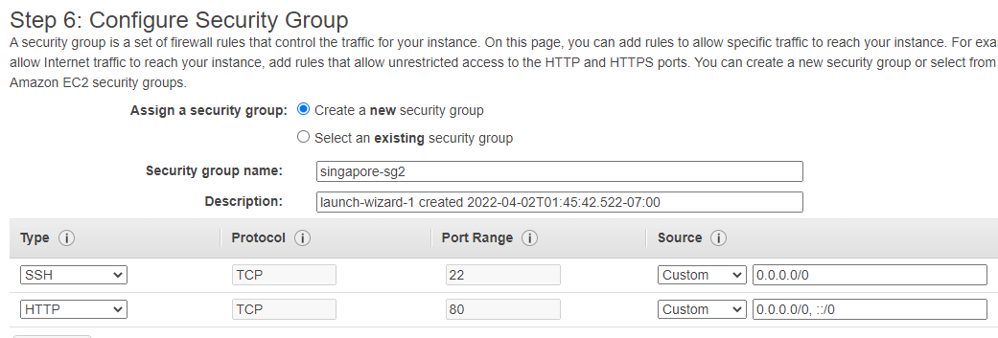



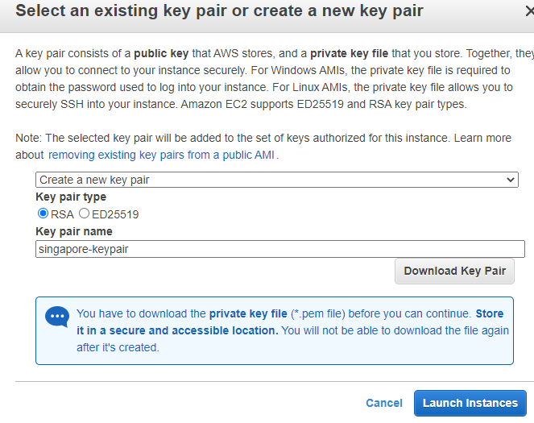



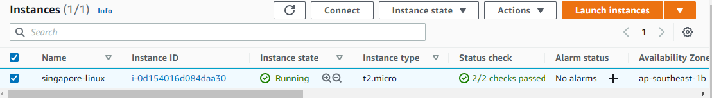

**1.4 Puttygen**

1. Puutygen > load > select pem keypair > save private key.

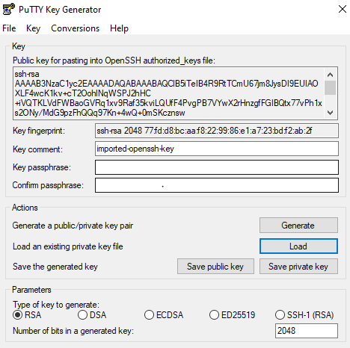

**1.5 Putty**

1. Put public ip on putty.



1. Open putty > put public ip > ssh > auth > browse select .ppk file > open.

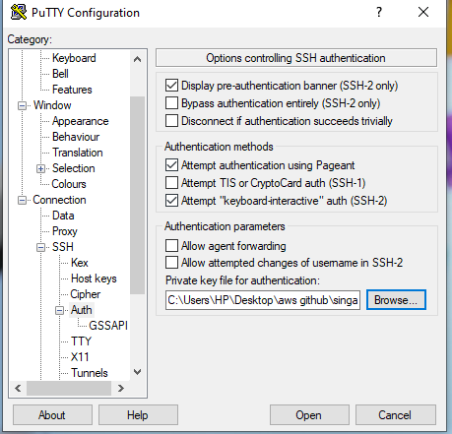

1. Click on accept

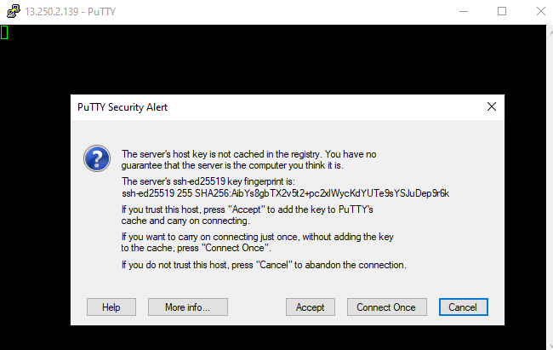

1. Install git on server.

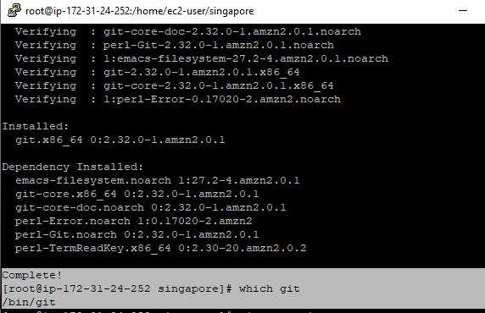

1. git init

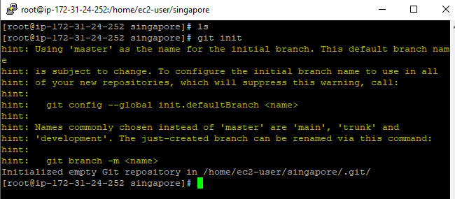







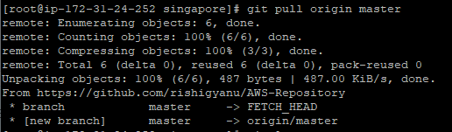



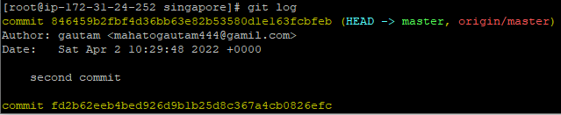



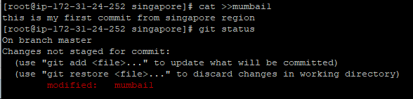



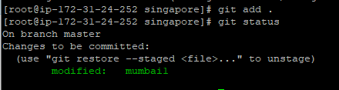



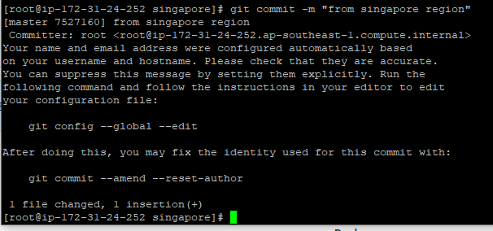



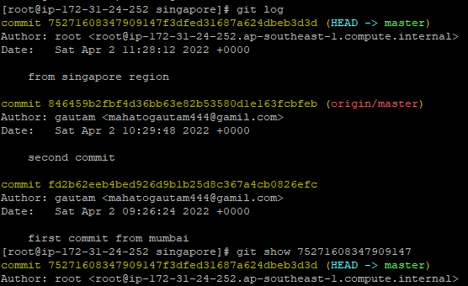



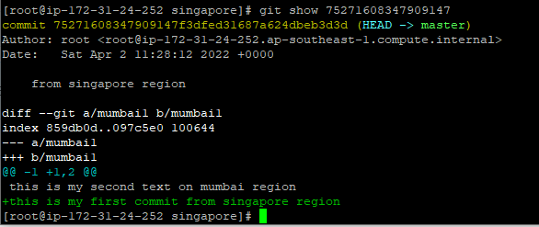

1. It successfully push on github.

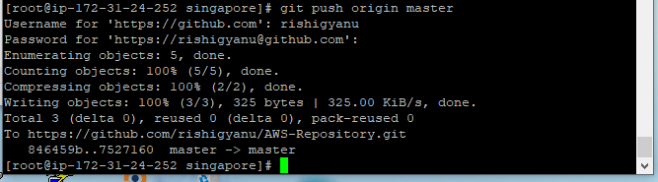

**Command line**

* Ec2-user (login)
* sudo su (as root user)
* yum update -y (to update the package)
* yum install git -y (to install git on server)
* which git ( to check is it install or not )
* git --version ( to check git version )
* git config --global user.name “gautam”
* Git config --global user.email “[mahatogautam444@gmail.com](mailto:mahatogautam444@gmail.com)”
* mkdir singapore ( to create a directory)
* cd singapore ( to get in side)
* git init ( to connect directory with github )
* git remote add origin <central git url>
* git pull origin master ( to pull committed from mumbai region )
* git log ( to check what is committed )
* git show <commit id more than 7 no>
* cat >mumbai1 ( to create a mumbai1 file and write something or

code )

* cntrld ( to exit)
* git status ( to check status )
* git add . ( to add or recognise the file which created )
* git commit -m “description about commit”
* git status
* git log ( to check what is committed )
* git push origin master
* User id
* personal access token instead of password.

**THANK YOU**