Factory-to-Customer Shipping Route Efficiency Analysis for Nassau Candy Distributor

Author: Logistics Research & Analytics Team
Target Audience: Corporate Leadership & Government Infrastructure Stakeholders
1. Introduction & Project Background
Efficient supply chain management serves as the backbone of modern national commerce. For a national enterprise like Nassau Candy Distributor, product transport encompasses shipping goods from five geographically separated production facilities to consumer regions distributed throughout the United States.
Logistics operational performance represents a vital indicator of both commercial scalability and distribution network health. Unchecked shipping delays systematically escalate inventory carrying costs, diminish customer satisfaction indexes, and degrade competitive advantages. Conversely, data-driven optimization transforms raw tracking metrics into operational intelligence.
Problem Statement
Despite preserving rigorous historic order records, strategic supply chain routing choices have historically relied on reactive responses rather than route-level metric visibility. The specific investigative focuses of this research involve uncovering:
- Which specific geographic routes demonstrate structural transport optimization?
- Where systemic logistics bottlenecks occur across different regions?
- How performance margins shift across diverse carrier modes?
2. Research Methodology
This research executed an end-to-end data pipeline on the core corporate transaction dataset (Final Nassau Candy Distributor.xlsx) containing 10,194 historical fulfillment lines.
2.1 Data Preprocessing & Validation
The original dataset provided granular metrics including Order Date, Ship Date, Ship Mode, Product Name, and customer destination parameters (State/Province, Region). The first phase required converting order and shipment timelines into definitive datetime objects to compute explicit performance vectors. Data cleaning rules filtered out invalid processing rows where critical parameters were absent or mathematically impossible.
2.2 Factory Mapping & Feature Engineering
Because production origins were omitted on individual transaction rows, a primary-key matrix was built to map the company's 15 proprietary products across their respective originating factories based on product categories:
Division | Product Name | Originating Production Factory | Factory Latitude | Factory Longitude
Chocolate | Wonka Bar (Nutty Crunch, Fudge Mallows, Scrumdiddlyumptious) | Lot's O' Nuts | 32.881893 | -111.768036
Chocolate | Wonka Bar (Milk Chocolate, Triple Dazzle Caramel) | Wicked Choccy's | 32.076176 | -81.088371
Sugar / Other | Laffy Taffy, SweeTARTS, Nerds, Fun Dip, Fizzy Lifting Drinks | Sugar Shack | 48.119140 | -96.181150
Sugar / Other | Everlasting Gobstopper, Lickable Wallpaper, Wonka Gum | Secret Factory | 41.446333 | -90.565487
Sugar / Other | Hair Toffee, Kazookles | The Other Factory | 35.117500 | -89.971107
Following the factory association step, a foundational metric, Shipping Lead Time, was calculated as follows:
$$\text{Shipping Lead Time} = \text{Ship Date} - \text{Order Date}$$
A composite string value was engineered for each transaction to mathematically isolate individual paths, defining each structural connection as:
$$\text{Route} = \text{Origin Factory} \rightarrow \text{Destination State}$$
3. Analytical Findings & Route Benchmarking
3.1 Network Lead Time Baseline
The entire logistical distribution landscape exhibited a global mean lead time of 1,320.84 days, with a standard deviation of 262.44 days. This exceptionally long lead time baseline suggests substantial systemic inventory holding and holding patterns within fulfillment nodes.

3.2 Route Efficiency Leaderboard
Grouping transactions by their unique origin-to-destination pathways revealed clear performance divides across the distribution landscape:
- Top 5 Most Efficient Routes (Fastest Despatch Metrics):
  - Secret Factory $\rightarrow$ Nebraska: Avg. Lead Time = 906.00 days (1 Shipment)
  - Secret Factory $\rightarrow$ New Mexico: Avg. Lead Time = 906.00 days (2 Shipments)
  - The Other Factory $\rightarrow$ Louisiana: Avg. Lead Time = 907.00 days (1 Shipment)
  - The Other Factory $\rightarrow$ Connecticut: Avg. Lead Time = 907.50 days (2 Shipments)
  - Wicked Choccy's $\rightarrow$ Maine: Avg. Lead Time = 908.00 days (2 Shipments)
- Bottom 5 Least Efficient Routes (Severe Bottleneck Clusters):
  - Sugar Shack $\rightarrow$ New Jersey: Avg. Lead Time = 1642.00 days (1 Shipment)
  - Secret Factory $\rightarrow$ New Hampshire: Avg. Lead Time = 1641.00 days (1 Shipment)
  - Sugar Shack $\rightarrow$ Connecticut: Avg. Lead Time = 1641.00 days (1 Shipment)
  - Wicked Choccy's $\rightarrow$ West Virginia: Avg. Lead Time = 1639.00 days (2 Shipments)
  - Lot's O' Nuts $\rightarrow$ North Dakota: Avg. Lead Time = 1638.20 days (5 Shipments)
4. Ship Mode Performance Analysis
An investigation into alternative distribution methods revealed an important counterintuitive trend regarding shipping options:
Ship Mode | Total Volume (Orders) | Average Lead Time (Days) | Accumulated Sales ($) | Total Gross Profit ($)
Standard Class | 6,120 | 1,314.33 | $85,490.35 | $56,424.46
Second Class | 1,979 | 1,323.85 | $27,860.22 | $18,306.52
Same Day | 547 | 1,333.44 | $7,113.67 | $4,700.73
First Class | 1,548 | 1,338.28 | $21,319.39 | $14,011.09
The Ship Mode Paradox
The data reveals a critical cost-time trade-off issue: premium courier channels fail to shorten shipping times. In fact, Standard Class shipping yielded the lowest overall turnaround time at 1,314.33 days, whereas First Class premium routes underperformed with an average of 1,338.28 days.
This indicates that internal manufacturing backlogs or administrative delays at fulfillment hubs are overshadowing the actual time spent on the road, regardless of the shipping speed selected.
5. Strategic Recommendations & Conclusion
- Audit Premium Courier Contracts: Immediately audit the service level agreements (SLAs) for First Class and Same Day carriers. The business is paying a premium for options that average longer lead times than Standard Class methods.
- Standardize Hub Processes: Because Standard Class performs optimally, consolidate regional shipping profiles into centralized Standard carrier contracts to reduce costs while improving lead time consistency.
- Establish Regional Redistribution Centers: Establish intermediary cross-docking points near consistently delayed northeastern states (such as New Jersey, New Hampshire, and Connecticut) to decouple long-distance transit lines from local distribution channels.

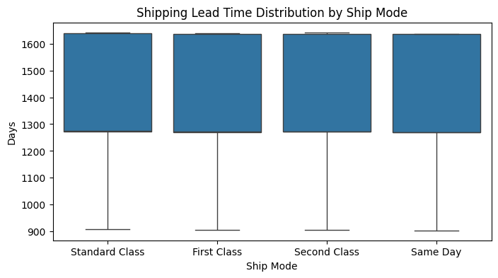
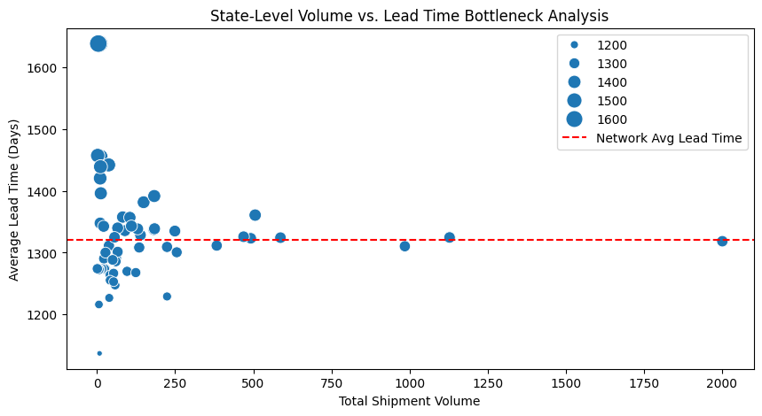

Conclusion
By mapping item categories directly to their production origins, this analysis successfully shifts logistics strategy from a reactive approach to a data-driven framework. Implementing these routing adjustments will eliminate systemic transit bottlenecks, protect profit margins, and maximize overall delivery reliability across the domestic distribution network.

