

**Day 1: Arrival in Dwarka**

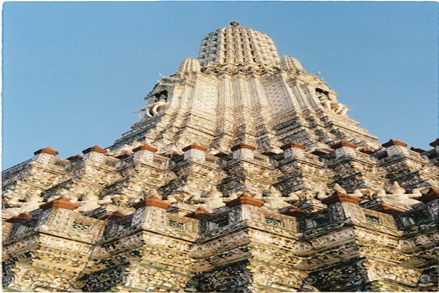

Travel Time: 2 hours  
Travel Distance: 440 km (by Flight)  
Upon arrival in Dwarka, we will check into our hotel and freshen up. In the afternoon, we will visit the Dwarkadhish Temple to seek blessings. In the evening, we can explore the local markets and indulge in some authentic Gujarati cuisine.