

**Day 3: Journey to Somnath**

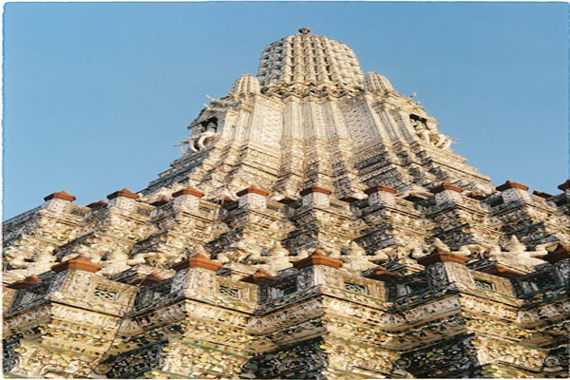

Travel Time: 3 hours  
Travel Distance: 230 km  
After breakfast, we will drive to Somnath. Upon reaching, we will visit the famous Somnath Temple, known for its architectural beauty and spiritual aura. In the evening, we can witness the mesmerizing aarti ceremony at the temple.