

**Day 4: Cultural Delights in Somnath**

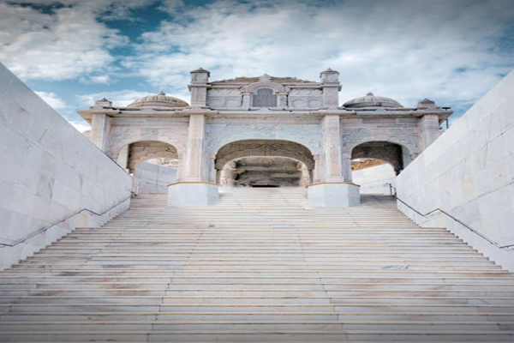

Travel Time: Not Applicable  
Today, we will explore the nearby attractions like Bhalka Tirth, Triveni Sangam, and Somnath Beach. We can also engage in some water sports activities at the beach and savor delicious seafood.