

**Day 5: Pilgrimage to Palitana**

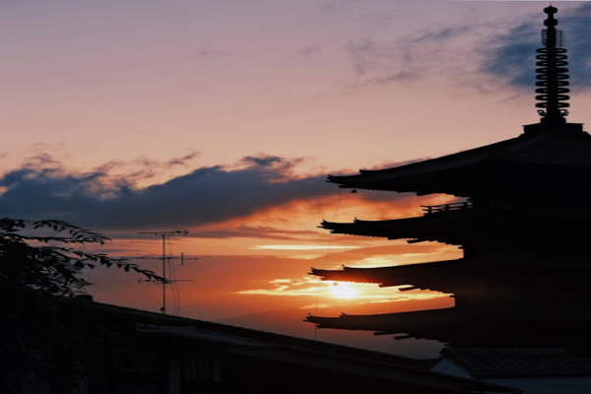

Travel Time: 6 hours  
Travel Distance: 358 km  
We will depart for Palitana, known for its Jain temples. Upon arrival, we will climb the Shatrunjaya Hill to visit the stunning Palitana Temples. The panoramic views from the hilltop are truly mesmerizing.