**9. Create a React Application named “cricketapp” with the following components:**

1. **ListofPlayers**
2. **IndianPlayers**

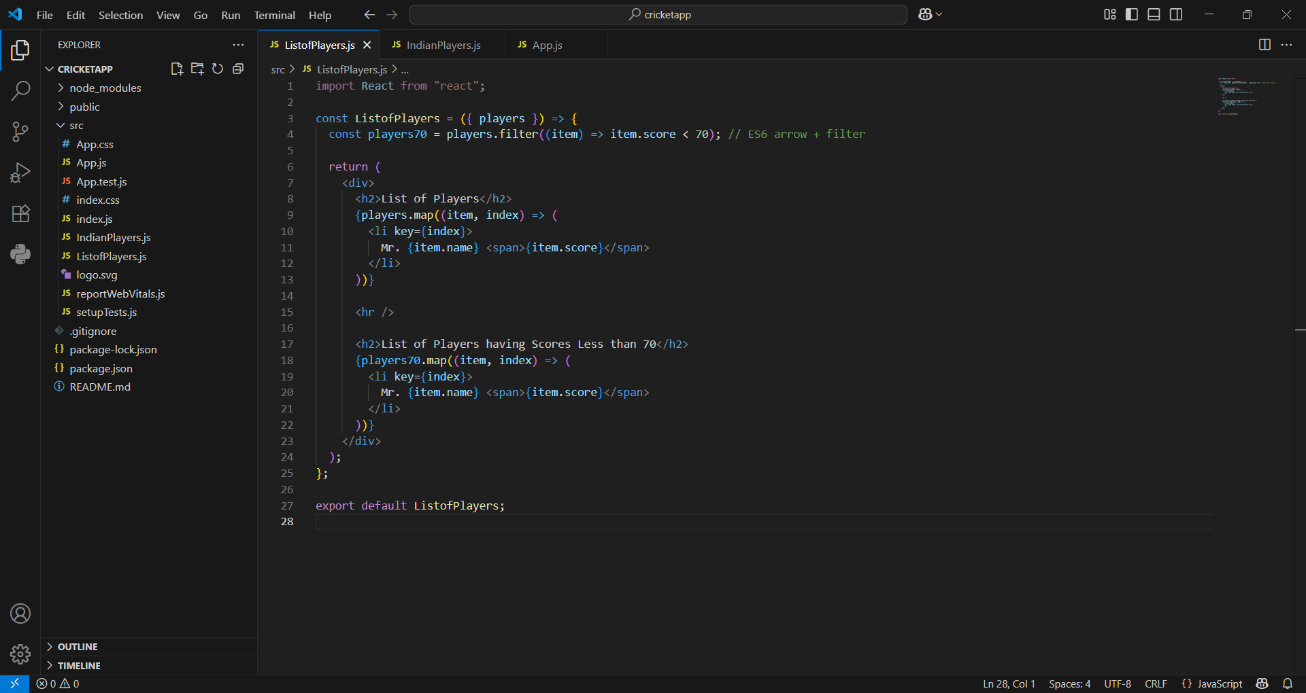

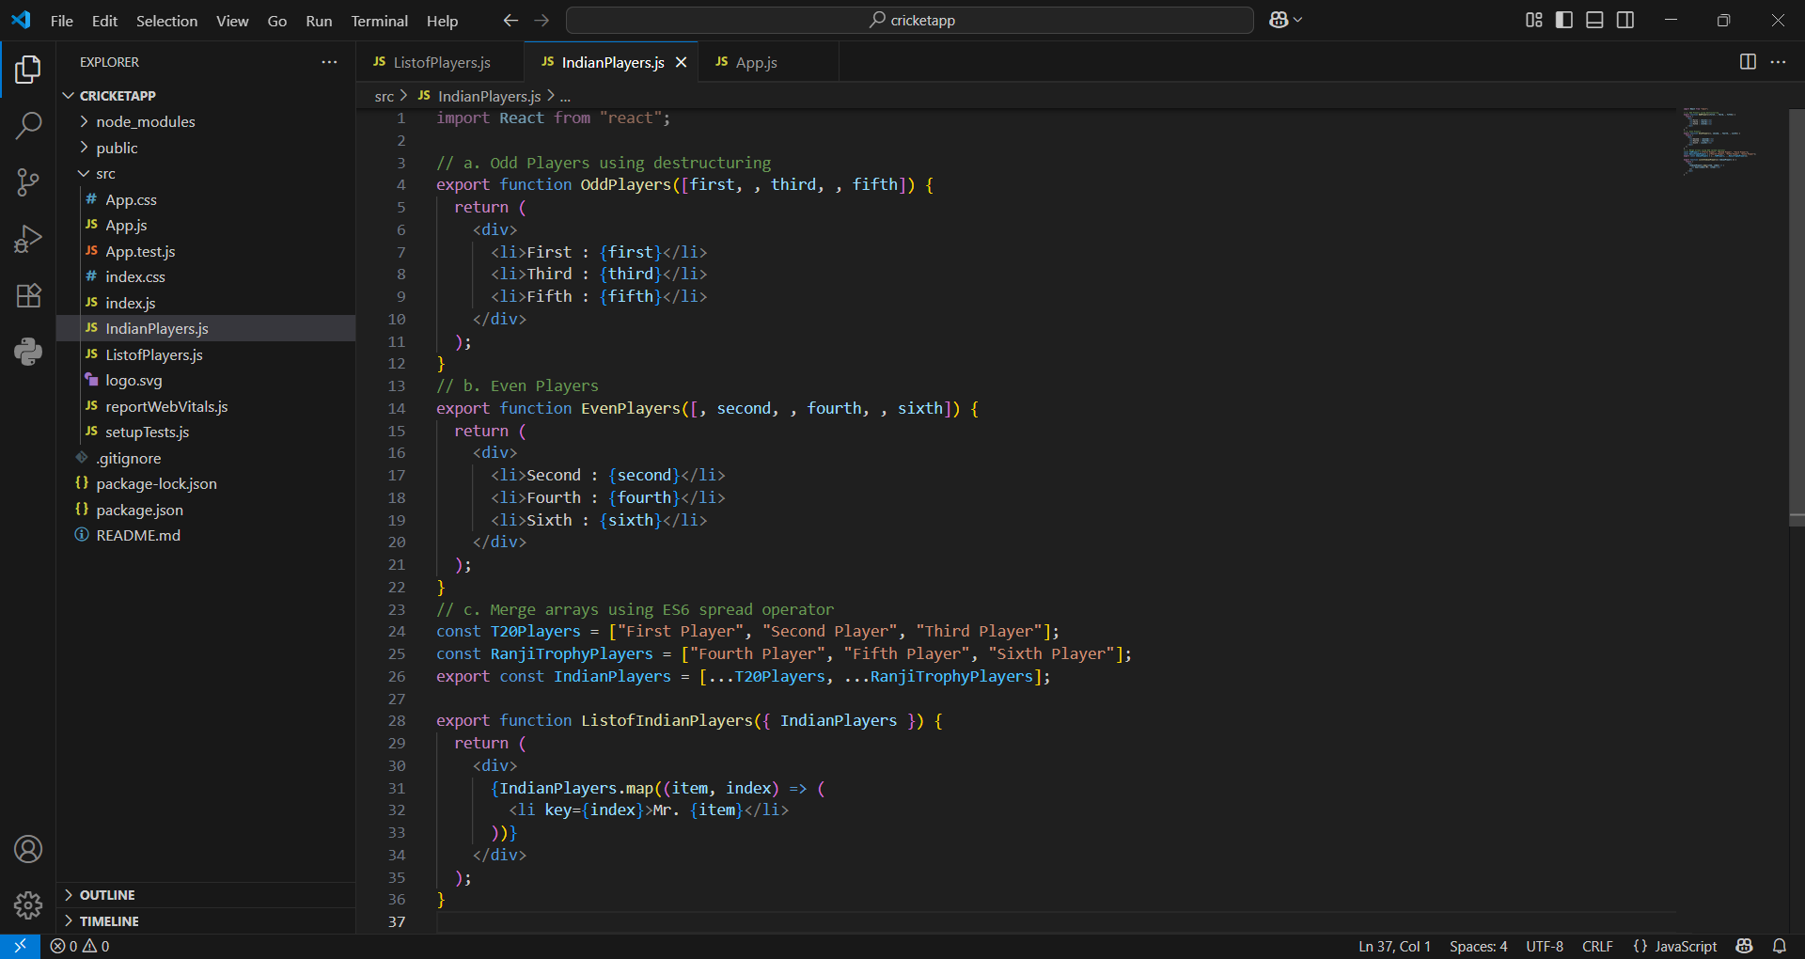

**App.js:**

import React from "react";

import ListofPlayers from "./ListofPlayers";

import {

  OddPlayers,

  EvenPlayers,

  ListofIndianPlayers,

  IndianPlayers

} from "./IndianPlayers";

function App() {

  const flag = true;

  const players = [

    { name: "Jack", score: 50 },

    { name: "Michael", score: 70 },

    { name: "John", score: 40 },

    { name: "Ann", score: 61 },

    { name: "Elisabeth", score: 61 },

    { name: "Sachin", score: 95 },

    { name: "Dhoni", score: 100 },

    { name: "Virat", score: 84 },

    { name: "Jadeja", score: 64 },

    { name: "Raina", score: 75 },

    { name: "Rohit", score: 80 }

  ];

  const IndianTeam = ["Sachin1", "Dhoni2", "Virat3", "Rohit4", "Yuvaraj5", "Raina6"];

  if (flag === true) {

    return (

      <div>

        <h1>List of Players</h1>

        <ListofPlayers players={players} />

      </div>

    );

  } else {

    return (

      <div>

        <h1>Indian Team</h1>

        <h1>Odd Players</h1>

        {OddPlayers(IndianTeam)}

        <hr />

        <h1>Even Players</h1>

        {EvenPlayers(IndianTeam)}

        <hr />

        <h1>List of Indian Players Merged:</h1>

        <ListofIndianPlayers IndianPlayers={IndianPlayers} />

      </div>

    );

  }

}

export default App;

**Output:**

const flag = true;

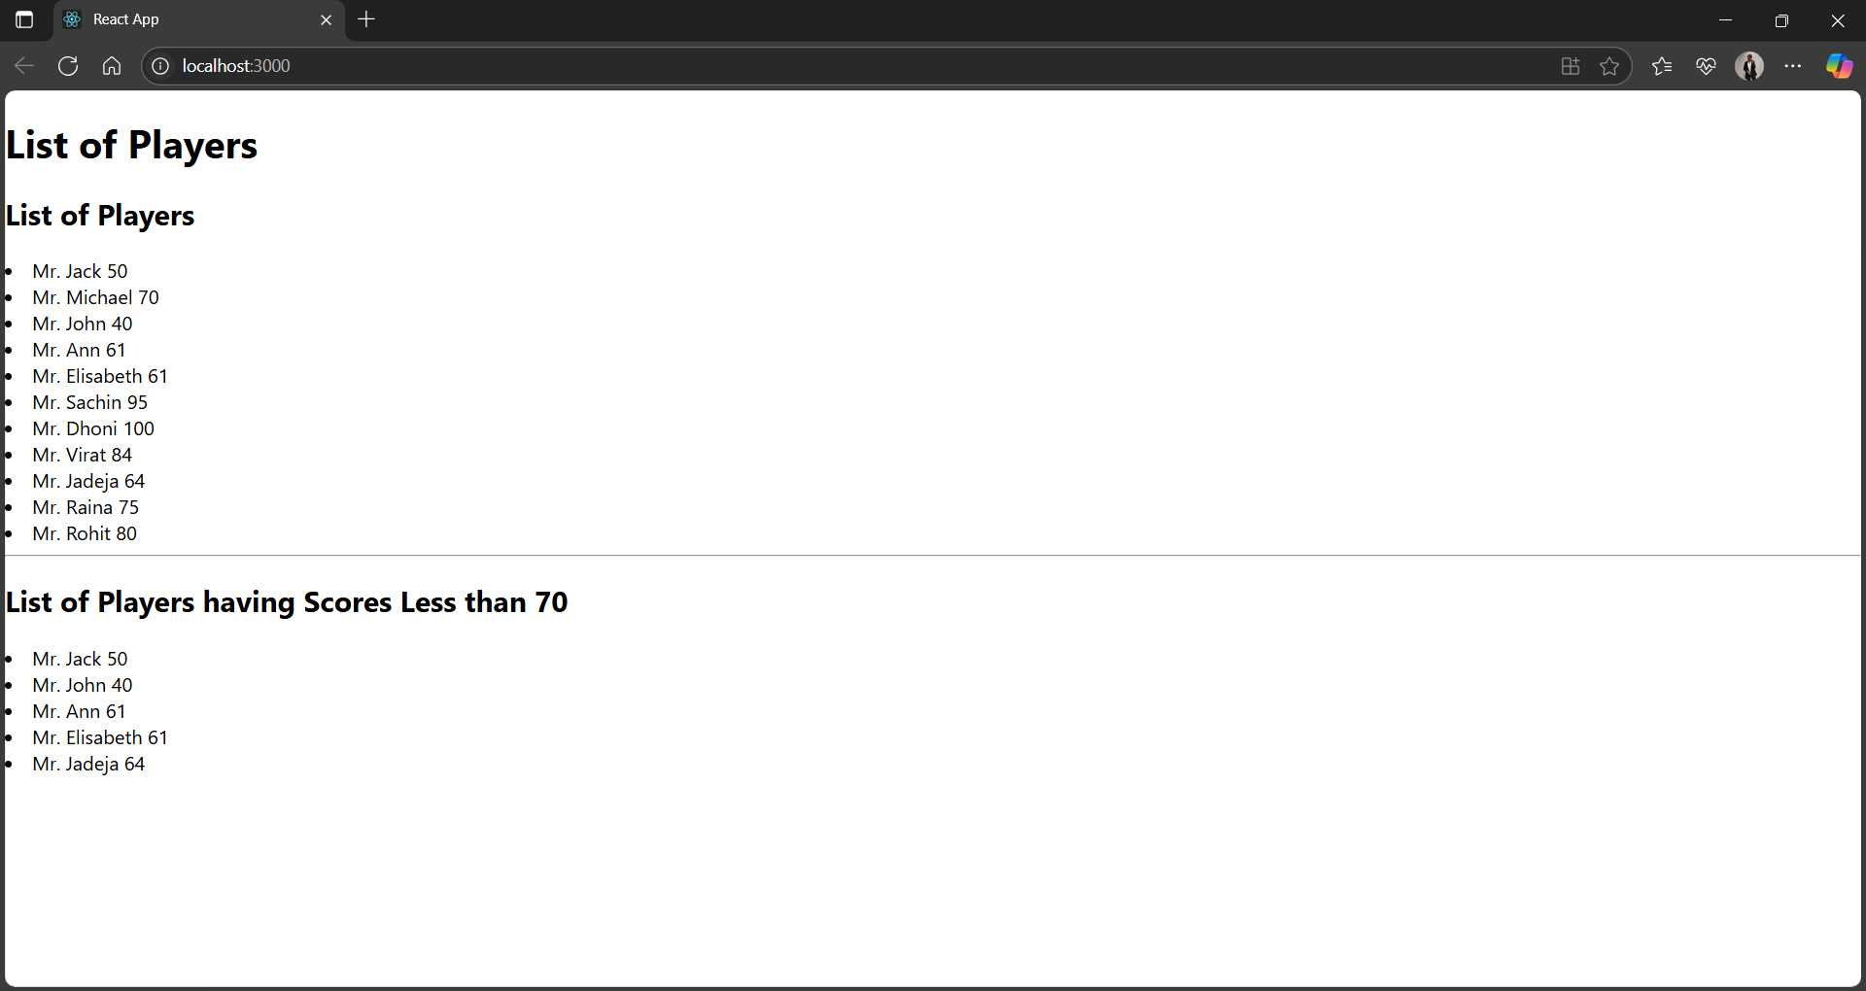

flag = false

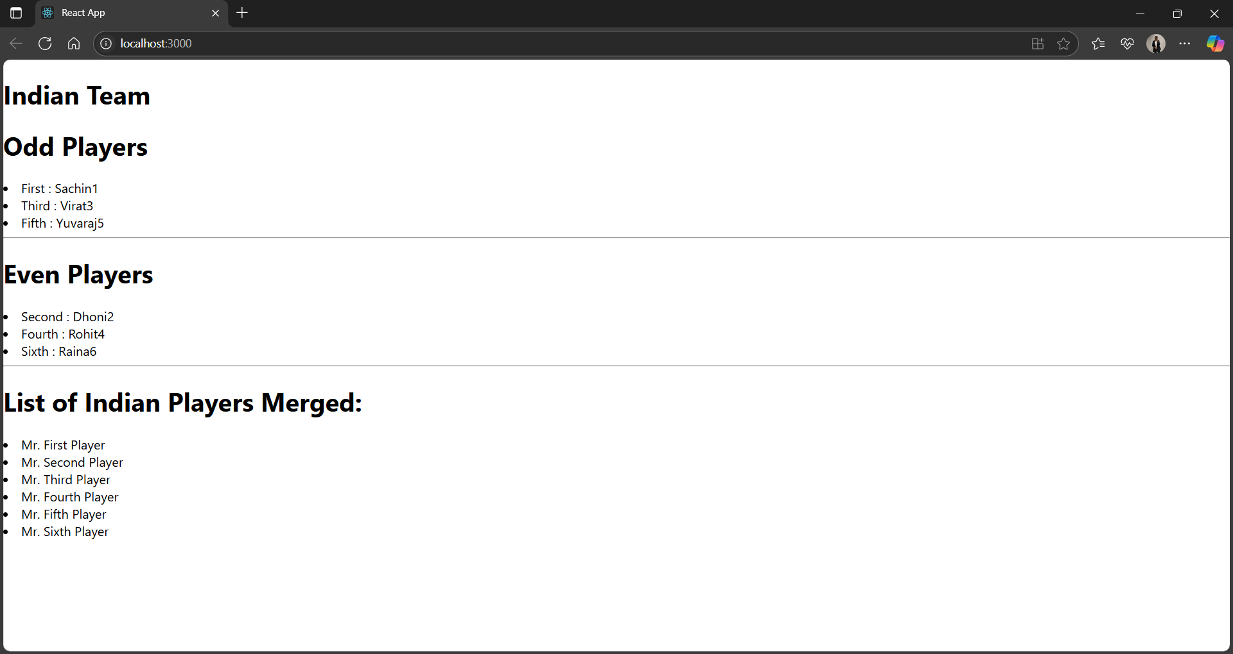

**10. Create a React Application named “officespacerentalapp” which uses React JSX to create elements, attributes and renders DOM to display the page.**

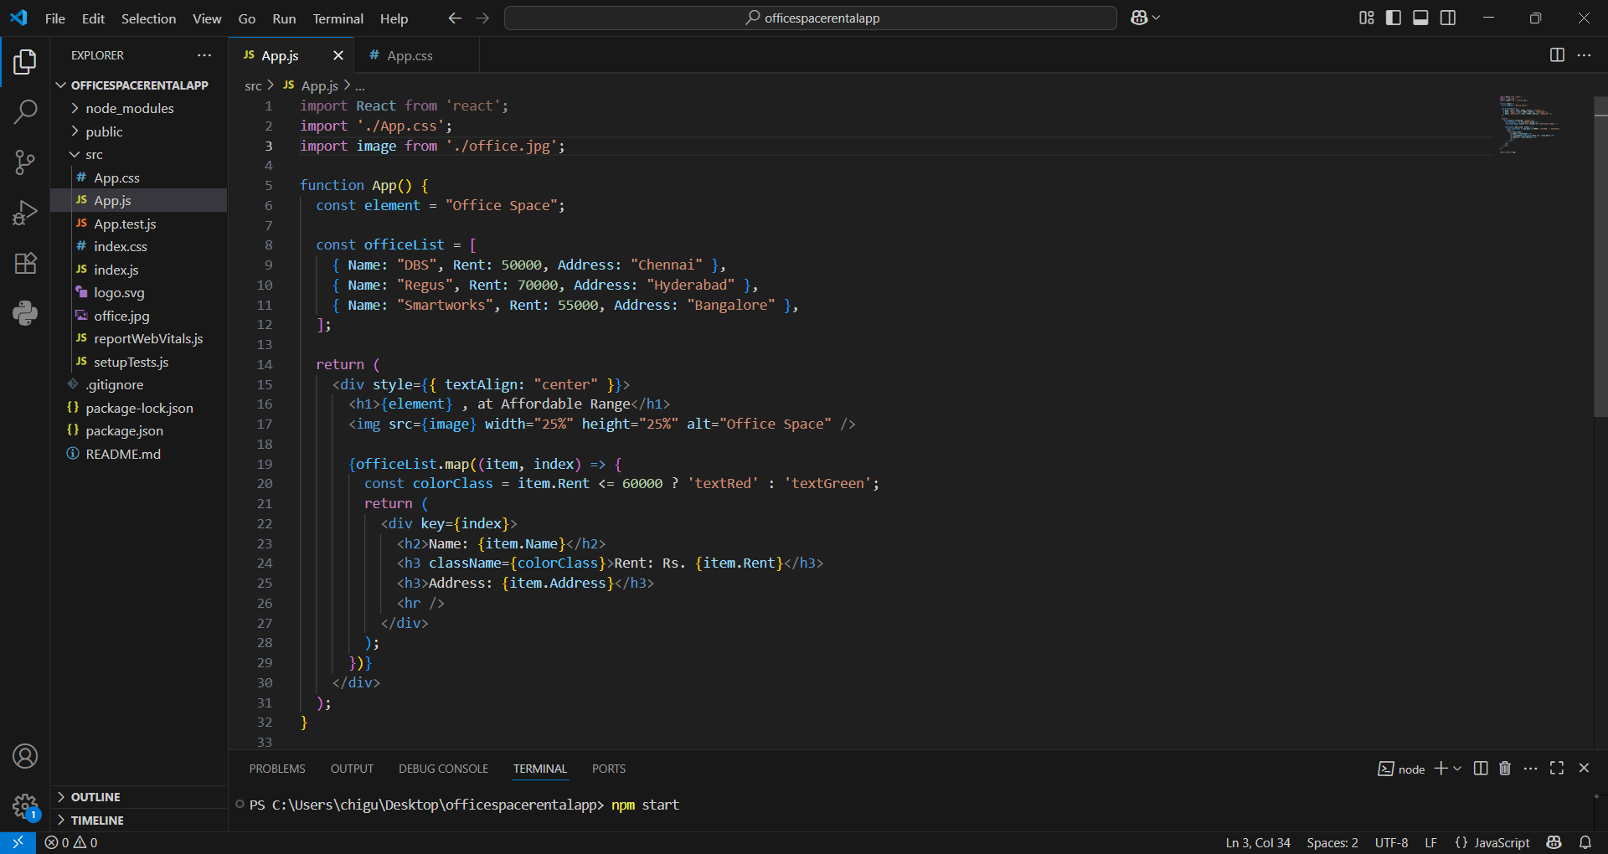

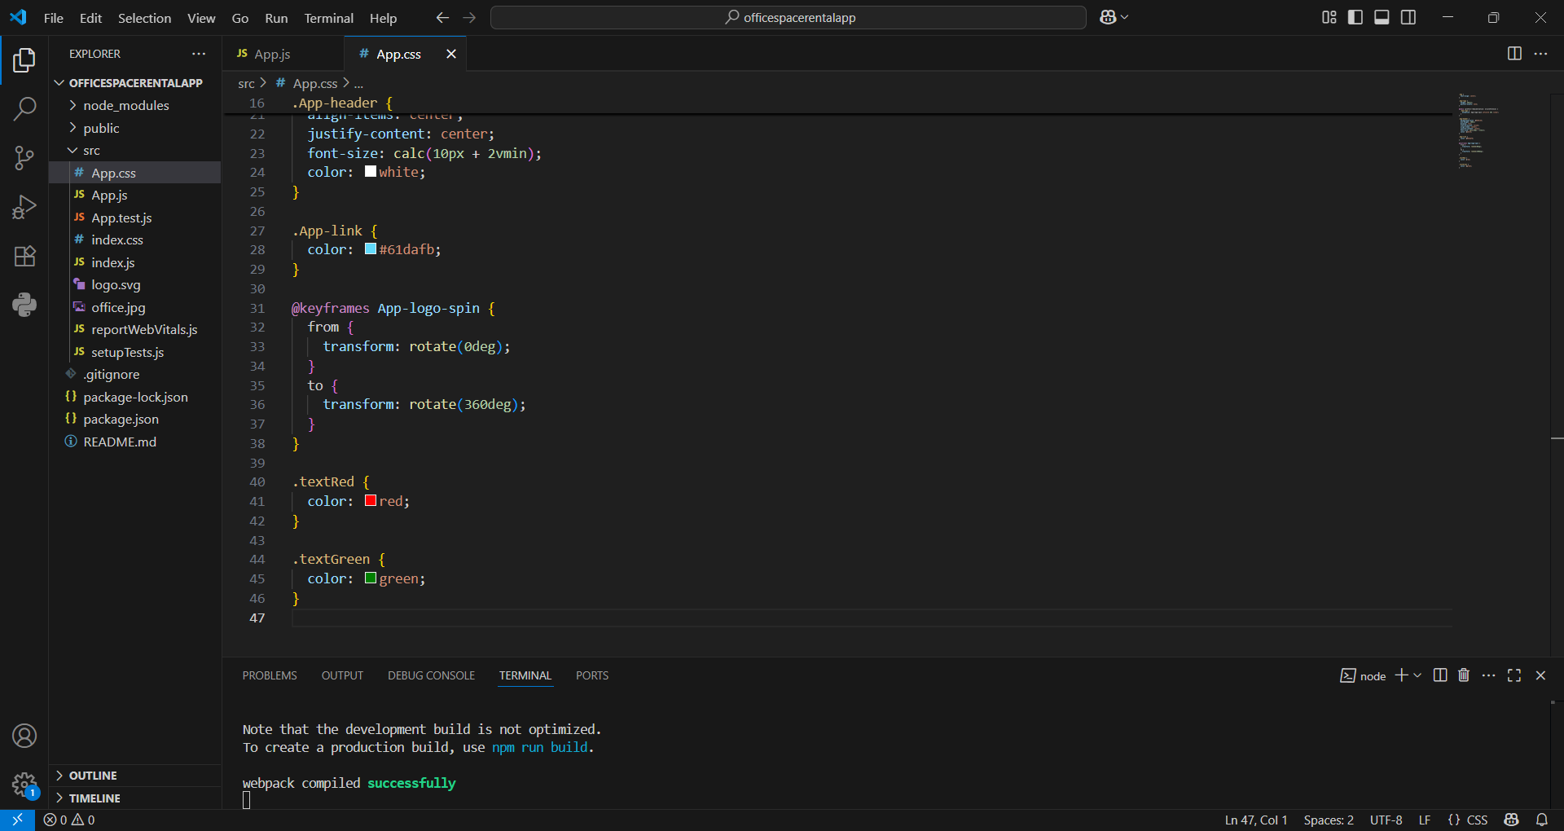

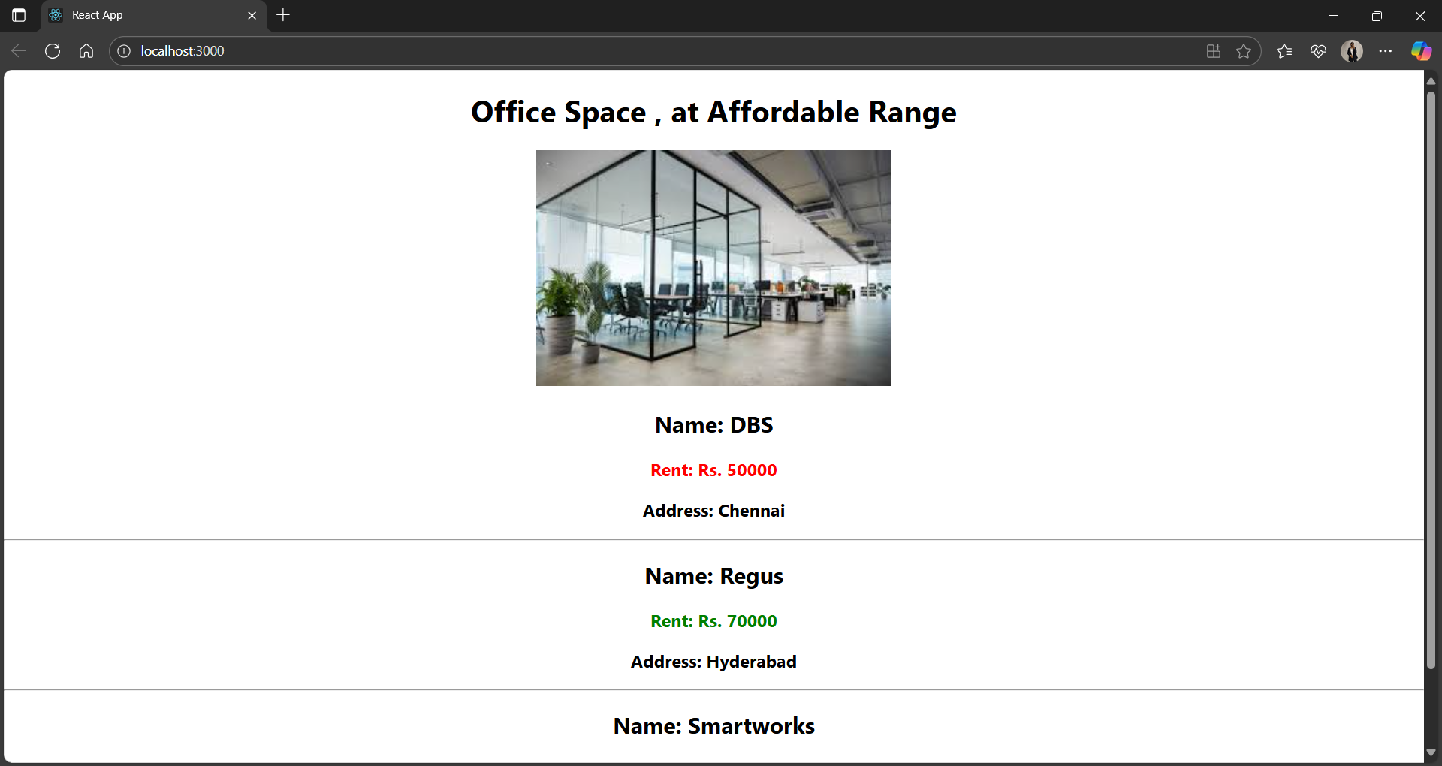

**11. Create a React Application “eventexamplesapp” to handle various events of the form elements in HTML.**

1. **Create “Increment” button to increase the value of the counter and “Decrement” button to decrease the value of the counter. The “Increase” button should invoke multiple methods (To increment the value, Say Hello followed by a static message).**
2. **Create a button “Say Welcome” which invokes the function which takes “welcome” as an argument.**
3. **Create a button which invokes synthetic event “OnPress” which display “I was clicked”**
4. **Create a “CurrencyConvertor” component which will convert the Indian Rupees to Euro when the Convert button is clicked.**

**App.js:**

import React from 'react';

import './App.css';

import CurrencyConvertor from './CurrencyConvertor';

class App extends React.Component {

  constructor(props) {

    super(props);

    this.state = {

      count: 5,

    };

    this.handleIncrement = this.handleIncrement.bind(this);

    this.sayHello = this.sayHello.bind(this);

    this.handleClick = this.handleClick.bind(this);

    this.handleDecrement = this.handleDecrement.bind(this);

    this.sayWelcome = this.sayWelcome.bind(this);

  }

  handleIncrement() {

    this.setState({ count: this.state.count + 1 });

    this.sayHello("Hello! Member1");

  }

  handleDecrement() {

    this.setState({ count: this.state.count - 1 });

  }

  sayHello(message) {

    alert(message);

  }

  sayWelcome(message) {

    alert(message);

  }

  handleClick(e) {

    alert("I was clicked");

    // e is a SyntheticEvent here

  }

  render() {

    return (

      <div className="App" style={{ padding: '20px' }}>

        <p>{this.state.count}</p>

        <button onClick={this.handleIncrement}>Increment</button>

        <br /><br />

        <button onClick={this.handleDecrement}>Decrement</button>

        <br /><br />

        <button onClick={() => this.sayWelcome("welcome")}>Say welcome</button>

        <br /><br />

        <button onClick={this.handleClick}>Click on me</button>

        <br /><br />

        <CurrencyConvertor />

      </div>

    );

  }

}

export default App;

**CurrencyConvertor.js:**

import React, { Component } from 'react';

class CurrencyConvertor extends Component {

  constructor(props) {

    super(props);

    this.state = {

      amount: '',

      currency: ''

    };

    this.handleChange = this.handleChange.bind(this);

    this.handleSubmit = this.handleSubmit.bind(this);

  }

  handleChange(e) {

    this.setState({

      [e.target.name]: e.target.value

    });

  }

  handleSubmit(e) {

    e.preventDefault();

    const { amount, currency } = this.state;

    if (currency.toLowerCase() === 'euro') {

      const result = parseFloat(amount) * 80; // 1 Euro = 80 INR (example)

      alert(`Converting to  ${currency} Amount is ${result}`);

    } else {

      alert("Unsupported currency or empty input");

    }

  }

  render() {

    return (

      <div>

        <h1 style={{ color: 'green' }}>Currency Convertor!!!</h1>

        <form onSubmit={this.handleSubmit}>

          <label>

            Amount:

            <input

              type="text"

              name="amount"

              value={this.state.amount}

              onChange={this.handleChange}

            />

          </label>

          <br /><br />

          <label>

            Currency:

            <textarea

              name="currency"

              value={this.state.currency}

              onChange={this.handleChange}

            />

          </label>

          <br /><br />

          <button type="submit">Submit</button>

        </form>

      </div>

    );

  }

}

export default CurrencyConvertor;

**Project structure:**

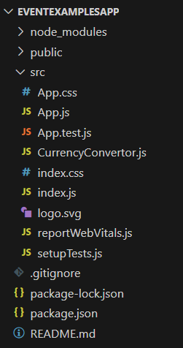

**Outputs:**

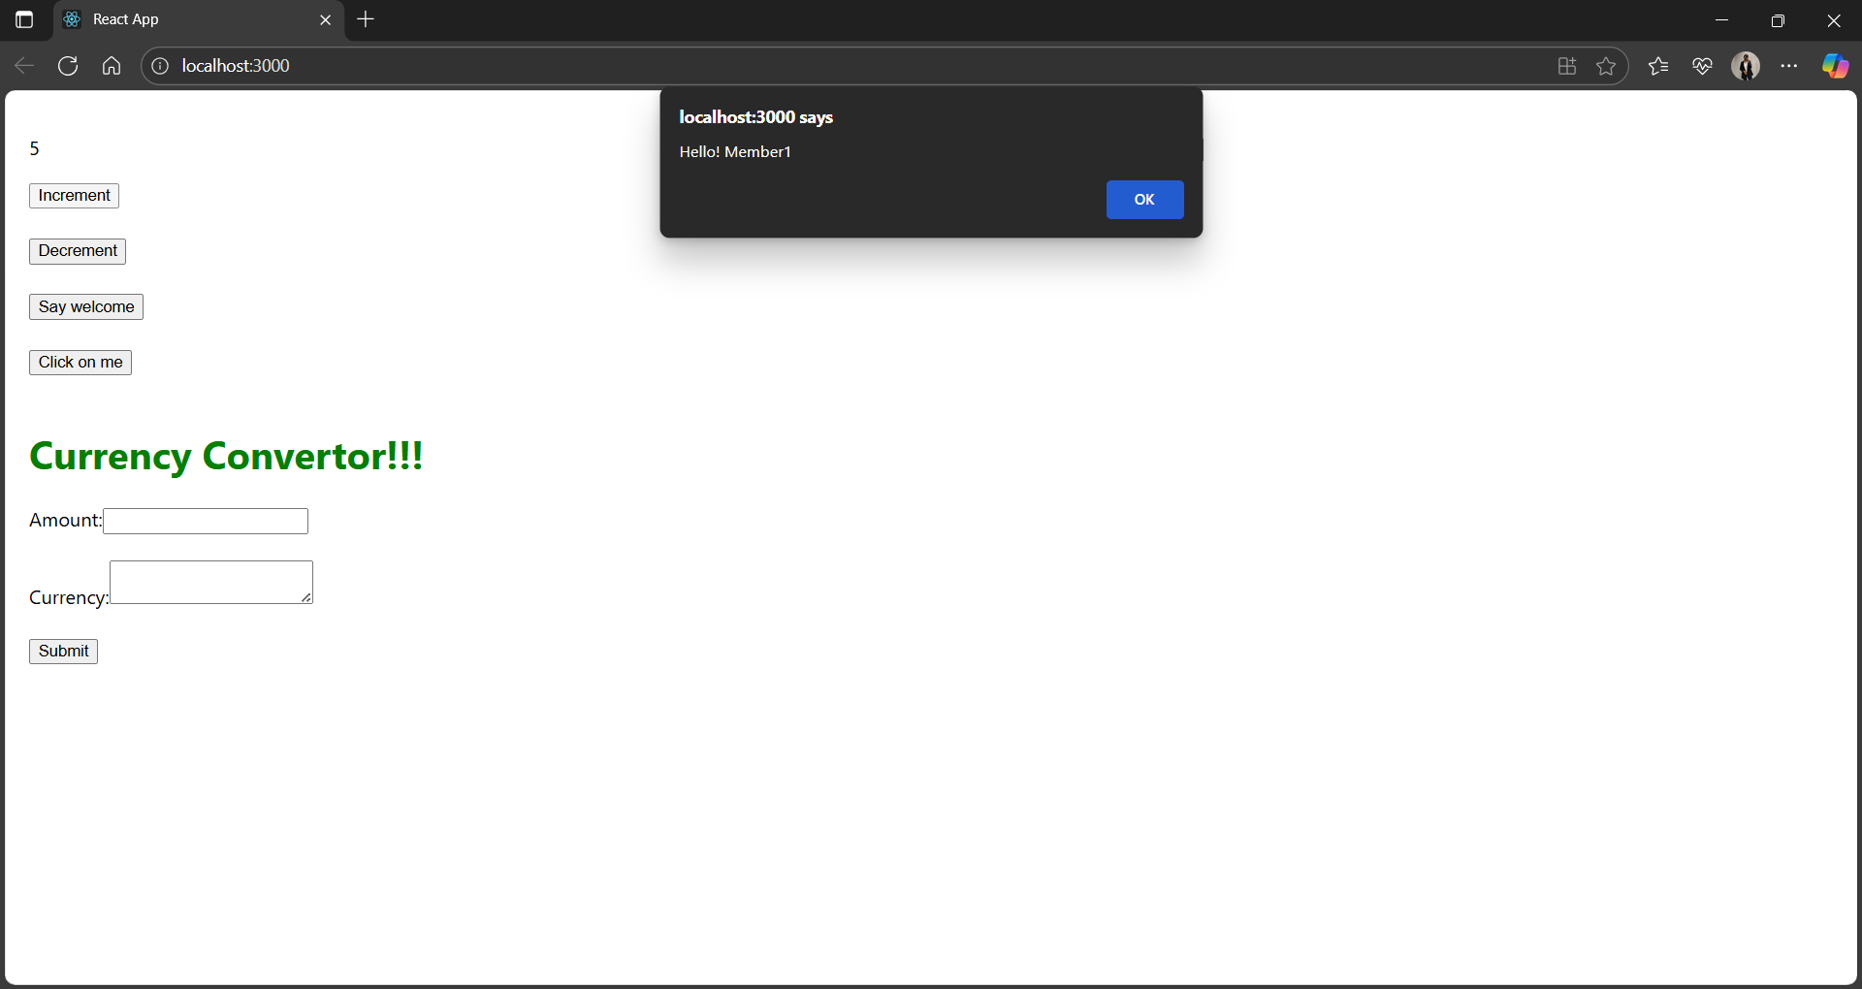

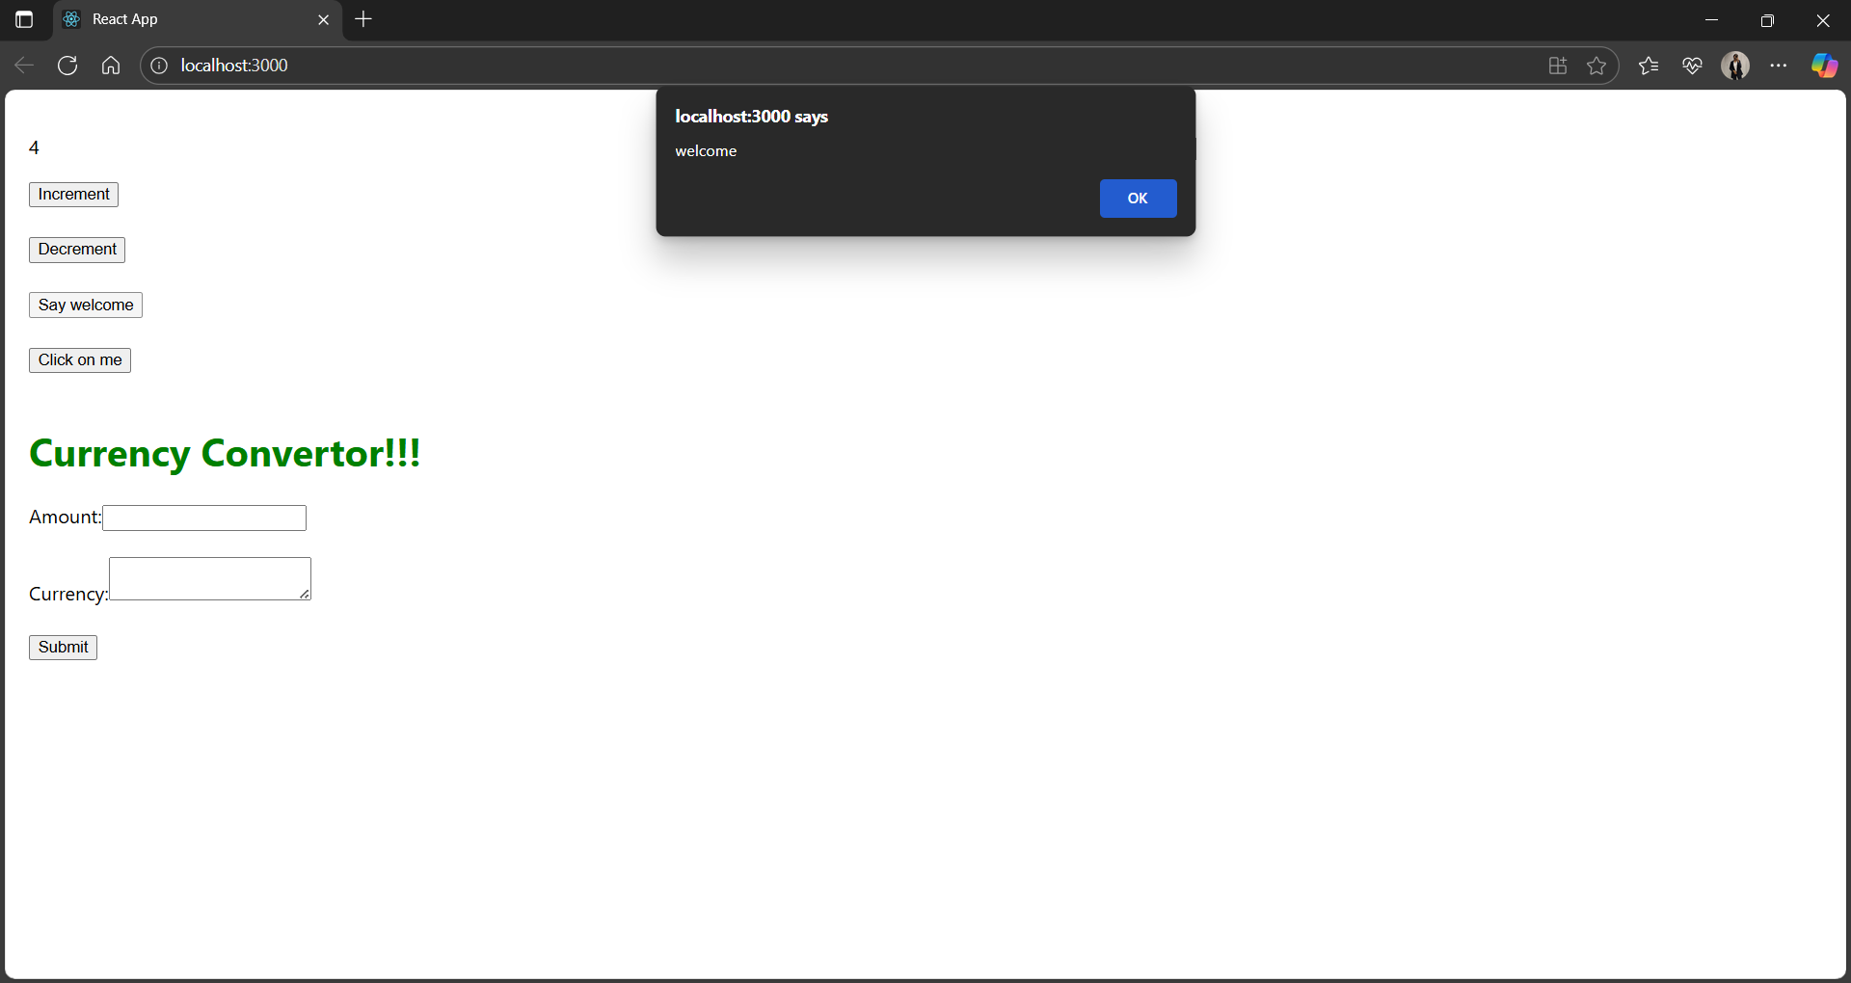

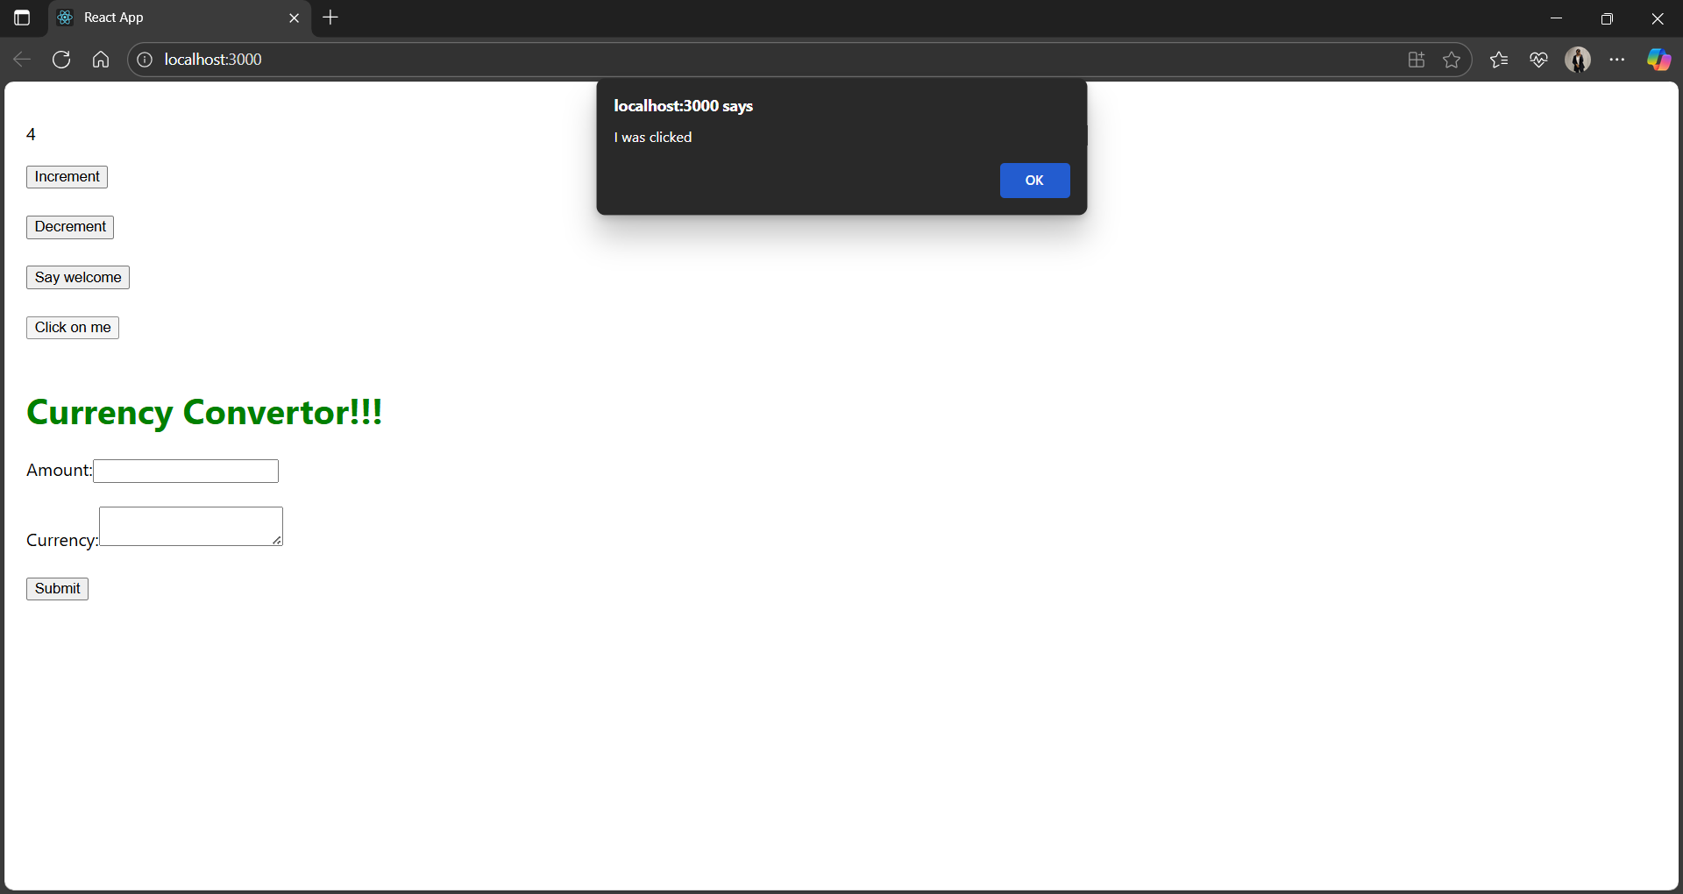

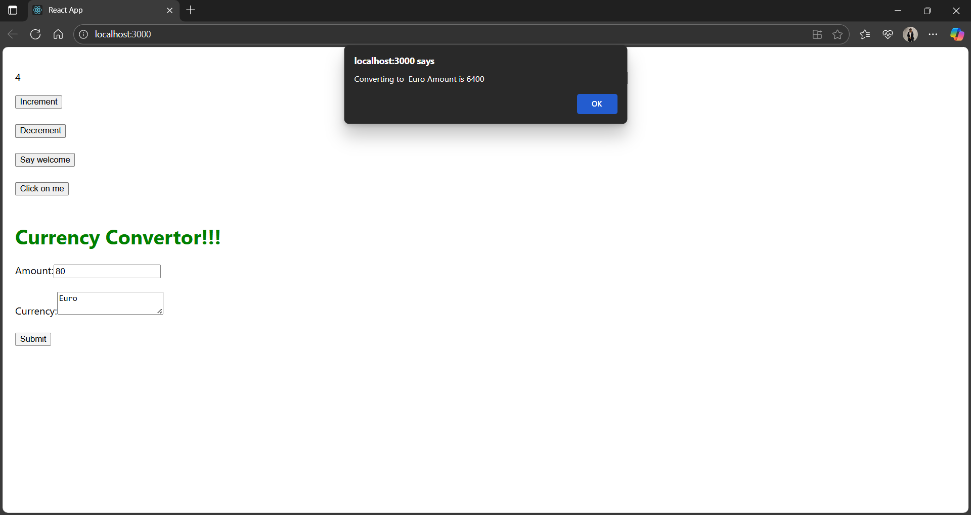

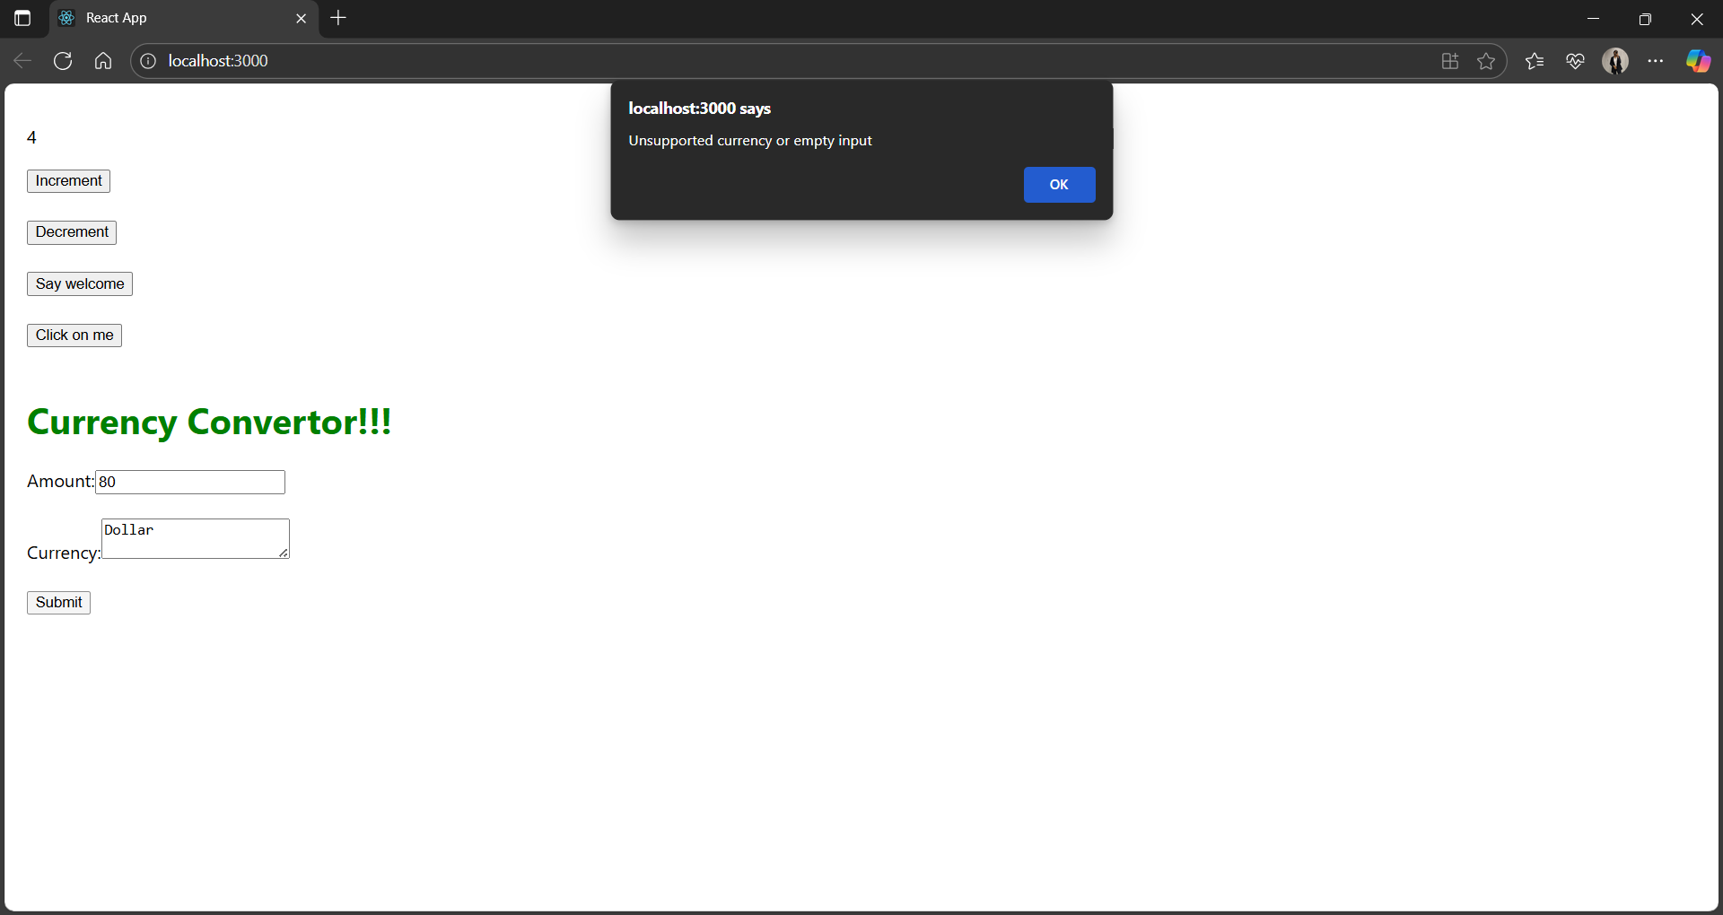

**12. Create a React Application named “ticketbookingapp” where the guest user can browse the page where the flight details are displayed whereas the logged in user only can book tickets.**

**App.js:**

import React, { useState } from 'react';

import './App.css';

function UserGreeting() {

  return <h1>Welcome back</h1>;

}

function GuestGreeting() {

  return <h1>Please sign up.</h1>;

}

function Greeting(props) {

  const isLoggedIn = props.isLoggedIn;

  if (isLoggedIn) {

    return <UserGreeting />;

  }

  return <GuestGreeting />;

}

function LoginButton(props) {

  return <button onClick={props.onClick}>Login</button>;

}

function LogoutButton(props) {

  return <button onClick={props.onClick}>Logout</button>;

}

function App() {

  const [isLoggedIn, setIsLoggedIn] = useState(false);

  const handleLoginClick = () => {

    setIsLoggedIn(true);

  };

  const handleLogoutClick = () => {

    setIsLoggedIn(false);

  };

  let button;

  if (isLoggedIn) {

    button = <LogoutButton onClick={handleLogoutClick} />;

  } else {

    button = <LoginButton onClick={handleLoginClick} />;

  }

  return (

    <div className="App">

      <Greeting isLoggedIn={isLoggedIn} />

      {button}

    </div>

  );

}

export default App;

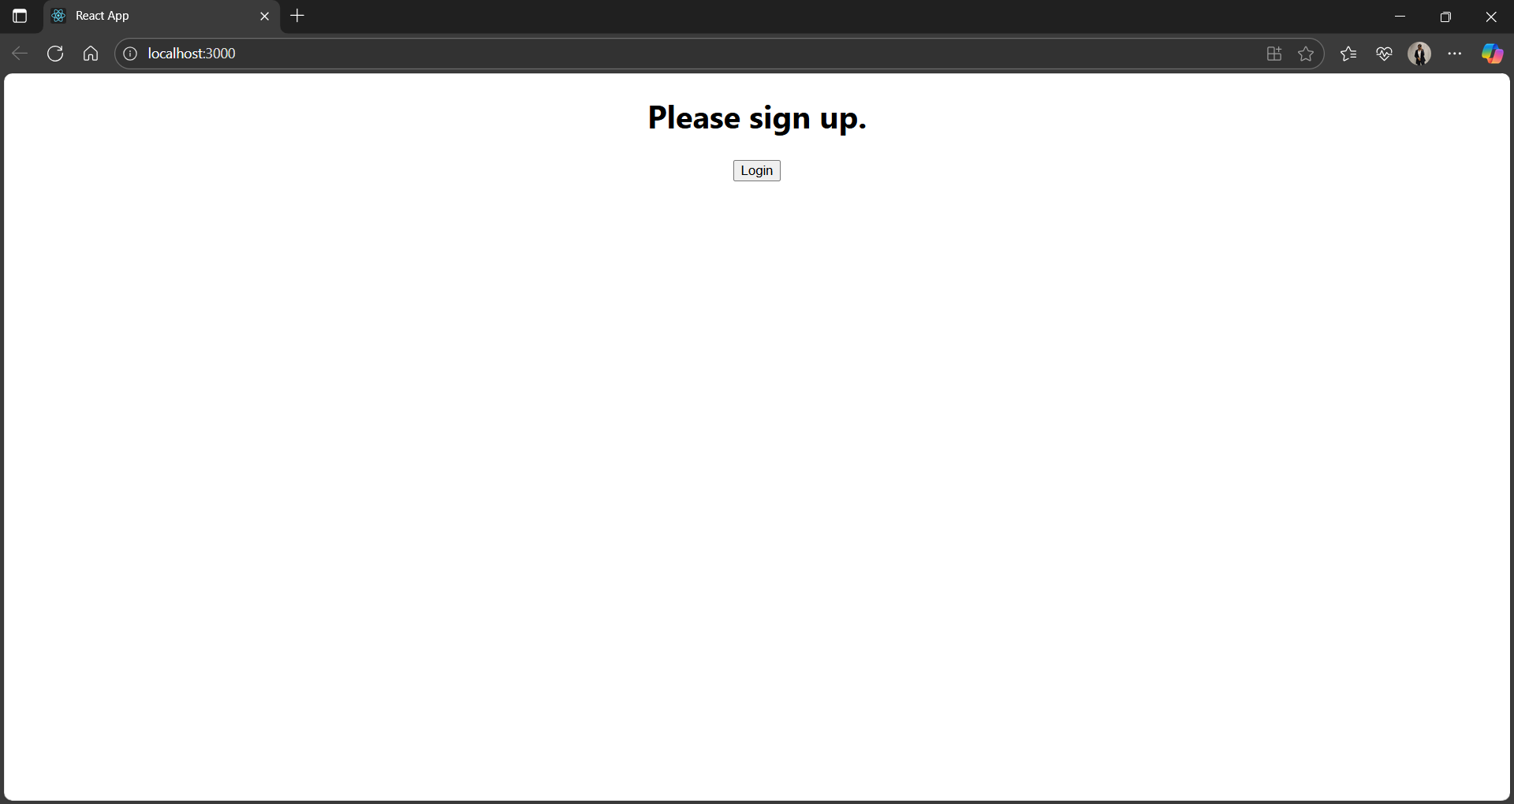

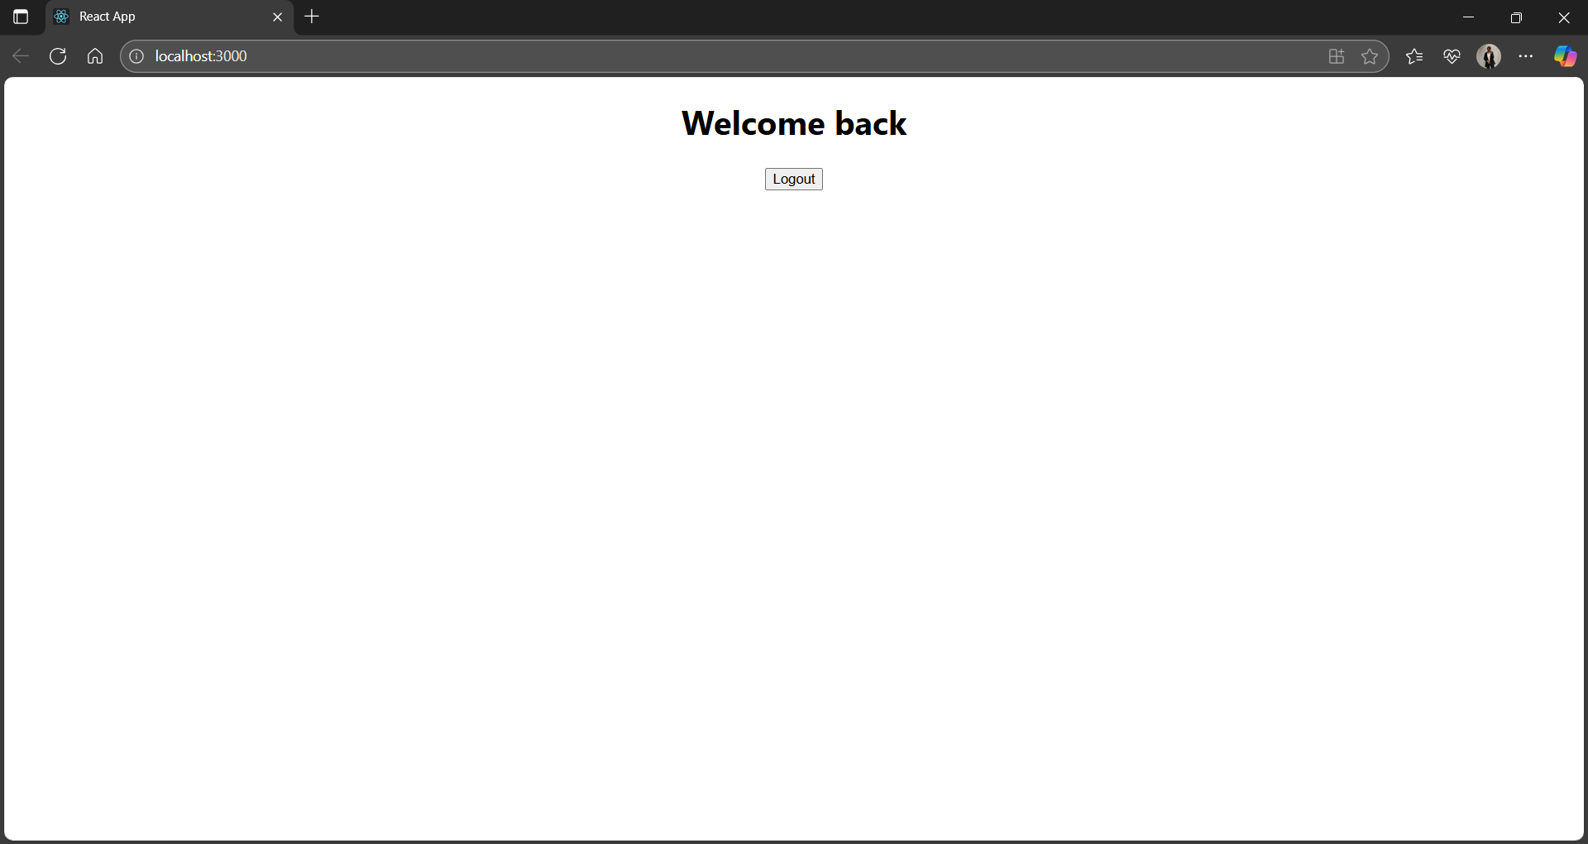

**13. Create a React App named “bloggerapp” in with 3 components.**

1. **Book Details**
2. **Blog Details**
3. **Course Details**

