A Project Report

On

DESIGN OF AUTONOMOUS DRIVING VEHICLES

BY

SIRIGIRIPET RISHIKESH REDDY-(SE20UCSE141);

SANIKOMMU KAPIL REDDY-(SE20UCSE165);

VENKATA SAIRAJA BOJJA-(SE20UCSE222);

ALLA ANUDEEP-SE20UCSE248;

VADDE UDAYKIRAN REDDY-SE20UCSE214;

MALLAGARI VENKATA NAYAN REDDY-SE20UCAM040;

CHEVIREDDY DHYANESH REDDY-SE20UMEE049.

Under the supervision of

Prof. Dr. RAMA MURTHY

**SUBMITTED IN PARTIAL FULLFILLMENT OF THE REQUIREMENTS OF**

**SE 421/SE 422: PROJECT TYPE COURSE**





**MAHINDRA ECOLE CENTRALE**

**COLLEGE OF ENGINEERING**

**HYDERABAD**

**(June 2022**)

ACKNOWLEDGMENTS

We would like to express our deepest gratitude to our mentors Prof. Dr. RAMA MURTHY for providing us with the opportunity to work on this project under his guidance. We would like to sincerely thank them for contributing their valuable time and efforts in helping us pursue this project. Their suggestions and constant feedback have had a monumental effect on understanding the technical aspects and improving the overall quality of the project.



**Mahindra Ecole Centrale**

**Hyderabad**

**Certificate**

This is to certify that the project report entitled “**DESIGN AUTONOMOUS VEHICLES”** submitted by Mr. SIRGIRIPET RISHIKESH REDDY (ID No. SE20UCSE141), Mr. SANIKOMMU KAPIL REDDY (ID No. SE20UCSE165), Mr. VENKATA SAIRAJA BOJJA (ID No. SE20UCSE222), Mr. ALLA ANUDEEP (ID No. SE20UCSE248), Mr. VADDE UDAYKIRAN REDDY (ID No. SE20UCSE214), Mr. MALAGARI VENKATA NAYAN REDDY (ID No. SE20UCAM040), Mr. CHEVIREDDY DHYANESH REDDY(ID No. SE20UMEE049), in partial fulfillment of the requirements of the course PR301, Project Course, embodies the work done by him/her under my supervision and guidance.

**(SUPERVISOR NAME & Signature) (EXTERNAL NAME & Signature)**

Mahindra Ecole Centrale, Hyderabad. Mahindra Ecole Centrale, Hyderabad.

Date: Date :

ABSTRACT

Autonomous driving vehicles have gained significant momentum in recent years as they offer a multitude of advantages for navigation and transportation systems. These vehicles utilize advanced sensor technologies such as cameras, radars, and lidars to enhance their autonomy in decision-making processes. However, an essential and challenging aspect of enabling autonomous navigation lies in the fusion of information generated by these sensors, which can vary in dimensionality, including one-dimensional (1-D), two-dimensional (2-D), or three-dimensional (3-D) data. The fusion of sensor information plays a pivotal role in achieving accurate perception and informed decision-making for autonomous vehicles.

This research project aims to investigate sensor fusion and other critical design problems that arise in the context of autonomous driving vehicles. By addressing these challenges, the project aims to enhance the capabilities of autonomous vehicles, including their perception of the environment and their ability to make informed decisions based on the fused sensor data. The project will delve into various aspects of sensor fusion.

Furthermore, the project will explore the techniques employed in sensor fusion, such as multi-object tracking, environment perception, and localization. It will examine the impact of sensor limitations, including occlusion, adverse weather conditions, and sensor noise, on the fusion process and develop strategies to mitigate these challenges. Additionally, the research will address important design problems related to sensor placement, redundancy, and fault tolerance in autonomous driving systems to enhance overall system reliability.

The research methodology encompasses a thorough review of existing literature and research papers on sensor fusion techniques in autonomous driving vehicles. It will involve the design and implementation of algorithms for sensor fusion using simulated or real sensor data. The performance of these algorithms will be evaluated in terms of accuracy, robustness, and real-time processing capabilities. Iterations on the algorithms and system design will be conducted based on the analysis of results, aiming to optimize performance and efficiency.

The expected outcomes of this research project include the identification and analysis of key challenges and design problems related to sensor fusion in autonomous driving vehicles. Techniques will be developed to enhance the perception and decision-making capabilities of these vehicles. The research will provide insights into the trade-offs between different sensor fusion approaches in terms of accuracy, computational complexity, and real-time performance. Moreover, recommendations will be formulated for sensor placement, redundancy, and fault tolerance strategies in autonomous driving systems.

In conclusion, this project seeks to address the critical issue of sensor fusion and other important design challenges in autonomous driving vehicles. By exploring and resolving these challenges, the research aims to enhance the autonomy, safety, and navigation capabilities of self-driving cars. The outcomes of this project will contribute to the ongoing research and development efforts in the field of autonomous driving, bringing us closer to a future where self-driving vehicles are commonplace and trusted modes of transportation.

**CONTENTS**

Title page……………………………………………………………………………………….1

Acknowledgements…………………………………………………………….…………...…..2

Certificate……………………………………………………………………….…………........3

Abstract…………………………………………………………………….…………...……....4

1. Introduction…………………………………………….…………….…………...……….....6

2. Problem Definition………………………………………………..……..…………………..8

3. Background and Work done………………………………………..……….………………..9

3.1 Overview of Autonomous Driving Vehicles……………………….……………….9

3.2 Sensor technologies used in autonomous vehicles…………………………………10

3.2.1 Cameras…………………………………………………………………..10

3.2.2 Radars…………………………………………………………………….11

3.2.3 Lidars……………………………………………………………………..11

3.2.4 Other sensors……………………………………………………………..12

3.3 Sensor Fusion Techniques: Object Detection, Tracking, and Localization………13

3.4 Fuzzy logic in autonomous systems……………………………..……..………15

4. Applications of fuzzy logic in autonomous vehicles………………..……………………16

5. Implementation: ………………..…………………..…………………..…………….20

5.1 Sensor selection and placement…………………………………………………….20

5.2 Sensor data acquisition and preprocessing………………………………………….21

5.3 Integration of fuzzy rules for decision-making……………………………………..24

Conclusion……………………………………………………………..……..……..28

References……………………………………………………………..……..……..30

INTRODUCTION

According to the World Health Organization (WHO), the reported number of road traffic deaths in 2018 was 1.35 million, ranking it as the eighth leading cause of unnatural deaths worldwide[1]. In the European Union (EU), although there has been a decline in reported annual road fatalities, there are still over 40,000 deaths each year, with 90% attributed to human error. To address this issue and improve traffic efficiency, significant investments have been made by global investors to support the development of self-driving vehicles. Furthermore, autonomous vehicles (AVs) are expected to contribute to reducing carbon emissions and meeting emission reduction targets[2].

AVs, also known as self-driving vehicles, possess the transportation capabilities of conventional vehicles but have the ability to perceive the environment and navigate with minimal or no human intervention. The global AV market reached approximately 6,500 units in 2019 and is projected to grow at a compound annual growth rate of 63.5% from 2020 to 2027, according to a report by Precedence Research[3].

While autonomous driving (AD) systems face common challenges and limitations, such as safe operation in adverse weather conditions and interactions with pedestrians and other vehicles, the complexity increases for on-road AVs due to unpredictable conditions and behaviours of other vehicles. Adverse weather conditions like glare, snow, mist, rain, haze, and fog can significantly affect the performance of perception-based sensors used for navigation. Comprehensive prediction modules are crucial in AVs to anticipate future movements and minimize collision risks.

Although AD systems share common challenges, they also have noticeable differences. For example, unmanned tractors in agriculture navigate in a fixed environment between crop rows, while on-road vehicles must navigate through complex and dynamic environments with crowds and traffic.

AV systems consist of various subcomponents and are complex in nature. The architecture of an AD system includes both hardware and software components, which serve as the primary layers of the system. These layers comprise several subcomponents that facilitate communication between the hardware and software layers. From a functional perspective, AV systems are composed of four primary blocks: perception, planning and decision-making, motion and vehicle control, and system supervision. These functional blocks define the stages of processing and information flow, starting from data collection to vehicle control.

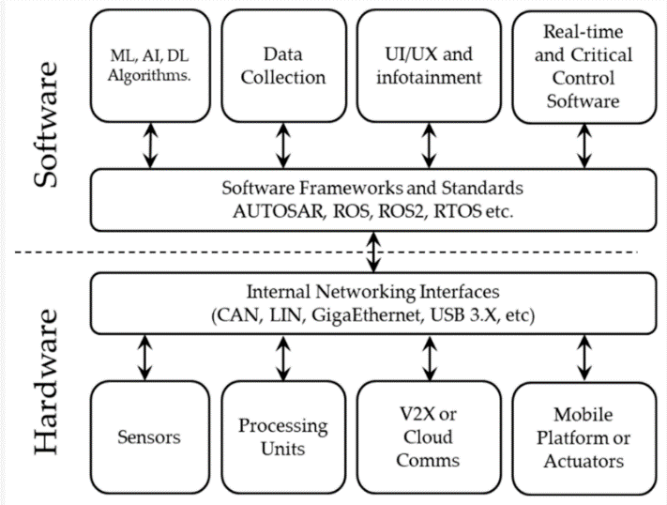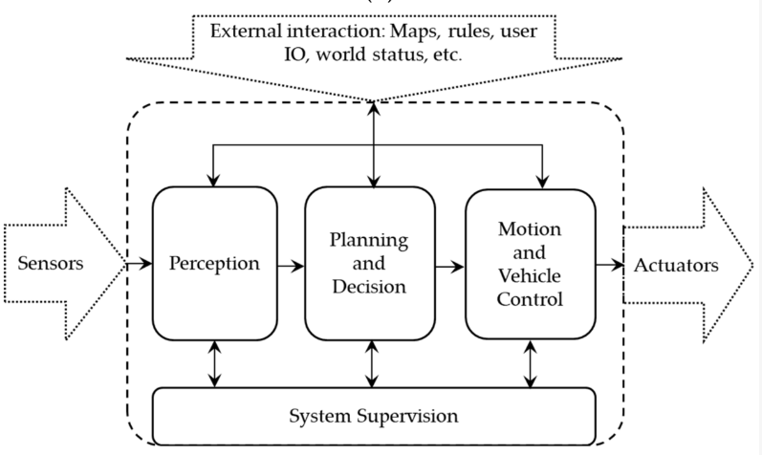

The sensing capabilities of autonomous vehicles (AVs) rely on a diverse set of sensors, and their cooperation and performance directly impact the viability and safety of the AV. Therefore, selecting the right sensors and configuring them optimally is a critical consideration in any autonomous driving (AD) system.

When choosing sensors for an AD system, it is essential to evaluate their advantages, disadvantages, and limitations. There are two categories of sensors: smart sensors and non-smart sensors. The concept of "smart sensors" has evolved with the emergence of the Internet of Things (IoT), where interconnected devices collect and transfer data without human intervention. In the IoT context, smart sensors can condition input signals, process and interpret data, and make decisions without relying on a separate computer. In the context of AVs, range sensors like cameras, LiDAR’s, and radars can be considered "smart" if they provide additional information such as target tracking and event descriptions. On the other hand, "non-smart" sensors only condition raw data or waveforms and require external computing resources for data processing and interpretation. A sensor is considered "smart" when it incorporates computing resources as an integral part of its design. The overall performance of an AV system is greatly enhanced by using multiple sensors of different types and modalities, incorporating their data to produce a fused output. This multi-sensor fusion is crucial to overcome the limitations of individual sensor types and improve the efficiency and reliability of the AD system.

Recent reviews have covered various aspects of multi-sensor fusion in AD systems, including architectural structures, sensor technologies, calibration, state estimation, object tracking, and fusion techniques such as deep learning-based approaches. This review paper focuses on three major considerations in sensor fusion for AVs. Firstly, it discusses the operating principles and characteristics of different sensor modalities, comparing commercially available hardware. Secondly, it explores sensor calibration, including the main open-source calibration systems and their compatibility with commercial sensors. Finally, it delves into sensor fusion methods and algorithms for obstacle detection in AV environments.

2. PROBLEM DEFINATION

Problem Statement:

The integration of data from multiple sensors in autonomous systems presents several challenges that need to be addressed for reliable and efficient operation. Furthermore, incorporating fuzzy rules into the sensor fusion process can enable the handling of uncertainties and enhance decision-making capabilities. Therefore, this research paper aims to address the following key problems:

1. Sensor Fusion Challenges:

a. Sensor Heterogeneity: Different sensors possess unique characteristics, such as measurement noise, accuracy, and field of view, making the fusion of their information challenging.

b. Data Association: Associating measurements from different sensors with the corresponding objects or features in the environment is a complex task due to uncertainties, occlusions, and sensor limitations.

c. Sensor Calibration and Synchronization: Ensuring accurate alignment and synchronization of sensor data is crucial for effective fusion and maintaining the integrity of the fused information.

d. Real-Time Processing: Sensor fusion in autonomous systems requires real-time processing to enable timely decision-making, necessitating efficient algorithms and computational resources.

2. Fuzzy Rules Integration:

a. Uncertainty Handling: Fuzzy logic provides a mechanism to represent and reason with uncertain and imprecise information, enabling more robust decision-making in complex and uncertain environments.

b. Rule Base Development: Designing an appropriate rule base that captures the knowledge and expertise of human operators is essential for effective fuzzy rule integration into the sensor fusion process.

c. Rule Inference and Aggregation: Developing efficient algorithms for inferring and aggregating fuzzy rules to generate meaningful and actionable outputs from the fused sensor data.

Addressing these challenges and integrating fuzzy rules into the sensor fusion process can significantly improve the performance, reliability, and decision-making capabilities of autonomous systems. This research paper aims to investigate innovative approaches and techniques to overcome these challenges and explore the benefits of integrating fuzzy rules into the sensor fusion process for various applications, with a particular focus on autonomous driving systems.

3. BACKGROUND AND WORK DONE

3.1 Overview of Autonomous Driving Vehicles:

Autonomous driving vehicles, also known as self-driving cars or driverless cars, are vehicles capable of navigating and operating without human intervention. They use a combination of advanced technologies, sensors, and algorithms to perceive the environment, make decisions, and control the vehicle's movements. Here's an overview of autonomous driving vehicles:

1. Perception: Autonomous vehicles are equipped with various sensors, including cameras, lidar, radar, and ultrasonic sensors, to perceive the surrounding environment. These sensors provide data about the vehicle's surroundings, including the road, objects, pedestrians, and other vehicles. Perception algorithms process this sensor data to detect and understand the environment accurately.

2. Localization: Autonomous vehicles need to know their precise location and orientation on the road. Localization techniques, such as GPS, inertial measurement units (IMUs), and visual odometry, are used to determine the vehicle's position relative to a map or landmarks in the environment. High-definition maps can also be utilized for precise localization.

3. Mapping: Mapping is the process of creating and updating detailed maps of the environment. Autonomous vehicles may use mapping techniques like Simultaneous Localization and Mapping (SLAM) to construct and maintain maps that help in navigation and decision-making. HD maps provide additional information, including lane markings, traffic signs, and road geometry, which aids in accurate positioning and understanding the driving environment.

4. Decision-Making: Autonomous vehicles utilize advanced algorithms and artificial intelligence to analyse sensor data, perceive the environment, and make decisions in real-time. These algorithms consider factors such as traffic rules, road conditions, obstacles, and other vehicles to determine safe and efficient driving manoeuvres. Decision-making involves path planning, trajectory generation, and control algorithms that ensure the vehicle follows the desired path and avoids collisions.

5. Control: The control system of an autonomous vehicle is responsible for executing the planned driving manoeuvres. It receives commands from the decision-making module and controls various vehicle components, including steering, braking, and acceleration, to drive the vehicle safely and smoothly.

6.Communication: Autonomous vehicles can communicate with other vehicles and infrastructure through vehicle-to-vehicle (V2V) and vehicle-to-infrastructure (V2I) communication systems. This enables information sharing, cooperative manoeuvres, and enhances overall traffic efficiency and safety.

7. Safety and Redundancy: Autonomous driving systems prioritize safety and include redundant systems to ensure reliability. Redundant sensors, control systems, and backup power sources are often incorporated to handle failures or unexpected events.

The goal of autonomous driving vehicles is to improve road safety, reduce traffic congestion, enhance transportation efficiency, and provide mobility solutions for various applications, including personal transportation, ride-hailing services, and goods delivery. Continuous advancements in technology, sensor capabilities, and artificial intelligence algorithms are driving the development and adoption of autonomous driving vehicles.

3.2 SENSOR TECHNOLOGIES USED IN AUTONOMOUS VEHICLES:

Autonomous driving vehicles rely on various sensor technologies to perceive and understand their surroundings. These are the different type of sensors in autonomous vehicles:

3.2.1 CAMERAS:

Cameras capture visual data and provide information about the environment, including lane markings, traffic signs, and objects. They are crucial for object detection, recognition, and tracking. Advanced computer vision algorithms are employed to analyse camera data and extract relevant information. Cameras in autonomous driving vehicles provide visual data for object detection, lane tracking, traffic sign recognition, object tracking, scene understanding, visual odometry, and event recording.

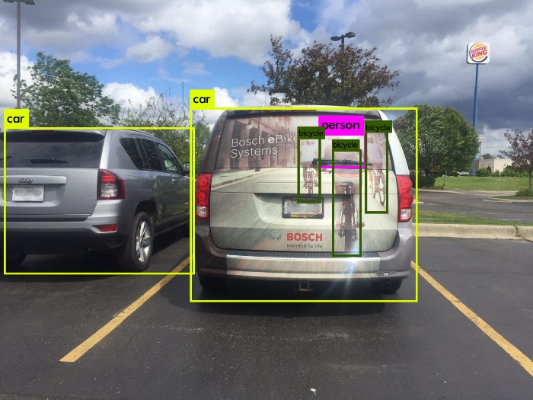

An image from camera sensor

LIMITATIONS: Cameras have a limited field of view compared to other sensors like lidar or radar. They provide a narrow perspective, and objects outside the camera's field of view may not be directly visible. This can pose challenges in situations where a comprehensive 360-degree view is required. Cameras are sensitive to lighting conditions and can struggle in challenging lighting scenarios such as low light, glare, or direct sunlight. Changes in lighting conditions can impact the quality. Cameras provide 2D images, which means they have limited depth perception capabilities compared to sensors like lidar. Cameras can be affected by adverse weather conditions such as rain, snow, fog, or dust, which can obstruct the camera's view and reduce image quality.

3.2.2 RADAR:

Radar (Radio Detection and Ranging) sensors use radio waves to detect objects and measure their distance, velocity, and angle. They are effective in providing long-range object detection and tracking, and are especially useful for detecting and tracking moving objects, such as vehicles or pedestrians. Radar can operate in various weather conditions and can complement other sensors' capabilities

. 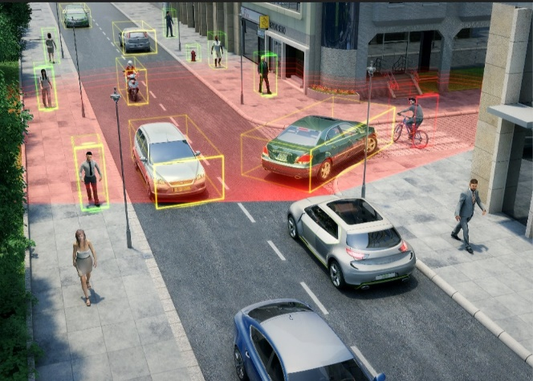

An image from a radar sensor

LIMITATIONS: Radar sensors have lower resolution compared to cameras or lidar, limiting their ability to provide fine-grained details or distinguish small objects. They primarily measure distance, speed, and relative motion but may struggle with object classification. Radar is robust in various weather conditions but may have difficulty detecting objects behind non-metallic materials or penetrating highly reflective or absorptive surfaces. Radar sensors also have limited angular resolution, impacting object localization and tracking accuracy in scenarios requiring precise spatial information. Combining radar with other sensors can help improve object classification and enhance overall perception capabilities.

3.2.3 LIDAR:

Lidar (Light Detection and Ranging) sensors emit laser pulses and measure the time it takes for the light to bounce back after hitting objects. This creates a 3D point cloud representation of the surroundings, which helps in precise object detection, localization, and mapping. Lidar sensors provide accurate distance measurements and are particularly useful in low-light or adverse weather conditions.

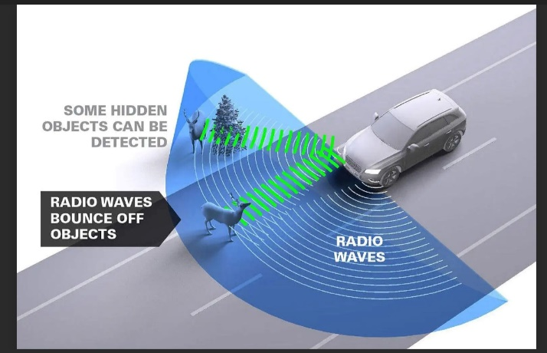

LIMITATIONS: Lidar sensors have a limited range compared to other sensors like radar. Objects beyond the sensor's range may not be detected, which can be a limitation in high-speed driving scenarios or on open highways. Adverse weather conditions such as rain, snow, fog, or dust can affect the performance of lidar sensors. Lidar sensors rely on laser beams that bounce off objects to detect and measure their distance. Lidar sensors can receive multiple returns from a single laser pulse due to reflections from different surfaces or objects within its field of view. Multiple returns can complicate the processing and interpretation of the received data. Lidar sensors are very expensive compared to other sensors commonly used in autonomous driving, such as cameras or radar.

3.2.4 OTHER SENSORS:

IMU (Inertial Measurement Units): Consist of accelerometers and gyroscopes to measure the vehicle's acceleration, orientation, and angular velocity. They are used to estimate the vehicle's motion, compensate for sensor errors, and improve localization accuracy. IMUs in autonomous driving vehicles provide information about vehicle motion and orientation. They measure accelerations, angular rates, and magnetic field strength to enable functionalities such as vehicle localization, navigation, and motion control.

LIMITATIONS:IMUs rely on integrating acceleration measurements to estimate velocity and position. However, over time, small errors in acceleration measurements accumulate due to integration. This can result in drift and errors in estimating the vehicle's velocity and position, leading to a degradation of localization accuracy. IMUs are sensitive to initial conditions, such as the initial orientation and velocity. Any inaccuracies in the initial conditions can propagate and magnify over time, leading to increasing errors in the estimation of the vehicle's motion. Proper calibration and initialization techniques are crucial to minimize the impact of these initial condition errors. IMUs measure relative motion but do not provide absolute positioning information. They are unable to determine the vehicle's absolute position without external aiding sensors or data sources, such as GPS or map information. IMUs can be sensitive to vibrations and shocks, which can introduce noise and disturbances in the acceleration and angular rate measurements.

ULTRASONIC SENSORS: Ultrasonic sensors use sound waves to measure distances to nearby objects. They are commonly used for short-range proximity sensing and parking assistance. Ultrasonic sensors are valuable for low-speed manoeuvres and close-range object detection.

LIMITATIONS: Ultrasonic sensors have limited range and are affected by adverse weather conditions. They provide a narrow beam angle, making precise object detection challenging. Environmental factors like temperature and humidity can introduce errors. Ultrasonic sensors are primarily used for proximity sensing but struggle with object discrimination and detailed information. They can have blind spots and acoustic shadowing, leading to reduced detection in certain areas.

GPS:GPS (Global Positioning System) receivers provide accurate position and velocity information by receiving signals from satellites. GPS is used for vehicle localization and navigation, although it typically has limited accuracy (several meters) and can be affected by signal blockage in urban environments.

LIMITATIONS:GPS provides position estimates with a certain level of accuracy. However, the accuracy can vary depending on factors such as the number of visible satellites, signal interference, atmospheric conditions, and multipath effects. GPS signals can be affected by various factors, including tall buildings, tunnels, dense foliage, or electromagnetic interference. GPS primarily provides horizontal position information, and its vertical accuracy is generally lower compared to the horizontal accuracy. These reflected signals can cause multi-path errors, where the receiver receives both the direct and reflected signals, leading to errors in positioning. PS receivers require an initial acquisition phase to lock onto satellite signals and determine the receiver's position. The time required for this initial fix can vary depending on factors like the receiver's location, signal availability, and satellite visibility.

V2X:V2X (Vehicle-to-Everything) Communication technology enables vehicles to communicate with other vehicles (V2V), infrastructure (V2I), pedestrians (V2P), and other devices. This communication provides additional information about the surrounding environment, such as traffic conditions, road hazards, or emergency situations.

LIMITATIONS: V2X communication relies on the presence of supporting infrastructure, such as roadside units or dedicated communication networks. The availability and coverage of this infrastructure may be limited, especially in rural or remote areas. V2X communication requires standardization and interoperability between different manufacturers and stakeholders. The effective range of V2X communication depends on various factors, including the transmission power, antenna design, and environmental conditions. V2X communication involves the transmission and reception of messages between vehicles and infrastructure. The time taken for these messages to reach their intended recipients can introduce latency and delay. In safety-critical situations, such as collision avoidance, minimal latency is essential to ensure timely and accurate communication.V2X communication involves sharing sensitive information about the vehicle's position, speed, and intentions. Protecting this data from unauthorized access, manipulation, or misuse is crucial. The scalability and cost-effectiveness of V2X implementation need to be carefully considered for widespread adoption.

These sensors work together in a sensor fusion system, combining their data to obtain a comprehensive understanding of the environment. By fusing and analysing the sensor data, autonomous vehicles can make informed decisions, plan trajectories, and navigate safely in various driving scenarios. The combination and configuration of sensors may vary depending on the specific autonomous vehicle platform and its intended use case.

3.3 SENSOR FUSION TECHNIQUES: OBJECT DETECTION, TRACKING, AND LOCALIZATION:

Object detection, tracking, and localization are vital components of autonomous driving systems. They enable vehicles to perceive and understand their environment, identify relevant objects, track their movements, and accurately determine their positions. Here's an overview of how these processes take place in autonomous driving vehicles:

3.3.1 OBJECT DETECTION:

Object detection is the process of identifying and localizing objects of interest in the vehicle's surroundings. It involves analysing sensor data, such as images from cameras or point cloud data from lidar sensors, to detect objects like vehicles, pedestrians, cyclists, and traffic signs. Several techniques are employed for object detection, including:

Convolutional Neural Networks (CNNs): CNN-based models, such as Faster R-CNN, SSD, and YOLO, are commonly used for real-time object detection. These models learn to classify and locate objects by processing input data through multiple convolutional layers.

Lidar-based Detection: Lidar sensors provide 3D point cloud data, which can be analysed to detect objects using techniques like clustering, region growing, or voxel-based approaches.

Sensor Fusion: Object detection can be enhanced by fusing information from multiple sensors, such as using both camera and lidar data. Fusion techniques combine the strengths of different sensors to improve object detection accuracy and robustness.

3.3.2 OBJECT TRACKING:

Once objects are detected, object tracking algorithms are employed to follow their movements over time. Tracking algorithms maintain associations between object detections across consecutive frames to establish tracks. This enables the vehicle to understand object trajectories and predict future positions. Common object tracking techniques include:

Kalman Filter and its variants: Kalman filters are used to estimate and predict the state of an object (e.g., position and velocity) based on previous observations. Extended Kalman Filter (EKF) and Unscented Kalman Filter (UKF) are often used for tracking objects with nonlinear dynamics.

Particle Filter: Particle filters, also known as Sequential Monte Carlo methods, can handle nonlinear and non-Gaussian systems. They estimate the object's state using a set of weighted particles that represent possible object positions.

Data Association: Assigning detections to existing tracks, known as data association, is a critical step in object tracking. Techniques like the Hungarian algorithm or probabilistic methods like Joint Probabilistic Data Association (JPDA) are commonly used for data association.

3.3.3 OBJECT LOCALIZATION:

Object localization refers to estimating the precise position and orientation of detected objects. Localization is crucial for path planning and decision-making by providing accurate object positions in the vehicle's reference frame. Localization techniques in autonomous driving include:

Sensor Fusion: Localization benefits from sensor fusion techniques that integrate data from multiple sensors, such as combining GPS, inertial sensors, lidar, and camera data. Fusion algorithms like Kalman filters or particle filters can be used to integrate and estimate the object's position accurately.

Map-based Localization: High-definition maps, such as those used in HD map-based systems, can be leveraged to improve object localization. Matching sensor measurements to the map allows the vehicle to determine its position relative to known landmarks and road features.

Simultaneous Localization and Mapping (SLAM): SLAM algorithms utilize sensor data to simultaneously estimate the vehicle's pose (position and orientation) and construct a map of the surrounding environment. SLAM can aid in object localization by providing a reference frame for objects.

Object detection, tracking, and localization in autonomous driving vehicles involve a combination of sensor data processing, machine learning algorithms, and sensor fusion techniques. These processes enable the vehicle to perceive and understand the environment accurately, track objects' movements, and localize them relative to the vehicle's position for safe and effective autonomous driving.

3.4 Fuzzy logic in autonomous systems

Fuzzy logic is a mathematical framework that deals with uncertainty and imprecision in decision-making. It is a powerful tool used in autonomous systems to handle complex and uncertain situations where traditional binary logic may not be suitable. Here's an overview of fuzzy logic in autonomous systems:

1. Linguistic Variables and Membership Functions:

Fuzzy logic uses linguistic variables to represent qualitative or subjective information. Linguistic variables are defined with membership functions that assign a degree of membership to different linguistic terms. For example, in an autonomous vehicle, the linguistic variable "distance to an obstacle" could have terms like "far," "medium," and "close," with corresponding membership functions defining the degree of closeness to each term.

2. Fuzzy Rules and Rule-Based Reasoning:

Fuzzy logic systems use fuzzy rules to model the relationships between the input variables and output actions. These rules express expert knowledge or system behaviour in the form of "if-then" statements. Fuzzy rule-based reasoning combines the fuzzy input values with the fuzzy rules to determine the appropriate output actions. The rules can be defined using linguistic terms and logical operators like "and," "or," and "not."

3. Fuzzy Inference System:

A fuzzy inference system comprises three main components: fuzzification, rule evaluation, and defuzzification. Fuzzification involves converting crisp input values into fuzzy values using the defined membership functions. Rule evaluation applies the fuzzy rules to the fuzzy input values and determines the fuzzy output values. Defuzzification converts the fuzzy output values into crisp output values for further action or decision-making.

4. Handling Uncertainty and Vagueness:

Fuzzy logic allows for the representation and manipulation of uncertainty and vagueness inherent in many real-world problems. It provides a framework to handle situations where input data or conditions are not precisely known or when there is ambiguity in decision-making. Fuzzy logic allows gradual transitions between different states rather than relying on crisp binary distinctions.

5. Adaptability and Learning:

Fuzzy logic systems can adapt and learn from data to improve their performance. Adaptive fuzzy systems can adjust their membership functions or fuzzy rules based on feedback or training data, allowing the system to evolve and improve its decision-making capabilities over time.

4 APPLICATIONS OF FUZZY LOGICS IN AUTONOMOUS VEHICLES

In autonomous systems, fuzzy logic can be applied to various tasks, such as:

Obstacle avoidance: Fuzzy logic can help determine the appropriate steering and braking actions based on the proximity and speed of detected obstacles.

Speed control: Fuzzy logic can adjust the vehicle's speed based on factors like traffic conditions, road conditions, and driver preferences.

Decision-making under uncertainty: Fuzzy logic can aid in decision-making when faced with uncertain or conflicting information, such as determining the best route or making driving decisions in complex traffic situations.

Human-machine interaction: Fuzzy logic can be used to interpret and respond to user inputs or commands, providing a more natural and flexible interaction between the autonomous system and humans.

Fuzzy rules have been used in various applications to model complex systems. One such application is in traffic control, where fuzzy rules can be used to improve the efficiency of traffic flow. In this presentation, we will explore the concept of fuzzy rules for cars in traffic and how they can be applied to improve traffic flow.

We will start by discussing the basics of fuzzy logic and how it can be used to model complex systems. We will then move on to discuss the specific fuzzy rules that can be used for cars in traffic, including the use of sensors and algorithms to optimize traffic flow.

## Fuzzy Logic Basics

Fuzzy logic is a mathematical framework that deals with uncertain or imprecise information. It allows for reasoning with vague or ambiguous concepts, which is particularly useful in complex systems where precise measurements are difficult to obtain.

In fuzzy logic, variables are represented as fuzzy sets, which assign degrees of membership to each element in the set. This allows for more nuanced reasoning than traditional Boolean logic, which only deals with binary values.

## Fuzzy Rules for Cars in Traffic

Fuzzy rules can be used to model the behaviour of cars in traffic and optimize traffic flow. For example, sensors can be used to detect the speed and distance between cars, and algorithms can be used to adjust the speed and acceleration of each car to maintain a safe and efficient distance from other cars.

Other fuzzy rules can be used to model the behaviour of drivers, such as their willingness to change lanes or their reaction time to sudden changes in traffic. By incorporating these fuzzy rules into a larger traffic control system, traffic flow can be optimized to reduce congestion and improve safety.

Here are some possible fuzzy rules for a car in traffic based on conditions:

Speed Conditions:

* + If the car in front is very close and the car's speed is slow, then the car should start breaking.
  + If the car in front is very close and the car's speed is slow, then the car should slow down

Lane Conditions:

* + If the car is in a lane with a lot of cars and the speed is slow, then the car should stay in its lane.
  + If the car is in a lane with few cars and the speed is slow, then the car could start accelerating and switch to a faster lane.
  + If the car notices any pothole try to avoid it by switching lanes if neighbouring lanes are free or else slow down.
  + If the car wants to turn left at an intersection, then the car should stay on left most lane to use free left.

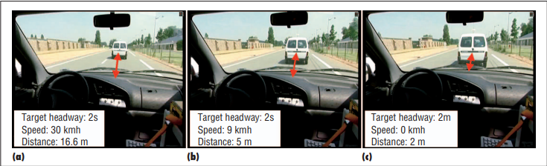

Figure shows how an AV reduces its speed when it detects another vehicle

Lane merging conditions:

* + If the merging lane is clear and the speed is high, then maintain speed.
  + If the merging lane is clear and the speed is moderate, then accelerate slightly.
  + If the merging lane is clear and the speed is low, then accelerate moderately.
  + If there is a vehicle merging into the lane and the distance is small, then reduce speed slightly.
  + If there is a vehicle merging into the lane and the distance is moderate, then reduce speed moderately.
  + If there is a vehicle merging into the lane and the distance is large, then reduce speed sharply.
  + If there is a vehicle merging into the lane and the speed is high, then change lane if safe to do so.
  + If there is a vehicle merging into the lane and the speed is moderate, then reduce speed slightly and wait for the vehicle to merge.
  + If there is a vehicle merging into the lane and the speed is low, then reduce speed moderately and wait for the vehicle to merge.
  + If there are multiple vehicles merging into the lane, then reduce speed sharply and wait for all the vehicles to merge.

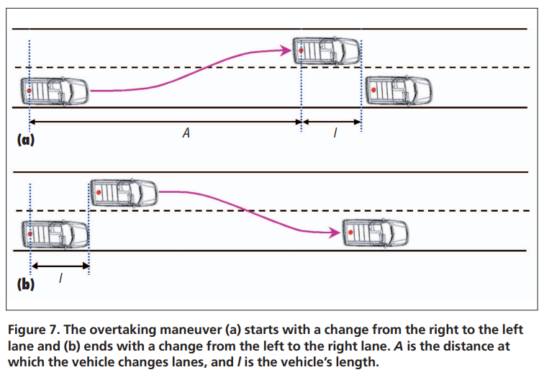

Traffic Signal Conditions:

* + If the car is at an intersection and the traffic light is red, then the car should stop and can also off the engine to conserve energy.
  + If the car is at an intersection and the traffic light is orange, then the car should start the engine and get ready to move.
  + If the car is at an intersection and the traffic light is green, then the car should start moving

Detecting Conditions:

* + If the car detects an obstacle in the road ahead, then the car should slow down and avoid the obstacle if possible.
  + If the car detects a pedestrian crossing the road, then the car should slow down and stop if necessary.
  + If the car detects that it is drifting out of its lane, then the car should adjust its steering to stay in its lane.

Highway Conditions:

* + If the car is merging onto a highway, then the car should accelerate to match the speed of the traffic on the highway.
  + If the car is exiting a highway, then the car should slow down and take the exit ramp.
  + If the car notices any speed breakers slow down.

Indicator Conditions:

* + If the car wants to switch to left lane or turn left, it must use left indicator to notify fellow cars behind.
  + If the car wants to switch to right lane or turn right, it must use right indicator to notify fellow cars behind.
  + If car ahead of you switches on its indicator, slow down until it turns.
  + While parking a car on the side of the road, then it should turn on the parking lights.

Horn Conditions:

* + If the other car's horn is soft, then the car should continue driving normally.
  + If the other car's horn is medium, then the car should slow down and be cautious.
  + If the other car's horn is loud, then the car should immediately stop and assess the situation.

Emergency Conditions:

* + If you sense any siren vehicles immediately try creating a way, so that they can pass freely and rapidly.

Overtaking Conditions:

* If there is no car ahead, then the car can overtake without hesitation.
* If there is a car ahead but it is driving much slower, then the car can overtake when it is safe to do so and there is enough room to pass.
* If there is a car ahead and it is driving slightly slower, then the car should maintain its speed and wait for a better opportunity to overtake.
* If there is a car ahead and it is driving at the same speed, then the car should maintain its current speed and stay behind the other car.
* If there is a car ahead and it is driving slightly faster, then the car should maintain its speed and wait for the other car to pass.
* If there is a car ahead and it is driving much faster, then the car should not attempt to overtake and instead maintain a safe distance behind the other car.

Weather Conditions:

* If it is sunny and dry, then the car should drive normally.
* If it is raining lightly, then the car should slow down and increase following distance.
* If it is raining heavily, then the car should slow down significantly, turn on the headlights, and use the windshield wipers.
* If it is snowing, then the car should slow down significantly, increase following distance, and use snow chains or snow tires if available.
* If there is fog, then the car should slow down significantly, turn on the low beam headlights, and use fog lights if available.
* If there is ice on the road, then the car should slow down significantly, increase following distance, and use studded tires or tire chains if available.

## Challenges and Limitations

While fuzzy rules can be effective in improving traffic flow, there are also challenges and limitations to their use. One challenge is the difficulty of obtaining accurate sensor data in real-time, particularly in high-traffic areas where multiple sensors may be needed to capture all relevant information.

Another limitation is the complexity of modelling human behaviour, which can be unpredictable and difficult to quantify. Despite these challenges, fuzzy rules remain a promising approach to improving traffic flow and reducing congestion in urban areas.

## Real-World Applications

Fuzzy rules have already been implemented in several real-world applications for traffic control. For example, the city of Barcelona uses a traffic control system called SITRA that incorporates fuzzy logic to optimize traffic flow.

Other cities, such as Tokyo and Singapore, have also implemented similar systems to improve traffic flow and reduce congestion. As technology continues to advance and more data becomes available, the use of fuzzy rules for traffic control is likely to become even more widespread.

Fuzzy logic in autonomous systems provides a means to handle uncertainty, imprecision, and complexity, allowing autonomous vehicles and other autonomous systems to make intelligent decisions and adapt to dynamic environments.

5. IMPLEMENTATION

5.1 SENSOR SELECTION AND PLACEMENT:

Sensor selection is the process of carefully choosing the appropriate sensors based on the specific application requirements and desired measurements. It involves considering factors such as the type of physical quantity to be measured, the measurement range, accuracy, resolution, response time, environmental conditions, and cost. By selecting the right sensors, one can ensure the collection of accurate and reliable data, enabling the monitoring and analysis of the desired parameters in each system or environment.

There are several factors to consider when choosing sensors to measure different characteristics.

1. Measurement Specifications:

• Determine the required measurement range and accuracy tolerances.

• Select a sensor capable of accurate and consistent measurements within the desired range.

2. Sensitivity and Response Time:

• Evaluate the sensor's sensitivity to detect minute changes in the measured parameter.

• Consider the required response time, whether real-time or slower responses are acceptable.

3. Environmental Considerations:

• Assess the environmental conditions, including pressure, temperature, humidity, and exposure to chemicals or gases.

• Choose a sensor that can withstand the specific environmental conditions for reliable measurements.

4. Calibration, Maintenance, and Compatibility:

• Determine if the sensor requires regular calibration or maintenance.

• Ensure compatibility with your data collection system in terms of electrical connections, signal output, and communication protocols.

5. Cost, Reliability, and Safety:

• Consider the sensor's price in relation to its reliability and suitability for the application.

• Evaluate the sensor's track record, reviews, and adherence to safety certifications or industry requirements.

For Sensor Placement:

1)Research Objective and Variables: Define the research objective and identify the specific variables to be measured.

2)Literature Review: Conduct a comprehensive review of existing studies and best practices related to sensor placement in similar applications.

3)System Analysis and Sensor Characteristics: Analyse the system under investigation and evaluate the characteristics and capabilities of available sensors.

4)Environmental Factors and Data Requirements: Consider environmental factors that could affect sensor performance and determine the data requirements for effective analysis.

5)Placement Strategies and Validation: Develop sensor placement strategies based on system analysis, sensor characteristics, and environmental factors. Validate the effectiveness of the selected placement through simulation or experimental evaluation.

5.2 SENSOR DATA ACQUISITION AND PREPROCESSING:

Data acquisition is the process of capturing measurements from sensors or instruments to obtain reliable and accurate data. It involves techniques like sampling, converting analogy to digital signals, and applying signal conditioning. Various methods, such as direct, wireless, real-time, remote, distributed, high-speed, multi-channel, and simultaneous data acquisition, can be used based on application needs. It plays a critical role in scientific research, industrial monitoring, and data-driven systems by providing valuable insights and supporting informed decision-making based on the collected data.

1)Direct Data Acquisition: Direct data acquisition involves directly interfacing with the sensors to obtain analog or digital measurements. This can be achieved using specialized hardware, such as data acquisition cards or modules, that interface with the sensors and provide digital outputs.

2)Wireless Data Acquisition: Wireless data acquisition eliminates the need for physical wiring connections between the sensors and the data acquisition system. Sensors equipped with wireless communication capabilities can transmit data wirelessly to a receiver or directly to a central data acquisition unit.

3)Real-Time Data Acquisition: Real-time data acquisition involves capturing and processing data in real-time, with minimal delay between data capture and analysis. This is critical in applications where immediate decision-making or control actions are required based on the acquired data.

4)Remote Data Acquisition: Remote data acquisition refers to capturing data from sensors located in remote or inaccessible locations. This can be achieved by using wireless communication networks, satellite communication, or remote telemetry units to transmit the sensor data to a central data acquisition system.

5)Distributed Data Acquisition: In distributed data acquisition, multiple data acquisition units are deployed in different locations to capture data from various sensors. The distributed units then transmit the acquired data to a centralized system for further processing and analysis.

6)High-Speed Data Acquisition: High-speed data acquisition is used when capturing rapidly changing or transient signals that require high sampling rates. This is common in applications such as high-frequency signal analysis, vibration monitoring, or fast response measurements.

7)Multi-Channel Data Acquisition: Multi-channel data acquisition involves simultaneously capturing data from multiple sensors or multiple channels of a sensor. This is useful when multiple parameters need to be monitored or when spatially distributed sensors need to be synchronized for data analysis.

8)Simultaneous Data Acquisition: Simultaneous data acquisition ensures that measurements from multiple sensors are captured at precisely the same time. This is critical when precise synchronization is required, especially in applications where the correlation between different sensors' measurements is important.

Sensor fusion, the process of combining data from multiple sensors to obtain a more accurate and comprehensive understanding of the environment, presents several challenges. Here are some common challenges associated with sensor fusion:

Heterogeneous Sensor Data: Different sensors, such as cameras, lidar, radar, and GPS, provide different types of data with varying levels of accuracy, precision, and reliability. Integrating these diverse data sources and ensuring their compatibility can be challenging.

Sensor Calibration: Each sensor has its own characteristics and calibration requirements. Accurate calibration is crucial to align sensor data properly and achieve accurate fusion. Maintaining calibration over time and under various environmental conditions can be complex.

Data Synchronization: Sensors may have different data sampling rates, time delays, or latencies. Synchronizing the data from multiple sensors in real-time is essential for accurate fusion. Handling temporal discrepancies and ensuring consistent timestamps across sensors can be challenging.

Data Association: Determining which measurements from different sensors correspond to the same object or feature in the environment is a critical step. This process, known as data association or sensor registration, can be challenging in complex and dynamic scenarios where objects may move, occlude each other, or exhibit similar characteristics.

Sensor Redundancy and Reliability: Sensors may fail or provide unreliable measurements due to various factors, such as occlusions, adverse weather conditions, or hardware malfunctions. Designing robust sensor fusion algorithms that can handle sensor failures, assess sensor reliability, and gracefully degrade in degraded sensor situations is crucial.

Computational Complexity: Sensor fusion often involves complex mathematical models and algorithms to fuse and process data in real-time. Handling the computational complexity while meeting the real-time constraints of autonomous systems can be demanding, requiring efficient algorithms and hardware acceleration techniques.

Validation and Verification: Validating and verifying the performance and accuracy of sensor fusion systems is challenging. It requires comprehensive testing in diverse scenarios, including edge cases and corner scenarios, to ensure reliable operation and avoid potential safety risks.

Data preprocessing refers to the transformation and preparation of raw data before it can be effectively utilized for analysis and modelling. It involves a series of techniques and steps to clean, format, and enhance the data, ensuring its quality and suitability for further processing. Here is an explanation of data preprocessing, including its types and how to solve it:

1)Data Cleaning: Data cleaning involves the identification and handling of missing values, noisy data, outliers, and inconsistencies. Techniques such as imputation, filtering, and outlier detection are employed to address these issues and ensure the data is as accurate and complete as possible.

2)Data Integration: Data integration deals with combining data from multiple sources, which may have different formats, structures, or representations. It involves resolving schema and attribute conflicts, merging datasets, and establishing consistent data representations to create a unified and coherent dataset.

3)Data Transformation: Data transformation involves converting the data into a suitable format for analysis. This may include normalizing or standardizing variables to remove scaling effects, encoding categorical variables into numerical representations, or applying mathematical transformations to achieve desired data distributions.

4)Data Reduction: Data reduction techniques aim to reduce the dimensionality of the dataset while preserving its important characteristics. This can involve feature selection, where relevant attributes are chosen based on their relevance to the problem at hand, or feature extraction, where new representative features are derived from the existing ones.

5)Data Discretization: Data discretization is the process of converting continuous variables into discrete intervals or categories. This is often done to handle large or noisy datasets, simplify analysis, or facilitate the application of specific algorithms that require discrete inputs.

To solve data preprocessing challenges, several techniques and tools can be applied:

1)Exploratory Data Analysis: Conducting exploratory data analysis helps to understand the data's structure, identify patterns, and detect outliers or inconsistencies. This analysis provides insights that guide the selection of appropriate preprocessing techniques.

2)Imputation Methods: For handling missing data, various imputation methods can be employed, such as mean imputation, regression imputation, or advanced techniques like k-nearest neighbours (KNN) imputation or multiple imputation.

3)Filtering and Outlier Detection: Applying filters or statistical methods can help identify and handle outliers. Techniques like z-score, box plots, or clustering-based methods can be used to detect and either remove or impute outliers.

4)Standard Libraries and Tools: Utilizing data preprocessing libraries and tools provided by programming languages like Python (e.g., NumPy, Pandas) or software packages like MATLAB can simplify and streamline the preprocessing process. These libraries offer built-in functions and methods for data cleaning, transformation, and reduction.

5)Domain Expertise: Leveraging domain knowledge and expertise is essential for making informed decisions during data preprocessing. Understanding the specific context, characteristics, and requirements of the data and the problem being addressed can guide the selection of appropriate preprocessing techniques.

5.3 INTEGRATION OF FUZZY RULES FOR DECISION-MAKING:

Decision-making is, as the name implies, the study of how decisions are made and how they can be made better or more successfully. In other words, the field is concerned with both descriptive and normative theories. Much of the emphasis in developing the field has been on management, where the decision-making process is critical for functions such as inventory control, investment, personnel actions, new product development, and resource allocation, among many others. However, decision-making is broadly defined to include any choice or selection of alternatives and is thus important in many fields, including both the “soft” social sciences and the “hard” disciplines of natural sciences and engineering.

The integration of fuzzy rules for decision-making involves several steps and elements. Here is a detailed explanation of the process and the key elements used:

1) Problem Formulation: Define the decision-making problem and identify the variables and parameters involved. Determine the goals, constraints, and objectives of the decision-making process.

2) Linguistic Variables: Identify the linguistic variables that represent the different aspects of the problem. Linguistic variables are qualitative terms used to describe the variables in a human-understandable way. For example, in a temperature control system, linguistic variables could be "cold," "warm," and "hot."

3) Fuzzy sets are a fundamental concept in fuzzy logic, which allows for the representation of uncertainty and vagueness in data. Unlike traditional sets in classical logic, where an element either belongs to a set completely or not at all, fuzzy sets allow for partial membership. In other words, elements can have degrees of membership ranging between 0 and 1, indicating the extent to which they belong to a fuzzy set.

4)Membership Functions: A membership function in fuzzy logic determines the degree to which an element belongs to a fuzzy set. It maps each element from the universal set to a value between 0 and 1, indicating the degree of membership. The shape and characteristics of the membership function define the boundaries and distribution of the fuzzy set.

Here are the various membership functions :

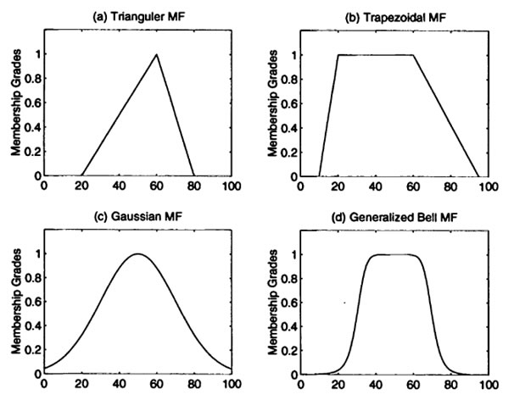

A)Triangular Membership Function: This function has a triangular shape and is defined by three parameters: a lower bound, a peak, and an upper bound. The membership value starts at 0, increases linearly from the lower bound to the peak, remains at 1 within the peak range, and then decreases linearly to 0 at the upper bound.

B)Trapezoidal Membership Function: This function has a trapezoidal shape and is defined by four parameters: a left shoulder, a left peak, a right peak, and a right shoulder. The membership value starts at 0, increases linearly from the left shoulder to the left peak, remains at 1 within the peak range, decreases linearly from the right peak to the right shoulder, and then becomes 0

C)Gaussian Membership Function: This function has a bell-shaped curve resembling a Gaussian distribution. It is defined by two parameters: the mean and the standard deviation. The membership value is highest at the mean and gradually decreases symmetrically on both sides

D)Sigmoidal Membership Function: This function has an S-shaped curve and is defined by two parameters: the center and the slope. The membership value gradually increases or decreases in a sigmoidal manner, depending on the slope parameter.

5)Fuzzy Rules: Create a set of fuzzy rules that represent the decision-making logic. Fuzzy rules consist of an antecedent (condition) and a consequent (action). The antecedent uses linguistic variables and their associated fuzzy sets to describe the input conditions. The consequent specifies the output or action to be taken based on the satisfaction of the antecedent. We had already have written above the fuzzy rules for a car in various situations in fuzzy rules

A fuzzy inference engine is a core component of a fuzzy logic system that processes fuzzy inputs, applies fuzzy rules, and produces crisp outputs based on fuzzy logic principles. It mimics human reasoning and decision-making by using fuzzy sets, fuzzy rules, and fuzzy reasoning techniques. The main components of a fuzzy inference engine include fuzzification, rule evaluation, aggregation, and defuzzification.

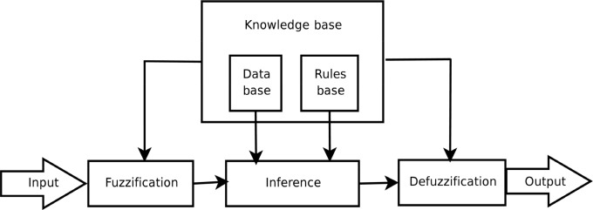

6)Fuzzy Inference Engine:

A) Fuzzification: Fuzzification is the process of converting crisp inputs into fuzzy sets by assigning membership degrees to relevant fuzzy sets. Each input value is mapped to its corresponding membership degree in the fuzzy sets defined for that variable. This step allows for the representation of imprecise and uncertain input information in the form of fuzzy sets.

B) Rule Evaluation: Rule evaluation involves determining the degree to which each fuzzy rule is satisfied based on the fuzzified inputs. Each fuzzy rule consists of antecedents (if-conditions) and a consequent (then-action). The antecedents are evaluated by considering the membership degrees of the input variables in the corresponding fuzzy sets. The degree of rule satisfaction is calculated based on fuzzy logic operators such as "AND" and "OR" applied to the membership degrees.

C)Aggregation: Aggregation combines the degrees of rule satisfaction from multiple rules to obtain a single aggregated output fuzzy set. This step involves applying fuzzy logic operators such as "OR" or maximum to combine the individual rule satisfaction degrees. The resulting aggregated fuzzy set represents the overall output distribution.

D)Defuzzification: Defuzzification converts the aggregated fuzzy set into a crisp output value. It determines the representative value that best represents the aggregated fuzzy set. Common defuzzification methods include the centroid method, mean of maximum, and weighted average. These methods calculate a single crisp output value based on the shape and characteristics of the aggregated fuzzy set.

E)Rule Base Refinement: Refine and tune the fuzzy rule base based on expert knowledge or by using optimization techniques. This step involves adjusting the membership functions, adding or removing rules, or modifying rule weights to improve the decision-making process.

F)Validation and Testing: Validate and test the fuzzy rule-based system using representative data or scenarios. Assess the performance and accuracy of the system by comparing the results with known outcomes or expert opinions. Iterate and refine the system as needed.

Some of the commonly known applications can be summarized as,

• Fuzzy Logic is used with Neural Networks because it simulates how people make decisions, but much faster. It is accomplished by aggregating data and transforming it into more meaningful data using partial truths in the form of fuzzy sets.

• In the large company business, it is used for decision-making support systems and personal evaluation.

• It has been used in automotive systems to control speed and traffic.

• Fuzzy logic is used in Natural Language Processing and a variety of Artificial Intelligence applications.

• It’s used in the aerospace industry to control the altitude of spacecraft and satellites.

• Modern control systems, such as expert systems, make extensive use of fuzzy logic.

CONCLUSION

In this research paper, we investigated the design challenges of autonomous driving vehicles, focusing on the problem of sensor fusion and the integration of fuzzy rules. The fusion of information generated by various sensors is crucial for accurate perception and decision-making in autonomous vehicles. Additionally, the incorporation of fuzzy logic and fuzzy rules provides a powerful framework for handling uncertainty and imprecision in autonomous systems.

Through our analysis, we have identified several key findings and insights:

1. Sensor Fusion Challenges:

Sensor fusion plays a vital role in autonomous driving vehicles as it enables the vehicle to perceive its surroundings accurately. The fusion of data from sensors such as cameras, radars, and lidars allows for a comprehensive understanding of the environment and enhances the vehicle's decision-making capabilities. However, sensor fusion poses several challenges, including data alignment, calibration, synchronization, and dealing with sensor limitations and uncertainties. Addressing these challenges is crucial to ensure reliable and robust perception in autonomous vehicles.

2. Fuzzy Rules Integration:

Fuzzy logic and fuzzy rules provide a valuable framework for dealing with uncertainty and imprecision in autonomous systems. The integration of fuzzy rules allows for more flexible and adaptive decision-making, considering various factors and linguistic variables. By incorporating expert knowledge and capturing human-like reasoning, fuzzy rules can enhance the intelligence and responsiveness of autonomous vehicles. However, the design and tuning of fuzzy rule-based systems require careful consideration and expertise to ensure optimal performance.

3. Benefits and Potential Applications:

The integration of sensor fusion and fuzzy rules in autonomous vehicles offers numerous benefits. Accurate sensor fusion enhances perception and enables the vehicle to detect and track objects reliably, ensuring safer and more efficient driving. Fuzzy rules integration allows for intelligent decision-making under uncertainty, enabling autonomous vehicles to handle complex scenarios and adapt to dynamic environments. These technologies have the potential to revolutionize transportation systems, improve road safety, reduce congestion, and enhance the overall driving experience.

4. Future Directions and Challenges:

While significant progress has been made in sensor fusion and fuzzy logic integration in autonomous vehicles, there are still ongoing research challenges and opportunities for further improvement. The development of more advanced sensor technologies, such as high-resolution cameras, multi-modal sensors, and advanced lidar systems, can enhance the accuracy and robustness of sensor fusion. Additionally, the integration of machine learning and artificial intelligence techniques with fuzzy logic can further enhance the intelligence and learning capabilities of autonomous systems.

In conclusion, the design of autonomous driving vehicles requires addressing the challenges of sensor fusion and integrating fuzzy rules. Sensor fusion ensures accurate perception of the environment, while fuzzy logic provides a framework to handle uncertainty and imprecision in decision-making. By addressing these challenges and leveraging the benefits of sensor fusion and fuzzy rules integration, autonomous vehicles can achieve safer, more efficient, and more intelligent navigation. Continued research and development in this field are essential for realizing the full potential of autonomous driving technology and revolutionizing the future of transportation.

REFERENCES

1. World Health Organization. Global Status Report on Road Safety; WHO: Geneva, Switzerland, 2018; ISBN 978-9241565684. [link](https://books.google.co.in/books?hl=en&lr=&id=wV40DgAAQBAJ&oi=fnd&pg=PP1&ots=DKYAyZcZni&sig=PT3ai1baPyPzO6rnbcJq38bR10E&redir_esc=y#v=onepage&q&f=false)
2. Road | Mobility and Transport. Available online: [https://ec.europa.eu/transport/themes/its/road_it](https://ec.europa.eu/transport/themes/its/road_it%20).
3. Autonomous Vehicle Market to Garner Growth 63.5%. Available online: [https://www.precedenceresearch.com/autonomous-vehicle-market](https://www.precedenceresearch.com/autonomous-vehicle-market%20).
4. [Machine Learning And Fuzzy Logic For Better Decision Making](http://www.ijstr.org/final-print/oct2019/A-Review-On-Big-Data-With-Machine-Learning-And-Fuzzy-Logic-For-Better-Decision-Making.pdf)
5. [Application Of Fuzzy Logic In Decision Making](https://www.ijert.org/research/application-of-fuzzy-logic-in-decision-making-grid-technology-IJERTV2IS80407.pdf)