The question is based on Fibonacci encoding which is used to provide a representation of large numbers for data compression, i.e. to store them efficiently.

Basically we take the number and create an array of nums in the Fibonacci sequence <= to the number, starting from 3rd Fibonacci num, which is 1 (to avoid repetition of 1 and neglect 0). From there on, select the greatest num <= input which is the last element of our array. Initialize that index with 1 and update the original to (original - that num). Now repeat the process for the number thus obtained till it reaches 0. Finally append ‘1’ at the end. Therefore last 2 chararcters of output must always be ‘1’.

For example (Sourced from GfG: <https://www.geeksforgeeks.org/fibonacci-coding/>):

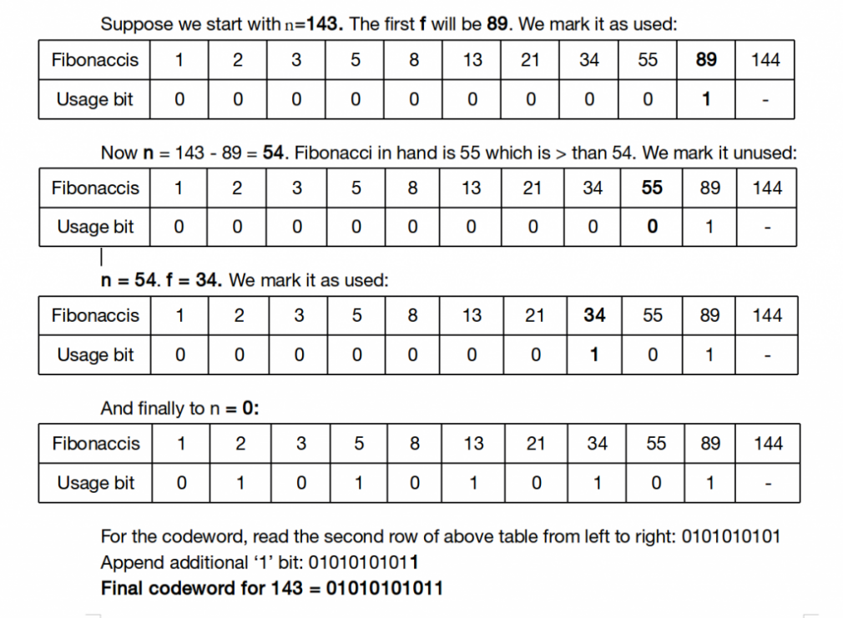

Finally for our problem, we simply replace ‘1’ with ‘0’ and ‘0’ with ‘1’.

**NOTE:** If the last two chars of output are not ‘1’ then it will be treated as invalid. Same goes for the input of decoder file for resp. problem. Decoder file is currently written to treat the output as a string rather thana number since starting bit can be ‘0’.

**Additional:** to make the problem more complex we can perform swapping or other operations aswell in the final output and onLy change specific bits from ‘0’ to ‘1’ or vice versa